**Rentalz247.com**

1. Image ratio must be 1:1(square)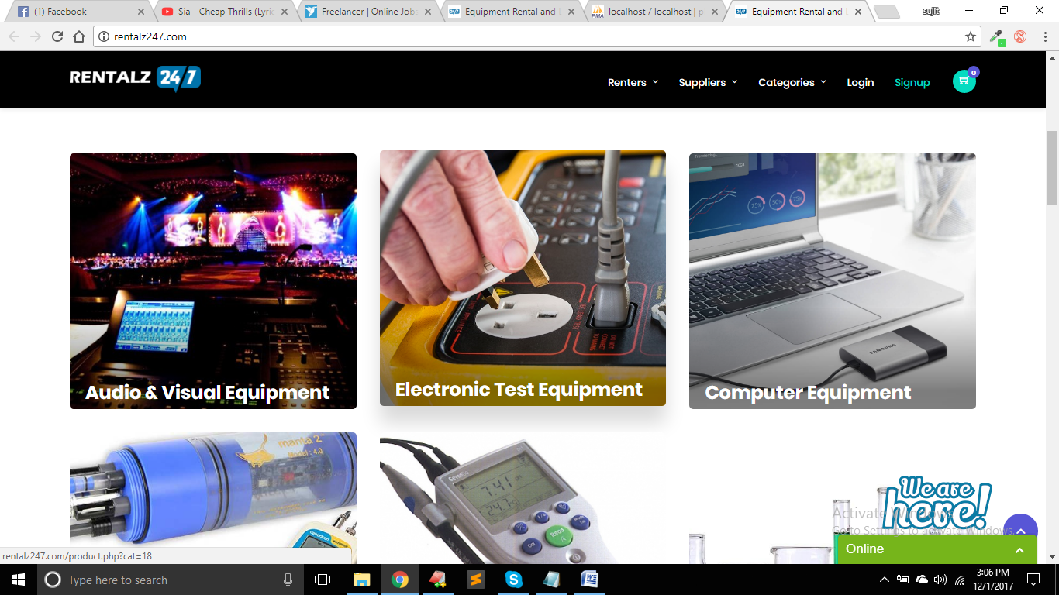
2. Width : 350px Height : 260px

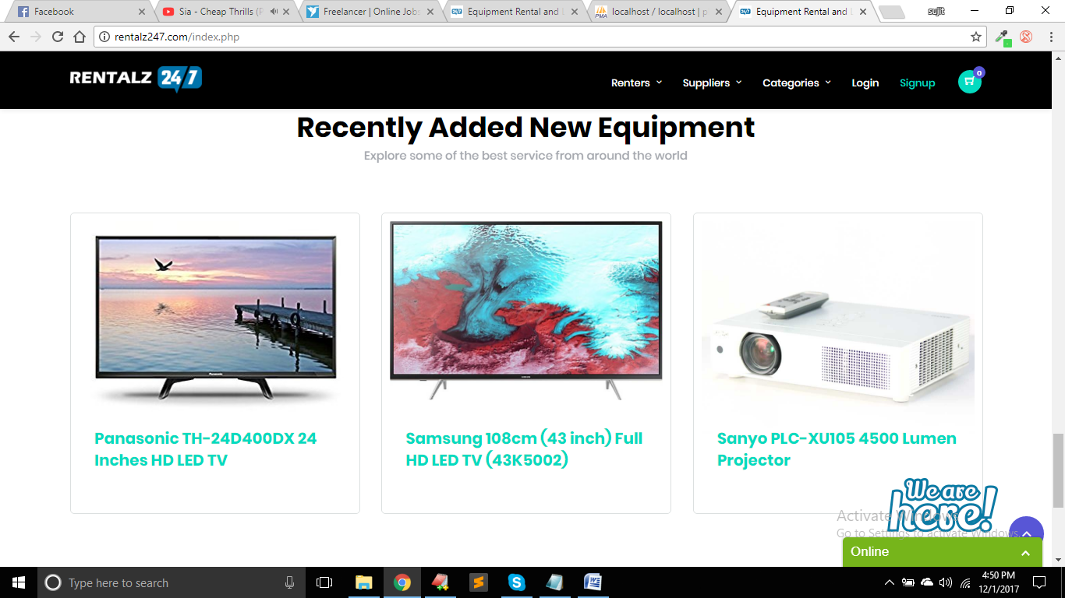

1. Width : 268px Height: 250px

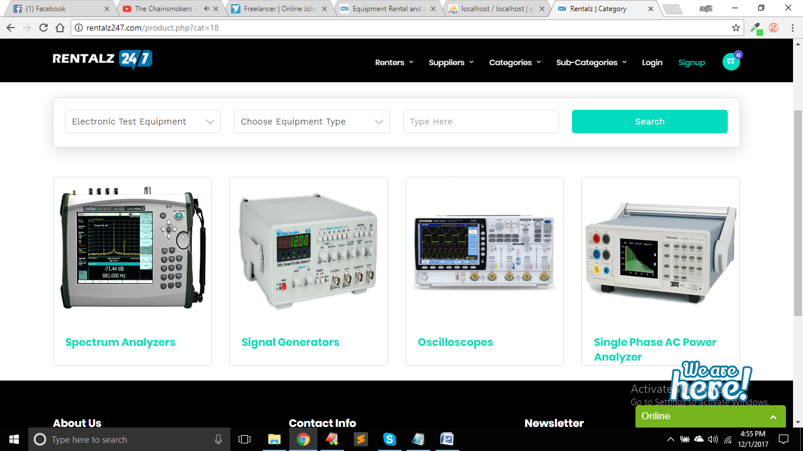

1. Width : 243.7px Height : 230px

