SWEN 432
Advanced Database Design and Implementation
Assignment 2

Boxiong TAN
300300835

Question1:

<?xml version="1.0"?>
<xs:schema xmlns:xs="http://www.w3.org/2001/XMLSchema">
<!--define simple elements-->
<xs:element name="Color" type="xs:string"/>
<xs:element name="Name" type="xs:string"/>
<xs:element name="Skills" type="xs:string"/>
<xs:element name="Address" type="xs:string"/>
<xs:element name="Rows"/>
<xs:element name="Sail"/>
<xs:element name="Motor"/>

<!--define attribute-->
<xs:attribute name="name" type="xs:string"/>
<xs:attribute name="location" type="xs:string"/>
<xs:attribute name="MarinaId" type="xs:ID"/>

<xs:attribute name="Number" type="xs:ID"/>
<xs:attribute name="date" type="xs:string"/>

<xs:attribute name="ref_sail" type="xs:IDREF"/>
<xs:attribute name="grade" type="xs:string"/>
<xs:attribute name="from" type="xs:string"/>
<xs:attribute name="to" type="xs:string"/>

<xs:attribute name="SailorId">
<xs:simpleType>
<xs:restriction base="xs:ID">
<xs:pattern value="sa[0-9][0-9][0-9]"/>
</xs:restriction>
</xs:simpleType>
</xs:attribute>

<xs:attribute name="ref_grade" type="xs:IDREF"/>

<xs:attribute name="GradeId" type="xs:ID"/>

<!-- define complexType -->

<xs:element name="Boat_Hire">
<xs:complexType>
<xs:sequence>
<xs:element ref="Marina" minOccurs="1" maxOccurs="unbounded"/>
<xs:element ref="Sailors"/>
<xs:element ref="Grade" minOccurs="1" maxOccurs="unbounded"/>
</xs:sequence>
</xs:complexType>
</xs:element>

<xs:element name="Marina">
<xs:complexType>
<xs:sequence>
<xs:element ref="Boat" minOccurs="1" maxOccurs="unbounded"/>
</xs:sequence>
<xs:attribute ref="name" use="required"/>
<xs:attribute ref="location" use="optional"/>
<xs:attribute ref="MarinaId" use="required"/>
</xs:complexType>
</xs:element>

<xs:element name="Boat">
<xs:complexType>
<xs:sequence>
<xs:element ref="Color"/>
<xs:element ref="Powered_By"/>
<xs:element ref="Reserves" minOccurs="0" maxOccurs="unbounded"/>
</xs:sequence>
<xs:attribute ref="name" use="required"/>
<xs:attribute ref="Number" use="required"/>
</xs:complexType>
</xs:element>

<xs:element name="Powered_By">
<xs:complexType>
<xs:choice>
<xs:sequence>
<xs:element ref="Rows"/>
<xs:choice minOccurs="0" maxOccurs="1">
<xs:element ref="Sail"/>
<xs:element ref="Motor"/>
</xs:choice>
</xs:sequence>
<xs:choice>
<xs:sequence>
<xs:element ref="Sail"/>
<xs:element ref="Motor" minOccurs="0" maxOccurs="1"/>
</xs:sequence>
<xs:element ref="Motor"/>
</xs:choice>
</xs:choice>
</xs:complexType>
</xs:element>

<xs:element name="Reserves">
<xs:complexType>
<xs:sequence>
<xs:element ref="Res_Sailor" minOccurs="1" maxOccurs="unbounded"/>
</xs:sequence>
<xs:attribute ref="date" use="required"/>
</xs:complexType>
</xs:element>

<xs:element name="Res_Sailor">
<xs:complexType>
<xs:attribute ref="ref_sail" use="required"/>
<xs:attribute ref="grade" fixed="S"/>
<xs:attribute ref="from" use="required"/>
<xs:attribute ref="to" use="required"/>
</xs:complexType>
</xs:element>

<xs:element name="Sailors">
<xs:complexType>
<xs:sequence>
<xs:element ref="Sailor" minOccurs="0" maxOccurs="unbounded"/>
</xs:sequence>
</xs:complexType>
</xs:element>

<xs:element name="Sailor">
<xs:complexType>
<xs:sequence>
<xs:element ref="Name"/>
<xs:element ref="Skills"/>
<xs:element ref="Address" minOccurs="0" maxOccurs="1"/>
</xs:sequence>
<xs:attribute ref="SailorId" use="required"/>
<xs:attribute ref="ref_grade" use="required"/>
</xs:complexType>
</xs:element>

<xs:element name="Grade">
<xs:complexType>
<xs:sequence>
<xs:element ref="Name"/>
</xs:sequence>
<xs:attribute ref="GradeId" use="required"/>
</xs:complexType>
</xs:element>

</xs:schema>

Boat_Hire_A2_b_14.xsd

<?xml version="1.0"?>
<xs:schema xmlns:xs="http://www.w3.org/2001/XMLSchema">
<!--define simple elements-->
<xs:element name="Color" type="xs:string"/>
<xs:element name="Name" type="xs:string"/>
<xs:element name="Skills" type="xs:string"/>
<xs:element name="Address" type="xs:string"/>
<xs:element name="Rows"/>
<xs:element name="Sail"/>
<xs:element name="Motor"/>

<!--define attribute-->
<xs:attribute name="name" type="xs:string"/>
<xs:attribute name="location" type="xs:string"/>
<xs:attribute name="MarinaId" type="xs:ID"/>

<xs:attribute name="Number" type="xs:ID"/>
<xs:attribute name="date" type="xs:string"/>

<xs:attribute name="ref_sail" type="xs:IDREF"/>
<xs:attribute name="grade" type="xs:string"/>
<xs:attribute name="from" type="xs:time"/>
<xs:attribute name="to" type="xs:time"/>

<xs:attribute name="SailorId" type="xs:ID"/>
<xs:attribute name="ref_grade" type="xs:IDREF"/>

<xs:attribute name="GradeId" type="xs:ID"/>

<!-- define complexType -->

<xs:element name="Boat_Hire">
<xs:complexType>
<xs:sequence>
<xs:element ref="Marina" minOccurs="1" maxOccurs="unbounded"/>
<xs:element ref="Sailors"/>
<xs:element ref="Grade" minOccurs="1" maxOccurs="unbounded"/>
</xs:sequence>
</xs:complexType>
</xs:element>

<xs:element name="Marina">
<xs:complexType>
<xs:sequence>
<xs:element ref="Boat" minOccurs="1" maxOccurs="unbounded"/>
</xs:sequence>
<xs:attribute ref="name" use="required"/>
<xs:attribute ref="location" use="optional"/>
<xs:attribute ref="MarinaId" use="required"/>
</xs:complexType>
</xs:element>

<xs:element name="Boat">
<xs:complexType>
<xs:sequence>
<xs:element ref="Color"/>
<xs:element ref="Powered_By"/>
<xs:element ref="Reserves" minOccurs="0" maxOccurs="unbounded"/>
</xs:sequence>
<xs:attribute ref="name" use="required"/>
<xs:attribute ref="Number" use="required"/>
</xs:complexType>
</xs:element>

<xs:element name="Powered_By">
<xs:complexType>
<xs:choice>
<xs:sequence>
<xs:element ref="Rows"/>
<xs:choice minOccurs="0" maxOccurs="1">
<xs:element ref="Sail"/>
<xs:element ref="Motor"/>
</xs:choice>
</xs:sequence>
<xs:choice>
<xs:sequence>
<xs:element ref="Sail"/>
<xs:element ref="Motor" minOccurs="0" maxOccurs="1"/>
</xs:sequence>
<xs:element ref="Motor"/>
</xs:choice>
</xs:choice>
</xs:complexType>
</xs:element>

<xs:element name="Reserves">
<xs:complexType>
<xs:sequence>
<xs:element ref="Res_Sailor" minOccurs="1" maxOccurs="unbounded"/>
</xs:sequence>
<xs:attribute ref="date" use="required"/>
</xs:complexType>
</xs:element>

<xs:element name="Res_Sailor">
<xs:complexType>
<xs:attribute ref="ref_sail" use="required"/>
<xs:attribute ref="grade" fixed="S"/>
<xs:attribute ref="from" use="required"/>
<xs:attribute ref="to" use="required"/>
<xs:assert test="@from le @to"/>
</xs:complexType>
</xs:element>

<xs:element name="Sailors">
<xs:complexType>
<xs:sequence>
<xs:element ref="Sailor" minOccurs="0" maxOccurs="unbounded"/>
</xs:sequence>
</xs:complexType>
</xs:element>

<xs:element name="Sailor">
<xs:complexType>
<xs:sequence>
<xs:element ref="Name"/>
<xs:element ref="Skills"/>
<xs:element ref="Address" minOccurs="0" maxOccurs="1"/>
</xs:sequence>
<xs:attribute ref="SailorId" use="required"/>
<xs:attribute ref="ref_grade" use="required"/>
</xs:complexType>
</xs:element>

<xs:element name="Grade">
<xs:complexType>
<xs:sequence>
<xs:element ref="Name"/>
</xs:sequence>
<xs:attribute ref="GradeId" use="required"/>
</xs:complexType>
</xs:element>

</xs:schema>

Question2.

<?xml version="1.0"?>
<xs:schema xmlns:xs="http://www.w3.org/2001/XMLSchema">
<!--define simple elements-->
<xs:element name="Color" type="xs:string"/>
<xs:element name="Name" type="xs:string"/>
<xs:element name="Skills" type="xs:string"/>
<xs:element name="Address" type="xs:string"/>
<xs:element name="Rows"/>
<xs:element name="Sail"/>
<xs:element name="Motor"/>

<!--define attribute-->
<xs:attribute name="name" type="xs:string"/>
<xs:attribute name="location" type="xs:string"/>
<xs:attribute name="MarinaId" type="xs:string"/>

<xs:attribute name="Number" type="xs:string"/>
<xs:attribute name="date" type="xs:string"/>

<xs:attribute name="ref_sail" type="xs:string"/>
<xs:attribute name="grade" type="xs:string"/>
<xs:attribute name="from" type="xs:string"/>
<xs:attribute name="to" type="xs:string"/>

<xs:attribute name="SailorId" type="xs:string"/>
<xs:attribute name="ref_grade" type="xs:string"/>

<xs:attribute name="GradeId" type="xs:string"/>

<!-- define complexType -->

<xs:element name="Boat_Hire">
<xs:complexType>
<xs:sequence>
<xs:element ref="Marina" minOccurs="1" maxOccurs="unbounded"/>
<xs:element ref="Sailors"/>
<xs:element ref="Grade" minOccurs="1" maxOccurs="unbounded"/>
</xs:sequence>
</xs:complexType>

<xs:key name="key_MarinaId">
<xs:selector xpath=".//Marina"/>
<xs:field xpath="@MarinaId"/>
</xs:key>

<xs:key name="key_GradeId">
<xs:selector xpath="Grade"/>
<xs:field xpath="@GradeId"/>
</xs:key>

<!--
<xs:key name="key_grad">
<xs:selector xpath=".//Res_Sailor"/>
<xs:field xpath=".//Sailor/@SailorId"/>
<xs:field xpath=".//@GradeId"/>
</xs:key>

<xs:keyref name="ref_sai" refer="key_grad">
<xs:selector xpath="Sailor"/>
<xs:field xpath="@ref_grade"/>
<xs:field xpath=".//@grade"/>
</xs:keyref>
-->
<xs:keyref name="r_grade" refer="key_GradeId">
<xs:selector xpath=".//Sailor"/>
<xs:field xpath="@ref_grade"/>
</xs:keyref>

<xs:keyref name="r_sail" refer="key_SailorId">
<xs:selector xpath=".//Res_Sailor"/>
<xs:field xpath="@ref_sail"/>
</xs:keyref>
</xs:element>

<xs:element name="Marina">
<xs:complexType>
<xs:sequence>
<xs:element ref="Boat" minOccurs="1" maxOccurs="unbounded"/>
</xs:sequence>
<xs:attribute ref="name" use="required"/>
<xs:attribute ref="location" use="optional"/>
<xs:attribute ref="MarinaId" use="required"/>
</xs:complexType>

<xs:key name="Number_key">
<xs:selector xpath="Boat"/>
<xs:field xpath="@Number"/>
</xs:key>

<xs:unique name="boat_name">
<xs:selector xpath="Boat"/>
<xs:field xpath="@name"/>
</xs:unique>

</xs:element>

<xs:element name="Boat">
<xs:complexType>
<xs:sequence>
<xs:element ref="Color"/>
<xs:element ref="Powered_By"/>
<xs:element ref="Reserves" minOccurs="0" maxOccurs="unbounded"/>
</xs:sequence>
<xs:attribute ref="name" use="required"/>
<xs:attribute ref="Number" use="required"/>
</xs:complexType>

<!-- Question2_i: No, we can not make a key like this. Because we could not contraint Reserves from higher level
<xs:key name="Res_key">
<xs:selector xpath="Reserves"/>
<xs:field xpath="@Number"/>
<xs:field xpath="Reserves/@date"/>
</xs:key>
-->
</xs:element>

<xs:element name="Powered_By">
<xs:complexType>
<xs:choice>
<xs:sequence>
<xs:element ref="Rows"/>
<xs:choice minOccurs="0" maxOccurs="1">
<xs:element ref="Sail"/>
<xs:element ref="Motor"/>
</xs:choice>
</xs:sequence>
<xs:choice>
<xs:sequence>
<xs:element ref="Sail"/>
<xs:element ref="Motor" minOccurs="0" maxOccurs="1"/>
</xs:sequence>
<xs:element ref="Motor"/>
</xs:choice>
</xs:choice>
</xs:complexType>
</xs:element>

<xs:element name="Reserves">
<xs:complexType>
<xs:sequence>
<xs:element ref="Res_Sailor" minOccurs="1" maxOccurs="unbounded"/>
</xs:sequence>
<xs:attribute ref="date" use="required"/>
</xs:complexType>

<xs:unique name="R_Sailor">
<xs:selector xpath="Res_Sailor"/>
<xs:field xpath="@ref_sail"/>
</xs:unique>

</xs:element>

<xs:element name="Res_Sailor">
<xs:complexType>
<xs:attribute ref="ref_sail" use="required"/>
<xs:attribute ref="grade" fixed="S"/>
<xs:attribute ref="from" use="required"/>
<xs:attribute ref="to" use="required"/>
</xs:complexType>
</xs:element>

<xs:element name="Sailors">
<xs:complexType>
<xs:sequence>
<xs:element ref="Sailor" minOccurs="0" maxOccurs="unbounded"/>
</xs:sequence>
</xs:complexType>

<xs:key name="key_SailorId">
<xs:selector xpath="Sailor"/>
<xs:field xpath="@SailorId"/>
</xs:key>

</xs:element>

<xs:element name="Sailor">
<xs:complexType>
<xs:sequence>
<xs:element ref="Name"/>
<xs:element ref="Skills"/>
<xs:element ref="Address" minOccurs="0" maxOccurs="1"/>
</xs:sequence>
<xs:attribute ref="SailorId" use="required"/>
<xs:attribute ref="ref_grade" use="required"/>
</xs:complexType>
</xs:element>

<xs:element name="Grade">
<xs:complexType>
<xs:sequence>
<xs:element ref="Name"/>
</xs:sequence>
<xs:attribute ref="GradeId" use="required"/>
</xs:complexType>
</xs:element>

</xs:schema>

Question3

Boat_Hire_A2_WRONG_a_14.xml:21: element Res_Sailor: Schemas validity error :
Element 'Res_Sailor': Duplicate key-sequence ['sa777'] in unique
identity-constraint 'R_Sailor'.

comment:

There are two [sa777] in <Reserves date = "2014-03-17">. In the question, we
have define that there can not be more than one sailor reserve the boat at the
same date.

The error can not be solved by ID/IDREF.
ID/IDREF could not detect duplicated situation like this. It could only detect
definition of elements or attributes.

==========================================

Boat_Hire_A2_WRONG_a_14.xml:43: element Marina: Schemas validity error :
Element 'Marina': Duplicate key-sequence ['pn'] in key identity-constraint
'key_MarinaId'.

comment:
ID/IDREF could detect the error. But it gives a confused feedback of the
error.

Marina: Schemas validity error : Element 'Marina', attribute 'MarinaId': 'pn' is
not a valid value of the atomic type 'xs:ID'.

==========================================

Boat_Hire_A2_WRONG_a_14.xml:136: element Sailor: Schemas validity error :
Element 'Sailor': Duplicate key-sequence ['sa999'] in key identity-constraint
'key_SailorId'.

comment:
Duplicate [sa999] in the Sailor definitions. It can be validated by ID/IDREF

==========================================

Boat_Hire_A2_WRONG_a_14.xml:153: element Grade: Schemas validity error :
Element 'Grade': Duplicate key-sequence ['A'] in key identity-constraint
'key_GradeId'.

comment:
Duplicate [A], It can be detected by ID/IDREF

==========================================

Boat_Hire_A2_WRONG_a_14.xml:136: Schemas validity error : Element 'Sailor': No
match found for key-sequence ['sv'] of keyref 'r_grade'.

comment:
[sv] can not be found in the Grade definition.
This problem can be detected by IDREF.

==========================================

Boat_Hire_A2_WRONG_a_14.xml:24: Schemas validity error : Element 'Res_Sailor':
No match found for key-sequence ['b515'] of keyref 'r_sail'.

comment:
Could not find [b515] in the Sailors' definition.
This problem can not be solved by ID/IDREF.
If define Sailor number="xs:ID", if there is a sailor's number is b515.
However, there is Boat also has a number = b515. Then comflicts appear.
Boat_Hire_A2_Q3_14.xsd

<?xml version="1.0"?>
<xs:schema xmlns:xs="http://www.w3.org/2001/XMLSchema">
<!--define simple elements-->
<xs:element name="Color" type="xs:string"/>
<xs:element name="Name" type="xs:string"/>
<xs:element name="Skills" type="xs:string"/>
<xs:element name="Address" type="xs:string"/>
<xs:element name="Rows"/>
<xs:element name="Sail"/>
<xs:element name="Motor"/>

<!--define attribute-->
<xs:attribute name="name" type="xs:string"/>
<xs:attribute name="location" type="xs:string"/>
<xs:attribute name="MarinaId" type="xs:string"/>

<xs:attribute name="Number" type="xs:string"/>
<xs:attribute name="date" type="xs:string"/>

<xs:attribute name="ref_sail" type="xs:string"/>
<xs:attribute name="grade" type="xs:string"/>
<xs:attribute name="from" type="xs:string"/>
<xs:attribute name="to" type="xs:string"/>

<xs:attribute name="SailorId">
<xs:simpleType>
<xs:restriction base="xs:string">
<xs:pattern value="sa[0-9][0-9][0-9]"/>
</xs:restriction>
</xs:simpleType>
</xs:attribute>
<xs:attribute name="ref_grade" type="xs:string"/>

<xs:attribute name="GradeId" type="xs:string"/>

<!-- define complexType -->

<xs:element name="Boat_Hire">
<xs:complexType>
<xs:sequence>
<xs:element ref="Marina" minOccurs="1" maxOccurs="unbounded"/>
<xs:element ref="Sailors"/>
<xs:element ref="Grade" minOccurs="1" maxOccurs="unbounded"/>
</xs:sequence>
</xs:complexType>
<xs:key name="key_MarinaId">
<xs:selector xpath=".//Marina"/>
<xs:field xpath="@MarinaId"/>
</xs:key>

<xs:key name="key_GradeId">
<xs:selector xpath="Grade"/>
<xs:field xpath="@GradeId"/>
</xs:key>

</xs:element>

<xs:element name="Marina">
<xs:complexType>
<xs:sequence>
<xs:element ref="Boat" minOccurs="1" maxOccurs="unbounded"/>
</xs:sequence>
<xs:attribute ref="name" use="required"/>
<xs:attribute ref="location" use="optional"/>
<xs:attribute ref="MarinaId" use="required"/>
</xs:complexType>
<xs:key name="Number_key">
<xs:selector xpath="Boat"/>
<xs:field xpath="@Number"/>
</xs:key>

<xs:unique name="boat_name">
<xs:selector xpath="Boat"/>
<xs:field xpath="@name"/>
</xs:unique>

</xs:element>

<xs:element name="Boat">
<xs:complexType>
<xs:sequence>
<xs:element ref="Color"/>
<xs:element ref="Powered_By"/>
<xs:element ref="Reserves" minOccurs="0" maxOccurs="unbounded"/>
</xs:sequence>
<xs:attribute ref="name" use="required"/>
<xs:attribute ref="Number" use="required"/>
</xs:complexType>
</xs:element>

<xs:element name="Powered_By">
<xs:complexType>
<xs:choice>
<xs:sequence>
<xs:element ref="Rows"/>
<xs:choice minOccurs="0" maxOccurs="1">
<xs:element ref="Sail"/>
<xs:element ref="Motor"/>
</xs:choice>
</xs:sequence>
<xs:choice>
<xs:sequence>
<xs:element ref="Sail"/>
<xs:element ref="Motor" minOccurs="0" maxOccurs="1"/>
</xs:sequence>
<xs:element ref="Motor"/>
</xs:choice>
</xs:choice>
</xs:complexType>
</xs:element>

<xs:element name="Reserves">
<xs:complexType>
<xs:sequence>
<xs:element ref="Res_Sailor" minOccurs="1" maxOccurs="unbounded"/>
</xs:sequence>
<xs:attribute ref="date" use="required"/>
</xs:complexType>
<xs:unique name="R_Sailor">
<xs:selector xpath="Res_Sailor"/>
<xs:field xpath="@ref_sail"/>
</xs:unique>
<xs:key name="grade_key">
<xs:selector xpath="Res_Sailor"/>
<xs:field xpath="@ref_sail"/>
<xs:field xpath="@grade"/>
</xs:key>
</xs:element>

<xs:element name="Res_Sailor">
<xs:complexType>
<xs:attribute ref="ref_sail" use="required"/>
<xs:attribute ref="grade" fixed='S'/>
<xs:attribute ref="from" use="required"/>
<xs:attribute ref="to" use="required"/>
</xs:complexType>

</xs:element>

<xs:element name="Sailors">
<xs:complexType>
<xs:sequence>
<xs:element ref="Sailor" minOccurs="0" maxOccurs="unbounded"/>
</xs:sequence>
</xs:complexType>

<xs:keyref name="ref_grade_" refer="grade_key">
<xs:selector xpath="Sailor"/>
<xs:field xpath="@SailorId"/>
<xs:field xpath="@ref_grade"/>
</xs:keyref>
</xs:element>

<xs:element name="Sailor">
<xs:complexType>
<xs:sequence>
<xs:element ref="Name"/>
<xs:element ref="Skills"/>
<xs:element ref="Address" minOccurs="0" maxOccurs="1"/>
</xs:sequence>
<xs:attribute ref="SailorId" use="required"/>
<xs:attribute ref="ref_grade" use="required"/>
</xs:complexType>
</xs:element>

<xs:element name="Grade">
<xs:complexType>
<xs:sequence>
<xs:element ref="Name"/>
</xs:sequence>
<xs:attribute ref="GradeId" use="required"/>
</xs:complexType>
</xs:element>

</xs:schema>

Question 4

There are 25 maximal trees.
Because it is not allow duplication in the maximal trees, so each station will generate a new maximal tree.

There are total 25 stations. Therefore there are 25 maximal trees.

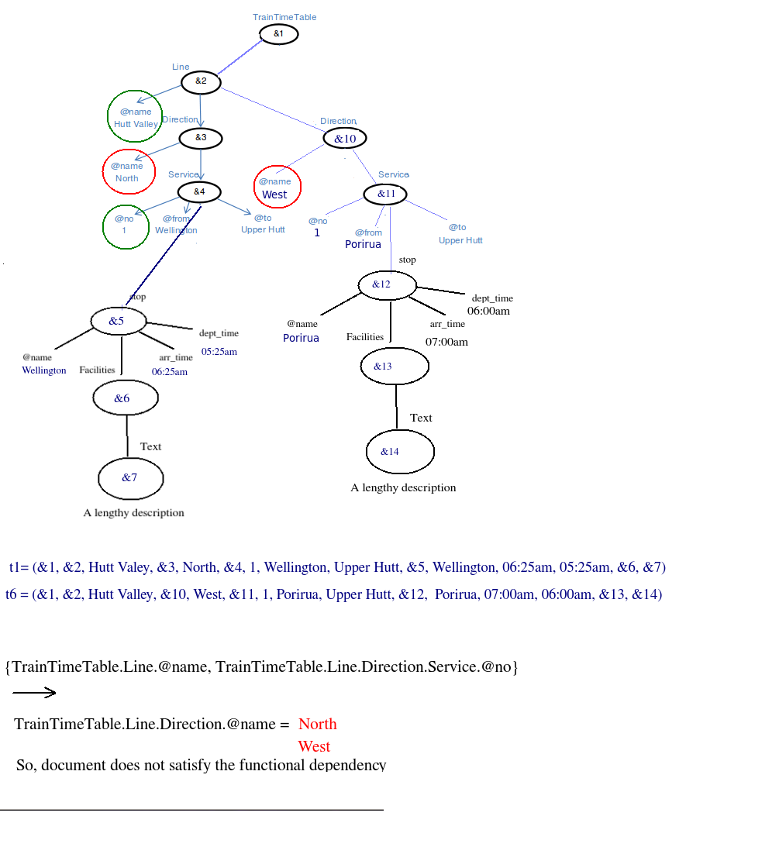
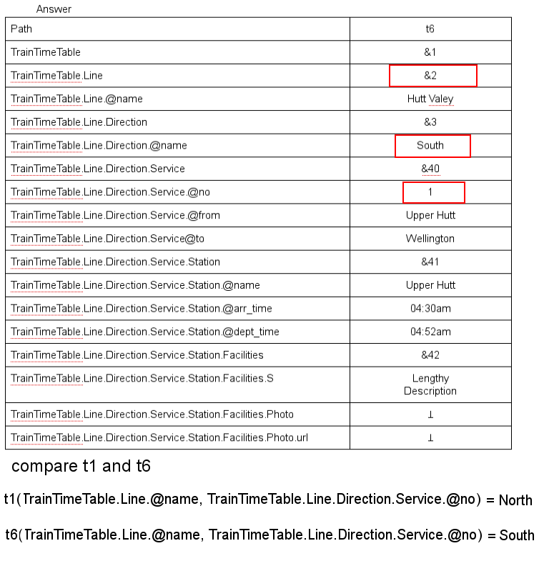
Question d:
{TrainTimeTable.Line.@name, TrainTimeTable.Line.Direction.@name, TrainTimeTable.Line.Direction.Service.@no}

Question e:
{TrainTimeTable.Line.Direction.@name, TrainTimeTable.Line.Direction.Service.@no, TrainTimeTable.Line.Direction.Service.Station.@name, TrainTimeTable.Line.Direction.Service.Station.@arr_time}
Question 5

anomalous functional dependencies:

TrainTimeTable.Line.Direction.Service.Station.@name ->
TrainTimeTable.Line.Direction.Service.Station.Facilities.Text.S

t1(TrainTimeTable.Line.Direction.Service.Station.@name) = Wellington
t4(TrainTimeTable.Line.Direction.Service.Station.@name) = Wellington

t1(TrainTimeTable.Line.Direction.Service.Station.Station.Facilities.Text) = &7
t4(TrainTimeTable.Line.Direction.Service.Station.Station.Facilities.Text) = &55

Therefore, the functional dependency is not satisfied

<!ELEMENT TrainTimeTable (Line*, Station_list)>

<!ELEMENT Line (Direction*)>
<!ELEMENT Station_list(Station)+> <!--after transformation paths doesn't contain
TrainTimeTable.Line.Direction.Service.Station
-->
<!ATTLIST Line name CDATA #REQUIRED>

<!ELEMENT Direction (Service*)>

<!ATTLIST Direction name CDATA #REQUIRED>

<!ELEMENT Service (Station_index)>

<!ATTLIST Service no CDATA #REQUIRED from CDATA #REQUIRED to CDATA #REQUIRED>
<!ELEMENT Station_index EMPTY>
<!ATTLIST Station_index name IDREF #REQUIRED dept_time CDATA #IMPLIED arr_time CDATA #IMPLIED>

<!ELEMENT Station (Station_Facilities)>

<!ATTLIST Station name ID #REQUIRED>

<!ELEMENT Station_Facilities (Text | Photo)+>
<!ELEMENT Text (#PCDATA)>
<!ELEMENT Photo EMPTY>
<!ATTLIST Photo url CDATA #REQUIRED>

Question6

a:
Each @lid point to only Lecturer

b:
<!ELEMENT NAME (#PCDATA)>
<!ELEMENT POSITION (#PCDATA)>
<!ELEMENT ADDRESS (#PCDATA)>
These three element may be anomalous in the document.
∑= {Department.Course.Lecturer.@lid ->Department.Course.Lecturer}

each lid identify a lecturer. However, lecturer could in different courses. Although element lecturer satisfies the denpendency, element name, position, address do not. Therefore, they are anomolous.

