|  |
| --- |
| Ice Cream Catcher |

|  |
| --- |
|  |
| Design Document |

|  |
| --- |
| Nidhi, Maxine and Jananni  7/8/2014 |

## Purpose

The aim of the game is to follow instructions and only catch one color of the ice cream scoops. This will hopefully educate our audience to not just blindly catch ice cream scoops but only the ones that are required. Our intended audience is children 6+ years old.

## System Overview

Our game was based on many arcade games online that the user controlling a component to catch targeted objects. Similar popular games include SkyBurger, Lilo & Stitch Sandwiches etc. Our game was designed using Processing.

## User Interface

### Starting Menu

When the user launches the game, the starting menu is displayed. There are 3 options: Start, Exit and Instructions. Clicking exit will close the application. Clicking instructions will display a page with instructions teaching the user how to play the game. Clicking Start will display the game page.

### Game Page

The game will start once the game page is launched. A message will be displayed notifying the user which color the user should aim to catch, for example: “Catch the blue scoops!”. Scoops with randomized colors will proceed to fall and the user will be able to navigate the cone on the bottom of the screen using a mouse to catch the scoops.

### Points System

There will be a score counter on the top right of the screen keeping track of the user’s progress. With each correct scoop the user catches, 1 point will be added to the counter. If the user catches a wrong color, or misses a right colored scoop, then 1 point will be deducted from the counter. When the user reaches 10 points the game will stop, and a congratulatory message will be displayed. However if the user reaches -3 points, a game over message will also display.

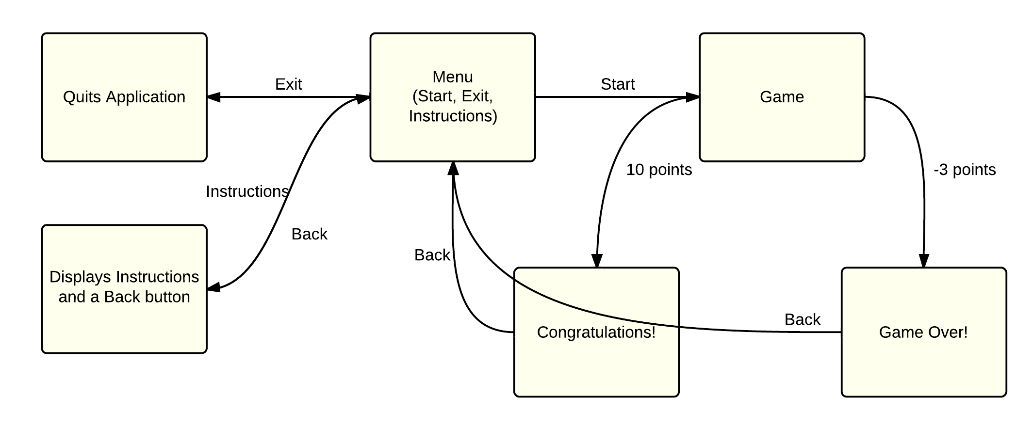Page flowchart

Screenshots:

References:

* Ice cream scoop: <http://clipartpin.com/clipart_file/ice-cream-scoop-clipart-1.png>
* Ice cream cone: <http://ateachersupply.com/cart/images/ice%20cream%20and%20cones%20cut-outs.gif>
* Button maker: <http://dabuttonfactory.com/>
* Game font: Ardaka
* Photo editor for opacity and resizing: Pixlr