Question 1 – 2013
P(positive test result) = P(positive test result | contaminated).P(contaminated)
+ P(positive test result | uncontaminated).P(uncontaminated)
= 0.8 x 0.2 + 0.1 x 0.8
= 0.24

P(contaminated | positive test result) = | P(Positive test result | contaminated) P(contaminated)  P(positive test result)
= | 0.8 x 0.2  0.24
= | 0.667

P(negative test result) = 1 – 0.24 = 0.76

P(contaminated | negative test result) = | P(negative test result | contaminated) P(contaminated)  P(negative test result)
= | 0.2 x 0.2  0.76
= | 0.053

P(uncontaminated | positive test result) = 1 – 0.667 = 0.333
P(uncontaminated | negative test result) = 1 – 0.053 = 0.947

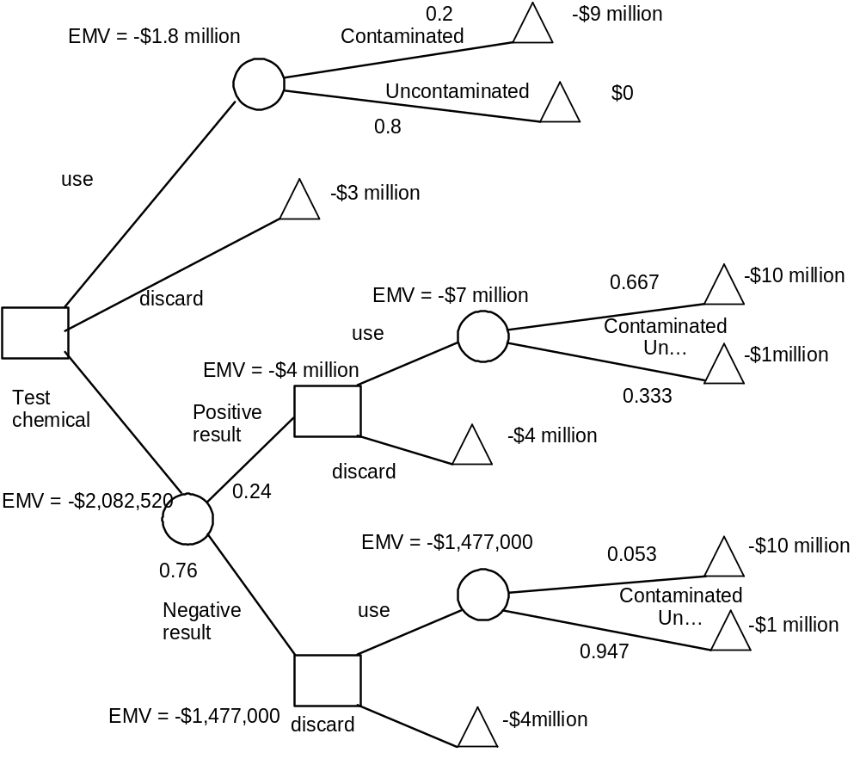
d) Therefore, just use the chemical as is.

Question 2

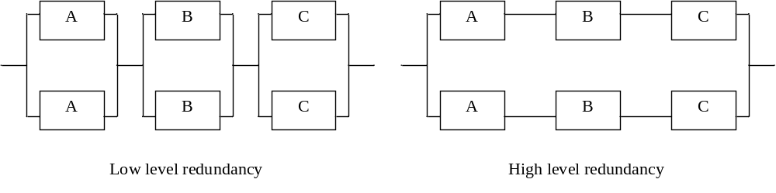 Low level redundancy gives better reliability improvement than high level unless common mode failures dominate.

- A remote facility might have two solar panels so that if one stops functioning then the other will still provide power. However, a hail storm may break both panels.

Module | R | beta | Common R | Independent R
GPS | 0.8 | 0
Recording | 0.9 | 0.4 | 0.9^{0.4} = 0.958732 | 0.9^{0.6} = 0.938740

First configuration:
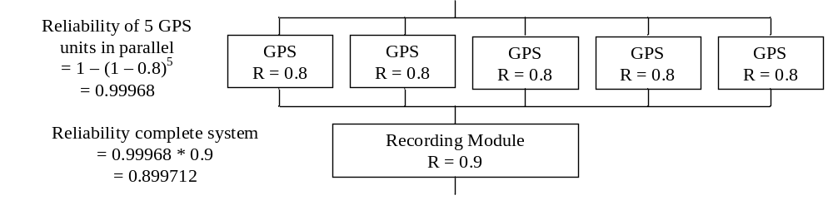
Second configuration
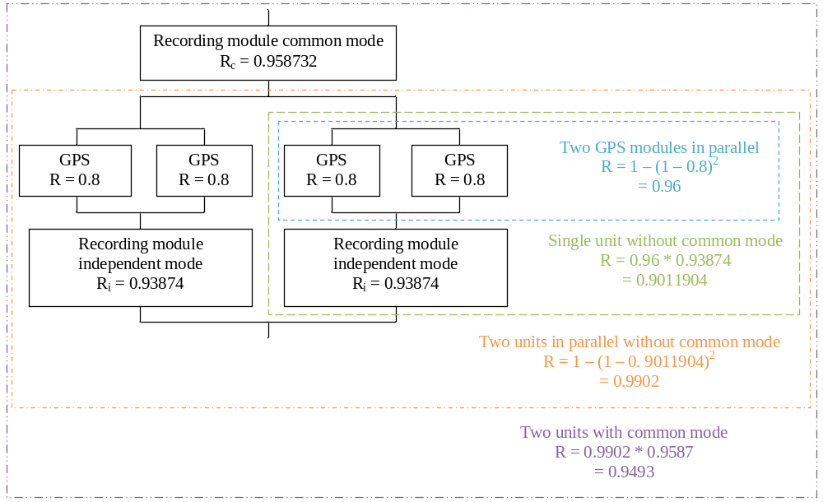
Question 3

a)
x | f | xf | x^2 * f | p | pn | o | e | (o-e)2/e
0 | 8 | 0 | 0 | 0.189927 | 5.697813 | 8 | 5.697813 | 0.930193
1 | 9 | 9 | 9 | 0.350635 | 10.51904 | 9 | 10.51904 | 0.219362
2 | 7 | 14 | 28 | 0.283205 | 8.496148 | 7 | 8.496148 | 0.263467
3 | 3 | 9 | 27 | 0.13071 | 3.921299 | 6 | 5.28699 | 0.096155
4 | 2 | 8 | 32 | 0.037705 | 1.131144
5 | 1 | 5 | 25 | 0.006961 | 0.208827
6 | 0 | 0 | 0 | 0.000803 | 0.024095
7 | 0 | 0 | 0 | 5.3E-05 | 0.001589
8 | 0 | 0 | 0 | 1.53E-06 | 4.58E-05
n= | 30 | 45 | 121 |  | 30 |  | sum | 1.50977

Mean = 45 / 30
= 1.5
Variance = (121 – 30 * 1.5²) / (30 – 1)
=1.8448
Confidence interval of variance:
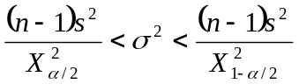

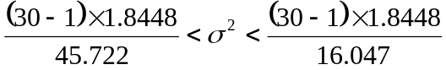
1.17 < σ² < 3.334

b) p = 1.5 / 8 = 0.1875
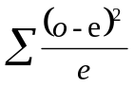 = 1.50977
ν = 4 – 2 = 2 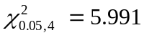

Therefore we should not reject the null hypothesis and we may conclude that the data does come from a binomial distribution

c) The null hypothesis is that the probability distribution underlying the samples is the binomial distribution.

