# Illinois Institute of Technology

ITMT 492/592 Project Report and Business Proposal

Author:

Maxime Descos, Jordan Mynes, Scott Rigg, Hugo Zamarripa, Zdenek Jaks

**Abstract**

The purpose of this project was to improve the current state of security devices. Today, most security companies use several guards for different tasks, but at least one guard has to monitor the cameras or other systems. The goal of the project is to add mobility to guards, so one guard doesn’t have to stay in a room to monitor. Also, the real time communications between the guards and the system can help to reduce burglaries or malfunction. Indeed, some facilities need security, but also temperature or luminosity monitoring for sensitive material, such as server room. The business goal is to be able to mass produce the sensor networks from our project, and make them compatible across multiple platforms of wearable devices.

The proposal has two parts: a technical point of view in which our solution is detailed and a more business point of view. The technical point is written in great detail but keeping the perspective of someone who may not have a good grasp on the terminologies of an embedded system in mind.The purpose of the business proposal is to pitch the idea of turning our Glass Security project into a marketable product. The proposal gives a description of the cost, securing initial funding, and some research on the market and competition. It outlines all the components and code used, as well as cost and functionality of the components.

**Introduction**

As said, one the purposes of the report is to give a complete understanding of our solution as a security system. Our system is composed of several sensor boards and a main controller. Each sensor board retrieves diﬀerent forms data and sends all the information to the main controller which sends the data to a web server and its database. The second part of the network is to display the information retrieved to the security guard. The best way to let the guards keep their mobility is to give us the ability to move and monitor at the same time. That’s where the Google Glass is perfect. All the network will be described from a technical point of view in the following pages but there will also be a cost analysis and the beneﬁts of our solution compared to the industry standards.

**The network**

The network is composed of several sensor boards (in our current system, three). The sensor board is put on a door and retrieves data from the room. The data are sent to the main board via Xbee (radio communication). The main Arduino will connect to a web server and send the data. The main board acts as a gateway for the system. The web server is composed of three PHP pages to retrieve the data, store to a database and list the information contained in the database. The Google glass uses the information from the database to make the charts displayed to the end user. The sensor board is composed of three sensors, one microcontroller and a radio communication device.

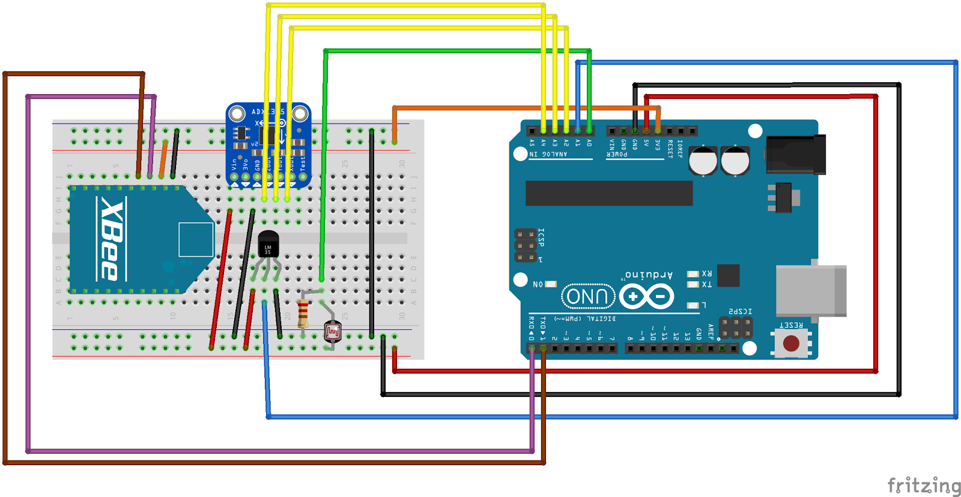

Figure 1: Fritzing Diagram of the sensor board

The microcontroller used is an Arduino Uno. It has several advantages: cheap, several input and output, all the schematics available online which will be really useful to construct our own board for the production step. The microcontroller is programmed in C/C++ via several libraries.

The libraries are used to communicate with the sensors. The Arduino can, after, send the retrieved data with the Xbee to the coordinator, which is the main Arduino. **3.1.1 Accelerometer**

The security team need to know when a door is opened to know if a robbery is currently happening. In order to do that, each sensor board has a accelerometer. Since the board is attached to the door, when the door is used, the accelerometer observes a difference on the X, Y and Z axis. By comparing the usual values on each axis and the values received, the system can know when a door is opened. The accelerometer is a ADXL 335 from Sparkfun.

**3.1.2 Temperature sensor**

Some room need to be at the same temperature, or at least not to be too cold or too warm (server room, sensitive material, etc ...). Hence, a temperature sensor is added to the board, the user will have, in real time, the temperature in the room and could act fast if the cooling system stops working. The temperature sensor is a TMP 36 from Adafruit.

**3.1.3 Photoresistor**

As well as temperature, some times, the luminosity in a room as to be consistent and part of our data collection model. So, a luminosity sensor has been added to the board. It is composed of photoresistor and a 10 kiloOhms resistor. The resistance of the photoresistor increased with the opposite of the luminosity. Adding the resistor permits to make a voltage divider, hence the Arduino can see a different voltage as the luminosity changes.

**3.1.4 Xbee**

The Arduino has to communicate the result of the sensors as data tranmission. In order to do that, the easiest way is to use radio communication. The boards don’t have to be connected via cable. Also, the Xbee are often used with Arduino to do that. Hence, each sensor board has a Xbee configured as a router with the address of the main board Xbee (the coordinator) as the destination address (The PAN ID has to be the same on each boards). Xbee is a product from the DIGI company.

**3.2 Main board**

The system needs a gateway to gather the data from the different sensor boards and fill a database with that. That is the purpose of this main board. The diagram is really simple. There is a Xbee configured as an coordinator, it is connected in serial communication with the Arduino. When the data are on the Arduino, it has to send them to the Internet. To keep the maximum of mobility, a WiFi shield is used on the Arduino. This shield allows the Arduino to communication via WiFi. So, the Arduino can act as a web client or web server. It will be used as a web client here because the server already exists on another more powerful machine

All the libraries are furnished to communicate to the Internet via the WiFi shield. This shield is made by Arduino company.

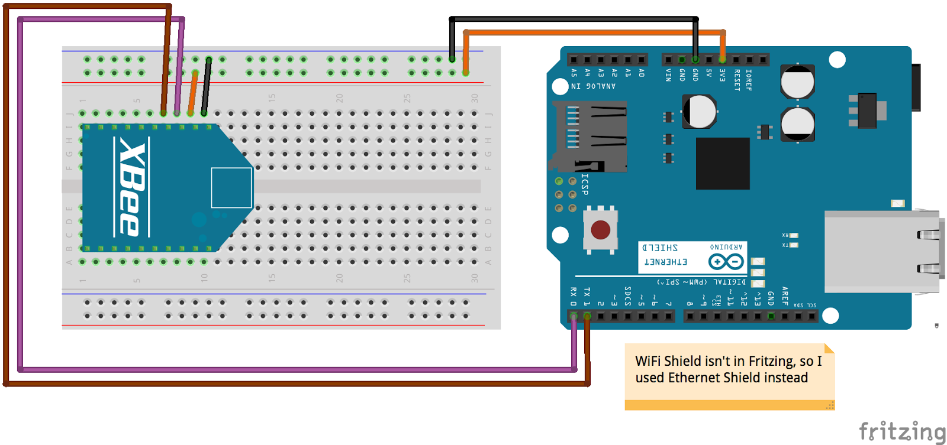Figure 2: Fritzing Diagram of the main board

**3.3 Web Server**

The data has to be stored so the Glass can fetch them. In order to do that, a web server has been built. This server has three PHP script. The first one to connect to the MySQL database created. This database has the following table :

CREATE TABLE sensor (

timeStamp TIMESTAMP NOT NULL PRIMARY KEY,

luminosity int (4) NOT NULL,

temperature float (5 ,2) NOT NULL,

x int(4) NOTNULL,

y int(4) NOTNULL,

z int(4)NOTNULL,

alert int(2) NOT NULL

);

The alert field can be used to store several error code. The second script is the one used to add the data to the database. It simply connects to the database and insert a new row. And the last one is used to display the data.

**Working process**

The project built on a foundation established from earlier assignments in the class. Recreating a simple environmental monitor was simple. It incorporated the three sensors explained earlier as our data collection. The more difficult part that spent multiple days in development was getting the data to be transferred between Arduinos. This was done by radio signal from the Xbee’s as our data transmissions. We choose radio signal because it was the easiest to do for a short-range communications network as well as realistically keeping this information safe. It is easier to have a closed-circuit radio connection rather than having the system connected to a wireless network that could potentially be hacked into. The part that is connected to a web-based platform is the server to which all the data is stored. While in the process of getting the server to work we ran into many issues such as trying to get the google glass to pull data from the server, many connectivity issues there. Another was organizing data and being able to read the data in order to select what readings would trigger an alert. Once our server was running to some degree development on push notifications was in our crosshairs as our form of data presentation.

**Introduction to Marketing**

In order for this to become a marketable product, we will need to produce a commercial version of our security system and receive funding in order to get started. Cost of production needs to be estimated so that we will know how much funding to receive. We will require several rounds of funding to get our initial product out until we can become self-sustainable with our costs. The cost of our product to the customer will need to be affordable so that we can push out as many units as possible, but also be sold at a profit. Once we have the money, we will put further development efforts on bringing the product to other platforms besides Google Glass. By doing this we will expand our audience to a much wider variety of customers. This will make our application more accessible, and we will be able to sell a lot more volume of our product.

Costs

XBee radio x2: $36.38

Wifi Shield: $19.95

ADXL335 triple-axis accelerometer: $14.95

Arduino Uno R3 x2: $49.90

Thermometer Temperature Sensor: $1.98

Photocell: $0.95

Miscellaneous: $2.00

Enclosure: $10

PCB Production Cost: $87.38

Total cost: $223.49

**Other security models**

As a security system, what makes ours different or more effective, we are the future aiming to be more efficient and cost effective. The leading security system out in the market is Simple Safe with packages starting at over three-hundred dollars. The packages include motion sensors, glass break sensors, cameras, and temperature monitors. These systems all must be monitored either through a phone app or t triggered by the alarm. This means that sometimes you may not even notice when the alarm was set off outside of home. With our solution not only is ours cost half as much, but it can be customizable with more data collectors for way less than the most popular package of 300 dollars. Keeping in mind that each our one units(one unit for temperature, motion, light) is three different units for them(one separate unit for each data collector). We also have the benefit of utilizing google glass to make sure any breach in security is sent while multitasking on other jobs.

**Initial Plan**

The cost of assembling one set of our sensor network will be around $223.49. If we were to mass produce these, we could get some of the components for much cheaper, lowering the cost. Especially PCB Production Cost, which drops from $0.96 at 50 cm^2 to $0.48 at over 500 cm^2. Ordering more than 13 shields will cost $18/shield instead of $40/shield for just one which also significantly lowers the cost. Without factoring in labor costs or cost of shipping, this is a good amount to start with. We will price the arduino sensor network at around $300 in order to make profit off of this.

Additional Router node:

Xbee Radio: $18.19

Enclosure: $5.00

Photocell: $0.95

Arduino Uno: $24.95

Miscellaneous: $1.00

Total: $50.09

Each additional Router node will cost us about $50.09 to manufacture. This cost can also be reduced by producing a large amount of them. Our customer will need at least one of these nodes for each area they are trying to monitor. After purchasing our initial bundle, we will charge the customer around $80 for each additional node they wish to purchase.

In order to kickstart our business, we would like to create about 100 of the sensor packages, with an additional 200 sensor boards created. Because we are ordering in bulk, we can expect around a 20% discount for all the components. This will come out to a total of $17,879.20 for the package, and $8,014.40 for all the additional boards. This brings us to a total cost of $25,893.60 for all of our product we will be selling. Shipping and labor costs should be another $5,000 so we will initially need $30,893.6 to start our business. Factoring in other miscellaneous costs, we should ask for around $40,000 from investors to kickstart our business.

We will need to sell around 60 sensor/router packages in order to break even for the cost of producing them. For the additional sensor boards, we will need to sell 100 to break even for that cost. If we sell all of our initial product, we will have a total revenue of: $46,000. Paying back our initial investors, we will have a total of $6,000 left for ourselves.

I am currently unsure of whether or not we will want to offer an installation fee that our company will personally install, or outsource the installation to another company. An installation service will allow us to generate more revenue from our business.

There is a large barrier of entry for businesses that wish to install our security sensor network system however, and that is the cost of a Google Glass device. Right now, the cheapest you can get a Glass is for around $1,500. Most businesses will not be able to see their need for our system with this large barrier of entry. Due to this, we will need to focus future development efforts on implementing our security system for a larger variety of devices. Some of these devices should include Smartwatches, Smartphones, Tablets, and other wearables.

Moving forward if our business is successful and we manage to sell all of the original product, we will invest in development of our application onto other devices than Google Glass.

Once we allow connectivity from our server to devices other than Google Glass, we open the barrier of entry that was preventing some customers from wanting to business with us. This way, they will not need to make such a large investment on purchasing the Google Glass and can instead use the device they already own. This will open up more savings for our customer that they can then use to buy more of our product.

After we have done this, we will need to go secure a second round of Investors to mass produce our product. This time we will try and produce around 1,000 sensor package bundles, and 3,000 additional sensor boards. Because this order is a very large volume, we can expect up to 40% discount on the components and manufacturing cost. This will bring us to a total of: $134,094 for the bundles and $90,162 for additional boards. That is a total of $224,256 for all of our product. Shipping and Labor costs should be an additional $20,000, so we will need $250,000 from our second round of investors. Our second round of investors should be easier to secure because we will be able to show them our business progress so far, how much we sold and how much we made, etc. To break even with this loan, we need to sell 450 Sensor bundles, and 1,130 additional boards. If we sell all of our product this time around, we will generate a total revenue of: $300,000 + $240,000 or $540,000. This is without factoring in revenues from our installation service. $540,000 is more than double the loan amount we took during this round of investing. It leaves us with a total profit of : $290,000. At this point, we should be self sufficient as a company and able to handle production/manufacturing costs on our own.

**Sources of Funding**

For our first round of funding, we will require an amount of $40,000. To get this, we will apply for a small business loan from the U.S. Small Business Administration (SBA). The following are typical items that will be required for any small business loan application: “information about personal background, resumes, a business plan, personal credit report, business credit report, income tax return, financial statement, bank statement, collateral, and legal documents. The legal documents require a business licenses and registrations required to conduct business, articles of incorporation, copies of any contracts we have with third parties, franchise agreements, and commercial leases.”[2]

Questions our lender may ask us include why we are applying for this loan, how will the loan proceeds be used, what assets need to be purchased and who are our suppliers, what other business debt we may have, and who are the members of our management team. Hopefully after providing this documentation and answering any questions with our business plan, we will be able to secure our first round of funding. Lenders may charge up to 6.5 % over the base rate for loans of $50,000 or less, so we will need to take that into account when considering how much to charge for our product and how much revenue we’ll need to generate.

For our second round of funding, we will require $250,000. The maximum loan amount allowed by the SBA for small business loans is $350,000 , so we will secure this funding through the same process of our first loan. Lenders may charge up to 4.5 % over the base rate for loans over $50,000, so our interest we’ll need to pay back is at a lower rate than our first loan. Once we have established our business, we will need to secure all of the proper licenses and documents to get started on securing our first loan.

**Competitive Analysis**

We are entering into a large industry which is that of security systems. Our system is primarily a security monitoring system service. Data collected from SDM magazine in their 2016 Industry Forecast (Figure 1.1) shows that Video Surveillance technologies have the greatest potential for sales in 2016, where as Monitoring technologies have the next biggest potential for sales beating out home control, burglar alarms, access control, and emergency communication systems. 47% of people saw an excellent potential for growth in monitoring systems, 25% saw a good potential, and 28% saw a poor/fair potential.

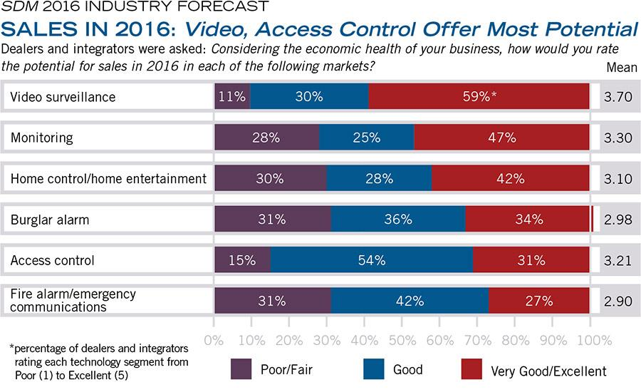

(Figure 1.1: Sales in 2016 [3])

There is a large potential for sales of our type of product for this year based on the data collected. Figure 1.2 shows that 37% of people expect to spend 1-10% more on monitoring in the next year, 22% of people expect to spend 11-22% greater, and 6% of people expect to spend more than 20% in the next year on monitoring systems. This is very promising growth for this area that we plan on getting into.

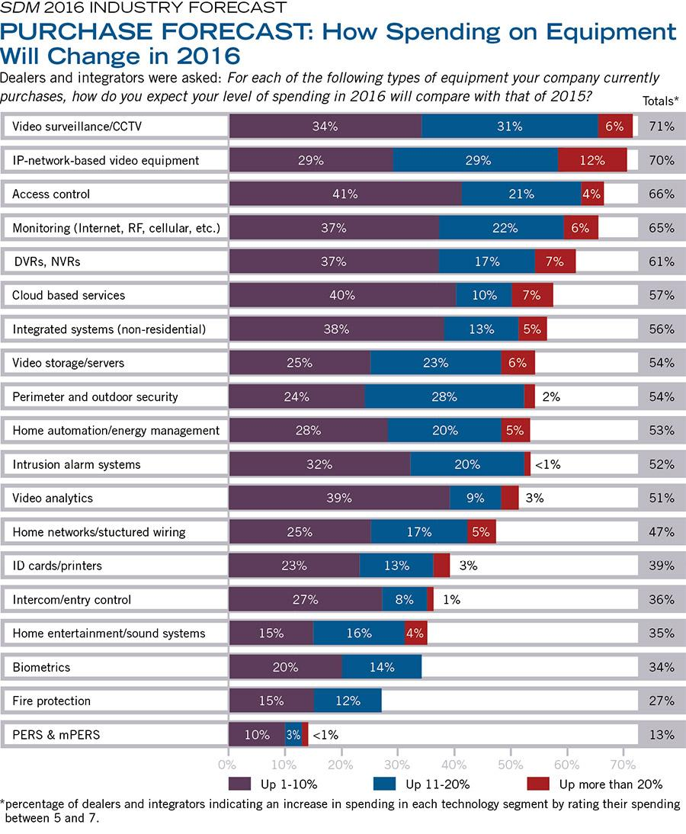

(Figure 1.2: Spending on Equipment [3])

In terms of where security companies revenues are coming from, there are differing distributions depending on the company. Dean Belisle stated in his interview with SDM magazine that:

“We see our annual revenues [in 2015] estimated to be right around $2.4 million. We’ve been running between a 3 percent and a 6 percent increase over the last couple of years; I would expect next year would be about the same. Our monitoring revenue is about $1.6 million out of that $2.5 million, so it’s a large part of our revenue. Our installation revenue is quite a bit smaller, comparatively. Like anything else, margins are down. We don’t do low-cost, free systems, but our margins are pretty tight on installations. And the only area we are down in the actual sales from last year is in CCTV camera sales. We’re actually up in number of sales, but down in overall sales dollars. The cost of equipment has come down so low and the competition is up higher. We’ve also changed our model. We used to sell the systems outright which had a much higher margin; we now have cut the margins down, but we attach a recurring revenue stream to it.” [3]

They had to adapt their business model from making large margins on the equipment itself, to charging monthly fees for the monitoring for a recurring revenue. This leads us to believe that a razor/razor blade business model may be a better way for us to make our revenue as well. Piyush Sodha said in his interview with SDM magazine something very similar:

“We only do projects where there’s a recurring monthly revenue; we will not do an installation, otherwise. The company is expecting to end the year at around $84 million. Twenty-five percent of the business is installation, 75 percent, approximately, is recurring monthly revenue-oriented. Year-over-year growth is approximately a little north of 7.5 percent.”[3]

Initially we thought that the majority of our revenues would be from installation and hardware sales, but after doing research into the industry we see that the companies seeing growth and high revenues are making it off of monitoring revenues on a recurring basis. Due to this, we will re-evaluating our business model so that we are charging monthly fees to our customers for usage of our app’s services, and less for the initial installation costs.

**Conclusion**

Our Arduino based security system can be mass produced and sold to business in need of this type of security system. Revenues generated will go to development of a system that connects to any wearable device for more accessibility and usability for our system. As of right now, the Google Glass is still a barrier of entry which may prevent our product from being sold. We have two products that we’d be manufacturing, a security system bundle pack that comes with one of each type of board, and standalone sensor boards we will sell for an additional cost. An installation service may be offered by our company as an additional source of revenue, and we will have to look into whether that or outsourcing the installation is a more feasible business decision.

With this business proposal we hope that we’ve stated what our initial goals are, and that we may use this proposal to help us secure our initial funding. We will have to evolve our business into one that focusses on security monitoring service rather than that of hardware sales. We had initially planned our business model around equipment sales and installation costs, but after researching security companies seeing a lot of growth in the past year, we learned that recurring monitoring costs from the customer is a much better revenue model. Once our company is running and we have made our initial sales, we will switch over to that business model. This concludes our initial business proposal. I hope it was informative on how we will turn our security system project into an actual marketable product and business.

**References**

[1] Goriel, N. (2013, September 04). 6 Step Guide- How to Get a Business Loan | The U.S. Small Business Administration | SBA.gov. Retrieved December 04, 2016, from https://www.sba.gov/blogs/6-step-guide-how-get-business-loan

[2] 7(a) Loan Application Checklist | The U.S. Small Business Administration | SBA.gov. (n.d.). Retrieved December 04, 2016, from https://www.sba.gov/loans-grants/see-what-sba-offers/sba-loan-programs/general-small-business-loans-7a/7a-loan-application-checklist

[3] Stepanek, L. (n.d.). SDM 2016 Industry Forecast: Is the Security Space Too Congested? Retrieved December 04, 2016, from http://www.sdmmag.com/articles/91952-sdm-2016-industry-forecast-is-the-security-space-too-congested

[4]Digital Communications, John G. Proakis & Masoud Salehi, McGrawHill Higher Education

[5] Introducion a la teoria y sistemas de communicacion, B. Lathi, Limusa Noriega Editores [6]Modern Digital and Analog Communication Systems, B. Lathi, Oxford University Press Digital Communication Signal Processing, John Cio

[7]SimpliSafe: Home Security Systems. (n.d.). Retrieved December 05, 2016, from http://simplisafe.com/