All steps to be followed

First we generate first app

<https://start.spring.io/>

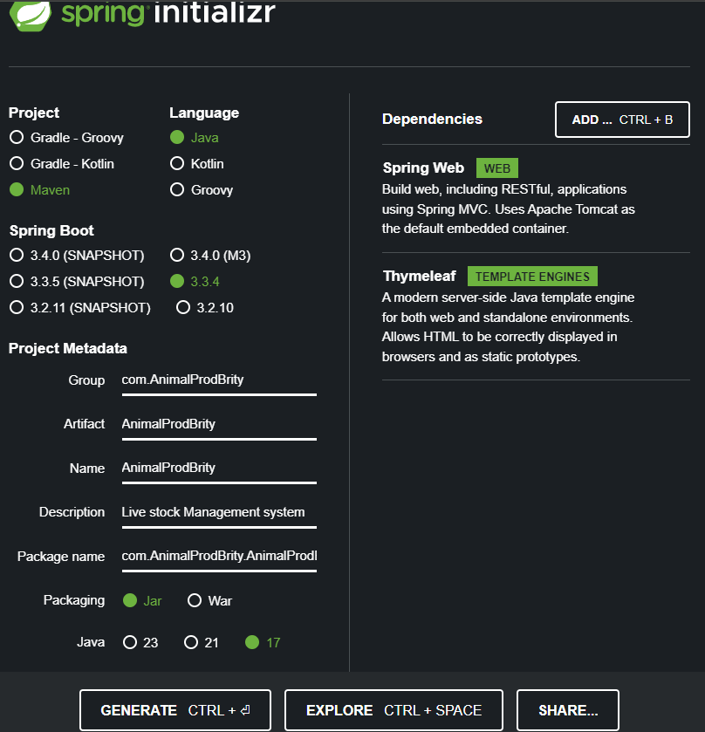

We call the project in IDE

First we create home controller:

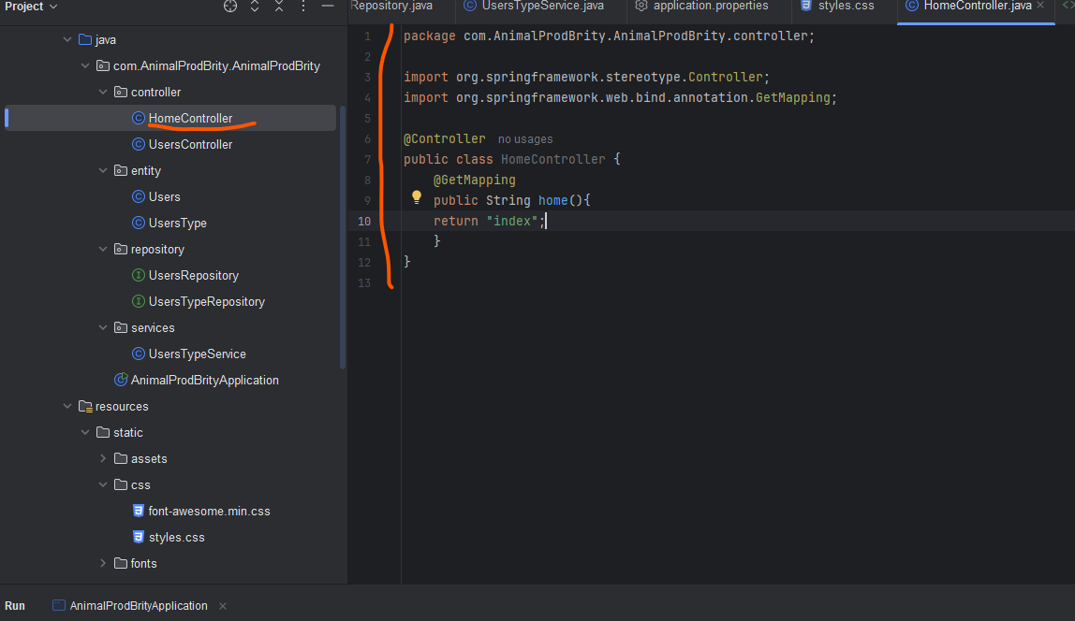

Second we create index.html in templates and run the system to make sure if it is running:

Step 2: we generate Entity (Users, UsersType)

After we generate Repository

After service

The after we crate controller repository

Entity: Users.java

Entity:UsersType.java

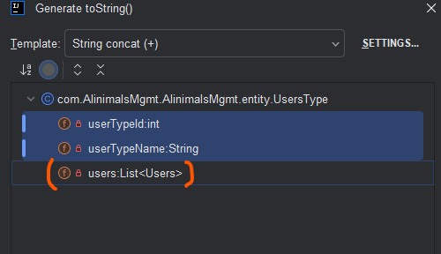

Step for creating this app:

1. Create db
2. Generate project using start.io
3. Create controller folder and a file
4. Create entity folder and add files
5. Create repository folder and add files
6. Create services folder and
7. Add css & js in static folder
8. Add .html files in templates

To avoid email duplication on register form

1. We add method in UsersRepository
2. We add the same method in UsersService
3. Add some info in Contoler
4. Add some thymeleaf tag