First, I download the QGIS, following the instructions on their page.
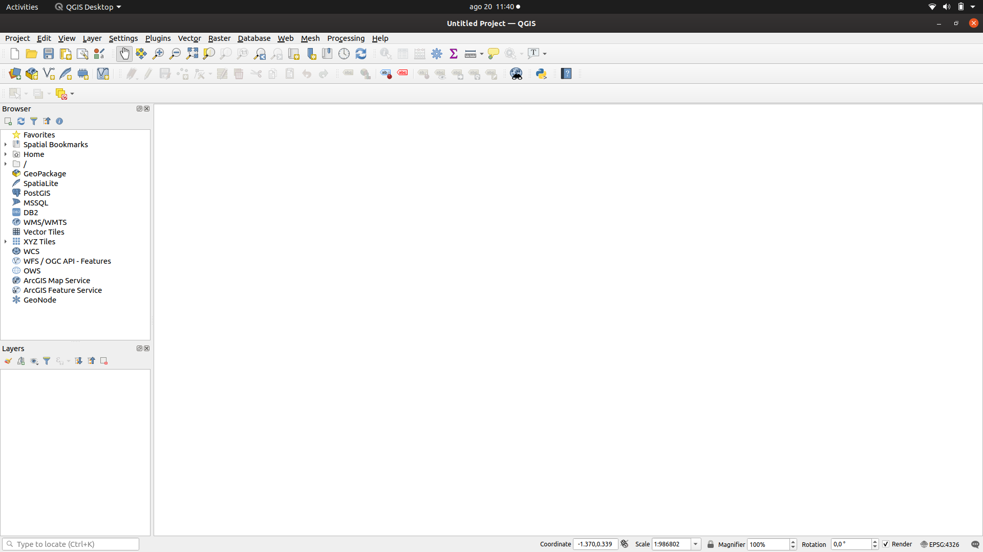
Next, I chose the same regions on both websites given in the assignment.
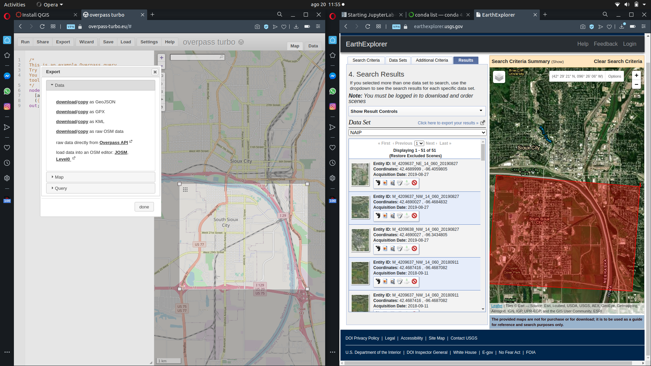
For the map from which I generated GeoJson, I run the scritp ‘building’ predifined by the provider.
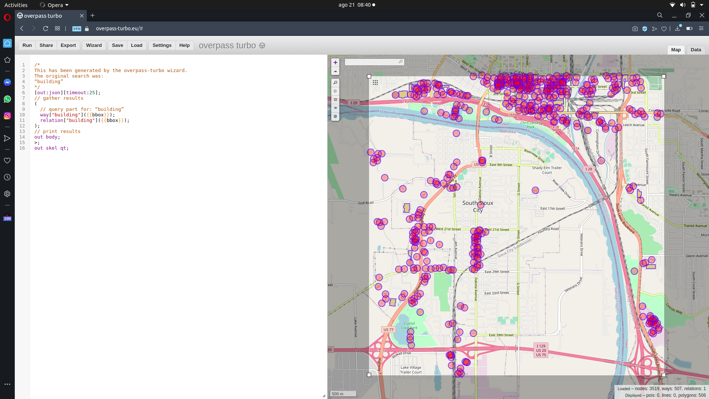
As suggested in the assignment, I chose the NAIP format to achieve good quality of the map. I checked if everything looks proper while zoming out:
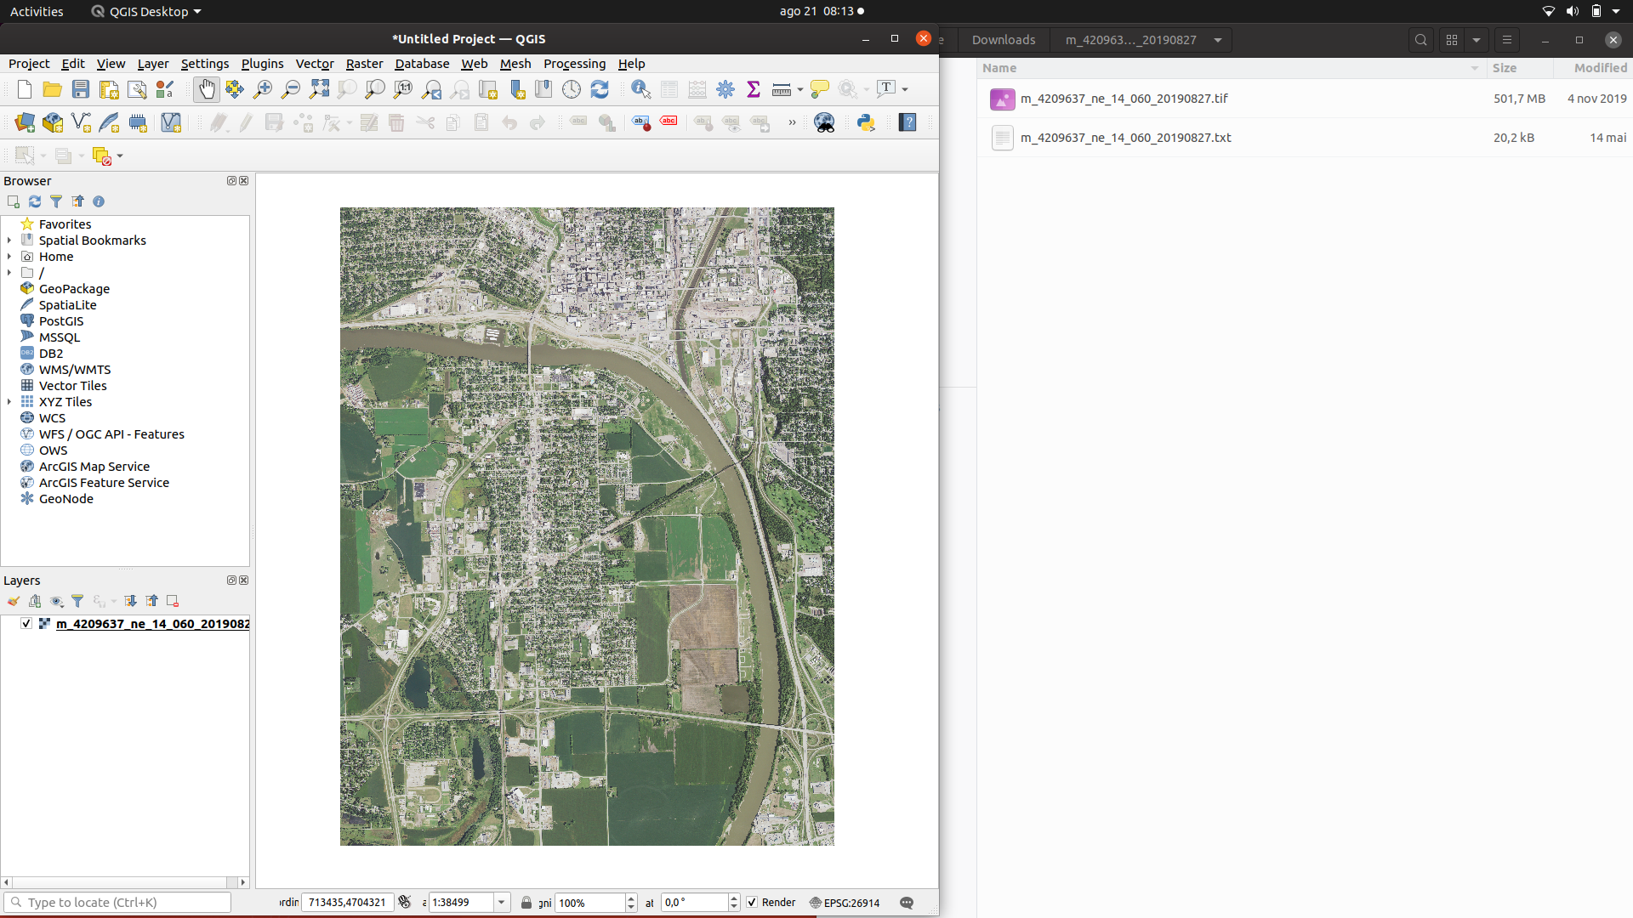
and zooming in:
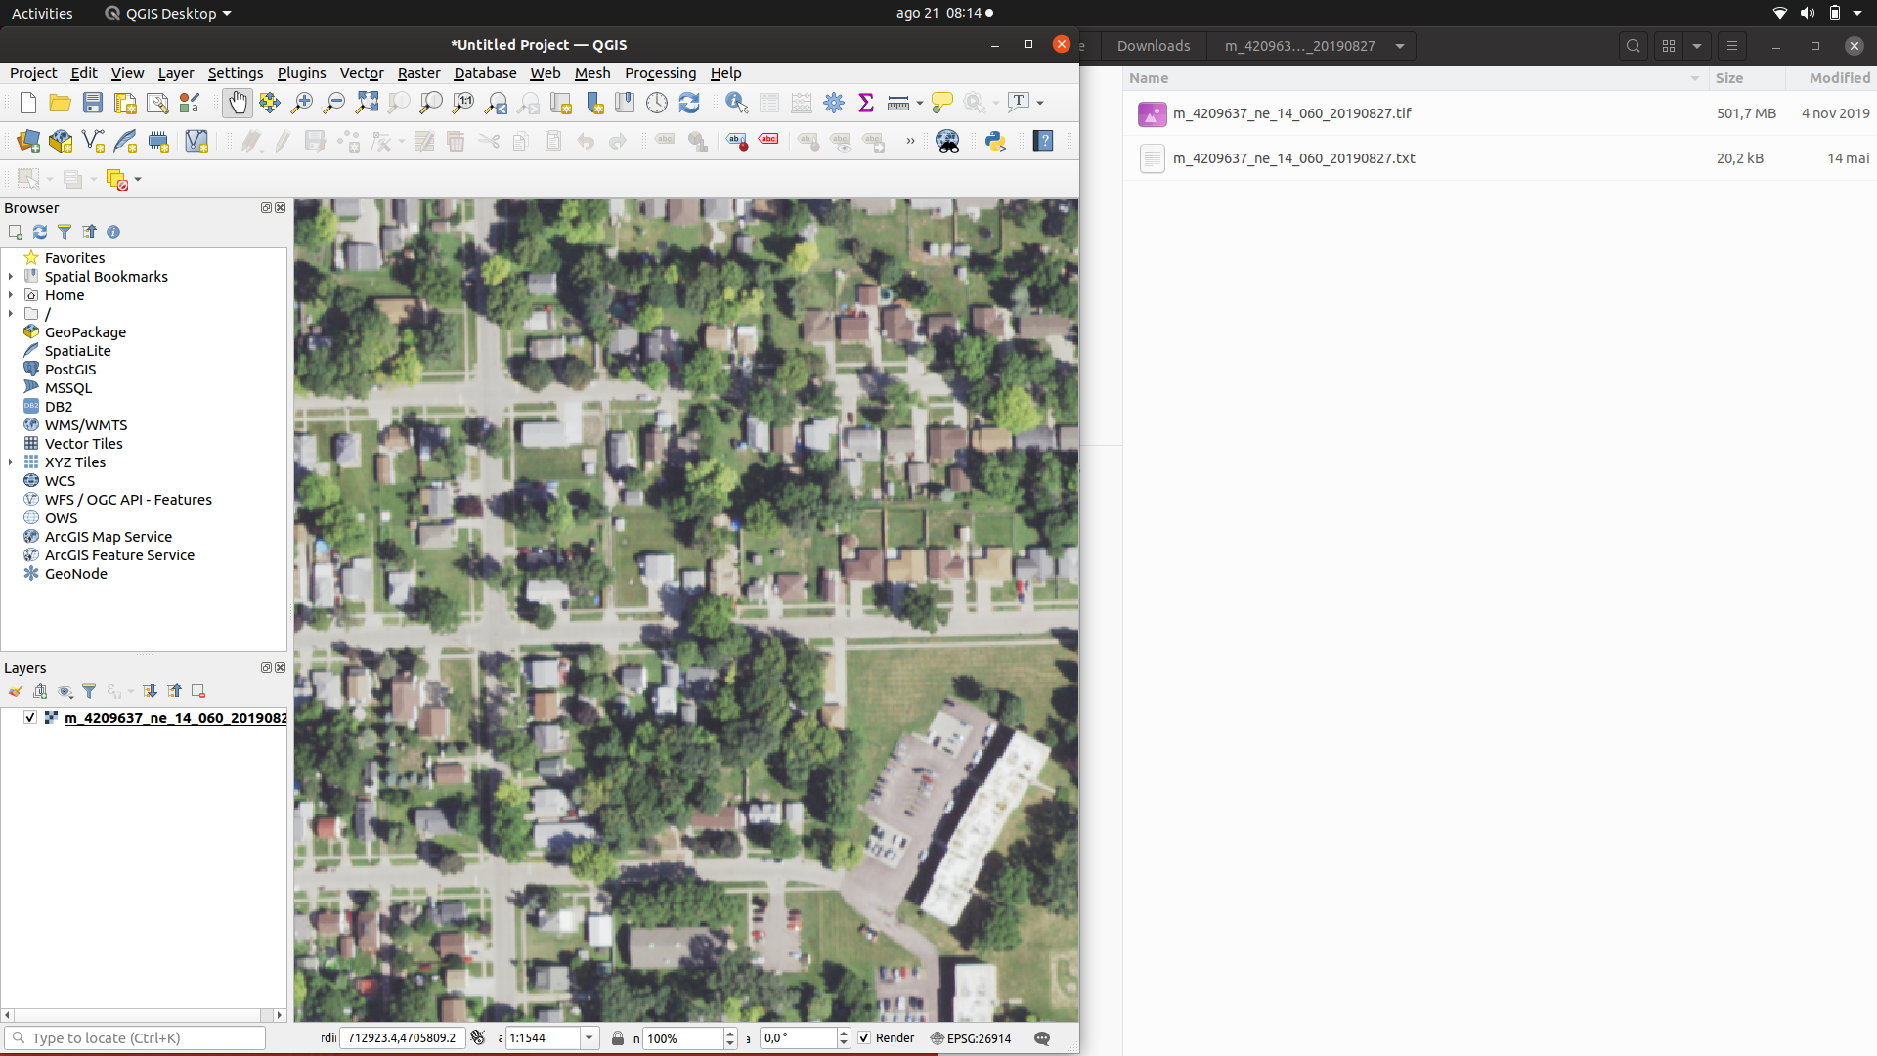
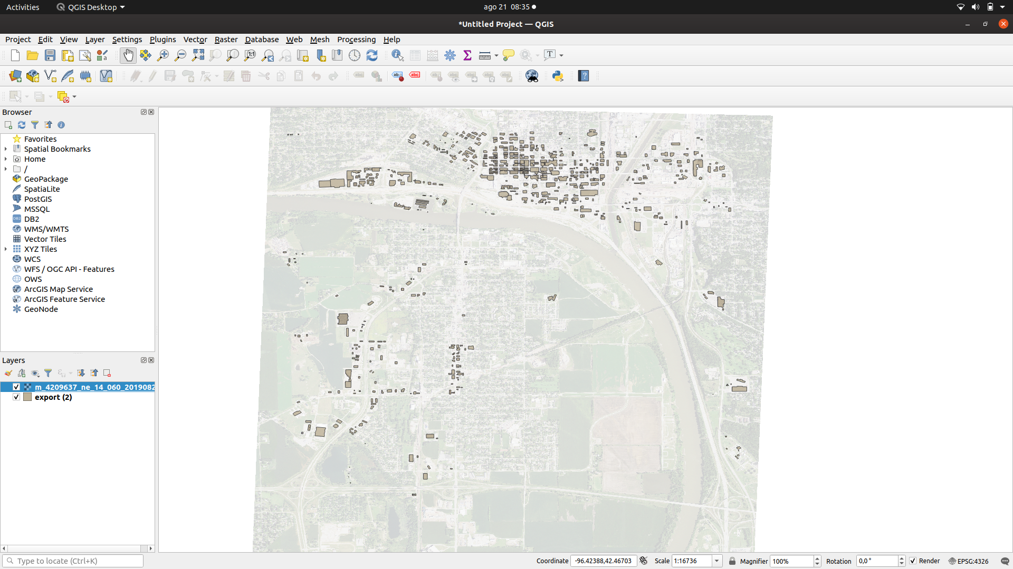
After that I added the GeoJson file and change the transparency of the map in order to see the location of the regions from .geojson file.

