Supplementary Materials for “An Adaptive Multi-Scale Transformer for Green-Energy Stock Return Forecasting: A Controlled Evaluation of Static Scale Aggregation and Sample-Dependent Routing”
This file contains the router diagnostics with price-level inputs referred to in Sections 3.11 and 4.6 of the main text: the definitions of the diagnostic measures, Tables S19 and S20 and Figure S1. Supplementary Tables S1–S18 are provided in the accompanying workbook (computers-4613491_Supplementary_Tables_S1-S18.xlsx). The window-relative comparison of routing variation is reported in Table 12 of the main text.

A. Router Diagnostic Definitions
Router diagnostics characterize whether the learned scale allocations vary across observations, how concentrated they are, how reproducible they are across training runs, and whether deviations from Static weights are associated with relative forecast loss. The analysis uses the Daily+Weekly models with price-level inputs from the five-seed evaluation and reports results separately for each forecast horizon and resolution-specific branch. These diagnostics describe routing behavior rather than identify causal contributions to predictive performance.
Let $α_{s,i,t}^{(f,h)}$ denote the Adaptive routing vector for seed $s$, stock $i$, date $t$, resolution $f$, and horizon $h$. Each vector contains $K=4$ non-negative scale weights summing to one. Differences between routing vectors are measured using total variation distance:
$TV(p,q)=\frac{1}{2}\sum_{k=1}^{K}{\left|p_{k}−q_{k}\right|}.$ (A1)
Overall Sample TV compares each observation’s routing vector with the corresponding fitted router’s mean vector over test observations. Within-ticker temporal TV and within-date cross-sectional TV separately summarize variation within stocks over time and across stocks on a given date. These measures are compared as distinct descriptive summaries rather than additive components of a formal decomposition.
Weight concentration is characterized using entropy, normalized entropy, and the effective number of scales: $\text{H}\text{(}\text{w}\text{)=−}\sum_{\text{k}\text{=1}}^{\text{K}}{{\text{w}}_{\text{k}}}\text{log}{{\text{w}}_{\text{k}}}$, ${\text{H}}_{\text{norm}}\text{(}\text{w}\text{)=}\frac{\text{H}\text{(}\text{w}\text{)}}{\text{log}{\text{K}}}$, ${\text{N}}_{\text{eff}}\text{(}\text{w}\text{)=}\text{exp}\text{(}\text{H}\text{(}\text{w}\text{))}\text{, }\text{K}\text{=4}$. The mean maximum routing weight is also reported to summarize the largest weight assigned within an observation. These quantities characterize concentration in the allocation vector; they do not directly measure the predictive contribution of individual experts.
Cross-seed stability is assessed for the same stock–date observation by computing all ten pairwise TV distances among the five fitted routers within each horizon and branch. Dominant-scale agreement provides a complementary summary of consistency in the highest-weighted scale across training runs. For each stock–date observation, each seed’s dominant scale is its highest-weight scale within the branch, and agreement is the share of the five seeds that select the most frequently selected dominant scale (possible values 0.4, 0.6, 0.8 and 1.0); the reported value is the mean over all 6,647 test stock–date observations. No exact ties in the highest weight occur.
To examine the relationship between routing differences and relative predictive performance, the Adaptive allocation is compared with the globally learned weights of the corresponding same-seed Static branch. Denoting the latter by $π_{s}^{(f,h)}$, the allocation distance is
$D_{s,i,t}^{(f,h)}=TV\left(α_{s,i,t}^{(f,h)},π_{s}^{(f,h)}\right)$. (A2)
Spearman correlations are reported at the sample and date levels between this distance and the joint Daily+Weekly relative squared forecast loss. The loss is calculated from the final combined prediction rather than from a separate branch-level prediction. The relative squared forecast loss is the Adaptive minus the same-seed Static squared loss for the same stock and date, so that positive values indicate a larger Adaptive loss.
The resulting Sample $ρ$ and Date $ρ$ summarize descriptive associations between allocation differences and relative forecast loss. Because the expert representations and prediction heads are also learned separately across models and seeds, these associations do not isolate the causal effect of routing weights or the contribution of an individual resolution. Tables S19 and S20 report the variation, concentration, stability, and loss-association summaries.

B. Router Diagnostics with Price-Level Inputs
Table S19. Sample variation and concentration of Adaptive routing weights across forecast horizons and branches (price-level inputs).
Horizon | Branch | Sample TV | Within-ticker TV | Within-date TV | Normalized entropy | Effective scales | Mean maximum weight
5 days | Daily | 0.043434 | 0.011443 | 0.043107 | 0.976740 | 3.874252 | 0.327476
5 days | Weekly | 0.044880 | 0.010754 | 0.044600 | 0.974096 | 3.859643 | 0.342920
10 days | Daily | 0.044964 | 0.011975 | 0.044729 | 0.975885 | 3.869684 | 0.327516
10 days | Weekly | 0.045741 | 0.011448 | 0.045386 | 0.974205 | 3.860532 | 0.340791
20 days | Daily | 0.047926 | 0.013467 | 0.047493 | 0.969545 | 3.836305 | 0.339682
20 days | Weekly | 0.058269 | 0.015133 | 0.057794 | 0.961927 | 3.798510 | 0.359753
Note: TV denotes total variation distance. Sample TV summarizes overall sample-level variation, while within-ticker and within-date TV describe temporal and cross-sectional variation, respectively. These distances are compared as distinct descriptive summaries, not as additive components of a formal decomposition. Each branch contains four candidate scales.
Table S20. Cross-seed stability of Adaptive routing weights and their descriptive associations with relative forecast loss.
Horizon | Branch | Cross-seed pairwise TV | Dominant-scale agreement | Sample $ρ$ | Date $ρ$
5 days | Daily | 0.151025 | 0.508741 | 0.061171 | 0.051214
5 days | Weekly | 0.157668 | 0.477238 | −0.018601 | 0.003305
10 days | Daily | 0.152287 | 0.561125 | 0.025216 | 0.015054
10 days | Weekly | 0.151440 | 0.459155 | −0.101627 | −0.015917
20 days | Daily | 0.171295 | 0.541327 | 0.015697 | −0.016553
20 days | Weekly | 0.175991 | 0.502392 | −0.079402 | −0.121975
Note: Cross-seed pairwise TV summarizes all ten seed-pair comparisons for the same stock–date observation. Sample $ρ$ and Date $ρ$ denote the reported sample-level and date-level Spearman correlations between Adaptive’s distance from the corresponding same-seed Static weights and the joint Daily+Weekly relative squared forecast loss. These correlations are descriptive and do not isolate branch-specific causal effects.
The routing weights vary across observations, with overall Sample TV ranging from 0.0434 to 0.0583. Within-ticker temporal TV is smaller, ranging from 0.0108 to 0.0151, whereas within-date cross-sectional TV ranges from 0.0431 to 0.0578 and is close to the corresponding overall Sample TV. Under these diagnostics, weight differences across stocks on the same date are more pronounced than temporal variation within individual stocks. This pattern describes the distribution of routing variation without identifying the economic factors responsible for it.
The weight distributions remain diffuse across all six horizon–branch configurations. Normalized entropy ranges from 0.9619 to 0.9767, and the effective number of scales ranges from approximately 3.80 to 3.87 out of four candidates. Mean maximum weights range from 0.3275 to 0.3598. These summaries indicate broad mixing of the available scales rather than near-exclusive allocation to a single expert. Diffuse allocation alone, however, does not establish whether sample-dependent weighting is beneficial.
Routing allocations also differ across training runs. Cross-seed pairwise TV ranges from 0.1510 to 0.1760, exceeding the corresponding within-model Sample TV in every horizon–branch configuration. Dominant-scale agreement ranges from 0.4592 to 0.5611. Thus, the weights assigned to the same observation vary across the five fitted routers. This comparison concerns the reproducibility of routing allocations; it does not establish equivalence or disagreement in the learned expert representations or their contributions to the final forecast.
Finally, deviations from Static weights exhibit weak and directionally inconsistent associations with relative forecast loss. Sample-level correlations are positive for the Daily branch and negative for the Weekly branch, ranging overall from −0.1016 to 0.0612. Date-level correlations range from −0.1220 to 0.0512. No consistent relationship is observed across branches and horizons between larger weight deviations and relative loss. These diagnostics characterize the learned routing behavior but do not provide a causal explanation for the Adaptive–Static performance difference. Figure S1 summarizes the variation and concentration measures.
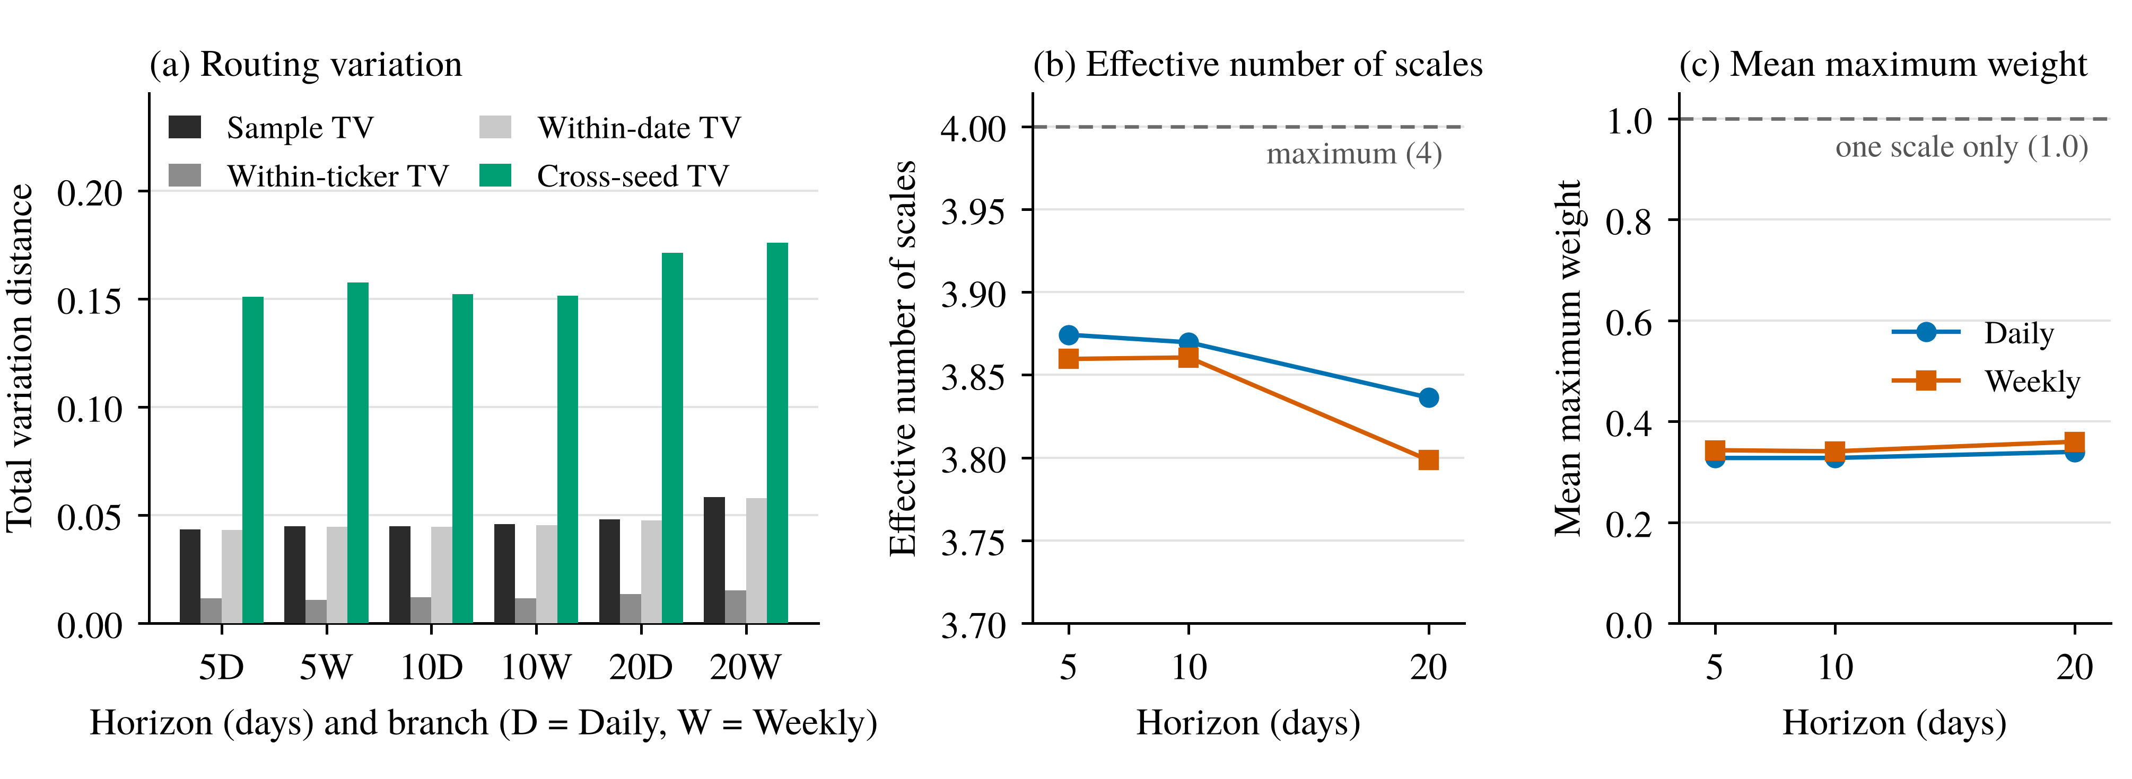
Figure S1. Diagnostics of Adaptive routing weights, summarized across five seeds for each horizon–branch configuration. (a) Overall Sample TV, within-ticker temporal TV, within-date cross-sectional TV, and cross-seed pairwise TV, displayed as distinct measures of routing variation rather than an additive decomposition. (b) Effective number of scales, with the dashed line marking the maximum of four candidate scales. (c) Mean maximum routing weight, with the dashed line at 1.0 indicating exclusive allocation to one scale for an observation. The panels describe weight variation and concentration; they do not identify causal drivers of forecast performance.

