SMARTBIN
SmartBin Connect
An IoT Smart Bin for Fill Monitoring and Collection Planning
Hardware Design and Implementation
PREPARED BY | Max Kabechani
SUBMITTED TO | Prof. J. Phiri
COURSE | Hardware Design and Implementation
DATE | 15 October 2026
PROJECT SUMMARY
A connected, single-compartment bin measures fill level with an ultrasonic sensor, gives local LED feedback, opens its flap on a button press, and sends readings to a web operations portal. The portal links bins to owners, raises collection tasks, and supports route planning.

Executive Summary
SmartBin Connect is a prototype that joins a physical waste bin to a web-based monitoring and collection workflow. A SunFounder ESP32 development board reads an ultrasonic distance sensor above the waste, maps the measured distance to a fill percentage, and lights a green, amber, or red indicator. A push button toggles a servo-driven flap so the bin can be opened for use or emptying. The ESP32 sends telemetry over Wi-Fi to a backend API; staff and bin owners use the portal to see the latest state and coordinate collection.
The project addresses a practical operations problem: fixed collection schedules do not reflect actual bin fullness. SmartBin makes the fill state visible and uses software to prioritize collection work. The AI service estimates time to capacity and arranges collection stops, while the portal applies different permissions to customers, collectors, and administrators.
Prototype status
The firmware and software design are prepared, and the repository includes a GitHub Actions ESP32 compile workflow. A native C++ syntax check has passed, but a successful ESP32 toolchain build and physical bench test have not been confirmed in this report. Sensor calibration, servo angles, power wiring, and the first end-to-end telemetry run remain validation steps.

Project objectives
- Measure the approximate fill level without contact using an ultrasonic sensor.
- Show fill bands locally with LEDs and provide a manually operated flap.
- Send readings to a web API and display bins, owners, alerts, and collection work.
- Use predictive prioritization and location-aware route ordering to support collection planning.
- Keep customer bin claiming and staff operations separated by role.

Scope and design choice
This is a single-compartment bin prototype. Its main smart feature is the connected sensing-to-collection loop, not automatic waste sorting. The lid remains manually openable through a button-controlled servo, which also allows the container to be emptied.

1. Problem Definition and Requirements
Waste bins are often emptied by schedule or visual inspection. A schedule can collect bins before they are full, or leave full bins waiting until the next visit. A sensor-based system can provide a more timely estimate of capacity and give the collection team a shared list of work.
Need | Prototype response | Verification evidence required
Know when a bin is filling | Distance-to-fill calculation and three LEDs | Compare readings at known empty and full distances
Open and empty the bin | Button toggles a servo flap open or closed | Test flap clearance, angles, and manual access
Share state remotely | Wi-Fi telemetry to /api/telemetry | Confirm HTTP success and dashboard update
Assign bins safely | Admin registration and one-time claim code | Test duplicate registration and single-use claim
Prioritize collection | Fill-time/priority service and dispatch queue | Compare predicted priority with observed use
Plan collection stops | Priority-weighted nearest-neighbour route | Validate coordinates and route order on site

Design constraints
The design uses a small set of components and a short firmware loop suitable for an ESP32. The web connection requires 2.4 GHz Wi-Fi, a registered bin ID, the deployed API endpoint, and an API key matching the backend configuration. The live predictive model is a proof of concept and has not been trained or evaluated with measured site data.

2. System Architecture
The bin is an IoT edge device. It performs sensing, local indication, and simple lid control; it does not contain the collection database or prediction model. It posts a JSON telemetry record to the public HTTPS domain. The website's /api route forwards that request to the Fastify API inside the Dokploy deployment. The backend validates the device key and registered bin, stores the reading in PostgreSQL, requests a prediction, and creates an open dispatch task when priority is high or urgent.
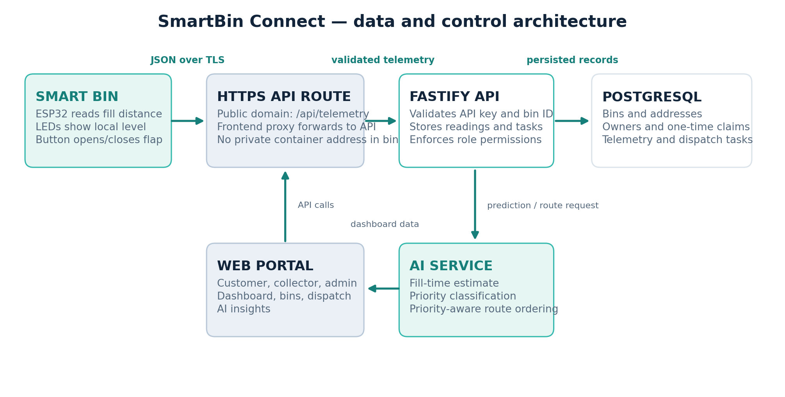
Figure 1. End-to-end data flow between the bin, API, database, AI service, and role-based portal.

Main software components
Component | Responsibility
ESP32 firmware | Reads the sensor, drives LEDs and servo, reconnects Wi-Fi, and posts telemetry.
Next.js portal | Provides dashboard, bin management, dispatch, AI insights, profile, and administration screens.
Fastify API | Authenticates users, checks staff roles, validates telemetry, manages bins and claims, and creates/ closes dispatch tasks.
PostgreSQL + Drizzle | Persists user roles, bin records and locations, readings, and dispatch tasks; migrations maintain schema.
Python AI service | Exposes fill-time prediction and route-optimization endpoints; uses a trained model when available and fallback logic otherwise.

Telemetry record
The firmware sends the bin identifier, fill percentage, lid state, Wi-Fi signal strength, and an API key in a JSON POST request. The actual key is kept in a local secrets.h file and is intentionally excluded from the repository and this report.
Network path
The ESP32 uses the public website domain and /api/telemetry route. It cannot address the private Docker service name directly from Wi-Fi. TLS protects the request while it travels over the network.

3. Hardware Design
The physical concept uses a box as the single-compartment bin body. The ultrasonic module is mounted under the top cover and faces downward. As waste rises, the measured air gap decreases. The ESP32 converts that distance to a percentage and drives three LEDs. The push button toggles a small servo attached to the flap.
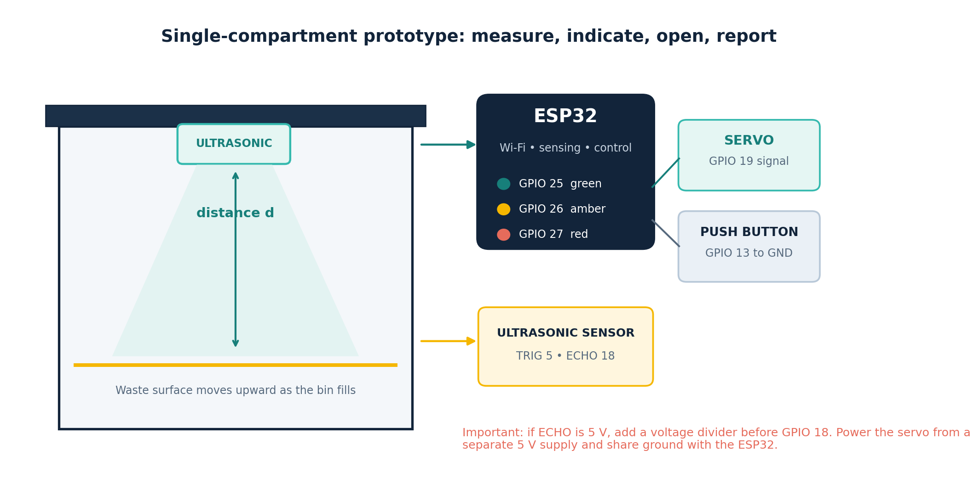
Figure 2. Proposed component arrangement and signal connections. The exact SunFounder board and sensor variant should be checked against the parts on hand.
Part | Firmware pin | Design note
SunFounder ESP32 board | — | 3.3 V GPIO logic; connect USB for programming and power the servo separately.
Ultrasonic sensor TRIG | GPIO 5 | ESP32 output trigger.
Ultrasonic sensor ECHO | GPIO 18 | If the module outputs 5 V, place a resistor divider/level shifter before the ESP32 input.
Green / amber / red LEDs | GPIO 25 / 26 / 27 | Use one current-limiting resistor per LED; share ground.
Momentary push button | GPIO 13 to GND | Firmware uses INPUT_PULLUP; pressed reads LOW.
Servo signal | GPIO 19 | Use a separate regulated 5 V supply sized for the servo and a common ground with the ESP32.
Box, flap, brackets, wiring | — | Mount sensor rigidly; keep the ultrasonic beam clear of the walls and flap.

Electrical and mechanical considerations
- A 5 V ECHO signal can damage a 3.3 V ESP32 input; use a voltage divider or suitable logic-level shifter.
- Do not power a servo from an ESP32 GPIO or the 3.3 V rail. Servo current can cause resets; use a dedicated supply and tie the grounds together.
- Fit resistors to all LEDs. Verify the actual board pin labels and avoid pins reserved by the chosen board.
- Mount the ultrasonic sensor away from angled walls and avoid a lid position that blocks the beam.
- Tune the closed and open angles on the actual flap. Test the linkage without a load and leave manual access for emptying.

4. Firmware and Measurement Method
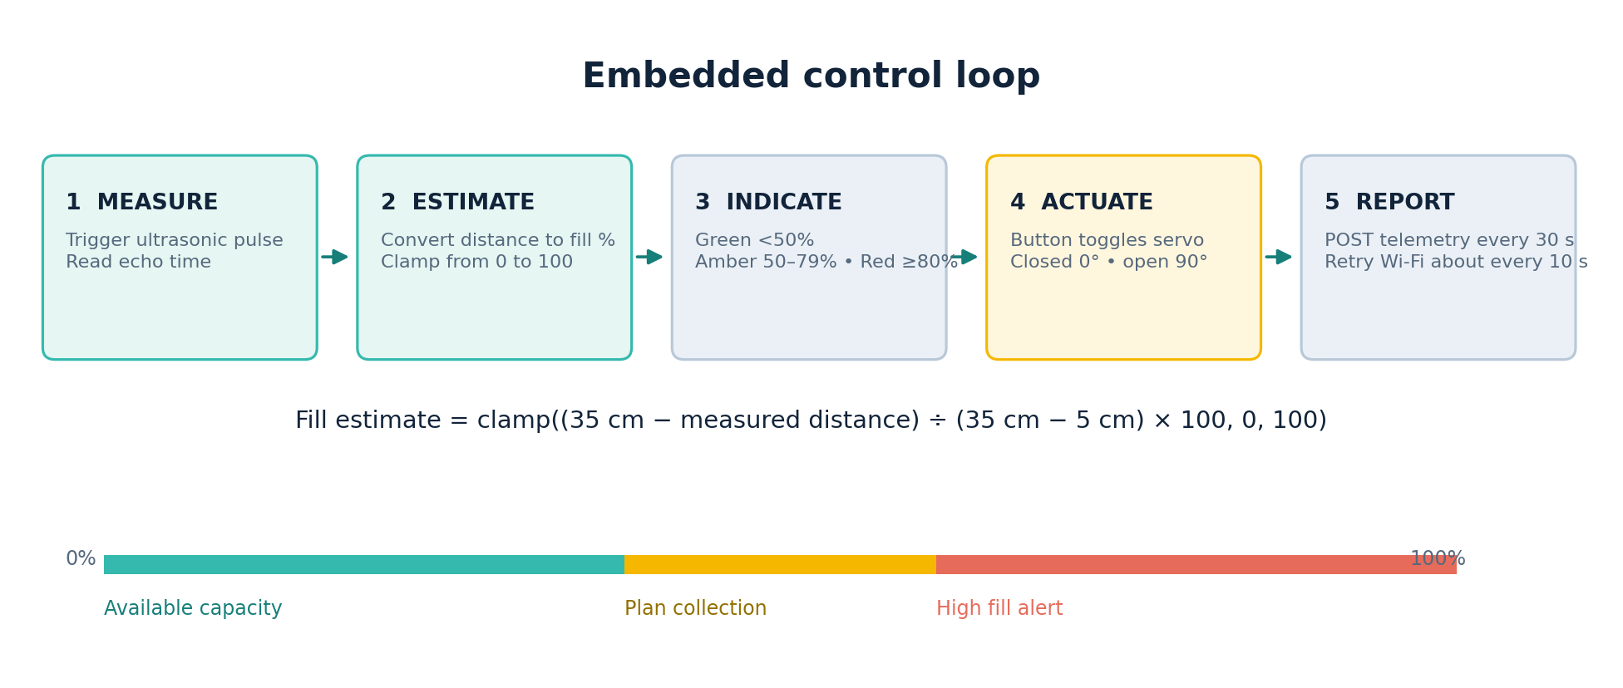
Figure 3. The firmware's sensing, status indication, flap control, and telemetry cycle.
The sketch generates a short TRIG pulse, measures the ECHO pulse duration, and estimates distance using the speed of sound. A timeout returns an invalid measurement so a missing echo is not interpreted as a full bin. The fill estimate is clamped to the 0–100% range:
Distance-to-fill mapping
fill (%) = clamp((35 cm − measured distance) ÷ (35 cm − 5 cm) × 100, 0, 100). The current reference distances are code constants and must be calibrated to the real bin depth.

Measured fill | Local indicator | Operational meaning
0–49% | Green | Capacity available
50–79% | Amber | Plan or monitor collection
80–100% | Red | High fill; review collection priority
No valid echo | All fill LEDs off | Measurement invalid; inspect sensor placement or wiring

Control and communication behaviour
- At startup, the firmware initializes GPIO, attaches the servo, closes the flap to 0°, and begins Wi-Fi connection.
- If Wi-Fi is disconnected, it retries approximately every 10 seconds.
- The button toggles the servo between 0° and 90° and requests an immediate telemetry send. The loop also sends readings every 30 seconds.
- A telemetry send is skipped if Wi-Fi is unavailable or the sensor reading is invalid. The current sketch has no offline queue.
- The button logic detects a press edge but does not yet debounce mechanically; a hardware test should check for multiple toggles from switch bounce.

Prototype firmware assumptions
The current compile-time configuration uses bin ID BIN-01, the public API URL, and a local secrets.h for Wi-Fi and API key values. The code must be uploaded to the correct ESP32 board target and tested with the actual servo and ultrasonic module. HTTP status codes are printed to Serial for debugging.

5. Portal, API, and User Roles
The portal connects household/bin owners with operations staff. A superadmin registers a bin with an identifier, name, address, and optional coordinates. The API generates a one-time claim code and stores its hash. A customer redeems the code to link the bin to their account; after a successful claim, the code is cleared. Collectors can work the dispatch queue but cannot register or claim bins.
Role | Allowed prototype actions
Customer | Claim a registered bin with its one-time code; view owned bins and readings; request collection for an owned bin.
Collector | View fleet and open dispatch work; review route stops; close a collection task after pickup.
Superadmin / Administrator | Register bins and locations; manage roles; create collector accounts; access fleet administration.

Operational sequence
1. Administrator enters the physical bin ID, display name, address, and coordinates in the portal.
2. Administrator gives the owner the one-time claim code through a private channel.
3. Customer signs up and redeems that code to link the registered bin.
4. ESP32 sends readings only after its bin ID is registered and the API key matches.
5. High-priority readings and customer requests create dispatch tasks for collector review.
6. Collector follows the proposed stop order and closes each task after physical pickup.

Role enforcement and data handling
Role checks are performed by the API, not only by hiding buttons in the browser. New accounts default to customer. Administrator-created bin claim codes are generated from a restricted alphabet, normalized, hashed before storage, and redeemed only once. The device API key is a separate credential from a user's portal login.

6. AI and Route Planning
The AI service supports two operations: estimating hours until the bin approaches capacity and ordering collection stops. When a model artifact is available, the predictor uses a scikit-learn RandomForestRegressor. The training script generates a deterministic synthetic set of 1,600 examples when no telemetry CSV is provided; it uses 180 trees. The input feature schema is fill level, fill rate, hour, weekday, and hours since collection.
The service labels a bin urgent at 90% fill or higher or an estimate of four hours or less; high at 80% or higher or within 12 hours; medium from 60%; and low below that. If the model is unavailable, the AI service uses an explainable fill-rate calculation. The API also has a static threshold fallback if the service cannot be reached.

Route ordering
For stops with coordinates, the route service repeatedly selects the nearest remaining stop, adjusted by a priority weight, using Haversine distance. Stops without coordinates are appended by priority and fill. The algorithm is a practical heuristic for a small prototype, not a proof of globally shortest route. The estimated route distance and savings should be treated as planning estimates until validated against actual journeys.
AI limitation to state during the presentation
The training examples are synthetic, not measured campus or household waste data. In the current API call, the live prediction request supplies fill level and bin ID; fill rate and time since collection use service defaults. No accuracy score has been established. The AI portion demonstrates a predictive workflow and needs real historical readings before its predictions should guide operations.

What makes the AI useful
The useful idea is the decision loop: a reading can be translated into a likely time-to-capacity, a priority label, and a suggested collection order. The portal then gives an operator a concrete next action. This is more compelling than an isolated sensor graph, while remaining honest about the need for real data and validation.

7. Verification and Results
The available verification evidence distinguishes source-level checks from hardware results. No claim is made here that a physical bin has been calibrated or operated end to end.
Check | Status at report preparation | What it establishes
Native C++ syntax check with Arduino stubs | Passed | Basic C++ syntax and local identifiers parse; it does not verify ESP32 libraries or board compatibility.
Git whitespace check | Passed | No whitespace errors in the staged source changes.
GitHub Actions build workflow | Added and pushed | Workflow installs Arduino CLI, ESP32 core, and ESP32Servo, then compiles against ESP32 Dev Module using the placeholder secrets template; first run result was not available when this report was prepared.
Real ESP32 compile in local environment | Not completed | The environment could not download the board platform, so no board-specific build result is claimed.
Sensor calibration and servo test | Pending physical test | Requires the actual board, sensor, resistor network, servo supply, flap, and bin geometry.
End-to-end portal telemetry | Pending bench test | Requires matching API key, registered BIN-01, Wi-Fi, and confirmation that a new reading appears in the portal.

Recommended acceptance checks
- Measure an empty bin and a known fill height; adjust EMPTY_CM and FULL_CM until the displayed percentage is useful.
- Check all LED bands at values around 49%, 50%, 79%, and 80%.
- Disconnect/reconnect Wi-Fi and verify retry without reboot.
- Press the button once and confirm one flap toggle; inspect for switch bounce and servo binding.
- Watch Serial output for HTTP success and confirm the dashboard timestamp advances.
- Verify customer claim, collector route view, and task close actions with separate test accounts.
- Confirm that no Wi-Fi password or API key is included in the submitted source bundle.

8. Risks, Improvements, and Future Work
Current limitation | Next engineering step
Ultrasonic readings vary with irregular waste surfaces | Take multiple readings, use a median filter, and test with representative contents.
Fixed reference distances may not match the box | Measure actual internal depth and make calibration values configurable.
Servo flap angle and torque are unknown | Prototype the linkage, tune endpoints, and test a separate 5 V supply under load.
No offline telemetry queue | Persist the latest unsent record and retry safely after Wi-Fi returns.
Synthetic model has no measured accuracy | Collect time-stamped fill and collection data; compare predictions with actual time-to-full.
Live API sends limited model features | Derive fill rate from historical readings and include elapsed time since last collection.
Simple route heuristic | Compare routes with map travel distances and a route solver using real addresses.
Button is not debounced | Add a short debounce interval and validate user operation.

Build and demo sequence
1. Assemble the sensor, LEDs with resistors, button, and servo; double-check the ECHO divider and common ground.
2. Create the local secrets.h from the example and enter Wi-Fi/API values privately.
3. Compile the ESP32 firmware using the CI result or Arduino IDE, flash the board, and check Serial output.
4. Register BIN-01 with an address and location in the administrator portal; link it to a customer using the one-time claim code.
5. Move a flat test target through measured distances to demonstrate local LED bands and portal telemetry.
6. Press the button to open the flap, show that the bin remains manually accessible, then demonstrate a collection request or collector task close.

Conclusion
SmartBin Connect demonstrates a complete smart-bin concept across hardware, embedded firmware, API, database, AI-assisted prioritization, and role-based operations. Its strongest design feature is the connection between local fill sensing and a concrete collection workflow. The prototype is intentionally simple: one compartment, three indicator LEDs, one ultrasonic sensor, a push button, and a servo-operated flap. The next milestone is physical integration and measured validation, followed by training the prediction model on real collection history.

References
1. Project source repository: SmartBin Connect, firmware/SmartBin/SmartBin.ino, api/src/server.ts, ai-service/app.py, and ai-service/train.py, accessed 15 October 2026.
2. Espressif Systems, ESP32 Series Datasheet. https://www.espressif.com/sites/default/files/documentation/esp32_datasheet_en.pdf
3. Espressif Systems, Arduino ESP32 Documentation. https://docs.espressif.com/projects/arduino-esp32/en/latest/
4. Fastify Documentation. https://fastify.dev/docs/latest/
5. scikit-learn, RandomForestRegressor API Reference. https://scikit-learn.org/stable/modules/generated/sklearn.ensemble.RandomForestRegressor.html

