The college application problem

OptimalApplication.jl
Solving the college application problem with Julia
… consists of deciding which colleges to apply to, given
- the utility associated with each school,
- the probability of being admitted,
- each school’s application fee, and
- a total budget to spend on applications.
Maximizing the expected maximum of a portfolio of random variables: a challenging combinatorial optimization problem. NP-hard or NP-complete depending on input encoding.

OptimalApplication.jl
… is a Julia package that provides exact, approximate, and heuristic solvers for the college application problem.
Special case: All application fees equal. applicationorder_​list() and applicationorder_​heap() are quadratic-time algorithms.
General case:
- Exact solution from optimalportfolio_​dynamicprogram() or optimalportfolio_​branchbound().
- ε-approximate solution from optimalportfolio_​fptas().
- Heuristic solution from optimalportfolio_​simulatedannealing().
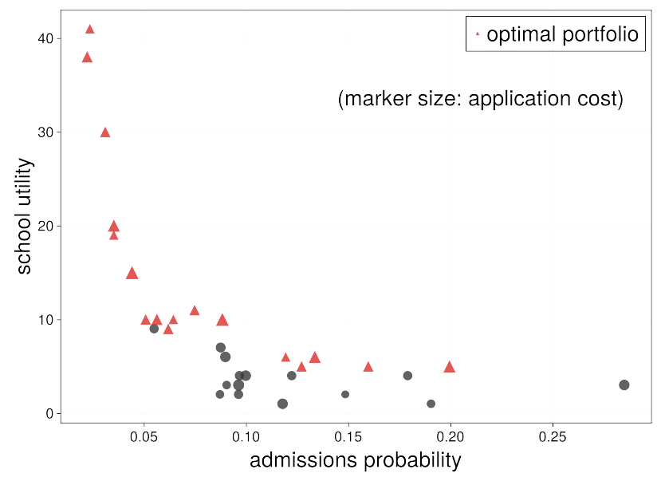A typical admissions market and the optimal portfolio.

Why Julia?
Multiple dispatch, parametric types ⇒ easy to accept different kinds of user input and preserve type stability.
Easy to parallelize validation study with @threads.
Simplicity of creating and sharing packages.

Future work
OptimalApplication.jl could be a lot more generic, e.g. accept DataFrames.jl series as input.
Integrate with Bonobo.jl to handle more sophisticated constraint structures that arise in real-world admissions markets.
For example, the Korean admissions process prevents students from applying exclusively to top schools, a diversification constraint.
Graphical interface/web app.

Links
OptimalApplication.jl:
- ]install OptimalApplication
- Source code and documentation on GitHub.
Theory: github.com/​maxkapur/​College​Application hosts an arXiv paper and various conference slides.
Presentation slides.

Presenter info
✍️ Max Kapur
📜 Master’s student
🏛️ Management Science/Optimization Lab,
Seoul National University
✉️ maxkapur@gmail.com
🕸️ maxkapur.com

