Version3
Status!
Author

Data Science Story
maXbox Starter 100
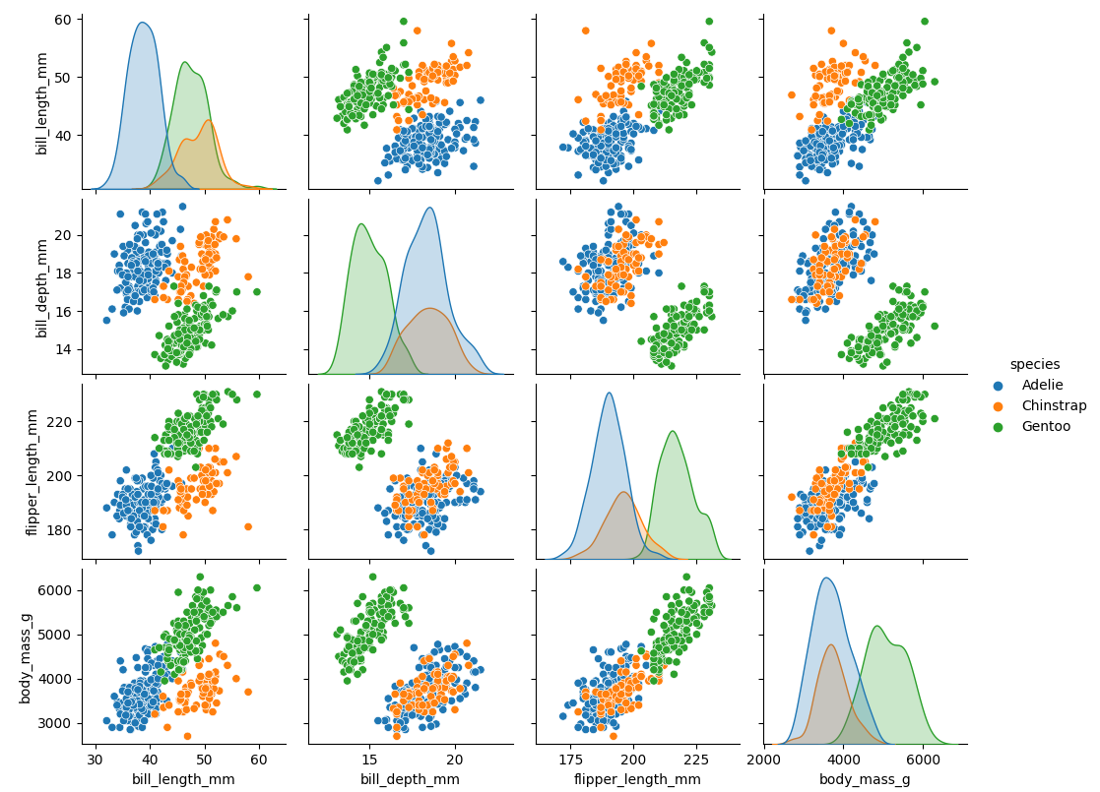

Links and Sources
Title
https://www.kaggle.com/code/parulpandey/penguin-dataset-the-new-iris

python4delphi/Tutorials/Webinar II at master · maxkleiner/python4delphi (github.com)
https://maxbox4.wordpress.com/

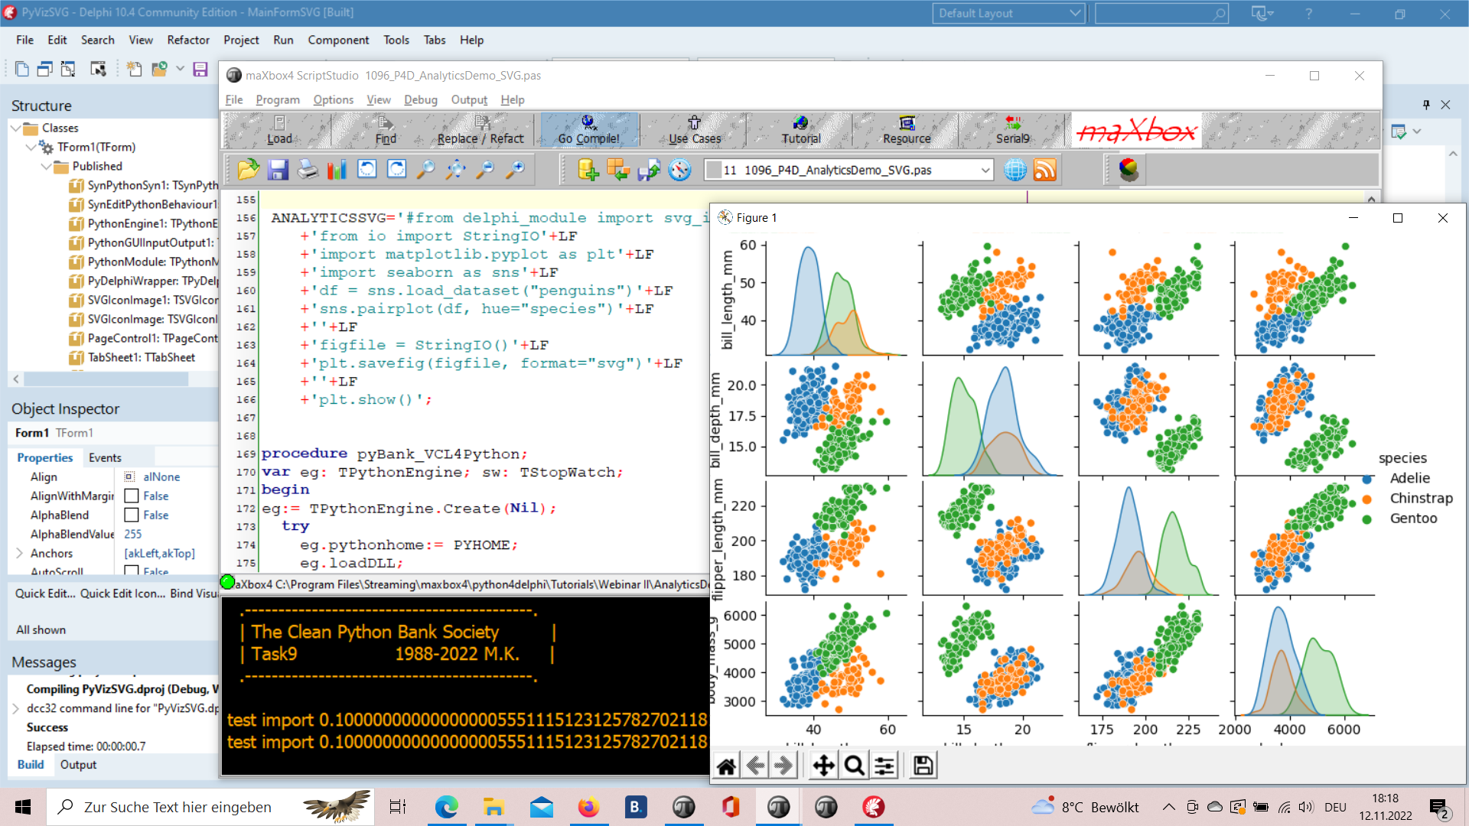
1096_2022-11-12_svg_delphi_maxbox_seaborn4.png

RAD Studio 11.4, maXbox4 and Python 3.8 with Seaborn

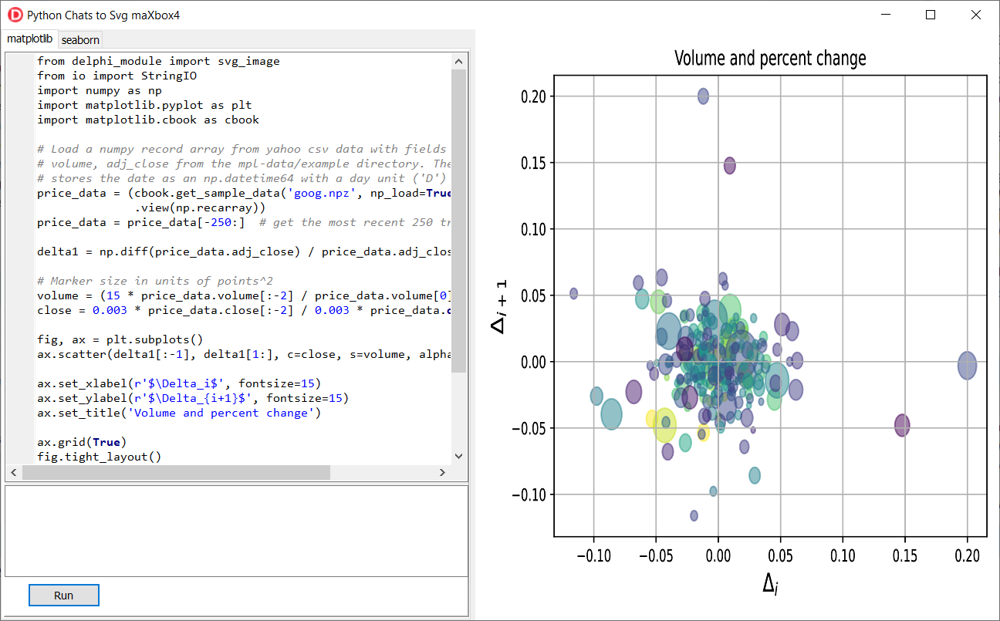
Python4Delphi with SVG Plot

From Data to Plot

Functions

The Iris flower data set or Fisher's Iris data set is a multivariate data set introduced by the British statistician and biologist Ronald Fisher in his 1936 paper.

Palmer Archipelago (Antarctica) penguin dataset appears to be a drop in replacemnt for the same. It is a great intro dataset for data exploration & visualization. But the penguins dataset has different number of samples for each species.

First we get the data:

import seaborn as sns
df = sns.load_dataset("penguins")

Or alternate

df = pd.read_csv('../input/palmer-archipelago-antarctica-penguin-data/penguins_size.csv')

df.head()

 | species | island | culmen_length_mm | culmen_depth_mm | flipper_length_mm | body_mass_g | sex
0 | Adelie | Torgersen | 39.1 | 18.7 | 181.0 | 3750.0 | MALE
1 | Adelie | Torgersen | 39.5 | 17.4 | 186.0 | 3800.0 | FEMALE
2 | Adelie | Torgersen | 40.3 | 18.0 | 195.0 | 3250.0 | FEMALE
3 | Adelie | Torgersen | NaN | NaN | NaN | NaN | NaN
4 | Adelie | Torgersen | 36.7 | 19.3 | 193.0 | 3450.0 | FEMALE

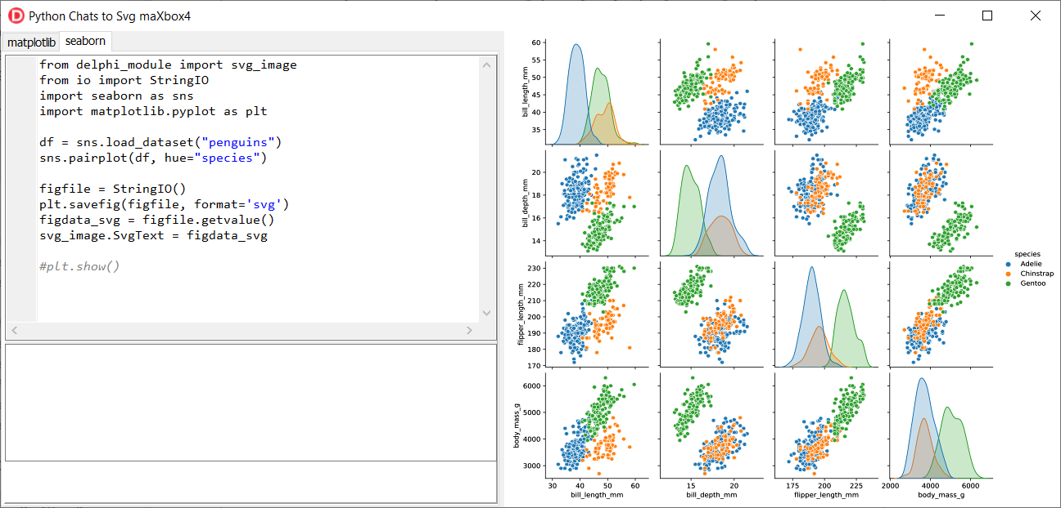
1096_2022-11-12_svg_python2seaborn.png

df.info()

<class 'pandas.core.frame.DataFrame'>
RangeIndex: 344 entries, 0 to 343
Data columns (total 7 columns):
# Column Non-Null Count Dtype
--- ------ -------------- -----
0 species 344 non-null object
1 island 344 non-null object
2 culmen_length_mm 342 non-null float64
3 culmen_depth_mm 342 non-null float64
4 flipper_length_mm 342 non-null float64
5 body_mass_g 342 non-null float64
6 sex 334 non-null object
dtypes: float64(4), object(3)
memory usage: 18.9+ KB
memory shape core cube #7
The dataset consists of 7 columns.
- species: penguin species (Chinstrap, Adélie, or Gentoo)
- culmen_length_mm: culmen length (mm)
- culmen_depth_mm: culmen depth (mm)
- flipper_length_mm: flipper length (mm)
- body_mass_g: body mass (g)
- island: island name (Dream, Torgersen, or Biscoe) in the Palmer Archipelago (Antarctica)
- sex: penguin sex
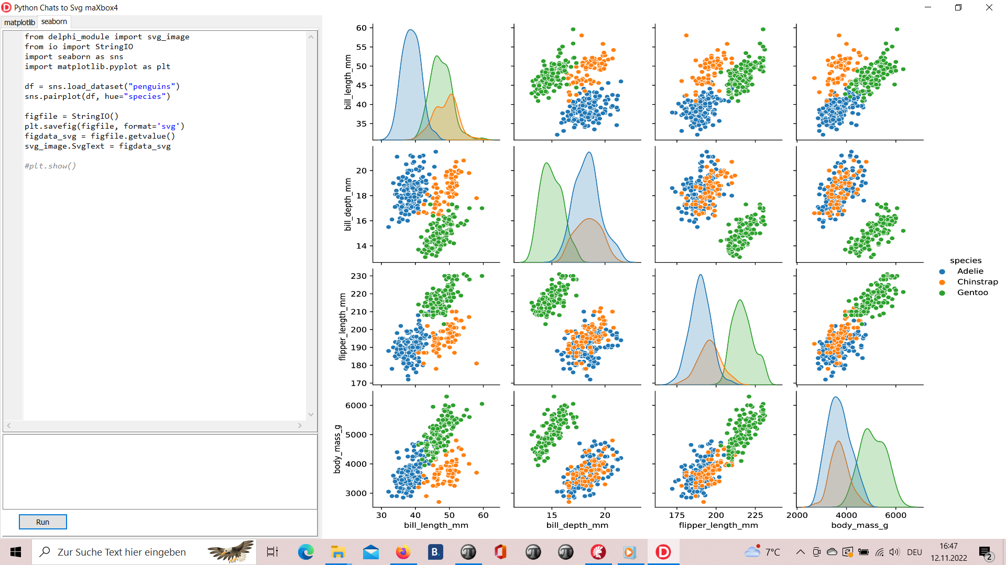
1096_2022-11-12_svg_python_delphi_scalable.png

Seaborn is a Python data visualization library based on matplotlib. It provides a high-level interface for drawing attractive and informative statistical graphics.

Covariance

“Covariance” indicates the direction of the linear relationship between variables. “Correlation” on the other hand measures both the strength and direction of the linear relationship between two variables.

Source: https://tinyurl.com/yd2pezss

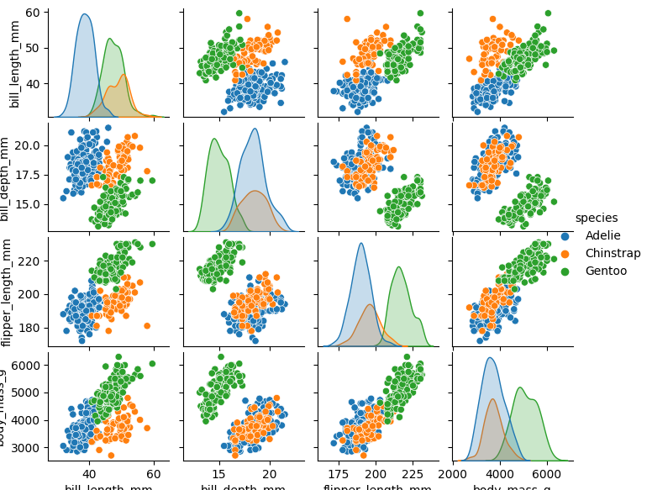
1096_Figure_1_species.png

The scatter plot which shows us the correlation with respect to other features. This method helps just to figure out the important features which account the most for the classification in our model.

Scatter Plot

A scatter plot (aka scatter chart, scatter graph) uses dots to represent values for two different numeric variables. The position of each dot on the horizontal and vertical axis indicates values for an individual data point. Scatter plots are used to observe relationships between variables.

A common modification of the basic scatter plot is the addition of a third variable. Values of the third variable can be encoded by modifying how the points are plotted. For a third variable that indicates categorical values (like geographical region or gender), the most common encoding is through point color.
Seaborn lets you create relational plots using the relplot() function. The function technically lets you create more than scatter plots.

Numpy arrays are a good substitute for python lists. They are better than python lists. They provide faster speed and take less memory space. Let’s begin with its definition for those unaware of numpy arrays. They are multi-dimensional matrices or lists of fixed size with similar elements.

Pandas is a popular Python library used to manipulate tabular data. It provides a versatile dataframe object that can read data from many popular formats, such as Excel, SQL, CSV and more.
The Pandas style API provides you with many different tools that makes working with styling tabular data much easier.

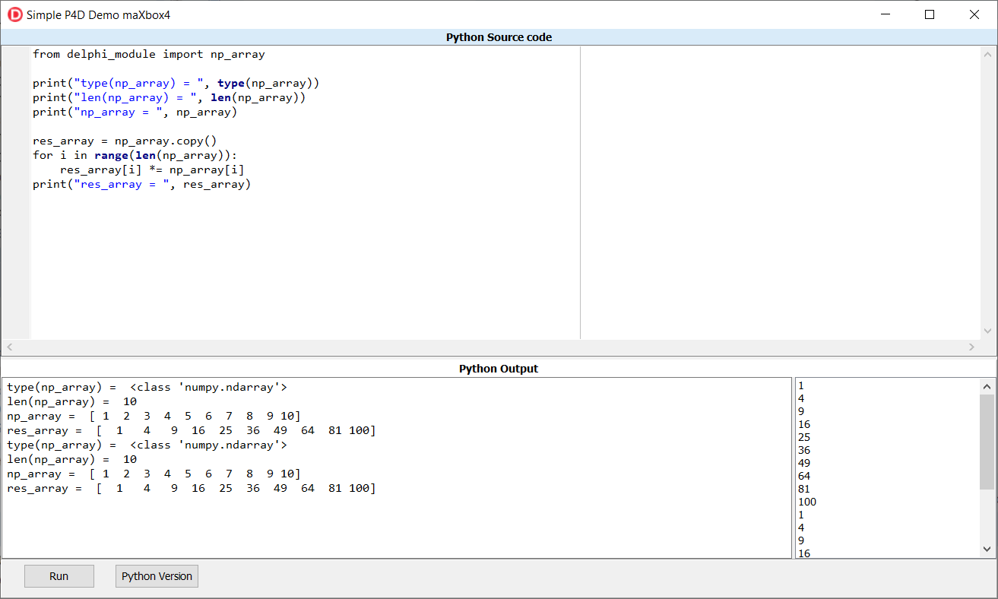
1096_2022-11-12_var_python.png

1096_2022-11-12_svg_python.png

python - Scaling a plot (matplotlib) - Stack Overflow
The graph is quite big, so in order to not only see many overlapping dots indicating the nodes, I have to scale the output picture. I used: f,ax = plt.subplots (1,1) ax.set_aspect ('equal') zoom=30 w, h = f.get_size_inches () f.set_size_inches (w * zoom, h * zoom) .

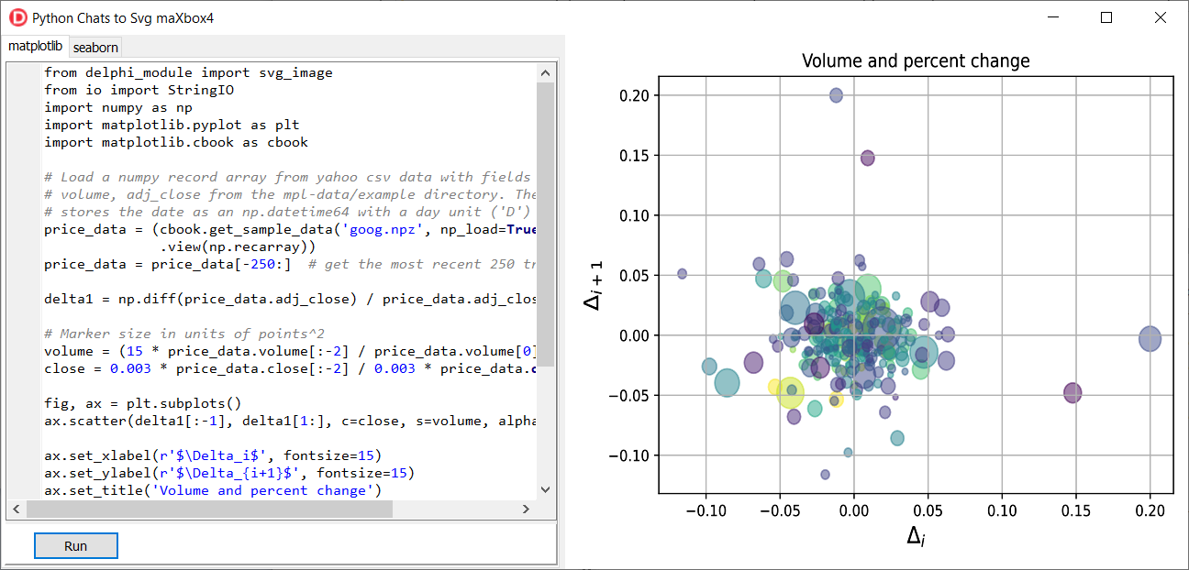
1096_2022-11-12_svg_python2.png

Predict and Dict the Pic

When you hear the word, ‘Bayesian’, you might think of Naive Bayes. However, Bayesian principles can also be used to perform regression. In this article, we will discuss and implement Bayesian Ridge Regression, which is not the same as regular Ridge Regression. To understand more about regular Ridge Regression, you can follow this link.

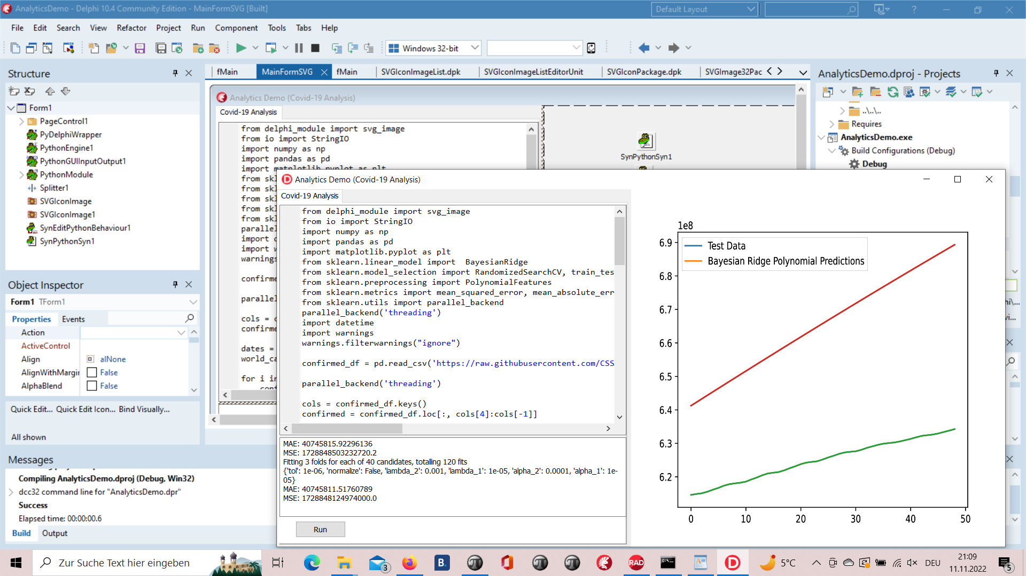
1096_2022-11-11_analytics.png

Predict in a Script

Regression is a Machine Learning task to predict continuous values (real numbers), as compared to classification, that is used to predict categorical (discrete) values.

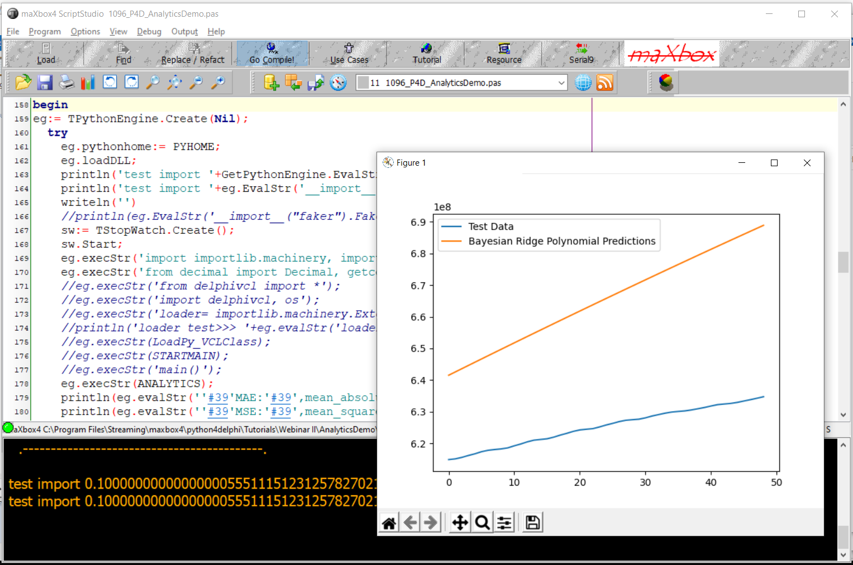
1096_2022-11-11_analytics_script.png

The algorithm uses a hyperparameter to control regularization strength and fully integrates over the hyperparameter in the posterior distribution, applying a hyperprior selected so as to be approximately noninformative.

Scikit-learn’s algorithm makes use of conjugate priors and because of that is restricted to use the Gamma prior which requires four hyperparameters chosen arbitrarily to be small values. Additionally, it requires initial values for parameters αα and λλ that are then updated from the data.

import numpy as np

iimport matplotlib.pyplot as plt

from sklearn.linear_model import BayesianRidge
In comparison, the algorithm we presented requires no initial parameters; and because the hyperparameter is integrated over, poor performing values contribute little to the posterior probability mass.

# #############################################################################
# Plot the true and predicted curves for bbai's BayesianRidgeRegression model
from bbai.glm import BayesianRidgeRegression
reg = BayesianRidgeRegression(fit_intercept=False)
fig, ax = plt.subplots(1, 1, figsize=(4, 4))

# Note: there are no parameters to tweak
reg.fit(X_train, y_train)
ymean, ystd = reg.predict(X_test, return_std=True)

ax.plot(x_test, func(x_test), color="blue", label="sin($2\\pi x$)")
ax.scatter(x_train, y_train, s=50, alpha=0.5, label="observation")
ax.plot(x_test, ymean, color="red", label="predict mean")
ax.fill_between(
x_test, ymean - ystd, ymean + ystd, color="pink", alpha=0.5, label="predict std"
)
ax.set_ylim(-1.3, 1.3)
ax.legend()

plt.tight_layout()
plt.show()

- Technical Description
maxkleiner (Max Kleiner) (github.com)
A Python program terminates as soon as it encounters an error. In Python, an error can be a syntax error or an exception. In his article, you will see what an exception is and how it differs from a syntax error. After that, you will learn about raising exceptions and making assertions. Then, you’ll finish with a demonstration of the try and except block.
https://realpython.com/python-exceptions/

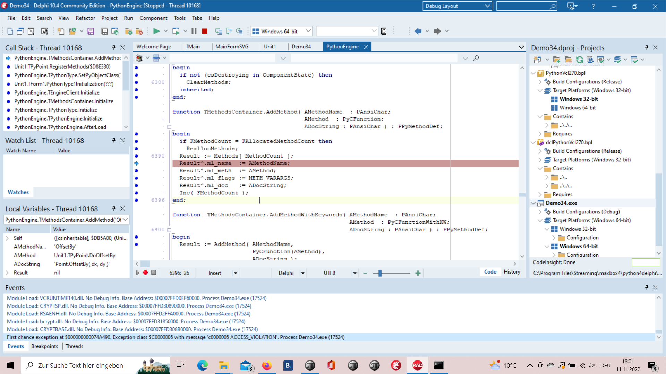
This Exception was prior to change between 32- and 64 bit.
1096_2022-11-11_exception.png

- Develop Overview
We value the quality of the material each student is learning. Our Instructor led classes help provide hands-on learning, one-on-one mentoring with experienced developers and peer-to-peer learning. To allow the most flexibility for students, we have Day and Night programs to choose from. *No prior coding experience required.

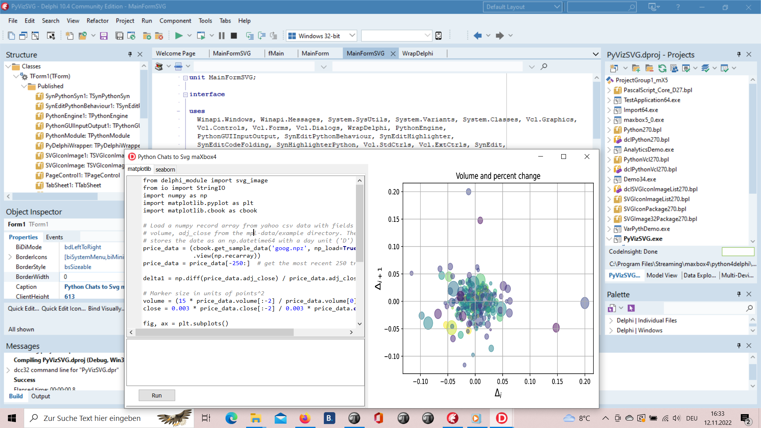
1096_2022-11-12_develop_overview.png

procedure pyBank_VCL4Python;
var eg: TPythonEngine; sw: TStopWatch;
begin
eg:= TPythonEngine.Create(Nil);
try
eg.pythonhome:= PYHOME;
eg.loadDLL;
println('test import '+GetPythonEngine.EvalStr('__import__("decimal").Decimal(0.1)'));
writeln('')
//println(eg.EvalStr('__import__("faker").Faker()'));
sw:= TStopWatch.Create();
sw.Start;
eg.execStr('import importlib.machinery, importlib.util');
eg.execStr('from decimal import Decimal, getcontext');
importlib.machinery.ExtensionFileLoader("DelphiVCL",'+VCLHOME+')')

eg.execStr(ANALYTICSSVG);
//println(eg.evalStr(''#39'MSE:'#39',mean_squared_error(test_bayesian_pred, y_test_confirmed)'));

sw.Stop;
//sw.ElapsedMilliseconds;
writeln('Stop Analytics Tester1: '+sw.getValueStr)
except
eg.raiseError;
writeln(ExceptionToString(ExceptionType, ExceptionParam));
finally
eg.Free;
sw.Free;
sw:= Nil;
end;
end;

