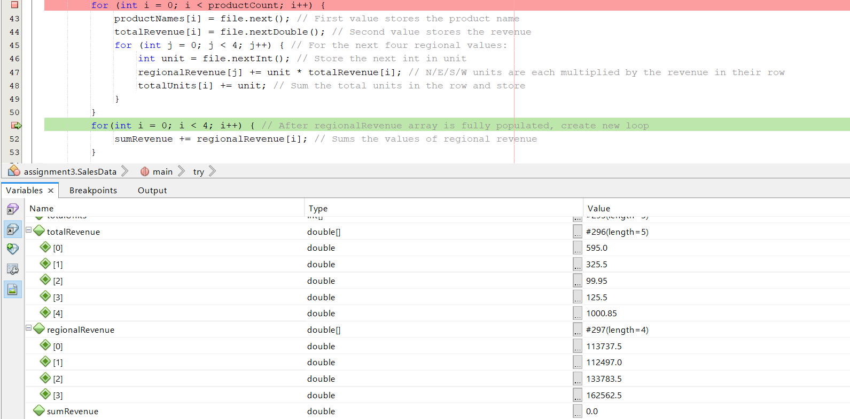

At this point, the productNames, totalRevenue, and regionalRevenue arrays have just been fully populated, and the debugger is displaying each value for totalRevenue and regionalRevenue. TotalRevenue was populated using the outer loop up until the product count of 5, and regionalRevenue was populated using the nested loop as it only had 4 regional values and needed the four columns (kept by j) multiplied by the totalRevenue of each row (kept by i).