HEAT EQUATION
by Maksym Komarov
Summary
Solve the heat equation on the GPU by iterative method with X parallelization and triangle method. This method efficiently use shared memory and emphasizes thread synchronization within a block instead of global synchronization.

Challenge and Background
Problem statement
Solving the heat equation is an important problem in many fields, including physics, engineering, and material science. The heat equation is a partial differential equation that describes the evolution of temperature in a given region over time, and it can be used to model a wide range of physical phenomena, such as heat transfer, diffusion, and wave propagation.
The heat equation has the form:
∂u/∂t = α (∂^2u/∂x^2 + ∂^2u/∂y^2 + ∂^2u/∂z^2)
where u is the temperature field, t is time, x, y, and z are the spatial coordinates, and α is the thermal diffusivity of the medium.
1D heat equation:
dU/dt = k * d^2U/dx^2
Iteratable solution approach
To solve the heat equation, one approach is to use numerical methods, such as finite difference, finite element, or spectral methods. In these methods, the region of interest is discretized into a grid, and the temperature values are approximated at each point on the grid. The heat equation is then approximated using the discrete values of the temperature and solved iteratively over time.
The iteratable solution approach, implemented in the GetU function, is a method for computing the solution at the next time step, given the solution at the previous time step. The approach involves discretizing the heat equation using the second-order finite difference method, which approximates the second derivative of the solution in terms of the values of the solution at neighboring grid points. The solution at the next time step is then approximated using the solution at the previous time step, the time step size, and the values of the solution at neighboring grid points.
The GetU function first computes the second derivative of the solution at the grid point i, using the values of the solution at neighboring grid points. It then uses this second derivative, along with the time step size and the values of the solution at neighboring grid points, to compute the solution at the next time step using the formula:
U_{i}^{n+1} = U_{i}^{n} + integr_step * (U_{i+1}^{n} - 2 * U_{i}^{n} + U_{i-1}^{n})
where U_{i}^{n} is the value of the solution at grid point i and time step n, and U_{i}^{n+1} is the value of the solution at grid point i and time step n+1. The parameter integr_step is a hyperparameter that determines the size of the time step and affects the accuracy of the solution. By choosing an appropriate value for integr_step, we can balance the trade-off between accuracy and computational efficiency.
Iterative solution parallelization
Therms: layer = array of points on current time step.
Parallelization of the iterative solution for the heat equation using shared memory involves using multiple threads to calculate the temperature distribution across a given 1D space.
In the task we have dependency nextLayer from previousLayer. So we need to split data between blocks and threads over X dimension: for each block a part of the array.
The solution approach consists of calculating multiple layers in every block independently using shared memory.
To start, a "triangle" is calculated in each block by the processTopTriangle function. This function uses the previous layer to calculate the next layer of the temperature distribution. After calculating each layer, the total number of values that we can calculate in the next layer is reduced by 2, because to calculate U_{i}^{n+1} it is necessary to know U_{i+1}^{n} and U_{i-1} that are unknown for boundary points.
So the result of all block calculations can be represented by the following image:
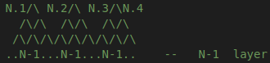

The processBotTriangle function is then used to calculate the flipped triangle, which uses the boundary and inner boundary values to calculate the temperature distribution for each layer. The boundaries are defined as the first and last element of the array, which correspond to the edge of the 1D space being considered. The inner boundaries are the values adjacent to the boundary values.
To calculate the value at the boundary of the flipped triangle, we need the inner boundary and the boundary value on the other side of the space.
By utilizing shared memory, the calculation of the temperature distribution across the 1D space can be efficiently parallelized by the GPU. Each thread calculates the temperature distribution for a specific subset of the space, with the results being combined to provide a final temperature distribution.
The use of shared memory ensures that the data needed for calculation is stored close to the threads performing the calculation, reducing the need to access global memory, which is significantly slower. Additionally, parallelization of the calculation ensures that the calculation time is significantly reduced, enabling faster and more efficient solutions to problems involving the heat equation.

Results:
Tested on my computer with NVIDIA GeForce GTX 1650.
Blocksize = 256
Coord Steps | Time steps | Test 1 Speedup | Test 2 Speedup
10000001 | 150 | 111.198 | 110.638
20000024 | 150 | 99.6735 | 121.793
30000047 | 150 | 114.822 | 107.039
10000001 ~=~ 2^32

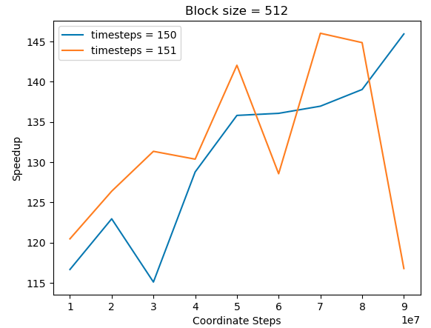

In case of less block size shared memory is used less efficient and less performance achieved:
For blocksize = 64; Average Speedup = 70;
GPU calculation time: ~176 milliseconds (coordSteps = 10000001; timeSteps = 150)

Explanation why the performances I obtain are not optimal & method upgrade
1)On the average it is used only a half of the threads per block.
2)There are many if statements.
Rhomb approach (triangle method upgrade)
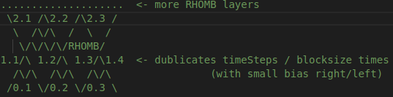

After calculation of the flipped triangle we can use the same shared memory to calculate normal triangle on top of it. But the base of the triangle must be 2 less than the inverted triangle and some other features which are more difficult to implement, which also makes the code less readable.

Conclusion:
The solution of the heat equation was implemented using CUDA (and sequential one). Proposed “triangle” method for efficient shared memory usage and thread synchronization within a block. Inside the code, there are descriptions for each function and the entire method pipeline.

