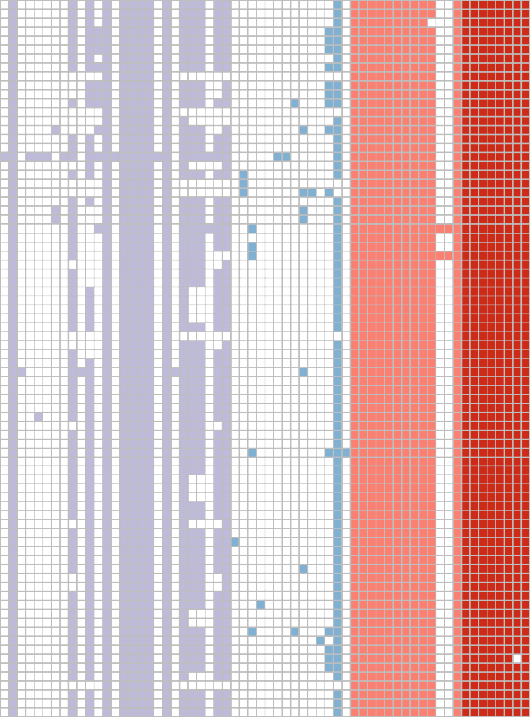SAL_CB1324AA_AS SAL_BB2970AA_AS SAL_BB2131AA_AS SAL_WA9926AA_AS SAL_XA1299AA_AS SAL_CB5243AA_AS SAL_FB5769AA_AS SAL_CB2598AA_AS SAL_BB1424AA_AS SAL_OA4072AA_AS SAL_OA4067AA_AS SAL_KA4888AA_AS SAL_NA2865AA_AS SAL_NB6620AA_AS SAL_CB1790AA_AS SAL_KA5244AA_AS SAL_AB7634AA_AS SG17−135 SAL_IB9302AA_AS SAL_CB9820AA_AS SAL_BB2899AA_AS SAL_BB1915AA_AS SAL_KA0676AA_AS SAL_CB9243AA_AS SAL_CB5468AA_AS SAL_HB2224AA_AS SAL_JB6580AA_AS SAL_CB2669AA_AS SAL_EB8845AA_AS SAL_EB1026AA_AS SAL_HB6699AA_AS SAL_CB5379AA_AS SAL_CB9822AA_AS SAL_EB4088AA_AS SAL_BB9086AA_AS SAL_SA9246AA_AS SAL_BB4524AA_AS SAL_MB7965AA_AS SAL_KA1119AA_AS SAL_HB2219AA_AS SAL_SA1344AA_AS SAL_AB7534AA_AS SAL_AB8884AA_AS SAL_CB9389AA_AS SAL_IB1406AA_AS SAL_BB5050AA_AS SAL_BB4937AA_AS SAL_IB6801AA_AS SAL_BB7027AA_AS SAL_WA2841AA_AS SAL_CB5376AA_AS SAL_BA7932AA_AS SAL_SA1324AA_AS SAL_BB9988AA_AS SAL_CB3497AA_AS SAL_AB7542AA_AS SAL_KB6210AA_AS SAL_BB9562AA_AS SAL_CB0053AA_AS SAL_KB2744AA_AS SAL_BB3127AA_AS SAL_BB8135AA_AS SAL_BB7197AA_AS SAL_BA8052AA_AS SAL_XA3156AA_AS SAL_CB0088AA_AS SAL_BB7261AA_AS SAL_BB6441AA_AS SAL_GB0225AA_AS SAL_EB6812AA_AS SAL_JB9521AA_AS SAL_EB2895AA_AS SAL_IB7996AA_AS SAL_FB8051AA_AS SAL_BB2967AA_AS SAL_KA0984AA_AS SAL_BB4431AA_AS SAL_CB2372AA_AS SAL_RA1599AA_AS SAL_RA1578AA_AS

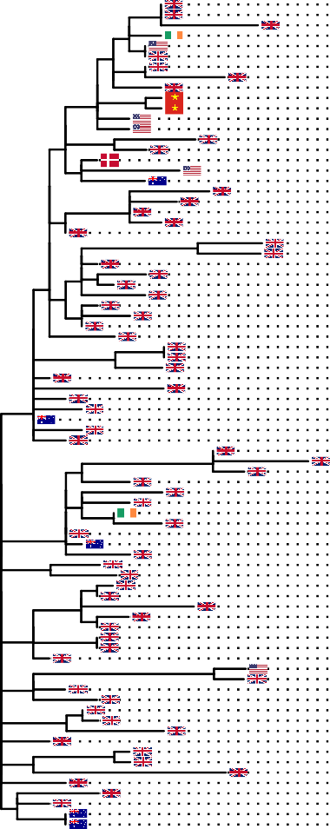

●

●

●

●

●

●

●

●

●

●

●

●

●

●

●

●

●

●

●

●

●

●

●

●

●

●

●

●

●

●

●

●

●

●

●

●

●

●

●

●

●

●

●

●

●

●

●

●

●

●

●

●

●

●

●

●

●

●

●

●

●

●

●

●

●

●

●

●

●

●

●

●

●

●

●

●

●

●

●

●

aac(3)−IId 1/80 (1%)

aac(6')−Iy 80/80 (100%)

aadA2 1/80 (1%)

ant(3'')−IIa 1/80 (1%)

aph(3')−Ia 2/80 (2%)

arr−2 1/80 (1%)

blaCMY−59 3/80 (4%)

blaCTX−M−55 1/80 (1%)

blaTEM−1 64/80 (80%)

cmlA1 1/80 (1%)

dfrA14 61/80 (76%)

floR 11/80 (14%)

fosA7 80/80 (100%)

linG 1/80 (1%)

mdsA 80/80 (100%)

mdsB 80/80 (100%)

mdsC 80/80 (100%)

mdtK 80/80 (100%)

mphA 1/80 (1%)

parC p.T57S 80/80 (100%)

qacH 1/80 (1%)

qnrS1 74/80 (92%)

strA 62/80 (78%)

strB 62/80 (78%)

sul2 3/80 (4%)

sul3 64/80 (80%)

tet(A) 74/80 (92%)

Col156 1/80 (1%)

Col440I 3/80 (4%)

ColpVC 5/80 (6%)

ColRNAI 1/80 (1%)

IncB/O/K/Z 1/80 (1%)

IncHI2 1/80 (1%)

IncHI2A 1/80 (1%)

IncI(Gamma) 2/80 (2%)

IncI1(Alpha) 7/80 (9%)

IncL/M(pMU407) 1/80 (1%)

IncL/M(pOXA−48) 1/80 (1%)

IncQ1 14/80 (18%)

IncX1 74/80 (92%)

pSL483 1/80 (1%)

csgABCDEFG 80/80 (100%)

fimCDFHI 80/80 (100%)

lpfA 80/80 (100%)

lpfB 80/80 (100%)

lpfC 80/80 (100%)

lpfE 80/80 (100%)

mgtB 80/80 (100%)

mgtC 80/80 (100%)

mig−14 80/80 (100%)

misL 79/80 (99%)

papB 2/80 (2%)

papI 2/80 (2%)

sinH 80/80 (100%)

C63PI 80/80 (100%)

SPI−1 80/80 (100%)

SPI−2 80/80 (100%)

SPI−3 80/80 (100%)

SPI−4 80/80 (100%)

SPI−5 80/80 (100%)

SPI−8 79/80 (99%)

SPI−9 80/80 (100%)