**Appendix S1**

**Supporting Information for**

***Bottom up and top down effects of temperature on body growth, population size spectra and yield – an application of a multi-species size-spectrum model***

Max Lindmarka,1, Asta Audzijonyteb, Julia Blanchardc, Anna Gårdmarkd

aSwedish University of Agricultural Sciences, Department of Aquatic Resources, Institute of Coastal Research, Skolgatan 6, Öregrund 742 42, Sweden

bInstitute for Marine and Antarctic Studies, University of Tasmania, Battery Point, TAS 7001, Australia

cInstitute for Marine and Antarctic Studies and Centre for Marine Socioecology, University of Tasmania, 20 Castray Esplanade, Battery Point, Hobart, TAS 7000, Australia

dSwedish University of Agricultural Sciences, Department of Aquatic Resources, Skolgatan 6, SE-742 42 Öregrund, Sweden

**Contents**

A. Model parameterization

B. Model calibration and validation

C. Analysis

1. **Model parameterization**

*Species specific parameters*

Below follows a description for how we acquired default parameters which are valid at the “reference” temperature, . See main text for which rates are assumed temperature dependent and how. In *‘mizer’*, MSSMs require species-specific parameters. Parameters that have no defaults and must be provided are: asymptotic size (), size at maturation (), preferred predator-prey mass ratio (PPMR) (), the standard deviation of PPMR () and the maximum recruitment in the Beverton-Holt stock recruitment function () (Scott *et al.* 2019).

For cod, we acquired and by calculating the mean and the standard deviation for the distribution of mean individual-level log10PPMR, using stomach data hosted by the International Council for the Exploration of the Sea (ICES) FISH STOMACH database (ICES 2010), which can be downloaded at <http://ecosystemdata.ices.dk/stomachdata/download.aspx>. We used only samples with fully intact prey (no digestion), observations from the time spatial area we consider (ICES subdivisions SD 25-29, 32) and from the time window we use for calibrating the model (1992-2002). When prey weight was not available, we used the relationship , where length is in cm, to approximate weight. For sprat and herring, we assumed and to be 1000 and 1, respectively, which reflects that forage fish typically feed on prey that are small in relation to their body size throughout ontogeny (Aydin *et al.* 2002; Reum *et al.* 2019).

*Figure S1. Distribution of individual level log10PPMR for cod. Mean and standard deviation are on normal scale and correspond to and . The dashed red vertical line corresponds to the mean log10 PPMR.*

From von Bertalanffy (VBGE) growth parameters and theory linking feeding parameters, the remaining species-specific parameters can be estimated. The allometric constant in the maximum food intake rate () is defined as , where is the Brody growth coefficient, is the assimilation efficiency, is the initial feeding level of small individuals and is asymptotic mass (Table SX) (Andersen *et al.* 2009; Scott *et al.* 2019) (but see calibration protocol). When is known, the allometric constant in the search rate function, , can be calculated according to equation S4 (Table SX). The allometric constant of standard metabolism, is also derived from and is by default 20% of (but see calibration protocol).

We estimated VBGE parameters and for cod, herring and sprat in the Baltic Sea using data from the Baltic International Trawl Survey (BITS), maintained by ICES. They are publicly available at the DATRAS database (<http://www.ices.dk/marine-data/data-portals/Pages/DATRAS.aspx>). We downloaded the full data for the years 1992-2002 (the calibration time period) on 2018.11.24, and applied further processing in R. We followed the approach in Ogle (2013) and fit the VBGE using the form when estimating parameters. Here is the expected or average length at age , is the asymptotic average length, is the Brody growth rate coefficient and is a modeling artifact that is said to represent the time or age when the average length was zero. Parameters were estimated using non-linear least squares regression (nls package in R), and the packages FSA (Ogle 2018) and FSAdata (Ogle 2017). We fit VBGE parameters using length-at-age data and convert between length and weight using the equation , where parameters and are estimated in this study from a subset of the BITS data where both weight and length information is available for the same individual. Length-at-maturity was taken from the literature, and where converted to weight-at-maturity using length-weight relationships estimated in this study from BITS. All models were fitted using R (R Core Team 2018), and for all statistical models we verified that assumptions about error homoscedasticity and normality were met.

Table S3. Species-specific parameters used in model. Source: 1 = estimated in this study, 2 = (Reum *et al.* 2019), 3 = (Hartvig *et al.* 2011), 4 = Asta, 5 = generalized values based on (Casini *et al.* 2004). Parameters in bold are tuned in the calibration process.

|  |  |  |  |  |  |  |
| --- | --- | --- | --- | --- | --- | --- |
| Symbol | Description | Unit | Sprat | Herring | Cod | Source |
|  | Maturation size* |  | 4 | 17 | 267 | 1 |
|  | Asymptotic weight |  | 21 | 125 | 44903 | 1 |
|  | Brody growth coefficient |  | 0.287 | 0.165 | 0.07 | 1 |
|  | Age at length 0 | - | -2.97 | -3.74 | -0.94 | 1 |
|  | Preferred predator prey mass ratio | - | 1000 | 1000 | 426 | 1,2 |
|  | Width of prey size preference | - | 1 | 1 | 5.6 | 1,2 |
|  | **Reproductive efficiency** | **-** | **0.01091 (0.1)** | **0.00447 (0.1)** | **0.00024 (0.1)** | **3, 4** |
|  | Constant in length-weight relationship | - | .0041 | .0042 | 0.0078 | 1 |
|  | Exponent in length-weight relationship | - | 3.15 | 3.14 | 3.07 | 1 |
|  | **Maximum recruitment in the Beverton-Holt stock recruitment function\*\*** | **-** | **27.309 (3.8695)** | **3.3417 (0.4186)** | **0.0069 (0.0044)** | **-** |
|  | Benthos availability | - | 0 | 0.5 | 0.5 | 5 |
|  | Plankton availability | - | 1 | 0.5 | 0.5 | 5 |

*Length at maturation for cod and sprat are taken from van Leeuwen *et al*. (2013) (30 cm and 9 cm, respectively) and for herring we used Huss *et al*. (2012) (14 cm).

**Values are acquired from the optimization procedure, see Calibration Protocol. Values in parenthesis are defaults. For , initial values were acquired by rescaling the values to the carrying capacity of the background spectrum in (Blanchard *et al.* 2014) and are thus relevant for the biomass unit of g/m2.

Table S4. General parameters. Parameters in bold have final values acquired from calibration protocol. Source: 1 = (Scott *et al.* 2019), 2 = (Hartvig *et al.* 2011), 3 = (Blanchard *et al.* 2014), 4 = this study.

|  |  |  |  |  |
| --- | --- | --- | --- | --- |
| Symbol | Description | Value | Unit | Source |
|  | Assimilation efficiency |  | - | 1,2 |
|  | Egg weight |  |  | 1,2 |
|  | Initial feeding level | 0.6 | - | 1,2 |
|  | Exponent of max. consumption |  | - | 1,2 |
|  | Exponent of search volume |  | - | 3 |
|  | Exponent of standard metabolism |  | - | 3 |
|  | Pre-factor for background mortality |  |  | 1 |
|  | Exponent of background spectra |  | - | 2 |
|  | Productivity/regeneration of background spectra |  |  | 4 |
|  | **Carrying capacity of background spectra** |  |  | **4** |
|  | Cut-off size of plankton spectrum |  |  | 4 |
|  | Cut-off size of benthic spectrum |  |  | 4 |

1. **Model calibration and validation**

*Figure S2. Time-series of spawning stock biomass (SSB) from stock assessment outputs (A) and fishing mortality (B). Grey background shows calibration time period dotted horizontal lines show the mean of each time series in the calibration time period.*

*Calibration protocol*

1. Determine a starting value for plankton and benthos . The aim is to find coexistence of the three fish species and be within an order of magnitude of SSB from stock assessment. Prioritize coexistence over SSB (for coexistence might yield high SSB for default parameters).
2. Evaluate growth rates against empirical data
   1. If growth rates are low, check the feeding level. The feeding level describes the satiation-level, with 0 being unfed and 1 completely satiated. A feeding level of 0.2 is the minimum to cover basic metabolic costs (by default) and thus does not allow for body growth, and a constant feeding level of 0.6 fits a von Bertalanffy curve (Andersen *et al.* 2009; Scott *et al.* 2019), for reference. If low feeding level and poor growth, check search rate or available prey. If feeding level looks ok, check biomass production.
      1. Net biomass production is largely determined by maximum consumption and metabolic losses. Earlier exploration suggest modelled growth rates can be lower than observed (Scott *et al.* 2019) with default and (constants in allometric metabolism and maximum consumption rates), so these can/may need to be modified based on empirical data or other theoretically derived relationships.
      2. Go back to step 1. With altered and/or , needed for coexistence may change. Therefore, a can be chosen that puts modelled SSB closer to SSB from stock assessment, while still allowing coexistence.
3. If allows for coexistence and yields SSB within an order of magnitude to assessment-SSB and growth is realistic, optimize to get relative biomasses between species and SSB closer to observed in the calibration time period. This is done by finding that minimizes the residual sum of square between predicted SSB and SSB from the stock assessment.
4. Verify that SSBs and growth rates are still close to empirical data, after optimizing . Then evaluate the ratio of egg production before and after density dependence is added from the Beverton-Holt type stock-recruit curve (RDI/RDD).
   1. If RDI/RDD is high () (Jacobsen *et al.* 2017), and RDD close to , consider lowering (default *‘mizer’* is 1). By default we use 0.1 (Hartvig *et al.* 2011; Jacobsen *et al.* 2017). At steady state, this leads to RDD being close to and dynamics therefore being largely externally driven by and the population becomes insensitive to fishing. If RDI/RDD ratio increases with , an allometric rather than constant can be considered.
      1. Go back to Step 2 and proceed forward from there. Make sure growth is still realistic. Evaluate if the modification to (constant in allometric maximum consumption rate) is still valid.
5. Verify that SSBs, growth rates and RDI/RDD are still realistic. Then assess emergent diets.
   1. If predatory interactions do not match independent stomach data, re-evaluate the predation kernel. We judged this based on (Niiranen *et al.* 2019), who show that benthos (*Saduria entomon*) are found in stomachs of small cod whereas sprat and herring start to appear in the size classes of 20-29 cm. Equivalent data for sprat and herring does not exist to the best of our knowledge. We assume they feed mostly on background spectra with only limited piscivory and cannibalism.
6. Project forward and backwards with time-varying fishing effort from stock assessment output and temperature data. Compare qualitative trends with stock assessment data. Since stock assessment data are outputs from different models and assumptions, this serves more as a useful comparison rather than validation of the model.

*Results from calibration procedure*

The following figures show model output from the final set of parameters found through the calibration procedure (Table S3-S4). In addition to the bold parameters in Tables S3-S4 ( and ), we also updated the constant in the maximum consumption rate () with a factor of 1.5 as growth was otherwise poor despite a normal feeding level. These changes in resulted in ratios of physiological recruitment to actual recruitment (RDI/RDD) of 7.6, 2.1 and 2.1 for cod, sprat and herring, respectively. The actual recruitment after density dependence is 87%, 51% and 53% of the respective for cod, sprat and herring. This suggests that there is enough density dependence in the model to ensure coexistence between the species, and that the optimized values result in mortality affecting recruitment via they stock-recruit function (see also Fig. SX on mortality vs SSB)

Figure S3. Top: biomass spectra of species and background resources at steady state. Bottom: feeding levels (see eqn. 5 in Table S1) as a function of body size (g) from the size spectrum model.

Figure S4. Growth curves from size spectrum model (solid green line) run to steady state in the calibration time period, growth curves from fitted von Bertalanffy growth equation (dashed pink line) and length-at-age data from the BITS (semitransparent dark grey points).

Figure S5. Predicted (size-spectrum mode) vs observed (stock assessment) spawning stock biomass (SSB). A) Mean predicted (last 20 time steps of projection) for each species and observed SSB in the calibration time window. B) Same data plotted against each other with a 1:1 line (red dashed).

Figure S6. Proportion of diet by mass as a function of predator body mass at steady state. Cod become piscivorous when in the size-class 20-29 cm (Niiranen et al. 2019). This roughly corresponds to a mass of about 140g which fits the ontogenetic diet shift observed in the model.

Figure S7. Maximum sustainable yield (MSY) in the size spectrum model (estimated by keeping each species at their mean assessment FMSY) compared to multispecies stock assessment. A) yield as a function of fishing mortality and (B) the fishing mortality corresponding to the highest long-term yield for each species compared to different stock assessment estimates. Note the yield corresponds to the model in g/m2 and not the biomasses scaled to the area of the ICES subdivisions 25-29, 32.

Figure S8. Temporal evolution of SSB. Temperature varies in the time series according to the RCA4-NEMO model using the RCP 8.5 scenario. The projections start in 1914 (not shown) to allow a 60 year burn-in period. This is enough to reach steady state before historical fishing efforts are introduced (in 1974-2012). F in the burn-in period is equal to the values in 1974 (first year of effort-time series). The solid lines are SSB from stock assessments, and the dashed green, two-dashed pink and dotted purple lines are SSBs from the size-spectrum model projections assuming constant temperatures (equivalent to no temperature effects), with physiological scaling of rates and with physiological scaling of rates and in addition temperature dependence of resource growth rates, respectively. Mean activation energies are used.

Figure S9. Correlation between SSB from size-spectrum model (“predicted”) and stock assessment (“observed”) from projections between 1974 and 2014 (model calibrated to average values between 1992-2002), with Pearson correlation coefficients indicated in the bottom right corner. Colors indicate years.

1. **Analysis**

Figure S10. 200 random samples from the distributions describing the activation energies of the rates resource carrying capacity and resource growth rates [assumed same for benthic and pelagic background resources], metabolic rate, background mortality rates and maximum consumption rates. See (Table 1). Combinations of these parameters where used in model projections to understand how uncertainty in these parameters affect individual- and population level metrics. The rate-scalars from the activation energies, using Equations 1-2, can be seen in Figure S10.

Figure S11. Relative temperature scenarios used in the time-varying temperature projections. The relative temperature is acquired by adding a constant of 9.57 to the relative change in sea surface temperature from the regional coupled model system RCA4-NEMO using the RCP 8.5, to set the mean temperature in the calibration period to 9.45. In the time-varying temperature projections (Figure 3-4, main text), we ensure that the temperature is the same at the onset of the projection in order to have the same starting values. The no-warming scenario gets a constant temperature equal to the mean temperature in the calibration time-period in 1997 (mid-year in calibration time window) while the warming scenario continuous along the temperature projection from the regional coupled model system RCA4-NEMO using the RCP 8.5 scenario.

*Figure S12. Abundance-at-size (abundance spectrum) of sprat, herring and cod in 2050 relative to projection with constant temperature after 2007 (see Figure S10) assuming different fishing mortalities, here implemented as scalars to average FMSY from stock assessments and size-spectrum models. The top row corresponds to no temperature increase, hence the pink line which shows the average FMSY scenario is at y=1. The middle and bottom rows show scenarios without and with temperature depended resource dynamics, respectively.*

* The rate of fishing changes the abundance spectrum quite drastically - higher fishing means removal of large fish and more biomass of medium sized fish, where’s low fishing rates increase the abundance of large fish.
* The qualitative and quantitative effect of warming on the size spectra depends on how the resources are temperature-dependent (more so than the growth rates do).
  + If growth rates do not increase with temperature and the carrying capacity is unchanged, warming leads to a lower abundance-at-size for all species given the same fishing effort – especially for the large fish (the pink lines increase initially but fall down after a certain size along the size-axis).
  + If resource growth rates increase with temperature abundance increases for medium sized fish but decreases for large and small fish.

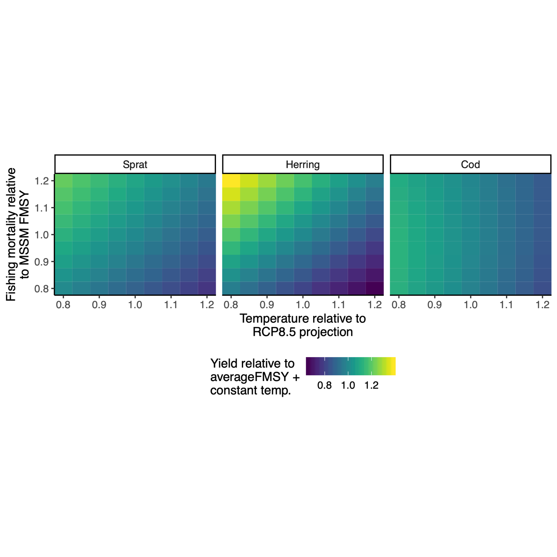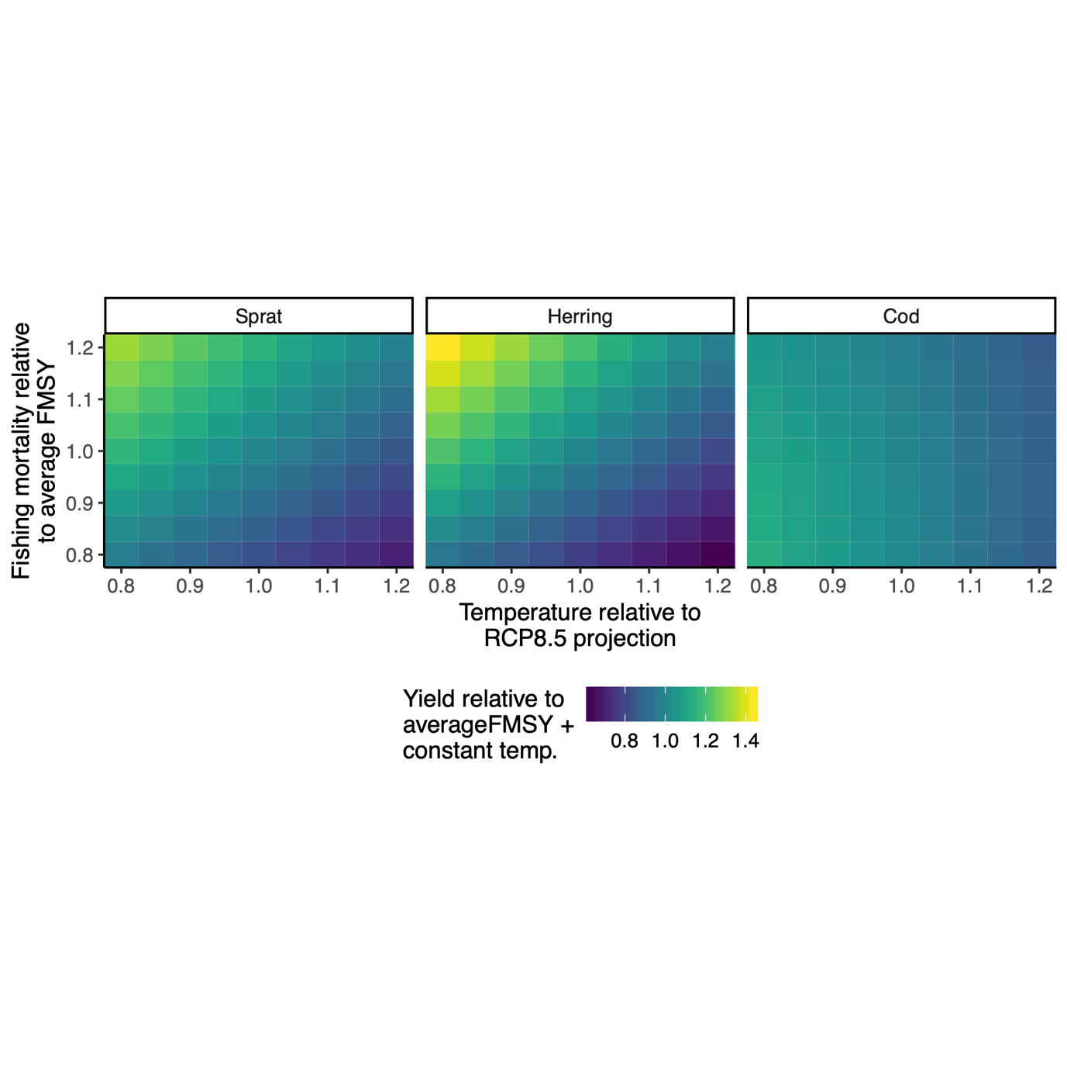

*Figure S13. Fisheries yield at steady state relative to a scenario with constant temperature () and average FMSY. In the top row the baseline fishing mortality is FMSY averaged from stock assessments and the size-spectrum model, bottom row corresponds to baseline FMSY from. The x-axis shows the scaling factor to (10) and the y-axis is a scalar to the average FMSY from size-spectrum model and stock assessment (top row) and size-spectrum model only (bottom row).*

* I need to look into this more…
  + Remember how I used the overall average FMSY in the projections? (See comment on Figure 1). That is not very good I think because cod SSM-FMSY is below the assessment-FMSY, but the other two are above. So the difference between species here is likely due to the scalar putting the species away from their SSM-FMSY in slightly different directions.
  + For this figure, I will simply just use the model FMSY to make the cross-species comparison relevant. I will also do it with 2*3 plot (probably), corresponding to models with and without temperature dependence on resource dynamics…
* BUT! What seems to come out is that warming reduces yield. This is despite it enhancing growth rates (Figure 3) and is likely connected to the reductions in SSB and abundance-at-most-sizes (especially larger ones or above maturation size which is the selection cut off.)
* Note also that there might be some variation between the time-varying temperature and effort scenarios and the constant ones. I’m not entirely sure yet but will look into it more. Guessing it has something to do with starting values. Anyway, I don’t think I’m comfortable comparing this too much with Figures 3-4 (which are from time-varying projections), because of this. So I will maybe redo this figure based on time-varying projections.

*Figure S14. Predation mortality in 2050 with warming relative to no warming (horizontal dotted line).*

*Figure S15. Feeding level in 2050 with warming relative to no warming (horizontal dotted line).*

References

Andersen, K.H., Farnsworth, K.D., Pedersen, M., Gislason, H. & Beyer, J.E. (2009). How community ecology links natural mortality, growth, and production of ﬁsh populations, 7.

Aydin, K.Y., Lapko, V.V., Radchenko, V.I. & Livingston, P.A. (2002). *A Comparison of the Eastern and Western Bering Sea Shelf/Slope Ecosystems Through the Use of Mass Balance Food Web Models. - US Dept of Commerce, NOAA Techical. Memo. NMFS-AFSC-130, 78*.

Blanchard, J.L., Andersen, K.H., Scott, F., Hintzen, N.T., Piet, G. & Jennings, S. (2014). Evaluating targets and trade-offs among fisheries and conservation objectives using a multispecies size spectrum model. *Journal of Applied Ecology*, 51, 612–622.

Casini, M., Cardinale, M. & Arrhenius, F. (2004). Feeding preferences of herring () and sprat () in the southern Baltic Sea. *ICES Journal of Marine Science*, 61, 1267–1277.

Hartvig, M., Andersen, K.H. & Beyer, J.E. (2011). Food web framework for size-structured populations. *Journal of Theoretical Biology*, 272, 113–122.

Huss, M., Gårdmark, A., van Leeuwen, A. & de Roos, A.M. (2012). Size- and food-dependent growth drives patterns of competitive dominance along productivity gradients. *Ecology*, 93, 847–857.

ICES. (2010). Stomach Dataset 2010, ICES, Copenhagen.

Jacobsen, N.S., Burgess, M.G. & Andersen, K.H. (2017). Efficiency of fisheries is increasing at the ecosystem level. *Fish and Fisheries*, 18, 199–211.

van Leeuwen, A., Huss, M., Gårdmark, A., Casini, M., Vitale, F., Hjelm, J., *et al.* (2013). Predators with multiple ontogenetic niche shifts have limited potential for population growth and top-down control of their prey. *American Naturalist*, 182, 53–66.

Niiranen, S., Orio, A., Bartolino, V., Bergström, U., Kallasvuo, M., Neuenfeldt, S., *et al.* (2019). Predator-prey body size relationships of cod in a low-diversity marine system. *Mar. Ecol. Prog. Ser.*, 627, 201–206.

Ogle, D.H. (2013). fishR Vignette - Von Bertalanffy Growth Models.

Ogle, D.H. (2017). *FSAdata: Fisheries Stock Analysis, Datasets*.

Ogle, D.H. (2018). *FSA: Fisheries Stock Analysis. R package*.

R Core Team. (2018). *R: A Language and Environment for Statistical Computing. R Foundation for Statistical Computing*. Vienna, Austria.

Reum, J.C.P., Blanchard, J.L., Holsman, K.K., Aydin, K. & Punt, A.E. (2019). Species‐specific ontogenetic diet shifts attenuate trophic cascades and lengthen food chains in exploited ecosystems. *Oikos*, 128, 1051–1064.

Scott, F., Blanchard, J. & Andersen, K. (2019). *mizer: Multi-Species sIZE Spectrum Modelling in R*. R. .