**Appendix S1**

**Supporting Information for**

***Bottom up and top down effects of temperature on body growth, population size spectra and yield – an application of a multi-species size-spectrum model***

Max Lindmarka,1, Asta Audzijonyteb, Julia Blanchardc, Anna Gårdmarkd

aSwedish University of Agricultural Sciences, Department of Aquatic Resources, Institute of Coastal Research, Skolgatan 6, Öregrund 742 42, Sweden

bInstitute for Marine and Antarctic Studies, University of Tasmania, Battery Point, TAS 7001, Australia

cInstitute for Marine and Antarctic Studies and Centre for Marine Socioecology, University of Tasmania, 20 Castray Esplanade, Battery Point, Hobart, TAS 7000, Australia

dSwedish University of Agricultural Sciences, Department of Aquatic Resources, Skolgatan 6, SE-742 42 Öregrund, Sweden

Table of Contents

Model parameterization 3

Species-specific parameters 3

Model calibration and validation 8

Calibration protocol 8

Results from calibration procedure 10

Analysis 17

References 24

# Model parameterization

## Species-specific parameters

Below follows a description for how we acquired default parameters which are valid at the “reference” temperature, , where the temperature scaling equals 1 for all rates (see main text for which rates are assumed temperature dependent and how). In *‘mizer’*, MSSMs require species-specific parameters. Parameters that have no defaults and must be provided are: asymptotic size (), size at maturation (), preferred predator-prey mass ratio (PPMR) (), the standard deviation of PPMR () and the maximum recruitment in the Beverton-Holt stock recruitment function () (Scott *et al.* 2019).

For cod, we acquired the parameters and by calculating the mean and the standard deviation for the distribution of mean individual-level log10PPMR, using stomach data (downloaded on 2019.03.20) hosted by the International Council for the Exploration of the Sea (ICES), in the FISH STOMACH database (ICES 2010), which can be downloaded at <http://ecosystemdata.ices.dk/stomachdata/download.aspx>. We used only samples with fully intact prey (no digestion) among the observations from the area we consider (ICES subdivisions SD 25-29, 32, see map in Figure X) and from the time window we use for calibrating the model (1992-2002). When prey weight was not available, we used the relationship , where length is in cm, to approximate weight. For the predator-prey mass ratio of sprat and herring, we assumed and to be 1000 and 1, respectively, which reflects that forage fish typically feed on prey that are small in relation to their body size throughout ontogeny (Aydin *et al.* 2002; Reum *et al.* 2019).

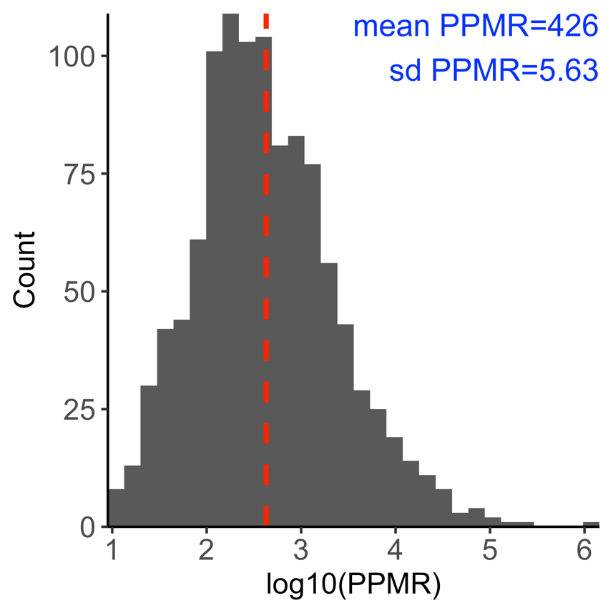

*Figure S1. Distribution of individual level predator-prey mass ratio (log10PPMR) for cod. Mean and standard deviation are on normal scale and correspond to and . The dashed red vertical line corresponds to the mean log10 PPMR.*

From von Bertalanffy (VBGE) growth parameters and theory linking feeding parameters (Hartvig *et al.* 2011), the remaining species-specific parameters can be estimated. The allometric constant in the maximum food intake rate () is defined as , where is the Brody growth coefficient, is the assimilation efficiency, is the initial feeding level of small individuals and is asymptotic mass (main text) (Andersen *et al.* 2009; Scott *et al.* 2019) (but see calibration protocol). When is known, the allometric constant in the search rate function, , can be calculated (main text). The allometric constant of standard metabolism, is by default (but see calibration protocol).

We estimated VBGE parameters and for cod, herring and sprat in the Baltic Sea using data from the Baltic International Trawl Survey (BITS), maintained by ICES. They are publicly available at the DATRAS database (<http://www.ices.dk/marine-data/data-portals/Pages/DATRAS.aspx>). We downloaded the full data for the years 1992-2002 (the calibration time period) on 2018.11.24, and applied further processing in R using the ‘*tidyverse*’ packages (Wickham 2017). We followed the approach in Ogle (2013) and fit the VBGE using the form when estimating parameters. Here is the expected length at age , is the asymptotic average length, is the Brody growth rate coefficient and is a modeling artifact that is said to represent the time or age when the average length would have been zero. Parameters were estimated using non-linear least squares regression (‘*nls*’ package in R), and the packages ‘*FSA*’ (Ogle 2018) and ‘*FSAdata*’ (Ogle 2017). We fit VBGE parameters using length-at-age data and convert between length and weight using the equation , where parameters and are estimated in this study from a subset of the BITS data where both weight and length information is available for the same individual. Length-at-maturity was taken from the literature (see Table S1), and where converted to weight-at-maturity using length-weight relationships estimated in this study from BITS. All models were fitted using R (R Core Team 2018), and for all statistical models we verified that assumptions about error homoscedasticity and normality were met by visual inspection.

*Figure S2. Map of the study area (ICES sub-divisions 25-29+32). Point size is proportional to abundance per ICES rectangle during the calibration time period (1992-2002), using data from the Baltic International Trawl Survey (BITS) for cod, and the Baltic International Acoustic Survey (BIAS) for sprat and herring.*

*Table S1. Species-specific parameters used in model. Source: 1 = estimated in this study, 2 = (Reum et al. 2019), 3 = (Hartvig et al. 2011), 4 = generalized values based on (Casini et al. 2004), 5 = calculated internally. Parameters in bold are tuned in the calibration process, parenthesis show default values pre-calibration.*

|  |  |  |  |  |  |  |
| --- | --- | --- | --- | --- | --- | --- |
| Symbol | Description | Unit | Sprat | Herring | Cod | Source |
|  | Maturation size* |  | 4 | 17 | 267 | 1 |
|  | Asymptotic weight |  | 21 | 125 | 44903 | 1 |
|  | Brody growth coefficient |  | 0.287 | 0.165 | 0.07 | 1 |
|  | Age at length 0 | - | -2.97 | -3.74 | -0.94 | 1 |
|  | Preferred predator prey mass ratio | - | 1000 | 1000 | 426 | 1,2 |
|  | Width of prey size preference | - | 1 | 1 | 5.6 | 1,2 |
|  | Constant for max. food intake |  | **9.9**  **(6.6)** | **10.3 (6.88)** | **31.1 (20.7)** | 5 |
|  | Constant for volumetric search rate |  | 0.78 | 0.81 | 0.39 | 5 |
|  | Constant for standard metabolism |  | 1.32 | 1.38 | 4.15 | 5 |
|  | Reproductive efficiency** | - | 0.01091 | 0.00447 | 0.00024 | 1 |
|  | Constant in length-weight relationship | - | .0041 | .0042 | 0.0078 | 1 |
|  | Exponent in length-weight relationship | - | 3.15 | 3.14 | 3.07 | 1 |
|  | **Maximum recruitment in the Beverton-Holt stock recruitment function** |  | **3.7**  **(7.3)** | **0.42 (11.1)** | **0.0047 (0.0826)** | **-** |
|  | Benthos availability | - | 0 | 0.5 | 0.5 | 4 |
|  | Plankton availability | - | 1 | 0.5 | 0.5 | 4 |

*Length at maturation for cod and sprat are taken from van Leeuwen *et al*. (2013) (30 cm and 9 cm, respectively) and for herring we used Huss *et al*. (2012) (14 cm).

**Calculated from the allometric function , to approximate declining with asymptotic size, as found when applying the internal ‘*mizer’*-function steady(), which returns the -values that lead to steady state when keeping recruitment constant (in these simulations ). The calculated values are comparable for sprat and herring, but slightly lower for cod compared to other studies, e.g. (Jacobsen *et al.* 2017).

*Table S2. General parameters. Parameters in bold have final values acquired from the application of the calibration protocol. Source: 1 = (Scott et al. 2019), 2 = (Hartvig et al. 2011), 3 = (Blanchard et al. 2014), 4 = this study.*

|  |  |  |  |  |
| --- | --- | --- | --- | --- |
| Symbol | Description | Value | Unit | Source |
|  | Assimilation efficiency |  | - | 1,2 |
|  | Egg weight |  |  | 1,2 |
|  | Initial feeding level | 0.6 | - | 1,2 |
|  | Exponent of max. consumption |  | - | 1,2 |
|  | Exponent of search volume |  | - | 3 |
|  | Exponent of standard metabolism |  | - | 3 |
|  | Pre-factor for background mortality |  |  | 1 |
|  | Exponent of background resource spectra |  | - | 2 |
|  | Regeneration rate of background resource spectra |  |  | 4 |
|  | **Carrying capacity of background resource spectra (benthos, plankton)** |  |  | **4** |
|  | Cut-off size of plankton size spectrum |  |  | 4 |
|  | Cut-off size of benthic size spectrum |  |  | 4 |

# Model calibration and validation

## Calibration protocol

We calibrated to the model using mean SSB and F between 1992-2002 from stock assessments, which were acquired from ICES Working Group Reports (ICES 2013, 2015), and are in unit 106 kg/area. This area corresponds to ICES subdivisions 25-29+32, which equals approximately 2.49E+11 m2 (estimated using ICES shapefiles in ArcGIS). We first defined the size spectrum model in units g/m2 and then used the conversion factor 249 to express biomasses in unit 1000 tonnes/total area. Below follows a step-by-step description of how the model was calibrated to the assembled Baltic Sea data after being parameterized.

1. Determine a starting value for plankton and benthos . The aim is to find coexistence of the three fish species and be within an order of magnitude of SSBs from stock assessment. Prioritize coexistence over fits of SSBs, as these are calibrated later. As starting values for , which ensures coexistence, we used the same ratio between and as calibrated in (Blanchard et al. 2014), expressed in unit m2 (by dividing with 1E11, which corresponds roughly to the area of the North Sea. This procedure resulted in a starting value for and of ~1, in unit m2.
2. Evaluate growth rates against empirical data.
   1. If modelled growth rates are low, check the species-specific feeding levels . The feeding level describes the level of satiation, with 0 being unfed and 1 completely satiated. For reference, a feeding level of 0.2 is the minimum to cover basic metabolic costs (by default) and thus does not allow for body growth, whereas a constant feeding level of 0.6 fits a von Bertalanffy curve (Andersen *et al.* 2009; Scott *et al.* 2019). If low feeding level seem likely as a cause for poor growth, check the search rate () or available prey. If not, check the net energy acquisition.
      1. Net energy acquisition is largely determined by maximum consumption and metabolic losses. Earlier explorations suggest modelled growth rates can be lower than observed (Scott *et al.* 2019) with default and (constants in allometric metabolism and maximum consumption rates), so these may need to be modified based on empirical data or other theoretically derived relationships.
      2. Go back to step 1. With altered and/or , needed for coexistence may change. Therefore, a can be chosen that puts modelled SSBs closer to SSBs from stock assessment, while still allowing for coexistence.
3. If allows for coexistence and yields SSBs within an order of magnitude to assessment-SSBs and growth is realistic, optimize to get relative biomasses between species and SSBs closer to those observed in the calibration time period. This is done by finding that minimizes the residual sum of square between predicted SSBs and SSBs from the stock assessment.
4. Verify that SSBs and growth rates are still close to empirical data, after optimizing . Then evaluate the ratio of egg production before and after density dependence is added from the Beverton-Holt type stock-recruit curve (RDI/RDD).
   1. If RDI/RDD is high () (Jacobsen *et al.* 2017), and RDD close to , consider lowering (default *‘mizer’* is 1).
      1. Go back to Step 2 and proceed forward from there. Make sure body growth is still close to observed. Evaluate if the modification to (constant in allometric maximum consumption rate) is still valid.
5. Verify that SSBs, growth rates and RDI/RDD are still realistic. Then assess emergent diets.
   1. If predatory interactions do not match independent stomach data, re-evaluate the predation kernel. We judged this based on (Niiranen *et al.* 2019), who show that benthos (*Saduria entomon*) are found in stomachs of small cod whereas sprat and herring start to appear in the size classes of 20-29 cm. Equivalent data for sprat and herring does not exist to the best of our knowledge. We assume they feed mostly on background spectra with only limited piscivory and cannibalism.
6. Project forward and backwards with time-varying fishing mortality from stock assessment output and temperature data. Compare qualitative trends with stock assessment data. Since the stock assessment data for the three fish species are outputs from different models and assumptions, this serves more as a useful comparison rather than validation of the model.

## Results from calibration procedure

The following figures show model output from the final set of parameters found through the calibration procedure (Table S1-S2). In addition to the bold parameters in Tables S1-S2 ( and ), we also updated the constant in the maximum consumption rate () with a factor of 1.5 as body growth was otherwise poor despite a normal feeding level (~0.6). These changes resulted in ratios of physiological recruitment to actual recruitment (RDI/RDD) of 9.8, 9.5 and 9.4 for cod, herring and, respectively. The actual recruitment after density dependence is 90%, 89% and 90% of the respective for cod, sprat and herring, and the physiological recruitment divided by is 8.8, 8.5 and 8.4 times, which is similar to predictions for small fish species in (Andersen & Beyer 2015). This suggests that there is enough density dependence in the model to ensure coexistence between the species, and that the optimized values result in mortality affecting recruitment via the stock-recruit function. The ability of the model to predict sprat biomasses outside the calibration time period is poor, while for herring and cod it captures the general trends (increase or decrease) relatively well, although underestimating temporal variation of all three species (Fig. S8). The poor fit of sprat, and the low temporal variation of all species, is likely due to the model not representing environmental variation and regime shifts.

*Figure S3. Time-series of spawning stock biomass (SSB) (A) and fishing mortality (B) from stock assessment model estimates. Grey background shows calibration period, dotted horizontal lines show the mean of each time series in the calibration time period.*

Figure S4. Biomass spectra of species and background resources (top) and feeding levels as a function of body size (g) from the size spectrum model simulated to steady state using the calibrated model parameters (Table S1-S2).

Figure S5. Size-at-age [g] from size spectrum model (solid green line) run to steady state using the calibrated model parameters, growth curves from von Bertalanffy growth equation (dashed pink line) fitted to length-at-age data from the BITS (semitransparent dark grey points) and then converted to mass.

Figure S6. Predicted (size-spectrum model) vs ‘observed’ (stock assessment) spawning stock biomass (SSB) per species. A) Mean predicted (last 20 time steps of projection) for each species and observed SSB in the calibration time window. B) Same data plotted against each other with a 1:1 line (red dashed).

Figure S7. Proportion of diet by mass as a function of predator body mass at steady state. Cod becomes piscivorous when in the size-class 20-29 cm (Niiranen et al. 2019). This roughly corresponds to a mass of about 140g, which fits the ontogenetic diet shift observed in the model.

Figure S8. Maximum sustainable yield (MSY) in the size spectrum model (estimated by keeping each species at their mean assessment FMSY) compared to that obtained in multispecies stock assessment model. A) Yield as a function of fishing mortality and (B) the fishing mortality corresponding to the highest long-term yield for each species compared to different stock assessment estimates.

Figure S9. Temporal development of spawning stock biomass (SSB). Temperature varies in the time series according to the RCA4-NEMO model using the RCP 8.5 scenario. The projections start in 1914 (not shown) to allow a 60-year burn-in period. This is enough to reach steady state before historical fishing efforts are introduced (in 1974-2012). F-values by species in the burn-in period are equal to the values in 1974 (first year of effort-time series). The solid lines are SSB from stock assessments, and the dashed green, two-dashed pink and dotted purple lines are SSBs from the size-spectrum model projections assuming constant temperatures (equivalent to no temperature effects), with temperature-dependent physiological processes and with temperature-dependence of both physiological processes and resource growth rates. Mean activation energies are used (Table XX).

Figure S10. Correlation between SSB from size-spectrum model (“predicted”) and stock assessment models (“observed”) between 1974 and 2014 (model calibrated to average values between 1992-2002), with Pearson correlation coefficients indicated in the bottom right corner. Colors indicate years.

# Analysis

Table S4 Parameters of distributions describing activation energies of temperature-dependent rates in the size spectrum model. See figure 2 for 200 random draws from these normal distributions that were used as input in projections.

|  |  |  |  |
| --- | --- | --- | --- |
| Symbol | Rate | Distribution (mean, s.d) | Source |
|  | Metabolism |  | Lindmark *et al.* (*in prep*) |
|  | Background mortality |  | (Brown *et al.* 2004); Lindmark *et al.* (*in prep*) |
|  | Maximum consumption |  | Lindmark *et al.* (*in prep*) |
|  | Background resource carrying capacity |  | Observational data from Barnes *et al.* (2004) on the temperature dependence of size-spectrum intercept of phytoplankton |
|  | Background resources regeneration rate |  | Experimental data from Savage *et al.* (2004) for algae, phyto- and zooplankton. |
|  | Background resource carrying capacity |  | Assumed to be , based on metabolic arguments and constant resources (Savage *et al.* 2004; Gilbert *et al.* 2014; Bernhardt *et al.* 2018) |

Figure S11. 200 random samples from the distributions describing the activation energies of the rates resource carrying capacity and resource growth rates [assumed same for benthic and pelagic background resources], metabolic rate, background mortality rates and maximum consumption rates. See Table 1. Combinations of these parameters where used in model projections to understand how uncertainty in these parameters affect individual- and population level metrics.

Figure S12. Time series of (A) fishing mortality by species and (B) temperature. For fishing mortality (A) the light grey area corresponds to years where mortality values are estimated from stock assessments. The dark grey area is the model calibration time period. We treated the 60 years prior to the start of the F-time series as burn-in and kept the constant and equal to the first time series (in year 1974). The future projections correspond to the mean FMSY from the multispecies stock assessments’ estimates and the size spectrum model (estimated by keeping each species at their mean assessment FMSY). The relative temperature is acquired by adding a constant of 10 to the relative change in sea surface temperature from the regional coupled model system RCA4-NEMO using the RCP 8.5, to set the mean temperature in the calibration period to the reference temperature, . Years prior to the temperature model are assigned the first value in the temperature record. In all time-varying temperature projections, the initial temperature is the same. The no-warming scenario gets a constant temperature equal to the mean temperature in the calibration time-period in 1997 (blue solid line, mid-year in calibration time window) while the warming scenario continuous along the temperature projection from the regional coupled model system RCA4-NEMO using the RCP 8.5 scenario (red dashed line).

*Figure S13. Feeding level from model projections to 2050 assuming warming according to RCP 8.5 while keeping fishing mortality at average FMSY levels, relative to non-warming scenarios. The dashed horizontal line depicts projections assuming no temperature increase and thus constitutes a baseline prediction. Activation energies are the means of their respective distributions (no uncertainty).*

*Figure S14. Predation mortality from model projections to 2050 assuming warming according to RCP 8.5 while keeping fishing mortality at average FMSY levels. The dashed horizontal line depicts projections assuming no temperature increase and thus constitutes a baseline prediction. Activation energies are the means of their respective distributions (no uncertainty).*

*Figure S15. Warming can counteract the negative effect of fishing on the abundance of large fish, relative to a non-warming scenario and fishing at the mean F (scaling factor = 1), depending on which temperature-scaling scenario is assumed. The figure shows abundance-at-weight of sprat, herring and cod in 2050 relative to projection with constant temperature after 2007 (see Figure S10) under different fishing mortalities (indicated by colors) implemented as scalars to average FMSY from stock assessments and size-spectrum models. The horizontal panels correspond to different temperature-scaling scenarios. The top row corresponds to no temperature increase, hence the orange line (corresponding to no change in fishing mortality) is horizontal.*

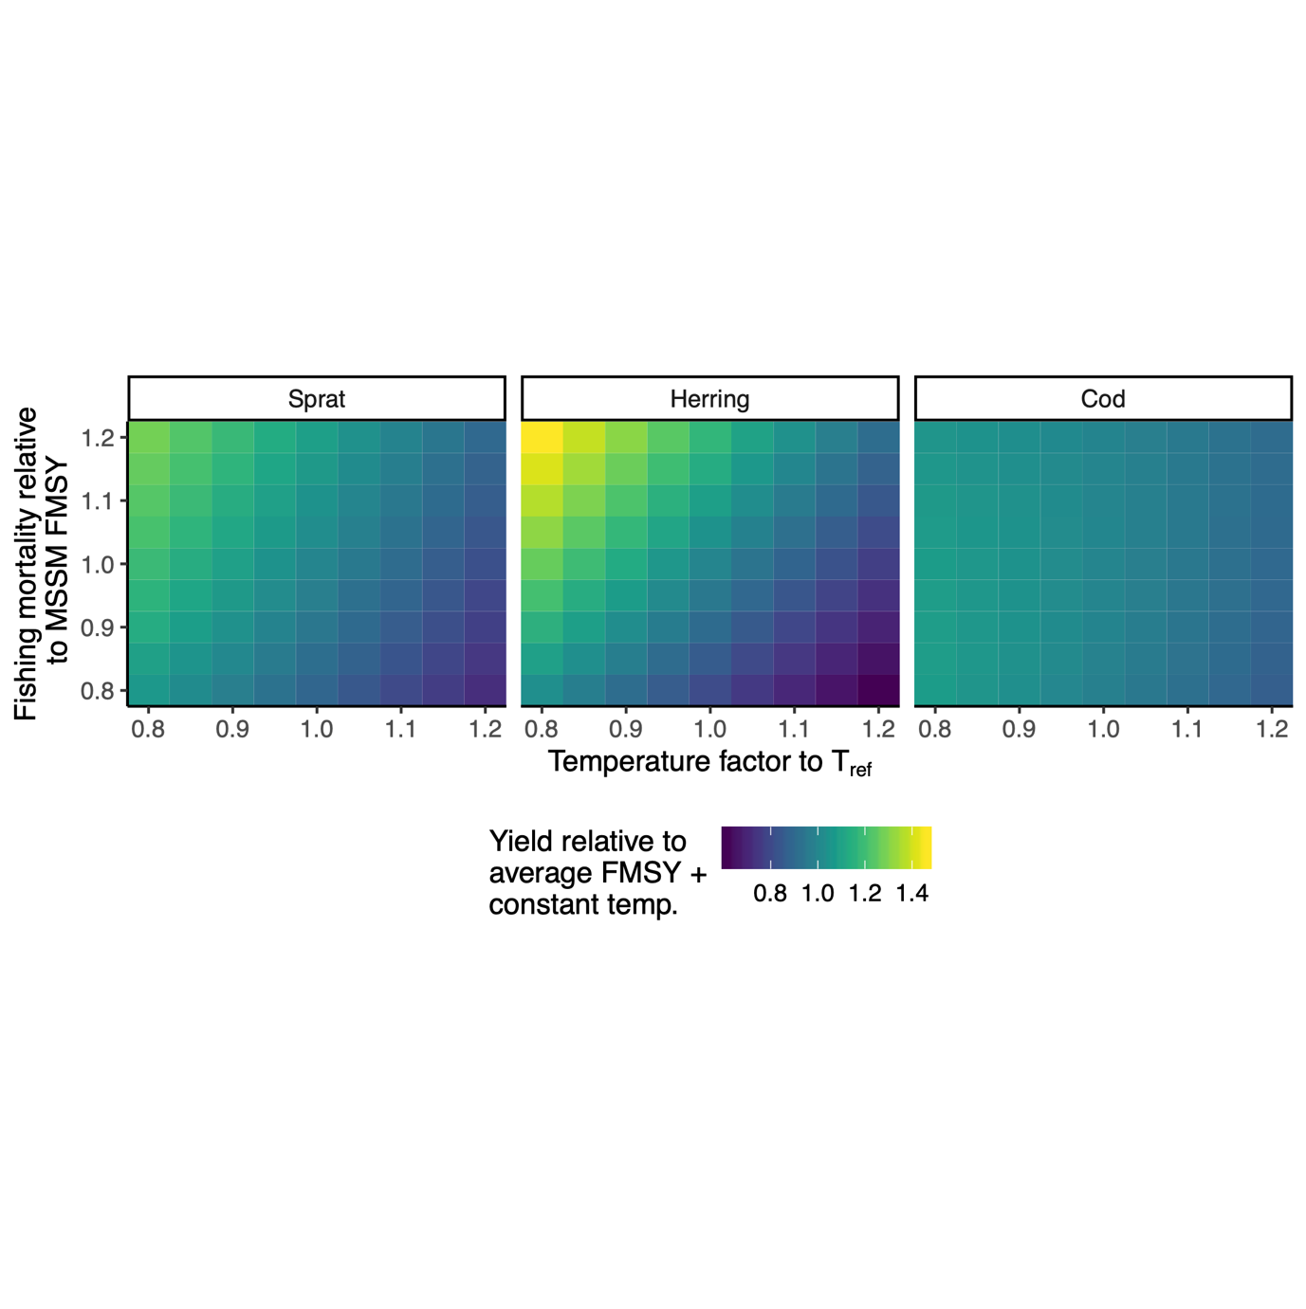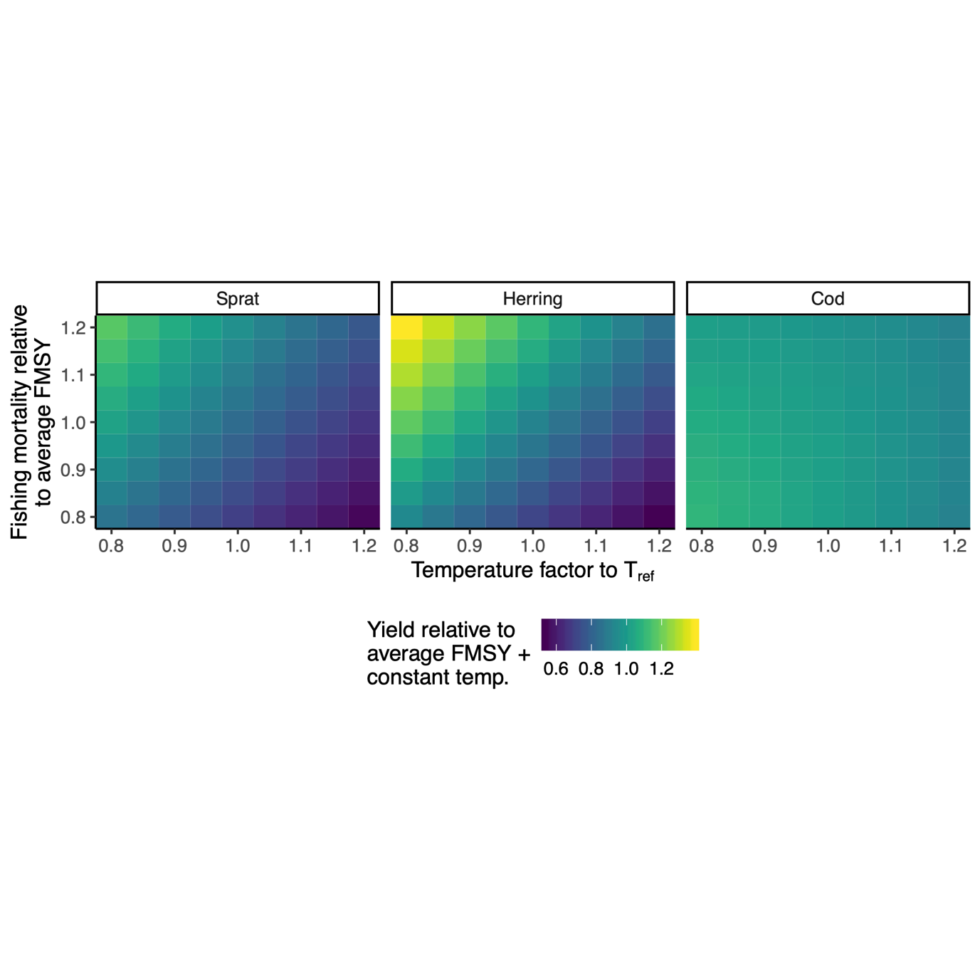

*Figure S16. Example of fisheries yield at steady state (assuming physiological processes and resource depend on temperature according to “exp.” scenario) relative to projections with constant temperature () and baseline FMSY using simulations with constant (not time-varying) temperatures. In the top row, the baseline fishing mortality is the average estimated from stock assessments and the size-spectrum model, and in the bottom row it corresponds to the size-spectrum FMSY only. The x-axis shows the scaling factor to (10) and the y-axis is a scalar to the baseline FMSY. Note the slightly different color legends.*

# References

Andersen, K.H. & Beyer, J.E. (2015). Size structure, not metabolic scaling rules, determines fisheries reference points. *Fish Fish*, 16, 1–22.

Andersen, K.H., Farnsworth, K.D., Pedersen, M., Gislason, H. & Beyer, J.E. (2009). How community ecology links natural mortality, growth, and production of ﬁsh populations, 7.

Aydin, K.Y., Lapko, V.V., Radchenko, V.I. & Livingston, P.A. (2002). *A Comparison of the Eastern and Western Bering Sea Shelf/Slope Ecosystems Through the Use of Mass Balance Food Web Models. - US Dept of Commerce, NOAA Techical. Memo. NMFS-AFSC-130, 78*.

Bernhardt, J.R., Sunday, J.M. & O’Connor, M.I. (2018). Metabolic Theory and the Temperature-Size Rule Explain the Temperature Dependence of Population Carrying Capacity. *The American Naturalist*, 192, 687–697.

Blanchard, J.L., Andersen, K.H., Scott, F., Hintzen, N.T., Piet, G. & Jennings, S. (2014). Evaluating targets and trade-offs among fisheries and conservation objectives using a multispecies size spectrum model. *Journal of Applied Ecology*, 51, 612–622.

Brown, J.H., Gillooly, J.F., Allen, A.P., Savage, V.M. & West, G.B. (2004). Toward a metabolic theory of ecology. *Ecology*, 85, 1771–1789.

Casini, M., Cardinale, M. & Arrhenius, F. (2004). Feeding preferences of herring () and sprat () in the southern Baltic Sea. *ICES Journal of Marine Science*, 61, 1267–1277.

Gilbert, B., Tunney, T.D., McCann, K.S., DeLong, J.P., Vasseur, D.A., Savage, V.M., *et al.* (2014). A bioenergetic framework for the temperature dependence of trophic interactions. *Ecology Letters*, 17, 902–914.

Hartvig, M., Andersen, K.H. & Beyer, J.E. (2011). Food web framework for size-structured populations. *Journal of Theoretical Biology*, 272, 113–122.

Huss, M., Gårdmark, A., van Leeuwen, A. & de Roos, A.M. (2012). Size- and food-dependent growth drives patterns of competitive dominance along productivity gradients. *Ecology*, 93, 847–857.

ICES. (2010). Stomach Dataset 2010, ICES, Copenhagen.

ICES. (2013). *Report of the Baltic Fisheries Assessment Working Group (WGBFAS)* ( No. ICES CM 2013/ACOM:10.). 10-17 April 2013 ICES Headquarters, Copenhagen.

ICES. (2015). *Report of the Baltic Fisheries Assessment Working Group (WGBFAS)* ( No. ICES CM 2015/ACOM:10). 14-21 April 2015 ICES Headquarters, Copenhagen.

Jacobsen, N.S., Burgess, M.G. & Andersen, K.H. (2017). Efficiency of fisheries is increasing at the ecosystem level. *Fish and Fisheries*, 18, 199–211.

van Leeuwen, A., Huss, M., Gårdmark, A., Casini, M., Vitale, F., Hjelm, J., *et al.* (2013). Predators with multiple ontogenetic niche shifts have limited potential for population growth and top-down control of their prey. *American Naturalist*, 182, 53–66.

Niiranen, S., Orio, A., Bartolino, V., Bergström, U., Kallasvuo, M., Neuenfeldt, S., *et al.* (2019). Predator-prey body size relationships of cod in a low-diversity marine system. *Mar. Ecol. Prog. Ser.*, 627, 201–206.

Ogle, D.H. (2013). fishR Vignette - Von Bertalanffy Growth Models.

Ogle, D.H. (2017). *FSAdata: Fisheries Stock Analysis, Datasets*.

Ogle, D.H. (2018). *FSA: Fisheries Stock Analysis. R package*.

R Core Team. (2018). *R: A Language and Environment for Statistical Computing. R Foundation for Statistical Computing*. Vienna, Austria.

Reum, J.C.P., Blanchard, J.L., Holsman, K.K., Aydin, K. & Punt, A.E. (2019). Species‐specific ontogenetic diet shifts attenuate trophic cascades and lengthen food chains in exploited ecosystems. *Oikos*, 128, 1051–1064.

Savage, V.M., Gillooly, J.F., Brown, J.H., West, G.B. & Charnov, E.L. (2004). Effects of Body Size and Temperature on Population Growth. *The American Naturalist*, 163, 429–441.

Scott, F., Blanchard, J. & Andersen, K. (2019). *mizer: Multi-Species sIZE Spectrum Modelling in R*. R. .

Wickham, H. (2017). *tidyverse: Easily Install and Load the “Tidyverse.”*