**Bottom up and top down effects of temperature on body growth, population size spectra and yield – an application of a multi-species size-spectrum model**

Max Lindmarka,1, Asta Audzijonyteb, Julia Blanchardc, Anna Gårdmarkd

aSwedish University of Agricultural Sciences, Department of Aquatic Resources, Institute of Coastal Research, Skolgatan 6, Öregrund 742 42, Sweden

bInstitute for Marine and Antarctic Studies, University of Tasmania, Battery Point, TAS 7001, Australia

cInstitute for Marine and Antarctic Studies and Centre for Marine Socioecology, University of Tasmania, 20 Castray Esplanade, Battery Point, Hobart, TAS 7000, Australia

dSwedish University of Agricultural Sciences, Department of Aquatic Resources, Skolgatan 6, SE-742 42 Öregrund, Sweden

**Abstract**

Resolving the combined effect of climate warming and exploitation in a food web context is key for predicting future biomass production, size-structure and potential yields of marine fishes. Previous studies based on mechanistic size-based models have found that bottom-up processes are important drivers of size-structure and fisheries yield at the ecosystem level in changing climates. However, we know less about the joint effects bottom up and top down effects (direct of warming on individual-level physiology) on exploited food webs. Using the Baltic Sea as a case study, we assess how various food web metrics are affected by warming and exploitation in a species-resolved size-based food web. We parameterize a dynamic size-spectrum model representing the offshore Baltic Sea food web, and investigate how individual growth rates, size-structure, relative abundances of species and yields are affected by warming under different scenarios of fishing mortality and physiological scaling. We find that the model is able to reproduce realistic biomass densities in the relatively stable time period (1992-2002). Evaluation of steady-state properties at simulated higher temperatures suggests that both warming leads to positive impacts on growth of younger fish within species, but the positive effect levels off and becomes negative for older fish within projected warming scenarios. Any key explanation why? The effect of warming on the abundance size-spectrum, spawning stock biomass and yields of the fisheries depend more strongly on the effect of temperature on basal resources than on individual physiology. Results from our model can be used to qualitatively evaluate how warming and exploitation interactively affect the Baltic Sea fish community, which can inform about potential future yields in a multispecies scenario and thus support strategic management decisions.

**Introduction**

Climate change affects aquatic food webs directly by shifting the distribution of species (Pinsky *et al.* 2013), abundance (McCauley *et al.* 2015), body size (Daufresne *et al.* 2009; Baudron *et al.* 2014), and ecosystem function (Pontavice *et al.* 2019), which can lead to indirect effects through the rewiring of food webs (Frainer *et al.* 2017). Global retrospective analysis of warming and fish population dynamics has revealed that declines in productivity of scientifically assessed fish populations across ecoregions has already declined due to climate change (Free *et al.* 2019). These results are also matched in magnitude and direction by projections from an ensemble of mechanistic ecosystem models, which predicts further declines in biomass by 2100, especially at higher trophic levels (Lotze *et al.* 2019). Large scale models are crucial for informing global assessments about the implications of climate change (Lotze *et al.* 2019). However, by necessity, these models rely on simplifying assumptions (Fulton *et al.* 2019), including species-resolved food webs and the effects of temperature on individual-level physiology (but see (Woodworth-Jefcoats *et al.* 2019)). Instead, temperature is often assumed to act mainly on ecosystem productivity (“bottom up”) rather than both individual physiology (“top down”) and productivity. Thus, there is a need to increase our mechanistic understanding of climate change impacts on individuals and how that affects regional dynamics (Blanchard *et al.* 2012).

The primary effect of temperature is on individual physiology, and individual-level processes such as metabolism, growth and mortality govern ecosystem properties such as biomass production rates, abundance and size spectra (Andersen & Beyer 2006; Jennings & Collingridge 2015; Blanchard *et al.* 2017). However, there is still uncertainty in both the scaling of physiological rates, such as metabolism and ecological rates with body mass and temperature (Brown *et al.* 2004; Dell *et al.* 2011; Englund *et al.* 2011), and there is no consensus or a single framework for implementing this into e.g. models of individual growth. This limits our ability to predict and understand “universal” responses to global warming, such as the shrinking of organisms with warming (Daufresne *et al.* 2009) and the temperature size rule, predicting faster growth rates but smaller asymptotic body sizes with warming (Atkinson 1994). One example of a mechanistic approach to predict changes in physiology to population dynamics and size structure is the model by (Cheung *et al.* 2013). Based on a generalization of the von Bertalanffy growth equation (VBGE), this model predicted a 14-24% reduction in average maximum body mass driven by changes in distribution and physiology. The underlying mechanism here is the assumption that increasing oxygen limitation with warming due to elevated metabolic demands impose growth constraints that lead to smaller asymptotic body masses. This model has however been criticized for not representing the underlying physiological processes accurately – both in what they represent and their parameters (Jutfelt *et al.* 2018; Lefevre *et al.* 2018). In addition, evaluating changes in food web size-structure based on static growth models (as in no food-dependence) is in conflict with the well-known observation that body growth depends on an interplay between body size, temperature and food availability (Brett *et al.* 1969). For instance, the optimum temperature for growth declines with reduced food rations (Huey & Kingsolver 2019), which means that the effects of temperature are mediated by changes in resources levels. It is therefore important to work on developing mechanistic models that are founded on an accurate description of size and temperature-dependence of key physiological processes, and to evaluate them in an ecological context to account for the food dependence of growth (Neubauer & Andersen 2019).

Process-based (or mechanistic) food web models aim represent the dynamics or structure of ecosystems based on an understanding of the key mechanisms behind the phenomena considered, considering both metabolic scaling and feeding interactions e.g. (Brose 2010; Persson & De Roos 2013). This means models can vary in their performance depending on the process they are tailored for (Spence *et al.* 2018), and it is therefore important to both identify and capture the dominant mechanisms in the model (Curtsdotter *et al.* 2019). Traditional Lotka-Volterra-type models describing pairwise species interactions often fail to accurately represent the life history of fish, which in general grow several orders of magnitude in body size and change feeding niches and trophic levels during ontogeny (Werner & Gilliam 1984). Hence, it is often necessary to account for intraspecific variation in body size to capture the ecological function of a typical fish (Hartvig *et al.* 2011). Not surprisingly, work in fish and fisheries ecology have pioneered to capture these processes, for example in physiologically structured models (PSPM) (Metz & Diekmann 1986; De Roos & Persson 2001). Later, the development of trait based size spectrum models allowed for more generic formulations of physiologically based life history description and using body weight at maturation as a distinguishing trait (Hartvig *et al.* 2011), which has provided general insights and mechanisms on e.g. trophic cascades (Andersen & Pedersen 2009). More recently, extensions of the size spectrum framework for modelling size-based food webs include more precise characterization of species, e.g. by defining species feeding preference and life history characteristics – so called multi-species size spectrum models (MSSMs) (Blanchard *et al.* 2014; Scott *et al.* 2014). Such species- and trait-based models have led to a closer connection to observational data, by e.g. both informing and validating model predictions. For instance, (Reum *et al.* 2019), by characterizing species predation preference by both species- and body size, were able to more accurately describe the true feeding links, which in addition weakened the effects of fishing on trophic cascades compared to strictly size-based models. These have also recently been applied to examine the effects of warming and fishing (Woodworth-Jefcoats *et al.* 2019), and a case study on the Hawaiian long line fishery suggest that fishing in general causes declines in mean size and yield, and that climate may enhance this. It is important however to acknowledge that all models come with different sources of uncertainty. In MSSMs, metabolic scaling parameters have a major impact on the uncertainty around model predictions (Zhang *et al.* 2015). This suggests also their temperature dependence is an important source of uncertainty, yet this is rarely quantified in mechanistic models (but see (Fussmann *et al.* 2014)).

Here we use a food web model representing the Baltic Sea as a case study to examine the relative and combined effects of warming on background resources and individual-level physiology affects individual growth trajectories, average body sizes, size-structure and yield in a fished ecosystem. The Baltic Sea is a semi-enclosed regional sea that is experiencing warming with a rate three times the global average (Belkin 2009). By 2050, the regional coupled model system RCA4-NEMO and the RCP 8.5 emission scenario predicts the surface temperature to have increased by 2 compared to the mean in 1970-1999 (Dieterich *et al.* 2019; Gröger *et al.* 2019). The food web model is a multi-species size spectrum model (Blanchard *et al.* 2014; Scott *et al.* 2014), modified to account for temperature dependence of metabolism, maximum consumption rate and background mortality, as well as resource turnover rate and carrying capacity. Uncertainty in the thermal dependence of these rates is incorporated by drawing samples from known distributions, based on meta-analysis and the metabolic theory of ecology. The temperature-dependent model is then projected forward with a time-varying ocean temperature based on the regional coupled model system RCA4-NEMO using the RCP 8.5 scenario. Brief summary of paper and findings. Relate to similar/large scale/ensemble models, e.g. 5%, both growth and yield? And spectera?. Intro to Baltic ecosystem (ecology, development, fishing and climate effects) + motivation for using the Baltic as case study. Cite Andersen food dependence, the size-aspect of interactions, the rate of warming, etc etc, the fishery.

**Materials and Methods**

*Food web*

In this study we develop a Multi-species size spectrum model (MSSM) inspired by a simplified version of the food web in the Baltic proper (ICES sub divisions 25-29+32, Appendix Fig SX). This food web is here characterized by three fish species: cod (*Gadus morhua*), sprat (*Sprattus sprattus*) and herring (*Clupea harengus*). These species all have analytical stock assessments, they are the most important species commercially in this southern sub-region of the Baltic and they constitute the main species in terms of biomass. We also model one pelagic and one benthic background resource spectra, which constitute dynamic food sources for the smallest individuals in each species (such as phyto- and zooplankton, gobiidaes and other small fish).

*Size-spectrum model*

Our model is based on source code for the multi-species implementation of size-spectrum models in the ‘R’-package *mizer* (Blanchard *et al.* 2014; Scott *et al.* 2014, 2019; R Core Team 2018), which we extend by adding multiple background resources and temperature-scaling of key physiological processes and background resource levels. All model code (parameterization, calibration and analysis), together with necessary data is available on GitHub (<https://github.com/maxlindmark/mizer-rewiring/tree/rewire-temp/baltic>), and will be deposited on Zenodo (<http://doi.org/>) upon publication. In this section we describe the key elements of the MSSM, which mostly follow the standard multispecies mizer model (Scott *et al.* 2014).

In MSSMs, individuals are characterized by their weight () and species identity (). The core equation is the McKendrik-von Foerster equation, which here describes the change in abundance at size through time from food dependent somatic growth and mortality, based on bioenergetic principles:

where [] is somatic growth (dependent on the availability of background resources or prey) and [] is total mortality. The total mortality, , consists of three components: constant allometric background mortality:

fishing mortality:

where is the selectivity (by default knife-edge selectivity is assumed with a weight at first catch corresponding to weight at maturation), and is fishing effort. The predation mortality for species equals the amount consumed by species :

The proportion of encountered food that is consumed follows a Holling functional response type II:

where is the *feeding level* (0:1), is the allometric maximum consumption rate and is the encountered food. The amount of encountered food for a predator of body weight is given by the available food in the system, scaled by a size-selection function and the search rate of the predator. Here, available food, , is the integral of all species and background resource

where is the weight of prey, is the preference of species on resource , and indicates species. Note that in contrast to other MSSMs (Blanchard *et al.* 2014; Reum *et al.* 2019) we have a species-preference for the background resources to account for species feeding differently on benthic and pelagic resource, but assume no preference in terms of the species interactions. This is for simplicity, as the body size-only prey selection and encounter captures the important predation interactions in this system (as inferred from independent stomach data, see model calibration, Appendix S1) and the species largely occupy similar spatial areas in the time period considered here. The body size-based selection function, , is given by a log-normal selection function (Ursin 1967):

where parameters and are the preferred predator-prey mass ratio and the standard deviation of the log-normal distribution. Together, the size-based selection function and the amount of available prey is multiplied with the allometric function describing the search rate:

to get the actual encountered food.

.

The rate at which food is consumed is given by the product , and is assimilated with efficiency and used to cover basal metabolic costs, which scale allometrically as . The remaining energy, , is thus:

which is allocated to growth or reproduction. This allocation to reproduction () increases smoothly from 0 at the weight maturation, , to 1 at the asymptotic weight, , according to the function:

which has the property that the growth rate, i.e.

approximates a von Bertalanffy growth curve when the feeding level is constant (Hartvig *et al.* 2011). Reproduction is given by the total egg-production in numbers, which is the integral of the energy allocated to reproduction multiplied by an efficiency factor () divided by the egg weight, :

The recruitment of offspring to each species relates to the total egg production via a Beverton-Holt stock recruit relationship, such that recruitment reaches a maximum as the egg production increases:

where is the maximum recruitment of each species. is here treated as a free parameter that is found in the calibration process by minimizing the residual sum of squares between spawning stock biomass from stock assessment and the MSSM. In doing so, it also ensures that the species coexist (Hartvig *et al.* 2011).

The temporal dynamics of the background resource () spectra (benthic and pelagic) is defined as:

where is the population regeneration rate, is the population carrying capacity and is predation mortality, and lambda is defined as .

*Temperature dependence*

Temperature affects individual metabolism (Clarke & Johnston 1999; Gillooly *et al.* 2001), and thus also affects the bioenergetic dynamics of individuals, e.g. maximum consumption rates (Englund *et al.* 2011; Rall *et al.* 2012), and mortality (Pauly 1980; Thorson *et al.* 2017). We scale individual metabolism (), maximum consumption () and background mortality () with temperature using an Arrhenius temperature correction factor:

where is the activation energy for individual rate [], is temperature [], is the reference temperature (283.15 , where the correction factor=1), and is Boltzmann’s constant in (). We chose an exponential temperature dependence as it provides a good statistical fit data, is widely adopted and because we assume that the projected change in ocean temperature in our time-range does not lead to temperature above physiological optimum (e.g. (Righton *et al.* 2010) as an example for cod). While temperature likely affects other individual-level processes as well (e.g. cost of growth (Barneche *et al.* 2019), food conversion efficiency (Handeland *et al.* 2008)), we focus on metabolism, maximum consumption and mortality as their temperature dependence is relatively well documented.

Temperature also affects the amount of available background resources. As background resources are not resolved by species or taxonomic group, but simply represent food items for the smallest individuals of each species through a semi-chemostat equation, we implement temperature dependence on background resources by scaling the regeneration rate () and carrying capacity () with the Arrhenius correction factor, with activation energy , where refers to resource parameter. We consider two scenarios based on the metabolic arguments and empirical patterns:

1. The regeneration rate increases due to elevated metabolic rates, which increases the rates of energy acquisition, growth, maintenance and reproduction (Savage *et al.* 2004). Note this is not explicitly modelled. The carrying capacity declines at the same rate as population regeneration rate increase with temperature (Savage *et al.* 2004; Gilbert *et al.* 2014), i.e. , if assuming a fixed supply of resources. This theoretical prediction has been verified experimentally (Bernhardt *et al.* 2018).

Time series of satellite data indicate a decline in primary production with climate change, potentially due to increased stratification and reduced resource levels (Gregg *et al.* 2003). Therefore, we also consider a scenario where the temperature effect is based on observed relationship between temperature and marine phytoplankton size-spectra (Barnes *et al.* 2011).

1. The carrying capacity declines with temperature , where

Activation energies, which dictate the temperature sensitivity of a rate, typically vary substantially between species, taxonomic groups and whether or not intra- or interspecific data are used (Savage *et al.* 2004; Downs *et al.* 2008; Englund *et al.* 2011; Rall *et al.* 2012). Moreover, MSSMs have been shown to be sensitive to metabolic scaling parameters (Zhang *et al.* 2015). To overcome this, we drew 200 combinations of activation energies for each temperature-dependent rate from probability distributions (Table 1; Fig S10). The model is then projected forward 200 times, each time with another set of parameters and quantify the overall mean response as well as individuals draws. The distributions for maximum consumption rate and metabolic rate stem from a dataset from a systematic literature review on the intraspecific size- and temperature dependent scaling (Lindmark et al, in prep) and mortality is assumed to scale in proportion to metabolic rate (Brown *et al.* 2004; Blanchard *et al.* 2012). Activation energies for resource parameters were acquired by fitting linear regression of natural log of growth rate as a function of Arrhenius temperature () from experimental data in (Savage *et al.* 2004) (pooling protists, algae, zooplankton) for the MTE-scenario. For the empirical scenario, we used an activation energy that best fit the decline in phytoplankton size-spectra intercept presented in (Barnes *et al.* 2011) (-0.045 ). We further assume the distributions from which the draws are taken are independent.

*Model calibration*

The Baltic Sea offshore food web has experienced dramatic structure changes over the last decades, which makes it difficult to identify a period of relative stability for model calibration. We chose to calibrate our model to the time period 1992-2002, as in (Jacobsen *et al.* 2017), which is a post-regime shift period characterized by high fishing mortality (F) on cod, low cod and herring abundance and high sprat abundance (Gårdmark *et al.* 2015). The cutoff at 2002 also ensures that we do not calibrate the model to years when the physiological state of cod started to drastically deteriorate, i.e. mid 2000’s and onwards when the growth capacity, condition, proportion of large fish in the population and reproductive capacity started to decline (Svedäng & Hornborg 2014; Mion *et al.* 2018; Neuenfeldt *et al.* 2019).

We calibrated the system to the Baltic Sea by finding the vector of -values that minimize the residual sum of square between the natural log of spawning stock biomass (SSB) from stock assessment output and modelled SSB, using the "L-BFGS-B" algorithm in the ‘R’-optimization function ‘*optim’*. During this time period we held the temperature constant at . Mean SSB and F during the calibration time period (1992-2002) from stock assessment were acquired from ICES Working Group Reports (ICES 2013, 2015), and are in unit 106 kg/area. This area corresponds to ICES subdivisions 25-29+32, which equals approximately 2.49E+11 m2 (estimated using ICES shapefiles in ArcGIS). To express the modelled SSB in the same scale, we first defined it in the units g/m2 and then used the converting factor 240.342. Given that the North Sea is approximately 1E11 m2, we used the and divided by 1E11 as starting values, before calibrating the model. This resulted in a starting value for and of 1. We also ensured that also growth-rates were realistic by comparing them to VBGE curves fitted to trawl survey data, and that the density dependence due to the stock-recruit function was appropriate. This was assessed from the ratio of recruitment before and after stock-recruitment density dependence was applied (Jacobsen *et al.* 2017). Lastly, we compared time series of model output simulated together with historical temperature and fishing effort data with stock assessment output. A detailed description of the step-by-step calibration protocol used in this study, inspired by (Jacobsen *et al.* 2017), can be found in Appendix S1.

*Model analyses*

The model was evaluated

Table 1 Parameters of distributions describing activation energies of temperature-dependent rates in the size-spectrum model. See figure 2 for 200 random draws from these distributions which were used as input in projections.

|  |  |  |  |
| --- | --- | --- | --- |
| Symbol | Rate | Distribution | Source |
|  | Metabolism |  | Lindmark *et al.* (*in prep*) |
|  | Background mortality |  | (Brown *et al.* 2004); Lindmark *et al.* (*in prep*) |
|  | Maximum consumption |  | Lindmark *et al.* (*in prep*) |
|  | Background resources carrying capacity |  | Data from Savage *et al.* (2004) for algae, phyto- and zooplankton. |
|  | Background resources growth rate |  | (Gilbert *et al.* 2014); (Savage *et al.* 2004) |

Figure 1. Time series of (A) effort by species and (B) temperature from the regional coupled model system RCA4-NEMO using the RCP 8.5 scenario. In panel A, the light grey area corresponds to years with from stock assessment. The dark grey area is the calibration time period. We treat the 60 years prior to the start of the F-time series as burn-in and keep the constant and equal to the first time series (in year 1974). The future projections correspond to the mean FMSY from the multispecies stock assessments’ estimates and the size-spectrum model (estimated by keeping each species at their mean assessment FMSY). In panel B, temperature is shown as deviations from the average in 1970-1999. Note the different x-axis of the figures.

**Results**

The inclusion of physiological scaling has a strong influence on the projected size-at-age in 2015 under the RCP 8.5 emission scenario relative to the baseline projection (no temperature effects). Including temperature scaling of physiological rates, with and without temperature-dependence of background resources, leads to warming having positive effects of size-at-age, whereas scenarios without physiological scaling all lead to negative effects of warming on size-at-age (Fig. 2). The effect of body size on the temperature-response also differs depending on if physiology is included. In scenarios with physiological scaling, the small individuals are benefitted more than large, whereas in scenarios where only resource dynamics scale with temperature, small individuals exhibit the largest relative change (negative) (Fig. 1). Despite the relatively narrow range of activation energies for physiological rates considered here (compared to cross-taxa observations), the uncertainty associated with variation in the activation energies are relatively large. In scenarios where both physiology and resources are temperature dependent, the range of predicted changes in size-at-age vary between a factor of 0.95-1.4 for the MTE scenario and 1.15-1.6 for the empirical scenario for a 3-year-old cod (Fig. 1). The relative difference in size-at-age of a 3-year-old fish in the warming versus the constant temperature scenarios across the scaling scenarios vary between approximately -20% to +50% for cod, -15% to +25% for herring (median 25%) and -12% to +15% for sprat. These changes in size-at-age are likely driven by the temperature-dependence of maximum consumption rates increasing the actual consumption rates, which is defined as , and not due to increased feeding levels, defined as (Fig. S12), and this parameter is more sensitive than the metabolic losses for the energy acquisition. This also leads to increases in the size-dependent predation mortality of fish above 1g for all scenarios, and for all body weights in the resource-only temperature scaling scenarios (Fig. S13).

*Figure 2. Individual growth trajectories of sprat, herring and cod from model projections to 2050 assuming warming according to RCP 8.5 while keeping fishing mortality at average FMSY levels. Top row shows size-at-age and bottom row shows size-at-age relative to a non-warming scenario. The dashed line in the top row depicts projections assuming a non-warming scenario and thus constitutes a baseline prediction. Colors indicate different scaling scenarios (see methods). Shaded areas encompass the minimum and maximum prediction from the set of 200 simulations with randomly assigned activation energies.*

*Figure 3. Projected mean weight of sprat, herring and cod from model projections to 2050 assuming warming according to RCP 8.5 while keeping fishing mortality at average FMSY levels. The dashed horizontal line depicts projections assuming no temperature increase and thus constitutes a baseline prediction. Each dot represents one of the 200 simulations each with randomly assigned activation energies. Boxplots depict 25%, 50% and 75% quantile.*

*Figure 4. Projected abundance-at-weight by species for different scenarios of temperature scaling (indicated by colors) at 2050 assuming fishing mortality held at average FMSY levels (Figure 1A) from different stock assessment estimates and this model. Left column shows size at age relative to a non-warming scenario and the right column shows the absolute abundance-at-weight with the non-warming scenario shown in black. Vertical red dotted line indicates weight-at-maturation. Activation energies are the means of their respective distributions.*

The scenarios resulting in larger size-at-age (i.e. when including physiological scaling) do not to the same extend translate to increased mean size in the population, except for cod to some degree (Fig. 2). For sprat and herring, the only scenario that has a median increase in mean body weight includes only physiological scaling and no temperature dependence of resource (i.e. decline in resource productivity) (Fig. 2). There is a positive relationship between the relative change in growth and the mean size, but this does not always mean the mean weight increases when the size-at-age does so (Fig.1-2). The change in mean body weight is also dependent on the change in the abundance size spectra (Fig. 4). The abundance-at-weight for the smallest fish until maturation size decreases by 10% in at the end of the projection (2050) by approximately 10% for all species. The increased predation and background mortality likely contribute to this (Fig. S13). For cod, the abundance of the largest fish (<500g) increase in all scenarios, which drives the general increase in mean body weight. By contrast, if sprat and herring larger than their respective maturation size increases or decreases with warming is determined by the scaling scenario (Fig. 4). Fishing mortality modulates this effect. Fishing removes the largest fish in the populations, but this can be counteracted by the changes in growth rates and size-from the scaling scenarios accounting for physiology (Fig. S14).

Figure 5. Time series of projected yield under different scaling scenarios and temperature projections according to RCP 8.5 emission scenarios. The horizontal black line corresponds to no temperature increase after 1997.

*Figure 6. Steady state fishery yield (top) (assuming knife edge selectivity at maturation size) and spawning stock biomass (SSB) under constant temperature simulations. Colors indicate the temperature, where blue means (all scaling factors = 1, i.e. no temperature effects), and red depicts warm temperature, here +2. Dashed lines correspond to resource dynamics being temperature dependent in addition to physiological rates, solid lines correspond to simulations with only physiological rates being temperature dependent. Arrows indicate F that leads to maximum sustainable yield. F is held constant at the mean F during calibration (mean 1992-2002) for the two other species while estimating it for one species.*

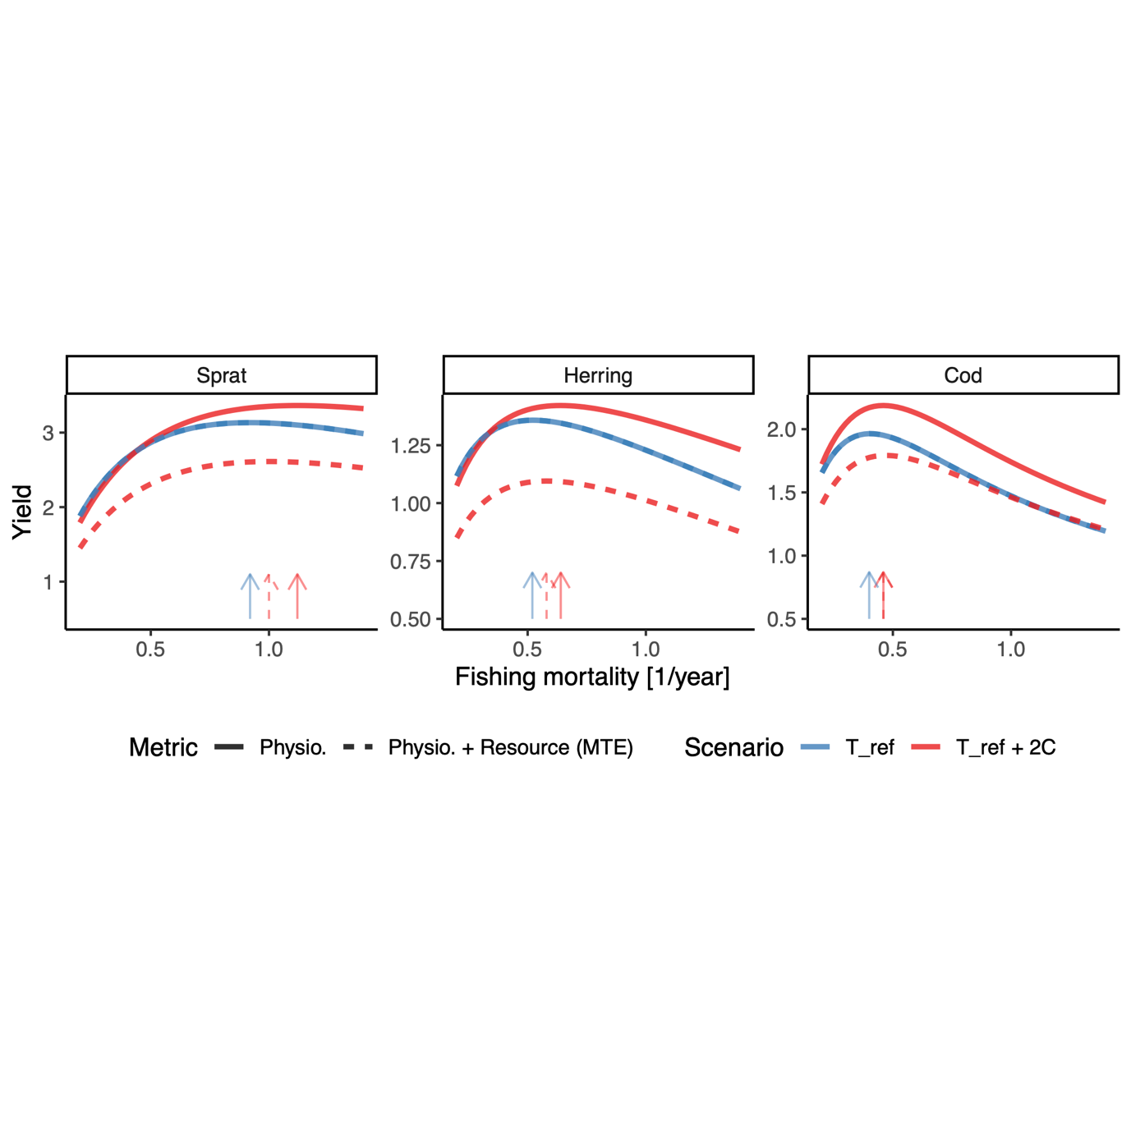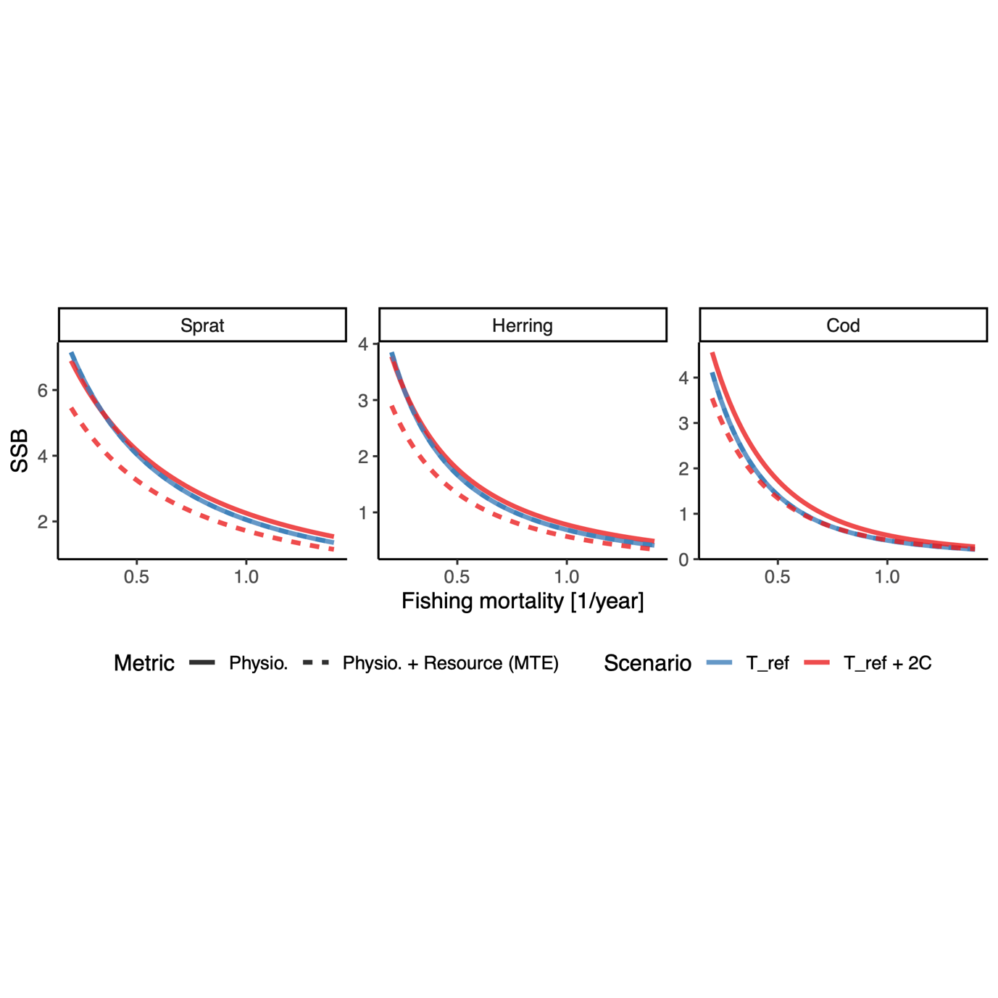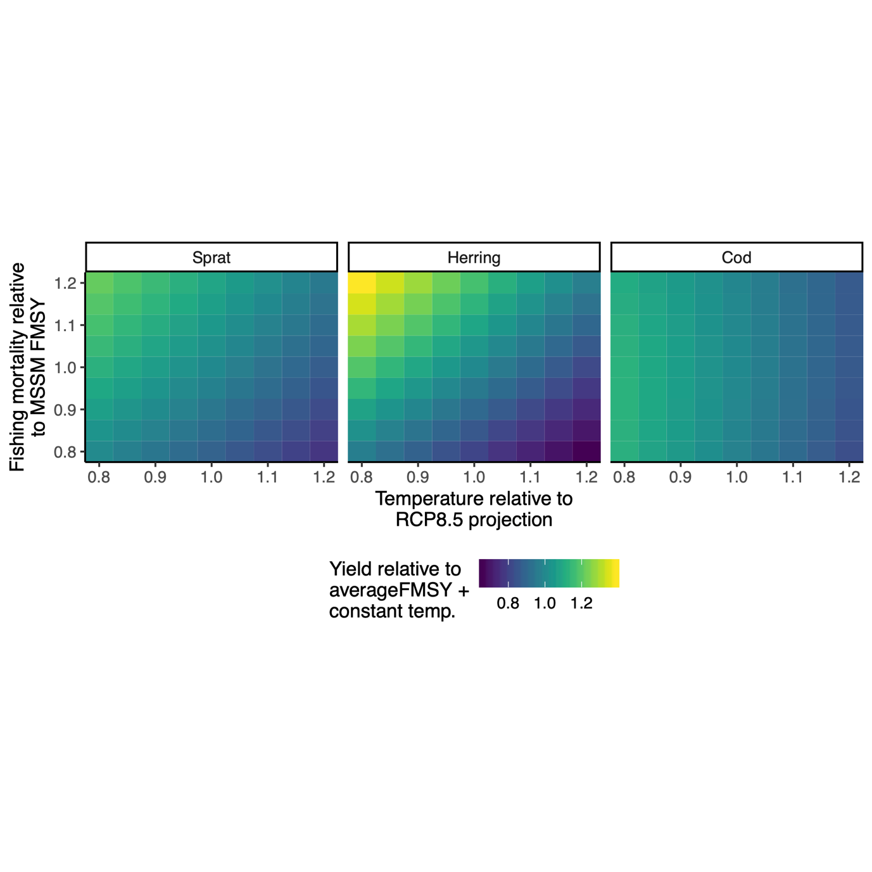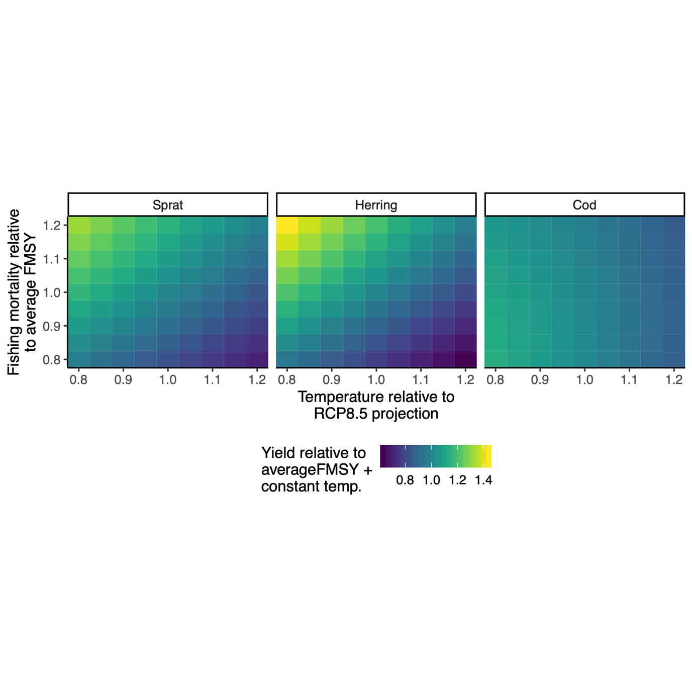

*Figure 7. Example of fisheries yield at steady state (assuming physiological and resource scaling (MTE)) relative to a scenario with constant temperature () and baseline FMSY. In the top row the baseline fishing mortality is the average from stock assessments and the size-spectrum model, and in the bottom row it corresponds to the size-spectrum FMSY only. The x-axis shows the scaling factor to (10) and the y-axis is a scalar to the baseline FMSY.*

Fisheries yields only increase with warming (relative to the no-warming scenario, where warming stops in 2007, Fig. S11) for one species (cod) and this occurs when temperature only affects physiological rates (Fig. 5). In the remaining scenarios, yields decline relative to the non-warming scenario. This is likely driven by decline in abundance of most size-classes above maturation size which is the minimum catch size targeted by the fishery (while the largest fish can in some cases increase, especially for cod, they are also more rare in the population and hence does not counteract the decline in fish around maturation size) (Fig. 4). This also influences the fishing effort leading to maximum sustainable yield (FMSY) and the corresponding spawning stock biomass (SSB). The fishing effort corresponding to FMSY increases when the temperature is +2 compared to the reference temperature (where scaling factors = 1) (Fig. S6), due to the enhanced growth rates (size-at-age). However, the fishery yield only increases in the warmer scenario when temperature only affects physiology. This can also be seen in Fig. S7, where the largest relative increases in fisheries yield are acquired in cold temperatures and higher fishing efforts when temperature affects physiological scaling and resource dynamics.

*Preliminary conclusions*

* Top down and bottom up effects of warming both shape food webs.
* An increase in temperature with 1.5C positively affects size-at-age for all species, but the positive effect diminishes with age and often becomes negative for cod aged 5+. This result is not very sensitive to temperature-driven changes in background resources.
* The effect of temperature on resources (bottom up) partly determines whether or not abundance-at-size increases or decreases with warming
* With the random combinations activation energies that we believe are more of less realistic, and for scenarios with/without effects of temperature on the background resources, body growth rates increase with warming.
* The positive effect of warming diminishes with age.
* For herring and sprat, warming always has a positive effect on growth given the temperature increase we model (which is about +1.5C, see Figure S11 for the scenario here) – even in the most “unfortunate” parameter combination.
* For cod, the “confidence bands” go below 1 in some combinations of parameters, with and without resource temperature-dependence, suggesting warming has a negative effect on size at age even with a 1.5C increase in temperature.
* These results show that the effect of warming on growth rates does not depend that much on how growth of background resources vary with temperature, as the two lines follow each other and largely overlap.
* I also note that the distributions of activation energies are relatively tight, which makes the “confidence bands” pretty tight. This is because it’s not very likely that we draw one really good activation energy for intake and one really bad for metabolic rate at the same time. This is also why I plot the minimum and maximum rather than some quantile.
* (Suggested sensitivity analysis: redo this analysis in a constant temperature and effort setting (not time-varying), and explore extremes of activation energies to get a better feeling for what the effects are. Will also show which the actual activation energies are that give the min, max and mean response that correspond to the ribbons.)

**Discussion**

* Compare predictions that match and don’t match to Woodworth-Jefcoats and Olivier
  + (also discuss different ways of adding background spectra changes: “Changes in abundance and size-structure of background resources can directly inferred from e.g. climate and earth systems models (Woodworth-Jefcoats et al. 2019). However, the simple metabolic approach provides a baseline model for temperature-dependence on population dynamics and allows for an easier interpretation of the relative effects of direct physiological effects (“top down”) vs changes in background productivity (“bottom up”)”)
  + There are indications that also the slope of the size-spectrum ( in the term for carrying capacity), declines with temperature (Yvon‐Durocher *et al.* 2011), however on a global scale this effect is less clear statistically (Barnes *et al.* 2011).
* Talk about growth and uncertainty in scaling parameters
* Need to talk about the state of the Baltic and how that limits our relatively simple model to predict the things that are happening there (range shifts of the pelagic, spatial contraction of cod, earlier maturation and poor growth of cod)
* Our approach categorized one source of uncertainty as environmental variability, but the size-spectrum model does not explicitly include environmental variables such as temperature, salinity, and dissolved oxygen into modelling (Andersen and Beyer, 2006; Scott et al., 2014). It is worth noting that incorporating multiple environmental variables into mechanistic modelling is exceedingly difficult as environmental effects on ecosystems are often non-linear and mixed, and it is impossible to include all environmental variables (Pauly, 1980; Pepin, 1991; Charnov and Gillooly, 2004; Po¨rtner and Knust, 2007). But see Woodwarth.-Jefcoats and Blanchard 2017

**Acknowledgements**

Romain Forestier and Jonatan Reum for contributing to developing code to implement temperature-dependence in mizer during a workshop, Christian Dietrich for providing temperature data, ICES staff and people involved in all stages of data collections and the mizer community.

**Author contributions**

The code was first developed from mizer (Scott *et al.* 2019) by AA to include multiple background resources, all authors contributed to developing the code to include temperature. ML conceived the idea. All authors contributed to study design. ML performed analysis and wrote the first draft. All authors contributed to writing the paper and to revisions.

**References**

Andersen, K.H. & Beyer, J.E. (2006). Asymptotic Size Determines Species Abundance in the Marine Size Spectrum., 8.

Andersen, K.Haste. & Pedersen, M. (2009). Damped trophic cascades driven by fishing in model marine ecosystems. *Proceedings of the Royal Society of London B: Biological Sciences*, 277, 795–802.

Atkinson, D. (1994). Temperature and Organism Size—A Biological Law for Ectotherms? In: *Advances in Ecological Research*. Elsevier, pp. 1–58.

Barneche, D.R., Jahn, M. & Seebacher, F. (2019). Warming increases the cost of growth in a model vertebrate. *Functional Ecology*, 33, 1256–1266.

Barnes, C., Irigoien, X., De Oliveira, J.A.A., Maxwell, D. & Jennings, S. (2011). Predicting marine phytoplankton community size structure from empirical relationships with remotely sensed variables. *J Plankton Res*, 33, 13–24.

Baudron, A.R., Needle, C.L., Rijnsdorp, A.D. & Marshall, C.T. (2014). Warming temperatures and smaller body sizes: synchronous changes in growth of North Sea fishes. *Global Change Biology*, 20, 1023–1031.

Belkin, I.M. (2009). Rapid warming of large marine ecosystems. *Progress in Oceanography*, 81, 207–213.

Bernhardt, J.R., Sunday, J.M. & O’Connor, M.I. (2018). Metabolic Theory and the Temperature-Size Rule Explain the Temperature Dependence of Population Carrying Capacity. *The American Naturalist*, 192, 687–697.

Blanchard, J.L., Andersen, K.H., Scott, F., Hintzen, N.T., Piet, G. & Jennings, S. (2014). Evaluating targets and trade-offs among fisheries and conservation objectives using a multispecies size spectrum model. *Journal of Applied Ecology*, 51, 612–622.

Blanchard, J.L., Heneghan, R.F., Everett, J.D., Trebilco, R. & Richardson, A.J. (2017). From Bacteria to Whales: Using Functional Size Spectra to Model Marine Ecosystems. *Trends in Ecology & Evolution*, 32, 174–186.

Blanchard, J.L., Jennings, S., Holmes, R., Harle, J., Merino, G., Allen, J.I., *et al.* (2012). Potential consequences of climate change for primary production and fish production in large marine ecosystems. *Philosophical Transactions of the Royal Society of London, Series B: Biological Sciences*, 367, 2979–2989.

Brett, J.R., Shelbourn, J.E. & Shoop, C.T. (1969). Growth Rate and Body Composition of Fingerling Sockeye Salmon, Oncorhynchus nerka, in relation to Temperature and Ration Size. *J. Fish. Res. Bd. Can.*, 26, 2363–2394.

Brose, U. (2010). Body-mass constraints on foraging behaviour determine population and food-web dynamics. *Functional Ecology*, 24, 28–34.

Brown, J.H., Gillooly, J.F., Allen, A.P., Savage, V.M. & West, G.B. (2004). Toward a metabolic theory of ecology. *Ecology*, 85, 1771–1789.

Cheung, W.W.L., Sarmiento, J.L., Dunne, J., Frölicher, T.L., Lam, V.W.Y., Deng Palomares, M.L., *et al.* (2013). Shrinking of fishes exacerbates impacts of global ocean changes on marine ecosystems. *Nature Climate Change*, 3, 254–258.

Clarke, A. & Johnston, N.M. (1999). Scaling of metabolic rate with body mass and temperature in teleost fish. *Journal of Animal Ecology*, 68, 893–905.

Curtsdotter, A., Banks, H.T., Banks, J.E., Jonsson, M., Jonsson, T., Laubmeier, A.N., *et al.* (2019). Ecosystem function in predator–prey food webs—confronting dynamic models with empirical data. *Journal of Animal Ecology*, 88, 196–210.

Daufresne, M., Lengfellner, K. & Sommer, U. (2009). Global warming benefits the small in aquatic ecosystems. *Proceedings of the National Academy of Sciences, USA*, 106, 12788–12793.

De Roos, A.M. & Persson, L. (2001). Physiologically structured models - from versatile technique to ecological theory. *Oikos*, 94, 51–71.

Dell, A.I., Pawar, S. & Savage, V.M. (2011). Systematic variation in the temperature dependence of physiological and ecological traits. *Proceedings of the National Academy of Sciences*, 108, 10591–10596.

Dieterich, C., Wang, S., Schimanke, S., Gröger, M., Klein, B., Hordoir, R., *et al.* (2019). Surface Heat Budget over the North Sea in Climate Change Simulations. *Atmosphere*, 10, 272.

Downs, C.J., Hayes, J.P. & Tracy, C.R. (2008). Scaling metabolic rate with body mass and inverse body temperature: A test of the Arrhenius fractal supply model. *Functional Ecology*, 22, 239–244.

Englund, G., Öhlund, G., Hein, C.L. & Diehl, S. (2011). Temperature dependence of the functional response. *Ecology Letters*, 14, 914–921.

Frainer, A., Primicerio, R., Kortsch, S., Aune, M., Dolgov, A.V., Fossheim, M., *et al.* (2017). Climate-driven changes in functional biogeography of Arctic marine fish communities. *Proc Natl Acad Sci USA*, 114, 12202–12207.

Free, C.M., Thorson, J.T., Pinsky, M.L., Oken, K.L., Wiedenmann, J. & Jensen, O.P. (2019). Impacts of historical warming on marine fisheries production. *Science*, 363, 979–983.

Fulton, E.A., Blanchard, J.L., Melbourne-Thomas, J., Plagányi, É.E. & Tulloch, V.J.D. (2019). Where the Ecological Gaps Remain, a Modelers’ Perspective. *Front. Ecol. Evol.*, 7, 424.

Fussmann, K.E., Schwarzmüller, F., Brose, U., Jousset, A. & Rall, B.C. (2014). Ecological stability in response to warming. *Nature Climate Change*, 4, 206–210.

Gårdmark, A., Casini, M., Huss, M., van Leeuwen, A., Hjelm, J., Persson, L., *et al.* (2015). Regime shifts in exploited marine food webs: detecting mechanisms underlying alternative stable states using size-structured community dynamics theory. *Phil. Trans. R. Soc. B*, 370, 20130262.

Gilbert, B., Tunney, T.D., McCann, K.S., DeLong, J.P., Vasseur, D.A., Savage, V.M., *et al.* (2014). A bioenergetic framework for the temperature dependence of trophic interactions. *Ecology Letters*, 17, 902–914.

Gillooly, J.F., Brown, J.H., West, G.B., Savage, V.M. & Charnov, E.L. (2001). Effects of size and temperature on metabolic rate. *Science*, 2248–2251.

Gregg, W.W., Conkright, M.E., Ginoux, P., O’Reilly, J.E. & Casey, N.W. (2003). Ocean primary production and climate: Global decadal changes. *Geophysical Research Letters*, 30.

Gröger, M., Arneborg, L., Dieterich, C., Höglund, A. & Meier, H.E.M. (2019). Summer hydrographic changes in the Baltic Sea, Kattegat and Skagerrak projected in an ensemble of climate scenarios downscaled with a coupled regional ocean–sea ice–atmosphere model. *Clim Dyn*, 53, 5945–5966.

Handeland, S.O., Imsland, A.K. & Stefansson, S.O. (2008). The effect of temperature and fish size on growth, feed intake, food conversion efficiency and stomach evacuation rate of Atlantic salmon post-smolts. *Aquaculture*, 283, 36–42.

Hartvig, M., Andersen, K.H. & Beyer, J.E. (2011). Food web framework for size-structured populations. *Journal of Theoretical Biology*, 272, 113–122.

Huey, R.B. & Kingsolver, J.G. (2019). Climate Warming, Resource Availability, and the Metabolic Meltdown of Ectotherms. *The American Naturalist*, 194, E140–E150.

ICES. (2013). *Report of the Baltic Fisheries Assessment Working Group (WGBFAS)* ( No. ICES CM 2013/ACOM:10.). 10-17 April 2013 ICES Headquarters, Copenhagen.

ICES. (2015). *Report of the Baltic Fisheries Assessment Working Group (WGBFAS)* ( No. ICES CM 2015/ACOM:10). 14-21 April 2015 ICES Headquarters, Copenhagen.

Jacobsen, N.S., Burgess, M.G. & Andersen, K.H. (2017). Efficiency of fisheries is increasing at the ecosystem level. *Fish and Fisheries*, 18, 199–211.

Jennings, S. & Collingridge, K. (2015). Predicting consumer biomass, size-structure, production, catch potential, responses to fishing and associated uncertainties in the world’s marine ecosystems. *PLoS ONE*, 10, 1–28.

Jutfelt, F., Norin, T., Ern, R., Overgaard, J., Wang, T., McKenzie, D.J., *et al.* (2018). Oxygen- and capacity-limited thermal tolerance: blurring ecology and physiology. *Journal of Experimental Biology*, 221.

Lefevre, S., McKenzie, D.J. & Nilsson, G.E. (2018). In modelling effects of global warming, invalid assumptions lead to unrealistic projections. *Global Change Biology*, 24, 553–556.

Lotze, H.K., Tittensor, D.P., Bryndum-Buchholz, A., Eddy, T.D., Cheung, W.W.L., Galbraith, E.D., *et al.* (2019). Global ensemble projections reveal trophic amplification of ocean biomass declines with climate change. *Proceedings of the National Academy of Sciences*, 116, 12907–12912.

McCauley, D.J., Pinsky, M.L., Palumbi, S.R., Estes, J.A., Joyce, F.H. & Warner, R.R. (2015). Marine defaunation: Animal loss in the global ocean. *Science*, 347.

Metz, J.A.J. & Diekmann, O. (1986). *The dynamics of physiologically structured populations*. Springer-Verlag, Heidelberg, Germany.

Mion, M., Thorsen, A., Vitale, F., Dierking, J., Herrmann, J.P., Huwer, B., *et al.* (2018). Effect of fish length and nutritional condition on the fecundity of distressed Atlantic cod *Gadus morhua* from the Baltic Sea: POTENTIAL FECUNDITY OF BALTIC *G. MORHUA*. *Journal of Fish Biology*, 92, 1016–1034.

Neubauer, P. & Andersen, K.H. (2019). Thermal performance of fish is explained by an interplay between physiology, behaviour and ecology. *Conserv Physiol*, 7.

Neuenfeldt, S., Bartolino, V., Orio, A., Andersen, K.H., Andersen, N.G., Niiranen, S., *et al.* (2019). Feeding and growth of Atlantic cod (Gadus morhua L.) in the eastern Baltic Sea under environmental change. *ICES Journal of Marine Science*, fsz224.

Pauly, D. (1980). On the interrelationships between natural mortality, growth parameters, and mean environmental temperature in 175 fish stocks. *ICES Journal of Marine Science*, 39, 175–192.

Persson, L. & De Roos, A.M. (2013). Symmetry breaking in ecological systems through different energy efficiencies of juveniles and adults. *Ecology*, 94, 1487–1498.

Pinsky, M.L., Worm, B., Fogarty, M.J., Sarmiento, J.L. & Levin, S.A. (2013). Marine Taxa Track Local Climate Velocities. *Science*, 341, 1239–1242.

Pontavice, H. du, Gascuel, D., Reygondeau, G., Maureaud, A. & Cheung, W.W.L. (2019). Climate change undermines the global functioning of marine food webs. *Global Change Biology*.

R Core Team. (2018). *R: A Language and Environment for Statistical Computing. R Foundation for Statistical Computing*. Vienna, Austria.

Rall, B.C., Brose, U., Hartvig, M., Kalinkat, G., Schwarzmuller, F., Vucic-Pestic, O., *et al.* (2012). Universal temperature and body-mass scaling of feeding rates. *Philosophical Transactions of the Royal Society of London, Series B: Biological Sciences*, 367, 2923–2934.

Reum, J.C.P., Blanchard, J.L., Holsman, K.K., Aydin, K. & Punt, A.E. (2019). Species‐specific ontogenetic diet shifts attenuate trophic cascades and lengthen food chains in exploited ecosystems. *Oikos*, 128, 1051–1064.

Righton, D.A., Andersen, K.Haste., Neat, F., Thorsteinsson, V., Steingrund, P., Svedäng, H., *et al.* (2010). Thermal niche of Atlantic cod Gadus morhua: limits, tolerance and optima. *Marine Ecology Progress Series*, 420, 1–13.

Savage, V.M., Gillooly, J.F., Brown, J.H., West, G.B. & Charnov, E.L. (2004). Effects of body size and temperature on population growth. *The American Naturalist*, 163, 429–441.

Scott, F., Blanchard, J. & Andersen, K. (2019). *mizer: Multi-Species sIZE Spectrum Modelling in R*. R. .

Scott, F., Blanchard, J.L. & Andersen, K.Haste. (2014). mizer: An R package for multispecies, trait-based and community size spectrum ecological modelling. *Methods in Ecology and Evolution*, 5, 1121–1125.

Spence, M.A., Blanchard, J.L., Rossberg, A.G., Heath, M.R., Heymans, J.J., Mackinson, S., *et al.* (2018). A general framework for combining ecosystem models. *Fish Fish*, 19, 1031–1042.

Svedäng, H. & Hornborg, S. (2014). Selective fishing induces density-dependent growth. *Nature Communications*, 5, 4152.

Thorson, J.T., Munch, S.B., Cope, J.M. & Gao, J. (2017). Predicting life history parameters for all fishes worldwide. *Ecological Applications*, 27, 2262–2276.

Ursin, E. (1967). A Mathematical Model of Some Aspects of Fish Growth, Respiration, and Mortality. *Journal of the Fisheries Research Board of Canada*, 24, 2355–2453.

Werner, E.E. & Gilliam, J.F. (1984). The ontogenetic nice and species interactions in size-structured populations. *Annual Review of Ecology and Systematics*, 15, 393–425.

Woodworth-Jefcoats, P.A., Blanchard, J.L. & Drazen, J.C. (2019). Relative Impacts of Simultaneous Stressors on a Pelagic Marine Ecosystem. *Frontiers in Marine Science*, 6.

Yvon‐Durocher, G., Montoya, J.M., Trimmer, M. & Woodward, G. (2011). Warming alters the size spectrum and shifts the distribution of biomass in freshwater ecosystems. *Global Change Biology*, 17, 1681–1694.

Zhang, C., Chen, Y. & Ren, Y. (2015). Assessing uncertainty of a multispecies size-spectrum model resulting from process and observation errors. *ICES J Mar Sci*, 72, 2223–2233.