**Bottom up and top down effects of temperature on body growth, population size spectra and yield – an application of a multi-species size-spectrum model**

Max Lindmarka,1, Asta Audzijonyteb, Julia Blanchardc, Anna Gårdmarkd

aSwedish University of Agricultural Sciences, Department of Aquatic Resources, Institute of Coastal Research, Skolgatan 6, Öregrund 742 42, Sweden

bInstitute for Marine and Antarctic Studies, University of Tasmania, Battery Point, TAS 7001, Australia

cInstitute for Marine and Antarctic Studies and Centre for Marine Socioecology, University of Tasmania, 20 Castray Esplanade, Battery Point, Hobart, TAS 7000, Australia

dSwedish University of Agricultural Sciences, Department of Aquatic Resources, Skolgatan 6, SE-742 42 Öregrund, Sweden

**Word count**

Abstract: 236

Introduction: 1252

Methods: 2153

Results: 707

Discussion: NA

**Abstract**

Resolving the combined effect of climate warming and exploitation in a food web context is key for predicting future biomass production, size-structure and potential yields of marine fishes. Previous studies based on mechanistic size-based community models have found that bottom-up processes are important drivers of size-structure and fisheries yield at the ecosystem level in changing climates. However, we know less about the joint effects bottom up and ‘top down’ effects (direct effects of warming on individual-level physiology) on exploited food webs. Here we assess how various food web metrics are affected by warming through both this pathways and by exploitation in a species-resolved size-based food web. We parameterize a dynamic size-spectrum model representing the offshore Baltic Sea food web, and investigate how individual growth rates, size-structure, relative abundances of species and yields are affected by warming under different scenarios of fishing mortality and physiological scaling of temperature effects. When accounting also for how temperature affects physiology, projected size-at-age increases for all species in 2050 based on temperature projections according to the RCP 8.5 scenario, whereas size-at-age decreases when temperature only affects resource dynamics. However, the faster growth rates in the fully temperature-dependent models do not to the same extent translate to larger yields, as spawning stock biomass declines due to increased predation mortality rates. Results from our model suggest that reduced fishing mortality can counteract the potentially negative effects of warming on the abundance of fish above maturation size.

**Introduction**

Climate change affects aquatic food webs directly by shifting species’ distribution (Pinsky *et al.* 2013), abundance (McCauley *et al.* 2015), body size (Daufresne *et al.* 2009; Baudron *et al.* 2014), and ecosystem function (Pontavice *et al.* 2019). This can further lead to indirect effects through the rewiring of food webs (Frainer *et al.* 2017). Global retrospective analysis of warming and fish population dynamics has revealed that productivity of scientifically assessed fish populations across ecoregions has already declined due to climate change (Free *et al.* 2019). These results are also matched in magnitude and direction by projections from an ensemble of mechanistic ecosystem models, which predicts further declines in biomass by 2100, especially at higher trophic levels (Lotze *et al.* 2019). Large scale models are crucial for informing global assessments about the implications of climate change (Lotze *et al.* 2019). However, by necessity, such models rely on simplifying assumption and tend to not include species-resolved food webs and the effects of temperature on individual-level physiology (but see (Woodworth-Jefcoats *et al.* 2019)). Instead, temperature is often assumed to act mainly on ecosystem productivity (“bottom up”) rather than on both individual physiology (“top down”) and productivity. Thus, there is a need to increase our mechanistic understanding of climate change impacts on individuals and how that affects food webs and regional dynamics (Blanchard *et al.* 2012).

The primary effect of temperature is on individual physiology, and individual-level processes such as metabolism, growth and mortality govern ecosystem properties such as biomass production rates, abundance and size spectra (Andersen & Beyer 2006; Jennings & Collingridge 2015; Blanchard *et al.* 2017). However, there is still uncertainty in both the scaling of physiological rates with body mass and temperature (Brown *et al.* 2004; Dell *et al.* 2011; Englund *et al.* 2011), and there is no consensus or a single framework for implementing this into e.g. models of individual growth. This limits our ability to predict and understand “universal” responses to global warming, such as the shrinking of organisms with warming (Daufresne *et al.* 2009) and the temperature size rule, predicting faster growth rates but smaller asymptotic body sizes with warming (Atkinson 1994). One example of a mechanistic approach to predict changes in population dynamics and size structure through physiological scaling is the model by (Cheung *et al.* 2013). Based on a generalization of the von Bertalanffy growth equation (VBGE), this model predicted a 14-24% reduction in average maximum body mass driven by changes in distribution and physiology. The underlying mechanism is the assumption that increasing oxygen limitation with warming due to elevated metabolic demands impose growth constraints that lead to smaller asymptotic body masses. This model has however been criticized for not representing the underlying physiological processes accurately – both in what they represent and their parameters (Jutfelt *et al.* 2018; Lefevre *et al.* 2018). In addition, evaluating changes in food web size-structure based on static growth models (as in growth being independent of food) is in conflict with the well-known observation that body growth depends on an interplay between body size, temperature and food availability (Brett *et al.* 1969). For instance, the optimum temperature for growth declines with reduced food rations (Huey & Kingsolver 2019), which means that the effects of temperature are mediated by changes in resources levels. It is therefore important to work on developing mechanistic models that are founded on an accurate description of size and temperature-dependence of key physiological processes, and to evaluate them in an ecological context to account for the food dependence of individual growth (Neubauer & Andersen 2019).

Process-based food web models aim to represent the dynamics or structure of ecosystems based on an understanding of the key mechanisms behind the phenomena considered, considering both metabolic scaling and feeding interactions e.g. (Brose 2010; Persson & De Roos 2013). Thus, models can vary in their performance depending on the process they are tailored for (Spence *et al.* 2018), and it is therefore important to both identify and capture the dominant mechanisms in the model (Curtsdotter *et al.* 2019). Traditional Lotka-Volterra-type models describing pairwise species interactions often fail to accurately represent the life history of fish, which in general grow several orders of magnitude in body size and change feeding niches and trophic levels during ontogeny (Werner & Gilliam 1984). Hence, it is often necessary to account for intraspecific variation in body size to capture the ecological function of a typical fish (Hartvig *et al.* 2011). Not surprisingly, work in fish and fisheries ecology have pioneered to represent these processes, for example in physiologically structured models (PSPM) (Metz & Diekmann 1986; De Roos & Persson 2001). Later, the development of trait based size spectrum models allowed for more generic formulations of physiologically based life history description and using body weight at maturation as a distinguishing trait (Hartvig *et al.* 2011), which has provided general insights and mechanisms on e.g. trophic cascades (Andersen & Pedersen 2009). More recently, extensions of the size spectrum framework for modelling size-based food webs include more precise characterization of species, e.g. by defining species feeding preference and life history characteristics – so called multi-species size spectrum models (MSSMs) (Blanchard *et al.* 2014; Scott *et al.* 2014). Such species- and trait-based models have led to a closer connection to observational data, by e.g. both informing and validating model predictions. For instance, (Reum *et al.* 2019), by characterizing species predation preference by both species- and body size, were able to more accurately describe the true feeding links, which in addition weakened the effects of fishing on trophic cascades compared to strictly size-based models. These have also recently been applied to examine the effects of warming and fishing and a case study on the Hawaiian long line fishery suggest that fishing in general causes declines in mean size and yield, and that climate may enhance this effect (Woodworth-Jefcoats *et al.* 2019). It is important however to acknowledge that all models come with different sources of uncertainty. In MSSMs, metabolic scaling parameters have a major impact on the uncertainty around model predictions (Zhang *et al.* 2015). This suggests also their temperature dependence is an important source of uncertainty, yet this is rarely quantified in mechanistic models (but see (Fussmann *et al.* 2014)).

Here we use a size-spectrum food web model representing the Baltic Sea as a case study to examine the relative and combined effects of warming on resources of fish (“bottom up”) and individual-level physiology (“top down”) of fish, and how these impact individual growth trajectories, average body sizes, population size-structure and yield in a fished ecosystem. The Baltic Sea is a semi-enclosed regional sea that is experiencing warming with a rate three times the global average (Belkin 2009). By 2050, the regional coupled model system RCA4-NEMO and the RCP 8.5 emission scenario predicts the surface temperature to have increased by 2 compared to the mean in 1970-1999 (Dieterich *et al.* 2019; Gröger *et al.* 2019). The food web model is a multi-species size spectrum model (Blanchard *et al.* 2014; Scott *et al.* 2014), modified to account for temperature dependence of metabolism, maximum consumption rate and background mortality, as well as resource turnover rate and carrying capacity. Uncertainty in the thermal dependence of these rates is incorporated by drawing samples from known distributions, based on meta-analysis and the metabolic theory of ecology. The temperature-dependent food web model was projected to 2050 with a time-varying ocean temperature and different fishing scenarios. The inclusion of temperature-dependent physiological processes in the model leads increased size-at-age, especially for smaller individuals, in contrast to models where only the resource dynamics are temperature dependent, where size-at-age declines with warming. This has implications for populations size-structure and yield.

**Materials and Methods**

*Food web*

We developed a Multi-species size spectrum model (MSSM) parameterized to represent a simplified version of the food web in the pelagic central Baltic Sea ecosystem? (Baltic proper) (ICES sub divisions 25-29+32, Appendix Fig SX). Baltic Sea is semi-enclosed brackish sea and has high simplified food web, with the pelagic component dominated by xxx. This food web is here characterized by three fish species: cod (*Gadus morhua*), sprat (*Sprattus sprattus*) and herring (*Clupea harengus*), and their prey. These species are dominant species in terms of biomass, they are the most important species commercially in this southern sub-region of the Baltic and they all have analytical stock assessments. We also model one pelagic (such as phyto- and zooplankton, mysids) and one benthic background resource spectrum (benthic inverts, gobiidaes and other small fish?), which constitute dynamic food sources for the smallest individuals of each of the three fish species,.

*Size-spectrum model*

The model is based on source code for the multi-species implementation of size-spectrum models in the ‘R’-package *mizer* (Blanchard *et al.* 2014; Scott *et al.* 2014, 2019; R Core Team 2018), which has been extended to include multiple background resources (hopefully a reference to Audzijonyte et al. soon) and size-dependent temperature-scaling of key physiological processes (hopefully a reference to Gardmark et al. soon?).. All model code (parameterization, calibration and analysis), together with necessary data is available on GitHub (<https://github.com/maxlindmark/mizer-rewiring/tree/rewire-temp/baltic>), and will be deposited on Zenodo (<http://doi.org/>) upon publication. In this section we describe the key elements of the MSSM, which mostly follow the standard multispecies mizer model (Scott *et al.* 2014).

In MSSMs, individuals are characterized by their weight () and species identity (). The core equation is the McKendrik-von Foerster equation, which here describes the change in abundance at size through time from food dependent somatic growth and mortality, based on bioenergetic principles:

where [] is somatic growth (dependent on the availability of background resources or prey) and [] is total mortality. The total mortality, , is the sum of the background-, fishing-, and predation mortality. The constant size-independent species-specific allometric background mortality depends on the maximum body size of a species and is given by:

Fishing mortality is defined as:

where is the selectivity (by default knife-edge selectivity is assumed with a weight at first catch corresponding to weight at maturation), and is fishing effort. The predation mortality for a prey species equals the amount consumed by species :

The proportion of encountered food that is consumed by a species i follows a Holling functional response type II:

where is the feeding level (which describes the level of satiation and varies between 0:1), is the allometric maximum consumption rate and is the encountered food. The amount of encountered food for a predator of body weight is given by the available food in the system, scaled by a size-selection function and the search rate of the predator. Here, available food, , is the integral of the biomass of all species and background resource that falls within the prey preference and size-selectivity of species i

where is the weight of prey, is the preference of species on resource , and indicates species. Note that in contrast to other MSSMs (Blanchard *et al.* 2014; Reum *et al.* 2019) we have a species-preference for the background resources to account for species feeding differently on benthic and pelagic resources, but assume no preference in terms of the other species interactions (all terms in the species interaction matrix are identical and equal to xx). This is for simplicity, as the body size-only prey selection and encounter captures the important predation interactions in this system (as inferred from independent stomach data, see model calibration, Appendix S1) and the species largely occupy similar spatial areas in the time period of the model calibration. The size-selectivity of feeding, , is given by a log-normal selection function (Ursin 1967):

where parameters and are the preferred predator-prey mass ratio and the standard deviation of the log-normal distribution, respectivly. Together, the size-based selection function and the amount of available prey is multiplied with the allometric function describing the mass-specific coefficient of search rate:

to get the actual biomass of food encountered, , as

.

Here q is the size scaling exponent of the search rate. The rate at which food is consumed is given by the product , and is assimilated with efficiency and used to cover basal metabolic costs, which scale allometrically as . The remaining energy, , is thus:

and is allocated to growth or reproduction. The allocation to reproduction () increases smoothly from 0 at the weight maturation, , to 1 at the asymptotic weight, , according to the function:

.

This function results in that the growth rate, i.e.

approximates a von Bertalanffy growth curve when the feeding level is constant (Hartvig *et al.* 2011). Reproduction is given by the total egg production in numbers, which is the integral of the energy allocated to reproduction multiplied by a reproduction efficiency factor () divided by the egg weight, :

The recruitment of offspring to each species relates to the total egg production via a Beverton-Holt stock recruit relationship, such that recruitment reaches a maximum as the egg production increases,

,

where is the maximum recruitment of each species. is here treated as a free parameter that is found in the calibration process by minimizing the residual sum of squares between spawning stock biomass from stock assessment and the MSSM. In doing so, it also ensures that the species coexist in the model (Hartvig *et al.* 2011).

The temporal dynamics of the background resource () spectra (benthic and pelagic) is defined as:

where is the population regeneration rate, is the population carrying capacity and is predation mortality and lambda is defined as . (Andersen 2019 – his book could be an easy reference)

*Temperature dependence*

Temperature affects the rate of metabolism (Clarke & Johnston 1999; Gillooly *et al.* 2001), and thus the bioenergetics of individuals, also through e.g. maximum consumption rates (Englund *et al.* 2011; Rall *et al.* 2012), , and mortality (Pauly 1980; Thorson *et al.* 2017). We scale rates of individual metabolism (), maximum consumption () and background mortality () with temperature using an Arrhenius temperature correction factor:

where is the activation energy for individual rate [], is temperature [], is the reference temperature (here 283.15 , where the correction factor=1), and is Boltzmann’s constant in (). We chose an exponential temperature dependence as it provides a good statistical fit to data, is widely adopted and because we assume that the projected change in ocean temperature in our time-range does not lead to temperatures above physiological optimum, where physiological rates might be expected to decline (e.g. (Righton *et al.* 2010) as an example for cod). While temperature likely affects other physiological processes as well (e.g. cost of growth (Barneche *et al.* 2019), food conversion efficiency (Handeland *et al.* 2008)), we focus on metabolism, maximum consumption and mortality as their temperature dependence is relatively well documented.

Temperature also affects the amount of available background resources, via the same type of individual-level processes. However, as background resources are not resolved by species or taxonomic group, but are modelled through a semi-chemostat equation, we implement temperature dependence on background resources by scaling their population biomass regeneration rate and maximum population biomass with the Arrhenius correction factor with activation energy , where refers to background resource parameter. We consider two scenarios for temperature-dependence of background resources based on predictions from metabolic scaling theory and empirical patterns:

1. Metabolic Theory of Ecology (MTE) scenario: The regeneration rate () increases proportionally todue to elevated metabolic rates in resource organisms, which increases the rates of energy acquisition, growth, maintenance and reproduction (Savage *et al.* 2004) (but note these individual-level rates of resources are not explicitly modelled). The maximum population biomass () declines at the same rate as population regeneration rate increases with temperature (Savage *et al.* 2004; Gilbert *et al.* 2014), i.e. proportionally to , if assuming a fixed supply of resources for the resource populations. This theoretical prediction has been verified experimentally (Bernhardt *et al.* 2018).
2. Empirical scenario: The maximum population biomass declines with temperature proportionally to , based on the observed relationship between temperature and the intercept of marine phytoplankton size-spectra (Barnes *et al.* 2011). Time scenarios represents a decline in primary production with climate change, potentially due to increased stratification and reduced resource levels (Gregg *et al.* 2003).

Activation energies (), which dictate the temperature sensitivity of a rate, typically vary substantially between processes, species, taxonomic groups and whether or not intra- or interspecific data are used for estimation (Savage *et al.* 2004; Downs *et al.* 2008; Englund *et al.* 2011; Rall *et al.* 2012). Moreover, MSSMs have been shown to be sensitive to metabolic scaling parameters (Zhang *et al.* 2015). To overcome this, we assigned activation energies by drawing 200 random combinations of activation energies for each temperature-dependent rate and species from probability distributions (Table 1; Fig S10). The model is then projected forward 200 times, each time with another set of parameters. We then quantify the overall mean response and the ranges of predictions from the full set of runs with all temperature-dependency draws. The probability distributions for the temperature-dependencies of maximum consumption rate and metabolic rate are taken from a systematic literature review on the intraspecific size- and temperature dependent scaling (Lindmark et al, in prep) and mortality is assumed to scale in proportion to metabolic rate (Brown *et al.* 2004; Blanchard *et al.* 2012). Activation energies for resource parameters were acquired by fitting linear regression of natural log of growth rate as a function of Arrhenius temperature () from experimental data in (Savage *et al.* 2004) (pooling protists, algae, zooplankton) for the MTE-scenario. For the empirical scenario, we used an activation energy that best fit the decline in phytoplankton size-spectra intercept presented in (Barnes *et al.* 2011) (-0.045 ). We further assume the distributions of each rate from which the draws are taken are independent.

*Model calibration*

The MSSM is parameterized to represent the Baltic Sea offshore food web by estimating life history parameters from scientific trawl survey data (for details, see Appendix S1, Table S1-S2). Next, the model is calibrated to averaged stock assessment data (fishing mortality, F and spawning stock biomass, SSB) in a specific time window to tune the system to get realistic biomass ratios. Ideally the period for calibration should exhibit relative stability, but such periods do not exist in the Baltic Sea, which is largely influenced by anthropogenic activities and has experienced dramatic structural changes over the last four decades (Möllmann et al. 2009). We chose to calibrate our model to the time period 1992-2002 as in (Jacobsen *et al.* 2017), which is a post-regime shift period characterized by high fishing mortality (F) on cod, low cod and herring abundance and high sprat abundance (Gårdmark *et al.* 2015) (Fig. 1, Fig.S2). The cutoff at 2002 also ensures that we do not calibrate the model to the period starting from mid 2000’s when the growth capacity, condition, proportion of large fish in the population and reproductive capacity of cod started to decline rapidly (Svedäng & Hornborg 2014; Mion *et al.* 2018; Neuenfeldt *et al.* 2019).

Maximum recruitment values (Rmax) for the three model species were calibrated vby minimizing the residual sum of squares between the natural log of spawning stock biomass (SSB) estimated in stock assessment output and those emergent in the model for the years 1992-2002, while holding the temperature constant at . Calibration was done using the "L-BFGS-B" algorithm in the ‘R’-optimization function ‘*optim’* (ref) Mean SSB and F during the calibration time period (1992-2002) from stock assessments were acquired from ICES Working Group Reports (ICES 2013, 2015), and are in unit 106 kg/area. This area corresponds to ICES subdivisions 25-29+32, which equals approximately 2.49E+11 m2 (estimated using ICES shapefiles in ArcGIS). To express the modelled SSB in the same scale, we first defined it in the units g/m2 and then used the converting factor 240.342. Given that the North Sea is approximately 1E11 m2, we used the and divided by 1E11 as starting values, before calibrating the model. This resulted in a starting value for and of 1.

We ensured that also growth-rates were close to observed by comparing the growth curves emerging in the model to VBGE curves fitted to trawl survey data (Appendix), and that the density dependence due to the stock-recruit function was appropriate. This was assessed from the ratio of recruitment before and after stock-recruitment density dependence was applied (Jacobsen *et al.* 2017). Lastly, we compared time series of model output simulated together with historical temperature and fishing effort data with stock assessment output. A detailed description of the step-by-step calibration protocol used in this study, can be found in Appendix S1 and Fig. S3-S9.

*Climate change / temperature change / warming scenarios*

We evaluated the effect of warming by projecting the model from XXXX to 2050 using the predicted change in sea surface temperature by the regional coupled model system RCA4-NEMO under the RCP 8.5 scenario (removing burn-in period, see Appendix for details). We further projected the model to a steady state under different constant temperatures. The fishing mortalities were varied in relation to FMSY-levels based on either the current model or an average between the current model and stock assessment FMSY (as the model is calibrated to stock assessment outputs). To examine the effects of temperature affecting fish physiology, their resources or both, we considered 5 different scenarios and for each we analyzed weight-at-age, mean population weight, abundance-at-weight and fisheries yield. These metrics are evaluated both in absolute terms and in relation to non-warming baseline scenario, which is modelled assuming no warming past 1997 (midpoint of calibration time period) in the projections and temperature equaling reference temperature (where all temperature scalars equal 1) in the non-time varying simulations.

Table 1 Parameters of distributions describing activation energies of temperature-dependent rates in the size-spectrum model. See figure 2 for 200 random draws from these normal distributions that were used as input in projections.

|  |  |  |  |
| --- | --- | --- | --- |
| Symbol | Rate | Distribution (mean, variance?) | Source |
|  | Metabolism |  | Lindmark *et al.* (*in prep*) |
|  | Background mortality |  | (Brown *et al.* 2004); Lindmark *et al.* (*in prep*) |
|  | Maximum consumption |  | Lindmark *et al.* (*in prep*) |
|  | Background resource carrying capacity |  | Data from Savage *et al.* (2004) for algae, phyto- and zooplankton. |
|  | Background resources regeneration rate |  | (Gilbert *et al.* 2014); (Savage *et al.* 2004) |

Figure 1. Time series of (A) fishing mortality by species and (B) temperature used in the simulations?. Temperature values are taken from the regional coupled model system RCA4-NEMO using the RCP 8.5 scenario. For fishing mortality (A) the light grey area corresponds to years where mortality values are estimated from stock assessments. The dark grey area is the model calibration time period. We treated the 60 years prior to the start of the F-time series as burn-in and kept the constant and equal to the first time series (in year 1974). The future projections correspond to the mean FMSY from the multispecies stock assessments’ estimates and the size-spectrum model (estimated by keeping each species at their mean assessment FMSY). In panel B, temperature is shown as deviations from the average in 1970-1999. Note the different x-axis of the figures.

**Results**

The inclusion of temperature effects on fish physiological processes (“top-down”, in addition to temperature-dependence of their background resources, the “bottom-up”) has a strong influence on the projected size-at-age in 2050 under the RCP 8.5 emission scenario relative to the baseline projection (no warming). Including temperature dependence of maximum consumption, mortality and metabolism, with or without temperature-dependence of background resources, leads to warming having positive effects on size-at-age, whereas scenarios without temperature-dependent physiological processes all lead to size-at-age decreasing with warming (Fig. 2).

How the temperature-response varies with body size also differs depending on if physiological processes is temperature-dependent or not. In scenarios with temperature-dependent physiological processes, the positive effect of warming is largest for small individuals and declines with size, whereas when only resource dynamics scale with temperature, small individuals have the largest relative change (negative), and this negative effect of warming declines with body size (Fig. 2).

Despite the relatively narrow range of activation energies for physiological rates considered here (Fig. S10), the uncertainty associated with variation in the activation energies are large. In scenarios where both physiology and resources depend on temperature, the range of predicted changes in size-at-age vary at approximately 5% to 40% for the MTE scenario and approximately 15% to 60% for the empirical scenario for a 3-year-old cod (Fig. 1). The relative difference in size-at-age of a 3-year-old fish in the warming versus the constant temperature scenarios across scaling scenarios vary between approximately 20% to 50% for cod, 15% to 25% for herring and 12% to 15% for sprat (Fig. 2). These changes in size-at-age seems to be driven by the temperature-dependence of maximum consumption rate increasing the actual consumption rates , and not due to increased feeding levels (Fig. S12), and the consumption rate is more sensitive than the metabolic losses for the energy acquisition. This also leads to increases in the size-dependent predation mortality of fish above 1g for all scenarios, and for all body weights in the scenarios where only resources are temperature-dependent (Fig. S13).

There is a positive relationship between the relative change in growth due to warming (Fig. 2) and that of the mean population body weight (Fig. 3). However, the mean body weight does not always increase with warming when the size-at-age does so (Figs. 2-3), reflecting a change in the size composition of the populations (Fig. 4). For sprat and herring, the only scenario that has a median increase in mean body weight includes only temperature-dependent physiological processes and no temperature dependence of resources (Fig. 3). The abundance-at-weight for fish below maturation size decreases by 10% at the end of the projection for all species. The increase in predation and background mortality with warming likely contribute to this (Fig. S13). For cod, the abundance of the largest fish (>500g) increases in all scenarios (Fig 4-subplot), which drives the increase in their mean body weight (Fig. 3). By contrast, the abundance of sprat and herring individuals above maturation size only increase with warming if the background resources are independent of temperature (Fig. 4).

Fishing mortality modulates the effect of warming Fishing removes the largest fish in the populations, but this can be counteracted by the changes in growth rates and size-from the scaling scenarios accounting for physiology (Fig. S14).

Fisheries yield increases with the projected warming for cod if temperature only affects physiological rates (Fig. 5). For sprat and herring, and for cod in all other scenarios, yields decline, or are more or less unaffected by warming (Fig. 5). This is likely driven by the warming-induced decline in abundance of most size-classes above maturation size (Fig. 4), which is the minimum size targeted by the fishery. While the largest fish can in some cases increase in abundance, especially for cod, they are also rarer in the population and hence this does not counteract the decline in fish that constitute the main catches (Fig. 4).

Warming, and whether it acts on background resources or also physiological rates,This also influences the fishing effort leading to maximum sustainable yield (FMSY) and the corresponding spawning stock biomass (SSB) (Fig. 6). In the non-time varying simulation, the fishing effort corresponding to FMSY increases when the temperature is +2 compared to the reference temperature (where scaling factors = 1) at steady state, due to the enhanced growth rates (size-at-age) (Fig. S6). However, the fishery yield increases only if temperature acts on physiology alone. Thus, when temperature affects physiological scaling and resource dynamics, the largest relative increases in fisheries yield are acquired in colder temperatures and higher fishing efforts (Fig. S15).

*Figure 2. Individual growth trajectories of sprat, herring and cod from model projections to year 2050 assuming warming according to RCP 8.5 while keeping fishing mortality at average FMSY levels. Top row shows size-at-age and bottom row shows size-at-age relative to a non-warming scenario. The dashed line in the top row depicts projections assuming a non-warming scenario and thus constitutes a baseline prediction. Colors indicate different temperature-scaling scenarios. Shaded areas encompass the minimum and maximum prediction from the set of 200 simulations with randomly assigned activation energies.*

*Figure 3. Mean weight across all individuals in the populations of sprat, herring and cod from model projections to year 2050 assuming warming according to RCP 8.5 while keeping fishing mortality at average FMSY levels. The dashed horizontal line depicts projections assuming no temperature increase and thus constitutes a baseline prediction. Each dot represents one of the 200 simulations, each with randomly assigned activation energies. Boxplots depict 25%, 50% and 75% quantiles.*

*Figure 4. Projected abundance-at-weight by species for different scenarios of temperature scaling (indicated by colors) at 2050 assuming fishing mortality held at average FMSY levels (Figure 1A) from different stock assessment estimates and this model. The left column shows size at age relative to a non-warming scenario. Vertical red dotted line indicates weight-at-maturation and horizontal black dotted lines indicate the baseline projection (no warming). The right column shows the absolute abundance-at-weight with the non-warming scenario shown in black. Activation energies are the means of their respective distributions (no uncertainty).*

*Figure 5. Time series of projected yield under different temperature scaling scenarios (indicated by colors) and temperature projections according to RCP 8.5 emission scenarios, assuming fishing mortality held at average FMSY levels (after 2014) from different stock assessment estimates and this model. The horizontal black line corresponds to no temperature increase after 1997. Activation energies are the means of their respective distributions (no uncertainty).*

*Figure 6. Steady state fishery yield (top) assuming knife edge selectivity at maturation size and spawning stock biomass (SSB) (bottom) under constant temperature simulations. Colors indicate the temperature, where blue means (all scaling factors = 1, i.e. no temperature effects), and red depicts warm temperature, here +2. Dashed lines correspond to resource dynamics being temperature dependent in addition to physiological rates, solid lines correspond to simulations with only physiological rates being temperature dependent. Arrows indicate F that leads to maximum sustainable yield. F is held constant at the mean F during calibration (mean 1992-2002) for the two other species while estimating it for one species.*

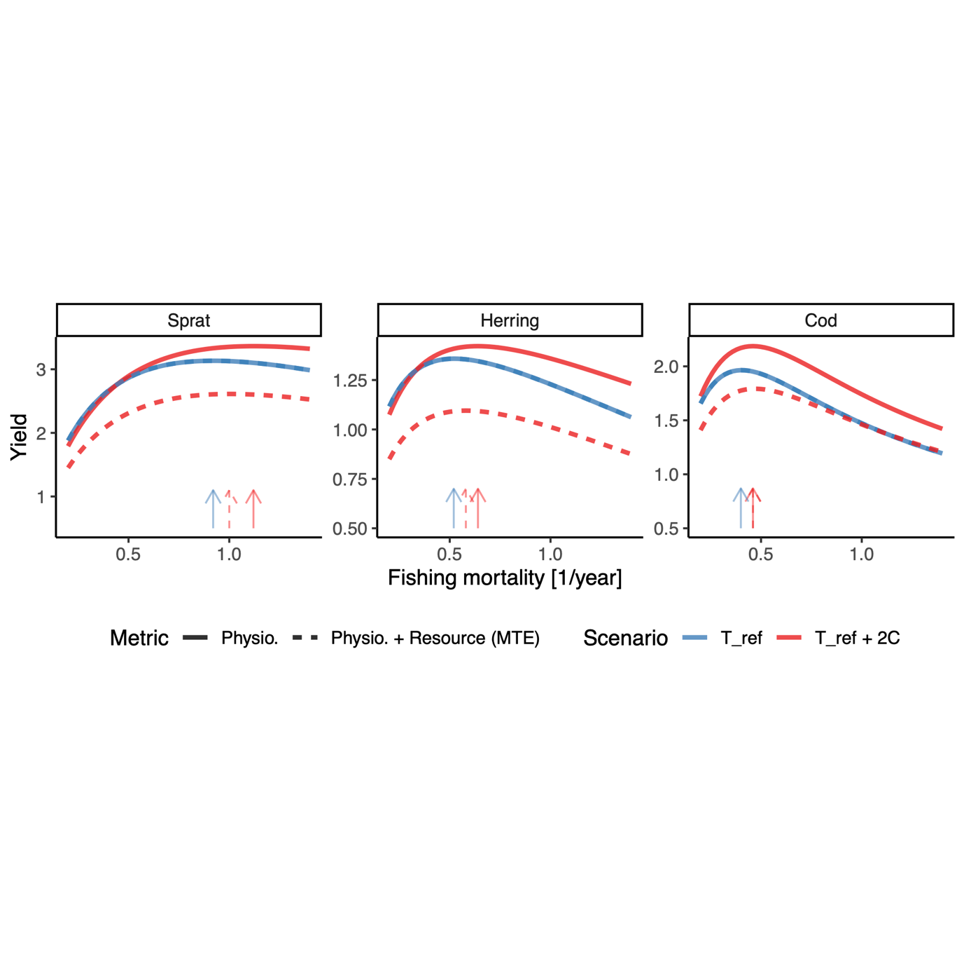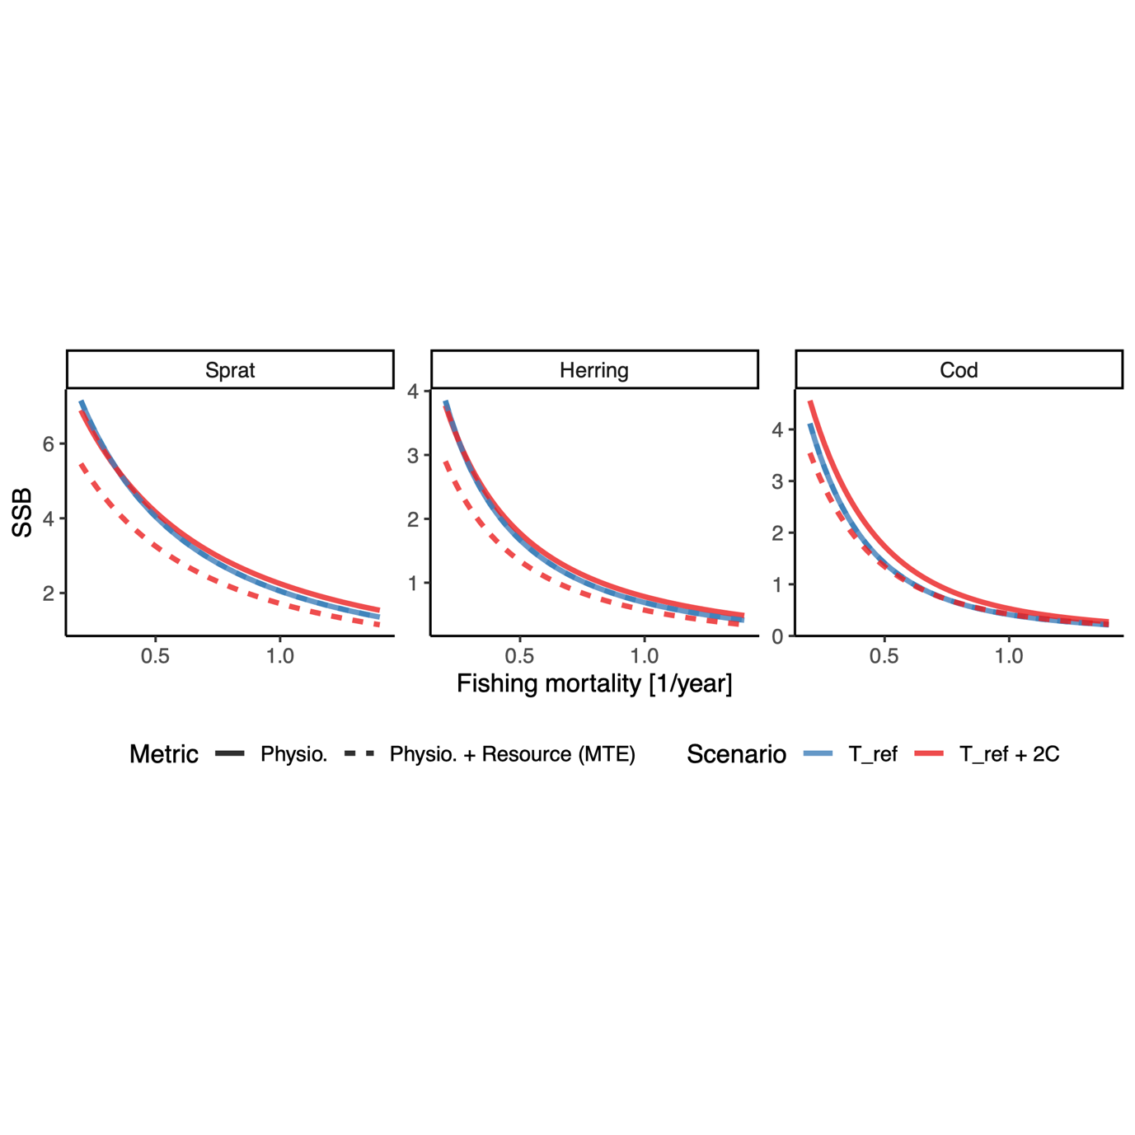

*Main conclusions*

1. The inclusion of temperature-dependent physiological processes can turn around the predicted effect of warming on size-at-age (from declining to increasing), and this happens for most of the random combinations of activation energies (based on meta-analysis).
2. The increased growth rates do not always lead to increased yields in warming scenarios. My interpretation (could be wrong) is that it’s because of changes in the size-spectra. Specifically, declines in abundance of most sizes below and slightly above w_mat, possibly from higher predation mortality rates. The only sizes that increase is the really large fish which do not contribute that much to yield)

**Discussion**

**(Just suggestions for topics at this point)**

* Discuss the main results: large differences in predictions when including physiological scaling, e.g. increased growth rates. Link this to empirical findings (this is often found, especially for young fish).
  + Also, model is relatively sensitive to physiological scaling, as previously found. This is based on that we see large effects even though activation energies are very similar compared to other literature estimates (e.g. Rall et al. 2010 ~ vs Englund et al 2011 ~ for ).
* Compare predictions that match and don’t match to Woodworth-Jefcoats (quite similar model) and Maury & Poggiale.
  + Here I also want to discuss different ways of adding background spectra changes: “Changes in abundance and size-structure of background resources can directly inferred from e.g. climate and earth systems models (Woodworth-Jefcoats et al. 2019)”. However, the simple metabolic approach provides a baseline model for temperature-dependence on population dynamics and allows for an easier interpretation of the relative effects of direct physiological effects (“top down”) vs changes in background productivity (“bottom up”). There are indications that also the slope of the size-spectrum ( in the term for carrying capacity), declines with temperature (Yvon‐Durocher *et al.* 2011), however on a global scale this effect is less clear statistically (Barnes *et al.* 2011).
* Limitations and strengths of this type of modelling approach (size spectrum vs other)
* Talk about other temperature effects we do not account for (range shifts, physiological parameters etc etc.)
  + “Our approach categorized one source of uncertainty as environmental variability, but the size-spectrum model does not explicitly include environmental variables such as temperature, salinity, and dissolved oxygen into modelling (Andersen and Beyer, 2006; Scott et al., 2014). It is worth noting that incorporating multiple environmental variables into mechanistic modelling is exceedingly difficult as environmental effects on ecosystems are often non-linear and mixed, and it is impossible to include all environmental variables (Pauly, 1980; Pepin, 1991; Charnov and Gillooly, 2004; Pörtner and Knust, 2007). But see Woodwarth.-Jefcoats and Blanchard 2017”
* Need to talk about the state of the Baltic and how that limits our relatively simple model to predict the things that are actually happening there (range shifts of the pelagic, spatial contraction of cod, earlier maturation and poor growth of cod, vitamin deficiency etc etc)

**Acknowledgements**

Romain Forestier and Jonatan Reum for contributing to developing code to implement temperature-dependence in mizer during a workshop, Christian Dietrich for providing temperature data, ICES staff and people involved in all stages of data collections and the mizer community.

**Author contributions**

The code was first developed from mizer (Scott *et al.* 2019) by AA to include multiple background resources, all authors contributed to developing the code to include temperature. ML conceived the idea. All authors contributed to study design. ML performed analysis and wrote the first draft. All authors contributed to writing the paper and to revisions.

**References**

Andersen, K.H. & Beyer, J.E. (2006). Asymptotic Size Determines Species Abundance in the Marine Size Spectrum., 8.

Andersen, K.Haste. & Pedersen, M. (2009). Damped trophic cascades driven by fishing in model marine ecosystems. *Proceedings of the Royal Society of London B: Biological Sciences*, 277, 795–802.

Atkinson, D. (1994). Temperature and Organism Size—A Biological Law for Ectotherms? In: *Advances in Ecological Research*. Elsevier, pp. 1–58.

Barneche, D.R., Jahn, M. & Seebacher, F. (2019). Warming increases the cost of growth in a model vertebrate. *Functional Ecology*, 33, 1256–1266.

Barnes, C., Irigoien, X., De Oliveira, J.A.A., Maxwell, D. & Jennings, S. (2011). Predicting marine phytoplankton community size structure from empirical relationships with remotely sensed variables. *J Plankton Res*, 33, 13–24.

Baudron, A.R., Needle, C.L., Rijnsdorp, A.D. & Marshall, C.T. (2014). Warming temperatures and smaller body sizes: synchronous changes in growth of North Sea fishes. *Global Change Biology*, 20, 1023–1031.

Belkin, I.M. (2009). Rapid warming of large marine ecosystems. *Progress in Oceanography*, 81, 207–213.

Bernhardt, J.R., Sunday, J.M. & O’Connor, M.I. (2018). Metabolic Theory and the Temperature-Size Rule Explain the Temperature Dependence of Population Carrying Capacity. *The American Naturalist*, 192, 687–697.

Blanchard, J.L., Andersen, K.H., Scott, F., Hintzen, N.T., Piet, G. & Jennings, S. (2014). Evaluating targets and trade-offs among fisheries and conservation objectives using a multispecies size spectrum model. *Journal of Applied Ecology*, 51, 612–622.

Blanchard, J.L., Heneghan, R.F., Everett, J.D., Trebilco, R. & Richardson, A.J. (2017). From Bacteria to Whales: Using Functional Size Spectra to Model Marine Ecosystems. *Trends in Ecology & Evolution*, 32, 174–186.

Blanchard, J.L., Jennings, S., Holmes, R., Harle, J., Merino, G., Allen, J.I., *et al.* (2012). Potential consequences of climate change for primary production and fish production in large marine ecosystems. *Philosophical Transactions of the Royal Society of London, Series B: Biological Sciences*, 367, 2979–2989.

Brett, J.R., Shelbourn, J.E. & Shoop, C.T. (1969). Growth Rate and Body Composition of Fingerling Sockeye Salmon, Oncorhynchus nerka, in relation to Temperature and Ration Size. *J. Fish. Res. Bd. Can.*, 26, 2363–2394.

Brose, U. (2010). Body-mass constraints on foraging behaviour determine population and food-web dynamics. *Functional Ecology*, 24, 28–34.

Brown, J.H., Gillooly, J.F., Allen, A.P., Savage, V.M. & West, G.B. (2004). Toward a metabolic theory of ecology. *Ecology*, 85, 1771–1789.

Cheung, W.W.L., Sarmiento, J.L., Dunne, J., Frölicher, T.L., Lam, V.W.Y., Deng Palomares, M.L., *et al.* (2013). Shrinking of fishes exacerbates impacts of global ocean changes on marine ecosystems. *Nature Climate Change*, 3, 254–258.

Clarke, A. & Johnston, N.M. (1999). Scaling of metabolic rate with body mass and temperature in teleost fish. *Journal of Animal Ecology*, 68, 893–905.

Curtsdotter, A., Banks, H.T., Banks, J.E., Jonsson, M., Jonsson, T., Laubmeier, A.N., *et al.* (2019). Ecosystem function in predator–prey food webs—confronting dynamic models with empirical data. *Journal of Animal Ecology*, 88, 196–210.

Daufresne, M., Lengfellner, K. & Sommer, U. (2009). Global warming benefits the small in aquatic ecosystems. *Proceedings of the National Academy of Sciences, USA*, 106, 12788–12793.

De Roos, A.M. & Persson, L. (2001). Physiologically structured models - from versatile technique to ecological theory. *Oikos*, 94, 51–71.

Dell, A.I., Pawar, S. & Savage, V.M. (2011). Systematic variation in the temperature dependence of physiological and ecological traits. *Proceedings of the National Academy of Sciences*, 108, 10591–10596.

Dieterich, C., Wang, S., Schimanke, S., Gröger, M., Klein, B., Hordoir, R., *et al.* (2019). Surface Heat Budget over the North Sea in Climate Change Simulations. *Atmosphere*, 10, 272.

Downs, C.J., Hayes, J.P. & Tracy, C.R. (2008). Scaling metabolic rate with body mass and inverse body temperature: A test of the Arrhenius fractal supply model. *Functional Ecology*, 22, 239–244.

Englund, G., Öhlund, G., Hein, C.L. & Diehl, S. (2011). Temperature dependence of the functional response. *Ecology Letters*, 14, 914–921.

Frainer, A., Primicerio, R., Kortsch, S., Aune, M., Dolgov, A.V., Fossheim, M., *et al.* (2017). Climate-driven changes in functional biogeography of Arctic marine fish communities. *Proc Natl Acad Sci USA*, 114, 12202–12207.

Free, C.M., Thorson, J.T., Pinsky, M.L., Oken, K.L., Wiedenmann, J. & Jensen, O.P. (2019). Impacts of historical warming on marine fisheries production. *Science*, 363, 979–983.

Fussmann, K.E., Schwarzmüller, F., Brose, U., Jousset, A. & Rall, B.C. (2014). Ecological stability in response to warming. *Nature Climate Change*, 4, 206–210.

Gårdmark, A., Casini, M., Huss, M., van Leeuwen, A., Hjelm, J., Persson, L., *et al.* (2015). Regime shifts in exploited marine food webs: detecting mechanisms underlying alternative stable states using size-structured community dynamics theory. *Phil. Trans. R. Soc. B*, 370, 20130262.

Gilbert, B., Tunney, T.D., McCann, K.S., DeLong, J.P., Vasseur, D.A., Savage, V.M., *et al.* (2014). A bioenergetic framework for the temperature dependence of trophic interactions. *Ecology Letters*, 17, 902–914.

Gillooly, J.F., Brown, J.H., West, G.B., Savage, V.M. & Charnov, E.L. (2001). Effects of size and temperature on metabolic rate. *Science*, 2248–2251.

Gregg, W.W., Conkright, M.E., Ginoux, P., O’Reilly, J.E. & Casey, N.W. (2003). Ocean primary production and climate: Global decadal changes. *Geophysical Research Letters*, 30.

Gröger, M., Arneborg, L., Dieterich, C., Höglund, A. & Meier, H.E.M. (2019). Summer hydrographic changes in the Baltic Sea, Kattegat and Skagerrak projected in an ensemble of climate scenarios downscaled with a coupled regional ocean–sea ice–atmosphere model. *Clim Dyn*, 53, 5945–5966.

Handeland, S.O., Imsland, A.K. & Stefansson, S.O. (2008). The effect of temperature and fish size on growth, feed intake, food conversion efficiency and stomach evacuation rate of Atlantic salmon post-smolts. *Aquaculture*, 283, 36–42.

Hartvig, M., Andersen, K.H. & Beyer, J.E. (2011). Food web framework for size-structured populations. *Journal of Theoretical Biology*, 272, 113–122.

Huey, R.B. & Kingsolver, J.G. (2019). Climate Warming, Resource Availability, and the Metabolic Meltdown of Ectotherms. *The American Naturalist*, 194, E140–E150.

ICES. (2013). *Report of the Baltic Fisheries Assessment Working Group (WGBFAS)* ( No. ICES CM 2013/ACOM:10.). 10-17 April 2013 ICES Headquarters, Copenhagen.

ICES. (2015). *Report of the Baltic Fisheries Assessment Working Group (WGBFAS)* ( No. ICES CM 2015/ACOM:10). 14-21 April 2015 ICES Headquarters, Copenhagen.

Jacobsen, N.S., Burgess, M.G. & Andersen, K.H. (2017). Efficiency of fisheries is increasing at the ecosystem level. *Fish and Fisheries*, 18, 199–211.

Jennings, S. & Collingridge, K. (2015). Predicting consumer biomass, size-structure, production, catch potential, responses to fishing and associated uncertainties in the world’s marine ecosystems. *PLoS ONE*, 10, 1–28.

Jutfelt, F., Norin, T., Ern, R., Overgaard, J., Wang, T., McKenzie, D.J., *et al.* (2018). Oxygen- and capacity-limited thermal tolerance: blurring ecology and physiology. *Journal of Experimental Biology*, 221.

Lefevre, S., McKenzie, D.J. & Nilsson, G.E. (2018). In modelling effects of global warming, invalid assumptions lead to unrealistic projections. *Global Change Biology*, 24, 553–556.

Lotze, H.K., Tittensor, D.P., Bryndum-Buchholz, A., Eddy, T.D., Cheung, W.W.L., Galbraith, E.D., *et al.* (2019). Global ensemble projections reveal trophic amplification of ocean biomass declines with climate change. *Proceedings of the National Academy of Sciences*, 116, 12907–12912.

McCauley, D.J., Pinsky, M.L., Palumbi, S.R., Estes, J.A., Joyce, F.H. & Warner, R.R. (2015). Marine defaunation: Animal loss in the global ocean. *Science*, 347.

Metz, J.A.J. & Diekmann, O. (1986). *The dynamics of physiologically structured populations*. Springer-Verlag, Heidelberg, Germany.

Mion, M., Thorsen, A., Vitale, F., Dierking, J., Herrmann, J.P., Huwer, B., *et al.* (2018). Effect of fish length and nutritional condition on the fecundity of distressed Atlantic cod *Gadus morhua* from the Baltic Sea: POTENTIAL FECUNDITY OF BALTIC *G. MORHUA*. *Journal of Fish Biology*, 92, 1016–1034.

Neubauer, P. & Andersen, K.H. (2019). Thermal performance of fish is explained by an interplay between physiology, behaviour and ecology. *Conserv Physiol*, 7.

Neuenfeldt, S., Bartolino, V., Orio, A., Andersen, K.H., Andersen, N.G., Niiranen, S., *et al.* (2019). Feeding and growth of Atlantic cod (Gadus morhua L.) in the eastern Baltic Sea under environmental change. *ICES Journal of Marine Science*, fsz224.

Pauly, D. (1980). On the interrelationships between natural mortality, growth parameters, and mean environmental temperature in 175 fish stocks. *ICES Journal of Marine Science*, 39, 175–192.

Persson, L. & De Roos, A.M. (2013). Symmetry breaking in ecological systems through different energy efficiencies of juveniles and adults. *Ecology*, 94, 1487–1498.

Pinsky, M.L., Worm, B., Fogarty, M.J., Sarmiento, J.L. & Levin, S.A. (2013). Marine Taxa Track Local Climate Velocities. *Science*, 341, 1239–1242.

Pontavice, H. du, Gascuel, D., Reygondeau, G., Maureaud, A. & Cheung, W.W.L. (2019). Climate change undermines the global functioning of marine food webs. *Global Change Biology*.

R Core Team. (2018). *R: A Language and Environment for Statistical Computing. R Foundation for Statistical Computing*. Vienna, Austria.

Rall, B.C., Brose, U., Hartvig, M., Kalinkat, G., Schwarzmuller, F., Vucic-Pestic, O., *et al.* (2012). Universal temperature and body-mass scaling of feeding rates. *Philosophical Transactions of the Royal Society of London, Series B: Biological Sciences*, 367, 2923–2934.

Reum, J.C.P., Blanchard, J.L., Holsman, K.K., Aydin, K. & Punt, A.E. (2019). Species‐specific ontogenetic diet shifts attenuate trophic cascades and lengthen food chains in exploited ecosystems. *Oikos*, 128, 1051–1064.

Righton, D.A., Andersen, K.Haste., Neat, F., Thorsteinsson, V., Steingrund, P., Svedäng, H., *et al.* (2010). Thermal niche of Atlantic cod Gadus morhua: limits, tolerance and optima. *Marine Ecology Progress Series*, 420, 1–13.

Savage, V.M., Gillooly, J.F., Brown, J.H., West, G.B. & Charnov, E.L. (2004). Effects of body size and temperature on population growth. *The American Naturalist*, 163, 429–441.

Scott, F., Blanchard, J. & Andersen, K. (2019). *mizer: Multi-Species sIZE Spectrum Modelling in R*. R. .

Scott, F., Blanchard, J.L. & Andersen, K.Haste. (2014). mizer: An R package for multispecies, trait-based and community size spectrum ecological modelling. *Methods in Ecology and Evolution*, 5, 1121–1125.

Spence, M.A., Blanchard, J.L., Rossberg, A.G., Heath, M.R., Heymans, J.J., Mackinson, S., *et al.* (2018). A general framework for combining ecosystem models. *Fish Fish*, 19, 1031–1042.

Svedäng, H. & Hornborg, S. (2014). Selective fishing induces density-dependent growth. *Nature Communications*, 5, 4152.

Thorson, J.T., Munch, S.B., Cope, J.M. & Gao, J. (2017). Predicting life history parameters for all fishes worldwide. *Ecological Applications*, 27, 2262–2276.

Ursin, E. (1967). A Mathematical Model of Some Aspects of Fish Growth, Respiration, and Mortality. *Journal of the Fisheries Research Board of Canada*, 24, 2355–2453.

Werner, E.E. & Gilliam, J.F. (1984). The ontogenetic nice and species interactions in size-structured populations. *Annual Review of Ecology and Systematics*, 15, 393–425.

Woodworth-Jefcoats, P.A., Blanchard, J.L. & Drazen, J.C. (2019). Relative Impacts of Simultaneous Stressors on a Pelagic Marine Ecosystem. *Frontiers in Marine Science*, 6.

Yvon‐Durocher, G., Montoya, J.M., Trimmer, M. & Woodward, G. (2011). Warming alters the size spectrum and shifts the distribution of biomass in freshwater ecosystems. *Global Change Biology*, 17, 1681–1694.

Zhang, C., Chen, Y. & Ren, Y. (2015). Assessing uncertainty of a multispecies size-spectrum model resulting from process and observation errors. *ICES J Mar Sci*, 72, 2223–2233.