Bottom-up and top-down effects of temperature on body growth, population size spectra and yield in a size-structured food web

Max Lindmark^{a,1}, Asta Audzijonyte^{b}, Julia Blanchard^{c}, Anna Gårdmark^{d}
ªSwedish University of Agricultural Sciences, Department of Aquatic Resources, Institute of Coastal Research, Skolgatan 6, Öregrund 742 42, Sweden
^{b}Institute for Marine and Antarctic Studies, University of Tasmania, Battery Point, TAS 7001, Australia
^{c}Institute for Marine and Antarctic Studies and Centre for Marine Socioecology, University of Tasmania, 20 Castray Esplanade, Battery Point, Hobart, TAS 7000, Australia
^{d}Swedish University of Agricultural Sciences, Department of Aquatic Resources, Skolgatan 6, SE-742 42 Öregrund, Sweden

Abstract
Resolving the combined effect of climate warming and exploitation in a food web context is key for predicting future biomass production, size-structure, and potential yields of marine fishes. Previous studies based on mechanistic size-based food web models have found that bottom-up processes are important drivers of size-structure and fisheries yield in changing climates. However, we know less about the joint effects of ‘bottom-up’ and ‘top-down’ effects of temperature: how do temperature effects propagate from individual-level physiology through food webs and alter the size-structure of exploited species in a community? Here we assess how a species-resolved size-based food web is affected by warming through both these pathways, and by exploitation. We parameterize a dynamic size spectrum food web model inspired by the offshore Baltic Sea food web, and investigate how individual growth rates, size-structure, relative abundances of species and yields are affected by warming. The magnitude of warming is based on projections by the regional coupled model system RCA4-NEMO and the RCP 8.5 emission scenario, and we evaluate different scenarios of temperature dependence on fish physiology and resource productivity. When accounting for temperature-effects on physiology in addition to on basal productivity, projected size-at-age in 2050 increases on average for all fish species, mainly for young fish, compared to scenarios without warming. In contrast, size-at-age decreases when temperature affects resource dynamics only, and the decline is largest for young fish. Faster growth rates due to warming, however, do not always translate to larger yields, as lower resource carrying capacities with increasing temperature tend to result in declines in the abundance of larger fish and hence spawning stock biomass – the part of the population exposed to fishing. These results show that to understand how global warming impacts the size structure of fish communities, both direct metabolic effects and indirect effects of temperature via basal resources must be accounted for.

Key words
Body size, climate change, fisheries yield, food web, metabolic theory, multi species, size spectrum

Introduction
Climate change affects aquatic food webs directly by affecting species’ distribution (Pinsky et al. 2013), abundance (McCauley et al. 2015), body size (Daufresne et al. 2009; Baudron et al. 2014), and ecosystem function (Pontavice et al. 2019). Global retrospective analysis of warming and fish population dynamics has revealed that productivity (population growth at a given biomass) of scientifically assessed fish populations across ecoregions has already declined by ~4% on average between 1930 and 2010 due to climate change (Free et al. 2019). These results are also matched in magnitude and direction by projections from an ensemble of mechanistic ecosystem models, which predict ~5% decline in animal biomass for every 1 $℃$ of warming, especially at higher trophic levels (Lotze et al. 2019). Across a range of process-based ecosystem models, declines in productivity of fish stocks and abundance of large fish, have been mostly linked to changes in primary production or zooplankton abundance (Blanchard et al. 2012; Woodworth-Jefcoats et al. 2013, 2015; Barange et al. 2014; Lotze et al. 2019). However, even in areas where warming is predicted to have positive effects on primary production, fish productivity does not appear to increase (Free et al. 2019). This suggests that fish population dynamics might be strongly influenced by other factors, such as temperature-driven changes in recruitment, mortality or somatic growth (Free et al. 2019), yet the driving mechanisms remain poorly understood.
Global warming is also predicted to cause reductions in the adult body size of organisms, and this is often referred to as the third universal response to warming (Daufresne et al. 2009; Sheridan & Bickford 2011; Forster et al. 2012). Such decrease, often referred to as the temperature-size rule (TSR) is observed in a wide range of ectotherms (Forster et al. 2012). This rule states that individuals reared at warmer temperatures develop faster, mature earlier but reach smaller adult body sizes (Atkinson 1994; Ohlberger 2013). In line with TSR expectations, faster growth rates or larger size-at-age of young life stages are commonly found in both experimental, field data and modelling studies (Thresher et al. 2007; Neuheimer et al. 2011; Ohlberger et al. 2011; Neuheimer & Grønkjaer 2012; Baudron et al. 2014; Huss et al. 2019; Van Dorst et al. 2019). Similarly, declines in maximum or asymptotic body size of fish have been reported to correlate with warming trends for a number of commercially exploited marine fishes (Baudron et al. 2014; van Rijn et al. 2017; Ikpewe et al. 2020). However, in intensively fished stocks, observed adult body sizes can decrease also for other reasons, including direct removals of large fish, or evolution towards earlier maturing and fast growth in response to fishing (Jorgensen et al. 2007; Audzijonyte et al. 2013). Moreover, decreasing adult fish size in warming waters is by far not universal. For example, no clear negative effects of warming on the body size or growth of large fish could be found in a recent experimental study (Barneche et al. 2019), or in a semi-controlled lake heating experiment (Huss et al. 2019). Similarly, across 335 coastal fish species mean species body size was similarly likely to be larger or smaller in warmer waters (Audzijonyte et al. 2020). Also Tu et al. (2018) found that temperature had a relatively minor effect on fish size structure, and even when combined with fishing, only 44% of variation in size structure could be explained. Thus, the effects of temperature on body sizes may be more complex than often depicted, and we still do not fully understand the mechanisms by which temperature affects growth and body size over ontogeny (Ohlberger 2013; Audzijonyte et al. 2019). Increasing our understanding of these mechanisms is important because body size is a key trait in aquatic ecosystems (Andersen et al. 2016) and warming-induced changes in growth and size-at-age of fish populations could have implications not only for biomass and productivity, but also ecosystem structure and stability (Audzijonyte et al. 2013).
Physiologically structured models can address the complex interplay of direct and indirect temperature impacts on food webs, as they account for the food and size dependence of body growth through ecological interactions using bioenergetic principles. Recent applications have demonstrated decreasing maximum body sizes in fish communities due to changes in plankton abundance or size (Woodworth-Jefcoats et al. 2019). Similar body size responses emerge in models that focus on temperature-dependence of physiological processes, such as metabolism and feeding rates (Lefort et al. 2015; Woodworth-Jefcoats et al. 2019), but it remains unclear to what extent these community body size shifts are driven by declining abundance of large fish versus changes in size-at-age across a range of ages.
To explore how direct and indirect effects of warming impact marine food web size structure and fisheries yields, we evaluate the impacts of temperature-driven changes in resource productivity and individual fish physiology using an example case of the Baltic Sea. The Baltic Sea constitutes a great example system, as it is a relatively well understood and species poor system (Mackenzie et al. 2007; Casini et al. 2009) that also is one of the warming hotspots globally (Belkin 2009). By using a temperature-dependent size spectrum model we analyse a set of different scenarios where either fish physiology, basal resources, or both depend on temperature, and contrast these scenarios to one other and to non-warming scenarios. We investigate the mechanisms warming effects on body growth trajectories, average body sizes, population size-structure and fisheries reference points and find that not only the magnitude of projected fish size-at-age, but also the effect of size, depend on whether temperature-dependence of physiological processes is accounted for or not. Most importantly, increased growth rates (mainly for juveniles) generally do not compensate for lower overall adult biomasses that is due to declining resource levels, such that warming often causes declining mean body sizes of fish populations and lower fisheries yields.

Materials and Methods
Food web
We developed a multi-species size spectrum model (MSSM) (Scott et al. 2014), parameterized to represent a simplified version of the food web in the offshore pelagic south-central Baltic Sea ecosystem (Baltic proper) (ICES sub divisions 25-29+32, Fig. S2, Supporting Information). This size structured food web is here characterized by three fish species: Atlantic cod (Gadus morhua), sprat (Sprattus sprattus) and herring (Clupea harengus), and two dynamic background resource spectra constituting food for small fish (pelagic and benthic resources). In this part of the Baltic Sea, these fish species are dominant in terms of biomass, they are the most important species commercially and they all have analytical stock assessments (ICES 2021). The pelagic background resource spectrum represents mainly phyto- and zooplankton while the benthic background resource spectrum represents benthic invertebrates, gobiidaes and small flatfish.

Size spectrum model
The model is based on source code for the multi-species implementation of size spectrum models in the ‘R’-package mizer (v1.1) (Blanchard et al. 2014; Scott et al. 2014; R Core Team 2020), which has been extended to include multiple background resources (Audzijonyte et al., unpublished) and temperature-scaling of key physiological processes. In this section we describe the key elements of the MSSM using the same notation when possible as in previous multispecies mizer models for consistency (Blanchard et al. 2014; Scott et al. 2014, 2018).
In MSSMs, individuals are characterized by their weight ($w$) and species identity ($i$). The core equation is the McKendrik-von Foerster equation, which here describes the change in abundance-at-size through time, from food dependent somatic growth and mortality, based on bioenergetic principles:
$$\begin{aligned}\frac{∂N_{i}\left(w\right)}{∂t}+\frac{∂g_{i}\left(w\right)N_{i}\left(w\right)}{∂w}=-μ_{i}\left(w\right)N_{i}\left(w\right)\#(1)\end{aligned}$$
where $g_{i}(w)$ ($g{ year}^{-1}$) is somatic growth (dependent on the availability of food) and $μ_{i}\left(w\right)$ (${ year}^{-1}$) is total mortality. At the boundary weight ($w_{0}$, egg size), the flux of individuals is given by recruitment. Total mortality is the sum of the background-, starvation-, fishing-, and predation mortality. The constant species-specific allometric background mortality ($μ_{bac,i}$) depends on the asymptotic weight of a species $W_{i}^{n-1}$ and is given by:
$$\begin{aligned}μ_{bac,i}=μ_{0}W_{i}^{n-1}\#(2)\end{aligned}$$
where $n$ is the mass-exponent of maximum consumption rate (Hartvig et al. 2011) and $μ_{0}$ is an allometric constant. Starvation mortality ($μ_{stv,i}$) is assumed to be proportional to energy deficiency (defined in Eq. 11) and inversely proportional to body mass (weight, $w$), and is defined as:
$$\begin{aligned}μ_{stv,i}\left(w\right)=\left\{\begin{matrix}0 & αf_{i}\left(w\right)h_{i}w^{n}>k_{met,i}w^{p} \\ \frac{k_{met,i}w^{p}-αf_{i}\left(w\right)h_{i}w^{n}}{ξw} & otherwise\end{matrix}\right.\#(3)\end{aligned}$$
where $ξ$, the fraction of energy reserves, is $0.1$ (Hartvig et al. 2011). Instantaneous fishing mortality ($μ_{fis,i}$) (1/year) is defined as:
$$\begin{aligned}μ_{fis,i}\left(w_{i}\right)=S_{i}\left(w\right)F_{i}\#(4)\end{aligned}$$
where $S_{i}$ is the selectivity (by default knife-edge selectivity is assumed with a weight at first catch corresponding to weight at maturation), and $F_{i}$ is fishing mortality. Predation mortality ($μ_{pre,j})$ for a prey species (or resource) $j$ with weight $w_{j}$ equals the amount consumed by predator species $i$ with weight $w_{i}$:
$$\begin{aligned}μ_{pre,j}\left(w_{j}\right)= \sum_{i}{\int{ϕ_{i}}\left(\frac{w_{j}}{w_{i}}\right)\left(1-f_{i}\left(w_{i}\right)\right)γ_{i}w_{i}^{q}θ_{i,j}N_{i}\left(w_{i}\right)dw}\#(5)\end{aligned}$$
where $θ_{i,j}$ is the non-size based preference of species $i$ on species $j$, and $ϕ_{j}$ describes the weight-based preference from the log-normal selection model (see below) (Ursin 1973). Satiation is represented in the model with a Holling functional response type II, which determines the feeding level $f_{i}\left(w\right)$:
$\begin{aligned}f_{i}\left(w\right)=\frac{E_{enc,i}\left(w\right)}{E_{enc,i}\left(w\right)+h_{i}w^{n}}\#(6)\end{aligned}$ describing the level of satiation (between 0 and 1). $h_{i}w^{n}$ is the allometric maximum consumption rate and $E_{enc,i}\left(w\right)$ is the encountered food (mass per time). The amount of encountered food for a predator of body weight $w$ is given by the available food in the system multiplied with the search volume, $γ_{i}$. Here, available food, $E_{ava,i}$, is the integral of the biomass of all prey species ($j$) and background resources ($R$) that falls within the prey preference ($θ_{i,j}, θ_{i,R}$) and size-selectivity ($ϕ_{i}$) of predator species $i$:
$$\begin{aligned}E_{ava,i}\left(w\right)=\int{\left(\sum_{R}{θ_{i,R}N_{R}\left(w_{R}\right)}+\sum_{j}{{θ_{i,j}N}_{j}\left(w_{j}\right)}\right)ϕ_{i}\left(\frac{w_{j}}{w_{i}}\right)w_{j}dw_{p}}\#(7)\end{aligned}$$
where $w_{j}$ is the weight of prey, $θ_{i,R}$ is the preference of species $i$ for resource $R$, and $j$ indicates prey species. Note that in contrast to other MSSMs (Blanchard et al. 2014) species have a preference for the background resources to account for them feeding differently on benthic and pelagic resources, but assume no preference in terms of the interactions among the size-structured fish species (all terms in the interaction matrix are identical and equal to 1). This is for simplicity, as the body size-only prey selection and encounter rate capture the important predation interactions in this system (as inferred from independent stomach data, see model calibration, Supporting Information), the species largely occupy similar spatial areas within the study area during the time period of the model calibration (Fig. S2), and we do not explicitly model any other prey sources these species could select. The size-selectivity of feeding, $ϕ_{i}\left(\frac{w_{j}}{w_{i}}\right)$, is given by a log-normal selection function (Ursin 1967):
$$\begin{aligned}ϕ_{i}\left(\frac{w_{j}}{w_{i}}\right)=exp\left[\frac{{-\left(ln\left(\frac{w_{i}}{\left(w_{j}β_{i}\right)}\right)\right)}^{2}}{2σ_{i}^{2}}\right]\#(8)\end{aligned}$$
where parameters $β_{i}$ and $σ_{i}$ are the preferred predator-prey mass ratio and the standard deviation of the log-normal distribution, respectively. The amount of available prey of suitable sizes (Eq. 7) is multiplied with the allometric function describing the search volume ($γ_{i}w^{q}$), where the allometric coefficient is calculated as:
$$\begin{aligned}γ_{i}\left(f_{0}\right)=\frac{f_{0}h_{i}β_{i}^{2-λ}\exp\left(-\frac{{\left(λ-2\right)}^{2}σ_{i}^{2}}{2}\right)}{\left(1-f_{0}\right)\sqrt{2π}κσ_{i}}\#(9)\end{aligned}$$
(Andersen & Beyer 2006; Scott et al. 2018), to give the actual biomass of food encountered, $E_{enc,i}\left(w\right)$:
$$\begin{aligned}E_{enc,i}\left(w\right)=γ_{i}w^{q}E_{ava,i}\left(w\right)\#(10)\end{aligned}$$
where $q$ is the size-scaling exponent of the search volume. The rate at which food is consumed is given by the product ${f_{i}\left(w\right)h}_{i}w^{n}$, which is assimilated with efficiency $α$ and used to cover metabolic costs. Metabolic costs scale allometrically as $k_{met,i}w^{p}$. The net energy, $E_{net,i}$, is thus:
$$\begin{aligned}E_{net.i}\left(w\right)=\max\left(0, αf_{i}\left(w\right)h_{i}w^{n}-k_{met,i}w^{p}\right)\#(11)\end{aligned}$$
which is allocated to growth or reproduction. The allocation to reproduction ($ψ_{i}$) increases smoothly from 0 around the weight maturation, $w_{mat,i}$, to 1 at the asymptotic weight, $W_{i}$, according to the function:
$$\begin{aligned}ψ_{i}={\left[1+{\left(\frac{w}{w_{mat,i}}\right)}^{-m}\right]}^{-1}{\left(\frac{w}{W_{i}}\right)}^{1-n}\#(12)\end{aligned}$$
(Andersen 2019). This function results in the growth rate, $g_{i}(w)$,
$$\begin{aligned}g_{i}\left(w\right)=E_{net,i}\left(w\right)\left(1-ψ_{i}\left(w\right)\right)\#(13)\end{aligned}$$
which approximates a von Bertalanffy growth curve when the feeding level is constant (Hartvig et al. 2011; Andersen 2019). Reproduction is given by the total egg production in numbers, which is the integral of the energy allocated to reproduction multiplied by a reproduction efficiency factor ($ϵ, erepro$) divided by the egg weight, $w_{0}$, and the factor 2, assuming only females reproduce:
$$\begin{aligned}R_{phy,i}=\frac{ϵ}{2w_{0}}\int{N_{i\left(w\right)}E_{net,i}\left(w\right)ψ_{i}\left(w\right)dw}\#(14)\end{aligned}$$
This total egg production (or physiological recruitment, $R_{phy,i}$) results in recruits via a Beverton-Holt stock recruit relationship, such that recruitment approaches a maximum recruitment for a species $i$ ($R_{max,i}$), as the egg production increases,
$$\begin{aligned}R_{i}=R_{max,i}\frac{R_{P,i}}{R_{P,i}+R_{max,i}}\#(15)\end{aligned}$$
where $R_{max,i}$ is treated as a free parameter and is estimated in the calibration process by minimizing the residual sum of squares between spawning stock biomass from stock assessments and the MSSM. The calibration also ensures that the species coexist in the model (Jacobsen et al. 2017).
The temporal dynamics of the background resource ($N_{R}$) spectra (benthic and pelagic) are defined as:
$$\begin{aligned}\frac{∂N_{R}\left(w,t\right)}{∂t}=r_{o}w^{p-1}\left[κw^{-λ}\left(w\right)-N_{R}\left(w,t\right)\right]-μ_{p, R}\left(w\right)N_{R}\left(w,t\right)\#(16)\end{aligned}$$
where $r_{o}w^{p-1}$ is the population regeneration rate, $κw^{-λ}$ is the carrying capacity of the background resource and $μ_{pre,R}$ is predation mortality on resource spectrum $R$, and λ is defined as $-2-q+n$ (Andersen 2019).

Temperature dependence
Temperature affects the rate of metabolism (Clarke & Johnston 1999; Gillooly et al. 2001), and thus also other biological rates (Englund et al. 2011; Rall et al. 2012; Thorson et al. 2017). We scale rates of individual metabolism ($k_{met.i}w^{p}$) (in mizer, this represents all metabolic costs, i.e., standard, activity digestions. Henceforth, we assume $k_{met.i}w^{p}$ scales as standard metabolic rate and refer to it as metabolism or metabolic rate), maximum consumption ($h_{i}w^{n}$), search volume ($γ_{i}w^{q}$) and background mortality ($μ_{0}W_{i}^{n-1}$) with temperature using an Arrhenius temperature correction factor:
$$\begin{aligned}r\left(T\right)=e^{\frac{A_{v}\left(T-T_{ref}\right)}{kTT_{ref}}}\#(17)\end{aligned}$$
where $A_{v}$ is the activation energy ($eV$) for individual rate $v$, $T$ is temperature ($K$), $T_{ref}$ is the reference temperature (here 283.27 $K$, the temperature where the Arrhenius correction factor equals 1), and $k$ is Boltzmann’s constant in $eV K^{-1}$ ($=8.617×{10}^{-5} eV K^{-1}$). We chose an exponential temperature dependence as it provides a good statistical fit to data, is widely adopted, and because we assume that the projected change in ocean temperature in the studied time range does not lead to temperatures above physiological optima (e.g. (Righton et al. 2010) as an example for cod), where physiological rates might be expected to decline. While temperature likely affects other physiological processes as well (such as cost of growth (Barneche et al. 2019) or food conversion efficiency (Handeland et al. 2008)), we focus on metabolism, maximum consumption, search volume and mortality, as their temperature dependencies are relatively well documented (Pauly 1980; Brown et al. 2004; Dell et al. 2011; Englund et al. 2011; Thorson et al. 2017; Lindmark et al. 2021).
Temperature also affects the amount of available background resources, via the same type of individual-level processes. In most size spectrum models to date, climate affects primary production (and in some cases zooplankton), and this is modelled by forcing the background spectra to observed abundance-at-size of plankton from either remotely sensed variables such as chlorophyll-a or from output from earth-system models (Blanchard et al. 2012; Barange et al. 2014; Canales et al. 2016; Reum et al. 2019; Woodworth-Jefcoats et al. 2019). An alternative approach is to force simulation with the growth rate or net primary production (Jennings & Collingridge 2015; Galbraith et al. 2017). These differences have been highlighted as a key source of ecosystem model uncertainties observed in global applications of size-structured models (Lotze et al. 2019) (Heneghan et al. 2021). In order to integrate the emergent responses of climate warming effects on “bottom-up” (e.g., background spectra) and “top-down” (physiology) processes, we apply the temperature scaling to the terms of the background resource’s semi-chemostat growth equation (Eq. 16), i.e. their biomass regeneration rate and carrying capacity. We use the same Arrhenius correction factor with activation energy $A_{r}$, where $r$ refers to background resource parameter. We assume that as temperature goes up, the carrying capacity ($κw^{λ}$) declines at the same rate as population regeneration ($r_{0}w^{p-1}$) rate increases (Savage et al. 2004; Gilbert et al. 2014), i.e. $κ$ scales with temperature in proportion to $e^{\frac{-A_{r}\left(T-T_{ref}\right)}{kTT_{ref}}}$. This is based on the metabolic theory of ecology (MTE), which predicts that if nutrient levels are constant, higher respiration rates lead to lower biomasses at carrying capacity (Savage et al. 2004; Bernhardt et al. 2018). Corroborating this assumption is the common prediction that primary production overall declines under global warming (though the trends vary regionally) (Steinacher et al. 2010; Kwiatkowski et al. 2019). Our implementation of temperature impacts on the background spectrum assumes that its size structure is not affected by the temperature (the slope of the spectrum does not change) – only the overall level of background resources in order to simplify the analyses.
As activation energies vary substantially between processes, species and taxonomic groups and are estimated with uncertainty, we parameterized 200 projections of the food web model using randomly sampled activation energies from normal distributions with rate-specific means and standard deviations. For metabolism and maximum consumption, we acquired means and standard deviations from the posterior distributions in (Lindmark et al. 2021) (note we assume search volume scales identically as maximum consumption and mortality as metabolism). The normal distributions describing activation energies for background resource parameters were defined by a mean equal to the point estimate from a linear regression of natural log of growth rate as a function of Arrhenius temperature ($1/kT$ [${eV}^{-1}$]) from experimental data in Savage et al. (2004) (pooling protists, algae and zooplankton, extracted using the software WebPlotDigitizer v. 4.1 (Rohatgi 2012)). We approximated a standard deviation by finding the value that resulted in 95% of the normal distribution being within the confidence interval of the linear regression. For each of the 200 parameter combinations, each of the six rate activation energy parameters was sampled independently from their respective distribution and the model was projected to 2050. We then quantified the overall mean response and the ranges of predictions resulting from 200 randomly parameterised simulations and visualized it for the analysis of growth and mean size.
We acknowledge that these scenarios are very simplified for evaluating changes in resource productivity versus physiology with warming, and that they do not necessarily reflect the predicted conditions in the Baltic Sea, nor all the potential pathways by which climate changes affects the environmental conditions in the Baltic Sea. However, the simplicity allows us to contrast effects of warming on basal food resources versus individual physiology of fish.

Model calibration
We estimated species-specific von Bertalanffy growth and length-weight parameters from scientific trawl survey data (for details, see Supporting Information, Table S1). Next, the model was calibrated to average spawning stock biomasses ($SSB_{i})$ from stock assessment data for cod, herring and sprat (ICES 2013, 2015) in 1992-2002, using average fishing mortalities ($F_{i}$) in the same time frame. Ideally, the period for calibration should exhibit relative stability, but such periods do not exist in the Baltic Sea, which is greatly influenced by anthropogenic activities and has undergone dramatic structural changes over the last four decades (Möllmann et al. 2009). We chose to calibrate our model to the time period of 1992-2002 as in Jacobsen et al. (2017), which is a post-regime shift period characterized by high fishing mortality on cod, low cod and herring abundance and high sprat abundance (Gårdmark et al. 2015) (Fig. S4). The cut-off at 2002 also ensured that we did not calibrate the model to the period starting from mid 2000’s when the growth capacity, condition, proportion of large fish in the population, and reproductive capacity of cod started to decline rapidly (Svedäng & Hornborg 2014; Casini et al. 2016; Mion et al. 2018, 2021; Neuenfeldt et al. 2020).
Model calibration was done by tuning the maximum recruitment parameter ($R_{max}$) for the three fish species to minimize the residual sum of squares between the natural log of spawning stock biomass estimated in stock assessment output (ICES 2013, 2015) and those emergent in the model for the years 1992-2002, while holding temperature constant at $T_{ref}$. We used the "L-BFGS-B" algorithm (Byrd et al. 1995) in the ‘R’-optimization function ‘optim’. We ensured that individual growth rates were close to observed by comparing the growth curves emerging in the model to the von Bertalanffy curves fitted to trawl survey data (Fig. S6), which they were after a stepwise manual increase of the constant in the allometric maximum-consumption rate ($h_{i}$) (Supporting Information). The level of density dependence imposed by the stock-recruitment function (see Eq. 14-15) was also evaluated by assessing the ratio of the physiological recruitment, $R_{phy,i}$, to the recruitment $R_{i}$ (Jacobsen et al. 2017) (Supporting Information). These values mean that stock recruitment is sensitive to the stock biomass, but there is some density dependence limiting recruitment (i.e., not all spawn produced become recruits). A detailed description of the step-by-step calibration protocol used in this study can be found in Fig. S4-S9, Supporting Information.

Analysis of responses to warming
Models were projected with historical fishing mortalities (1974-2014) (ICES 2013, 2015) and centred sea surface temperature trends (1970-2050, acquired from the regional coupled model system RCA4-NEMO under the RCP 8.5 scenario) (Dieterich et al. 2019; Gröger et al. 2019). To ensure steady state was reached before time-varying fishing mortality and temperature was introduced (1974 and 1970, respectively), we applied a 100-year burn-in period using the first fishing mortality and temperature value in the respective time series (Fig. S12). For each species, we used the fishing mortality at maximum long-term (‘sustainable’) yield, $F_{MSY}$, from the size spectrum model as fishing mortality in the years 2014-2050 (Fig. S12). We evaluated the effects of warming on weight-at-age, population mean weight and abundance-at-weight by species. This was done for both absolute values, and by comparing warming food webs to a baseline scenario where no warming occurred post 1997 (the mid-point of calibration time window, where temperature averages $T_{ref}$) (Fig. S12). In this way the three scenarios considered contrast the effects of temperature affecting fish physiology, their resources or both.
Finally, to explore the effect of temperature on fisheries yield and $F_{MSY}$, we specified a range of constant (not time-varying) temperatures and fishing mortalities, expressed as proportions of $T_{ref}$ and $F_{MSY}$ at the reference temperature ($F_{MSY,T_{ref}}$), respectively, and projected the models to steady state (200 years).

Results
Effects of warming on size-at-age depend on physiological temperature-dependence
The inclusion of temperature effects on fish physiological processes (“top-down” effects of warming) has a strong influence on the projected size-at-age in 2050 under the RCP 8.5 emission scenario, relative to the baseline projection (no warming) (Fig. 1). Including temperature dependence of metabolism, maximum consumption, search volume and mortality, with or without temperature-dependent background resource dynamics, leads to warming having positive effects on size-at-age (Fig. 1). In contrast, the scenarios without temperature-dependent physiological processes all lead to size-at-age decreasing with warming (Fig. 1). In scenarios with temperature-dependent physiological processes, the effects on size-at-age are positive and declines with age. When only resources are affected by temperature, small individuals have the largest relative decrease in size-at-age, and this negative effect of warming declines with age (Fig. 1).
Despite the relatively narrow range of activation energies for physiological rates considered here (Fig. S3; Table S3), the uncertainty in projected size-at-age associated with variation in the activation energies is large (Fig. 1). In the scenario where both physiology and resources are affected by temperature, the range of predicted changes in size-at-age vary at approximately $+10$% to $+$40% (Fig. 1). Changes in size-at-age seem to be driven by the temperature-dependence of maximum consumption rate $\left(h_{i}w^{n}(T)\right)$ increasing the actual consumption rates $\left({f_{i}\left(w\right)h}_{i}w^{n}(T)\right)$, and not due to increased feeding levels (Eq. 6; Fig. S13).

Fewer large individuals cause reductions in mean population body size
Increases in size-at-age (Fig. 1) do not always lead to increased mean body size in the populations (Fig. 2), due to changes in the population size structure, i.e., relative abundances at weight (Fig. 3). These changes in the size-structure vary between species, and there is no consistent pattern across species for each scenario.
The only scenario where mean body weight on average increases is where temperature only affects physiology and not the resource (Fig. 2), and this occurs only for cod and sprat. For cod this increase is strong and is driven by both faster growth rates and large increases in the abundance of large fish ($\sim 10 kg$) (Figs. 1, 3). For sprat the mean body weight in the populations increased only marginally and is mostly driven by faster growth rates and relative abundance of fish above $10 g$ (Figs. 1, 3). In contrast, scenarios where only resources are affected by temperature, relative numbers of large individuals and therefore mean body size of all species goes down. For herring, all scenarios lead to smaller mean body sizes in the population, and the relative (to non-warming simulation) abundance-at-weight declines with mass in most of the size range, with increases only in the very smallest size classes (< 1$g$; Fig. 3).

Temperature and fishing: higher sustained exploitation rates but reduced yields in warmer environments
Our simulations applying a range of stable (not time-varying) temperature and fishing scenarios showed that warming led to higher or equal $F_{MSY}$ (i.e., the fishing mortality leading to maximum sustainable yield) (Fig. 4) in six out of nine species$×$scenario combinations. The increase in $F_{MSY}$ is likely due to the enhanced growth rates (size-at-age), which allow higher fishing mortalities without impairing population growth. Cod in the scenario with only physiological scaling is the exemption, with higher yields as temperature increase, due to the increase in growth rate, average size and relative abundance of large individuals in that warming scenario for cod (See Figs. 1-3).
While $F_{MSY}$ generally increases, it results it lower yields in eight out of nine species$×$scenario combinations (Fig. 5). In general, the highest relative yield is found at the coolest temperatures and $F$ slightly lower than $F_{MSY}$ at the reference temperature (Fig. 5). The decline in relative yields of herring and sprat in all scenarios (Fig. 4) is likely driven by the warming-induced decline in abundance, due to resource limitation (Fig. 3). In all scenarios where only the resource is temperature dependent, the corresponding maximum sustainable yield ($MSY$) declines with warming (Fig. 4).

Discussion
Combined temperature impacts on fish growth rates, body size and fisheries yield
Using a size-structured and species-resolved food web model, we demonstrate how climate warming affects growth rates, population mean size and size-structure of interacting exploited fish species and assess its implications for fisheries yield. We contrasted the effects of warming on resource productivity and individual level physiology (metabolism, feeding and background mortality) of fish, and found that including temperature-dependence of physiological rates generally led to increased size-at-age of fishes with warming, whereas when temperature affects only the background resource species, size-at-age declines for fish of all sizes. The increase in size-at-age when including temperature dependence of physiological processes is strongest in juveniles of all three fish species, yet, despite increased growth rates, in most cases warming leads to smaller mean body size in the population, lower spawning stock biomass (biomass of mature fish) and reduced yields. This is because the carrying capacity of lower trophic level resources declines and fish mortality (background and to some extent predation mortality, see Fig. S14) increases with warming, which shifts the population size structure towards smaller individuals.
Mechanistic models exploring warming-driven declines in community-wide average body size often find these declines to be driven by lower food abundance or decreased energy transfer efficiency in the food web, due to a combination of declines in plankton density and shifts towards dominance of smaller plankton at higher temperatures (Lefort et al. 2015; Woodworth-Jefcoats et al. 2015, 2019). This leads to a community wide decline in mean size of fish, where large bodied species become relatively fewer. The cause of these community-level changes are different from those expected at an individual species level, where temperature can either lead to size-at-age changes over ontogeny (in accordance with the temperature-size rule), or a change in the relative abundance of small vs large individuals. TSR predicts higher growth rates and thus size-at-age of juveniles, but smaller adults body sizes (Atkinson 1994), although the physiological processes that lead to these changes remain debated (Audzijonyte et al. 2019). In our model, we include scenarios that reflect both warmer temperatures impact on food abundance as well physiological changes in metabolism and food intake rates. Scenarios with only temperature dependence of resource dynamics lead to declines in size-at-age (that in addition are strongest in young fish). This does not match general observations and predictions of how body growth is affected by warming (Thresher et al. 2007; Morita et al. 2010; Huss et al. 2019; Lindmark et al. 2021), and is not in accordance with the TSR. In contrast, inclusion of physiological temperature dependence leads to projections more in line with general observations from field data, which often find increased size-at-age that is strongest and positive for small individuals, and that this effect diminishes over ontogeny (Thresher et al. 2007; Huss et al. 2019).
The general increase in body growth is, however, in general not sufficient for maintaining similar mean population body sizes and size-structure if resource carrying capacities decline with warming, because this causes declines in the relative abundance of large fish. Mean body size in the population and yields therefore decline in the scenario with temperature dependence of both resource dynamics and physiology. These predictions on the net effect of warming are in line with similar models using empirically derived static plankton spectra (Blanchard et al. 2012; Canales et al. 2016; Woodworth-Jefcoats et al. 2019). If, however, resource carrying capacity would not decline with temperature, our results show that the increased body growth potential in fish due to faster metabolic and feeding rates can lead to changes towards dominance of larger fish in some populations. This is important to consider, given that predictions about effects of climate change on primary production are uncertain and show large regional variability (Steinacher et al. 2010). These results show that it is important to account for both direct and indirect effects of temperature in order to explain results such as increased growth rates and size-at-age but overall smaller-bodied populations, as also found in (Ohlberger et al. 2011; Ohlberger 2013; Neubauer & Andersen 2019; Gårdmark & Huss 2020). Focusing on changes only in bottom-up processes can therefore risk missing the potential for fish to increase their growth rates with initial warming, and how that response varies over ontogeny.
In fisheries stock assessment, plastic body growth is generally thought to be less important for stock dynamics than environmentally driven recruitment variation, density dependence at early life stages and mortality (Hilborn & Walters 1992; Lorenzen 2016). Due to the accumulating evidence of time-varying and climate-driven changes in vital rates (survival, growth and reproduction), their relative importance for fisheries reference points and targets are now becoming acknowledged (Thorson et al. 2015; Lorenzen 2016). In our modelling system, we find that maximum sustainable yields ($MSY$) and the fishing mortality leading to $MSY$, i.e., $F_{MSY}$, vary with both temperature and between modelling scenarios and that the effect can largely be predicted from changes in growth and abundance-at-size. When temperature affects both the background resources (mainly declining carrying capacity) and fish physiology, warming tends to increase $F_{MSY}$, but the yield ($MSY$) derived at this exploitation rate is lower. The decline in yields with warming is due to reduced resource availability, lowering overall fish abundance, and is in line with earlier studies (Blanchard et al. 2012; Lotze et al. 2019). In addition, the warming-induced decline in relative abundance of fish above minimum size caught in fisheries further decreases yields in our model. At the same time, faster growth rates (size-at-age), occurring when temperature affect vital rates in fish, can cause $F_{MSY}$ to increase with warming. These reference levels should not be viewed as absolute reference points, and the specific results may depend on the model calibration procedure. However, our findings suggest that climate change predictions on fisheries productivity must consider both temperature impacts on vital rates, in particular body growth, as well as bottom-up processes and their effects on both the overall abundance and size-structure of the stock. It also indicates that because productivity may decline with warming in large parts of the oceans (Lotze et al. 2019) (although there is large variation in these predictions across ecosystems (Steinacher et al. 2010)), reduced fisheries yields may be common in a warming world.

Parameterizing and modelling temperature effects
Including physiological temperature-dependence can strongly influence predictions of warming-effects and it allows for detailed understanding of temperature effects on populations and food webs via both individual bioenergetics and the emerging responses in fish body growth rates. However, it also requires more parameters, which in turn may vary across species. This could reduce generality of predictions and increased challenges in parameterizing models of data poor systems. We approached this by applying random parameterization, rather than fixed values of temperature dependence, by sampling parameters from distributions based on estimates of activation energies of physiological rates in the literature (Lindmark et al. 2021), to capture the uncertainty in these parameters. This approach revealed that in terms of body growth and mean body size in populations, the combination of activation energies can determine whether the mean size increases or decreases with warming, and at what age body sizes decline relative to the current temperatures (degree of decline in size-at-age). Hence, better knowledge of the temperature-dependence of rates of biological processes is needed and these parameters should be chosen carefully, and their uncertainty acknowledged in future modelling studies.
To disentangle temperature effects on background resources and physiological processes, we modelled temperature dependence of resources by scaling their parameters with the same general Arrhenius equation (Gillooly et al. 2001) that we used to scale the physiological processes in fish. Other similar studies using size spectrum models with physiological temperature-dependence instead import the plankton spectra from climate and earth systems models (Woodworth-Jefcoats et al. 2019) or from satellite data (Canales et al. 2016). Such approaches may lead to predictions that are more relevant for a specific system. However, it also becomes more difficult to separate the mechanisms behind the observed changes, as the resource dynamics then are externally forced and cannot respond to changes in the modelled food web. Moreover, populating a resource size spectrum based on observed data can be difficult as observed spectra result from both predation and bottom-up processes. As an alternative, our approach of directly scaling the carrying capacity or turnover rates of background resources with temperature provides a coherent way to model temperature-dependencies across trophic levels. The resource dynamics are then impacted by any warming-driven changes in predators, as well as inherent temperature-dependent dynamics, rather than driven by external data (Canales et al. 2016) or models (e.g., (Woodworth-Jefcoats et al. 2019). On the downside, this approach means relying on many major simplifications with respect to resource dynamics. In addition, our scenarios only include identical temperature dependencies and baseline carrying capacity of pelagic and benthic resources, and only negative effects of temperature on resource carrying capacity. These may not reflect the actual situation in the Baltic Sea and might better reflect the global decline in primary production (Steinacher et al. 2010) commonly predicted by coupled climate models (but see e.g. Flombaum et al. (2020)), which has been linked to declines in community-level body sizes (Woodworth-Jefcoats et al. 2019). It would be straightforward to model increases in productivity, as predicted on average by Sarmiento et al. (2004), with our approach by using positive activation energies. It is also possible to include temperature-effects of the slope of the size spectrum, as this is often found to be negatively related to temperature (e.g. (Morán et al. 2010; Yvon‐Durocher et al. 2011; Canales et al. 2016; Woodworth-Jefcoats et al. 2019), but see also Barnes et al. (2011)).

Conclusion
Ecological forecasting is inherently difficult, and climate change alters the already complex causal pathways that drive ecosystem dynamics. Size spectrum models have successfully been used to evaluate size-based mechanisms and structuring forces in ecosystems (Andersen & Pedersen 2009; Szuwalski et al. 2017; Reum et al. 2019). In this study, we have highlighted the important role of explicitly modelling temperature effects on individual-level metabolism and feeding rates. This not only makes predictions about temperature effects on size-at-age more in line with general observations and predictions (e.g., with the TSR), but also affects the levels of exploitation that leads to maximum sustainable yields, and the corresponding yields. Hence, accounting for temperature-dependence of both ecological and physiological processes underlying population dynamics is important for increasing our understanding of how and by which processes climate change affects individuals in food webs and resulting effects on fisheries yields, which is needed to generalize across systems and into novel conditions.

Acknowledgements
Thanks to Romain Forestier and Jonatan Reum for contributing to developing code on temperature-dependence in mizer during a workshop, Ken Haste Andersen for helpful discussion on model calibration, Christian Dietrich for providing temperature data, ICES staff and all involved in all stages of data collections, the helpful mizer community, Elizabeth Duskey and Magnus Huss for providing useful input. This study was supported by grants from the Swedish Research Council FORMAS (no. 217‐2013‐1315) and the Swedish Research Council (no. 2015‐03752) (both to AG).

Author contributions
The code was first developed from mizer (Scott et al. 2019) by AA to include multiple background resources, all authors contributed to developing the code to include temperature. ML conceived the idea. All authors contributed to study design. ML parameterized the model with input from AG. ML performed analysis and wrote the first draft. All authors contributed to writing the paper and to revisions.

Data availability
All model code (parameterization, calibration and analysis) and data are available on GitHub (https://github.com/maxlindmark/mizer-rewiring/tree/rewire-temp/baltic) and will be deposited on Zenodo upon publication.

References
Andersen, K.H. (2019). Fish Ecology, Evolution, and Exploitation: A New Theoretical Synthesis. Princeton University Press.
Andersen, K.H., Berge, T., Gonçalves, R.J., Hartvig, M., Heuschele, J., Hylander, S., et al. (2016). Characteristic Sizes of Life in the Oceans, from Bacteria to Whales. Ann Rev Mar Sci, 8, 217–241.
Andersen, K.H. & Beyer, J.E. (2006). Asymptotic Size Determines Species Abundance in the Marine Size Spectrum. The American Naturalist, 168, 8.
Andersen, K.Haste. & Pedersen, M. (2009). Damped trophic cascades driven by fishing in model marine ecosystems. Proceedings of the Royal Society of London B: Biological Sciences, 277, 795–802.
Atkinson, D. (1994). Temperature and organism size—A biological law for ectotherms? In: Advances in Ecological Research. Elsevier, pp. 1–58.
Audzijonyte, A., Barneche, D.R., Baudron, A.R., Belmaker, J., Clark, T.D., Marshall, C.T., et al. (2019). Is oxygen limitation in warming waters a valid mechanism to explain decreased body sizes in aquatic ectotherms? Global Ecology and Biogeography, 28, 64–77.
Audzijonyte, A., Kuparinen, A., Gorton, R. & Fulton, E.A. (2013). Ecological consequences of body size decline in harvested fish species: positive feedback loops in trophic interactions amplify human impact. Biology Letters, 9, 20121103.
Audzijonyte, A., Richards, S.A., Stuart-Smith, R.D., Pecl, G., Edgar, G.J., Barrett, N.S., et al. (2020). Fish body sizes change with temperature but not all species shrink with warming. Nat Ecol Evol, 4, 809–814.
Barange, M., Merino, G., Blanchard, J.L., Scholtens, J., Harle, J., Allison, E.H., et al. (2014). Impacts of climate change on marine ecosystem production in societies dependent on fisheries. Nature Clim Change, 4, 211–216.
Barneche, D.R., Jahn, M. & Seebacher, F. (2019). Warming increases the cost of growth in a model vertebrate. Functional Ecology, 33, 1256–1266.
Barnes, C., Irigoien, X., De Oliveira, J.A.A., Maxwell, D. & Jennings, S. (2011). Predicting marine phytoplankton community size structure from empirical relationships with remotely sensed variables. J Plankton Res, 33, 13–24.
Baudron, A.R., Needle, C.L., Rijnsdorp, A.D. & Marshall, C.T. (2014). Warming temperatures and smaller body sizes: synchronous changes in growth of North Sea fishes. Global Change Biology, 20, 1023–1031.
Belkin, I.M. (2009). Rapid warming of large marine ecosystems. Progress in Oceanography, 81, 207–213.
Bernhardt, J.R., Sunday, J.M. & O’Connor, M.I. (2018). Metabolic Theory and the Temperature-Size Rule Explain the Temperature Dependence of Population Carrying Capacity. The American Naturalist, 192, 687–697.
Blanchard, J.L., Andersen, K.H., Scott, F., Hintzen, N.T., Piet, G. & Jennings, S. (2014). Evaluating targets and trade-offs among fisheries and conservation objectives using a multispecies size spectrum model. Journal of Applied Ecology, 51, 612–622.
Blanchard, J.L., Jennings, S., Holmes, R., Harle, J., Merino, G., Allen, J.I., et al. (2012). Potential consequences of climate change for primary production and fish production in large marine ecosystems. Philosophical Transactions of the Royal Society of London, Series B: Biological Sciences, 367, 2979–2989.
Brown, J.H., Gillooly, J.F., Allen, A.P., Savage, V.M. & West, G.B. (2004). Toward a metabolic theory of ecology. Ecology, 85, 1771–1789.
Byrd, R.H., Lu, Peihuang., Nocedal, Jorge. & Zhu, Ciyou. (1995). A Limited Memory Algorithm for Bound Constrained Optimization. SIAM J. Sci. Comput., 16, 1190–1208.
Canales, T.M., Law, R. & Blanchard, J.L. (2016). Shifts in plankton size spectra modulate growth and coexistence of anchovy and sardine in upwelling systems. Canadian Journal of Fisheries and Aquatic Sciences, 73, 611–621.
Casini, M., Hjelm, J., Molinero, J.-C., Lövgren, J., Cardinale, M., Bartolino, V., et al. (2009). Trophic cascades promote threshold-like shifts in pelagic marine ecosystems. Proceedings of the National Academy of Sciences, USA, 106, 197–202.
Casini, M., Käll, F., Hansson, M., Plikshs, M., Baranova, T., Karlsson, O., et al. (2016). Hypoxic areas, density-dependence and food limitation drive the body condition of a heavily exploited marine fish predator. Royal Society Open Science, 3, 160416.
Clarke, A. & Johnston, N.M. (1999). Scaling of metabolic rate with body mass and temperature in teleost fish. Journal of Animal Ecology, 68, 893–905.
Daufresne, M., Lengfellner, K. & Sommer, U. (2009). Global warming benefits the small in aquatic ecosystems. Proceedings of the National Academy of Sciences, USA, 106, 12788–12793.
Dell, A.I., Pawar, S. & Savage, V.M. (2011). Systematic variation in the temperature dependence of physiological and ecological traits. Proceedings of the National Academy of Sciences, 108, 10591–10596.
Dieterich, C., Wang, S., Schimanke, S., Gröger, M., Klein, B., Hordoir, R., et al. (2019). Surface Heat Budget over the North Sea in Climate Change Simulations. Atmosphere, 10, 272.
Englund, G., Öhlund, G., Hein, C.L. & Diehl, S. (2011). Temperature dependence of the functional response. Ecology Letters, 14, 914–921.
Flombaum, P., Wang, W.-L., Primeau, F.W. & Martiny, A.C. (2020). Global picophytoplankton niche partitioning predicts overall positive response to ocean warming. Nat. Geosci., 13, 116–120.
Forster, J., Hirst, A.G. & Atkinson, D. (2012). Warming-induced reductions in body size are greater in aquatic than terrestrial species. PNAS, 109, 19310–19314.
Free, C.M., Thorson, J.T., Pinsky, M.L., Oken, K.L., Wiedenmann, J. & Jensen, O.P. (2019). Impacts of historical warming on marine fisheries production. Science, 363, 979–983.
Galbraith, E.D., Carozza, D.A. & Bianchi, D. (2017). A coupled human-Earth model perspective on long-term trends in the global marine fishery. Nat Commun, 8, 14884.
Gårdmark, A., Casini, M., Huss, M., van Leeuwen, A., Hjelm, J., Persson, L., et al. (2015). Regime shifts in exploited marine food webs: detecting mechanisms underlying alternative stable states using size-structured community dynamics theory. Phil. Trans. R. Soc. B, 370, 20130262.
Gårdmark, A. & Huss, M. (2020). Individual variation and interactions explain food web responses to global warming. Philosophical Transactions of the Royal Society B: Biological Sciences, 375, 20190449.
Gilbert, B., Tunney, T.D., McCann, K.S., DeLong, J.P., Vasseur, D.A., Savage, V.M., et al. (2014). A bioenergetic framework for the temperature dependence of trophic interactions. Ecology Letters, 17, 902–914.
Gillooly, J.F., Brown, J.H., West, G.B., Savage, V.M. & Charnov, E.L. (2001). Effects of size and temperature on metabolic rate. Science, 2248-2251.
Gröger, M., Arneborg, L., Dieterich, C., Höglund, A. & Meier, H.E.M. (2019). Summer hydrographic changes in the Baltic Sea, Kattegat and Skagerrak projected in an ensemble of climate scenarios downscaled with a coupled regional ocean–sea ice–atmosphere model. Clim Dyn, 53, 5945–5966.
Handeland, S.O., Imsland, A.K. & Stefansson, S.O. (2008). The effect of temperature and fish size on growth, feed intake, food conversion efficiency and stomach evacuation rate of Atlantic salmon post-smolts. Aquaculture, 283, 36–42.
Hartvig, M., Andersen, K.H. & Beyer, J.E. (2011). Food web framework for size-structured populations. Journal of Theoretical Biology, 272, 113–122.
Heneghan, R.F., Galbraith, E., Blanchard, J.L., Harrison, C., Barrier, N., Bulman, C., et al. (2021). Disentangling diverse responses to climate change among global marine ecosystem models. Progress in Oceanography, 198, 102659.
Hilborn, R. & Walters, C.J. (1992). Quantitative Fisheries Stock Assessment: Choice, Dynamics and Uncertainty. Springer, Norwell MA, USA.
Huss, M., Lindmark, M., Jacobson, P., Van Dorst, R.M. & Gårdmark, A. (2019). Experimental evidence of gradual size‐dependent shifts in body size and growth of fish in response to warming. Glob Change Biol, 25, 2285–2295.
ICES. (2013). Report of the Baltic Fisheries Assessment Working Group (WGBFAS) ( No. ICES CM 2013/ACOM:10.). 10-17 April 2013 ICES Headquarters, Copenhagen.
ICES. (2015). Report of the Baltic Fisheries Assessment Working Group (WGBFAS) ( No. ICES CM 2015/ACOM:10). 14-21 April 2015 ICES Headquarters, Copenhagen.
ICES. (2021). Report of the Baltic Fisheries Assessment Working Group (WGBFAS) ( No. 3:53).
Ikpewe, I.E., Baudron, A.R., Ponchon, A. & Fernandes, P.G. (2020). Bigger juveniles and smaller adults: Changes in fish size correlate with warming seas. Journal of Applied Ecology, Early View.
Jacobsen, N.S., Burgess, M.G. & Andersen, K.H. (2017). Efficiency of fisheries is increasing at the ecosystem level. Fish and Fisheries, 18, 199–211.
Jennings, S. & Collingridge, K. (2015). Predicting Consumer Biomass, Size-Structure, Production, Catch Potential, Responses to Fishing and Associated Uncertainties in the World’s Marine Ecosystems. PLOS ONE, 10, e0133794.
Jorgensen, C., Enberg, K., Dunlop, E.S., Arlinghaus, R., Boukal, D.S., Brander, K., et al. (2007). Ecology: managing evolving fish stocks. Science, 318, 1247–1248.
Kwiatkowski, L., Aumont, O. & Bopp, L. (2019). Consistent trophic amplification of marine biomass declines under climate change. Global Change Biology, 25, 218–229.
Lefort, S., Aumont, O., Bopp, L., Arsouze, T., Gehlen, M. & Maury, O. (2015). Spatial and body-size dependent response of marine pelagic communities to projected global climate change. Global Change Biology, 21, 154–164.
Lindmark, M., Ohlberger, J. & Gårdmark, A. (2021). Optimum growth temperature declines with body size within fish species. bioRxiv, 2021.01.21.427580.
Lorenzen, K. (2016). Toward a new paradigm for growth modeling in fisheries stock assessments: Embracing plasticity and its consequences. Fisheries Research, Growth: theory, estimation, and application in fishery stock assessment models, 180, 4–22.
Lotze, H.K., Tittensor, D.P., Bryndum-Buchholz, A., Eddy, T.D., Cheung, W.W.L., Galbraith, E.D., et al. (2019). Global ensemble projections reveal trophic amplification of ocean biomass declines with climate change. Proceedings of the National Academy of Sciences, 116, 12907–12912.
Mackenzie, B.R., Gislason, H., Möllmann, C. & Köster, F.W. (2007). Impact of 21st century climate change on the Baltic Sea fish community and fisheries. Global Change Biology, 13, 1348–1367.
McCauley, D.J., Pinsky, M.L., Palumbi, S.R., Estes, J.A., Joyce, F.H. & Warner, R.R. (2015). Marine defaunation: Animal loss in the global ocean. Science, 347.
Mion, M., Haase, S., Hemmer‐Hansen, J., Hilvarsson, A., Hüssy, K., Krüger‐Johnsen, M., et al. (2021). Multidecadal changes in fish growth rates estimated from tagging data: A case study from the Eastern Baltic cod (Gadus morhua, Gadidae). Fish and Fisheries, 22, 413–427.
Mion, M., Thorsen, A., Vitale, F., Dierking, J., Herrmann, J.P., Huwer, B., et al. (2018). Effect of fish length and nutritional condition on the fecundity of distressed Atlantic cod Gadus morhua from the Baltic Sea: POTENTIAL FECUNDITY OF BALTIC G. MORHUA. Journal of Fish Biology, 92, 1016–1034.
Möllmann, C., Diekmann, R., Müller‐Karulis, B., Kornilovs, G., Plikshs, M. & Axe, P. (2009). Reorganization of a large marine ecosystem due to atmospheric and anthropogenic pressure: a discontinuous regime shift in the Central Baltic Sea. Global Change Biology, 15, 1377–1393.
Morán, X.A.G., López‐Urrutia, Á., Calvo‐Díaz, A. & Li, W.K.W. (2010). Increasing importance of small phytoplankton in a warmer ocean. Global Change Biology, 16, 1137–1144.
Morita, K., Fukuwaka, M., Tanimata, N. & Yamamura, O. (2010). Size-dependent thermal preferences in a pelagic fish. Oikos, 119, 1265–1272.
Neubauer, P. & Andersen, K.H. (2019). Thermal performance of fish is explained by an interplay between physiology, behaviour and ecology. Conserv Physiol, 7.
Neuenfeldt, S., Bartolino, V., Orio, A., Andersen, K.H., Andersen, N.G., Niiranen, S., et al. (2020). Feeding and growth of Atlantic cod (Gadus morhua L.) in the eastern Baltic Sea under environmental change. ICES Journal of Marine Science, 77, 624–632.
Neuheimer, A.B. & Grønkjaer, P. (2012). Climate effects on size-at-age: growth in warming waters compensates for earlier maturity in an exploited marine fish. Global Change Biology, 18, 1812–1822.
Neuheimer, A.B., Thresher, R.E., Lyle, J.M. & Semmens, J.M. (2011). Tolerance limit for fish growth exceeded by warming waters. Nature Climate Change, 1, 110–113.
Ohlberger, J. (2013). Climate warming and ectotherm body size – from individual physiology to community ecology. Functional Ecology, 27, 991–1001.
Ohlberger, J., Edeline, E., Vollestad, L.A., Stenseth, N.C. & Claessen, D. (2011). Temperature-driven regime shifts in the dynamics of size-structured populations. The American Naturalist, 177, 211–223.
Pauly, D. (1980). On the interrelationships between natural mortality, growth parameters, and mean environmental temperature in 175 fish stocks. ICES Journal of Marine Science, 39, 175–192.
Pinsky, M.L., Worm, B., Fogarty, M.J., Sarmiento, J.L. & Levin, S.A. (2013). Marine Taxa Track Local Climate Velocities. Science, 341, 1239–1242.
Pontavice, H. du, Gascuel, D., Reygondeau, G., Maureaud, A. & Cheung, W.W.L. (2019). Climate change undermines the global functioning of marine food webs. Global Change Biology.
R Core Team. (2020). R: A Language and Environment for Statistical Computing. R Foundation for Statistical Computing. Vienna, Austria.
Rall, B.C., Brose, U., Hartvig, M., Kalinkat, G., Schwarzmuller, F., Vucic-Pestic, O., et al. (2012). Universal temperature and body-mass scaling of feeding rates. Philosophical Transactions of the Royal Society of London, Series B: Biological Sciences, 367, 2923–2934.
Reum, J.C.P., Blanchard, J.L., Holsman, K.K., Aydin, K. & Punt, A.E. (2019). Species‐specific ontogenetic diet shifts attenuate trophic cascades and lengthen food chains in exploited ecosystems. Oikos, 128, 1051–1064.
Righton, D.A., Andersen, K.Haste., Neat, F., Thorsteinsson, V., Steingrund, P., Svedäng, H., et al. (2010). Thermal niche of Atlantic cod Gadus morhua: limits, tolerance and optima. Marine Ecology Progress Series, 420, 1–13.
van Rijn, I., Buba, Y., DeLong, J., Kiflawi, M. & Belmaker, J. (2017). Large but uneven reduction in fish size across species in relation to changing sea temperatures. Global Change Biology, 23, 3667–3674.
Rohatgi, A. (2012). WebPlotDigitalizer: HTML5 based online tool to extract numerical data from plot images. Version 4.1. [WWW document] URL https://automeris.io/WebPlotDigitizer (accessed on January 2019).
Sarmiento, J.L., Slater, R., Barber, R., Bopp, L., Doney, S.C., Hirst, A.C., et al. (2004). Response of ocean ecosystems to climate warming. Global Biogeochemical Cycles, 18, n/a-n/a.
Savage, V.M., Gillooly, J.F., Brown, J.H., West, G.B. & Charnov, E.L. (2004). Effects of body size and temperature on population growth. The American Naturalist, 163, 429–441.
Scott, F., Blanchard, J. & Andersen, K. (2019). mizer: Multi-Species sIZE Spectrum Modelling in R. R. .
Scott, F., Blanchard, J.L. & Andersen, K.H. (2014). mizer: An R package for multispecies, trait-based and community size spectrum ecological modelling. Methods in Ecology and Evolution, 5, 1121–1125.
Scott, F., Blanchard, J.L. & Andersen, K.Haste. (2018). Multispecies, trait and community size spectrum ecological modelling in R ( mizer ), 1–87.
Sheridan, J.A. & Bickford, D. (2011). Shrinking body size as an ecological response to climate change. Nature Climate Change, 1, 401–406.
Steinacher, M., Joos, F., Frolicher, T.L., Bopp, L., Cadule, P., Cocco, V., et al. (2010). Projected 21st century decrease in marine productivity: a multi-model analysis. Biogeosciences, 7.
Svedäng, H. & Hornborg, S. (2014). Selective fishing induces density-dependent growth. Nature Communications, 5, 4152.
Szuwalski, C.S., Burgess, M.G., Costello, C. & Gaines, S.D. (2017). High fishery catches through trophic cascades in China. Proceedings of the National Academy of Sciences, 114, 717–721.
Thorson, J.T., Monnahan, C.C. & Cope, J.M. (2015). The potential impact of time-variation in vital rates on fisheries management targets for marine fishes. Fisheries Research, 169, 8–17.
Thorson, J.T., Munch, S.B., Cope, J.M. & Gao, J. (2017). Predicting life history parameters for all fishes worldwide. Ecological Applications, 27, 2262–2276.
Thresher, R.E., Koslow, J.A., Morison, A.K. & Smith, D.C. (2007). Depth-mediated reversal of the effects of climate change on long-term growth rates of exploited marine fish. Proceedings of the National Academy of Sciences, USA, 104, 7461–7465.
Tu, C.-Y., Chen, K.-T. & Hsieh, C. (2018). Fishing and temperature effects on the size structure of exploited fish stocks. Sci Rep, 8, 7132.
Ursin, E. (1967). A Mathematical Model of Some Aspects of Fish Growth, Respiration, and Mortality. Journal of the Fisheries Research Board of Canada, 24, 2355–2453.
Ursin, E. (1973). On the prey size preferences of cod and dab. Meddelelser fra Danmarks Fiskeri-og Havun- dersgelser, 7:8598.
Van Dorst, R.M., Gårdmark, A., Svanbäck, R., Beier, U., Weyhenmeyer, G.A. & Huss, M. (2019). Warmer and browner waters decrease fish biomass production. Global Change Biology, 25, 1395–1408.
Woodworth-Jefcoats, P.A., Blanchard, J.L. & Drazen, J.C. (2019). Relative Impacts of Simultaneous Stressors on a Pelagic Marine Ecosystem. Frontiers in Marine Science, 6.
Woodworth-Jefcoats, P.A., Polovina, J.J., Dunne, J.P. & Blanchard, J.L. (2013). Ecosystem size structure response to 21st century climate projection: large fish abundance decreases in the central North Pacific and increases in the California Current. Global Change Biology, 19, 724–733.
Woodworth-Jefcoats, P.A., Polovina, J.J., Howell, E.A. & Blanchard, J.L. (2015). Two takes on the ecosystem impacts of climate change and fishing: Comparing a size-based and a species-based ecosystem model in the central North Pacific. Progress in Oceanography, 138, 533–545.
Yvon‐Durocher, G., Montoya, J.M., Trimmer, M. & Woodward, G. (2011). Warming alters the size spectrum and shifts the distribution of biomass in freshwater ecosystems. Global Change Biology, 17, 1681–1694.

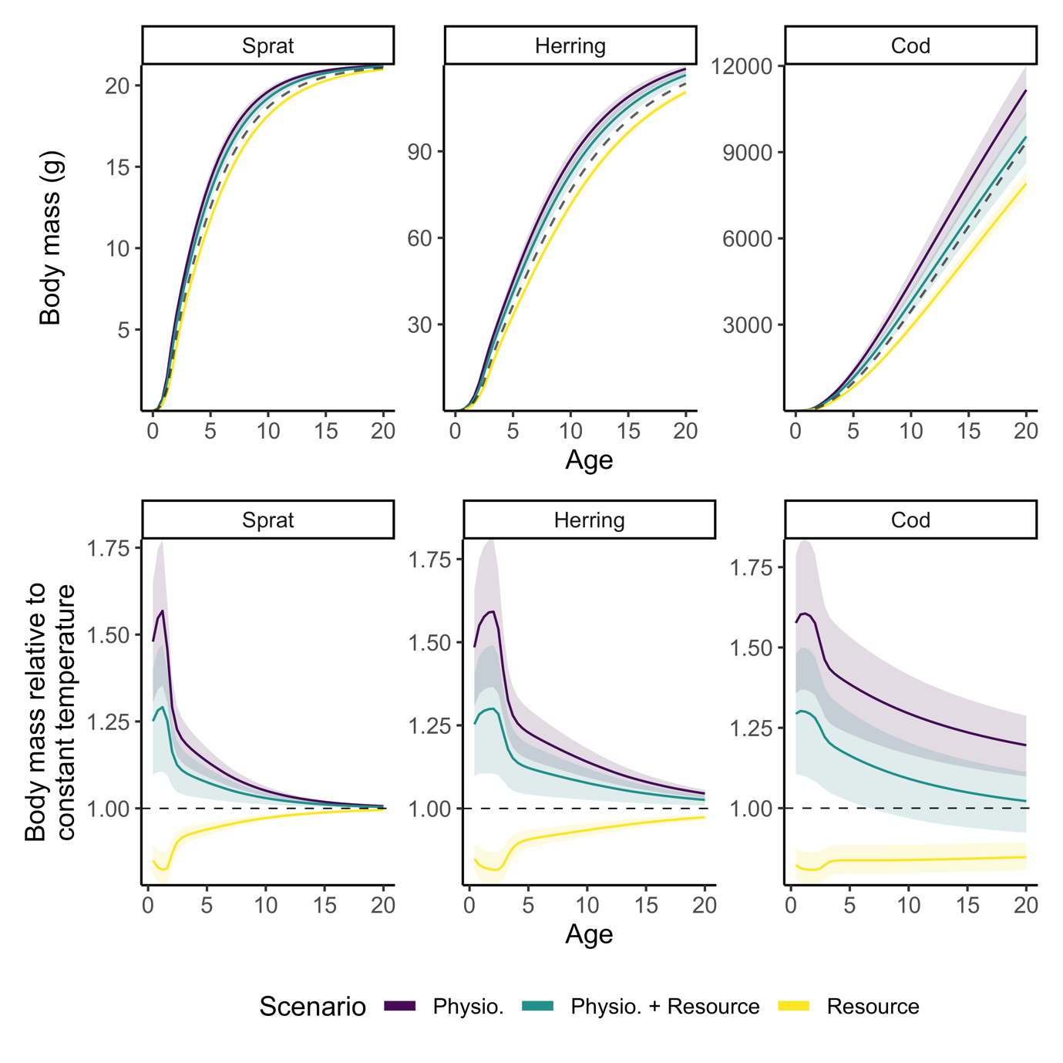
Figure 1. Individual growth trajectories of sprat, herring, and cod from model projections to year 2050 assuming warming according to RCP 8.5 while keeping fishing mortality at F_{MSY} levels from the size spectrum model. Top row shows size-at-age and bottom row shows size-at-age relative to a non-warming scenario. The dashed line in the top row depicts projections assuming a non-warming scenario and thus constitutes a baseline prediction. Colours indicate different temperature-scaling scenarios. Shaded areas encompass the 2.5 and 97.5 percentiles from the set of 200 simulations with randomly assigned activation energies.

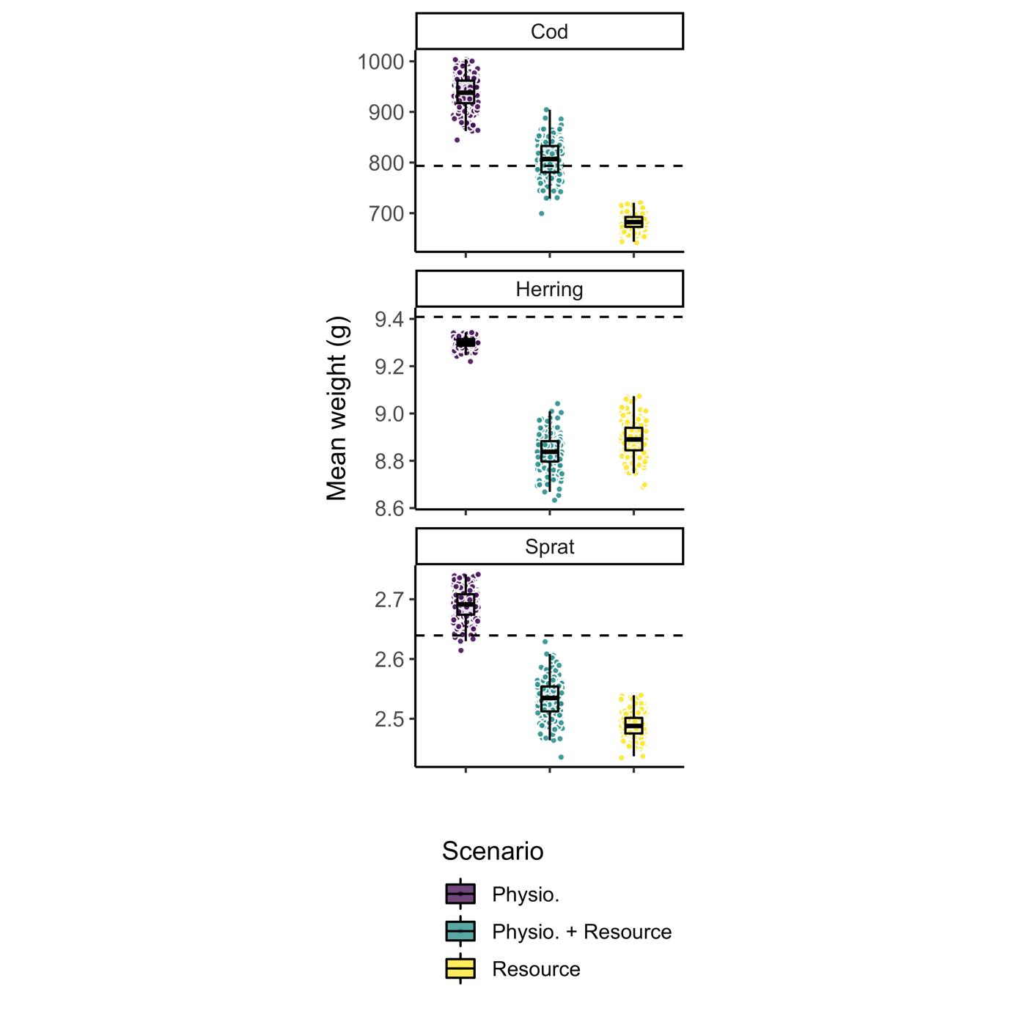
Figure 2. Mean weight across all individuals in the populations of sprat, herring and cod from model projections to year 2050 assuming warming according to RCP 8.5 while keeping fishing mortality at F_{MSY} levels from the size spectrum model. The dashed horizontal line depicts projections assuming no temperature increase and thus constitutes a baseline prediction. Each dot represents one of the 200 simulations, each with randomly assigned activation energies. Boxplots depict 25%, 50% and 75% quantiles of the 200 simulations in each scenario.

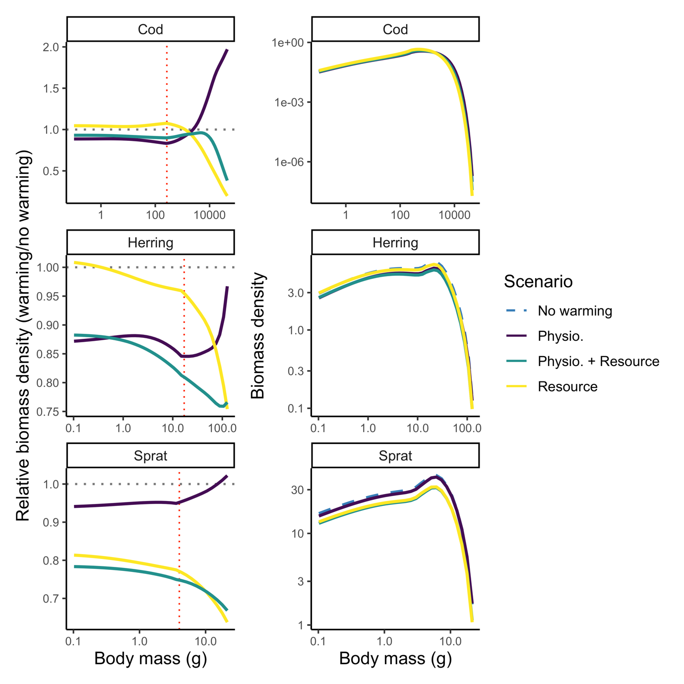
Figure 3. Projected abundance-at-weight by species for different scenarios of temperature scaling indicated by colours (and line types in the right column due to overplotting) in 2050 assuming fishing mortality held at F_{MSY} levels from the size spectrum model. The left column shows abundance-at-weight relative to a non-warming scenario and the right column shows absolute abundance-at-weight with the non-warming scenario shown in black. Vertical red dotted line indicates weight-at-maturation and horizontal black dotted lines indicate the baseline projection (no warming). Only mean activation energies are used (Table S3, Supporting Information).

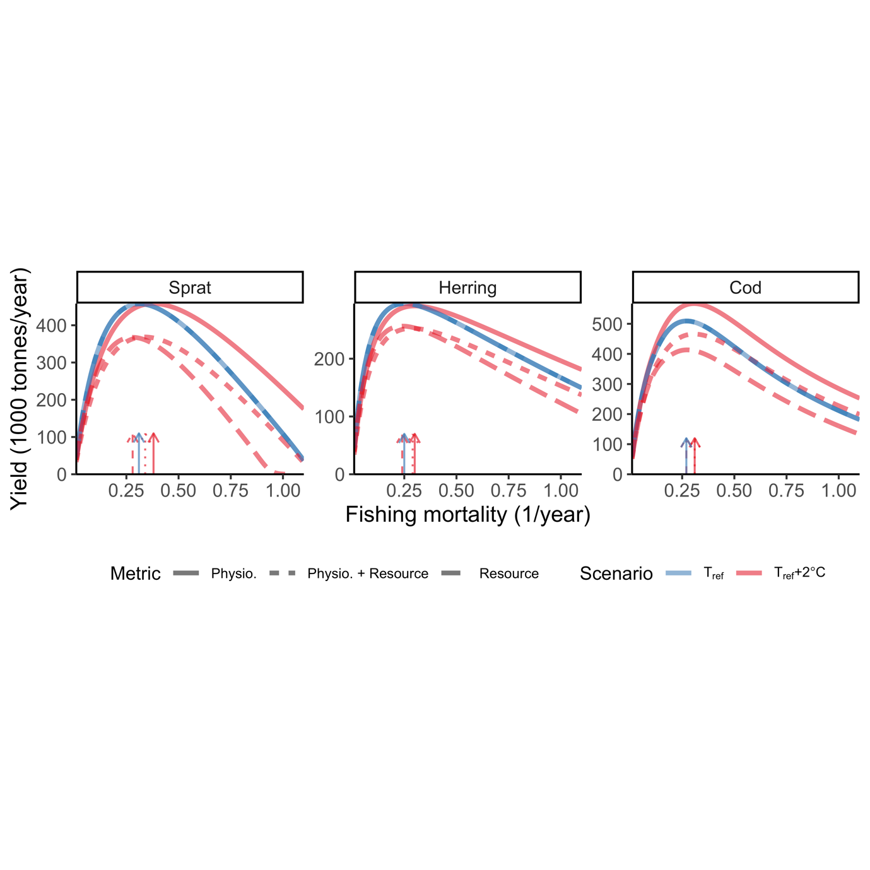
Figure 4. Steady state biomass yield assuming knife edge selectivity at maturation size under two constant temperature simulations and three scenarios for temperature dependence. Colours indicate temperature, where blue means $T=T_{ref}$ (i.e., no temperature effects), and red depicts warm temperature, here $T=T_{ref}$+2$℃$. Dashed lines correspond to resource dynamics being temperature dependent, dotted lines correspond to physiological rates and resource dynamics being temperature dependent and solid lines depicts only physiological temperature scaling. Arrows indicate fishing mortality (F) that leads to maximum sustainable yield ($F_{MSY})$. F is held constant at the mean F during calibration (mean 1992-2002) for the two other species while estimating yield curves for one species. Note the different scales between species. Only mean activation energies are used (Table S3, Supporting Information).

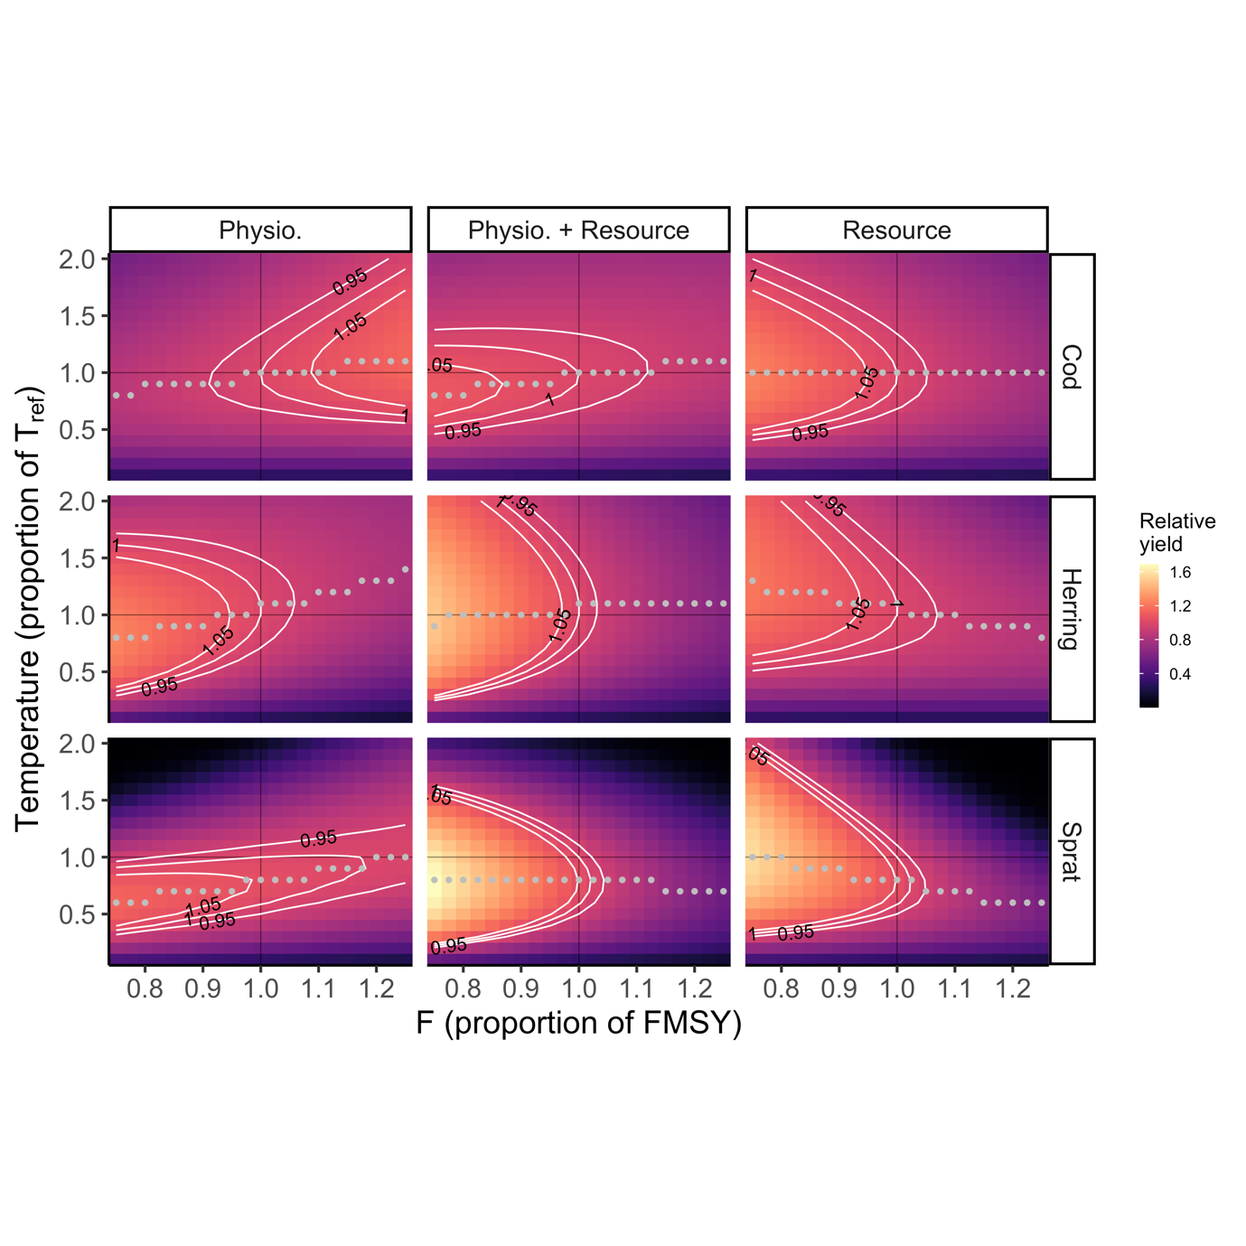
Figure 5. Example of fisheries yield at steady state relative to MSY at $T_{ref}$ (no effect of temperature) from simulations with constant (not time-varying) temperatures with the three temperature dependence scenarios (columns). The y-axis shows fishing mortality, $F$, as a proportion to $F_{MSY}$ (as estimated from the size spectrum model) at $T_{ref}$ and the x-axis shows temperature as a proportion of $T_{ref}$. The other two species are held at their $F_{MSY}$ when one species’ F is varied. White lines are 0.95, 1 and 1.05 yield isoclines (for example, the 1 isocline shows F and T-values where yield is equal $F_{MSY}$ without any warming). The fact that isoclines $≥1$ occur at relative temperatures below 1 in eight out of nine panels show that any warming will reduce the MSY. Grey points show at which F yields maximized across all temperatures (y-values). In three out of nine panels, $F_{MSY}$ declines with warming (for herring when only resource are temperature dependent, and for sprat whenever resources are temperature dependent). Only mean activation energies are used (Table S3, Supporting Information).

