*Intraspecific optimum growth temperature declines with body size across fishes*

Max Lindmarka,1, Jan Ohlbergerb, Anna Gårdmarkc

a Swedish University of Agricultural Sciences, Department of Aquatic Resources, Institute of Coastal Research, Skolgatan 6, Öregrund 742 42, Sweden

b School of Aquatic and Fishery Sciences (SAFS), University of Washington, Box 355020, Seattle, WA 98195-5020, USA

c Swedish University of Agricultural Sciences, Department of Aquatic Resources, Skolgatan 6, SE-742 42 Öregrund, Sweden

1 Author to whom correspondence should be addressed. Current address:

Max Lindmark, Swedish University of Agricultural Sciences, Department of Aquatic Resources, Institute of Coastal Research, Skolgatan 6, Öregrund 742 42, Sweden, Tel.: +46(0)104784137, email: [max.lindmark@slu.se](mailto:max.lindmark@slu.se)

**KEY WORDS**:

**WORD COUNT**:

Abstract: ~19

Introduction: ~1100

Methods: ~900

Results: ~500

Discussion: ~1400 (missing one section currently)

Total: ~ 3900

*Large body sizes restrict beneficial effects of warming on fish body growth*

1. Individual body growth rates affect fitness of individuals, population growth rates and ecosystem functions such as productivity and yield from capture fisheries. Warming of aquatic communities is generally predicted to cause faster growth rates and small asymptotic body sizes. However, we lack a mechanistic understanding the causes, and empirical data on changes in growth-related traits are limited to either field data on exploited species or limited to few specific studies.
2. Here we combine a literature search with a data mining approach to compile a unique dataset on intraspecific growth experiments of individual fish, and use hierarchical models to explore how individual growth rates scale with body size and temperature within-species.
3. We find positive effects of warming on growth, small negative effects of temperature on the mass-scaling exponent of growth and clear support for a declining optimum growth temperature as individuals grow in body size.
4. These findings suggests that small individuals within a species will likely be able to increase their growth rates with initial warming, while larger individuals may gain less. Size-dependent changes in growth dynamics due to climate warming may have implications for the structure and functioning of future aquatic ecosystems.

**Introduction**

Body growth is a fundamental process that links different levels of biological organization. It affects individuals’ fitness and life history traits such as maturation size, population growth rates (Savage *et al.* 2004) and ultimately energy transfer across trophic levels (Andersen *et al.* 2009; Barneche & Allen 2018). Therefore, understanding of how growth rates are affected by global warming is of key importance for making predictions about future ecosystem.

We only have a limited understanding of the mechanistic basis of fish growth bioenergetics, and this impairs our ability to predict changes in growth due to climate change (Rosenfeld *et al.* 2015; Lefevre *et al.* 2017; Audzijonyte *et al.* 2018; Barneche & Allen 2018; Marshall & White 2018). What we do know and where both theoretical models “of Pütter-type”, such as the Ontogenetic Growth Model (OGM) (West *et al.* 2001) or the von Bertalanffy Growth Equation (VBGE) (von Bertalanffy 1957), and empirical studies e.g. (Björnsson *et al.* 2007) agree is that specific growth rates decrease with body size and increase with temperature until an optimum temperature is reached (Pauly 1979; Jobling 1997; Morita *et al.* 2010). At temperatures below optimum, growth, being a biological process, has been suggested to scale with temperature as metabolic rate, i.e. as , where is Boltzmann’s constant () and is the activation energy or the coefficient to in a log-log regression (Sibly *et al.* 2015). In an attempt to mechanistically explain the temperature-dependence of growth, Sibly *et al.* 2015 used the metabolic theory of ecology-framework to show that in the VBGE is proportional to growth rate at 1/2. They found the slope to be , which is slightly lower than activation energy of metabolic rate (Clarke & Johnston 1999; Downs *et al.* 2008), and also that growth scales differently with asymptotic mass across and between species, which challenges current growth models. An important point however is that is not a growth rate per se as it is in unit time-1 (FishR), and is only proportional to growth rate at 1/2 under the assumption that anabolism and catabolism in the VBGE scale as 2/3 and 1, respectively (Sibly *et al.* 2015). This assumption has recently been questioned on physiological and evolutionary grounds (Lefevre *et al.* 2017, 2018; Marshall & White 2018, 2019). In addition, is in this case one of three parameters describing ontogenetic growth rates in the VBGE and is therefore not independent from estimates of with asymptotic size, (Pauly 1979). This warrants more research on characterizing growth rates over ontogeny rather than single growth parameters when possible.

Moreover, the effect of temperature on growth (e.g. or any other parameter related to growth performance) is often inferred from measurements across gradients of environmental temperatures. The response to warming over time of a single population is assumed to follow the same pattern as that found along the thermal gradient over a snapshot in time. The benefit of this assumption is that one can use the large amounts of data available on databases such as Fishbase. Using this approach, (Barneche & Allen 2018) showed that the cost of growth – the energy needed to produce one unit of biomass – could increase with warming, with potential consequences for energy transfer efficiency across trophic levels (Barneche & Allen 2018). Increasing costs of growth with warming was later also found in an detailed experimental study tracking growth over ontogeny (Barneche *et al.* 2019). However, in general, it is still unknown how well spatial temperature-patterns match responses to warming over time. The main difference between the two effects of temperature is that average habitat temperatures rarely exceed optimum temperatures and the response along a spatial gradient is rarely unimodal. Therefore, average field growth rates across populations of a species is not necessarily the same as the average growth rates within a population experiencing warming over time, as the inferred thermal performance curves may have different shapes. The latter might however be more relevant in the context of global warming. Better exemplify unknown about T\_opt being size dep (cite morita) and exponent being constant in this section.

Another potential issue that limits our understanding of how body growth rates scale is that the effects of temperature and body mass are commonly assumed to be independent (Zuo *et al.* 2012; Sibly *et al.* 2015). This could lead to biases when normalizing rates to a specific body mass or temperature if the effect of body size is not identical at different temperatures. In fact, interactions between temperature and mass are fairly common in the literature. For instance, temperature-dependent mass-scaling exponents and the related finding of declines in optimum growth temperature with mass have been found in experiments of fish (Fonds *et al.* 1991; Björnsson *et al.* 2007; García García *et al.* 2011) and also in other taxa e.g. molluscs and arthropods (Wyban *et al.* 1995; Heasman *et al.* 1996; Steinarsson & Imsland 2003). However, the generality of temperature-size interactions has also been questioned (Elliott & Hurley 1995), and the size-scaling exponents of specific growth rates are also often found to be constant at different temperatures (Brett & Shelbourn 1975). Understanding the effects of body mass for growth rates at different temperatures is important, as decreasing mass-scaling exponents with warming implies lower optimum-temperatures for growth as individuals grow in size (Björnsson *et al.* 2007; García García *et al.* 2011), and climate change may change may push species’ to experience thermal limits (Pörtner & Knust 2007).

In this study we assess how body growth rates scale with size and temperature, including potential interactions, within species of fish. We address the knowledge gaps outlined above by fitting models of actual growth rates rather than growth parameters using a compiled dataset of fish growth experiments were temperature is a treatment across different size groups within species. We compiled our data set by first searching the literature for relevant studies that fulfilled our criteria and then extracted data points from tables and figures. The dataset contains X data points from Y species, spanning masses Z, with an average of ZZ size-classes per species. Using hierarchical models, we asked the following questions: i) How does body growth rate depend on temperature and body mass within fish species, and are the effects independent? ii) What is the effect of body size on the optimum growth temperature? We find interactions between temperature and body size, meaning that the positive effect of warming on growth is largest for small individuals, and clear support for declining optimum temperatures for growth as fish grow in size. Size-dependent effects of warming on growth and reduced performance of large fish within a population has implications for productivity and energetic efficiency of aquatic food webs under climate warming.

**Methods**

*Data acquisition*

To find published studies to use data from on body growth rates across a large enough temperature and body size range we searched Web of Science Core Collection on 22/03/19 with the following terms: TOPIC: (*growth*) AND TOPIC: (*mass OR weight OR size*) AND TOPIC: (*temperature*\*) AND TOPIC: (*optim*\*). Further filtering by the Web of Science categories ‘*fisheries’*, *‘marine freshwater biology’*, *‘ecology’*, *‘zoology’*, *‘biology’*, *‘limnology and physiology’*, lead to a subset of 893 studies. First we manually removed studies that did not fulfill all of the following conditions: (1) experimental studies, (2) fish as study organism in life stages older than larval (3) replicates across both size and temperature. Next we evaluated the abstracts and lastly the whole paper. At this stage we also removed studies from which we could not extract (4) growth rates, (5) a single controlled temperature for each growth trial and (6) a clearly defined size class. In addition we ensured that no other treatment (e.g. food limitation) confounded the response variable. In cases where we found more than one study for the same species we selected the study we found most suitable or valuable given pre-defined criteria. While this reduces the number of data points, it ensures that all data within a given species are comparable as measurements of these rates can vary between studies due to e.g. measurement bias or differences experimental protocol. We compiled two separate data sets: (1) raw growth rates (growth\_data.xlsx) and (2) temperature at optimum growth (growth\_data\_Topt.xlsx), where we defined optimum temperature for growth as fitted optimum temperature (in the original study) or in some cases as temperature where the highest growth rate was achieved for a given size-class. All data were extracted from tables or figures using Web Plot Digitizer (Rohatgi 2012), since no study had associated data and authors could not provide it. The optimum growth-temperature data set has 45 data points and the growth data contains X measurements, both spread over the same 13 species. + More info on the spread of data (size ranges, biogeography etc)

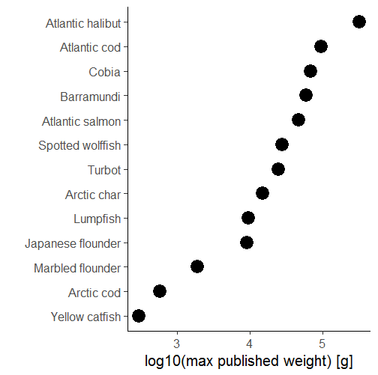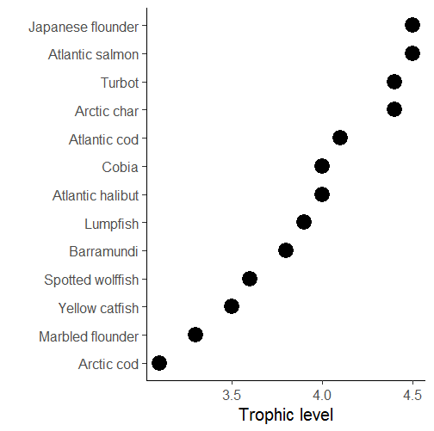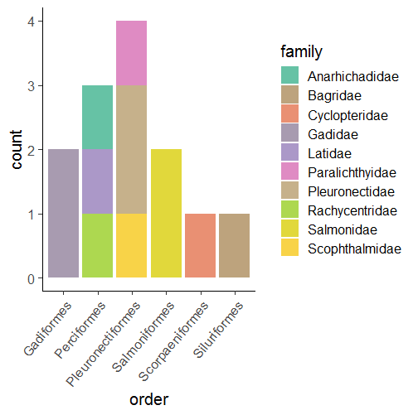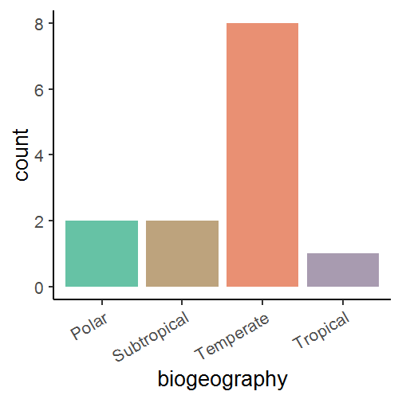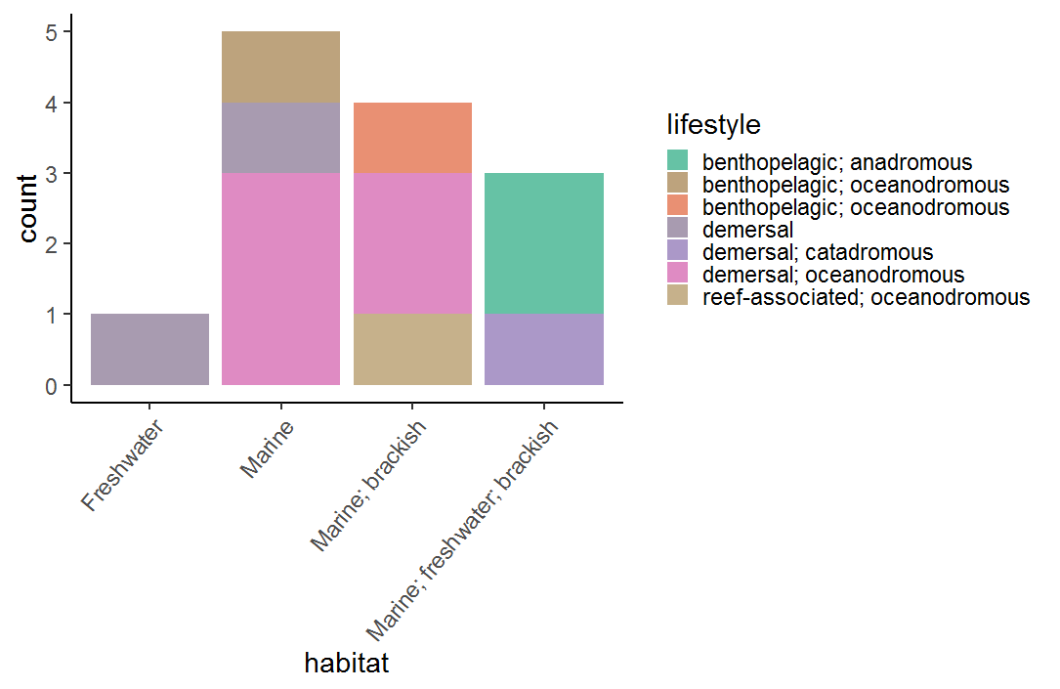

**A**

**B**

**C**

**D**

**E**

Fig. 1. Summary of data: A) Tropic level of species B) Log10 maximum published weight (Fishbase) C) Biogeography D) Taxonomic grouping E) Lifestyle

To account for species having different thermal preferences and body size ranges, we expressed predictor variables on relative scales. Relative temperature, was calculated as the median environment temperature (or preferred habitat temperature) from Fishbase (Froese & Pauly 2016) subtracted from the experimental temperature, both in unit Arrhenius-temperature (, where [K] is temperature and is Boltzmann’s constant ()). Relative mass, , was calculated as the natural log of (but see Appendix S1 for analyses with other methods of standardizing data across species). A more detailed description of the final data set can be found in Appendix S1 in Supporting Information. We performed sensitive analysis by fitting the models described below using different normalization methods (maximum body weight and experimental temperature instead).

*Data analysis*

We fitted hierarchical Bayesian models on both data sets with the R package *‘rstanarm’* (Goodrich *et al.* 2018), using species as a grouping factor as there are multiple data points per species. This allows us to estimate species-specific differences in growth rates, while using all data to inform estimates for each species, which is advantageous in our situation with few data points per species.

We assumed individual growth rate scale with size using a generalized version of the core equation in the metabolic theory of ecology (Gillooly *et al.* 2001; Brown *et al.* 2004). This allows us to evaluate the effects of temperature and body mass simultaneously, which is more appropriate if the mass-scaling exponent is not exactly 3/4 (Downs *et al.* 2008) and also to evaluate interactive effects of size and temperature (Ohlberger *et al.* 2012; Lindmark *et al.* 2018). We thus assumed growth scales as:

(1)

, which on normal scale becomes:

(2)

For the statistical analysis we used the natural log of mass-specific growth rate, , [% day-1] as the independent variable and relative temperature and relative mass as predictors. For the temperature-optimum data we subtract the median environmental temperature from the optimum growth temperature for each species as the dependent variable and as predictor (but see Appendix S1 for results on alternative normalization methods).

We use weakly informative priors (rescaled default values to ensure they are loosely based on the range of the outcome variable) for all regression models, as is default in ‘rstanarm’(Muth *et al.* 2018). The growth rate model can thus be written as:

, where the intercept is nested within species to account for group structure due to multiple replicates within species. The temperature-optimum model is identical in structure except for the single predictor (normalized mass). It can be written as:

, where is in unit . We did not conduct any formal model selection because more complex hierarchical structures lead to non-unimodal posterior distributions. We used 4 Markov chains with 3000 iteration each, treating the first 1500 as warmup. We assessed model convergence and effective samples sizes by ensuring and .

All data processing, statistical analysis and figures were made in R version 3.5.0 (R Core Team 2018). We relied heavily on the R packages within the *‘tidyverse’* collection (Wickham 2017) for data processeing and visualization, and *‘tidybayes’* (Kay 2019) and *‘sjPlot’* (Lüdecke 2019) for visualizing models. All data and R code (data manipulation, analyses and figures) can be downloaded from a GitHub repository (<https://github.com/maxlindmark/temperature-optimum>), and will be archived on Zenodo upon publication.

**Results**

We find that the size-and temperature dependence of growth can be described by the equation: . We estimate the mass-scaling exponent of growth (the mass-coefficient on log-log scale) to be to be (95% Bayesian credible intervals:) when equals the median environmental temperature (Fig. 2b). This estimate is very similar to other studies using another data set or experiments (Sibly *et al.* 2015; Barneche *et al.* 2019). We find some support for a temperature-size interaction. The mean of the posterior for the interaction coefficient is , meaning the mass-specific scaling exponent of growth increases with an increase in inverse temperature, i.e. the mass-exponent (on normal scale) is larger in colder temperatures. Specifically, the mass-scaling exponent of growth decreases with approximately 0.004 per unit change in . However, the interactions is less statistically clear than the mass-scaling exponent as the 80% Bayesian credible intervals just overlap zero (95% CI: ) (Fig. 1C). We estimate the activation energy, , (coefficient to the relative Arrhenius temperature, ) to be (95% CI: ), which is lower than what is typically found for metabolic rate (Downs *et al.* 2008) and growth based on field data (Sibly *et al.* 2015). To illustrate this in terms of specific growth (normal scale), an increase in relative temperature from to increases growth rates by a factor of 1.4 for a fish of mass but a factor of 1.2 for a fish of mass , respectively (Fig. 3).

The temperature at which optimum growth is achieved declines with body size declines with per order of magnitude increase in relative body size (Fig. 4). These result are robust to assumptions about temperature-normalization.

C:\R_STUDIO_PROJECTS\temperature-optimum\figs\growth_interaction.tif

Fig. 2. *Effects of temperature on body growth depends on body size. A) Growth rate [% day-1] as a function of body mass, both on natural log scale. Colors indicate normalized temperature groups made by splitting data into three equal intervals. Lines are mean marginal predictions on the mean environment-normalized Arrhenius temperature in each group (-1.5, -0.7 and 0.1, corresponding to* *-0.86, 4.89, 10.93 in unit deviations from median environment-temperature for each species in unit ), to visualize the effect of temperature on the mass-scaling exponent. Posterior distributions of B) , mass-scaling exponent, C) , activation energy and D) , the mass-temperature interaction coefficient are shown in the bottom row. Solid line is the posterior median, dotted is 80% credible interval and dashed depicts the 95% credible interval.*

*C:\R_STUDIO_PROJECTS\temperature-optimum\figs\growth_violin.tif*

Fig. 3. *Larger positive effect of temperature on growth for small individuals. Violin- and box plots of posterior distribution of predicted natural log of growth rate (% day-1) not conditioned on any group levels (species) for two relative body masses (mass at maturation, ): and , at two relative Arrhenius temperatures: and , which correspond to 0 and +10 deviation from the median temperature in the environment of species .*

C:\R_STUDIO_PROJECTS\temperature-optimum\figs\growth_scatter_pf.tif

Fig. 4. *Optimum temperature for growth declines with body size. Environment-normalized optimum temperature within species () as a function of log10(body mass). Probability bands based on draws from posterior fits given no group-level effects. Regression equation is based on posterior medians for the average effect.*

**Discussion**

We have shown that temperature affects body growth rates of fishes differently depending on their body mass, through 1) small changes in the mass-scaling exponent 2) clear declines in optimum growth temperatures with body size. These results mean that smaller individuals within a population may benefit more in terms of faster growth rates with, but this potential to capitalize on warming declines with body size.

The empirical observation that higher temperatures lead to faster development and smaller adult body sizes within species (“temperature-size rule”, TSR) (Atkinson 1994; Daufresne *et al.* 2009), has fueled research into climate-driven changes in growth trajectories of also fish - especially since TSR-effects are predicted to be stronger in aquatic systems (Forster *et al.* 2012; Horne *et al.* 2015). Studies on changes in individual growth trajectories typically utilize time series of age-at-length or catch data (Thresher *et al.* 2007; Baudron *et al.* 2014; van Rijn *et al.* 2017; Huss *et al.* 2019). In most cases such data are only available species with a long history of commercial exploitation and time-varying population abundances and food productivity, which could confound or dilute any climate change signals in individual growth data. Therefore, it is important to compare field studies with controlled environments. Our finding that growth rates increase with temperature is similar to finding positive correlations between and temperature, as was many have found also in field data.

While our data do not contain individuals that are close to their predicted asymptotic body sizes, we do see weak evidence of the positive effects of warming on growth leveling off over ontogeny. This would be analogous to declines in maximum body size, or in time series (Baudron *et al.* 2014; van Rijn *et al.* 2017). However, we estimate a relative small interaction-effect, meaning notable impacts on growth only manifest over large temperature and body mass ranges (see Fig. 3) (but we also note that this estimate is almost an order of magnitude lower than what has been reported for some single species studies, e.g. Björnsson *et al*. (2007)). On the contrary, we find clear effects of body mass on optimal growth temperatures. Assuming that fish exhibit similar temperatures in the environment over ontogeny, this would lead to warming lowering growth performance of the largest fish in a population first (we estimate roughly a 4 change in optimum over ontogeny). However, this may not always be the case, as for instance Heincke’s law states that individuals move to deeper habitats over ontogeny (Heincke 1913; Audzijonyte & Pecl 2018), and other type of ontogenetic habitat shifts are well documented, e.g. (Werner & Hall 1988). For inferences about impacts of climate change, the change in optimum growth temperature that we report here should be viewed in relation to size-dependent habitat temperatures if those change over ontogeny. That said, there are already empirical evidence of the largest individuals being the first to suffer negative impacts of warming from e.g. heatwaves (Pörtner & Knust 2007). Taken together, while temperature has a clear positive effect on growth at for small fish in a population, in line with empirical findings, the effect of temperature on the large fish within a species is still not properly understood. This was also mirrored in a recent experimental study by Barneche *et al*. (2019), where a negative relationship between asymptotic body size and temperature was evident only at high temperatures. The inability to capture clear temperature-effects on asymptotic size over a realistic temperature-range experimentally could mean other factors are involved in time series of field-sampled fish, e.g. life history evolution in response to intensive fishing. However, we are not really able to make that conclusion since large individuals are generally not covered in experimental studies, including those compiled in this study, and large fish may still find direct negative impacts of warming on body growth.

We still lack mechanistic understanding and theoretical models for the causes of TSR (Marshall & White 2019; Pauly 2019). This is likely because it appears to be a response to several co-varying mechanisms at different levels of biological organization (Ohlberger 2013; Audzijonyte *et al.* 2018). We are also still discussing what drives the asymptotic body size of fish, so perhaps it is not strange we cannot explain the causes of directional changes in asymptotic mass. One of the reasons could be to general lack of experimental data of ontogenetic growth rates. This is most likely an artefact of the logistical challenges of performing growth rate experiments in the factorial design (size x temperature) needed. Moreover, body growth is an ontogenetic process, and there is only so much interspecific comparisons can ultimately say about ontogenetic growth. In a step to overcome this, we have systematically compiled growth data for different size-classes at different temperatures in order to get as close as possible to the ontogenetic scaling of growth without limiting ourselves to “truly” ontogenetic data (in which case our data set would have been smaller). We argue that this approach to systematic review of already existing literature can be fruitful in combination with hierarchical models and variable-standardization, as this can address the general aspects of ontogenetic growth that are shared across species, which single species studies will struggle with. One example is the size-dependence of optimum growth temperatures, which we find clear signals of even when analyzing data from a diverse set of species on a common scale. In doing so, our study adds a new take on aspects of intra-specific growth scaling for a “general” fish, adds data to the literature and highlights the lack of representation of large individuals in growth experiments.

\*Add section here about limitations in experiments and all uncertainties from that\*

In the context of climate change impacts on ecosystem functioning and productivity, it is important to acknowledge the now widespread finding in field and experimental studies that warming has the potential to increase growth rates – at least in the smaller end of the species’ size-spectrum. This poses a challenge to general theoretical growth models that feed into climate projections. Body growth is a fundamental process, and not being able to characterize it properly may limits our understanding of important aspects beyond individual body size, including energy transfer & efficiency of food webs and ecosystems.

**Author contributions**

ML, JO, AG designed research; ML conceived the study; ML performed research; ML analyzed data; ML, JO, AG wrote the paper and contributed to revisions of the manuscript.

**Now that you’ve read so far…**

What do you think about in terms of article type? At first I had a short paper in mind, but in this version I put most text and main figures in the main text just to see how long it would get. If we go with a short paper we can put much of methods and some figures in the Appendix if needed. Or, we can keep it as it is in terms of length (or at least around this length) and choose journal more freely.

**Standard paper length, journal suggestions:**

1. **Functional Ecology** looks like a good fit (traits + physiology and some links to higher levels (albeit most in discussion, but at least it’s not a pure physiology paper)
2. **Oikos**, either as a meta-analysis or research. Also good fit since they state they like synthesizing papers across taxa (well, species in our case)
3. My feeling is that it would be hard to aim for higher impact journal. E.g. for PNAS it’s too fishy I think and we would need some other kind of synthesis or generalizable model or something like that. Same with ELE I think…

**Short paper, journal suggestions (let me know if you have other journals in mind for this format!):**

1. AmNat (note): <https://www.journals.uchicago.edu/journals/an/instruct>
   1. Max 3000 words and 3 figures/tables, otherwise fairly standard in terms of layout.
   2. Example: Saunders & Tarling *Southern Ocean Mesopelagic Fish Comply with Bergmann’s Rule*

**References**

Andersen, K.H., Beyer, J.E. & Lundberg, P. (2009). Trophic and individual efficiencies of size-structured communities. *Proceedings of the Royal Society B: Biological Sciences*, 276, 109–114.

Atkinson, D. (1994). Temperature and Organism Size—A Biological Law for Ectotherms? In: *Advances in Ecological Research*. Elsevier, pp. 1–58.

Audzijonyte, A., Barneche, D.R., Baudron, A.R., Belmaker, J., Clark, T.D., Marshall, C.T., *et al.* (2018). Is oxygen limitation in warming waters a valid mechanism to explain decreased body sizes in aquatic ectotherms? *Global Ecology and Biogeography*.

Audzijonyte, A. & Pecl, G.T. (2018). Deep impact of fisheries. *Nature Ecology & Evolution*, 2, 1348–1349.

Barneche, D.R. & Allen, A.P. (2018). The energetics of fish growth and how it constrains food-web trophic structure. *Ecology Letters*, 21, 836–844.

Barneche, D.R., Jahn, M. & Seebacher, F. (2019). Warming increases the cost of growth in a model vertebrate. *Functional Ecology*, 33, 1256–1266.

Baudron, A.R., Needle, C.L., Rijnsdorp, A.D. & Marshall, C.T. (2014). Warming temperatures and smaller body sizes: synchronous changes in growth of North Sea fishes. *Global Change Biology*, 20, 1023–1031.

von Bertalanffy, L. (1957). Laws in metabolism and growth. *The quarterly review of biology*, 32, 217–231.

Björnsson, B., Steinarsson, A. & Árnason, T. (2007). Growth model for Atlantic cod (Gadus morhua): Effects of temperature and body weight on growth rate. *Aquaculture*, 271, 216–226.

Brett, J.R. & Shelbourn, J.E. (1975). Growth Rate of Young Sockeye Salmon, Oncorhynchus nerka, in Relation to Fish Size and Ration Level. *Canadian Journal of Fisheries and Aquatic Sciences*, 32, 2103–2110.

Brown, J.H., Gillooly, J.F., Allen, A.P., Savage, V.M. & West, G.B. (2004). Toward a metabolic theory of ecology. *Ecology*, 85, 1771–1789.

Clarke, A. & Johnston, N.M. (1999). Scaling of metabolic rate with body mass and temperature in teleost fish. *Journal of Animal Ecology*, 68, 893–905.

Daufresne, M., Lengfellner, K. & Sommer, U. (2009). Global warming benefits the small in aquatic ecosystems. *Proceedings of the National Academy of Sciences, USA*, 106, 12788–12793.

Downs, C.J., Hayes, J.P. & Tracy, C.R. (2008). Scaling metabolic rate with body mass and inverse body temperature: A test of the Arrhenius fractal supply model. *Functional Ecology*, 22, 239–244.

Elliott, J.M. & Hurley, M.A. (1995). The Functional Relationship between Body Size and Growth Rate in Fish. *Functional Ecology*, 9, 625.

Fonds, M., Cronie, R., Vethaak, A.D. & van Der Puyl, P. (1991). Metabolism, food consumption and growth of plaice (Pleuronectes platessa) and flounder (Platichthys flesus) in relation to fish size and temperature. *Netherlands Journal of Sea Research*, 29, 127–143.

Forster, J., Hirst, A.G. & Atkinson, D. (2012). Warming-induced reductions in body size are greater in aquatic than terrestrial species, 109, 19310–19314.

Froese, R. & Pauly, D. (2016). *Editors. FishBase*. World Wide Web electronic publication. www.fishbase.org, (10/2016).

García García, B., Cerezo Valverde, J., Aguado-Giménez, F., García García, J. & Hernández, M.D. (2011). Effect of the interaction between body weight and temperature on growth and maximum daily food intake in sharpsnout sea bream (Diplodus puntazzo). *Aquaculture International*, 19, 131–141.

Gillooly, J.F., Brown, J.H., West, G.B., Savage, V.M. & Charnov, E.L. (2001). Effects of size and temperature on metabolic rate. *Science*, 2248–2251.

Goodrich, B., Gabry, J., Ali, I. & Brilleman, S. (2018). *rstanarm: Bayesian applied regression modeling via Stan*.

Heasman, M.P., O’Connor, W.A. & Frazer, A.W.J. (1996). Ontogenetic changes in optimal rearing temperatures for the commercial scallop, Pecten fumatus Reeve. *Journal of Shellfish Research*, 15, 627–634.

Heincke, F. (1913). Rapp. Proc. Verb. Réun. ICES 16, 1–70.

Horne, C.R., Hirst, Andrew.G. & Atkinson, D. (2015). Temperature-size responses match latitudinal-size clines in arthropods, revealing critical differences between aquatic and terrestrial species. *Ecology Letters*, 18, 327–335.

Huss, M., Lindmark, M., Jacobson, P., van Dorst, R.M. & Gårdmark, A. (2019). Experimental evidence of gradual size‐dependent shifts in body size and growth of fish in response to warming. *Global Change Biology*.

Jobling, M. (1997). Temperature and growth: modulation of growth rate via temperature change. In: *Global Warming: Implications for Freshwater and Marine Fish* (eds. Wood, C.M. & McDonald, D.G.). Cambridge University Press, Cambridge, pp. 225–254.

Kay, M. (2019). *tidybayes: Tidy Data and Geoms for Bayesian Models*.

Lefevre, S., McKenzie, D.J. & Nilsson, G.E. (2017). Models projecting the fate of fish populations under climate change need to be based on valid physiological mechanisms. *Global Change Biology*, 23, 3449–3459.

Lefevre, S., McKenzie, D.J. & Nilsson, G.E. (2018). In modelling effects of global warming, invalid assumptions lead to unrealistic projections. *Global Change Biology*, 24, 553–556.

Lindmark, M., Huss, M., Ohlberger, J. & Gårdmark, A. (2018). Temperature-dependent body size effects determine population responses to climate warming. *Ecology Letters*, 21, 181–189.

Lüdecke, D. (2019). *sjPlot: Data Visualization for Statistics in Social Science*.

Marshall, D.J. & White, C.R. (2018). Have We Outgrown the Existing Models of Growth? *Trends in Ecology & Evolution*.

Marshall, D.J. & White, C.R. (2019). Aquatic Life History Trajectories Are Shaped by Selection, Not Oxygen Limitation. *Trends in Ecology & Evolution*.

Morita, K., Fukuwaka, M., Tanimata, N. & Yamamura, O. (2010). Size-dependent thermal preferences in a pelagic fish. *Oikos*, 119, 1265–1272.

Muth, C., Oravecz, Z. & Gabry, J. (2018). User-friendly Bayesian regression modeling: A tutorial with rstanarm and shinystan. *The Quantitative Methods for Psychology*, 14, 99–119.

Ohlberger, J. (2013). Climate warming and ectotherm body size - from individual physiology to community ecology. *Functional Ecology*, 27, 991–1001.

Ohlberger, J., Mehner, Thomas., Staaks, Georg. & Hölker, Franz. (2012). Intraspecific temperature dependence of the scaling of metabolic rate with body mass in fishes and its ecological implications. *Oikos*, 121, 245–251.

Pauly, D. (1979). Gill size and temperature as governing factors in fish growth: a generalization of von Bertalanffy’s growth formula.

Pauly, D. (2019). Female Fish Grow Bigger – Let’s Deal with It. *Trends in Ecology & Evolution*.

Pörtner, H.O. & Knust, R. (2007). Climate change affects marine fishes through the oxygen limitation of thermal tolerance. *Science*, 315, 95–97.

R Core Team. (2018). *R: A Language and Environment for Statistical Computing. R Foundation for Statistical Computing*. Vienna, Austria.

van Rijn, I., Buba, Y., DeLong, J., Kiflawi, M. & Belmaker, J. (2017). Large but uneven reduction in fish size across species in relation to changing sea temperatures. *Global Change Biology*, 23, 3667–3674.

Rohatgi, A. (2012). *WebPlotDigitalizer: HTML5 based online tool to extract numerical data from plot images. Version 4.1. [WWW document] URL https://automeris.io/WebPlotDigitizer (accessed on January 2019).*

Rosenfeld, J., Leeuwen, T.V., Richards, J. & Allen, D. (2015). Relationship between growth and standard metabolic rate: measurement artefacts and implications for habitat use and life-history adaptation in salmonids. *Journal of Animal Ecology*, 84, 4–20.

Savage, V.M., Gillooly, J.F., Brown, J.H., West, G.B. & Charnov, E.L. (2004). Effects of body size and temperature on population growth. *The American Naturalist*, 163, 429–441.

Sibly, R.M., Baker, J., Grady, J.M., Luna, S.M., Kodric-Brown, A., Venditti, C., *et al.* (2015). Fundamental insights into ontogenetic growth from theory and fish. *Proceedings of the National Academy of Sciences, USA*, 112, 13934–13939.

Steinarsson, A. & Imsland, A.K. (2003). Size dependent variation in optimum growth temperature of red abalone (Haliotis rufescens). *Aquaculture*, 224, 353–362.

Thresher, R.E., Koslow, J.A., Morison, A.K. & Smith, D.C. (2007). Depth-mediated reversal of the effects of climate change on long-term growth rates of exploited marine fish. *Proceedings of the National Academy of Sciences, USA*, 104, 7461–7465.

Werner, E.E. & Hall, D.J. (1988). Ontogenetic Habitat Shifts in Bluegill: The Foraging Rate-Predation Risk Trade-off. *Ecology*, 69, 1352–1366.

West, G.B., Brown, J.H. & Enquist, B.J. (2001). A general model for ontogenetic growth. *Nature*, 413, 628–631.

Wickham, H. (2017). *tidyverse: Easily Install and Load the “Tidyverse.”*

Wyban, J., Walsh, W.A. & Godin, D.M. (1995). Temperature effects on growth, feeding rate and feed conversion of the Pacific white shrimp (Penaeus vannamei). *Aquaculture*, 138, 267–279.

Zuo, W., Moses, M.E., West, G.B., Hou, C. & Brown, J.H. (2012). A general model for effects of temperature on ectotherm ontogenetic growth and development. *Proceedings of the Royal Society of London B: Biological Sciences*, 279, 1840–1846.