**Appendix S1**

**Supporting Information for**

***Intraspecific optimum growth temperature declines with body size across fishes***

Max Lindmarka,1, Jan Ohlbergerb, Anna Gårdmarkc

a Swedish University of Agricultural Sciences, Department of Aquatic Resources, Institute of Coastal Research, Skolgatan 6, Öregrund 742 42, Sweden

b School of Aquatic and Fishery Sciences (SAFS), University of Washington, Box 355020, Seattle, WA 98195-5020, USA

c Swedish University of Agricultural Sciences, Department of Aquatic Resources, Skolgatan 6, SE-742 42 Öregrund, Sweden

1 Author to whom correspondence should be addressed. Current address:

Max Lindmark, Swedish University of Agricultural Sciences, Department of Aquatic Resources, Institute of Coastal Research, Skolgatan 6, Öregrund 742 42, Sweden, Tel.: +46(0)104784137, email: [max.lindmark@slu.se](mailto:max.lindmark@slu.se)

Contents

[Data acquisition 3](#_Toc19803880)

[Data exploration 4](#_Toc19803881)

[Data analysis 5](#_Toc19803882)

[Growth rate model 5](#_Toc19803883)

[Model evaluation 5](#_Toc19803884)

[Model fits 6](#_Toc19803885)

[Optimum growth-temperature model 8](#_Toc19803886)

[Model evaluation 8](#_Toc19803887)

[Model fits 8](#_Toc19803888)

[Sensitivity analysis 9](#_Toc19803889)

# 

# Data acquisition & explanation

Below are some notes for myself when I write this section

* How was optimum temperature defined? We used either fitted optimum temperature, or in cases where the effect of temperature on growth rates where not estimated, we took the temperature yielding the highest growth (minimum number of temperatures = 3, and they need to be in or around optimum). Indicate that in the data.
* I considered fitting polynomials to data where there’s is no fitted optimum, maybe in excel. That makes it consistent with how most other studies did it. How many studies do I need to do this for? If I don’t do this, just say we took the highest growth T given the curve was an optimum curve.

## Growth rate data

* Add table here explaining all the columns
* Size refers to geometric mean mostly, otherwise size class
* Body sizes in meta-data are sometimes taken from length and converted
* Add that we got weight from Fishbase length weight parameters if only length was given (e.g. for maximum size)

## Growth optimum temperature data

* Same as above

# Data exploration

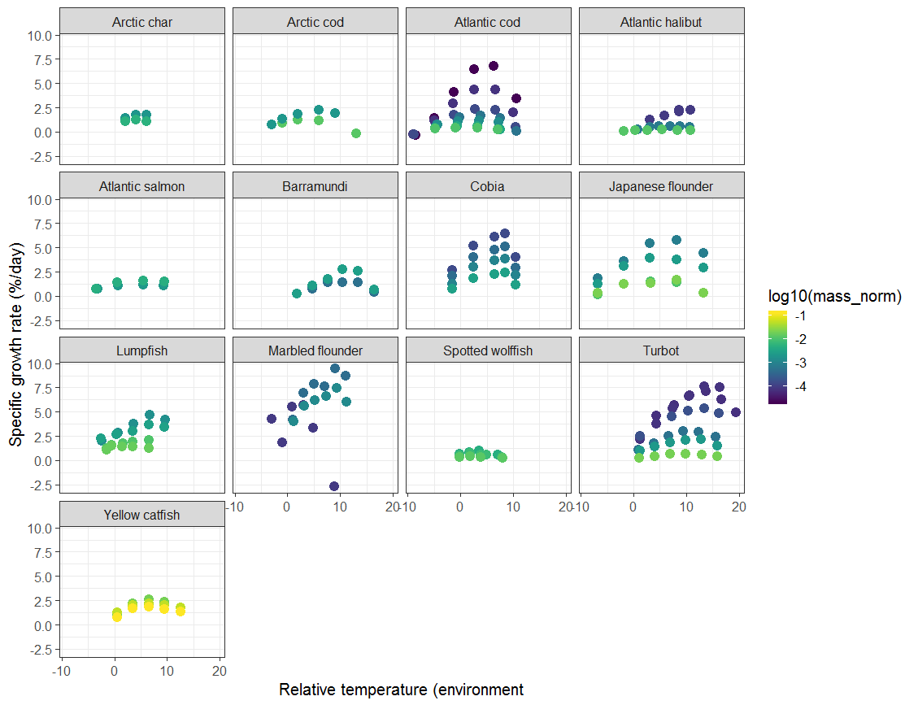

Fig. S2. Raw growth rate data

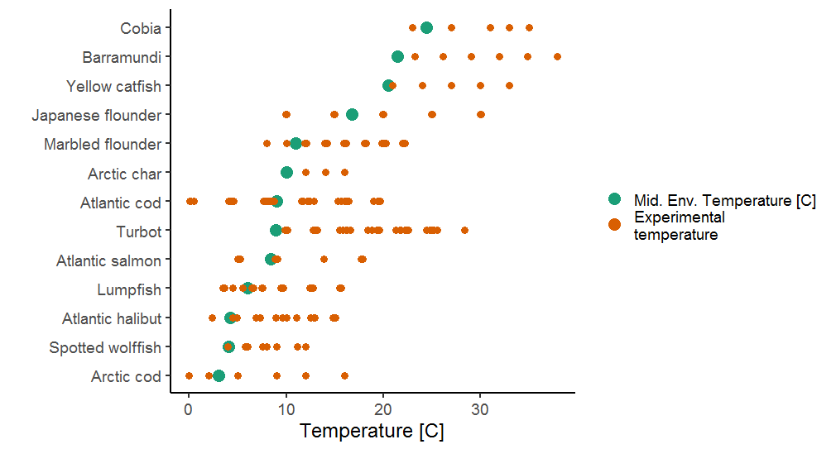

Fig. S3. Experimental temperature and environmental mid-point temperature for comparison, reason for normalizing.

# Data analysis

## Growth rate model

### Model evaluation

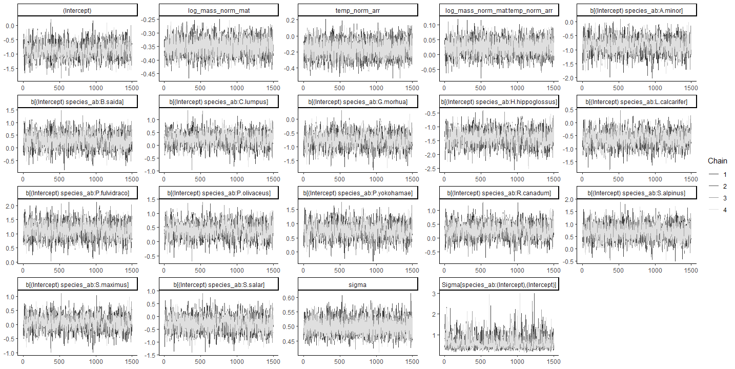

Fig. S4. Trace plot of all parameters in model for growth as a function of normalized mass and temperature

### Model fits

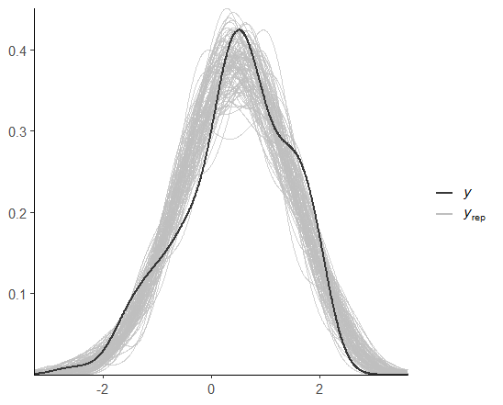

Fig. S5. Posterior predictive plot for growth rate

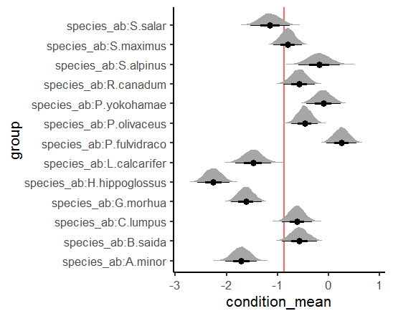

Fig. S6. Species-varying intercepts in growth rate model.

C:\R_STUDIO_PROJECTS\temperature-optimum\figs\G_M_interaction_ppd.tif

Fig. S7. Posterior predictive distribution of growth rate model

## Optimum growth-temperature model

### Model evaluation

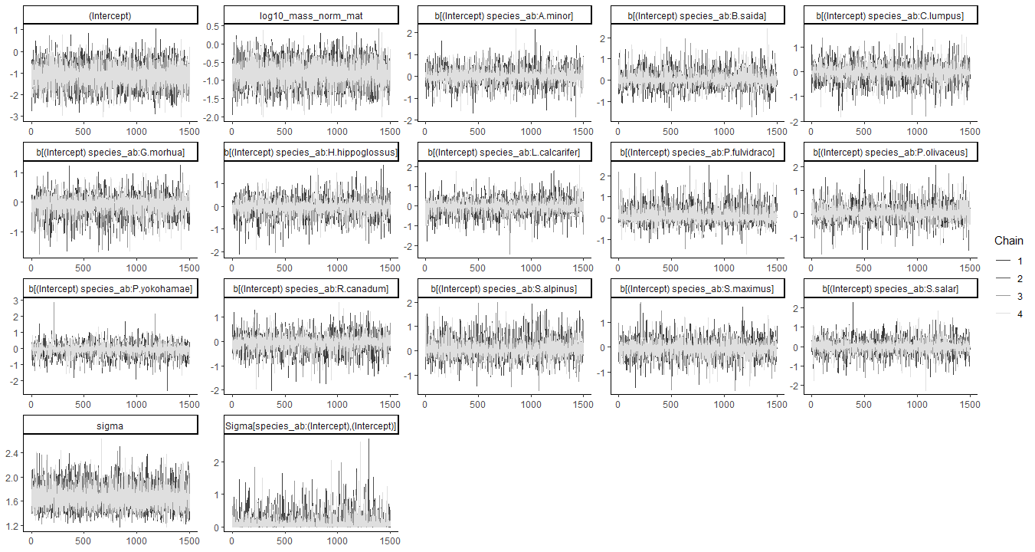

Fig. S8. Trace plot of all parameters in model for temperature-optimum as a function of normalized mass

### Model fits

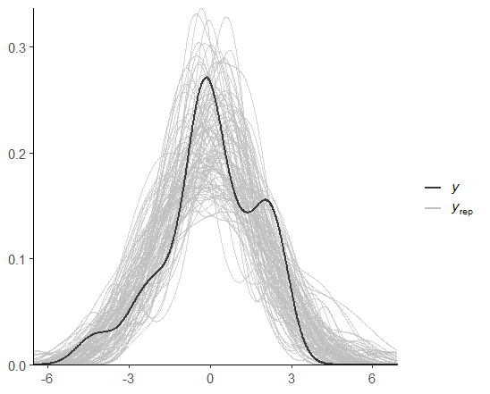

Fig. S9. Posterior predictive plot for optimum growth temperature

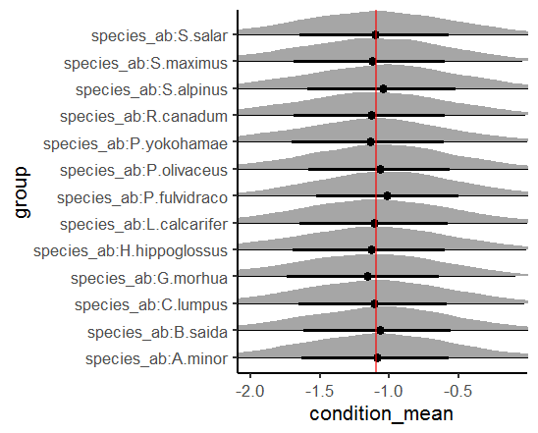

Fig. S10. Species-varying intercepts.

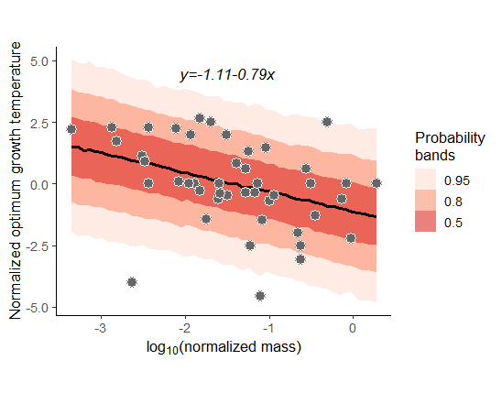

Fig. S11. Posterior predictive distribution

## Sensitivity analysis

**Notes**: Difference between normalizing T\_opt with mean T­\_opt within study or environment? Both consider species-differences… but T\_opt is not always close to habitat, so we choose to normalize first to mean T\_opt. But since T\_opt depends on size, and different species have different size-ranges, this is not perfect either. Normalize growth rate model with temperature-optimum!

C:\R_STUDIO_PROJECTS\temperature-optimum\figs\growth_sensitivity.tif

Fig. S12. Growth rate model with different normalization variables

Here I plan to do a similar figure as above for T\_opt… but what do you think about it? I don’t want to do any model averaging really, but on the other hand it’s not like it’s clear that the variables we chose for the main analyses are the most appropriate.

Fig. S12. Optimum-temperature model with different normalization