**Appendix S1**

**Supporting Information for**

***Scaling of metabolism and maximum consumption with temperature and body size within species of fish***

Max Lindmarka,1, Jan Ohlbergerb, Anna Gårdmarkc

a Swedish University of Agricultural Sciences, Department of Aquatic Resources, Institute of Coastal Research, Skolgatan 6, Öregrund 742 42, Sweden

b School of Aquatic and Fishery Sciences (SAFS), University of Washington, Box 355020, Seattle, WA 98195-5020, USA

c Swedish University of Agricultural Sciences, Department of Aquatic Resources, Skolgatan 6, SE-742 42 Öregrund, Sweden

1 Author to whom correspondence should be addressed. Current address:

Max Lindmark, Swedish University of Agricultural Sciences, Department of Aquatic Resources, Institute of Coastal Research, Skolgatan 6, Öregrund 742 42, Sweden, Tel.: +46(0)104784137, email: [max.lindmark@slu.se](mailto:max.lindmark@slu.se)

Contents

Literature search 3

*Metabolic rate* 3

*Maximum consumption rate* 4

*Growth rates & optimum temperature for growth over size* 4

Selection process and criteria 5

*Growth data* 5

*Metabolic and consumption rate* 6

Data acquisition 7

Data explanation 7

Data exploration 7

*Growth rate* 8

*Metabolic rate* 8

*Maximum consumption rate* 8

Supplementary analysis 8

*Optimum growth temperature* 8

*Growth rate* 8

*Metabolic rate* 8

*Maximum consumption rate* 8

Bibliography 8

# Literature search

Prior to starting the actual literature review, we conducted several test-searches on with alternative search-strings on Web of Science Core Collection, basic search. This was done in order to find a manageable number of papers to review and to have a reasonable ratio article titles that passed the first screening, given our pre-defined criteria for when to choose a study. As we suspected that relatively few studies considered both size- and temperature treatments, our goal was to get an as extensive as possible list of studies as possible. Therefore, we also evaluated papers cited by papers in the literature list, and from published review-type papers and reviews of applications of bioenergetics models such as the Wisconsin model (Deslauriers *et al.* 2017).

## *Growth rates & optimum temperature for growth over size*

Growth rates were taken from data found in the literature search for optimum growth temperatures. We choose the following search strings for optimum growth rate experiments:

*(growth) AND TOPIC: (mass OR weight OR size) AND TOPIC: (temperature*) AND TOPIC: (optimum)*

This resulted in 3313 articles (search date: 2019.03.22). We then also applied additional filters on subject (Web of Science Categories). These were: ‘*fisheries’, ‘marine freshwater biology’, ‘ecology’, ‘zoology’, ‘biology’, ‘limnology’, ‘physiology’*. This reduced the number of studies to 566.

To find papers using optimal or optima, we also did the following search:

*(growth) AND TOPIC: (mass OR weight OR size) AND TOPIC: (temperature*) AND TOPIC: (optim*)*

This resulted in 3747 articles (search date: 2019.08.05). We then also applied additional filters on subject (Web of Science Categories). These were: *‘marine freshwater biology’,* ‘*fisheries’, ‘ecology’, ‘zoology’, ‘biology’, ‘limnology’, ‘physiology’*. This reduced the number of studies to 893, from which we removed the studies already found in the first search.

## *Metabolic rate*

We choose the following search strings for metabolic rate experiments:

TOPIC: *(metabolism OR "oxygen-consumption" OR "oxygen consumption") AND TOPIC: (mass OR weight OR size) AND TOPIC: (temperature*)*

This resulted in 8405 articles (search date: 2019.06.06). We then also applied additional filters on subject (Web of Science Categories). These were: ‘*zoology’, ‘physiology’, ‘marine freshwater biology’, ‘ecology’, ‘fisheries’ and ‘biology’.* This reduced the number of studies to 3,458

## *Maximum consumption rate*

We choose the following search strings for maximum consumption rate experiments:

TOPIC: *(consumption or feeding$rate or food$intake or bio$energ* or ingestion or food-intake) AND TOPIC: (mass or weight or size) AND TOPIC: (temperature*).*

This resulted in 15259 articles (search date: 2018.12.18). We then also applied additional filters on subject (Web of Science Categories). These were: ‘*marine freshwater biology’, ‘fisheries’, ‘zoology’, ‘physiology’, ‘ecology’, ‘biology’, ‘limnology’, ‘evolutionary biology’, w*hich reduced the number of studies to 3449.

However, due to a typo and misunderstanding of search syntax, we had to make a second search:

TOPIC: *(feeding-rate or bio-energ*) AND TOPIC:(mass or weight or size) AND TOPIC:(temperature*)*

This yielded 431 additional titles after filtering the following categories: ‘*marine freshwater biology’, ‘fisheries’, ‘zoology’, ‘physiology’, ‘ecology’, ‘biology’, ‘limnology’, ‘evolutionary biology’.*

# Selection process and criteria

We filtered out articles at three levels of the search: title, abstract and full paper. Appendix SX contains lists of paper titles at each of these steps in the filtering process. We also used studies that did not appear in the literature search but that we found by following cited literature in papers to the original source. Such studies are indicated in the data set as an explanation for why they do not appear in Appendix SX (see ‘*Data explanation*’, this document). When treatments where conducted in the experiment, we extracted data from the control-scenario. When several studies were found for the same species, we did not mix the data but instead chose the study with the largest size and temperature range (in that order), as there can be large differences in absolute values of some physiological parameters between studies. We manually removed studies based on titles if it was clear that it did not fulfill all of the following conditions: (1) experimental study, (2) fish as study organism in life stages older than larval (3) replicates across both size and temperature. After titles we evaluated abstracts and then the whole paper.

## *Growth data*

At the abstract and whole-paper stage, we removed studies from which we could not extract (4) growth rates, (5) a single controlled temperature for each growth trial and (6) a defined size class. In addition, we ensured that no other treatment (e.g. food limitation) confounded the response variable and thus only used data from experiments with food supply corresponding to satiation. It is important to control for feeding rations as it affects the temperature optimum for growth (Brett *et al.* 1969). This was achieved in different ways between studies, but normally mean excess feeding rations once or more times per day. The key description we looked for in the study was that food rations should not be limiting or “reduced” rations. In the case growth was length-based, we converted them to mass using weight-length-relationships from FishBase (Froese *et al.* 2014; Froese & Pauly 2016). In cases where we found more than one study for the same species, we selected the study with most size-classes and largest size-range if more than one study had equal numbers of size-groups. While this reduces the number of data points, it avoids additional observation error due to different experimental setups and experimenters. We compiled two separate data sets: (1) raw growth rates (growth_data.xlsx) and (2) temperature at optimum growth (growth_data_Topt.xlsx), where we defined optimum temperature for growth as fitted optimum temperature (in the original study) or in some cases as temperature where the highest growth rate of a unimodal growth-temperature relationship was achieved in cases where optimum temperature was estimate by the authors. All data were extracted from tables or figures using Web Plot Digitizer (Rohatgi 2012).

## *Metabolic and consumption rate*

At the abstract and whole-paper stage for metabolic- and consumption rate, articles where filtered out if the original reference could not be identified and evaluated, if it was a generic parameter-value based on literature, consumption rate was not ad-libitum (as with the growth data, definitions of ad-libitum may differ between studies – the key for our purpose is that rations should lead to satiation and not be limiting) or if it was not standard/routine/resting metabolic rate, if there was no acclimation, if multiple rates measured at multiple temperatures where pooled prior to estimating the size-dependence of the rate, if units were normalized using a prior defined scaling relationships and no acclimation was done.

# Data acquisition

Here I will talk about:

* Unit standardization (in more detail than I do in the ms)
* Additional data in the data sets (how we got them and what we did we when didn’t, e.g. temperature data, body mass data).

# Data explanation

Here I will put all the columns in my data in a table like below and explain in words what all columns mean.

Table 1 EXAMPLE: Explanation of metabolic rate, maximum consumption and growth data

|  |  |
| --- | --- |
| Column | Explanation |
| e.g. temp_mid_fishbase | If no info, then used something else |
|  |  |
|  |  |
|  |  |
|  |  |
|  |  |
|  |  |

# Data exploration

Here I will put figures describing the data. Some examples are there, but more can come and maybe some of them can be combined

## *Growth rate*

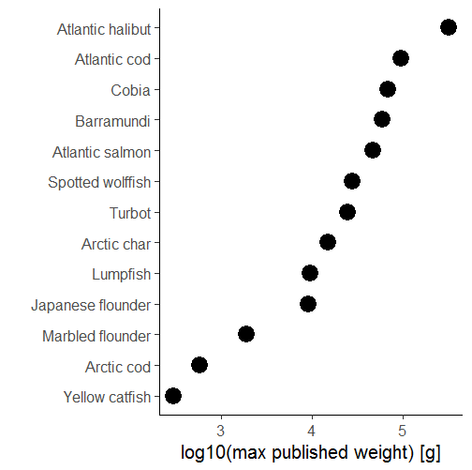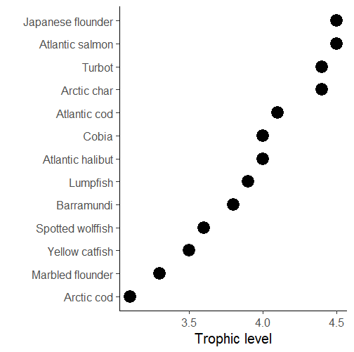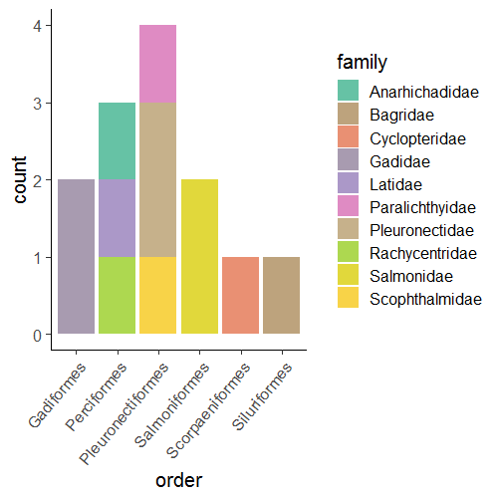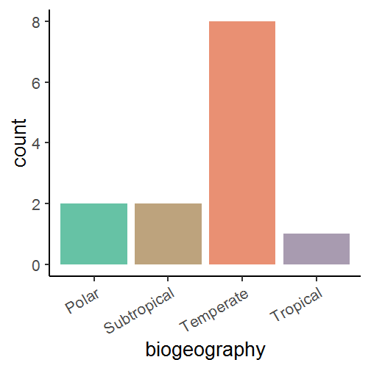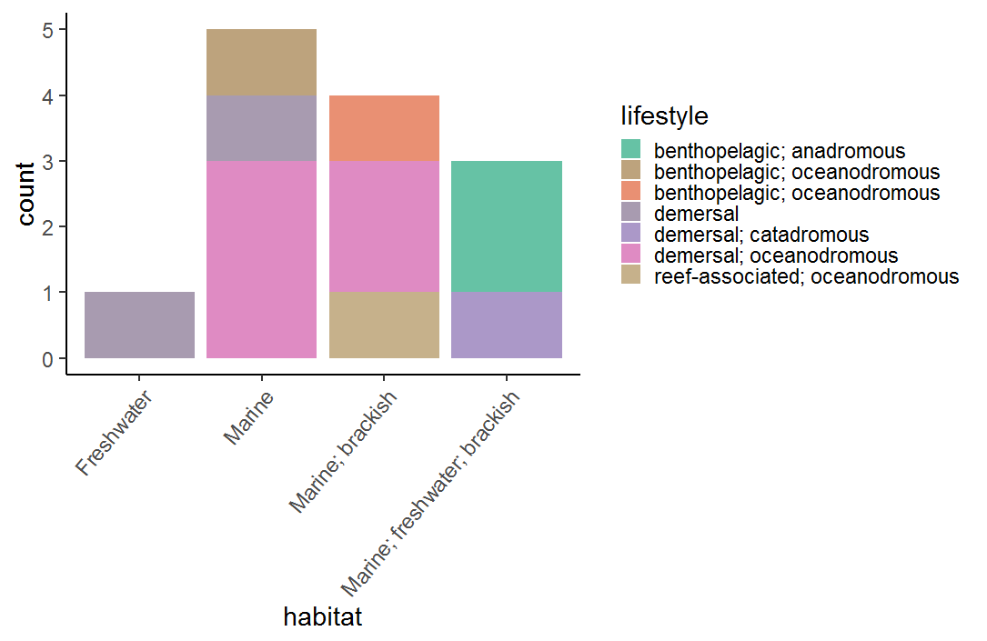

**A**

**B**

**C**

**D**

**E**

Fig. S1. Summary of data: A) Tropic level of species B) Log10 maximum published weight (Fishbase) C) Biogeography D) Taxonomic grouping E) Lifestyle

Fig. S2. Experimental temperatures (orange) compared to median environmental temperature (green) for growth data.

## *Metabolic &* *maximum consumption rate*

Fig. S3. Taxonomic representation in metabolism and consumption data.

Fig. S4. Biogeography and lifestyle of species in metabolism and consumption data.

Fig. S5. Log10 of maximum published weight of species in metabolism and consumption data

Fig. S6. Experimental temperatures (orange) compared to range and median environmental temperature (green) for metabolism and consumption data

Fig. S7. Distribution of relative body masses in metabolism and consumption data

Fig. S8. Top row: natural log of consumption (A) and metabolism (B) plotted against natural log of mass. Colors indicate species (legend not shown), to illustrate clustering in data due to species. Bottom row: natural log of consumption (A) and metabolism (B) plotted against environment-standardized Arrhenius temperature, colors indicate body masses.

# Supplementary analysis

## *Optimum growth temperature*

## *Growth rate*

## *Metabolic rate*

## *Maximum consumption rate*

# Bibliography

Brett, J.R., Shelbourn, J.E. & Shoop, C.T. (1969). Growth Rate and Body Composition of Fingerling Sockeye Salmon, Oncorhynchus nerka, in relation to Temperature and Ration Size. *J. Fish. Res. Bd. Can.*, 26, 2363–2394.

Deslauriers, D., Chipps, S.R., Breck, J.E., Rice, J.A. & Madenjian, C.P. (2017). Fish Bioenergetics 4.0: An R-Based Modeling Application. *Fisheries*, 42, 586–596.

Froese, R. & Pauly, D. (2016). *Editors. FishBase*. World Wide Web electronic publication. www.fishbase.org, (10/2016).

Froese, R., Thorson, J.T. & Reyes, R.B. (2014). A Bayesian approach for estimating length‐weight relationships in fishes. *Journal of Applied Ichthyology*, 30, 78–85.

Rohatgi, A. (2012). *WebPlotDigitalizer: HTML5 based online tool to extract numerical data from plot images. Version 4.1. [WWW document] URL https://automeris.io/WebPlotDigitizer (accessed on January 2019).*