StoreSense: Retail Data Warehouse and Market Basket Analysis
  - Project Report — Data Mining and Data Warehousing (DMDW)
Table of Contents

Title Page
STORESENSE
Retail Data Warehouse and Market Basket Analysis
A project report submitted for the course
Data Mining and Data Warehousing (DMDW)
by
# | Name | Roll / Registration No. | GitHub
1 | Manish Sarkar | 24051496 | @maxlovesher
2 | Kavya Agarwal | 24052086 | @Kavya-025
3 | Kartik Biswal | 24051938 | @KB-0141
4 | Manish Dey | 24051562 | @foresto-dreamer
5 | Animesh Prakash | 24051610 | @DIO4699
6 | Rohit Gupta | 24052654 | @rohitguptanit7070-lab
Under the guidance of
Dr. Chittaranjan Pradhan
Associate Professor, School of Computer Engineering
School of Computer Science and Engineering
Kalinga Institute of Industrial Technology (KIIT)
Bhubaneswar, Odisha
Academic Year: 2026–27
Date of Submission: 15 October 2026

Abstract
Background and motivation. Grocery retailers record millions of baskets, but raw transaction files do not answer business questions directly. Answering them requires two things taught in the Data Mining and Data Warehousing (DMDW) course: a warehouse that organises the data for fast analytical queries, and mining methods that find patterns no single query shows.
Problem. Given the public Instacart order history (3,421,083 orders from 206,209 users, 33,819,106 order lines, 49,688 products in 134 aisles and 21 departments), the project asks when and what customers buy, which products are bought together, what kinds of customers there are and, as a stretch goal, whether a customer will buy a product again.
Solution. StoreSense is a Python pipeline and dashboard. An ETL process (extract, transform, load, validate) built on the embedded analytical database DuckDB turns the six raw CSV files into a star-schema warehouse with two fact tables (fact_order_line, fact_order) and three dimension tables (dim_product, dim_user, dim_time). Twenty-three SQL validation checks confirm row counts, key integrity and the NULL policy, and all 23 pass on the full data. On this warehouse the project implements the OLAP operations roll-up, drill-down, slice, dice and pivot (with GROUP BY ROLLUP, CUBE and PIVOT); association rule mining with both Apriori and FP-Growth at aisle and product level, together with a runtime and memory benchmark of the two algorithms; customer segmentation with K-Means on RFM-style features; and reorder prediction with Logistic Regression and LightGBM, using features built from prior orders only so that the label does not leak into the inputs. A five-page Streamlit dashboard presents all results, including an interactive OLAP query builder and a rotatable 3-D data cube.
Results. Produce and dairy eggs account for 45.9% of all order lines, and the two weekend days (Sunday and Saturday, under the assumption that day 0 is Sunday) account for 33.2%. The strongest aisle rule links pasta sauce with dry pasta and packaged cheese (lift 4.80). FP-Growth was about three times faster than Apriori at product level with low minimum support, but Apriori was faster at aisle level. K-Means with k = 4 gives four segments (silhouette ≈ 0.27); the “loyal frequent shopper” segment is 29.4% of users and places about 62% of orders. LightGBM predicts reorders with ROC-AUC 0.829 and F1 0.429 on held-out users, slightly ahead of the Logistic Regression baseline (0.822 and 0.419). An automated test suite of 90 tests passed on 15 October 2026.
Significance. The project applies the course’s main topics (ETL, dimensional modelling, OLAP, frequent-pattern mining, clustering and classification) end to end on a real dataset of more than 33 million rows, and states its limits openly: the data has no prices and no calendar dates, and the day-of-week coding is assumed.
Keywords: data warehouse, star schema, ETL, OLAP, association rules, Apriori, FP-Growth, K-Means, RFM, reorder prediction, DuckDB, Streamlit.

Table of Contents
Page numbers are left out of this Markdown version. After the report is imported into Microsoft Word, insert an automatic table of contents (References → Table of Contents) to generate them.
- Abstract
- List of Figures
- List of Tables
Part I — Academic Project Report
- Introduction 1.1 Background · 1.2 Motivation · 1.3 Problem Statement · 1.4 Objectives · 1.5 Scope · 1.6 Significance
- Existing System and Proposed System 2.1 Existing approach · 2.2 Limitations of the existing approach · 2.3 Need for the proposed system · 2.4 The proposed StoreSense system · 2.5 Comparison
- Literature Review and Related Work 3.1 Knowledge discovery and data mining · 3.2 Data warehousing and dimensional modelling · 3.3 OLAP and the data cube · 3.4 Frequent-pattern and association rule mining · 3.5 Clustering and customer segmentation · 3.6 Classification, imbalance and leakage · 3.7 Related work on the Instacart data · 3.8 What StoreSense adopts, adapts and contributes
- System Requirements 4.1 Functional requirements · 4.2 Non-functional requirements · 4.3 Hardware requirements · 4.4 Software requirements
- Technology Stack
- System Architecture and Design 6.1 Overall architecture · 6.2 Module description · 6.3 Data flow · 6.4 System workflow · 6.5 Architecture diagram · 6.6 Additional diagrams
- Dataset and Data Preparation
- DMDW Concepts and Methodology
- Implementation Details 9.1 Project structure · 9.2 Module-level implementation · 9.3 Data processing · 9.4 Analytical components · 9.5 Database and storage · 9.6 User interface · 9.7 Integration · 9.8 Important code examples
- Results and Discussion
- Testing 11.1 Testing approach · 11.2 Test cases · 11.3 Testing summary
Part II — Team Contribution and Individual Responsibilities
- Team Contribution and Individual Work Distribution 12.1 Team member information · 12.2 Work allocation · 12.3 GitHub contribution analysis · 12.4 Individual contribution details · 12.5 Contribution percentage estimation · 12.6 Responsibility matrix · 12.7 Collaboration and integration · 12.8 Contribution evidence and limitations · 12.9 Individual presentation responsibilities
- Advantages, Limitations and Challenges
- Future Enhancements
- Conclusion
References
Appendices A. Repository and reproduction · B. Warehouse schema (DDL) · C. OLAP query catalogue · D. Result files · E. Complete automated test list · F. Detailed GitHub evidence

List of Figures
No. | Title | Section
6.1 | Overall architecture of StoreSense | 6.5
6.2 | Use case view | 6.6
6.3 | Level-1 data flow diagram | 6.6
6.4 | Entity-relationship view of the star schema | 6.6
6.5 | ETL activity flow | 6.6
6.6 | Sequence of an OLAP Explorer query | 6.6
9.1 | Overview page | 9.6
9.2 | OLAP Explorer, roll-up and drill-down tab | 9.6
9.3 | OLAP Explorer, 3-D cube tab | 9.6
9.4 | Basket Rules page | 9.6
9.5 | Customer Segments page | 9.6
9.6 | Reorder Model page | 9.6
8.1 | Star schema diagram (from the team’s DBML source) | 8.3
10.1 | Runtime of the mining step: Apriori vs FP-Growth | 10.4
10.2 | Peak memory of the mining step: Apriori vs FP-Growth | 10.4
10.3 | Elbow curve (inertia against k) | 10.5
10.4 | Silhouette score against k | 10.5
10.5 | The four segments projected onto two principal components | 10.5
10.6 | ROC curves of the two reorder models on the test users | 10.6
10.7 | LightGBM feature importance | 10.6
12.1 | Dependencies between modules | 12.7

List of Tables
No. | Title
2.1 | Comparison of the existing approach and StoreSense
4.1 | Functional requirements
4.2 | Non-functional requirements
4.3 | Recommended hardware
4.4 | Software versions used for verification
5.1 | Technology stack
7.1 | Raw dataset files
7.2 | Data preparation operations
8.1 | DMDW concepts: implemented, partial, future
8.2 | Warehouse tables and grain
8.3 | Association rule settings at the two levels
8.4 | Reorder model features
10.1 | Warehouse load results
10.2 | Roll-up of order lines by department
10.3 | Top association rules
10.4 | Benchmark of Apriori and FP-Growth
10.5 | Segment profiles
10.6 | Reorder model metrics
11.1 | Test cases
12.1 – 12.6 | Team, allocation, GitHub evidence, contribution estimates and responsibility matrix

PART I — ACADEMIC PROJECT REPORT

1. Introduction

1.1 Background
Online grocery shopping produces a detailed record of customer behaviour: every order lists the products in it, the order in which they were added to the cart, whether each was bought before, and when the order was placed. A retailer can use this record to plan stock and staff, to place products that are bought together near each other, to recommend products, and to treat different groups of customers differently.
Turning such a record into decisions is the subject of the DMDW course. Data warehousing reorganises transactional data into a structure designed for analysis, usually a dimensional model with fact and dimension tables, on which OLAP operations summarise the data along business hierarchies [14], [17]. Data mining finds patterns in the data that are not visible in a single summary: frequent itemsets and association rules [1]–[3], clusters [5], [18] and predictive models [18].
StoreSense applies both to the Instacart Online Grocery Shopping Dataset 2017, published by Instacart through the Kaggle competition “Instacart Market Basket Analysis” [23]. The dataset is large enough to make design choices matter (its largest file holds about 32 million order lines) but small enough to process on one laptop with an embedded analytical database [13].

1.2 Motivation
The project was motivated by three practical aims:
- To work with realistic scale. Course examples often use a few dozen transactions. A dataset with 33.8 million order lines forces real decisions about where computation happens (in the database or in memory), about sampling, and about the cost of database constraints.
- To connect warehousing and mining. In StoreSense the warehouse is not a side exercise: every mining module reads its input from the star schema, and the segmentation module writes its result back into a dimension table.
- To present results to a non-technical user. A retailer would not read SQL output, so the results are shown in an interactive dashboard with plain-English interpretations.

1.3 Problem Statement
Design and build a retail data warehouse from the raw Instacart grocery transaction files, and mine it to answer:
- When and what do people buy? (OLAP analysis along the product and time dimensions)
- Which products are bought together? (association rules with Apriori and FP-Growth, and a comparison of the two)
- What kinds of customers exist? (customer segmentation with K-Means on RFM-style features)
- (Stretch goal) Will a customer buy a product again? (reorder prediction by classification)
The results must be presented in an interactive dashboard, and the analysis must take into account three properties of the data: it has no prices, no calendar dates, and an undocumented day-of-week coding. (Source: docs/PROJECT_BRIEF.md, sections 1 and 3.)

1.4 Objectives
Primary objectives (from docs/PROJECT_BRIEF.md, section 2):
- Build an ETL pipeline that turns the raw CSV files into a clean, validated star-schema data warehouse.
- Support the OLAP operations roll-up, drill-down, slice, dice and pivot, each with a saved demonstration query.
- Mine association rules with Apriori and FP-Growth, and compare the two algorithms’ runtime and memory.
- Segment customers with K-Means on RFM-style features, and write each customer’s segment back into the warehouse.
- Present everything in an interactive dashboard with clear business insights.
Secondary (stretch) objective:
- Predict whether a customer will reorder a product, evaluated with precision, recall, F1 and ROC-AUC, without data leakage.
Supporting objectives that the team added during the work (visible in the repository):
- Automated tests for each module (90 tests at the time of writing).
- A single assembled report built from per-module sections (reports/build_report.py).
- A small committed demo extract so that the dashboard can be hosted without the 0.23 GB warehouse file (dashboard/build_demo_data.py, docs/DEPLOY.md).
All nine objectives were implemented. Their results are in Chapter 10, and the status of each one is summarised in Section 10.1.

1.5 Scope
In scope (implemented):
- Data: the six Instacart CSV files (orders, prior and train order lines, products, aisles, departments). The ~75,000 test orders, whose contents the competition hides, are kept as orders with no lines.
- Warehouse: a DuckDB star schema with 2 fact and 3 dimension tables, built by a repeatable ETL and checked by 23 validation queries.
- Analysis: OLAP queries (roll-up, drill-down, slice, dice, pivot, CUBE); association rules at aisle and product level; an Apriori vs FP-Growth benchmark; K-Means segmentation; reorder classification.
- Presentation: a five-page Streamlit dashboard (Overview, OLAP Explorer, Basket Rules, Customer Segments, Reorder Model), run locally, with a configuration and guide for hosting on Streamlit Community Cloud.
- Users: the intended user is an analyst or a store manager exploring the data, and the course evaluators. The dashboard is a single-user analysis tool.
Out of scope:
- Revenue or profit analysis (the data has no prices).
- Trend, seasonal or month-by-month analysis (the data has no calendar dates).
- Live or incremental data loading; the warehouse is rebuilt from fixed files.
- User accounts, access control, or a production recommendation service.
- Sequential pattern mining across orders, and itemsets of more than three items.

1.6 Significance
- For the course. StoreSense covers most of the DMDW syllabus in one connected system: the KDD process [19], ETL, dimensional modelling, OLAP [16], [17], frequent-pattern mining [1], [2], clustering [5], [7] and classification [10], [11], with evaluation that accounts for class imbalance [20], [21] and leakage [22].
- For the practice of analysis. Several results came from measuring rather than assuming. For example, a primary key on the largest fact table made its load about 21 times slower, and the textbook expectation that FP-Growth beats Apriori held at product level but not at aisle level (Chapter 10).
- For a retailer (as an illustration). The results suggest concrete actions: placing pasta, sauce and cheese together, staffing for the Sunday and late-morning peaks, and building “buy it again” lists from recency and frequency. These suggestions follow from patterns in the data. They have not been tested in a store.

2. Existing System and Proposed System

2.1 Existing approach
The raw Instacart data is distributed as six CSV files in a normalised, transaction-oriented layout: order lines refer to orders and products by id, and products refer to aisles and departments by id. Without a warehouse, the usual ways to analyse such files are:
- Spreadsheets or ad-hoc scripts on the flat files. Analysts open or load the files (often a sample, because a 32-million-row file does not fit in a spreadsheet) and write a new join and aggregation for each question.
- Queries on the operational (OLTP) schema. Analytical queries run against the normalised transactional tables, repeating the same multi-table joins for every report.
- Separate, one-off mining notebooks. Each analysis (for example a basket analysis) reads and reshapes the raw files on its own, so results from different analyses are not stored in one place or linked to one another.
This description is a general characterisation of how un-warehoused transaction files are commonly analysed, stated as an assumption. The project did not survey or evaluate any specific commercial product.

2.2 Limitations of the existing approach
Limitation | Effect
Every question needs new joins across orders, order lines, products, aisles and departments | Slow to write, easy to get wrong, hard to reuse
No defined hierarchies (department → aisle → product; hour band → hour) | Roll-up and drill-down must be rebuilt by hand each time
Data quality is not checked systematically | Orphan keys, wrong NULL handling (e.g. first orders) or dropped rows can go unnoticed
Large files do not fit into spreadsheets or comfortably into memory | Analysts sample without saying so, or cannot answer the question at all
Mining results live in separate notebooks | Insights are not linked to the data model and are not visible to decision makers

2.3 Need for the proposed system
A retailer needs (a) one consistent, validated store of the history, organised for analysis; (b) fast summaries along business hierarchies; (c) pattern discovery that scales to the full product range; and (d) a single place where the results can be explored. StoreSense was designed to meet these four needs on the Instacart data.

2.4 The proposed StoreSense system
StoreSense consists of five connected parts (detailed in Chapter 6):
- ETL pipeline (etl/): reads the CSV files through DuckDB views without copying them into Python memory, transforms them in SQL, loads the star schema, and runs 23 validation checks.
- Star-schema warehouse (sql/schema.sql, data/warehouse/storesense.duckdb): two fact tables and three dimensions with defined hierarchies.
- OLAP layer (sql/olap_queries.sql, and the query builder in dashboard/data.py): roll-up, drill-down, slice, dice, pivot and CUBE.
- Mining modules (mining/): association rules and benchmark, segmentation, reorder prediction. Each writes small result files to reports/results/.
- Dashboard (dashboard/): a Streamlit application that queries the warehouse read-only and reads the result files.
Main features and advantages:
- One validated warehouse that every module reads; segmentation writes its output back into dim_user.segment.
- All heavy processing happens inside DuckDB SQL, so the 32-million-row file is never loaded into pandas.
- Hierarchies are built into the dimensions, so roll-up and drill-down are single GROUP BY ROLLUP queries.
- Two mining algorithms are run on the same data and checked against each other.
- Every result has an automated test, and the dashboard shows the same numbers as the report.

2.5 Comparison
Table 2.1 – Comparison of the existing approach and StoreSense
Aspect | Existing approach (flat files / OLTP queries) | StoreSense
Data model | Normalised source files | Star schema: 2 facts, 3 dimensions
Data quality | Not checked systematically | 23 validation checks, all passing on the full data
Scale handling | Sampling or memory limits | All 33.8M order lines processed in DuckDB; sampling only in mining, and stated explicitly
Hierarchical analysis | Re-written per question | Built-in hierarchies; ROLLUP / CUBE / PIVOT queries
OLAP query time | Not measured (no baseline was built) | 0.4 s or less per demo query on the full data (team measurement, Section 10.3)
Pattern discovery | Separate notebooks | Apriori and FP-Growth at two levels, K-Means, reorder model, all reading the warehouse
Algorithm choice | Usually by convention | Chosen from a benchmark on the actual data
Presentation | Static tables | Interactive five-page dashboard
Reproducibility | Depends on the analyst | Scripted pipeline, committed result files, 90 automated tests
The project did not build or time the “existing approach” as a baseline. The left column describes the approach qualitatively, so the table does not claim a measured speed-up.

3. Literature Review and Related Work

3.1 Knowledge discovery and data mining
Fayyad, Piatetsky-Shapiro and Smyth describe knowledge discovery in databases (KDD) as a process of selection, preprocessing, transformation, data mining, and interpretation and evaluation, of which data mining is one step [19]. Han, Kamber and Pei’s textbook, a standard reference for DMDW courses, organises the field in the same way: data preprocessing, warehousing and OLAP, frequent patterns, classification and clustering [18]. StoreSense follows this process: ETL performs selection, cleaning and transformation; the warehouse supports exploration; three mining modules find patterns; and the dashboard and report handle interpretation.

3.2 Data warehousing and dimensional modelling
Inmon defines a data warehouse as a subject-oriented, integrated, time-variant and non-volatile collection of data that supports management decisions [15]. Kimball and Ross describe dimensional modelling: facts (measurable events at a declared grain) are stored in fact tables, which refer through keys to denormalised dimension tables holding descriptive attributes and hierarchies; the resulting star schema keeps analytical queries simple and fast [14]. They also describe aggregate fact tables that store pre-summarised measures at a coarser grain. StoreSense uses both ideas: fact_order_line is the atomic fact table (one product in one order) and fact_order is an aggregate fact table (one order, with basket size already counted).

3.3 OLAP and the data cube
Gray et al. introduced the CUBE operator, which generalises GROUP BY to compute aggregates for every combination of the grouping attributes, together with ROLLUP for hierarchical subtotals [16]. Chaudhuri and Dayal survey warehousing and OLAP technology and define the standard operations roll-up, drill-down, slice and dice, and pivot [17]. StoreSense implements these operations with DuckDB’s GROUPING SETS, ROLLUP, CUBE and PIVOT support [13], [25].

3.4 Frequent-pattern and association rule mining
Agrawal, Imieliński and Swami formulated association rule mining over market-basket data with the measures support and confidence [3]. Agrawal and Srikant’s Apriori algorithm generates candidate itemsets level by level and prunes them with the downward-closure property (every subset of a frequent itemset is frequent) [1]. Brin et al. introduced the measure now called lift (originally “interest”), which compares the observed co-occurrence with what independence would predict [4]. Han, Pei and Yin’s FP-Growth compresses the transactions into a prefix tree (the FP-tree) and mines frequent itemsets without generating candidates, which is usually faster when there are many frequent itemsets [2]. StoreSense uses the mlxtend implementations of both algorithms [12] and compares them empirically on its own data.

3.5 Clustering and customer segmentation
K-Means partitions observations into k clusters by minimising the within-cluster sum of squared distances (the inertia), and is usually computed with Lloyd’s iterative algorithm [5], [6]; scikit-learn initialises it with k-means++ seeding by default [8], [11]. Because K-Means depends on Euclidean distance, features are usually standardised first [18]. Common ways to choose k are the elbow heuristic (look for a bend in the inertia curve), whose idea goes back to Thorndike [30], and the silhouette coefficient, which compares each point’s cohesion with its own cluster against its separation from the nearest other cluster [7]. RFM analysis (recency, frequency, monetary value) is a long-established basis for customer segmentation in direct marketing [9]. StoreSense adapts RFM to a dataset without prices or dates (Section 8.6).

3.6 Classification, imbalance and leakage
Logistic Regression is a standard linear baseline for binary classification, and gradient-boosted decision trees are a strong non-linear alternative. LightGBM is an efficient gradient-boosting implementation that uses histogram-based splits and leaf-wise tree growth [10]. When the positive class is rare, accuracy is misleading, and precision, recall, F1 and ROC analysis are preferred [20], [21]. Kaufman et al. formalise leakage: information that would not be available at prediction time entering the training data, which inflates evaluation results [22]. StoreSense uses these principles to design its features, its user-level split and its metrics (Section 8.7).

3.7 Related work on the Instacart data
The dataset was released for the Kaggle competition “Instacart Market Basket Analysis”, whose task was to predict which previously purchased products would appear in each user’s next order [23]. StoreSense’s stretch objective is a simplified version of that task: it uses the same prior/train split to define labels, but evaluates with precision, recall, F1 and ROC-AUC on a sample of users, rather than producing competition submissions. The team did not compare its results with competition leaderboards, so this report makes no claim about relative standing.

3.8 What StoreSense adopts, adapts and contributes
 | Description
Adopts | Kimball-style star schema with an atomic and an aggregate fact table [14]; standard OLAP operators [16], [17]; Apriori, FP-Growth, support, confidence and lift [1]–[4]; K-Means with standardisation, elbow and silhouette [5], [7]; precision/recall/F1/ROC-AUC for imbalanced data [20], [21].
Adapts | RFM without prices or dates: basket size replaces monetary value, and the gap before the last order replaces recency (Section 8.6). Association rules at two levels of the product hierarchy (aisle and product), with explicit sampling and a top-1,000 product filter. A “validate instead of constrain” approach: database primary and foreign keys are replaced by post-load SQL checks after both options were measured (Section 8.3).
Contributes (as a course project) | An end-to-end, tested, reproducible pipeline on 33.8M rows; an empirical comparison of Apriori and FP-Growth that shows the result depends on the number of items; a leakage test that changes the label data and checks that no feature changes; an OLAP dashboard with a parameterised query builder and a 3-D cube view. These are contributions within the scope of a course project, not claims of research novelty.

4. System Requirements

4.1 Functional Requirements
Table 4.1 – Functional requirements (all implemented)
ID | Requirement | Implemented in
FR-1 | Read the six raw CSV files without copying them into Python memory | etl/extract.py (register_raw_views)
FR-2 | Stop with a clear message if a raw file is missing, without touching an existing warehouse | etl/extract.py, etl/load.py
FR-3 | Build the dimension and fact tables from SQL SELECT statements | etl/transform.py, etl/load.py
FR-4 | Refuse to overwrite an existing warehouse unless --force is given | etl/load.py
FR-5 | Validate the warehouse: row counts, orphan keys, unique keys, NULL policy and value ranges (23 checks) | etl/validate.py
FR-6 | Run roll-up, drill-down, slice, dice, pivot and CUBE queries | sql/olap_queries.sql, dashboard/data.py
FR-7 | Mine frequent itemsets and rules with Apriori and FP-Growth at aisle and product level, keeping lift > 1 | mining/association_rules.py
FR-8 | Check that Apriori and FP-Growth return identical itemsets | mining/association_rules.py
FR-9 | Benchmark the runtime and peak memory of both algorithms over several min_support values | mining/benchmark.py
FR-10 | Return “frequently bought together” products for a given product | frequently_bought_together()
FR-11 | Build RFM-style features, choose k, cluster users, name the segments and write them into dim_user.segment | mining/segmentation.py
FR-12 | Build prior-only features, train Logistic Regression and LightGBM, tune the threshold on validation users, and report metrics on test users | mining/reorder_model.py
FR-13 | Save every mining result as a small CSV file with fixed columns in reports/results/ | all mining scripts
FR-14 | Show KPIs, OLAP results, rules, recommendations, the benchmark, segments and model metrics in a web dashboard | dashboard/
FR-15 | Let the dashboard user choose dimensions, hierarchy levels and filters, and view a pivot heatmap and a rotatable 3-D cube | dashboard/views/1_OLAP_Explorer.py
FR-16 | Run the dashboard from a small demo extract when the warehouse is not present | dashboard/data.py, dashboard/build_demo_data.py
FR-17 | Assemble the per-module report sections into one report | reports/build_report.py

4.2 Non-Functional Requirements
Table 4.2 – Non-functional requirements
Quality | What StoreSense does | Status
Performance | Heavy work in DuckDB SQL; full warehouse load measured at 8.6 s and 13.8 s in two separate team runs; OLAP demo queries ≤ 0.4 s; dashboard queries 0.1–0.3 s on the full data; results cached in the dashboard | Implemented; figures are the team’s single-machine measurements
Reliability / data integrity | 23 validation checks; --force guard; missing-file checks; the dashboard opens the warehouse read-only and closes it after each query | Implemented and tested
Correctness | 90 automated tests, many with hand-worked answers | Implemented; 90/90 passed on 15 Oct 2026
Security | Dashboard filter values are passed to DuckDB as parameters, and column names come from a whitelist; a test sends an SQL-injection string and checks that nothing is dropped. No credentials are stored in the repository | Implemented for the dashboard’s inputs; there is no authentication, because the tool is single-user
Usability | Plain-English rule interpretations, named segments, a message naming the command that creates any missing result file | Implemented; no formal usability study was carried out
Maintainability | One module per role; shared helper common/db.py; fixed result-file contract checked by a test; commented code | Implemented
Portability | Pure Python and an embedded database; runs on Windows, macOS and Linux; hosting guide for Streamlit Community Cloud | Implemented locally; hosted deployment pending verification
Scalability | Handles 33.8M rows on one machine. Mining uses samples (500,000 orders for rules, 30,000 users for the reorder model) to bound memory and time | Design goal met for this dataset; no multi-machine scaling
Reproducibility | Fixed random seeds (42); scripted steps; committed result files | Implemented

4.3 Hardware Requirements
The project documentation does not record the specification of the machine used for the full-data runs. The figures below are recommendations derived from the data sizes measured in the project.
Table 4.3 – Recommended hardware
Component | Minimum (recommended) | Comfortable (recommended) | Reason
CPU | 4 cores, 64-bit | 8 cores | DuckDB and LightGBM use several cores
RAM | 8 GB | 16 GB | Mining at product level; Apriori without low_memory asked for 81.6 GiB, so the low-memory mode and sampling are required
Disk | 3 GB free | 5 GB free | ~0.7 GB raw CSVs, ~0.23 GB warehouse, Python environment
Display | 1366 × 768 | 1920 × 1080 | Dashboard heatmaps and 3-D cube
The hosted dashboard needs no warehouse: it runs from a 4.3 MB extract within the resources of a free Streamlit Community Cloud app.

4.4 Software Requirements
Category | Requirement
Operating system | Windows 10/11, macOS or Linux. Development and the test run in this report were on Windows 11; Streamlit Community Cloud runs Linux
Language | Python 3.11 or newer (pyproject.toml: requires-python = ">=3.11")
Database | DuckDB (embedded; no server)
Python packages | requirements.txt: duckdb, pandas, numpy, pyarrow, mlxtend, scikit-learn, lightgbm, plotly, matplotlib, streamlit, jupyter, pytest. The hosted app uses the smaller dashboard/requirements.txt
Tools | Git and GitHub; a web browser; optionally the Kaggle CLI to download the data; Jupyter for the EDA notebook
Data | Instacart Market Basket Analysis files from Kaggle (the competition rules must be accepted to download them)
Table 4.4 – Software versions in the environment where the tests were run (15 Oct 2026)
Software | Version
Python | 3.13.9
DuckDB | 1.5.6
pandas | 3.0.6
NumPy | 2.5.4
PyArrow | 21.0.0
mlxtend | 0.25.0
scikit-learn | 1.9.1
LightGBM | 4.7.0
Streamlit | 1.51.0
Plotly | 6.3.0
Matplotlib | 3.11.2
requirements.txt gives minimum versions (for example duckdb>=1.1), not pinned versions. The versions used for the original mining runs were not recorded.

5. Technology Stack
Table 5.1 – Technology stack
Technology | Category | Purpose in StoreSense | Actual usage
Python 3.11+ | Programming language | All ETL, mining, dashboard and test code | Every module; scripts runnable from the project root
SQL (DuckDB dialect) | Query language | Transformations, warehouse DDL, OLAP and feature engineering | etl/transform.py, sql/schema.sql, sql/olap_queries.sql, FEATURE_SQL in mining/reorder_model.py
DuckDB | Embedded analytical (OLAP) database | Reads CSVs, stores the star schema, runs all heavy queries | data/warehouse/storesense.duckdb (~0.23 GB); ROLLUP, CUBE, PIVOT; read-only connections from the dashboard
pandas | Data analysis library | Holding small result tables and query outputs | Converting query results; building one-hot baskets; writing result CSVs
NumPy | Numerical library | Arrays, random sampling, splits | User sampling and splitting; log transforms
PyArrow / Parquet | Columnar file format | Storing the demo extract | data/demo/*.parquet, read through DuckDB read_parquet
mlxtend | Data mining library | Apriori, FP-Growth and rule generation | apriori(low_memory=True), fpgrowth, association_rules
scikit-learn | Machine learning library | K-Means, scaling, PCA, silhouette, Logistic Regression, metrics | KMeans(n_init=10), StandardScaler, PCA, silhouette_score, LogisticRegression(class_weight="balanced"), precision_recall_curve, roc_auc_score
LightGBM | Gradient-boosting library | Non-linear reorder classifier | LGBMClassifier (300 trees, learning rate 0.05, 63 leaves)
Matplotlib | Plotting library | Static charts for the report | PNG files in reports/figures/
Plotly | Interactive visualisation | Dashboard charts, heatmap and 3-D cube | All dashboard charts
Streamlit | Web application framework | The five-page dashboard | dashboard/app.py with st.navigation; st.cache_data; headless page tests with AppTest
Jupyter | Notebook environment | Exploratory data analysis | notebooks/eda.ipynb
pytest | Testing framework | Unit, integration and page tests | tests/ (90 tests)
DBML (dbdiagram.io) | Diagram notation | Star schema diagram | reports/figures/star_schema.dbml and .png
Git / GitHub | Version control and collaboration | Feature branches, pull requests | Private repository maxlovesher/StoreSense; 9 merged pull requests
Streamlit Community Cloud | Hosting platform | Free hosting of the dashboard | Configured through dashboard/requirements.txt and docs/DEPLOY.md; deployment status to be confirmed
Kaggle | Dataset source | Distribution of the Instacart data | Manual download or Kaggle CLI into data/raw/
No external web API or cloud database is used. All processing is local.

6. System Architecture and Design

6.1 Overall Architecture
StoreSense is a batch analytical system with four layers:
- Source layer: six CSV files from Kaggle in data/raw/ (not committed to git).
- Warehouse layer: a DuckDB database file data/warehouse/storesense.duckdb holding the star schema, built by the ETL scripts in etl/ from the DDL in sql/schema.sql.
- Analysis layer: saved OLAP queries (sql/olap_queries.sql) and three mining scripts (mining/). The mining scripts read the warehouse and write small result files (CSV) and charts (PNG) to reports/. Segmentation also writes one column back into the warehouse.
- Presentation layer: a Streamlit dashboard (dashboard/) that queries the warehouse read-only (or, when it is absent, a 4.3 MB Parquet demo extract in data/demo/) and reads the result files. The written report is assembled from per-module sections by reports/build_report.py.
A shared helper, common/db.py, gives every module the same project paths and the same DuckDB connection function, so all modules agree on where the data lives.

6.2 Module Description
Module | Purpose | Inputs | Processing | Outputs
Extract (etl/extract.py) | Make the raw files queryable | Six CSVs | Registers one DuckDB view per CSV with explicit column types (read_csv); checks that all files exist | raw_* views
Transform (etl/transform.py) | Define each warehouse table | raw_* views; loaded tables | One SQL SELECT per table: time dimension generated from range(7) × range(24); product hierarchy by LEFT JOIN; order lines with user and time copied from the order; basket sizes and user aggregates | SQL statements (LOAD_STEPS)
Load (etl/load.py) | Build the warehouse | sql/schema.sql, LOAD_STEPS | Creates tables, then INSERT INTO … SELECT in a fixed order; refuses to overwrite without --force | storesense.duckdb
Validate (etl/validate.py) | Prove the load is correct | Warehouse, raw row counts | 23 SQL checks; each counts problems, and 0 means pass | Pass/fail report
Warehouse & OLAP (sql/) | Schema and analytical queries | Warehouse | DDL; roll-up, drill-down, slice, dice, pivot and CUBE queries | Query results
Association rules (mining/association_rules.py, benchmark.py) | Find products and aisles bought together | fact_order_line ⨝ dim_product | Sample orders, build sparse one-hot baskets, Apriori and FP-Growth, rules with lift > 1, agreement check; benchmark of time and memory | rules_aisle.csv, rules_product.csv, benchmark.csv, 2 charts
Segmentation (mining/segmentation.py) | Group customers | fact_order, dim_user | RFM-style features, log transform, standardisation, K-Means for k = 2–10, choice of k, naming, PCA | dim_user.segment, segment_profiles.csv, segment_pca_sample.csv, 3 charts
Reorder model (mining/reorder_model.py) | Predict repeat purchases | Warehouse and orders.csv (for eval_set) | Prior-only features in SQL, user-level split, Logistic Regression and LightGBM, threshold tuned on validation users | reorder_metrics.csv, reorder_feature_importance.csv, 2 charts
Dashboard data layer (dashboard/data.py, ui.py) | All SQL and file reading for the app | Warehouse or demo extract; result CSVs | Whitelisted, parameterised query builder; KPIs; roll-up, pivot and cube builders; cached wrappers | DataFrames for the pages
Dashboard pages (dashboard/app.py, views/) | Show the results | Data-layer functions | Plotly charts, tables, filters | Five web pages
Demo extract (dashboard/build_demo_data.py) | Allow hosting without the warehouse | Warehouse | Counts order lines per product and day-hour slot; copies two dimensions and the KPIs | 4 Parquet files (4.3 MB)
Report builder (reports/build_report.py) | One report from many sections | reports/sections/*.md | Orders sections, builds a contents list, fixes image paths | reports/StoreSense_report.md

6.3 Data Flow
- Raw → views. DuckDB reads each CSV lazily through a view. Nothing is copied into Python memory.
- Views → dimensions. dim_time (168 generated rows) and dim_product (products joined to aisles and departments) are loaded first.
- Views → fact_order_line. Prior and train order lines are stacked with UNION ALL and joined to orders to obtain user_key and time_key (33,819,106 rows).
- fact_order_line → fact_order. Basket sizes and reordered-item counts are aggregated from the loaded order lines, rather than by reading the 32-million-row CSV a second time. Orders without lines (test orders) get basket_size = 0.
- fact_order → dim_user. Per-user aggregates (total orders, average basket, average gap, reorder ratio).
- Validation. 23 checks run on the finished warehouse.
- Warehouse → mining. Each mining script queries the warehouse, brings only the rows it needs into pandas, and writes results to reports/results/ and reports/figures/. Segmentation writes dim_user.segment back in one set-based UPDATE.
- Warehouse / results → dashboard. The dashboard queries the warehouse read-only (or the demo extract) and reads the result CSVs.

6.4 System Workflow
From a fresh checkout, the end-to-end operation is:
- Download the Instacart files into data/raw/ (manual step; the Kaggle rules must be accepted).
- python etl/load.py: build the warehouse (all five tables).
- python etl/validate.py: confirm that all 23 checks pass.
- Run the OLAP queries in sql/olap_queries.sql (or use the dashboard).
- python mining/association_rules.py and python mining/benchmark.py.
- python mining/segmentation.py (writes to the warehouse, so the dashboard and notebooks must not hold it open).
- python mining/reorder_model.py.
- streamlit run dashboard/app.py and open http://localhost:8501.
- python reports/build_report.py: re-assemble the module report.
- pytest: run the 90 automated tests.
Steps 5–7 are optional for running the dashboard, because their result files are committed to the repository.

6.5 Architecture Diagram
Figure 6.1 – Overall architecture of StoreSense
flowchart TB
CSV["Raw data: data/raw (not in git)<br/>orders · order_products__prior · order_products__train<br/>products · aisles · departments"]
subgraph ETL["ETL (etl/)"]
direction LR
EX["extract.py<br/>DuckDB views"] --> TR["transform.py<br/>one SELECT per table"] --> LD["load.py<br/>schema.sql + INSERT…SELECT"] --> VA["validate.py<br/>23 checks"]
end
subgraph WH["Warehouse (DuckDB star schema)"]
direction LR
F1[("fact_order_line")] ~~~ F2[("fact_order")] ~~~ D1[("dim_product")] ~~~ D2[("dim_user<br/>segment ← segmentation.py")] ~~~ D3[("dim_time")]
end
subgraph AN["Analysis"]
direction LR
OL["OLAP queries<br/>sql/olap_queries.sql"] ~~~ AR["association_rules.py<br/>+ benchmark.py"] ~~~ SG["segmentation.py"] ~~~ RM["reorder_model.py"]
end
RES[["Result files<br/>reports/results/∗.csv · reports/figures/∗.png"]]
DEMO[["Demo extract<br/>data/demo/*.parquet (4.3 MB)"]]
subgraph UI["Dashboard (Streamlit)"]
direction LR
DL["data.py / ui.py"] --> PG["Overview · OLAP Explorer · Basket Rules ·<br/>Customer Segments · Reorder Model"]
end
CSV --> ETL
ETL --> WH
WH --> AN
CSV -...->|"eval_set only (reorder model)"| AN
AN --> RES
WH --> DEMO
WH -- "read-only queries" --> UI
DEMO -. "if warehouse missing" .-> UI
RES --> UI
The diagram shows only components that exist in the repository. The dotted arrows are the two special paths: the reorder model reads eval_set directly from orders.csv, because the warehouse does not store it, and the dashboard falls back to the demo extract when the warehouse file is absent. The segmentation step also writes dim_user.segment back into the warehouse, as noted on the dim_user table.

6.6 Additional Diagrams

Use case view
Figure 6.2 – Use case view (a Mermaid flowchart used in place of a UML use case diagram)
flowchart LR
A(["Analyst / store manager"])
D(["Developer / team member"])
E(["Evaluator"])
subgraph S["StoreSense"]
U1["View headline KPIs"]
U2["Roll-up / drill-down a hierarchy"]
U3["Slice and dice with filters"]
U4["Pivot heatmap / 3-D cube"]
U5["Search association rules"]
U6["Get 'customers also bought' products"]
U7["Compare Apriori and FP-Growth"]
U8["Explore customer segments"]
U9["Inspect reorder model metrics"]
U10["Build and validate the warehouse"]
U11["Run mining scripts"]
U12["Run tests / assemble report"]
end
A --> U1 & U2 & U3 & U4 & U5 & U6 & U7 & U8 & U9
E --> U1 & U2 & U5 & U8 & U9
D --> U10 & U11 & U12
The dashboard has no login, so the analyst and the evaluator use the same functions. The developer use cases are command-line scripts.

Data flow diagram (level 1)
Figure 6.3 – Level-1 data flow diagram
flowchart TB
K["Kaggle (external source)"] -- "6 CSV files" --> P1(("1.0 Extract"))
P1 -- "raw_* views" --> P2(("2.0 Transform & load"))
P2 -- "5 tables" --> DS1[("D1: Warehouse")]
DS1 --> P3(("3.0 Validate"))
P3 -- "23 pass/fail results" --> Dev["Developer"]
DS1 -- "order lines + products" --> P4(("4.0 Mine rules"))
DS1 -- "orders + users" --> P5(("5.0 Segment users"))
P5 -- "segment names" --> DS1
DS1 -- "prior-order history" --> P6(("6.0 Predict reorders"))
P4 --> DS2[("D2: Result files")]
P5 --> DS2
P6 --> DS2
DS1 -- "aggregated queries" --> P7(("7.0 Present"))
DS2 --> P7
P7 -- "charts, tables, recommendations" --> User["Analyst / evaluator"]

Entity-relationship view of the star schema
Figure 6.4 – Entity-relationship view of the star schema
erDiagram
DIM_PRODUCT ||--o{ FACT_ORDER_LINE : "product_key"
DIM_USER ||--o{ FACT_ORDER_LINE : "user_key"
DIM_TIME ||--o{ FACT_ORDER_LINE : "time_key"
FACT_ORDER ||--o{ FACT_ORDER_LINE : "order_id"
DIM_USER ||--o{ FACT_ORDER : "user_key"
DIM_TIME ||--o{ FACT_ORDER : "time_key"
FACT_ORDER_LINE {
INTEGER order_id
INTEGER product_key
INTEGER user_key
SMALLINT time_key
SMALLINT add_to_cart_order
TINYINT reordered
}
FACT_ORDER {
INTEGER order_id PK
INTEGER user_key
SMALLINT time_key
INTEGER order_number
INTEGER days_since_prior "NULL on first order"
INTEGER basket_size
INTEGER reordered_items
}
DIM_PRODUCT {
INTEGER product_key PK
VARCHAR product_name
INTEGER aisle_id
VARCHAR aisle
INTEGER department_id
VARCHAR department
}
DIM_USER {
INTEGER user_key PK
INTEGER total_orders
DOUBLE avg_basket_size
DOUBLE avg_days_between_orders
DOUBLE reorder_ratio
VARCHAR segment "filled by segmentation"
}
DIM_TIME {
SMALLINT time_key PK
SMALLINT order_dow
VARCHAR day_name
BOOLEAN is_weekend
SMALLINT order_hour_of_day
VARCHAR hour_band
}
The relationships are logical. As explained in Section 8.3, the schema declares primary keys on the dimensions and fact_order but deliberately no foreign-key constraints; etl/validate.py enforces the relationships after loading.

ETL activity flow
Figure 6.5 – ETL activity flow (etl/load.py and etl/validate.py)
flowchart TD
S(["Start: python etl/load.py"]) --> C1{"All 6 CSVs present?"}
C1 -->|No| X1["Stop with a message naming the missing files<br/>(existing warehouse untouched)"]
C1 -->|Yes| C2{"Warehouse exists?"}
C2 -->|"Yes, without --force"| X2["Stop: use --force to rebuild"]
C2 -->|"No, or --force given"| C3{"schema.sql defines the 5 tables?"}
C3 -->|No| X3["Stop with a clear message"]
C3 -->|Yes| L1["Create tables from sql/schema.sql"]
L1 --> L2["Load dim_time"] --> L3["Load dim_product"] --> L4["Load fact_order_line"]
L4 --> L5["Load fact_order<br/>(basket sizes from fact_order_line)"] --> L6["Load dim_user<br/>(aggregates from fact_order)"]
L6 --> V["python etl/validate.py: run 23 checks"]
V --> C4{"All checks 0 problems?"}
C4 -->|Yes| OK(["Warehouse ready"])
C4 -->|No| FAIL(["Report failing checks, exit with error"])

Sequence of an OLAP Explorer query
Figure 6.6 – Sequence of an OLAP Explorer query
sequenceDiagram
actor U as User
participant P as OLAP Explorer page
participant C as ui.py (st.cache_data)
participant D as data.py
participant DB as DuckDB (read-only)
U->>P: choose "Department > Aisle", filter Weekend only
P->>C: rollup(levels, filters)
alt result cached
C-->>P: cached DataFrame
else not cached
C->>D: olap_rollup(levels, filters)
D->>D: build SQL from the DIMENSIONS whitelist<br/>(filter values become ? parameters)
D->>DB: open read-only connection
D->>DB: SELECT … GROUP BY ROLLUP(...) with parameters
DB-->>D: rows (detail, subtotals, grand total)
D->>DB: close connection
D-->>C: DataFrame
C-->>P: DataFrame
end
P-->>U: table + chart + grand-total metric
Because the connection is read-only and closed after every query, the dashboard never blocks mining/segmentation.py, the one script that writes to the warehouse.

7. Dataset and Data Preparation

7.1 Data source and collection
The data is the Instacart Online Grocery Shopping Dataset 2017, distributed through the Kaggle competition Instacart Market Basket Analysis [23]. The team did not collect any data itself. Each member downloads the files from Kaggle after accepting the competition rules, either through the website or with the Kaggle CLI (kaggle competitions download -c instacart-market-basket-analysis -p data/raw). The files (about 700 MB) are excluded from git by .gitignore.

7.2 Structure and attributes
Table 7.1 – Raw dataset files
File | One row is… | Rows (measured) | Key attributes
orders.csv | an order | 3,421,083 | order_id, user_id, eval_set (prior/train/test), order_number, order_dow (0–6), order_hour_of_day (0–23), days_since_prior_order
order_products__prior.csv | a product in a prior order | 32,434,489 | order_id, product_id, add_to_cart_order, reordered (0/1)
order_products__train.csv | a product in a user’s latest (train) order | 1,384,617 | same as prior
products.csv | a product | 49,688 | product_id, product_name, aisle_id, department_id
aisles.csv | an aisle | 134 | aisle_id, aisle
departments.csv | a department | 21 | department_id, department
There are 206,209 users. Every user has at least 4 orders (mean 16.6, median 10, maximum 100).
Data types. etl/extract.py declares every column type explicitly instead of letting DuckDB infer them: ids and counts are INTEGER, reordered is TINYINT, names are VARCHAR, and days_since_prior_order is DOUBLE (it is empty on first orders). order_dow and order_hour_of_day are read as INTEGER deliberately: an early version used TINYINT, and the expression order_dow * 24 overflowed. The automated tests caught this on synthetic data.

7.3 Known properties and limitations of the data
- No prices. A “sale” is one order line, and basket size (items per order) stands in for spending.
- No calendar dates. Only the day of the week, the hour and the days since the previous order exist, and the last of these is capped at 30 (369,323 orders sit exactly at 30).
- Undocumented day-of-week coding. The project assumes order_dow = 0 is Sunday. If this is wrong, the day names shift, but the numeric patterns do not change.
- Hidden test orders. 75,000 orders are marked test and have no products in the files.
- Uncategorised products. 1,258 products are in the dataset’s own missing department and aisle, and 548 in other. Together these two departments hold 115,482 order lines (0.34%).

7.4 Data preparation operations
Table 7.2 – Data preparation operations (what was and was not done)
Step | Implemented? | What the project does
Loading / ingestion | Yes | DuckDB views over the CSVs with fixed types; all transformation in SQL; nothing loaded into pandas for the ETL
Missing values | Yes | days_since_prior_order is empty only on each user’s first order. It is kept as NULL, not 0, because 0 would mean “ordered again the same day”, and AVG() ignores NULLs. A validation check confirms that the NULLs occur on every first order and nowhere else (206,209 NULLs, one per user)
Hidden values | Yes (by design) | Test orders are kept in fact_order with basket_size = 0, so every order in orders.csv is in the warehouse; basket statistics filter basket_size > 0
Duplicate removal | Checked, none needed | Validation checks that every dimension key and fact_order.order_id is unique; no duplicates were found, so no rows were removed. Duplicate (order, product) lines are not checked by a constraint (see Section 8.3)
Referential integrity | Yes | Orphan-key checks for every fact-to-dimension and line-to-order relationship; 0 orphans
Integration | Yes | Products joined to aisles and departments (LEFT JOIN, so no product is silently dropped); prior and train lines stacked; each line given its order’s user and time slot
Transformation | Yes | Computed time_key = order_dow × 24 + order_hour_of_day; day_name, is_weekend and hour_band (Morning 05–11, Afternoon 12–16, Evening 17–20, Night 21–04); per-order basket size and reordered items; per-user aggregates
Normalisation / scaling | In mining only | Segmentation applies log(1 + x) to the two skewed features and standardises all four; the Logistic Regression pipeline standardises its inputs. The warehouse stores unscaled values
Feature engineering | In mining only | RFM-style features for segmentation (Section 8.6); 13 prior-only user, product and user × product features for the reorder model (Section 8.7)
Feature selection | Partly | Features were chosen by design (from the brief and domain reasoning), not by an automatic selection method. avg_days_between_orders was deliberately left out of clustering because it overlaps with recency and frequency
Sampling | In mining only | 500,000 orders for rules; 100,000 for the benchmark; 20,000 users for silhouette scores; 30,000 users for the reorder model; all with seed 42
Outlier treatment | Partly | No rows were removed; the long right tails of order counts and basket sizes were reduced by the log transform before clustering
Storage and retrieval | Yes | A single DuckDB file (~0.23 GB); read-only connections for analysis; one writer at a time

7.5 Data quality considerations
The ETL’s quality checks (all 23 pass on the full data, re-run on 15 October 2026) cover:
- Completeness: fact_order rows = orders.csv rows; fact_order_line rows = prior + train rows; dim_product rows = products.csv rows; the basket sizes add up to the number of order lines.
- Consistency: no orphan keys, unique keys, no NULL keys, and every product has an aisle and a department.
- Validity: days_since_prior is between 0 and 30; reordered is only 0 or 1; time_key is between 0 and 167.
Remaining quality issues that the checks cannot remove are properties of the source: the 30-day cap, the assumed day coding, the absence of prices and dates, and the missing/other categories.

8. DMDW Concepts and Methodology
This chapter relates the implementation to the DMDW course concepts. Table 8.1 states, for each concept, whether StoreSense implements it.
Table 8.1 – DMDW concepts: implemented, partially supported, or future work
Concept | Status | Where
Knowledge discovery (KDD) process | Implemented | Whole pipeline (8.1)
Data preprocessing, cleaning, integration, transformation | Implemented | ETL (Chapter 7, 8.2)
ETL | Implemented | etl/ (8.2)
Data warehousing: fact and dimension tables, star schema | Implemented | sql/schema.sql (8.3)
Concept hierarchies | Implemented | Product and time hierarchies (8.3)
OLAP: roll-up, drill-down, slice, dice, pivot, CUBE | Implemented | sql/olap_queries.sql, dashboard (8.4)
Exploratory data analysis and descriptive statistics | Implemented | notebooks/eda.ipynb, report sections (8.1)
Frequent pattern / association rule mining (Apriori, FP-Growth) | Implemented | mining/association_rules.py (8.5)
Algorithm performance comparison | Implemented | mining/benchmark.py (8.5)
Clustering (K-Means), cluster validation (elbow, silhouette) | Implemented | mining/segmentation.py (8.6)
Dimensionality reduction (PCA) for visualisation | Implemented (visualisation only) | mining/segmentation.py
Classification and its evaluation | Implemented (stretch goal) | mining/reorder_model.py (8.7)
Data visualisation and analytical reporting | Implemented | Dashboard, figures, report (8.8)
Snowflake schema | Not used, by choice | Hierarchies are denormalised into dim_product (8.3)
Statistical hypothesis testing | Not implemented | Results are descriptive; no significance tests (Chapter 14)
Forecasting of demand over time | Not possible with this data | No calendar dates
Sequential pattern mining | Future work | Chapter 14
Incremental / real-time warehouse refresh | Future work | Chapter 14

8.1 Data mining and knowledge discovery
Concept. KDD is the process of turning raw data into useful knowledge through selection, preprocessing, transformation, mining and interpretation [19].
Relevance and implementation. StoreSense follows these steps in order: selection and preprocessing in the ETL (Chapter 7), transformation into a star schema, exploration with EDA and OLAP, mining with three modules, and interpretation in the dashboard and report (plain-English rule interpretations, named segments, written business insights).
EDA outputs (from notebooks/eda.ipynb and queries on the warehouse): mean basket 10.11 items (median 8, 95th percentile 25, maximum 145); 59.0% of all order lines are reorders, highest in dairy eggs (67.0%), beverages (65.4%) and produce (65.1%); Sunday and Monday are the busiest days; 10:00 and 11:00 are the busiest hours; the best-selling product is Banana (491,291 order lines).
Limitations. The EDA is descriptive. It does not include significance tests or confidence intervals.

8.2 ETL: extraction, transformation and loading
Concept. ETL extracts data from sources, transforms it into the warehouse’s model (cleaning, integrating, deriving), and loads it, usually followed by quality checks [14], [18].
Relevance. The warehouse is only as reliable as its load. With 33.8 million order lines, errors such as orphan keys or wrongly filled NULLs would not be visible by eye.
Implementation.
- Extract: typed DuckDB views over the CSVs (register_raw_views).
- Transform: five SQL statements (etl/transform.py), executed inside the database.
- Load: sql/schema.sql creates the tables, then INSERT INTO <table> (<columns>) SELECT … fills them in the order dim_time, dim_product, fact_order_line, fact_order, dim_user. The order matters: fact_order counts basket sizes from the already-loaded order lines, and dim_user aggregates from fact_order.
- Validate: 23 checks, each a SQL query that counts problems.
Inputs and outputs. Six CSV files in; a 0.23 GB DuckDB file with five tables out; 23/23 checks passed.
Limitations. A full rebuild is needed for any change (no incremental load), and a rebuild erases dim_user.segment, so segmentation must be run again afterwards.

8.3 Data warehousing: star schema, facts, dimensions and hierarchies
Concept. A star schema has fact tables that record events at a declared grain with numeric measures, and dimension tables that describe the events; dimension attributes form concept hierarchies used for roll-up and drill-down [14], [18]. A snowflake schema would normalise the dimensions further (for example, separate aisle and department tables).
Relevance. Every analytical question in the project has the shape “count order lines (or orders) grouped by product and/or time attributes, possibly filtered”. A star schema makes all of them one join from the fact table to one or two small dimensions.
Implementation.
Table 8.2 – Warehouse tables and grain
Table | Type | Grain | Measures / attributes | Rows
fact_order_line | Fact (atomic) | one product in one order | COUNT(*) (a “sale”), reordered, add_to_cart_order | 33,819,106
fact_order | Fact (aggregate) | one order | basket_size, reordered_items, days_since_prior, order_number | 3,421,083
dim_product | Dimension | one product | product → aisle → department | 49,688
dim_user | Dimension | one customer | order-history aggregates, segment | 206,209
dim_time | Dimension | one day-of-week × hour slot | day_name, is_weekend, hour_band, hour | 168
Design decisions:
- Keys. product_key = product_id and user_key = user_id, because the source ids are already unique integers and keeping them makes results traceable. time_key = order_dow × 24 + order_hour_of_day (0–167) is computed, so loading needs no lookup.
- Keys copied into the atomic fact. fact_order_line carries user_key and time_key copied from its order, so queries reach the user and time dimensions without joining fact_order.
- Hierarchies. Product: department (21) → aisle (134) → product (49,688). Time: hour band (4) → hour (24), with day of week as a separate attribute; together they give the 168 slots of a week.
- Star rather than snowflake. Aisle and department names are denormalised into dim_product (a few thousand repeated strings at most), which keeps every hierarchy query to a single join.
- Constraints measured, not assumed. The team tested the alternatives on the full data:
Variant | Measured result
Chosen: primary keys on the dimensions and fact_order, none on fact_order_line | fact_order_line loads in 2.6 s; whole warehouse 13.8 s; file 0.23 GB
PRIMARY KEY (order_id, product_key) on fact_order_line | that table loads in 56.1 s (≈ 21× slower); file 1.81 GB (≈ 8× larger)
FOREIGN KEY constraints on the fact tables | the load fails after 2.4 s, because fact_order_line is loaded before its parent fact_order
Referential integrity is therefore checked by etl/validate.py after loading instead of being enforced by the database.
Figure 8.1 – Star schema diagram (from the team’s DBML source)
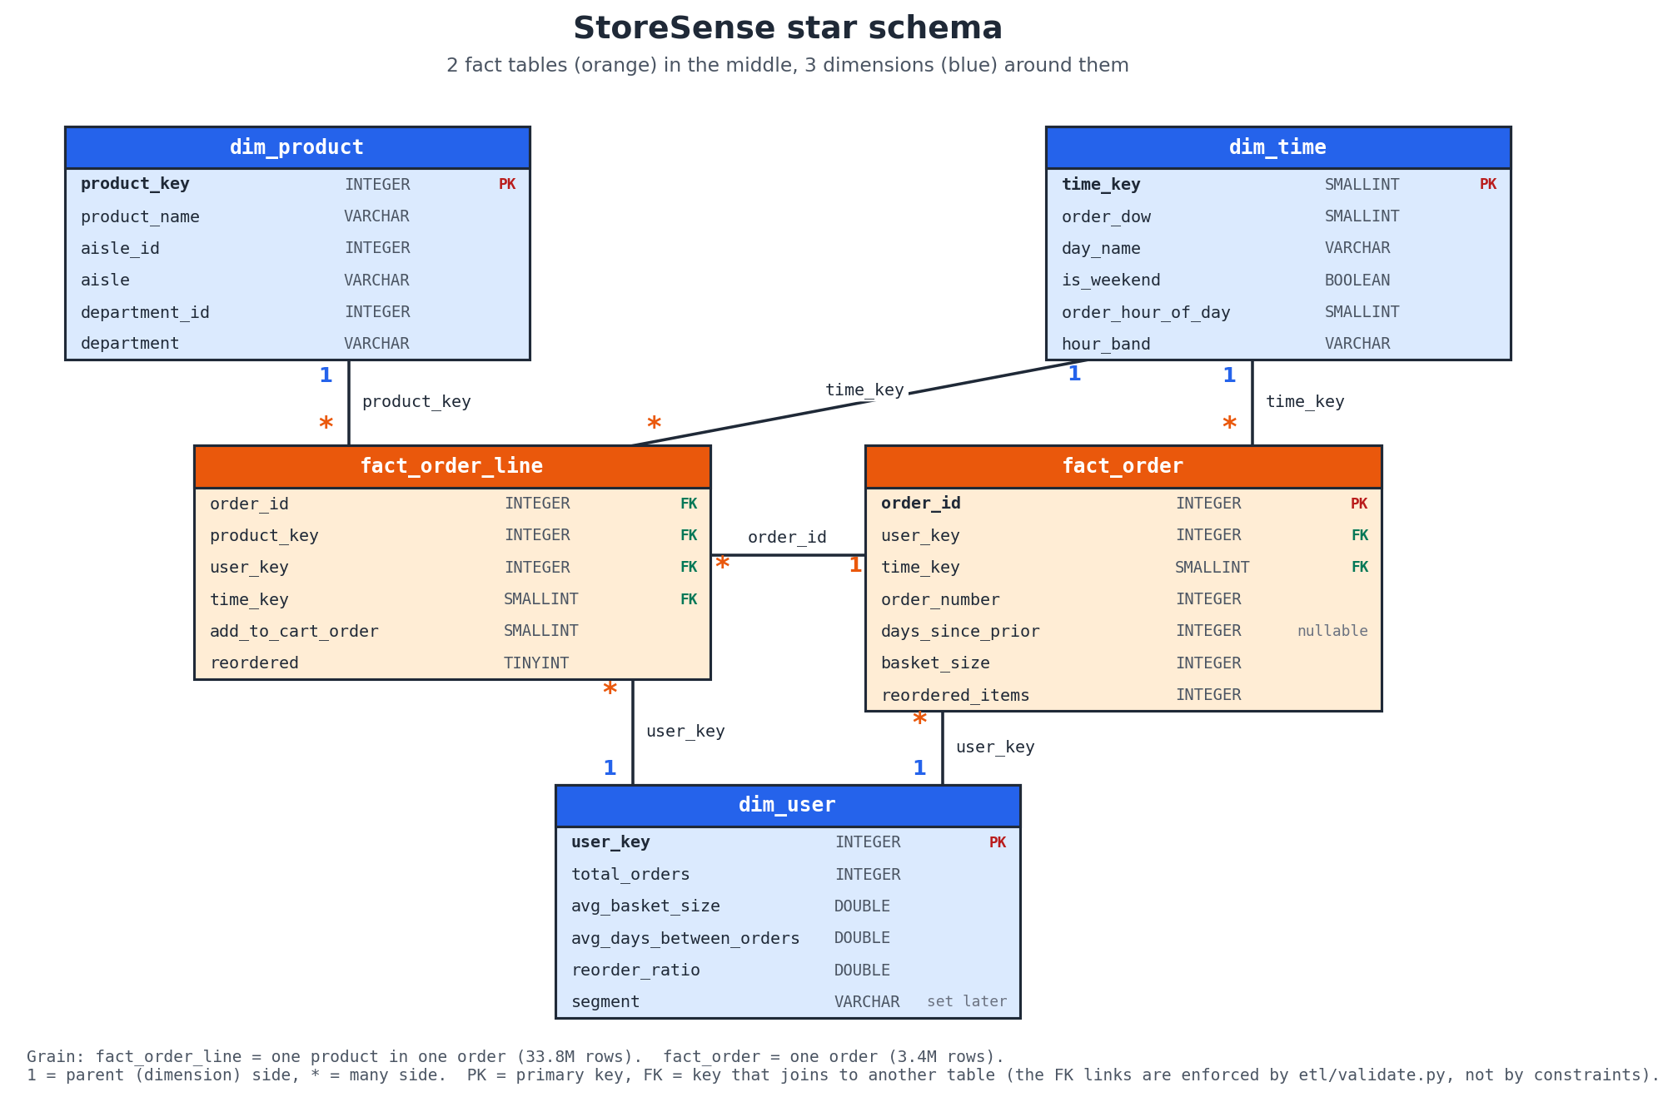
Star schema of the StoreSense warehouse
Limitations. No surrogate keys or slowly changing dimensions, because the data is a single snapshot. The time dimension has no calendar level.

8.4 OLAP operations
Concept. OLAP views data as a multidimensional cube. Roll-up aggregates to a coarser hierarchy level, drill-down moves to a finer one, a slice fixes one dimension to one value, a dice restricts several dimensions at once, and a pivot rotates the view, for example turning one dimension’s values into columns [16], [17].
Relevance. These operations answer “when and what do people buy?” directly.
Implementation. Saved queries in sql/olap_queries.sql (each commented), and the same operations generated on demand by the dashboard’s query builder:
Query | Operation | SQL technique | Result (full data)
Q1a | Roll-up department → aisle → grand total | GROUP BY ROLLUP (department, aisle) with GROUPING() to label levels | 156 rows; grand total 33,819,106 order lines
Q1b | Drill-down into one aisle (dairy eggs / yogurt) to product level | ROLLUP with a fixed department and aisle | aisle total 1,507,583 lines
Q2 | Slice: weekend only | WHERE t.is_weekend | 11,241,275 lines (33.2%)
Q3 | Dice: produce and dairy eggs, Evening band | WHERE department IN (…) AND hour_band = 'Evening' | 8 rows; both fall ~52% from 17:00 to 20:00
Q4 | Pivot: department × day of week | DuckDB PIVOT … ON day_name IN (…) USING COUNT(order_id) | 21 × 7 matrix
Q5 | Cube: department × hour band | GROUP BY CUBE (department, hour_band) | includes per-band totals across all departments
Q6 | Cube on the aggregate fact | CUBE (day_name, hour_band) on AVG(basket_size), filtering basket_size > 0 | Sunday baskets largest (11.16)
Roll-up semantics. For ROLLUP (a, b) the result contains the grouping sets (a, b), (a) and (), that is, details, subtotals and a grand total. CUBE (a, b) additionally contains (b), every combination, which ROLLUP cannot give because it follows one hierarchy from the left [16].
The dashboard’s 3-D cube view selects any three of department, aisle, day of week, hour band and hour, completes the cube with zero cells for empty combinations, and highlights the cells of a slice (values picked on one axis) or a dice (values picked on several axes).
Limitations. “Sales” are order-line counts (no prices). All demo queries ran in 0.4 s or less, but no formal benchmark against a non-warehouse baseline was run.

8.5 Association rule mining: Apriori and FP-Growth
Concept. For a rule A ⇒ B over a set of N baskets:
$$\text{support}(A⇒B)=\frac{|\{t:A∪B⊆t\}|}{N}, \text{confidence}(A⇒B)=\frac{\text{support}(A∪B)}{\text{support}(A)}, \text{lift}(A⇒B)=\frac{\text{confidence}(A⇒B)}{\text{support}(B)}$$
Lift = 1 means A and B are independent; lift > 1 means B is more likely in baskets with A than in a typical basket [3], [4].
Apriori [1] (level-wise candidate generation):
L1 ← frequent single items (support ≥ min_support)
for k = 2, 3, … while L(k-1) is not empty and k ≤ max_len:
C(k) ← candidate k-itemsets joined from L(k-1),
pruned if any (k-1)-subset is not in L(k-1) # downward closure
count the support of each candidate over the baskets
L(k) ← candidates with support ≥ min_support
return the union of all L(k)
FP-Growth [2] builds a compressed prefix tree (FP-tree) of the baskets in two passes, then mines it recursively through conditional pattern bases, without generating candidates.
Relevance. Answers “which products are bought together?”, and the brief also asks for a comparison of the two algorithms.
Implementation (mining/association_rules.py):
- Baskets are read from fact_order_line ⨝ dim_product. Only orders with at least 2 items are used (3,182,490 orders), because a single item cannot form a rule.
- A random sample of 500,000 orders (seed 42) is drawn.
- Baskets are one-hot encoded into a sparse DataFrame (only the True cells are stored).
- Frequent itemsets are mined with both algorithms (max_len = 3). The script stops with an error if they disagree, and a test checks this on a hand-worked example.
- Rules are generated with mlxtend’s association_rules, kept where lift > 1, sorted by lift, and given a plain-English interpretation.
Table 8.3 – Association rule settings at the two levels
 | Aisle level | Product level
Items | 132 aisles (missing and other removed) | top 1,000 products by order lines (53.9% of all lines)
Baskets used | 492,350 | 418,175
min_support | 0.01 | 0.0015
Frequent itemsets | 2,344 (96 single, 894 pairs, 1,354 triples) | 2,527
Rules with lift > 1 | 9,730; top 5,000 by lift kept (lift ≥ 1.42) | 3,410 (all kept)
Memory control. With default settings, mlxtend’s Apriori requested 81.6 GiB on the product baskets, because it builds a baskets × candidates table. The project therefore runs Apriori with low_memory=True. The sample and the top-1,000 filter are further memory controls; the full script runs in about 2 minutes.
Validation of the sample. The top product rule (Icelandic Style Skyr Blueberry Non-fat Yogurt ⇒ Non Fat Acai & Mixed Berries Yogurt) was recounted in SQL on the whole warehouse: confidence 20.6% and lift 61.0, against 22.1% and 63.1 in the sample, within about 7%.
Benchmark (mining/benchmark.py): on a 100,000-order sample, five min_support values per level, runtime and peak memory (tracemalloc) measured in separate runs, so that the memory tracer does not distort the times. Results are in Section 10.4.
Outputs. rules_aisle.csv, rules_product.csv, benchmark.csv, two charts, and frequently_bought_together(product_name, top_n), which the dashboard uses for “customers also bought”.
Limitations. Sampled orders; only the top 1,000 products; itemsets capped at 3; rules show association, not causation; the benchmark was run once per setting on one machine.

8.6 Clustering: customer segmentation with K-Means
Concept. K-Means chooses k centres $μ_{1},…,μ_{k}$ to minimise the inertia i​minjxi−μj2 by alternating between assigning points to their nearest centre and moving each centre to the mean of its points [5], [6]. For a point i, the silhouette is $s(i)=\frac{b(i)−a(i)}{max\{a(i),b(i)\}}$, where $a(i)$ is the mean distance to the other points of its cluster and $b(i)$ the mean distance to the nearest other cluster; the mean silhouette ranges from −1 to 1 [7].
Relevance. Answers “what kinds of customers exist?”, following the RFM idea from marketing [9].
Implementation (mining/segmentation.py):
Feature | Source | RFM role
recency_days | days_since_prior of the user’s last order | Recency (proxy)
total_orders | dim_user.total_orders | Frequency
avg_basket_size | dim_user.avg_basket_size | Monetary (proxy; no prices)
reorder_ratio | dim_user.reorder_ratio | Loyalty
- Transform: log(1 + x) on total_orders (skew 2.40 → 0.65) and avg_basket_size (skew 1.22 → −0.33); the other two are already symmetric.
- Standardise all four features to mean 0 and standard deviation 1.
- Evaluate k = 2 … 10 with KMeans(n_init=10, random_state=42) on all 206,209 users; inertia on all users, silhouette on a fixed sample of 20,000 users.
- Choose k with choose_k(): among k = 4 … 8, take the best silhouette rounded to 3 decimals, and the smallest k if several tie. k = 2 had the best silhouette (0.309) but only separates frequent from infrequent users, so it was excluded as too coarse to act on.
- Profile and name the clusters with rules on their averages (name_segment()).
- Write back each user’s segment name into dim_user.segment with one set-based UPDATE … FROM.
- PCA to two components on a 10,000-user sample, for the scatter plot only.
Recency caveat. Without dates, “recency” is the gap before the last order, not the time since it. 30.6% of users have the capped value 30.
Outputs. Four named segments (Section 10.5), segment_profiles.csv, segment_pca_sample.csv, three charts, and the filled dim_user.segment (206,209 users, 0 NULL).
Limitations. Weak to moderate structure (silhouette ≈ 0.27), so the segments overlap; K-Means assumes compact, similar-sized clusters; the monetary and recency features are proxies.

8.7 Classification: reorder prediction (stretch goal)
Concept. Binary classification learns $P(y=1∣x)$ from labelled examples. With a rare positive class, performance is measured by precision $=\frac{TP}{TP+FP}$, recall $=\frac{TP}{TP+FN}$, $F_{1}=\frac{2PR}{P+R}$ and ROC-AUC, the probability that a random positive is scored above a random negative [20], [21].
Relevance. It turns the reorder pattern seen in OLAP (59% of lines are reorders) into a per-product prediction, which could be used for a “buy it again” list.
Implementation (mining/reorder_model.py):
- Label. For each user with a train order (131,209 users), and each product in that user’s prior orders, y = 1 if the product is in the train order. On a sample of 30,000 users (seed 42) this gives 1,951,532 pairs, 9.7% positive.
- Features (13), all from prior orders only, computed in DuckDB SQL:
Table 8.4 – Reorder model features
Group | Features
User (5) | u_orders, u_avg_basket, u_reorder_ratio, u_avg_days_between, u_distinct_products
Product (3) | p_orders, p_reorder_rate, p_users
User × product (5) | up_times_bought, up_share, up_orders_since_last, up_days_since_last, up_avg_cart_pos
- Leakage prevention [22]: eval_set is read from the raw orders.csv (the warehouse does not store it); every feature query filters eval_set = 'prior'; the train order is used only for the label; candidate pairs come only from prior orders; and a test replaces the train orders with different baskets and checks that no feature changes, only the labels.
- Split by user, not by row: 60% / 20% / 20% (18,000 / 6,000 / 6,000 users), with a test that no user appears in two sets.
- Models: Logistic Regression (standardised inputs, class_weight="balanced") as the baseline, and LightGBM (300 trees, learning rate 0.05, 63 leaves, no class weights).
- Threshold: for each model, the probability threshold with the highest F1 on the validation users, then used unchanged on the test users. The model was chosen on validation ROC-AUC.
Outputs. reorder_metrics.csv, reorder_feature_importance.csv, ROC and importance charts (Section 10.6).
Limitations. One split, no hyper-parameter tuning, a 22.9% sample of eligible users, and no first-time purchases among the candidates by design.

8.8 Data visualisation and analytical reporting
Implementation. Matplotlib charts for the report (reports/figures/), and interactive Plotly charts in the Streamlit dashboard: a heatmap of orders by day and hour, roll-up tables and bars, a pivot heatmap, a 3-D cube scatter, rule tables, benchmark lines, segment bars and a PCA scatter, and ROC and importance charts. Reports are written as Markdown sections and assembled automatically.
Limitation. The dashboard was tested headless and checked by eye; no accessibility or formal usability evaluation was carried out.

9. Implementation Details

9.1 Project Structure
StoreSense/
├── common/db.py shared paths and DuckDB connection helpers (read-only by default)
├── etl/ extract.py · transform.py · load.py · validate.py
├── sql/ schema.sql (star schema DDL) · olap_queries.sql (Q1a–Q6)
├── mining/ association_rules.py · benchmark.py · segmentation.py · reorder_model.py
├── dashboard/
│ ├── app.py entry point: Overview page + st.navigation menu
│ ├── views/ 1_OLAP_Explorer · 2_Basket_Rules · 3_Customer_Segments · 4_Reorder_Model
│ ├── data.py all SQL and file reading (no Streamlit; testable)
│ ├── ui.py cached wrappers and "missing file" messages
│ ├── build_demo_data.py writes the 4.3 MB Parquet demo extract
│ └── requirements.txt slim package list for Streamlit Community Cloud
├── data/raw/ Kaggle CSVs (gitignored)
├── data/warehouse/ storesense.duckdb (gitignored)
├── data/demo/ Parquet demo extract (committed)
├── notebooks/eda.ipynb exploratory data analysis
├── reports/
│ ├── sections/ per-module report sections (00–07)
│ ├── results/ mining result CSVs (committed)
│ ├── figures/ charts and the star schema diagram
│ ├── build_report.py assembles StoreSense_report.md
│ └── StoreSense_report.md the assembled technical report
├── tests/ 90 pytest tests + a fixture schema
├── docs/ PROJECT_BRIEF.md · DEMO_FLOW.md · DEPLOY.md
├── README.md · CONTRIBUTING.md · requirements.txt · pyproject.toml
Code size (lines, including comments): ETL 521, mining 906, dashboard 996, common 70, SQL 284, tests 1,236.

9.2 Module-Level Implementation
- common/db.py defines PROJECT_ROOT, RAW_DIR, WAREHOUSE_PATH and FIGURES_DIR, and get_connection(read_only=True) and query_df(sql, params), which every module uses. A clear error is raised if the warehouse has not been built.
- ETL. extract.py registers views; transform.py holds only SQL constants and the ordered LOAD_STEPS; load.py checks the inputs, runs the DDL and the inserts, and refuses to overwrite without --force; validate.py builds the 23 checks from small SQL templates (_orphans, _duplicates, _count_differs) and prints a pass/fail table.
- Mining. Each script is runnable on its own (python mining/<name>.py), does its heavy selection in SQL, and writes results with the exact column names agreed in the team’s shared result-file contract, which a test checks.
- Dashboard. Pages contain no SQL; they call dashboard/data.py through cached wrappers in ui.py. The page folder is named views/ rather than Streamlit’s default pages/, so that the explicit st.navigation menu is always used.

9.3 Data Processing
The processing pipeline is the ETL described in Sections 6.3 and 8.2. All ETL processing happens in DuckDB SQL. Only mining inputs that fit comfortably in memory (sampled baskets, per-user features, a 30,000-user pair table) are brought into pandas.

9.4 Analytical Components
Component | Algorithm / calculation | Library
OLAP | GROUP BY, ROLLUP, CUBE, GROUPING(), PIVOT, window SUM() OVER () for shares | DuckDB
Frequent itemsets | Apriori (low_memory=True), FP-Growth, max_len = 3 | mlxtend
Rules | support, confidence, lift; filter lift > 1 | mlxtend + pandas
Benchmark | wall-clock time and tracemalloc peak memory, separate runs | Python standard library
Segmentation | log1p, StandardScaler, KMeans, silhouette_score, PCA | scikit-learn, NumPy
Reorder | LogisticRegression, LGBMClassifier, precision_recall_curve, roc_auc_score | scikit-learn, LightGBM

9.5 Database and Storage
- Engine: DuckDB, an in-process columnar analytical database [13]. One file, data/warehouse/storesense.duckdb (~0.23 GB).
- Schema: Section 8.3 and Appendix B.
- Concurrency: DuckDB allows one writer at a time. The dashboard and all analysis scripts open the file read-only; only etl/load.py and mining/segmentation.py write.
- Result storage: small CSV files in reports/results/, committed to git, each kept under about 5 MB.
- Demo extract: four Parquet files in data/demo/ (zstd-compressed): line_counts (order lines counted per product and day-hour slot, about 3.0 million rows), dim_product, dim_time and kpis.

9.6 User Interface
The Streamlit dashboard has five pages, listed in a sidebar menu:
Page | Contents
Overview | Five KPIs (orders, users, products, average basket, reorder rate); “When do people shop?” (orders by hour for each day); “What do they buy?” (top departments); “What the numbers say” (findings computed from the same data); data-source note
OLAP Explorer | Four tabs: Roll-up and drill-down (product or time hierarchy, choice of level, subtotals and grand total); Slice and dice (group by any dimensions with filters for department, aisle, day, hour band and weekend); Pivot heatmap (any two dimensions); 3D cube (any three dimensions, rotatable, with slice/dice highlighting)
Basket Rules | Three tabs: Rules table (aisle or product level, search, lift and confidence filters, CSV download); Recommendations (“Customers who buy X also buy”); Apriori vs FP-Growth (benchmark charts)
Customer Segments | Segment sizes; how each segment differs from the average user; PCA scatter of 10,000 users; profile table; a suggested store action per segment
Reorder Model | Metrics of both models; feature importance; ROC curve; guidance on reading the numbers
Screenshots (taken on 15 October 2026 from the dashboard running locally on the full warehouse, light theme):
Figure 9.1 – Overview page: headline KPIs, orders by hour for each day, top departments
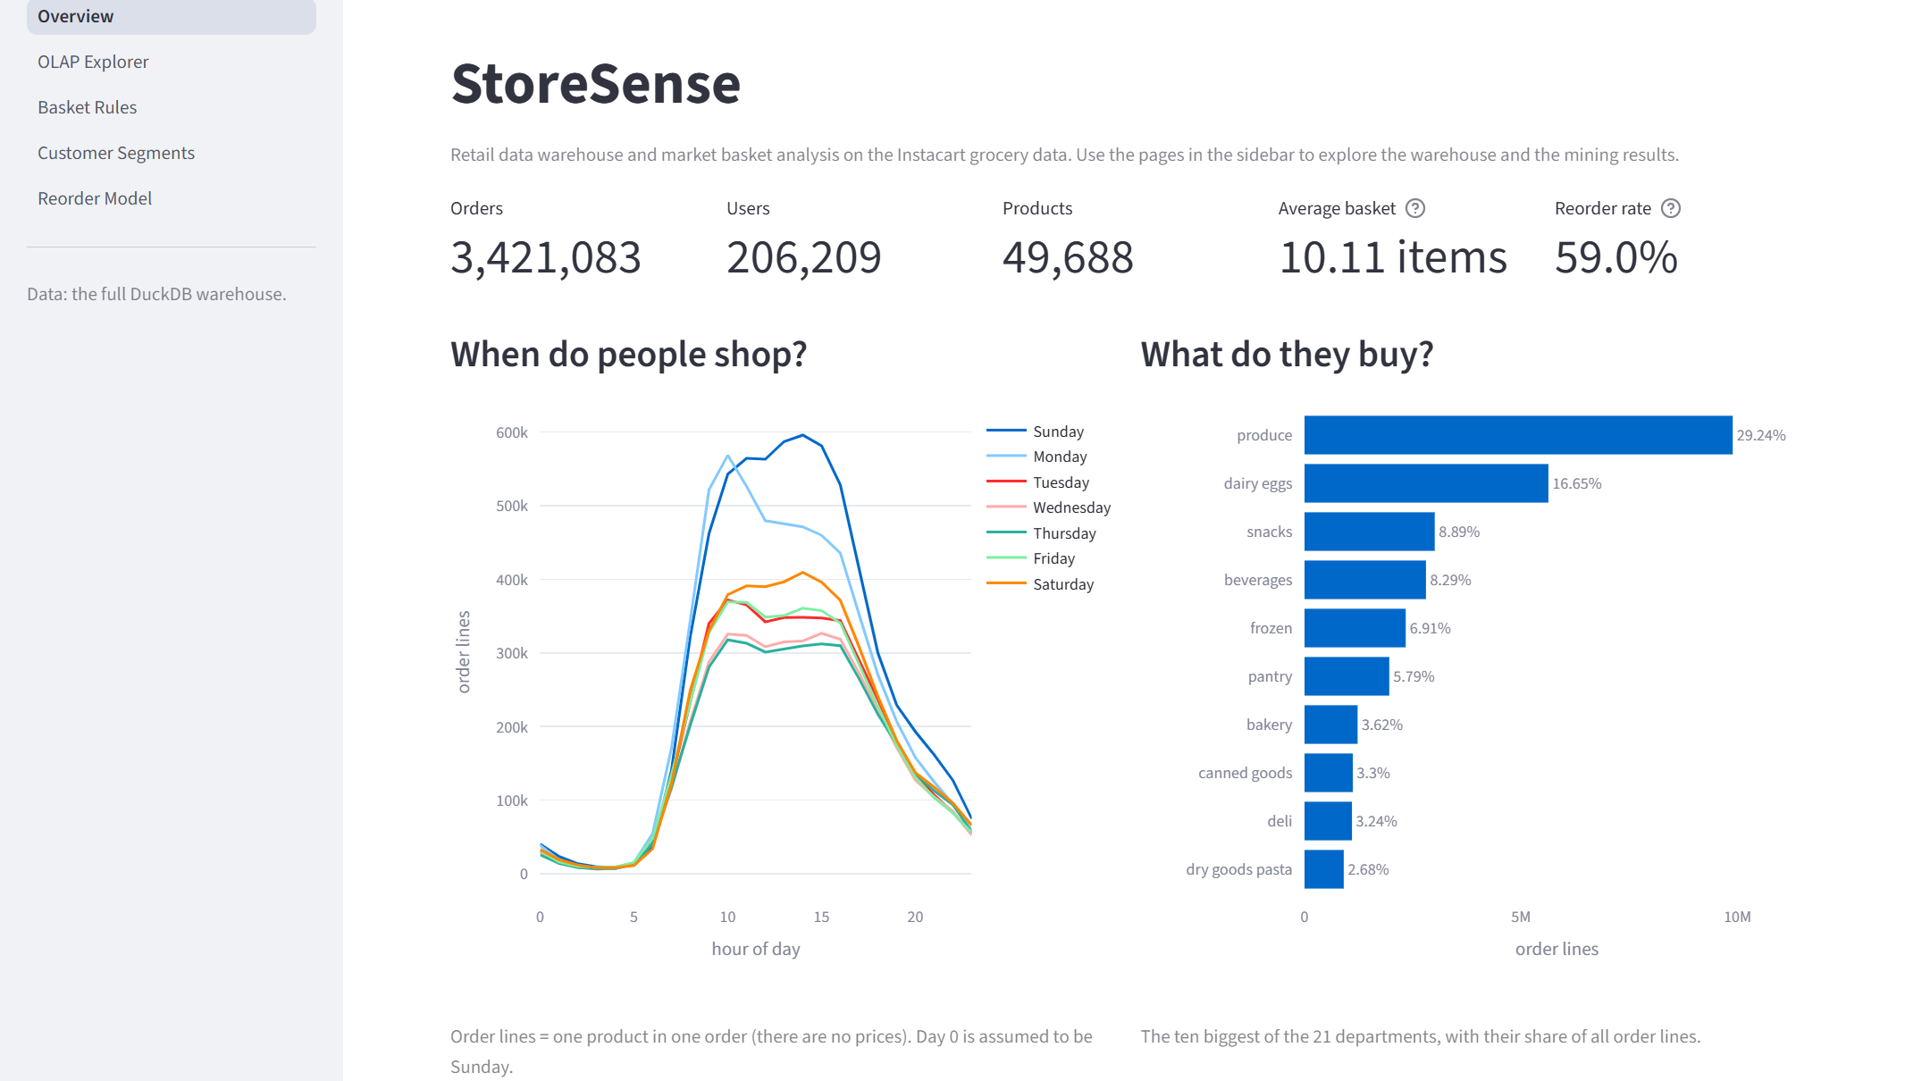
Overview page: headline KPIs, orders by hour for each day, top departments
Figure 9.2 – OLAP Explorer, roll-up and drill-down tab (department > aisle, grand total 33,819,106)
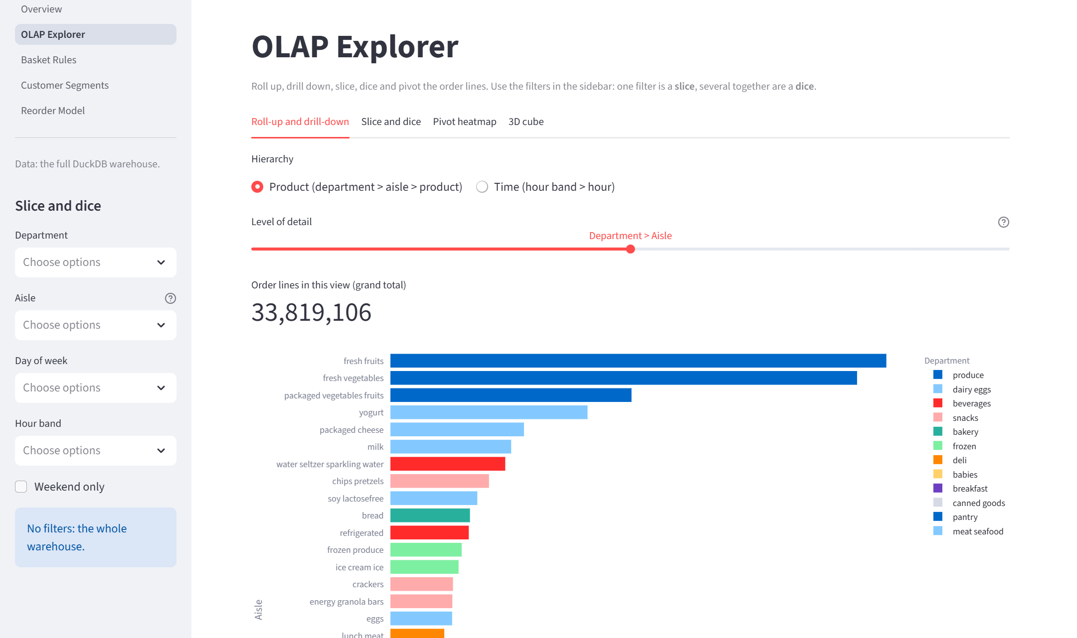
OLAP Explorer, roll-up and drill-down tab (department > aisle, grand total 33,819,106)
Figure 9.3 – OLAP Explorer, 3-D cube tab (department × day of week × hour band, 588 cells)
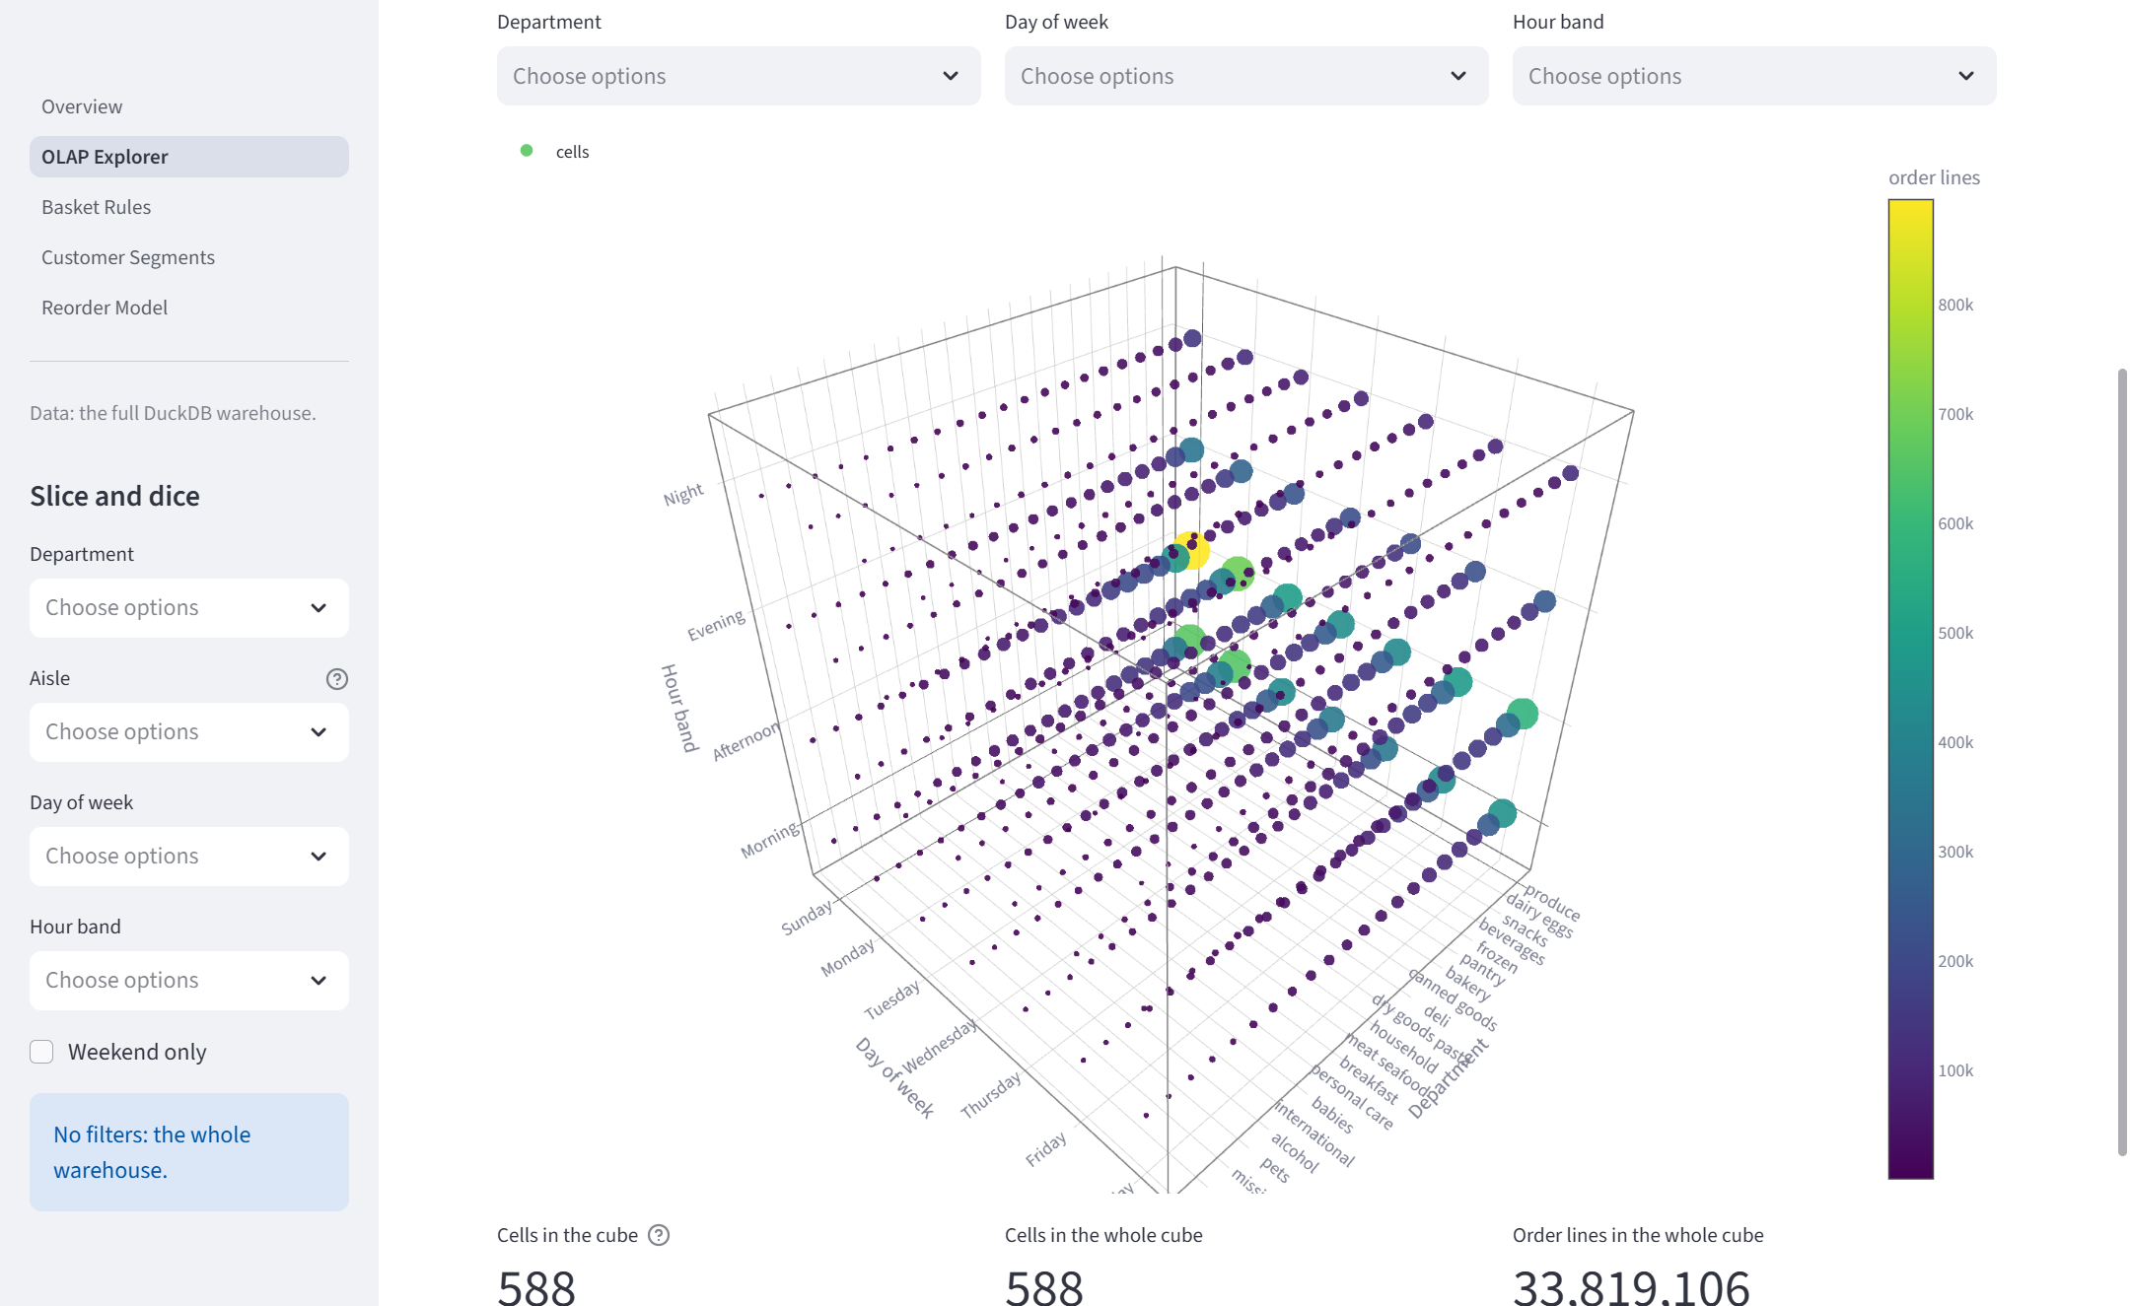
OLAP Explorer, 3-D cube tab (department × day of week × hour band, 588 cells)
Figure 9.4 – Basket Rules page: aisle-level rules sorted by lift, with filters and plain-English interpretations
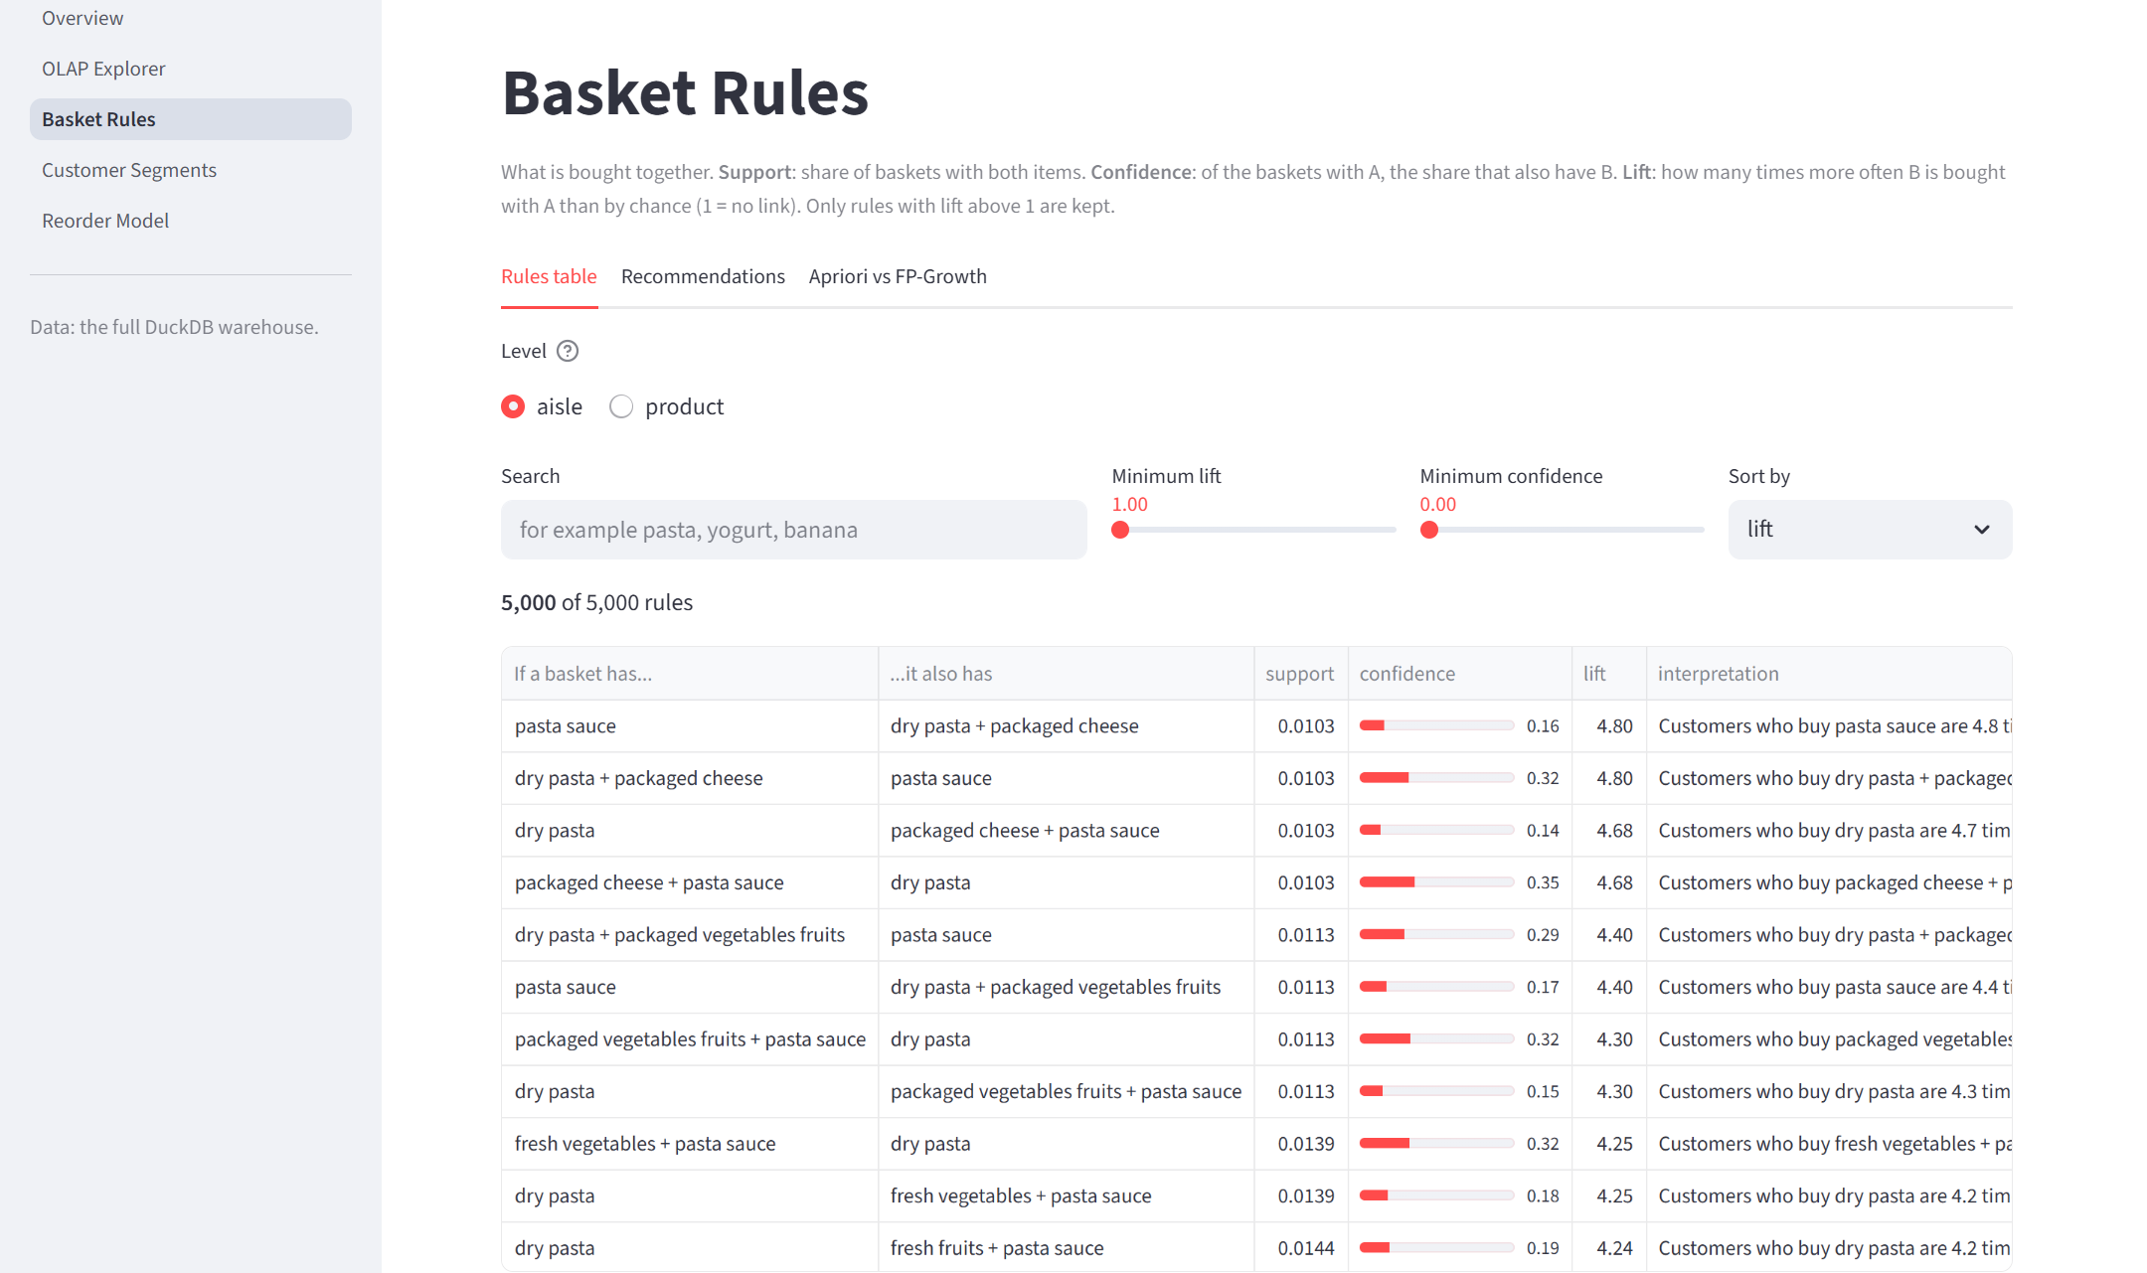
Basket Rules page: aisle-level rules sorted by lift, with filters and plain-English interpretations
Figure 9.5 – Customer Segments page: segment sizes and each segment against the average user
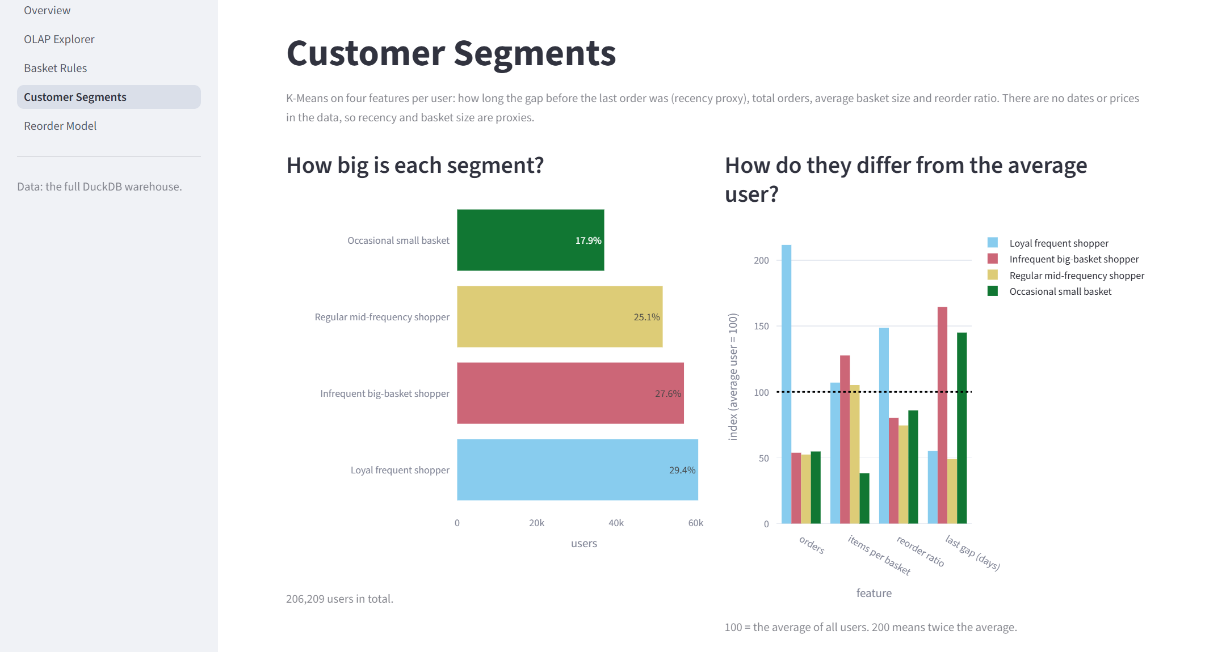
Customer Segments page: segment sizes and each segment against the average user
Figure 9.6 – Reorder Model page: headline metrics, the two models compared, feature importance
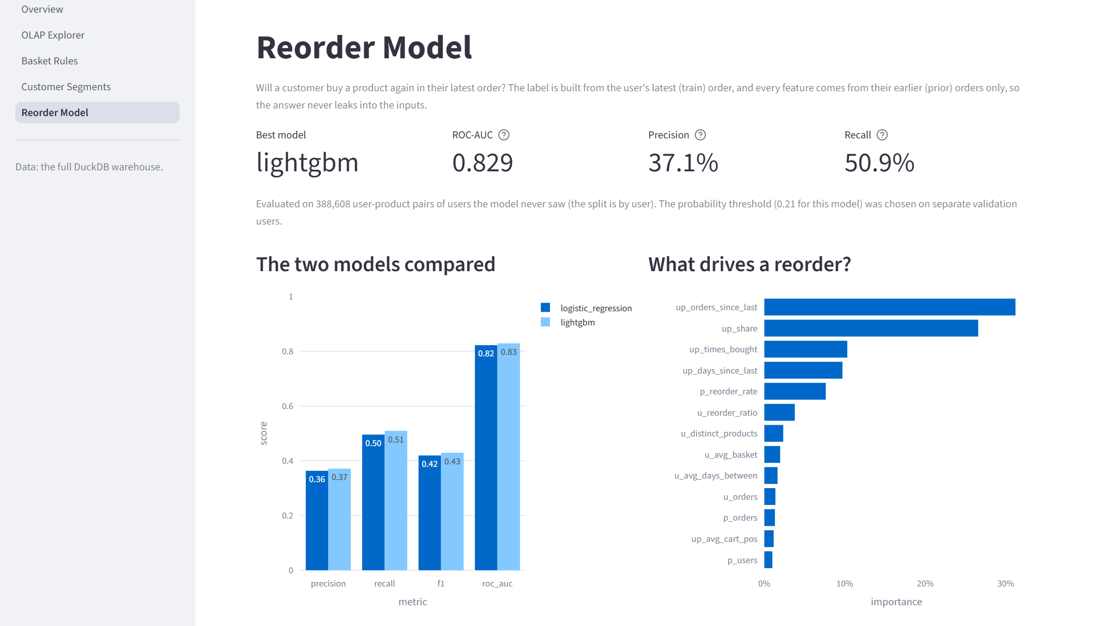
Reorder Model page: headline metrics, the two models compared, feature importance

9.7 Integration
Modules are integrated through files and a fixed contract, not through function calls between team members’ code:
- The schema (sql/schema.sql) is the contract between the warehouse design and the ETL: the ETL inserts by column name.
- The warehouse is the contract between the ETL and the mining modules.
- A result-file contract fixes the file names and exact columns that the mining scripts write and the dashboard reads. tests/test_dashboard.py::test_result_columns_match_the_shared_contract fails if a script changes its output format. (The written contract, handoff/PHASE4_SHARED_CONTRACT.md, exists in the repository owner’s working copy but is excluded from git, so it is not in the GitHub repository.)
- The only function call across modules is frequently_bought_together() from mining/association_rules.py, used by the Basket Rules page.

9.8 Important Code Examples
Example 1 – The time dimension is generated, not read (etl/transform.py). Every day-and-hour slot of a week gets one row, and the hour band is the time hierarchy’s upper level.
SELECT
d.dow * 24 + h.hr AS time_key,
d.dow AS order_dow,
CASE d.dow WHEN 0 THEN 'Sunday' WHEN 1 THEN 'Monday'
WHEN 2 THEN 'Tuesday' WHEN 3 THEN 'Wednesday'
WHEN 4 THEN 'Thursday' WHEN 5 THEN 'Friday'
WHEN 6 THEN 'Saturday' END AS day_name,
d.dow IN (0, 6) AS is_weekend,
h.hr AS order_hour_of_day,
CASE WHEN h.hr BETWEEN 5 AND 11 THEN 'Morning'
WHEN h.hr BETWEEN 12 AND 16 THEN 'Afternoon'
WHEN h.hr BETWEEN 17 AND 20 THEN 'Evening'
ELSE 'Night' END AS hour_band
FROM range(7) AS d(dow)
CROSS JOIN range(24) AS h(hr)
Example 2 – The aggregate fact table is built from the loaded atomic fact (etl/transform.py). Test orders, which have no lines, get basket_size = 0 through the LEFT JOIN and COALESCE.
SELECT o.order_id, o.user_id AS user_key,
o.order_dow * 24 + o.order_hour_of_day AS time_key,
o.order_number,
CAST(o.days_since_prior_order AS INTEGER) AS days_since_prior,
COALESCE(b.basket_size, 0) AS basket_size,
COALESCE(b.reordered_items, 0) AS reordered_items
FROM raw_orders o
LEFT JOIN (SELECT order_id, COUNT(*) AS basket_size, SUM(reordered) AS reordered_items
FROM fact_order_line GROUP BY order_id) b
ON o.order_id = b.order_id
Example 3 – Roll-up with labelled levels (sql/olap_queries.sql, Q1a). GROUPING() distinguishes a subtotal’s NULL from a real value.
SELECT CASE GROUPING(p.department, p.aisle)
WHEN 0 THEN 'aisle' WHEN 1 THEN 'department total' ELSE 'grand total' END AS level,
p.department, p.aisle, COUNT(*) AS order_lines
FROM fact_order_line l
JOIN dim_product p ON l.product_key = p.product_key
GROUP BY ROLLUP (p.department, p.aisle)
ORDER BY p.department NULLS LAST, p.aisle NULLS LAST;
Example 4 – Apriori in low-memory mode (mining/association_rules.py).
def mine_itemsets(onehot, min_support, algorithm, max_len=None):
# Apriori runs with low_memory=True: the default builds one (baskets x candidates)
# table for each itemset size, which asked for 81.6 GiB on the product baskets.
if algorithm == "apriori":
return apriori(onehot, min_support=min_support, use_colnames=True,
max_len=max_len, low_memory=True)
return fpgrowth(onehot, min_support=min_support, use_colnames=True, max_len=max_len)
Example 5 – Choosing k reproducibly (mining/segmentation.py).
def choose_k(scores, candidates=K_CANDIDATES): # K_CANDIDATES = range(4, 9)
pool = scores[scores["k"].isin(list(candidates))].copy()
pool["sil_rounded"] = pool["silhouette"].round(3)
best = pool["sil_rounded"].max()
return int(pool.loc[pool["sil_rounded"] == best, "k"].min()) # smallest k among ties
Example 6 – Splitting by user and tuning the threshold on validation users (mining/reorder_model.py).
def split_users(user_keys, seed=SEED):
users = np.random.default_rng(seed).permutation(np.unique(np.asarray(user_keys)))
n_train = int(len(users) * 0.6)
n_val = int(len(users) * 0.2)
return {"train": users[:n_train],
"validation": users[n_train:n_train + n_val],
"test": users[n_train + n_val:]}
def best_threshold(y_true, proba):
precision, recall, thresholds = precision_recall_curve(y_true, proba)
f1 = 2 * precision[:-1] * recall[:-1] / np.clip(precision[:-1] + recall[:-1], 1e-12, None)
return float(thresholds[int(np.argmax(f1))])
Example 7 – User input never enters the SQL text (dashboard/data.py). Column names come from a whitelist (DIMENSIONS); values become ? parameters.
for key, column, alias in (("departments", "p.department", "p"), ("aisles", "p.aisle", "p"),
("days", "t.day_name", "t"), ("hour_bands", "t.hour_band", "t")):
values = list(filters.get(key) or [])
if values:
clauses.append(f"{column} IN ({', '.join('?' * len(values))})")
params += values

10. Results and Discussion
All figures in this chapter come from the team’s runs on the full Instacart data. They are recorded in reports/sections/*.md and in the committed result files in reports/results/. The warehouse row counts and the 23 validation checks were re-run on 15 October 2026 and gave the same values.

10.1 Features successfully implemented
Objective | Status | Evidence
ETL and validated star schema | Complete | 5 tables, 23/23 checks pass (re-run 15 Oct 2026)
OLAP operations | Complete | Q1a–Q6 in sql/olap_queries.sql; dashboard OLAP Explorer
Association rules and benchmark | Complete | rules_aisle.csv (5,000 rules), rules_product.csv (3,410 rules), benchmark.csv
Customer segmentation | Complete | segment_profiles.csv; dim_user.segment filled
Reorder prediction (stretch) | Complete | reorder_metrics.csv, reorder_feature_importance.csv
Interactive dashboard | Complete (local) | 5 pages; headless page tests pass
Hosted dashboard | Configured; live status to be confirmed | docs/DEPLOY.md, dashboard/requirements.txt, demo extract
Tests | Complete | 90/90 passed on 15 Oct 2026

10.2 Warehouse
Table 10.1 – Warehouse load results
Item | Value
fact_order_line | 33,819,106 rows (32,434,489 prior + 1,384,617 train)
fact_order | 3,421,083 rows (= orders.csv)
dim_user / dim_product / dim_time | 206,209 / 49,688 / 168
Test orders kept with basket size 0 | 75,000
Orders at the 30-day cap | 369,323
Full load time | 8.6 s and 13.8 s in two recorded team runs (single machine)
Warehouse file | ≈ 0.23 GB (229,650,432 bytes on 15 Oct 2026)
Validation | 23 / 23 checks passed
The two load times come from different runs recorded in sections 1 and 2 of the team’s technical report. The machine and conditions of each run were not recorded, so the difference cannot be explained from the available evidence.

10.3 OLAP findings
Table 10.2 – Roll-up of order lines by department (top 5)
Department | Order lines | Share
produce | 9,888,378 | 29.2%
dairy eggs | 5,631,067 | 16.7%
snacks | 3,006,412 | 8.9%
beverages | 2,804,175 | 8.3%
frozen | 2,336,858 | 6.9%
grand total | 33,819,106 | 100%
- Concentration. Produce and dairy eggs together account for 45.9% of all order lines. The largest aisles are fresh fruits (3,792,661) and fresh vegetables (3,568,630).
- Weekly rhythm. The weekend (Sunday + Saturday) holds 33.2% of lines from 2 of 7 days (28.6%). Sunday is the busiest day (6,533,692 lines) and Thursday the quietest (3,942,696), a ratio of 1.66.
- Exception. Alcohol peaks on Friday (28,465 lines) and is lowest on Sunday (18,150).
- Daily rhythm. The busiest hour is 10:00. In the evening dice, produce and dairy eggs both fall by about 52% between 17:00 and 20:00.
- Basket size. The average basket over 3,346,083 non-empty orders is 10.11 items. Sunday baskets are the largest (11.16) and Wednesday baskets the smallest (9.34).
- Speed. Each demo query ran in 0.4 s or less on 33.8 million rows, and dashboard queries in 0.1–0.3 s (team measurements).
Interpretation. Demand is concentrated in a few departments and in time, which matters for stock, staffing and delivery slots. The day names depend on the assumption that day 0 is Sunday.

10.4 Association rules and the algorithm benchmark
Table 10.3 – Top association rules
Level | Rule | Support | Confidence | Lift
Aisle | pasta sauce ⇒ dry pasta + packaged cheese | 1.03% | 15.6% | 4.80
Aisle | dry pasta ⇒ pasta sauce | 2.08% | 27.6% | 4.17
Aisle | canned jarred vegetables ⇒ canned meals beans | 1.94% | 24.8% | 3.36
Aisle | frozen meals ⇒ frozen pizza | 1.07% | 13.6% | 2.95
Aisle | fresh herbs ⇒ fresh vegetables | 8.44% | 84.7% | 1.80
Product | Icelandic Style Skyr Blueberry Non-fat Yogurt ⇒ Non Fat Acai & Mixed Berries Yogurt | 0.16% | 22.1% | 63.1
Product | Icelandic Style Skyr Blueberry Non-fat Yogurt ⇒ Non Fat Raspberry Yogurt | 0.27% | 36.6% | 58.0
Product | Zero Calorie Cola ⇒ Soda | 0.16% | 53.4% | 46.9
Product | Organic Yellow Squash ⇒ Organic Zucchini | 0.20% | 47.8% | 11.8
Product | Bartlett Pears ⇒ Banana | 0.54% | 39.0% | 2.17
Interpretation. At aisle level the rules describe shopping “missions” (a pasta dinner, pantry cooking, a frozen “easy dinner”). At product level the strongest rules link flavours of the same product line. The fresh herbs rule shows why lift matters: its confidence is high (84.7%) only because fresh vegetables are in about 47% of all baskets, and its lift is a modest 1.8.
Table 10.4 – Benchmark of Apriori and FP-Growth (100,000-order sample, max_len = 3; selected rows)
Level | min_support | Itemsets | Apriori time | FP-Growth time | Apriori memory | FP-Growth memory
aisle | 0.05 | 170 | 0.18 s | 1.69 s | 18 MB | 69 MB
aisle | 0.01 | 2,329 | 1.14 s | 4.31 s | 26 MB | 134 MB
aisle | 0.005 | 6,142 | 2.32 s | 7.15 s | 30 MB | 147 MB
product | 0.01 | 159 | 0.42 s | 1.15 s | 26 MB | 83 MB
product | 0.003 | 1,078 | 5.80 s | 2.12 s | 109 MB | 104 MB
product | 0.0015 | 2,516 | 10.80 s | 3.51 s | 165 MB | 130 MB
Figure 10.1 – Runtime of the mining step
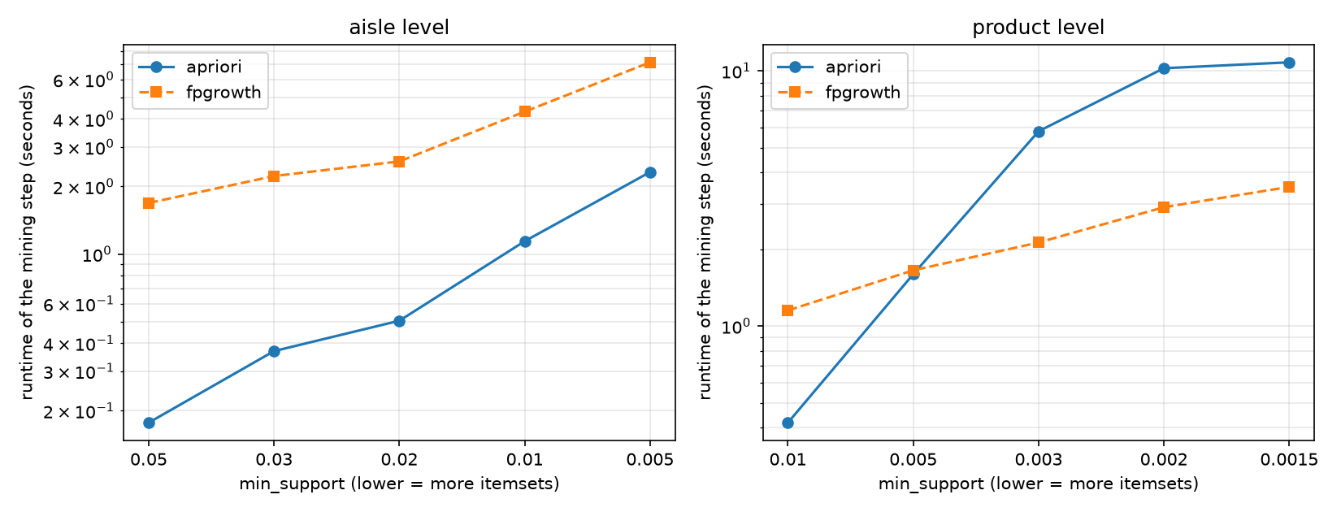
Runtime of Apriori and FP-Growth
Figure 10.2 – Peak memory of the mining step
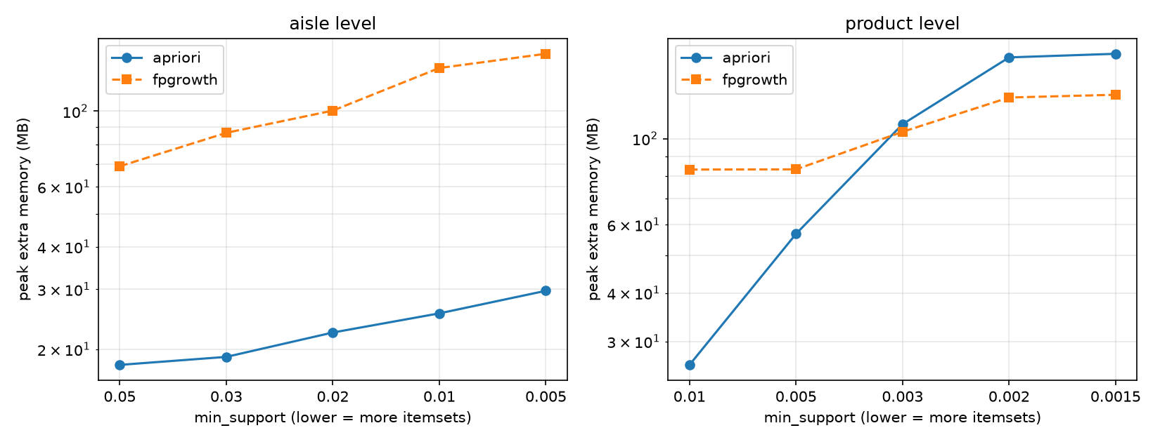
Peak memory of Apriori and FP-Growth
Discussion. At product level with low support, FP-Growth was about 3× faster than Apriori (3.5 s against 10.8 s at 0.0015) and used less memory, as the literature leads one to expect [2]. At aisle level (132 items), Apriori was faster and lighter at every setting tried. The team’s explanation, which was not tested, is that with few items and max_len = 3 Apriori has few candidates to check, while mlxtend’s Python FP-tree construction has a fixed overhead. Both algorithms found identical itemsets at every setting. The practical conclusion is that the faster algorithm depends on the data, and that a benchmark on the real data should decide.
Limits of this evaluation. One run per setting, on one machine, with one library’s implementations.

10.5 Customer segments
Figure 10.3 – Elbow curve and Figure 10.4 – Silhouette score against k
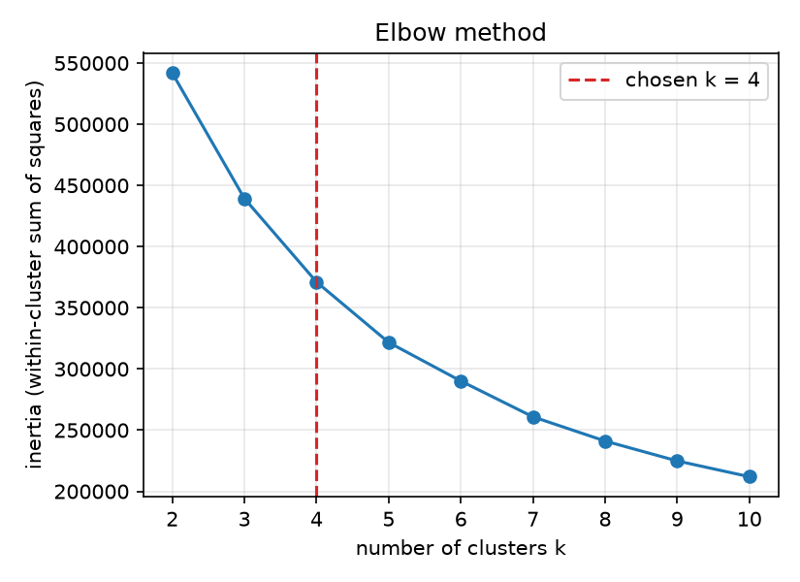
Elbow curve
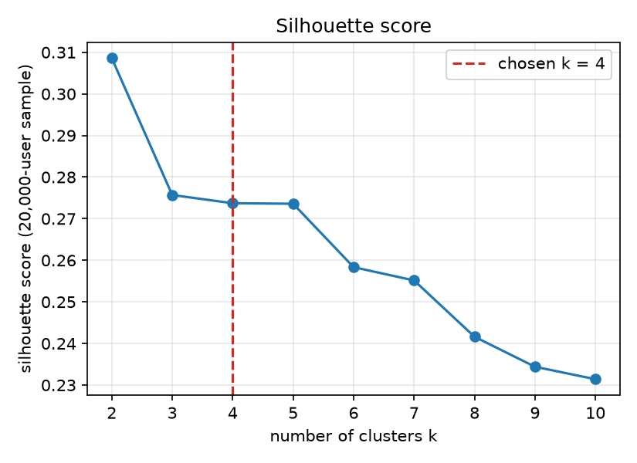
Silhouette score
k | 2 | 3 | 4 | 5 | 6 | 7 | 8 | 9 | 10
Inertia (thousands) | 542 | 439 | 371 | 322 | 290 | 261 | 241 | 225 | 212
Silhouette | 0.309 | 0.276 | 0.274 | 0.274 | 0.258 | 0.255 | 0.242 | 0.234 | 0.231
The elbow is not sharp, and k = 3, 4 and 5 have practically equal silhouettes. The team chose k = 4: it is the smallest k among the ties in the candidate range, and it keeps a distinct small-basket group, which k = 3 merges into the other groups.
Table 10.5 – Segment profiles (means)
Segment | Users | Share | Orders | Items / basket | Days between orders | Reorder ratio | Last gap (days)
Loyal frequent shopper | 60,586 | 29.4% | 35.1 | 10.7 | 9.7 | 66% | 9.4
Infrequent big-basket shopper | 57,005 | 27.6% | 8.9 | 12.8 | 20.3 | 36% | 28.1
Regular mid-frequency shopper | 51,657 | 25.1% | 8.7 | 10.5 | 13.9 | 33% | 8.4
Occasional small basket | 36,961 | 17.9% | 9.1 | 3.8 | 19.6 | 38% | 24.7
All users | 206,209 | 100% | 16.6 | 10.0 | 15.5 | 44% | 17.1
Figure 10.5 – The four segments projected onto two principal components (PC1 50%, PC2 25% of variance)
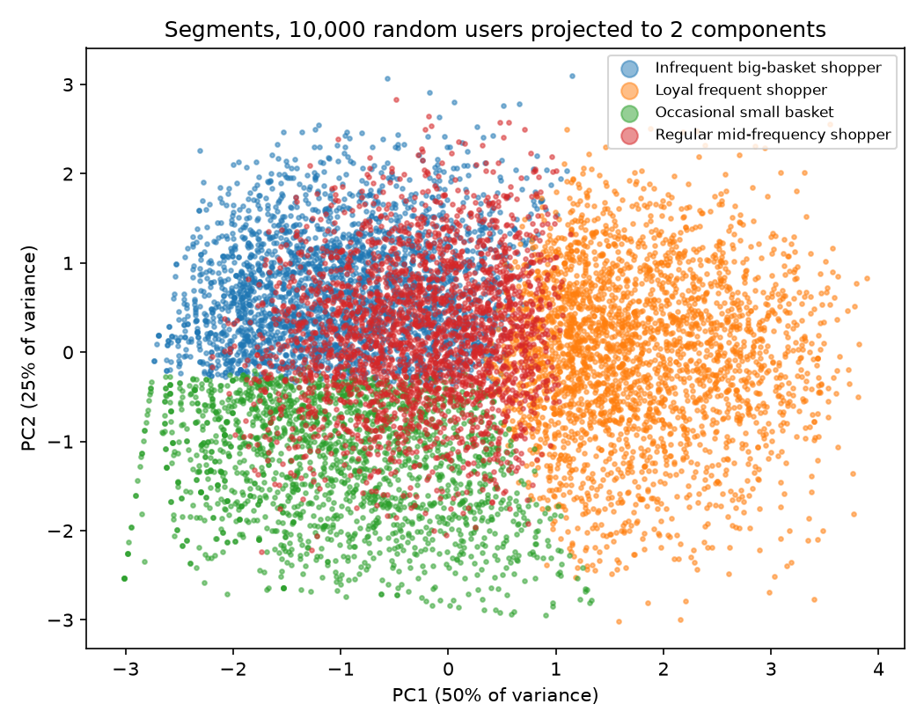
Segments in PCA space
Interpretation. The loyal frequent shoppers are 29.4% of users but place about 62% of all orders and buy about 65% of all items. The occasional small basket group is 17.9% of users but buys only about 3.6% of items. The PCA plot shows the loyal group well separated and the two middle groups overlapping. This is consistent with a silhouette of about 0.27, so the segment borders should be treated as soft.

10.6 Reorder prediction
Table 10.6 – Reorder model metrics on the 6,000 test users (388,608 pairs, 37,664 positive)
Model | Precision | Recall | F1 | ROC-AUC | Threshold (from validation)
Logistic Regression (baseline) | 0.363 | 0.496 | 0.419 | 0.822 | 0.675
LightGBM | 0.371 | 0.509 | 0.429 | 0.829 | 0.213
A model that always predicts “no reorder” would have an accuracy of 90.3% on these users and an F1 of 0. Both models have lower accuracy (86.7% and 86.9%) but find about half of the real reorders, which is why accuracy is not used to compare them.
Figure 10.6 – ROC curves on the test users
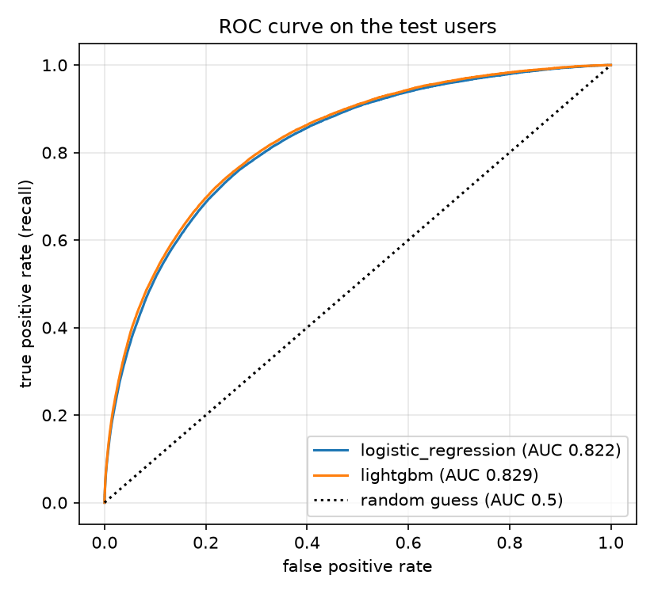
ROC curves
Figure 10.7 – LightGBM feature importance (share of total split gain)
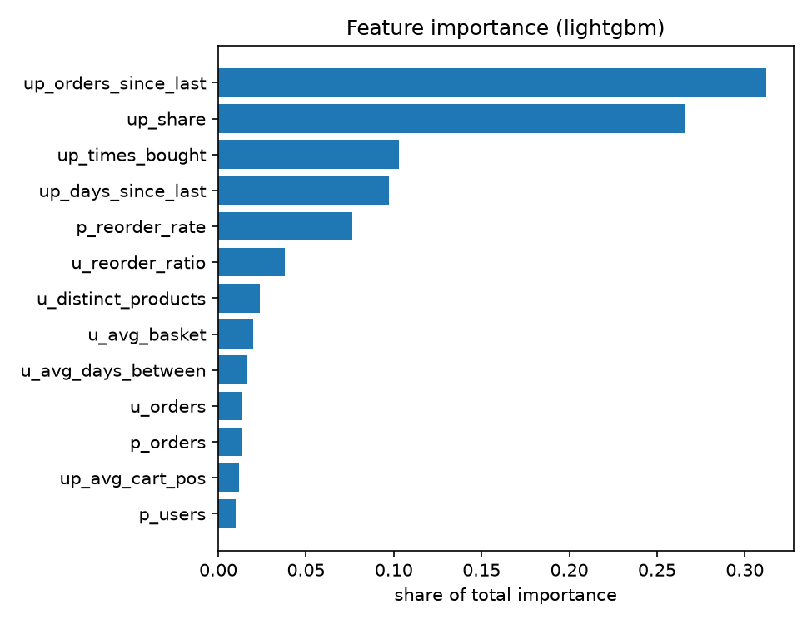
Feature importance
The top features are up_orders_since_last (31.2%), up_share (26.6%), up_times_bought (10.3%), up_days_since_last (9.7%) and p_reorder_rate (7.6%). User × product features together give about 79% of the importance. In the raw data, 27.9% of products bought in the user’s last prior order are bought again, against 2.8% of products last bought five or more orders ago.
Interpretation. Habit and recency predict a reorder far better than customer traits do. The gain of LightGBM over the baseline is small (0.007 ROC-AUC) and was measured on a single split without tuning, so it is not shown to be stable. A ROC-AUC well below 0.95 is consistent with the absence of leakage, though it does not prove it; the leakage test (Chapter 11, TC-23) is the stronger evidence.

10.7 Key insights (summary)
- Produce and dairy eggs make up 45.9% of order lines.
- Demand peaks on Sunday and at 10:00; the weekend carries 33.2% of sales.
- Alcohol peaks on Friday, unlike the store as a whole.
- Aisle rules reveal shopping missions (pasta dinner: lift up to 4.8).
- Product rules link flavours of one line (lift above 60).
- 29.4% of customers (loyal frequent shoppers) place about 62% of orders.
- Recency and frequency of past purchases drive reorders (ROC-AUC 0.83).
- The faster frequent-itemset algorithm depends on the number of items.
These are patterns in historical data. None of them has been tested as an intervention in a store.

10.8 Limitations of the evaluation
- No prices and no dates limit every analysis (Section 7.3).
- The mining results rest on samples (500,000 orders, 30,000 users), checked against the full data for the top rule only.
- The benchmark and the model comparison were each run once, without repetition or confidence intervals.
- The reorder model was not cross-validated or tuned.
- No user study of the dashboard was carried out.
- Suggested future evaluation: repeated benchmark runs with mean and standard deviation; k-fold user-level cross-validation; bootstrap confidence intervals for rule metrics; a small usability test of the dashboard with task completion times.

11. Testing

11.1 Testing Approach
Level | What was done | Evidence
Unit tests | Hand-worked expected values for small inputs: support, confidence and lift on a 5-basket example; feature values on a tiny database; K-Means on synthetic users in 3 clear groups; F1-optimal threshold; GROUPING level names | tests/test_rules.py, test_reorder.py, test_segmentation.py, test_dashboard.py
Integration tests | The real ETL run end to end on a hand-checkable mini dataset; validation run on deliberately broken warehouses (deleted product, forced wrong NULL); the demo extract compared with the warehouse | tests/test_etl.py, test_dashboard.py
Data-validation tests | The 23 warehouse checks, and tests that run on the real warehouse when it is present | etl/validate.py, test_real_* tests
System / functional tests | Every dashboard page run headless with Streamlit AppTest, checking for errors and for the real headline numbers; the rules search; a filter on the OLAP page; the 3-D cube slice | tests/test_dashboard.py
Security test | An SQL-injection string sent as a filter value; the test checks that no table is dropped | test_values_from_the_page_are_parameters_not_sql
Contract and regression tests | Result-file columns match the shared contract; the committed report is up to date with its sections; the committed demo extract matches the warehouse | test_dashboard.py, test_report.py
Manual testing | Each dashboard page opened in a browser on the full warehouse and checked by eye on 15 Oct 2026 (Figures 9.1–9.6); the team also reports doing this (reports/sections/06_dashboard.md) | Done for the pages shown in Section 9.6
Usability testing | Not performed | —
Test run used for this report: python -m pytest -q on 15 October 2026, branch feature/deploy at commit b61f423, Windows 11, Python 3.13.9, with the full warehouse and raw data present: 90 passed, 0 failed (2 warnings, in 26.7 s). python etl/validate.py: 23/23 checks passed.

11.2 Test Cases
Table 11.1 – Test cases. Actual results are from the 15 October 2026 run unless marked otherwise.
Test Case ID | Module | Test Scenario | Input | Expected Result | Actual Result | Status
TC-01 | Common | Opening a warehouse that does not exist | Missing path | Clear error raised | Error raised | Pass
TC-02 | ETL | Row counts after load | Mini fixture dataset | Each table has the hand-counted rows | As expected | Pass
TC-03 | ETL | Time dimension hierarchy | Generated dim_time | 168 rows; correct day names, weekend flag, bands | As expected | Pass
TC-04 | ETL | Every hour falls in exactly one band | Hours 0–23 | 4 bands cover all 24 hours | As expected | Pass
TC-05 | ETL | Product hierarchy with a quoted comma in a name | Fixture product CSV | Name parsed intact; aisle and department joined | As expected | Pass
TC-06 | ETL | First orders keep NULL, not 0 | Fixture orders | days_since_prior NULL on order 1 only | As expected | Pass
TC-07 | ETL | Validation detects an orphan key | Product deleted after load | Orphan check fails | Check failed as intended | Pass
TC-08 | ETL | Validation detects a wrong NULL | NULL forced on a later order | NULL-policy check fails | Check failed as intended | Pass
TC-09 | ETL | Existing warehouse needs --force | Second load without flag | Load refused | Refused | Pass
TC-10 | ETL | Missing raw file leaves existing warehouse untouched | One CSV removed | Error; warehouse unchanged | As expected | Pass
TC-11 | ETL | Real warehouse passes all checks | Full data | 23/23 pass | 23/23 pass | Pass
TC-12 | Rules | Frequent itemsets match a hand count | 5-basket example, both algorithms | Hand-counted supports | As expected (Apriori and FP-Growth) | Pass
TC-13 | Rules | Apriori and FP-Growth agree | Same baskets | Identical itemsets | Identical | Pass
TC-14 | Rules | Support, confidence and lift of rules | 5-basket example | Hand-worked values | As expected | Pass
TC-15 | Rules | max_len caps itemset size | Capped mining run | No itemset larger than the cap | As expected | Pass
TC-16 | Rules | “Frequently bought together” lookup | Product name | Products from the rules, ordered by strength | As expected | Pass
TC-17 | Segmentation | Recency is the gap before the last order | Synthetic orders | Gap of the highest order_number | As expected | Pass
TC-18 | Segmentation | Log transform reduces skew; scaling gives mean 0, sd 1 | Synthetic features | Lower skew; mean 0, sd 1 | As expected | Pass
TC-19 | Segmentation | K-Means recovers three clear groups and choose_k finds k = 3 | Synthetic users in 3 groups | 3 groups recovered | As expected | Pass
TC-20 | Segmentation | Ties in silhouette choose the smallest k | Synthetic scores | Smallest tied k | As expected | Pass
TC-21 | Segmentation | Write-back updates every user in one statement | Mini database | Every user has a segment | As expected | Pass
TC-22 | Reorder | Candidates are prior pairs only; labels from train order | Tiny database | Hand-worked pairs and labels | As expected | Pass
TC-23 | Reorder | No train-order data leaks into features | Train orders replaced with different baskets | All features identical; only labels change | As expected | Pass
TC-24 | Reorder | Split is by user with no overlap | User list | No user in two sets | As expected | Pass
TC-25 | Reorder | Metrics and threshold | Hand-made scores | Hand-counted precision/recall; F1-maximising threshold | As expected | Pass
TC-26 | Dashboard | Roll-up has details, subtotals and a grand total that add up | 7-line mini warehouse | Hand-counted totals | As expected | Pass
TC-27 | Dashboard | Slice (weekend) and dice (dairy eggs, Evening) | Mini warehouse | Hand-counted values | As expected | Pass
TC-28 | Dashboard | Pivot keeps week order and fills empty cells with 0 | Mini warehouse | Sunday…Saturday; zeros | As expected | Pass
TC-29 | Dashboard | 3-D cube includes empty cells; slice/dice highlight | Mini warehouse | Complete cube; correct mask | As expected | Pass
TC-30 | Dashboard | SQL injection through a filter | x'; DROP TABLE dim_product; -- | Treated as a value; table still exists | As expected | Pass
TC-31 | Dashboard | Demo extract gives the same answers as the warehouse | Both sources | Identical tables | Identical | Pass
TC-32 | Dashboard | Every page runs without an error | 5 pages, real data, headless | No exception | No exception | Pass
TC-33 | Dashboard | Overview shows the real numbers | Real data | 3,421,083 orders; 206,209 users; 59.0% | As expected | Pass
TC-34 | Dashboard | Cube tab Sunday slice | Department × day × band | 588 cells; Sunday slice = 6,533,692 lines | As expected | Pass
TC-35 | Dashboard | Result files match the contract | Committed CSVs | Exact column names | As expected | Pass
TC-36 | Report | Committed assembled report is up to date | Sections 00–07 | Rebuilt text equals committed file | As expected | Pass
TC-37 | Dashboard | Pages look correct in a browser | Manual inspection of the five pages | Readable charts and tables, real numbers | As expected (Figures 9.1–9.6) | Pass
TC-38 | Deployment | Hosted app on Streamlit Community Cloud loads and runs from the demo extract | App URL | All five pages work | Not verified for this report | Pending Verification
TC-39 | Usability | Users complete typical tasks | Task list, test users | Tasks completed | Not performed | Pending Verification
The complete list of the 90 automated tests is in Appendix E.

11.3 Testing Summary
- Confirmed: all 90 automated tests passed and all 23 warehouse checks passed on 15 October 2026, with the full data present. This includes the tests that run against the real warehouse.
- Warnings: the run reported 2 warnings, which did not affect any result. They were not investigated for this report.
- Manual check: every page was opened in a browser and checked by eye on 15 October 2026 (Figures 9.1–9.6).
- Pending: confirmation that the hosted deployment works, and any usability testing.
- Not covered by tests: the exact numerical results of the full mining runs (they depend on the data and take minutes; they are recorded in the result files), and the visual layout on different screen sizes.

PART II — TEAM CONTRIBUTION AND INDIVIDUAL RESPONSIBILITIES

12. Team Contribution and Individual Work Distribution
This chapter states who was responsible for each part of StoreSense and what evidence supports each attribution. It uses three kinds of evidence, and labels each statement with its kind:
- [Documented]: role allocation written in the repository (README.md team table, CONTRIBUTING.md “Who owns what”, docs/PROJECT_BRIEF.md §9, docs/DEMO_FLOW.md), and per-member task briefs kept in a local handoff/ folder of the working copy (not version-controlled).
- [Git]: commit authorship, pull requests and changed files in the GitHub repository maxlovesher/StoreSense, all branches, 3–15 October 2026, inspected on 15 October 2026.
- [To confirm]: anything that the repository cannot show, such as work done outside GitHub, pair work, reviews, and slide preparation. Each such item must be confirmed by the team before submission.

12.1 Team Member Information
Table 12.1 – Team members [Documented]
Team Member | Registration Number | Assigned Role | Main Responsibilities
Manish Sarkar (@maxlovesher) | 24051496 | Member 1 – Data & ETL Lead | Extract, transform, load and validate scripts; data validation; EDA notebook; shared database helper; project skeleton and project brief; owner of the GitHub repository
Kavya Agarwal (@Kavya-025) | 24052086 | Member 2 – Warehouse & OLAP | Star schema (sql/schema.sql); OLAP queries (sql/olap_queries.sql); star schema diagram; warehouse and OLAP report section
Kartik Biswal (@KB-0141) | 24051938 | Member 3 – Association Rules | Apriori and FP-Growth at aisle and product level; rule interpretation; Apriori vs FP-Growth benchmark; association rules report section
Manish Dey (@foresto-dreamer) | 24051562 | Member 4 – Customer Segmentation | RFM-style features; K-Means; choice of k; cluster profiling and naming; write-back to dim_user.segment; segmentation report section
Animesh Prakash (@DIO4699) | 24051610 | Member 5 – Reorder Prediction & Evaluation | Reorder classification (Logistic Regression, LightGBM); leakage control; metrics; model comparison; reorder report section
Rohit Gupta (@rohitguptanit7070-lab) | 24052654 | Member 6 – Dashboard & Integration | Streamlit dashboard; connecting all modules; report assembly; demo flow; hosting set-up

12.2 Work Allocation Across the Project
Table 12.2 – Work allocation (commit ids refer to the GitHub repository; see Appendix F)
Project Component / Module | Tasks Involved | Primary Contributor(s) | Supporting Contributor(s) | Completion Status | Evidence
Project planning and set-up | Project brief, repository skeleton, requirements, contributing guide, README | Member 1 | — | Complete | [Git] 5576bf6, ff4f2ea
Task briefs and result-file contract | Per-member task sheets; the Phase 4 contract fixing result-file names and columns | Not recorded | Member 6 (the contract says it must be agreed with Member 6) | Complete (local files) | [Documented] handoff/ folder, excluded from git; author not recorded [To confirm]
Data acquisition and ETL | Kaggle download instructions; extract, transform, load, validate (23 checks); ETL tests | Member 1 | Member 2 (schema the ETL loads into) | Complete | [Git] 4b96dd0; [Documented] CONTRIBUTING §2
Exploratory data analysis | notebooks/eda.ipynb; Data & ETL report section | Member 1 | Member 2 (filled in the full-data results) | Complete | [Git] f59ec4d; 0f498ed (Member 2)
Warehouse design | Star schema DDL; types; key and constraint experiments | Member 2 | Member 1 (load order; consulted, per schema.sql notes) | Complete | [Git] f0d86be
OLAP | Roll-up, drill-down, slice, dice, pivot, CUBE queries; star schema diagram; report section | Member 2 | — | Complete | [Git] de1114d, 7ebc352, 13edff7
Association rules | Mining at two levels; agreement check; lookup function; tests; report section | Member 3 | Member 6 (consumer of the result files) | Complete | [Git] b037c57, 983b01b, 7c45399
Algorithm benchmark | Runtime and memory of Apriori vs FP-Growth; charts | Member 3 | — | Complete | [Git] c8e6e5c
Customer segmentation | Features, k selection, K-Means, naming, write-back, PCA, tests, report section | Member 4 | Member 6 (consumer) | Complete | [Git] ed29dad, 3f263ad, bfde90a, 2d49686
Reorder prediction | Prior-only features, leakage test, user split, two models, metrics, report section | Member 5 | Member 6 (consumer) | Complete | [Git] 9b5ef95, 8c89661, 7d06373, 9e011a1
Dashboard | Data layer, five pages, OLAP query builder, 3-D cube, tests | Member 6 | Members 3–5 (result files read by the pages) | Complete | [Git] 3a3ee06, 9095d96, 9ed6b7e, c000312, f9268d8
Report assembly and demo script | Introduction, dashboard and insights sections; build_report.py; demo flow | Member 6 | All members (own sections) | Complete | [Git] 1414ecd, cc997dd, 871be48
Hosting | Demo extract; Streamlit Community Cloud configuration; deployment guide | Member 6 | Member 1 (deployment from the repository owner’s account, per docs/DEPLOY.md) | Configured; live status [To confirm] | [Git] 78d2004, 7bfe589, c588bd6, b61f423
Testing and debugging | Each module’s tests | Each module’s owner | — | Complete (90 tests pass) | [Git] test files in the commits above
Integration into main | Merging pull requests | Member 2 (6 merges), Member 1 (2), Member 3 (1) | — | Complete (9/9 PRs merged) | [Git] PRs #1–#9
This submission report | Compilation of this document from the repository | [To confirm] | — | Draft | —
Presentation | Slides and live demo | Each member for their module; Member 6 opens and closes | — | [To confirm] | [Documented] docs/DEMO_FLOW.md; no slides in the repository

12.3 GitHub Contribution Analysis
Scope examined. Repository github.com/maxlovesher/StoreSense (private), all local and remote branches, from the first commit (3 October 2026) to commit 94f0309 (15 October 2026). It contains 42 commits: 33 authored commits and 9 pull-request merge commits. All 9 pull requests were merged into main.
Table 12.3 – GitHub evidence by identity [Git]
Team Member / GitHub Identity | Commits or Changes Identified | Relevant Files or Modules | Evidence of Contribution | Limitations
Manish Sarkar / @maxlovesher (commits authored as “ocean” with an e-mail address that GitHub links to @maxlovesher) | 4 authored commits (3 and 11 Oct); 2 PR merges (#4, #6); opened 8 of the 9 PRs | Project skeleton (23 files incl. brief, README, CONTRIBUTING, requirements); common/db.py; pyproject.toml; etl/*.py; tests/test_etl.py, test_common_db.py, fixture schema; notebooks/eda.ipynb; report section 01 | ETL implementation (+801 lines in 4b96dd0), EDA notebook, shared helper | The 3 commits of 11 Oct share one timestamp (14:17:00)
Kavya Agarwal / @Kavya-025 | 5 authored commits (14 Oct); 6 PR merges (#1, #3, #5, #7, #8, #9); opened PR #2 | sql/schema.sql, sql/olap_queries.sql, star_schema.dbml/.png, report section 02; results added to section 01 | Schema, OLAP queries, diagram; most merges into main | The 4 warehouse commits share one timestamp (22:57:39)
Kartik Biswal / @KB-0141 | 4 authored commits (14 Oct); 1 PR merge (#2) | mining/association_rules.py, mining/benchmark.py, tests/test_rules.py, rule and benchmark result files and charts, report section 03 | Rule mining, benchmark, tests | All 4 commits share one timestamp (23:51:11); the PR was opened from @maxlovesher
Manish Dey / @foresto-dreamer | 4 authored commits (15 Oct) | mining/segmentation.py, tests/test_segmentation.py, segment result files, 3 charts, report section 04 | Segmentation, tests | All 4 commits share one timestamp (00:09:44); the PR was opened from @maxlovesher
Animesh Prakash / @DIO4699 | 4 authored commits (15 Oct) | mining/reorder_model.py, tests/test_reorder.py, reorder result files, 2 charts, report section 05 | Reorder model, leakage tests | Commits within one second (00:43:16–17); the PR was opened from @maxlovesher; @DIO4699 was not in the repository’s collaborator list on 15 Oct 2026
Rohit Gupta / @rohitguptanit7070-lab | 12 authored commits (15 Oct) | dashboard/*, data/demo/*, tests/test_dashboard.py, tests/test_report.py, reports/build_report.py, sections 00, 06, 07, StoreSense_report.md, docs/DEMO_FLOW.md, docs/DEPLOY.md, edits to README, CONTRIBUTING and the brief | Dashboard, integration, deployment preparation, report assembly | Commits fall into three bursts (about 01:02, 01:14 and 01:25), with shared timestamps inside each burst; the PRs were opened from @maxlovesher
Observations from the repository history [Git]:
- Commits were made in batches. Within each module, the commits carry the same author timestamp to the second (for example, all four @KB-0141 commits are dated 2026-10-14 23:51:11 +05:30), and modules 2 to 6 were committed within about 2.5 hours on the night of 14–15 October. The history therefore records when work was committed, not when or how it was developed.
- Pull requests were mostly opened from one account. Eight of the nine pull requests were opened from @maxlovesher, including those whose commits are attributed to other members; PR #2 was opened by @Kavya-025.
- No reviews are recorded. None of the nine PRs has a recorded review or review comment, although CONTRIBUTING.md asks for one team member’s review before merging. Reviews may have happened outside GitHub [To confirm].
- Commit identity is not proof of authorship. A commit’s author name and e-mail are set in the local git configuration and are not authenticated by GitHub. They show which account a commit is attributed to, not who wrote the code.
- Every module was delivered on its own branch, as CONTRIBUTING.md prescribes (feature/etl, feature/warehouse, feature/association-rules, feature/segmentation, feature/reorder-model, feature/dashboard, plus feature/etl-results and feature/deploy).
Because of observations 1–4, this report treats commit authorship as supporting evidence for the documented role allocation, not as an independent measure of who did the work or how much work each person did.

12.4 Individual Contribution Details
Each subsection lists the work that the documented role allocation and the commit history attribute to the member. Each member should check and amend their own subsection before submission [To confirm], in particular to add work that is not visible in GitHub.

12.4.1 Manish Sarkar — Member 1, Data & ETL Lead
- Role and responsibilities [Documented]: extract/transform/load scripts, data validation, EDA notebook (CONTRIBUTING.md §2; brief §9).
- Modules: etl/extract.py, etl/transform.py, etl/load.py, etl/validate.py, common/db.py, notebooks/eda.ipynb, tests/test_etl.py, tests/test_common_db.py.
- Concrete tasks: typed DuckDB views over the six CSVs; one SQL statement per warehouse table; dependency-ordered loading with a --force guard; the 23 validation checks; an ETL test suite that runs the real pipeline on a hand-checkable dataset and deliberately breaks the warehouse to prove that validation catches the faults; the project skeleton, brief, README and contributing guide.
- DMDW contribution: data preprocessing, integration and transformation; NULL policy for first orders; handling of hidden test orders; data quality validation; EDA findings (basket distribution, reorder rates, busiest days and hours).
- Coding, testing, integration: ETL code and tests (15 ETL tests, 4 helper tests); set-up of the shared helper that all modules use; repository owner, who opened 8 of 9 PRs and merged PRs #4 and #6.
- Documentation and presentation: report section 1 (Data & ETL); presents the Overview page and the ETL flow in the demo (docs/DEMO_FLOW.md).
- Deliverables: a working ETL that builds the 33.8M-row warehouse; validate.py (23/23 passing); EDA notebook.
- Evidence: [Git] 5576bf6, ff4f2ea, 4b96dd0, f59ec4d; PR #1.
- Contribution to the whole: every other module reads the warehouse that this module builds.

12.4.2 Kavya Agarwal — Member 2, Warehouse & OLAP
- Role [Documented]: star schema, schema.sql, OLAP queries, schema diagram.
- Modules: sql/schema.sql, sql/olap_queries.sql, reports/figures/star_schema.dbml and .png, report section 2.
- Concrete tasks: column types (including SMALLINT for time_key, which TINYINT cannot hold); primary keys on the dimensions and fact_order; measured comparison of a composite primary key and of foreign keys on the full data (2.6 s against 56.1 s; 0.23 GB against 1.81 GB; foreign keys fail with this load order); seven commented OLAP queries (Q1a–Q6); the DBML star schema diagram; filling in the full-data results of the ETL section.
- DMDW contribution: dimensional modelling, grain definition, hierarchies, OLAP operations with ROLLUP, CUBE, GROUPING() and PIVOT, and the interpretation of their results.
- Coding, testing, integration: schema verified against the ETL load; merged six of the nine pull requests into main (#1, #3, #5, #7, #8, #9).
- Documentation and presentation: report section 2; presents the star schema and the live OLAP demo (docs/DEMO_FLOW.md).
- Deliverables: the warehouse schema, the OLAP query catalogue and the schema diagram.
- Evidence: [Git] f0d86be, de1114d, 7ebc352, 13edff7, 0f498ed; PR #2 (opened by @Kavya-025).
- Contribution to the whole: the schema is the contract that the ETL loads into and that every analysis queries.

12.4.3 Kartik Biswal — Member 3, Association Rules (@KB-0141)
- Role [Documented]: Apriori and FP-Growth, rule interpretation, benchmark.
- Modules: mining/association_rules.py, mining/benchmark.py, tests/test_rules.py, rules_aisle.csv, rules_product.csv, benchmark.csv, two benchmark charts, report section 3.
- Concrete tasks: basket extraction in SQL; 500,000-order sample; sparse one-hot encoding; mining with both algorithms and an agreement check; lift > 1 filter and plain-English interpretations; Apriori’s low-memory mode after the default asked for 81.6 GiB; recounting the top rule on the full warehouse; a benchmark that measures time and memory in separate runs; the frequently_bought_together() lookup used by the dashboard.
- DMDW contribution: frequent-pattern mining, support/confidence/lift, algorithm comparison, and analysis of sampling error.
- Coding and testing: 10 tests, including a hand-worked 5-basket example; merged PR #2.
- Documentation and presentation: report section 3; presents the Basket Rules page (docs/DEMO_FLOW.md).
- Deliverables: 5,000 aisle rules, 3,410 product rules, the benchmark table and charts, the lookup function.
- Evidence: [Git] b037c57, 983b01b, c8e6e5c, 7c45399; PR #4.
- Contribution to the whole: answers “what is bought together” and supplies the dashboard’s recommendations.

12.4.4 Manish Dey — Member 4, Customer Segmentation (@foresto-dreamer)
- Role [Documented]: feature engineering, K-Means, cluster profiling.
- Modules: mining/segmentation.py, tests/test_segmentation.py, segment_profiles.csv, segment_pca_sample.csv, three charts, dim_user.segment, report section 4.
- Concrete tasks: RFM-style features from the warehouse; skew analysis and a log transform; standardisation; K-Means for k = 2–10 with elbow and sampled silhouette; the choose_k rule; rule-based naming of the four segments; a set-based write-back to the warehouse; PCA sample for the dashboard.
- DMDW contribution: clustering, cluster validation, adaptation of RFM to data without prices or dates, and segment interpretation with business actions.
- Coding and testing: 11 tests, including synthetic users in three clear groups.
- Documentation and presentation: report section 4; presents the Customer Segments page (docs/DEMO_FLOW.md).
- Deliverables: four named segments covering all 206,209 users; profile and PCA files; charts.
- Evidence: [Git] ed29dad, 3f263ad, bfde90a, 2d49686; PR #5.
- Contribution to the whole: answers “what kinds of customers exist” and adds the segment attribute to the user dimension.

12.4.5 Animesh Prakash — Member 5, Reorder Prediction & Evaluation (@DIO4699)
- Role [Documented]: classification model, metrics, model comparison (stretch goal).
- Modules: mining/reorder_model.py, tests/test_reorder.py, reorder_metrics.csv, reorder_feature_importance.csv, ROC and importance charts, report section 5.
- Concrete tasks: label definition from the train order; 13 prior-only features in SQL; reading eval_set from the raw file; a test that changes the train orders and checks that no feature changes; a user-level 60/20/20 split; Logistic Regression and LightGBM; threshold tuning on validation users; evaluation with precision, recall, F1 and ROC-AUC.
- DMDW contribution: classification, feature engineering, leakage prevention, and evaluation under class imbalance.
- Coding and testing: 12 tests.
- Documentation and presentation: report section 5; presents the Reorder Model page (docs/DEMO_FLOW.md).
- Deliverables: two evaluated models (best ROC-AUC 0.829), feature importance, charts.
- Evidence: [Git] 9b5ef95, 8c89661, 7d06373, 9e011a1; PR #6.
- Contribution to the whole: completes the stretch objective and turns the reorder pattern into a prediction.

12.4.6 Rohit Gupta — Member 6, Dashboard & Integration (@rohitguptanit7070-lab)
- Role [Documented]: Streamlit app, connecting all modules, final demo flow.
- Modules: dashboard/ (data layer, UI helpers, five pages, demo extract builder, hosting requirements), tests/test_dashboard.py, tests/test_report.py, reports/build_report.py, report sections 0, 6 and 7, docs/DEMO_FLOW.md, docs/DEPLOY.md.
- Concrete tasks: an OLAP query builder with a column whitelist and parameterised values; roll-up, pivot and 3-D cube builders with slice/dice highlighting; five pages; caching and friendly error messages; the views/ navigation fix; a 4.3 MB demo extract, with a test that it gives the same tables as the warehouse; Streamlit Community Cloud configuration; report assembly with a test that the committed report is up to date.
- DMDW contribution: interactive OLAP (roll-up, drill-down, slice, dice, pivot, cube) for end users; visualisation and analytical reporting; the cross-module business insights (report section 7).
- Coding, testing, integration: 30 dashboard tests and 8 report tests, including headless page runs on the real data, an SQL-injection test and a test that the result files match the shared contract.
- Documentation and presentation: report sections 0, 6, 7; the demo script; opens and closes the presentation (docs/DEMO_FLOW.md).
- Deliverables: the dashboard, the assembled technical report, the demo flow, the hosting set-up.
- Evidence: [Git] 12 commits from 3a3ee06 to b61f423; PRs #7, #8, #9.
- Contribution to the whole: makes all modules visible and usable in one place.

12.5 Contribution Percentage Estimation
Status: PROVISIONAL estimate. It requires confirmation by all six members before submission. The percentages estimate the share of the project’s scope assigned to each member’s documented role. They are not measurements of individual effort, hours worked or code written.
Method.
- The project was divided into the tasks in Table 12.4.
- Each task was given effort points (1 = small, 14 = largest) by judgement of its complexity and scope, using the code size, number of tests, the difficulty of the design decisions recorded in the report sections, and the importance to the whole system.
- Each task’s points were assigned to the member responsible for it under the documented role allocation, supported by commit authorship (Section 12.3).
- Each task was also placed in one of four categories, and the shares were computed within each category and overall.
Commit counts and lines of code were not used directly. Doing so would, for example, give Member 6 (12 commits) three times the share of Member 1 (4 commits), although Member 1’s four commits contain the whole ETL. Work outside GitHub (meetings, help given to others, slide preparation) could not be observed and is not included. If the team reports such work, the points should be adjusted.
Table 12.4 – Effort points by task (judgement-based)
Task | Member | Development | Data / DMDW | Testing & Integration | Documentation / Presentation | Total
ETL scripts (extract, transform, load, validate) | M1 | 10 |  |  |  | 10
EDA and ETL design decisions | M1 |  | 5 |  |  | 5
ETL tests; project set-up, shared helper, PR coordination | M1 |  |  | 6 |  | 6
Brief, README, contributing guide, section 1 | M1 |  |  |  | 3 | 3
Schema DDL | M2 | 4 |  |  |  | 4
Schema design and constraint experiments; OLAP queries | M2 |  | 9 |  |  | 9
Schema load checks; merging 6 PRs | M2 |  |  | 2 |  | 2
Star schema diagram; section 2; ETL results | M2 |  |  |  | 5 | 5
Rule mining and benchmark code | M3 | 6 |  |  |  | 6
Rule analysis, sampling check, benchmark analysis | M3 |  | 8 |  |  | 8
Rule tests | M3 |  |  | 2 |  | 2
Section 3 | M3 |  |  |  | 3 | 3
Segmentation code | M4 | 4 |  |  |  | 4
Feature design, k selection, profiling | M4 |  | 4 |  |  | 4
Segmentation tests | M4 |  |  | 2 |  | 2
Section 4 | M4 |  |  |  | 3 | 3
Reorder model code | M5 | 4 |  |  |  | 4
Label, features, leakage control, evaluation | M5 |  | 5 |  |  | 5
Reorder tests | M5 |  |  | 2 |  | 2
Section 5 | M5 |  |  |  | 3 | 3
Dashboard data layer, five pages, 3-D cube, demo extract | M6 | 14 |  |  |  | 14
OLAP query builder and cube design for end users | M6 |  | 3 |  |  | 3
Dashboard and report tests; hosting; contract checks | M6 |  |  | 6 |  | 6
Sections 0, 6, 7; report builder; demo flow; deploy guide | M6 |  |  |  | 4 | 4
Total |  | 42 | 34 | 20 | 21 | 117
Table 12.5 – Provisional contribution estimate (share of each column’s points; overall = member’s points ÷ 117)
Team Member | Development | Data / DMDW Work | Testing and Integration | Documentation / Presentation | Overall Contribution
Manish Sarkar (M1) | 23.8% | 14.7% | 30.0% | 14.3% | 20.5%
Kavya Agarwal (M2) | 9.5% | 26.5% | 10.0% | 23.8% | 17.1%
Kartik Biswal (M3) | 14.3% | 23.5% | 10.0% | 14.3% | 16.2%
Manish Dey (M4) | 9.5% | 11.8% | 10.0% | 14.3% | 11.1%
Animesh Prakash (M5) | 9.5% | 14.7% | 10.0% | 14.3% | 12.0%
Rohit Gupta (M6) | 33.3% | 8.8% | 30.0% | 19.0% | 23.1%
Total | 99.9%* | 100.0% | 100.0% | 100.0% | 100.0%
*The Development column adds to 99.9% because of rounding (exact shares: 10, 4, 6, 4, 4 and 14 of 42 points).
How to read this table. The differences between members come from the scope of the assigned roles. Integration roles (M1, M6) and the warehouse role (M2) carry more cross-cutting tasks, and the segmentation and reorder roles were narrower. A small scope does not mean low effort. The table says nothing about how hard each person worked, and it should be replaced by the team’s own agreed figures if they differ.

12.6 Responsibility Matrix
Table 12.6 – RACI matrix (R = Responsible, A = Accountable, C = Consulted, I = Informed; “—” = not established by the available evidence)
Task | M1 Manish Sarkar | M2 Kavya Agarwal | M3 Kartik Biswal | M4 Manish Dey | M5 Animesh Prakash | M6 Rohit Gupta
Project brief, repository set-up, contributing guide | R, A | I | I | I | I | I
ETL and validation | R, A | C | I | I | I | I
EDA notebook | R, A | — | — | — | — | —
Star schema and DDL | C | R, A | I | I | I | I
OLAP queries and schema diagram | — | R, A | — | — | — | C
Association rules and benchmark | — | — | R, A | — | — | C
Customer segmentation (incl. write-back) | — | — | — | R, A | — | C
Reorder prediction | — | — | — | — | R, A | C
Dashboard and integration | I | C | C | C | C | R, A
Report sections | R (s. 1) | R (s. 2) | R (s. 3) | R (s. 4) | R (s. 5) | R (s. 0, 6, 7), A (assembly)
Merging pull requests into main | R (2) | R (6) | R (1) | — | — | —
Hosting on Streamlit Community Cloud | R (owner account, per DEPLOY.md) [To confirm] | — | — | — | — | R, A (configuration)
Final demo | R (Overview) | R (OLAP) | R (Rules) | R (Segments) | R (Reorder) | R, A (opening, closing, flow)
“C” for Member 6 on the mining modules reflects the written result-file contract, which asks each mining member to agree it with the dashboard owner. “C” for Member 2 on ETL and Member 1 on the schema reflects the documented dependency: the ETL inserts into the schema by column name, and the schema’s design notes discuss the ETL’s load order.

12.7 Collaboration and Integration
Practices documented in the repository (CONTRIBUTING.md):
- Each member owns a set of files and works on their own feature/… branch.
- Changes reach main only through pull requests, and members tell the owner before changing a file they do not own.
- A fixed build order: ETL and schema first, because everything reads the warehouse; the mining members could prototype on samples meanwhile, and the dashboard on placeholder data.
- Data files are never committed; only small result files are.
Figure 12.1 – Dependencies between modules
flowchart LR
M2["M2 schema.sql"] --> M1["M1 ETL"]
M1 --> WH[("Warehouse")]
WH --> M2b["M2 OLAP queries"]
WH --> M3["M3 Rules"]
WH --> M4["M4 Segmentation"]
WH --> M5["M5 Reorder model"]
M4 -- "dim_user.segment" --> WH
M3 -- "result files + lookup()" --> M6["M6 Dashboard"]
M4 -- "result files" --> M6
M5 -- "result files" --> M6
WH -- "read-only queries" --> M6
How the parts were integrated.
- The schema is the contract between M2 and M1: the ETL inserts by column name, so the names had to match the brief exactly.
- The result-file contract is the contract between M3–M5 and M6. The dashboard test test_result_columns_match_the_shared_contract fails if a mining script changes its output format.
- Report sections were written per module and joined by build_report.py, with a test that the committed report is up to date.
Integration challenges recorded in the project:
Challenge | Resolution
Foreign keys fail with the ETL’s load order (fact_order_line before fact_order) | Constraints left out; orphan checks in validate.py instead (schema notes)
order_dow * 24 overflowed with TINYINT | Source types read as INTEGER; caught by the ETL tests
Apriori asked for 81.6 GiB on product baskets | low_memory=True, sampling, top-1,000 filter
DuckDB allows one writer; segmentation writes while the dashboard reads | Dashboard opens the warehouse read-only per query and closes it
Streamlit’s pages/ folder bypassed the custom navigation menu | Pages moved to dashboard/views/
The 0.23 GB warehouse cannot be committed for hosting | 4.3 MB demo extract with an equivalence test
Not documented: the repository does not record team meetings, the communication channel used, or code reviews (Section 12.3, observation 3). They are therefore not described here [To confirm].

12.8 Contribution Evidence and Limitations
- Evidence used: the role tables in README.md, CONTRIBUTING.md and docs/PROJECT_BRIEF.md; the per-member task briefs in the local handoff/ folder; docs/DEMO_FLOW.md; GitHub commits, changed files, pull requests and merge records, and the repository’s collaborator list (queried on 15 October 2026).
- Supported by GitHub history: for each module, the files and commits listed in Tables 12.2 and 12.3 are attributed to the account of the member who owns that role, and every PR was merged.
- Based on documentation only: the role allocation itself, the presentation assignments, and the result-file contract.
- Uncertain:
  - who actually wrote each module, because the commits were made in batches and most PRs were opened from one account (Section 12.3);
  - whether pull requests were reviewed;
  - who wrote the task briefs and the contract;
  - why @DIO4699 is not in the collaborator list;
  - work outside GitHub, including slide preparation and the preparation of this report.
- Needed to finalise this chapter: each member’s confirmation (or correction) of their subsection in 12.4; the team’s agreement on the percentages in 12.5; full names and roll numbers; a statement on reviews and on any tools used (see the Declaration placeholder).

12.9 Individual Presentation Responsibilities
The following assignments come from docs/DEMO_FLOW.md (a 10-minute demo). They are documented in the repository but must be confirmed as the final plan [To confirm].
Time | Part of the presentation | Presenter
0:00 | Problem statement, data limitations, architecture (slides) | Rohit Gupta (M6)
1:30 | Overview page: headline numbers, ETL flow, validation | Manish Sarkar (M1)
3:00 | Star schema; live OLAP demo (roll-up, drill-down, slice, dice, pivot) | Kavya Agarwal (M2)
5:00 | Basket Rules: rules, recommendations, Apriori vs FP-Growth | Kartik Biswal (M3)
6:30 | Customer Segments: sizes, scatter plot, profiles, actions | Manish Dey (M4)
8:00 | Reorder Model: metrics, feature importance, leakage control | Animesh Prakash (M5)
9:00 | Key insights, limitations, questions (slides) | Rohit Gupta (M6)
The demo flow mentions “five presenters” but assigns parts to all six members. The team should confirm the final split.

13. Advantages, Limitations and Challenges

13.1 Advantages of the implemented system
- One validated source of truth. All analyses read the same warehouse, which passes 23 integrity checks.
- Scales on a laptop. 33.8 million order lines are loaded and queried with an embedded database, with no server to install.
- Fast analytical queries. Hierarchy queries are single ROLLUP/CUBE statements that ran in under half a second on the full data (team measurements).
- Evidence-based design choices. Constraints, algorithm choice and the number of clusters were chosen by measurement on the real data.
- Honest evaluation. The reorder model is protected against leakage, is evaluated with metrics suited to imbalance, and has its threshold tuned on separate users.
- Reproducible and tested. Fixed seeds, scripted steps, committed results and 90 automated tests.
- Usable by non-specialists. Plain-English rules, named segments and a guided dashboard.

13.2 Practical value (potential, not demonstrated)
The results point to possible actions for a grocery retailer, such as co-locating or bundling “mission” products, staffing and stocking for Sunday and late-morning peaks, retention offers for the loyal segment, minimum-basket nudges for small-basket shoppers, and “buy it again” lists ranked by recency and frequency. These actions are suggestions drawn from historical patterns. None of them was tested in a store.

13.3 Technical challenges encountered
Data volume (32M-row file); the TINYINT overflow; the load-order conflict with foreign keys; the cost of a composite primary key; Apriori’s memory demand; the DuckDB single-writer rule; Streamlit’s page discovery; and hosting without the warehouse. Section 12.7 describes how each was resolved.

13.4 Data-related challenges
No prices; no calendar dates and a 30-day cap; an undocumented day-of-week coding; 75,000 orders with hidden contents; uncategorised products; and a long tail of rare products that cannot appear in rules.

13.5 Current limitations
- Revenue cannot be analysed; “basket size” is only a proxy for spending.
- Recency is the gap before the last order, not time since it.
- Rules cover the top 1,000 products only, with itemsets of at most 3 items, mined from a 15.7% sample.
- Segments overlap (silhouette ≈ 0.27).
- The reorder model is modest (precision ≈ 0.37), untuned, and evaluated on one split.
- The warehouse is a static snapshot, rebuilt in full; a rebuild erases the segments until the segmentation script is run again.
- The dashboard is single-user and has no authentication.

13.6 Limitations of the evaluation
No repeated runs or confidence intervals; benchmark on one machine; sample-based mining validated only for the top rule; no usability study; hosted deployment not verified for this report.

13.7 Dependencies and assumptions
- order_dow = 0 is Sunday.
- The Kaggle data is available to each member (the rules must be accepted).
- Python 3.11+, and the library versions in requirements.txt (minimum versions, not pinned).
- Streamlit Community Cloud remains free and available for hosting.

14. Future Enhancements
All items below are proposed work, not existing functionality.
# | Proposed improvement | Why it is useful | Limitation addressed | DMDW relationship
1 | Integrate a price source (or a synthetic price table) and add revenue measures to the facts | Rank rules, segments and recommendations by money, not counts | No prices | New fact measures; true RFM “monetary”
2 | Add a real date dimension (if a dated dataset is used) | Trends, seasonality, true recency | No calendar dates | Time hierarchy (day → week → month → year); time-series analysis
3 | Mine longer itemsets and the long tail (e.g. product-level rules per department, or higher max_len with closed/maximal itemsets) | Cover niche products and bigger bundles | Top-1,000 filter; max_len = 3 | Closed and maximal frequent itemsets
4 | Sequential pattern mining across a user’s orders | Learn what is bought after what | Rules are within one basket | Sequential patterns (e.g. GSP, PrefixSpan)
5 | Repeat the benchmark (several runs, several libraries) and test the aisle-level explanation | Turn an untested explanation into a finding | Single-run benchmark | Algorithm performance analysis
6 | Try other clustering methods (Gaussian mixtures, DBSCAN) and stability analysis | Softer or non-spherical segments; test robustness | Overlapping K-Means segments | Clustering evaluation
7 | Cross-validated, tuned reorder model with order-time features (day, hour, gap of the predicted order) | More accurate, better-validated predictions | One split, no tuning | Classification, model selection
8 | Incremental ETL and scheduled refresh; preserve segment across rebuilds | Keep the warehouse and segments current | Full rebuild; segments erased | ETL refresh strategies; slowly changing dimensions
9 | Serve recommendations through an API and evaluate with an A/B test | Measure real business impact | No live evaluation | Deployment of mined knowledge
10 | Usability and accessibility testing of the dashboard | Confirm the dashboard is usable by its intended users | No usability study | Analytical reporting
11 | Add statistical tests and confidence intervals (e.g. bootstrap for rule metrics) | Quantify uncertainty from sampling | Descriptive results only | Statistical data mining

15. Conclusion
StoreSense set out to show, on real grocery data, how a data warehouse and data mining work together. It turns the 3.4-million-order Instacart history into a validated DuckDB star schema with two fact tables and three dimensions. On that schema it answers “when and what do people buy?” with the five OLAP operations, “what is bought together?” with Apriori and FP-Growth at two levels of the product hierarchy (and a benchmark showing that the faster algorithm depends on the data), and “what kinds of customers are there?” with K-Means on RFM-style features adapted to data without prices or dates. As a stretch goal, it predicts reorders with a leakage-controlled classifier (ROC-AUC 0.829). A five-page Streamlit dashboard presents all results, and 90 automated tests and 23 validation checks passed on 15 October 2026.
The DMDW concepts genuinely applied are the KDD process, ETL and data quality validation, dimensional modelling with an atomic and an aggregate fact table and concept hierarchies, OLAP with ROLLUP, CUBE and PIVOT, frequent-pattern mining with support, confidence and lift, clustering with validation, and classification evaluated under class imbalance. The main limits are the missing prices and dates, the use of samples and filters in mining, modest cluster separation and predictive power, and single-run evaluations. The report states where each result depends on them.
The work was divided into six roles, each with its own module, tests and report section, and integrated through a shared schema, a result-file contract and the dashboard (Chapter 12). The contribution estimates in Chapter 12 are provisional and await the team’s confirmation.
The main learning outcomes were that design choices at this scale should be measured rather than assumed (constraints, algorithms, k); that evaluation must be protected from leakage and judged with suitable metrics; and that results are only as credible as the limitations reported with them.

References
IEEE style. Items marked “(verify)” should be checked for exact details or current URL before submission.
[1] R. Agrawal and R. Srikant, “Fast algorithms for mining association rules,” in Proc. 20th Int. Conf. Very Large Data Bases (VLDB), Santiago, Chile, 1994, pp. 487–499.
[2] J. Han, J. Pei, and Y. Yin, “Mining frequent patterns without candidate generation,” in Proc. ACM SIGMOD Int. Conf. Management of Data, Dallas, TX, USA, 2000, pp. 1–12.
[3] R. Agrawal, T. Imieliński, and A. Swami, “Mining association rules between sets of items in large databases,” in Proc. ACM SIGMOD Int. Conf. Management of Data, Washington, DC, USA, 1993, pp. 207–216.
[4] S. Brin, R. Motwani, J. D. Ullman, and S. Tsur, “Dynamic itemset counting and implication rules for market basket data,” in Proc. ACM SIGMOD Int. Conf. Management of Data, Tucson, AZ, USA, 1997, pp. 255–264.
[5] J. MacQueen, “Some methods for classification and analysis of multivariate observations,” in Proc. 5th Berkeley Symp. Mathematical Statistics and Probability, vol. 1, 1967, pp. 281–297.
[6] S. P. Lloyd, “Least squares quantization in PCM,” IEEE Trans. Inf. Theory, vol. 28, no. 2, pp. 129–137, Mar. 1982.
[7] P. J. Rousseeuw, “Silhouettes: A graphical aid to the interpretation and validation of cluster analysis,” J. Comput. Appl. Math., vol. 20, pp. 53–65, 1987.
[8] D. Arthur and S. Vassilvitskii, “k-means++: The advantages of careful seeding,” in Proc. 18th Annu. ACM-SIAM Symp. Discrete Algorithms (SODA), 2007, pp. 1027–1035.
[9] J. R. Bult and T. Wansbeek, “Optimal selection for direct mail,” Marketing Science, vol. 14, no. 4, pp. 378–394, 1995. (verify)
[10] G. Ke et al., “LightGBM: A highly efficient gradient boosting decision tree,” in Advances in Neural Information Processing Systems 30 (NIPS 2017), 2017, pp. 3146–3154.
[11] F. Pedregosa et al., “Scikit-learn: Machine learning in Python,” J. Mach. Learn. Res., vol. 12, pp. 2825–2830, 2011.
[12] S. Raschka, “MLxtend: Providing machine learning and data science utilities and extensions to Python’s scientific computing stack,” J. Open Source Softw., vol. 3, no. 24, p. 638, 2018.
[13] M. Raasveldt and H. Mühleisen, “DuckDB: An embeddable analytical database,” in Proc. 2019 Int. Conf. Management of Data (SIGMOD ’19), Amsterdam, Netherlands, 2019, pp. 1981–1984.
[14] R. Kimball and M. Ross, The Data Warehouse Toolkit: The Definitive Guide to Dimensional Modeling, 3rd ed. Indianapolis, IN, USA: Wiley, 2013.
[15] W. H. Inmon, Building the Data Warehouse, 4th ed. Indianapolis, IN, USA: Wiley, 2005.
[16] J. Gray et al., “Data cube: A relational aggregation operator generalizing group-by, cross-tab, and sub-totals,” Data Mining and Knowledge Discovery, vol. 1, no. 1, pp. 29–53, 1997.
[17] S. Chaudhuri and U. Dayal, “An overview of data warehousing and OLAP technology,” ACM SIGMOD Record, vol. 26, no. 1, pp. 65–74, 1997.
[18] J. Han, M. Kamber, and J. Pei, Data Mining: Concepts and Techniques, 3rd ed. Waltham, MA, USA: Morgan Kaufmann, 2012.
[19] U. Fayyad, G. Piatetsky-Shapiro, and P. Smyth, “From data mining to knowledge discovery in databases,” AI Magazine, vol. 17, no. 3, pp. 37–54, 1996.
[20] T. Fawcett, “An introduction to ROC analysis,” Pattern Recognit. Lett., vol. 27, no. 8, pp. 861–874, 2006.
[21] H. He and E. A. Garcia, “Learning from imbalanced data,” IEEE Trans. Knowl. Data Eng., vol. 21, no. 9, pp. 1263–1284, 2009.
[22] S. Kaufman, S. Rosset, C. Perlich, and O. Stitelman, “Leakage in data mining: Formulation, detection, and avoidance,” ACM Trans. Knowl. Discov. Data, vol. 6, no. 4, Art. 15, 2012.
[23] Instacart, “Instacart Market Basket Analysis” (competition data: The Instacart Online Grocery Shopping Dataset 2017), Kaggle, 2017. [Online]. Available: https://www.kaggle.com/competitions/instacart-market-basket-analysis/data
[24] Streamlit, “Streamlit documentation.” [Online]. Available: https://docs.streamlit.io (accessed Oct. 2026; verify)
[25] DuckDB Foundation, “DuckDB documentation: GROUPING SETS, ROLLUP and CUBE; PIVOT statement.” [Online]. Available: https://duckdb.org/docs/ (accessed Oct. 2026; verify exact page URLs)
[26] W. McKinney, “Data structures for statistical computing in Python,” in Proc. 9th Python in Science Conf. (SciPy 2010), 2010, pp. 56–61.
[27] Plotly Technologies Inc., “Plotly Python graphing library.” [Online]. Available: https://plotly.com/python/ (accessed Oct. 2026; verify)
[28] J. D. Hunter, “Matplotlib: A 2D graphics environment,” Computing in Science & Engineering, vol. 9, no. 3, pp. 90–95, 2007.
[29] I. T. Jolliffe, Principal Component Analysis, 2nd ed. New York, NY, USA: Springer, 2002.
[30] R. L. Thorndike, “Who belongs in the family?,” Psychometrika, vol. 18, no. 4, pp. 267–276, 1953.
[31] Streamlit, “Streamlit Community Cloud documentation.” [Online]. Available: https://docs.streamlit.io/deploy/streamlit-community-cloud (accessed Oct. 2026; verify)
[32] S. Raschka, “mlxtend documentation: apriori, fpgrowth, association_rules.” [Online]. Available: https://rasbt.github.io/mlxtend/ (accessed Oct. 2026; verify)
[33] Microsoft Corporation, “LightGBM documentation.” [Online]. Available: https://lightgbm.readthedocs.io/ (accessed Oct. 2026; verify)

Appendices

Appendix A – Repository and reproduction
- Repository: https://github.com/maxlovesher/StoreSense (private; evaluators need to be invited or given a copy) [To confirm access for evaluators]
- Hosted dashboard: [App URL on Streamlit Community Cloud — to confirm]
- Reproduction:
git clone https://github.com/maxlovesher/StoreSense.git
cd StoreSense
python -m venv .venv
# Windows: .venv\Scripts\activate macOS/Linux: source .venv/bin/activate
pip install -r requirements.txt
pip install -e .
# put the six Kaggle CSVs in data/raw/
python etl/load.py
python etl/validate.py
python mining/association_rules.py
python mining/benchmark.py
python mining/segmentation.py
python mining/reorder_model.py
streamlit run dashboard/app.py
pytest

Appendix B – Warehouse schema (DDL, abridged from sql/schema.sql)
CREATE TABLE dim_time (
time_key SMALLINT PRIMARY KEY, order_dow SMALLINT NOT NULL CHECK (order_dow BETWEEN 0 AND 6),
day_name VARCHAR NOT NULL, is_weekend BOOLEAN NOT NULL,
order_hour_of_day SMALLINT NOT NULL CHECK (order_hour_of_day BETWEEN 0 AND 23),
hour_band VARCHAR NOT NULL);
CREATE TABLE dim_product (
product_key INTEGER PRIMARY KEY, product_name VARCHAR NOT NULL,
aisle_id INTEGER NOT NULL, aisle VARCHAR, department_id INTEGER NOT NULL, department VARCHAR);
CREATE TABLE dim_user (
user_key INTEGER PRIMARY KEY, total_orders INTEGER NOT NULL, avg_basket_size DOUBLE,
avg_days_between_orders DOUBLE, reorder_ratio DOUBLE, segment VARCHAR);
CREATE TABLE fact_order (
order_id INTEGER PRIMARY KEY, user_key INTEGER NOT NULL, time_key SMALLINT NOT NULL,
order_number INTEGER NOT NULL, days_since_prior INTEGER,
basket_size INTEGER NOT NULL, reordered_items INTEGER NOT NULL);
CREATE TABLE fact_order_line (
order_id INTEGER NOT NULL, product_key INTEGER NOT NULL, user_key INTEGER NOT NULL,
time_key SMALLINT NOT NULL, add_to_cart_order SMALLINT NOT NULL, reordered TINYINT NOT NULL);

Appendix C – OLAP query catalogue (sql/olap_queries.sql)
Id | Operation | Question answered
Q1a | Roll-up (ROLLUP (department, aisle)) | Order lines per aisle, per department and in total
Q1b | Drill-down | Products within dairy eggs → yogurt, with aisle and department totals
Q2 | Slice (is_weekend) | Weekend order lines by department
Q3 | Dice (two departments × Evening) | Produce and dairy eggs per evening hour
Q4 | Pivot (PIVOT … ON day_name) | Department × day-of-week matrix
Q5 | CUBE (department, hour_band) | All combinations including per-band totals
Q6 | CUBE (day_name, hour_band) on fact_order | Average basket size by day and time of day

Appendix D – Result files (reports/results/)
File | Rows | Written by | Columns
rules_aisle.csv | 5,000 | association_rules.py | antecedents, consequents, antecedent_support, consequent_support, support, confidence, lift, algorithm, interpretation
rules_product.csv | 3,410 | association_rules.py | same as above
benchmark.csv | 20 | benchmark.py | level, algorithm, min_support, n_transactions, n_itemsets, runtime_seconds, peak_memory_mb
segment_profiles.csv | 4 | segmentation.py | segment, users, share_of_users, avg_total_orders, avg_basket_size, avg_days_between_orders, avg_reorder_ratio, avg_recency_days, description
segment_pca_sample.csv | 10,000 | segmentation.py | user_key, pc1, pc2, segment
reorder_metrics.csv | 2 | reorder_model.py | model, precision, recall, f1, roc_auc, threshold, n_train_rows, n_test_rows
reorder_feature_importance.csv | 13 | reorder_model.py | model, feature, importance
Figures in reports/figures/: star_schema.png (+ .dbml), benchmark_runtime.png, benchmark_memory.png, segmentation_elbow.png, segmentation_silhouette.png, segmentation_clusters.png, reorder_roc.png, reorder_feature_importance.png.

Appendix E – Complete automated test list (90 tests, all passed on 15 Oct 2026)
File | Tests | Count
test_common_db.py | missing warehouse raises; write-then-read round trip; query parameters; raw CSV present/missing | 4
test_etl.py | row counts; dim_time hierarchy; hour bands cover every hour; product hierarchy and quoted comma; fact_order values; first orders keep NULL; order lines carry user and time; dim_user aggregates; validation passes on a good warehouse; detects an orphan key; detects a wrong NULL; empty schema rejected; existing warehouse needs --force; missing raw file leaves warehouse untouched; real warehouse passes validation | 15
test_rules.py | one-hot shape; itemsets match hand count (Apriori; FP-Growth); the two agree; max_len cap; support/confidence/lift; multi-item join with ” + “; empty itemsets give empty rules; frequently bought together; real warehouse baskets | 10
test_segmentation.py | recency = gap before last order; write-back in one statement; scaling mean 0 / sd 1; log reduces skew; K-Means recovers three groups; choose_k finds 3; ties choose smallest k; repeatable clustering; profiles, sizes and names match; PCA sample columns and size; real warehouse features | 11
test_reorder.py | candidates are prior pairs only; labels from train order; times bought and user features; recency features; product features use all users’ prior lines; no train-order leakage; one prior order gives zero average gap; split by user without overlap; evaluate matches hand count; best threshold maximises F1; models fit and importances sum to one; real data features | 12
test_dashboard.py | KPIs ignore test orders; group by department and aisle; roll-up details/subtotals/total; three-level roll-up names; slice weekend; dice department and hour band; filter on a dimension outside the grouping; pivot day order and zeros; cube has every cell; cube keeps biggest values of a long axis; highlight mask for slice and dice; demo extract = warehouse; demo extract counts several lines per row; fallback to demo extract; committed demo extract matches the warehouse; values are parameters, not SQL; filter choices; missing result file names its command; every result file is in the repo; result columns match the contract; every page runs without error (×5); Overview shows the real numbers; OLAP page reacts to a filter; cube tab highlights a slice; rules page search; segments page names the four segments | 30
test_report.py | sections in number order, unnumbered files left out; assembled report has contents and separators; image links rewritten; heading and anchor; image targets; real report has all eight sections; every chart used exists; committed report is up to date | 8
Total |  | 90

Appendix F – Detailed GitHub evidence
All commits in maxlovesher/StoreSense, newest first (author as recorded in git; times in IST, +05:30).
Commit | Date / time | Author identity | Message (abridged) | PR
94f0309 | 15 Oct 01:28 | Kavya-025 (GitHub merge) | Merge PR #9 from feature/deploy | #9
95a67fa | 15 Oct 01:28 | Kavya-025 (GitHub merge) | Merge PR #8 from feature/dashboard | #8
b61f423 | 15 Oct 01:25 | rohitguptanit7070-lab | Add the deploy guide; describe the demo extract in the report | #9
c588bd6 | 15 Oct 01:25 | rohitguptanit7070-lab | Test that the demo extract gives the same tables as the warehouse | #9
7bfe589 | 15 Oct 01:25 | rohitguptanit7070-lab | Make the dashboard run on Streamlit Community Cloud | #9
78d2004 | 15 Oct 01:25 | rohitguptanit7070-lab | Add a 4 MB demo extract | #9
871be48 | 15 Oct 01:14 | rohitguptanit7070-lab | Document the 3-D cube and the dashboard/views folder | #8
f9268d8 | 15 Oct 01:14 | rohitguptanit7070-lab | Add a rotatable 3-D cube tab; move pages to dashboard/views | #8
c000312 | 15 Oct 01:13 | rohitguptanit7070-lab | Add the 3-D cube query and slice/dice highlight to the data layer | #8
2492429 | 15 Oct 01:05 | Kavya-025 (GitHub merge) | Merge PR #7 from feature/dashboard | #7
cc997dd | 15 Oct 01:02 | rohitguptanit7070-lab | README: report build step, demo flow | #7
1414ecd | 15 Oct 01:02 | rohitguptanit7070-lab | Report introduction, dashboard and insights sections; assembled report; demo flow | #7
9ed6b7e | 15 Oct 01:02 | rohitguptanit7070-lab | Dashboard tests | #7
9095d96 | 15 Oct 01:02 | rohitguptanit7070-lab | Add the dashboard pages | #7
3a3ee06 | 15 Oct 01:02 | rohitguptanit7070-lab | Add the dashboard data layer | #7
496f564 | 15 Oct 00:52 | Manish Sarkar (GitHub merge) | Merge PR #6 from feature/reorder-model | #6
9e011a1 | 15 Oct 00:43 | DIO4699 | Add the Reorder prediction report section | #6
7d06373 | 15 Oct 00:43 | DIO4699 | Add the reorder metrics, feature importance and charts | #6
8c89661 | 15 Oct 00:43 | DIO4699 | Add tests for label, features, leakage and user split | #6
9b5ef95 | 15 Oct 00:43 | DIO4699 | Add reorder prediction (Logistic Regression and LightGBM) | #6
a774308 | 15 Oct 00:36 | Kavya-025 (GitHub merge) | Merge PR #5 from feature/segmentation | #5
2d49686 | 15 Oct 00:09 | foresto-dreamer | Add the Customer segmentation report section | #5
bfde90a | 15 Oct 00:09 | foresto-dreamer | Add the segment profiles, PCA sample and charts | #5
3f263ad | 15 Oct 00:09 | foresto-dreamer | Add tests for segmentation | #5
ed29dad | 15 Oct 00:09 | foresto-dreamer | Add customer segmentation (K-Means, write-back) | #5
cda8fb2 | 14 Oct 23:58 | Manish Sarkar (GitHub merge) | Merge PR #4 from feature/association-rules | #4
7c45399 | 14 Oct 23:51 | KB-0141 | Add the Association rules report section | #4
c8e6e5c | 14 Oct 23:51 | KB-0141 | Add the Apriori vs FP-Growth benchmark and rule result files | #4
983b01b | 14 Oct 23:51 | KB-0141 | Add hand-worked tests for support, confidence, lift and the lookup | #4
b037c57 | 14 Oct 23:51 | KB-0141 | Add association rule mining at aisle and product level | #4
2fa096f | 14 Oct 23:21 | Kavya-025 (GitHub merge) | Merge PR #3 from feature/etl-results | #3
0f498ed | 14 Oct 23:12 | Kavya-025 | Fill in the Data & ETL results from the full-data run | #3
381b4ce | 14 Oct 23:08 | KB-0141 (GitHub merge) | Merge PR #2 from feature/warehouse | #2
13edff7 | 14 Oct 22:57 | Kavya-025 | Add the Warehouse & OLAP report section | #2
7ebc352 | 14 Oct 22:57 | Kavya-025 | Add the star schema diagram and its DBML source | #2
de1114d | 14 Oct 22:57 | Kavya-025 | Add OLAP demo queries | #2
f0d86be | 14 Oct 22:57 | Kavya-025 | Add the star schema: 2 fact and 3 dimension tables | #2
6d0ad53 | 14 Oct 18:47 | Kavya-025 (GitHub merge) | Merge PR #1 from feature/etl | #1
f59ec4d | 11 Oct 14:17 | ocean (→ @maxlovesher) | Add EDA notebook and the Data & ETL report section | #1
4b96dd0 | 11 Oct 14:17 | ocean (→ @maxlovesher) | Implement the ETL: extract, transform, load, validate | #1
ff4f2ea | 11 Oct 14:17 | ocean (→ @maxlovesher) | Add shared db helper, package config and team table | #1
5576bf6 | 3 Oct 13:41 | ocean (→ @maxlovesher) | Set up project skeleton (Phase 1) | (initial commit on main)
Pull requests (all merged; none has a recorded review):
PR | Title | Opened by | Merged by | Merged (UTC)
#1 | Data & ETL: extract, transform, load, validate, tests, EDA notebook | @maxlovesher | @Kavya-025 | 14 Oct 13:17
#2 | Add star schema, OLAP queries, diagram and report section | @Kavya-025 | @KB-0141 | 14 Oct 17:38
#3 | Data & ETL: fill in the results from the full-data run | @maxlovesher | @Kavya-025 | 14 Oct 17:51
#4 | Association rules: Apriori vs FP-Growth at aisle and product level | @maxlovesher | @maxlovesher | 14 Oct 18:28
#5 | Customer segmentation: K-Means on RFM-style features | @maxlovesher | @Kavya-025 | 14 Oct 19:06
#6 | Reorder prediction: Logistic Regression and LightGBM | @maxlovesher | @maxlovesher | 14 Oct 19:22
#7 | Dashboard and integration: Streamlit app, assembled report, demo flow | @maxlovesher | @Kavya-025 | 14 Oct 19:35
#8 | OLAP Explorer: rotatable 3-D cube with slice and dice highlighting | @maxlovesher | @Kavya-025 | 14 Oct 19:58
#9 | Deploy the dashboard on Streamlit Community Cloud (demo extract) | @maxlovesher | @Kavya-025 | 14 Oct 19:58
No credentials, keys or tokens are included in this report or in the files it quotes.

