TDDC17 Lab 3
Max Lund, maxlu701
Joakim Strandberg, joast388

1. Comparing heuristics, problem 03

We can see in the initial steps of the two planners that they begin by expanding nodes with different actions right after the initial node is expanded. The exact difference between these actions are different to interpret, but stepping through the first 40 nodes in both planners, we can see that the FF-heuristic produces mostly drives with some loads and unloads, while the goal-count heuristic produces mostly drives with a few loads and no unloads.

Looking at the first 40 steps of the two planners, we can see that the goal-count heuristic produces what looks like a BFS algorithm, while the FF-heuristic performs a search through the nodes which have the lowest cost (i.e. a greedy search). All nodes in the goal count heuristic has the same heuristic value and therfore it behaves as a BFS-search. The FF-heuristic has different cost for child-nodes, so it ”traverses” (expands nodes) through a single path of the children that has the lowest cost.
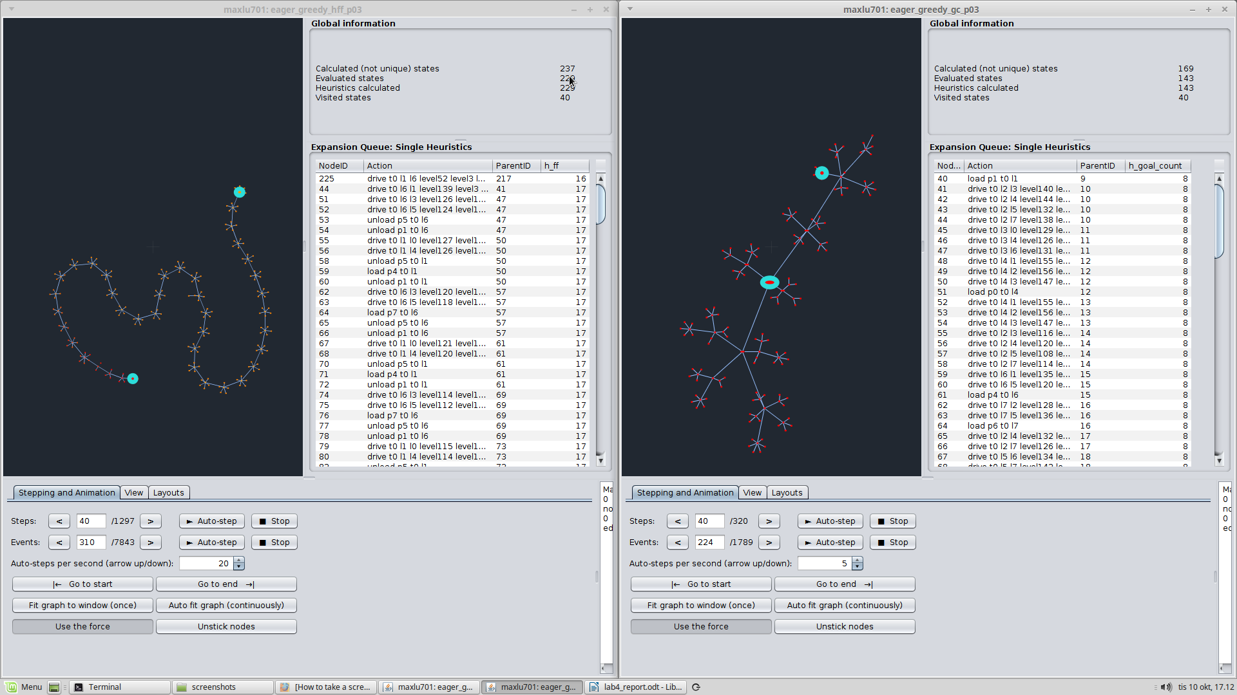
Planners at 40 steps.

Looking at the intial expansions of the two planners, we can see that the one using the goal-count heuristic, the cost of expanding different nodes doesn't change intially (it stays at 8). The planner using the greedy search heuristic has different cost for the nodes, and expands the ones with lowest cost. From seeing this, we reason that there might be a lot of randomness while using the goal-count heuristic, since it can take many expansions before there is any difference in cost between nodes, i.e. when a node that reduces the goal-count appears.
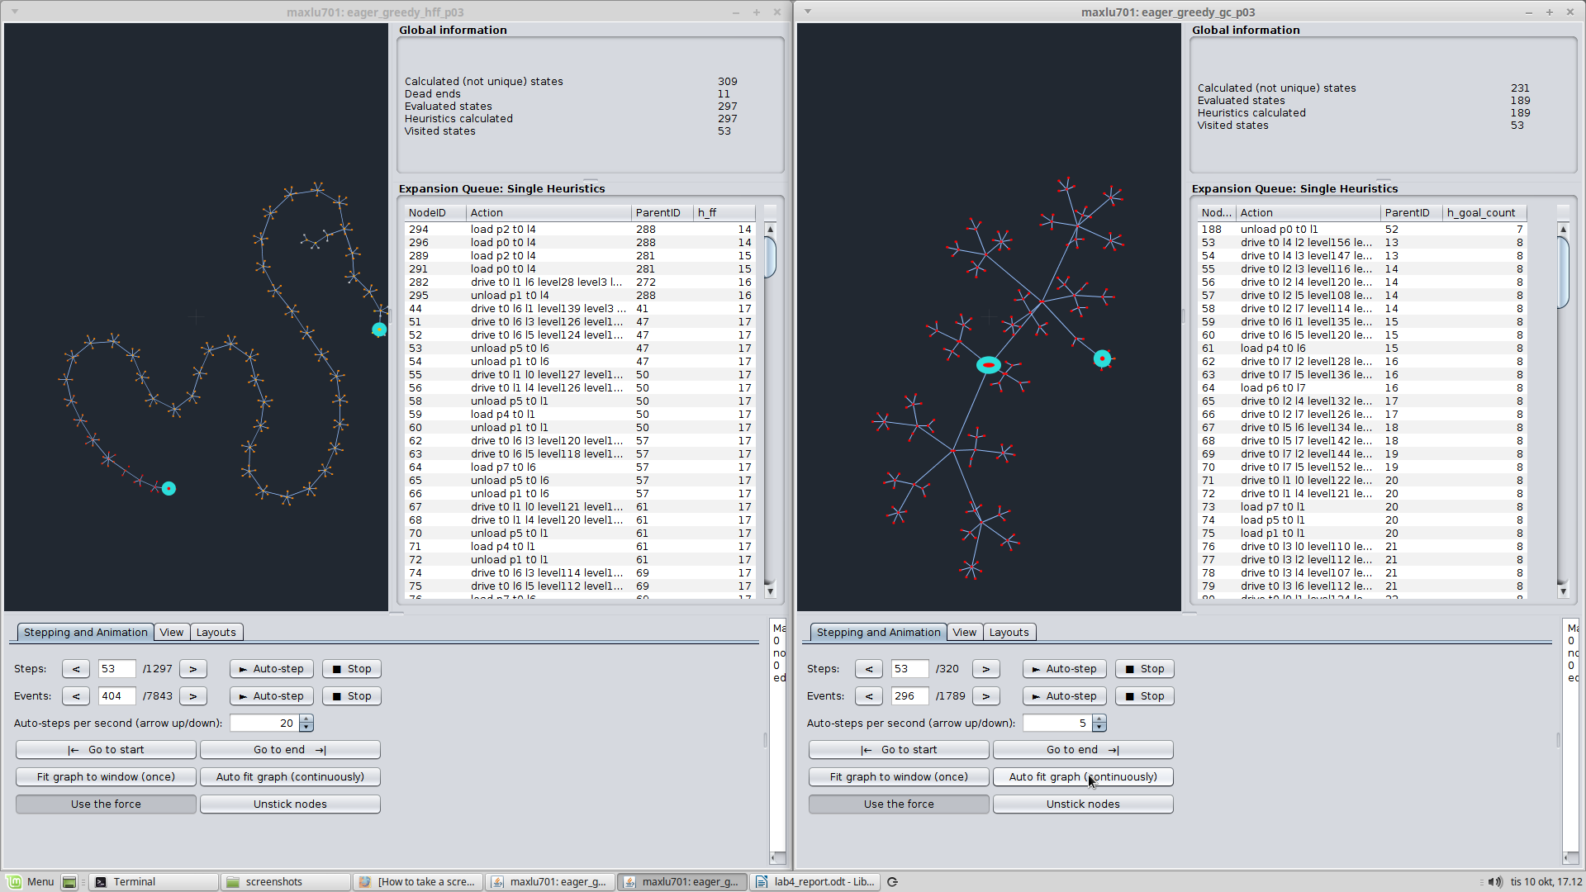
The first goal-count lower than 8 appears after 53 steps.

In the end, we can see that intial ”snake” generated by the FF-heuristic search was not used in the final path to the goal. Furthermore, this heuristic obviously used a lot more nodes to find a goal-path. The reason for this is that, just as any greedy-search algorithm, it can favor a path which might look promising but will not bring you closer to your actual goal, but rather into a ”dead-end”. While the goal-count heuristic also uses greedy search, it only goes down a path that is actually guaranteed to accomplish a goal, not just a path which might look promising. Perhaps it is possible to generate nodes which gets the goal-count down to 1, but still ends up being a dead-end, but from these examples, it seems that using goal-count as your heuristic in a greedy-search has a higher probability of actually getting you closer to a goal-path.

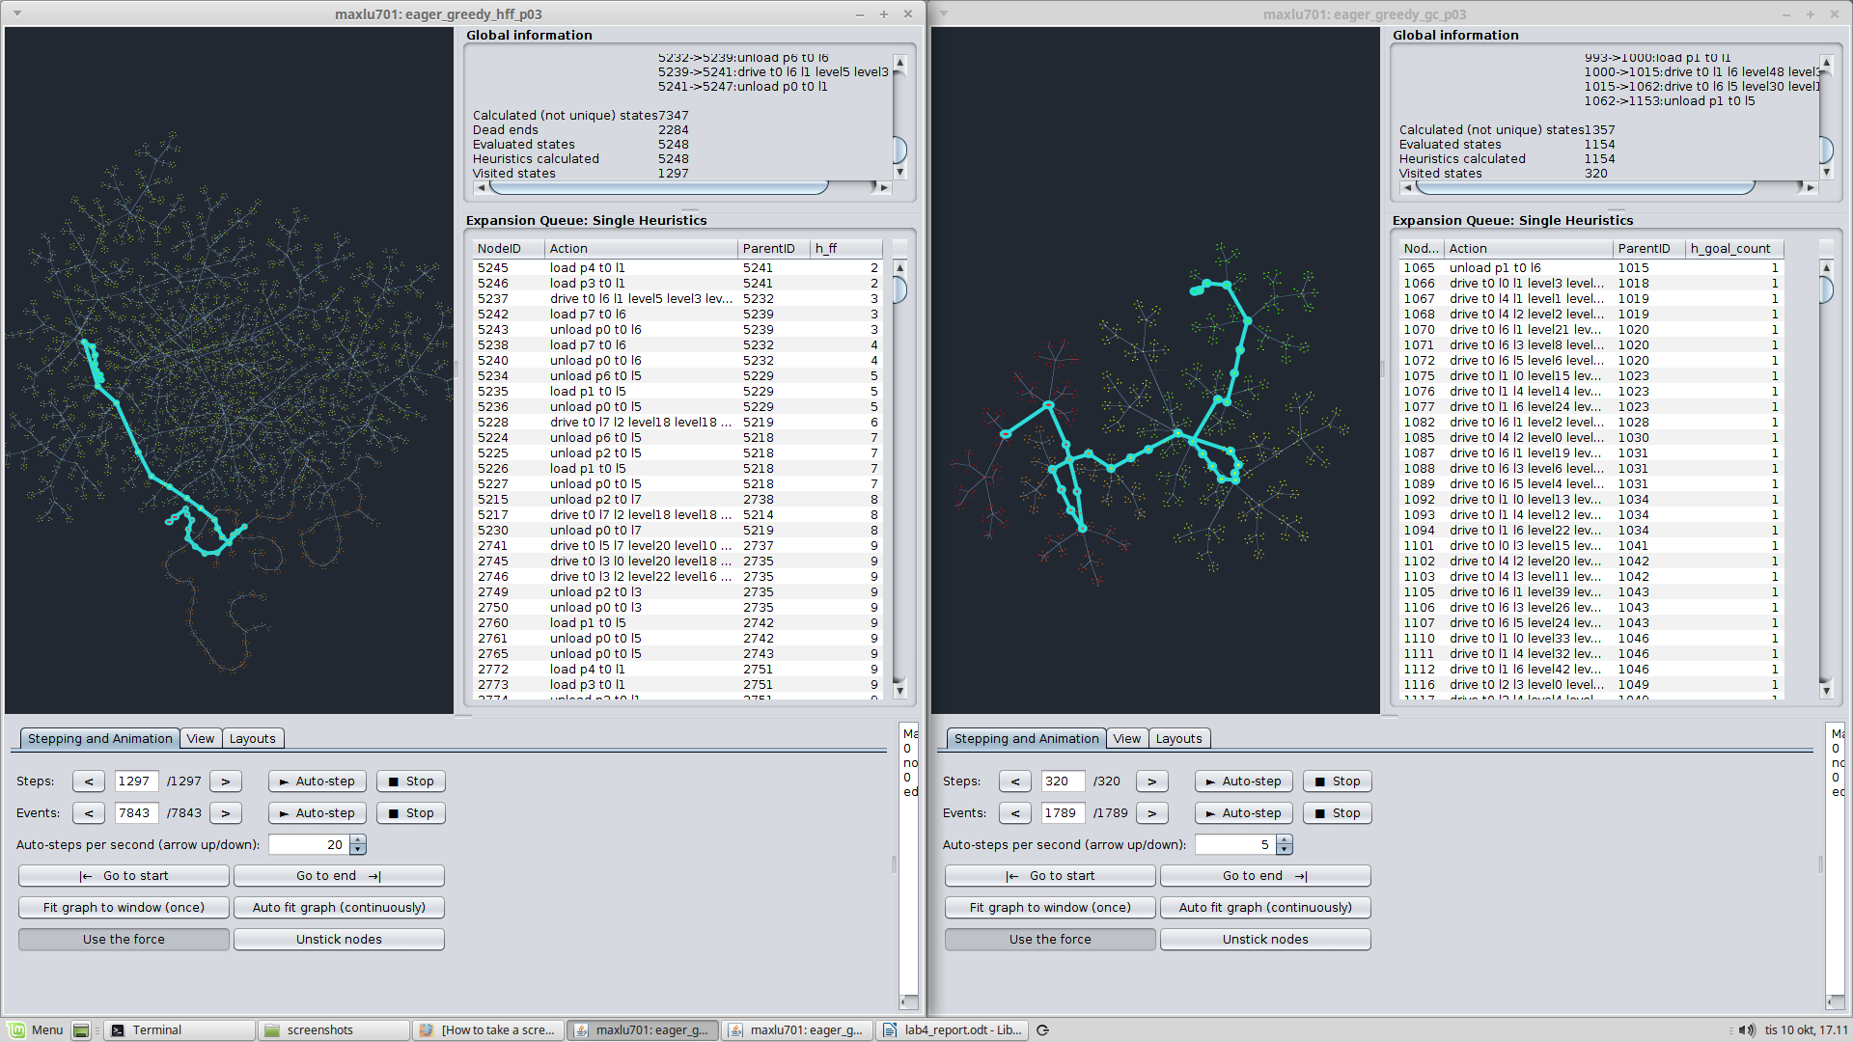
Final paths to goal.
2. Comparing heuristics, problem 02

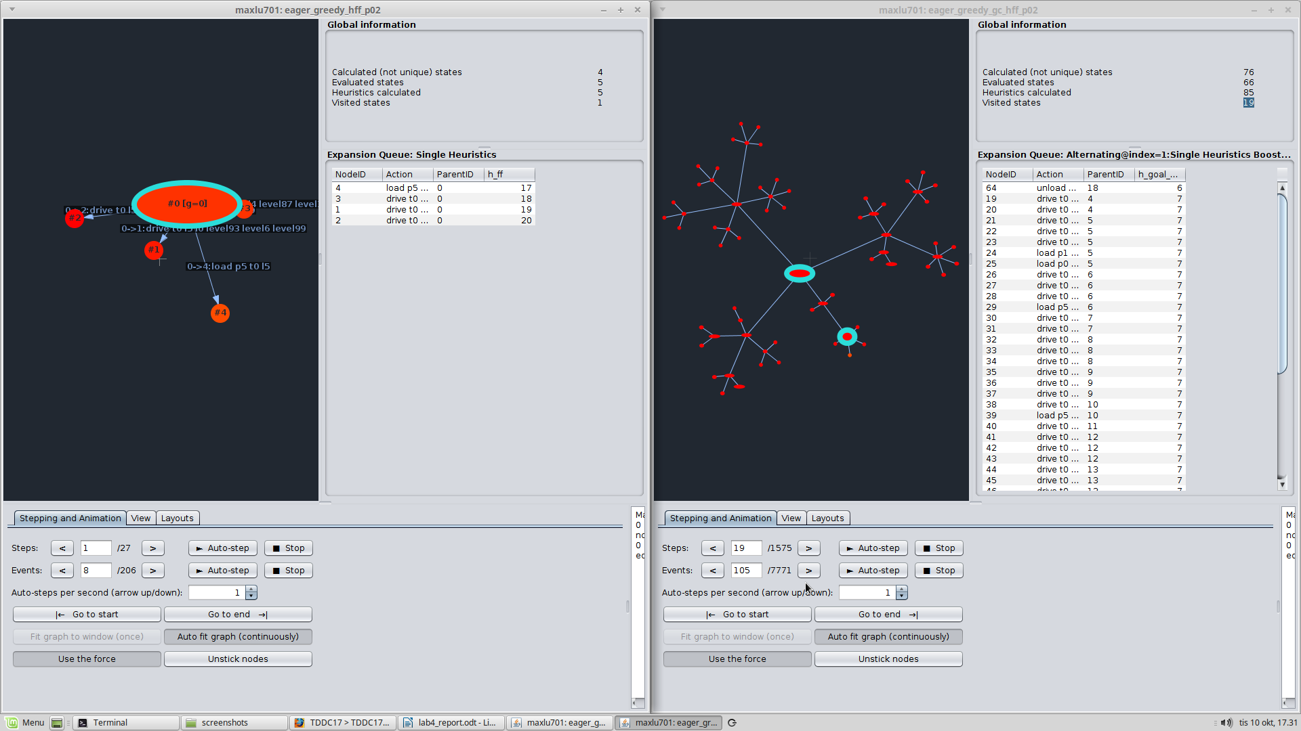
The FF-algorithm finds a node that reduces the heuristic value after the first expansion, time step1. The combined GC-FF-algorithm has to expand 19 nodes until the heuristic value is reduced from 7 to 6.
First time step where the heuristic value is reduced.

In the state that has progressed the longest at time step 27, the GC-heuristic still has 6 goals to expand.

The GC-heuristic never increase the heuristic value from one node to the next in the goal path.

3. Run one of the configurations on your own domain and problem. Is the graph similar to any of those that you have examined above? Can you explain why or why not?

Running our own problem in the visualiser, we used the goal-count heuristic. The results differed from the previous examples, in that we could see how the search expanded nodes that lowered the goal-count, but that did end up being dead-ends. In the previous examples, the lowering of the goal-count always seemed to get you closer to the goal-path, while in our example the goal-count even went down to 1 before going up to 5 again since the path did not end up being the correct goal-path. We can also see how the goal-path doesn't always decrease the goal-count for each node in the path, unlike the previous examples where every node on the goal-path had a lesser or equal goal-count as the previous node in the path.

The reason for this is perhaps that the goals are not in a sequential ordering, so that just clearing one goal is not guaranteed to give us a good path towards the final goal. For instance in our example with shakey, we want to have shakey end up in some specific room, but since the robot will have to move between rooms to clear all the goals, only going by a greedy heuristic that seeks to lower the goal-count will not guarantee to get us closer to the final goal.

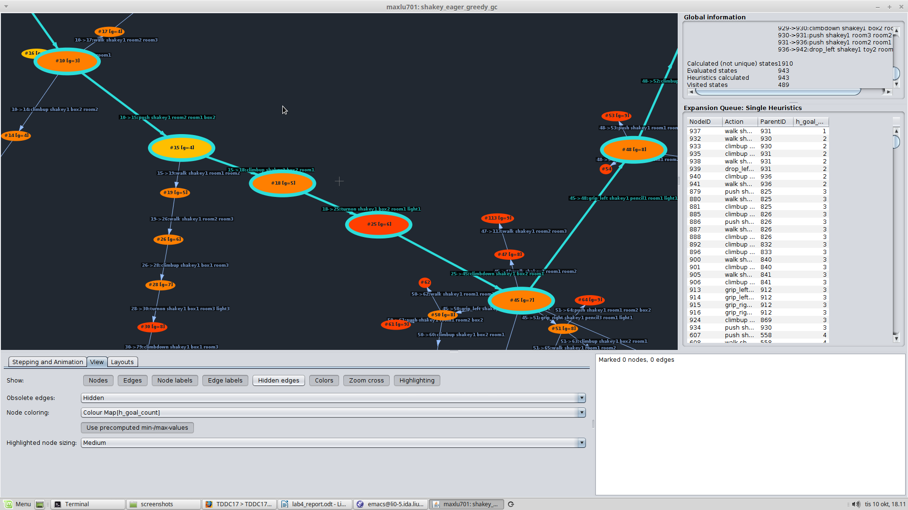
The colors of the nodes in the goal-path represents the goal-counts. We can see that it goes from a lower goal-count (more yellow) to a higher goal-count (more red) in nodes that brings us closer to the goal-node.

Was any configuration better than the other? Was it better on everything or just on some problems?
The goal-count heuristic seems to work a lot better for the given examples, since it searched through a clear path to the goal without expanding a lot of dead-ends like the FF-heuristic did. However, we can see from the example with our own shakey-problem compared to the given examples that using the goal-count heuristic was a lot better in the given exampels than in the shakey problem. The reason for this is stated in the previous section.

Are your findings applicable to all the infinite many possible domains and problems? If so why? Else, why not?
Since we could already observe that one heuristic that seemed good for the example domain did not work at all work as well on our shakey problem, we can conclude that our findings are not applicable to every possible domain. The reason for the heuristic working so well in the given examples is probably because clearing one goal dependant on having cleared a previous goal, so it is not possible to clear a later goal before clearing a previous one. In our example with shakey, we instead might have to go back and forth between ”goals”, such as moving in and out of rooms, or turning on and off lights. Just trying to clear these goals without any regard to ordering of them will not get us closer to our final goal and therefore take us down dead-ends in our search.

