**CMPS109 Make-up Examination**

**Max Zhao**

[**mlzhao@ucsc.edu**](mailto:mlzhao@ucsc.edu) **1466223**

1. HTTPHTMLService.cpp  
   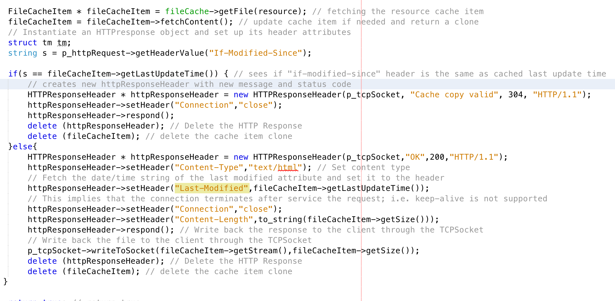
2. HTTPImageService.h  
   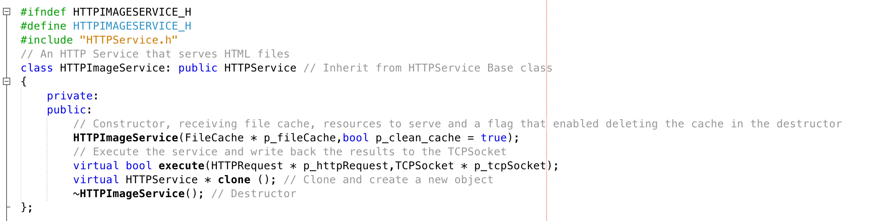
3. HTTPImageService.cpp  
   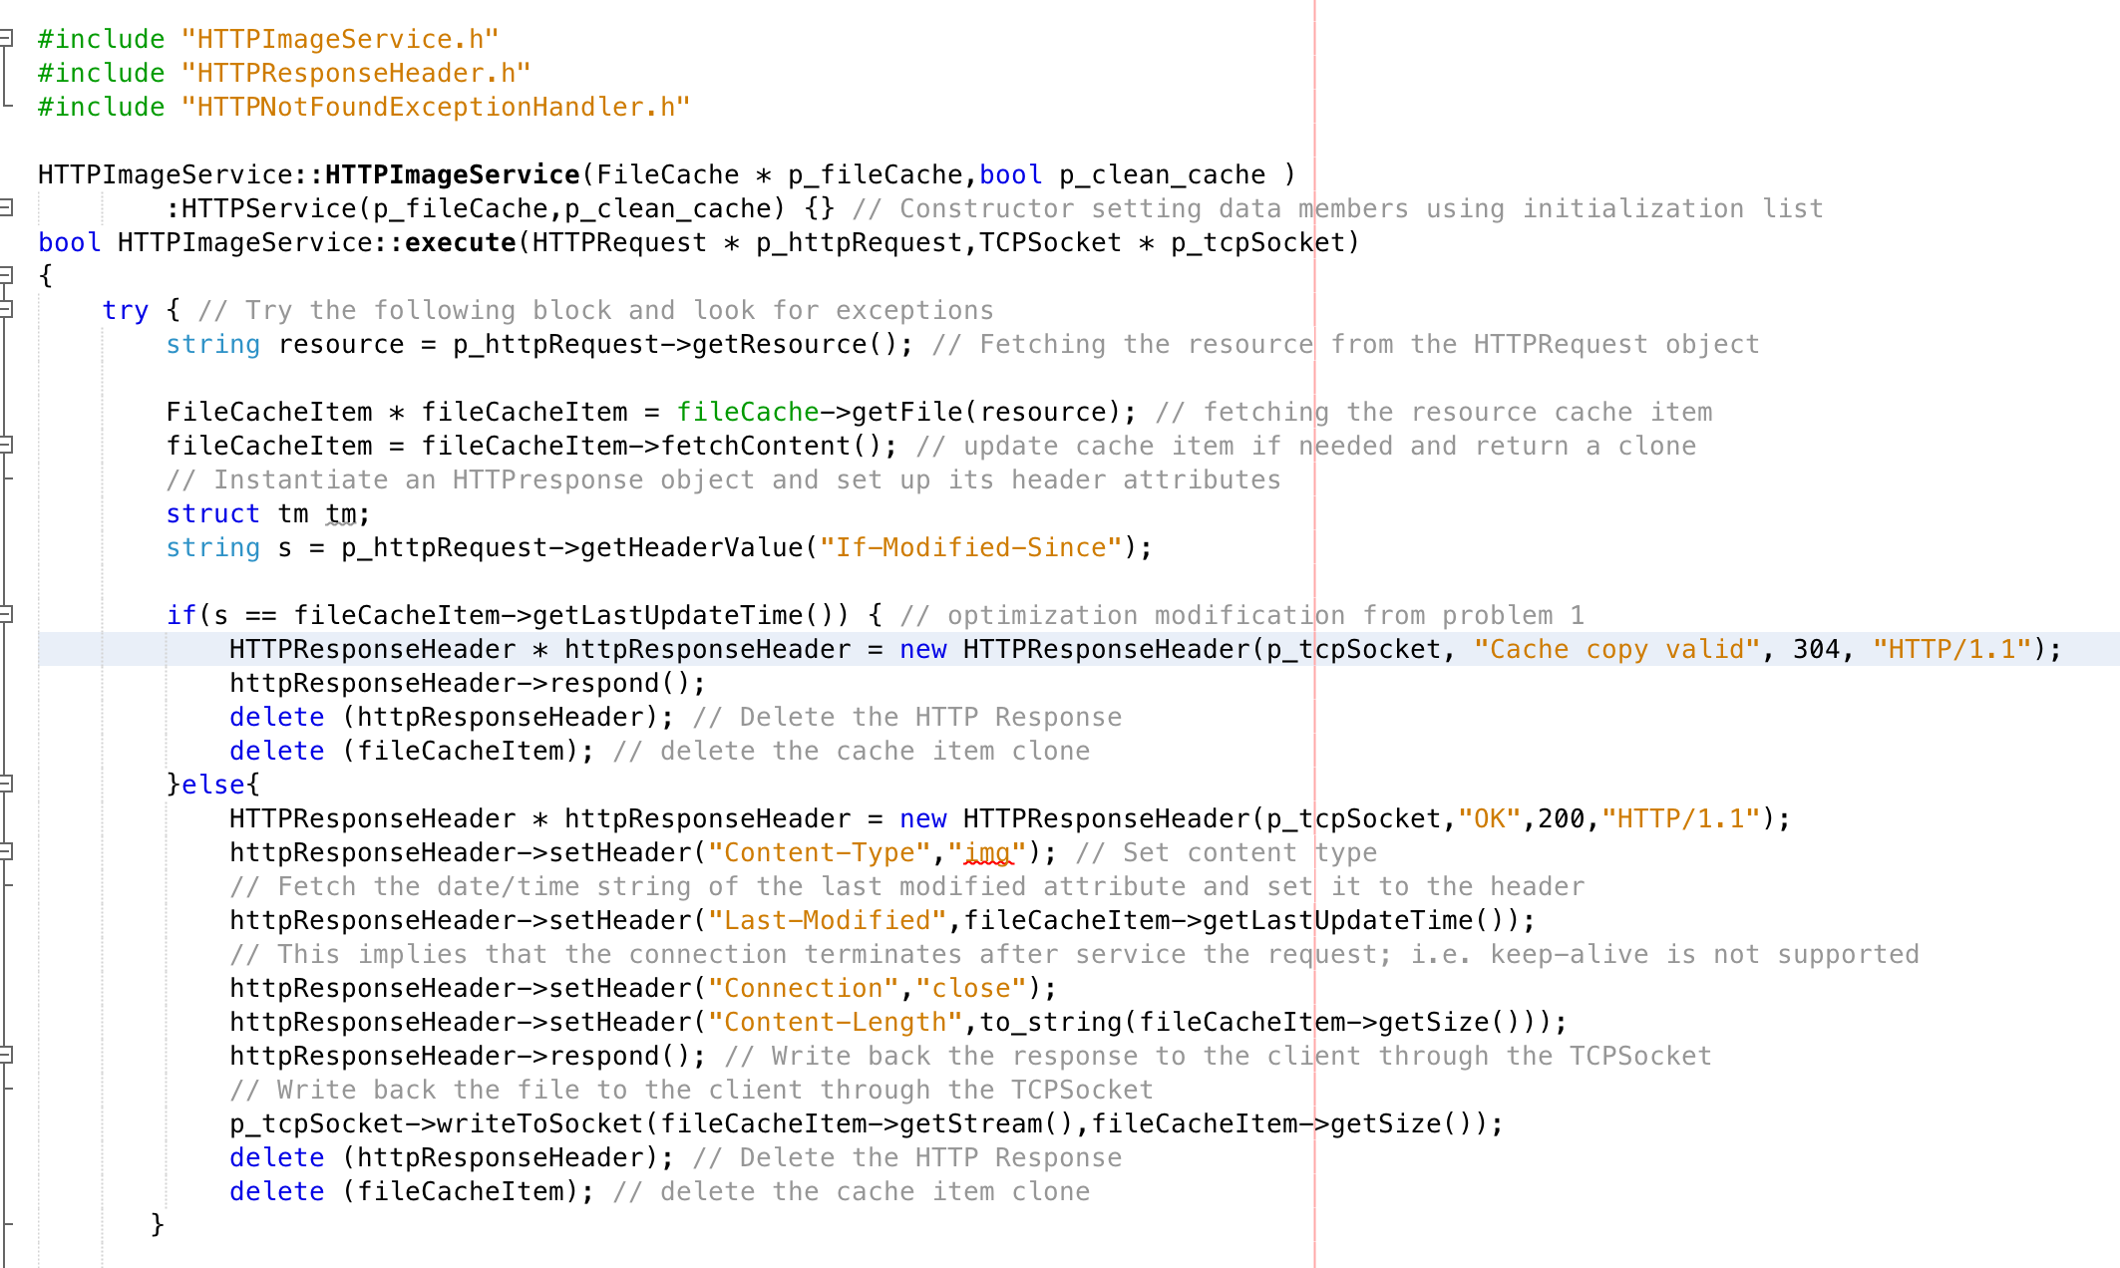  
   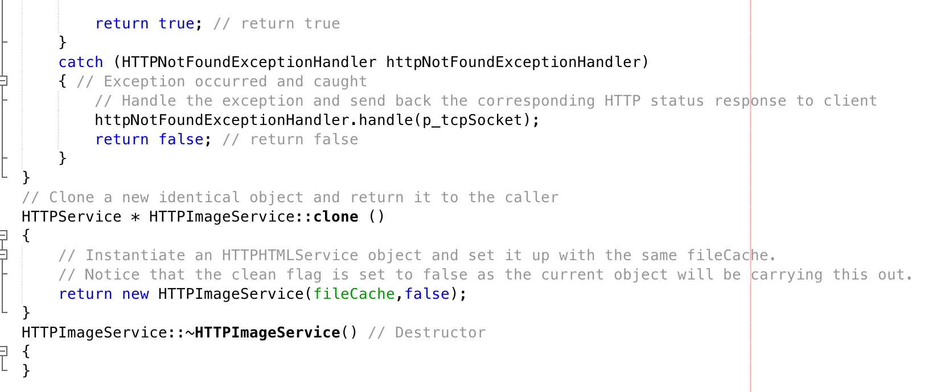
4. HTTPServiceManager.cpp  
   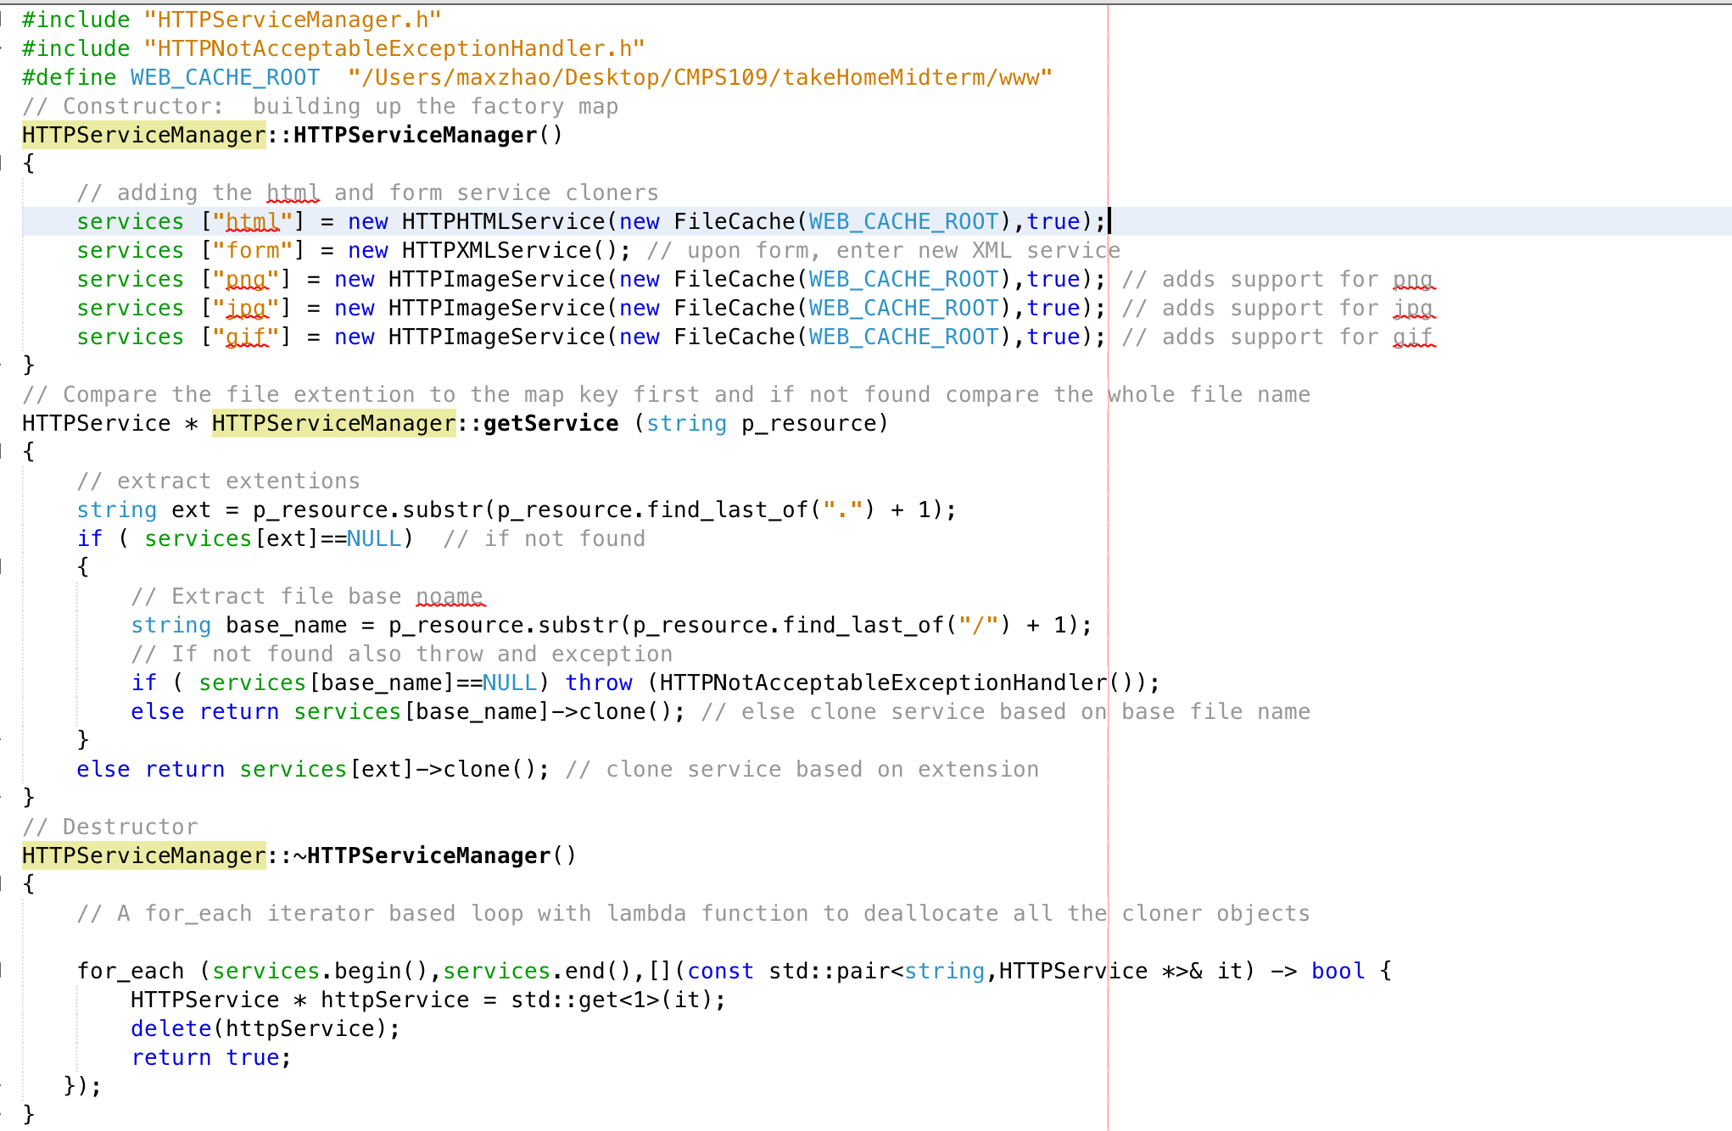
5. HTTPXMLService.h  
   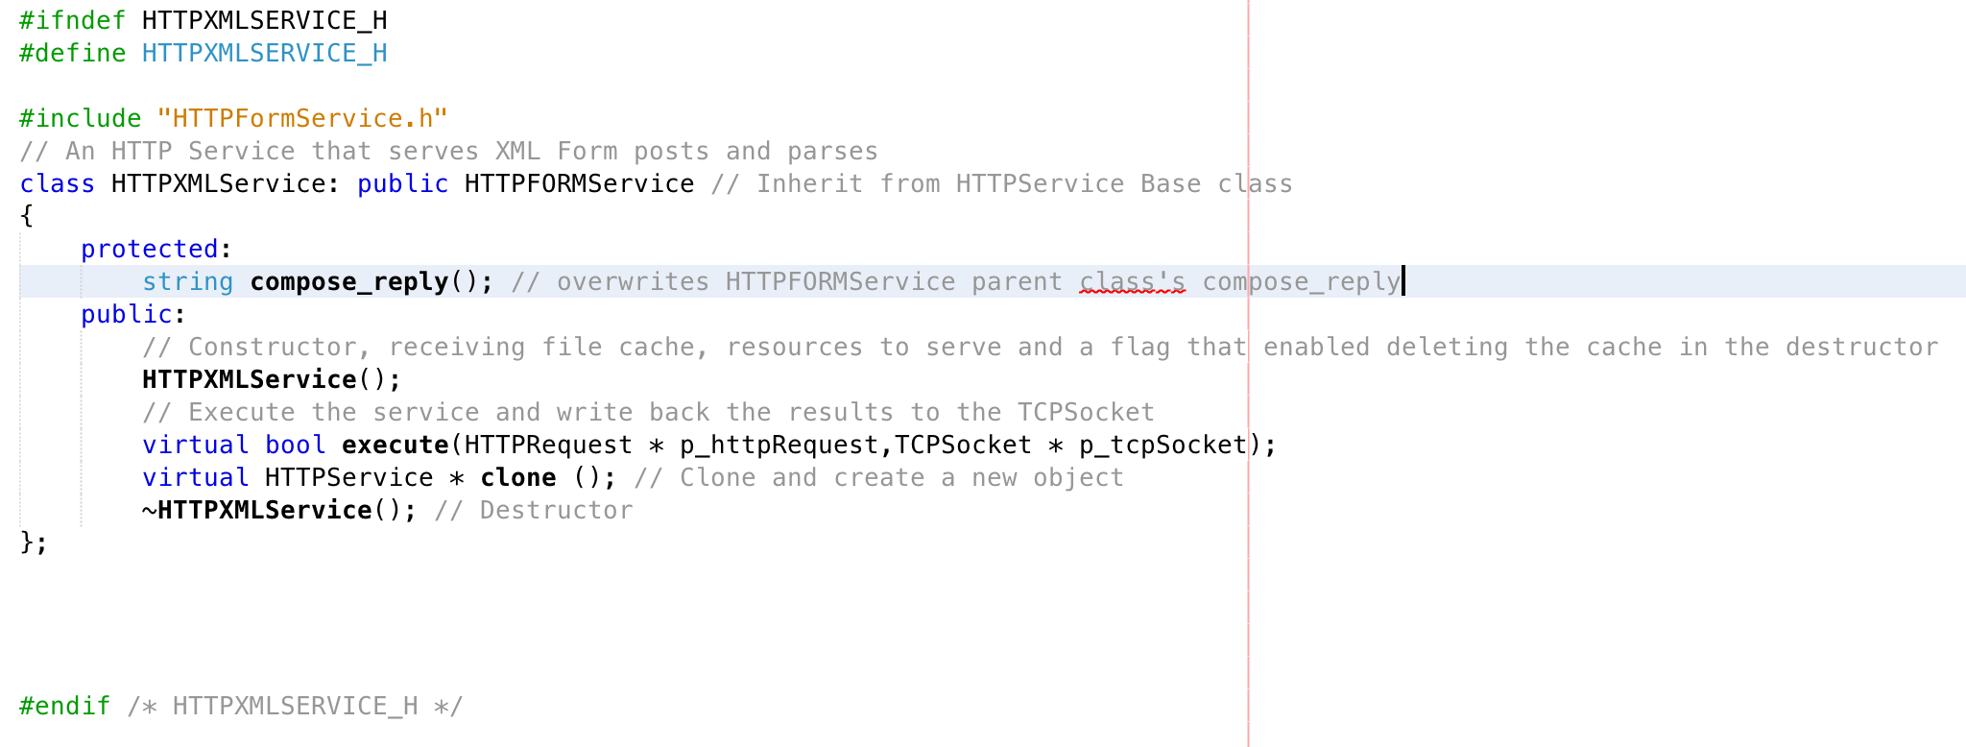
6. HTTPXMLService.cpp

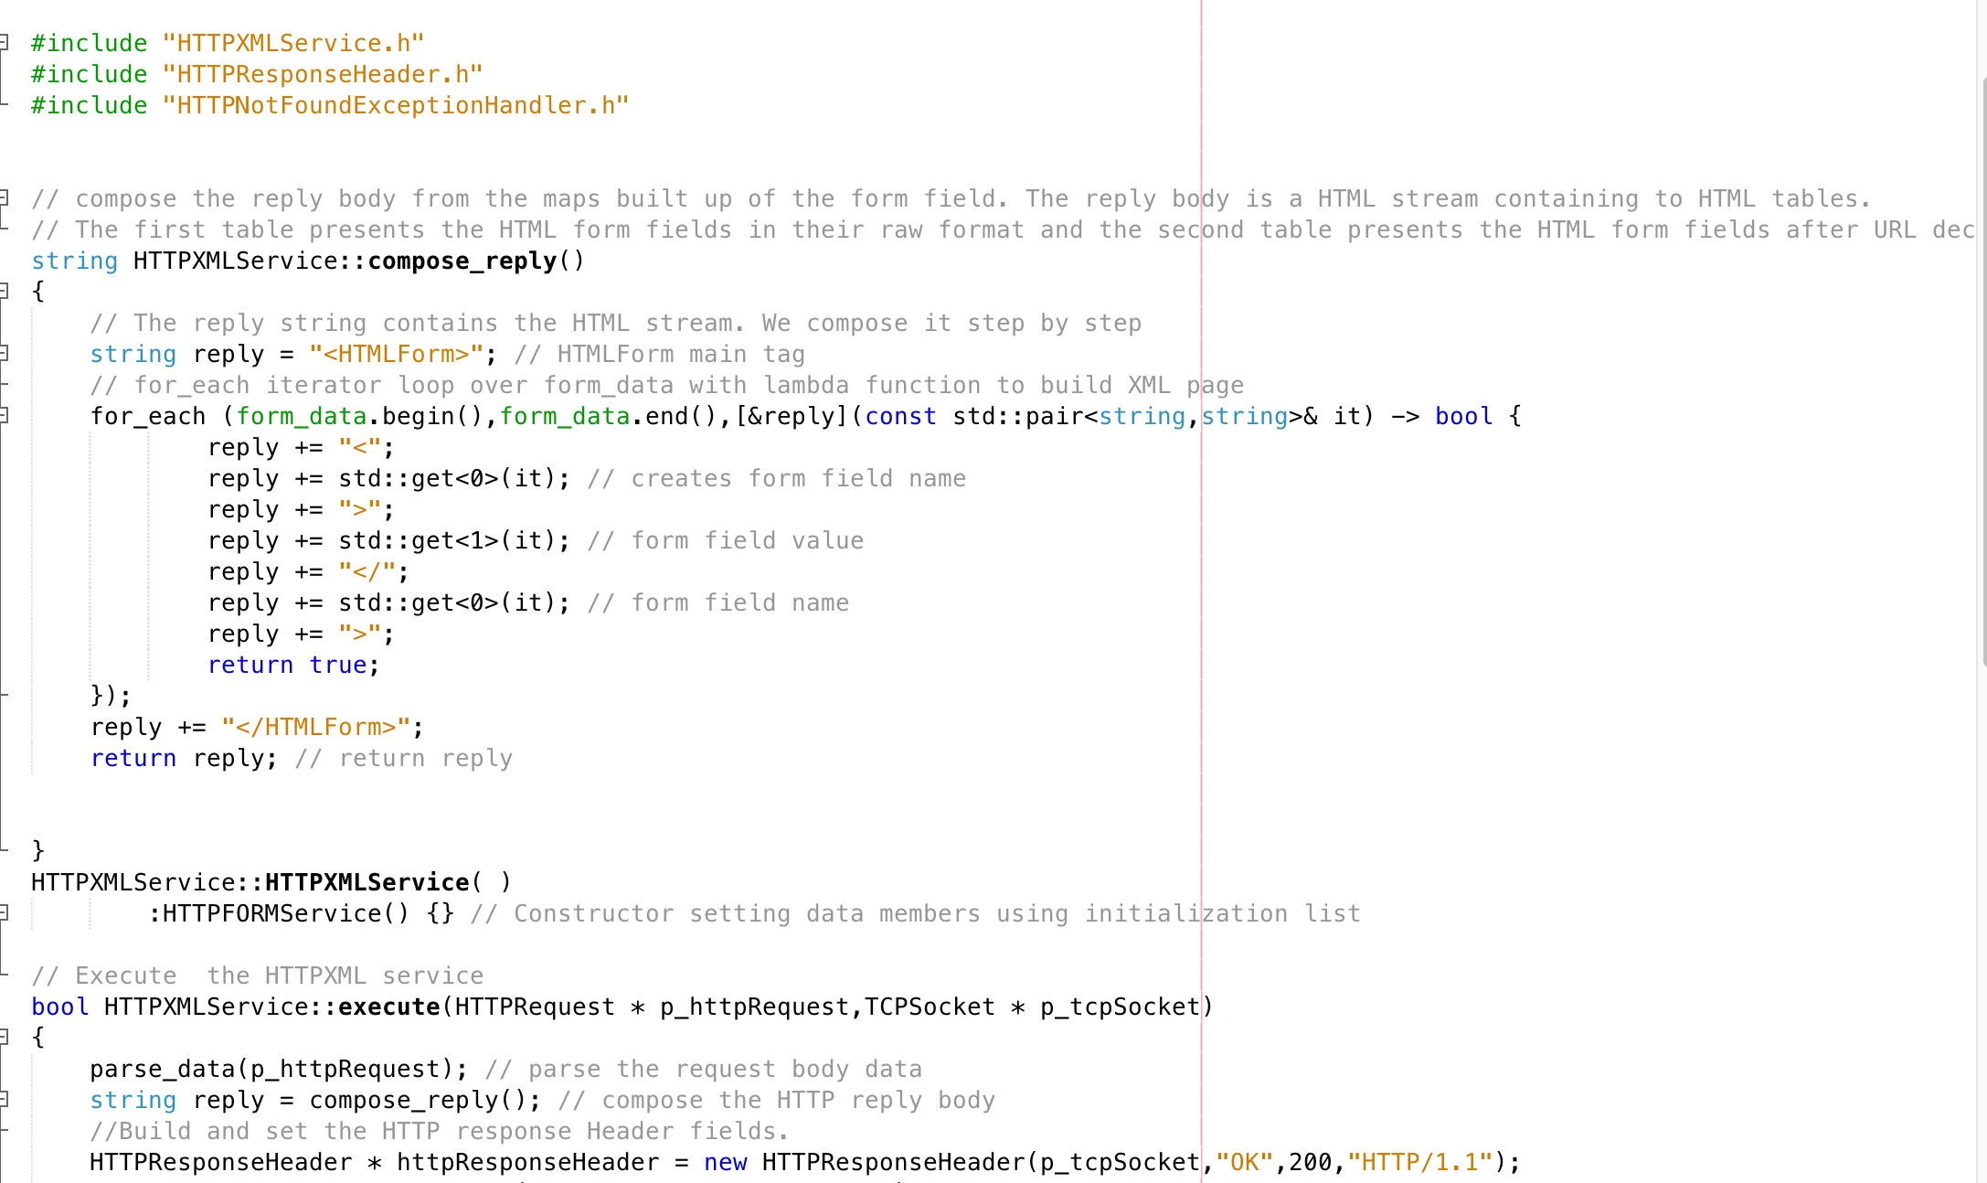  
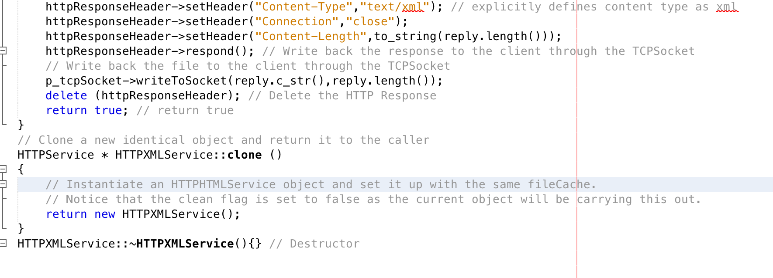

For number 1, we were to optimize and modify the HTTPHTMLService class, so that the “If-Modified-Since” request header would only send back the target HTML file content if the provided date is less than the cache last modified date. I was able to check the provided date by getting the header value from p_httpRequest->getHeaderValue, and the cached date from fileCacheItem->getLastUpdateTime(). Comparing the two timestamps, if the cached time time was equal to the if-modified-since header, I passed in a new HTTPResponseHeader object with status code 304 “Cache copy valid”, and set only the connection header. Otherwise, I passed in the HTML file content normally as given in the skeleton code, with a status code of “200 OK.” For number 2, the new HTTPImageService class was very similar to the HTTPHTMLService class, created simply in sake of cleanliness, reading the file and fetching content. The biggest change was made in HTTPServiceManager, where I added new service cloners supporting the image types, “png”, “jpg”, “gif” and creating respective new HTTPImageService objects.

For number 3, I extended the HTTPFormService class to parse an HTML form post and return an XML stream representing the form fields by creating a new HTTPXMLService class. Using the protected variables of formdata and HTTPFormService’s parsing functionality, I overrode the compose_reply function to create the necessary xml document with the required tags. I also made sure to set the content-type response header as “text/xml,” and redirect the “form” service in HTTPServiceManager to create a new HTTPXMLService() in order to go straight to the new XML page upon pressing submit on the form.