Hiperparameters setting - Deflected Subgradient
Final Model
Learning Algorithm | #Units, lambda, beta, delta, R, rho | RMSE(TR/VL/TS)
Stepsize-restricted | h1=30, h2=20, λ=1e-4, β=0.3, δ=0.1, R=0.1, ρ=0.7 | 0.5415/0.6737/0.7087

Some results abouts hyperparameters for Deflected Subgradient

Red curve: Validation Blue curve: Training

h1=40, h2=30, λ=5e-5, β=0.07, δ=0.07, R=0.1, ρ=0.7
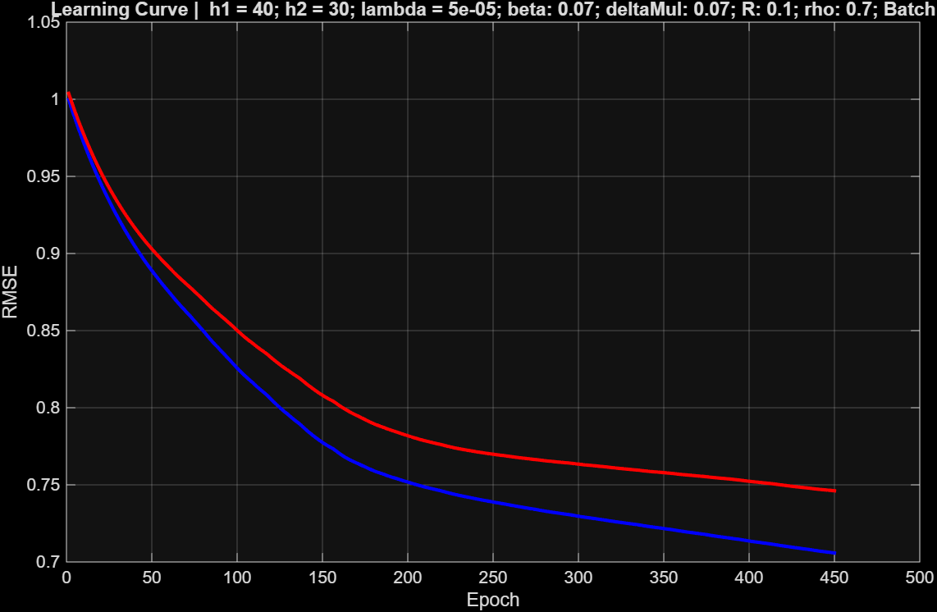

Lower values of β and δ were tested compared to the final model. As observed from both the training and validation RMSE, the model performs significantly worse (approximately 5 percentage points lower), due to a too slow descent, which triggers early stopping before full convergence. This behavior was observed in the majority of models tested with β and δ values lower than those of the final model.

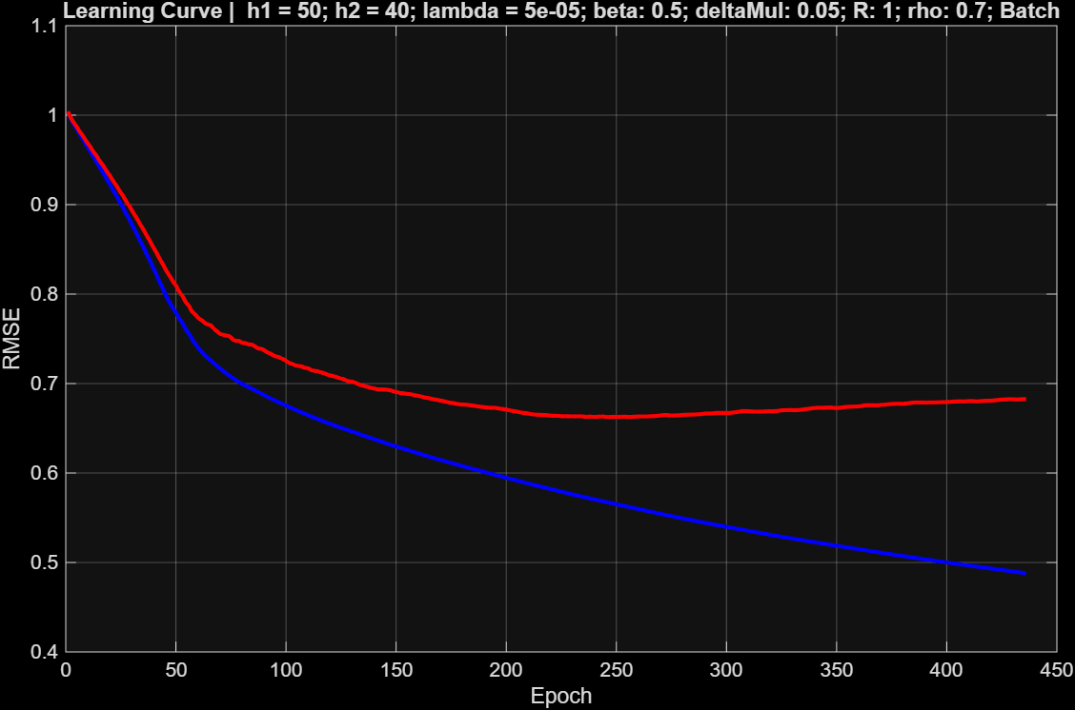
h1=50, h2=40, λ=5e-5, β=0.5, δ=0.05, R=1, ρ=0.7
In this case, however, higher values of the hyperparameters R and β were tested in an attempt to speed up convergence. As seen from the validation curve, these overly aggressive values lead to overfitting.

h1=30, h2=30, λ=1e-7, β=0.1, δ=0.5, R=1, ρ=0.7
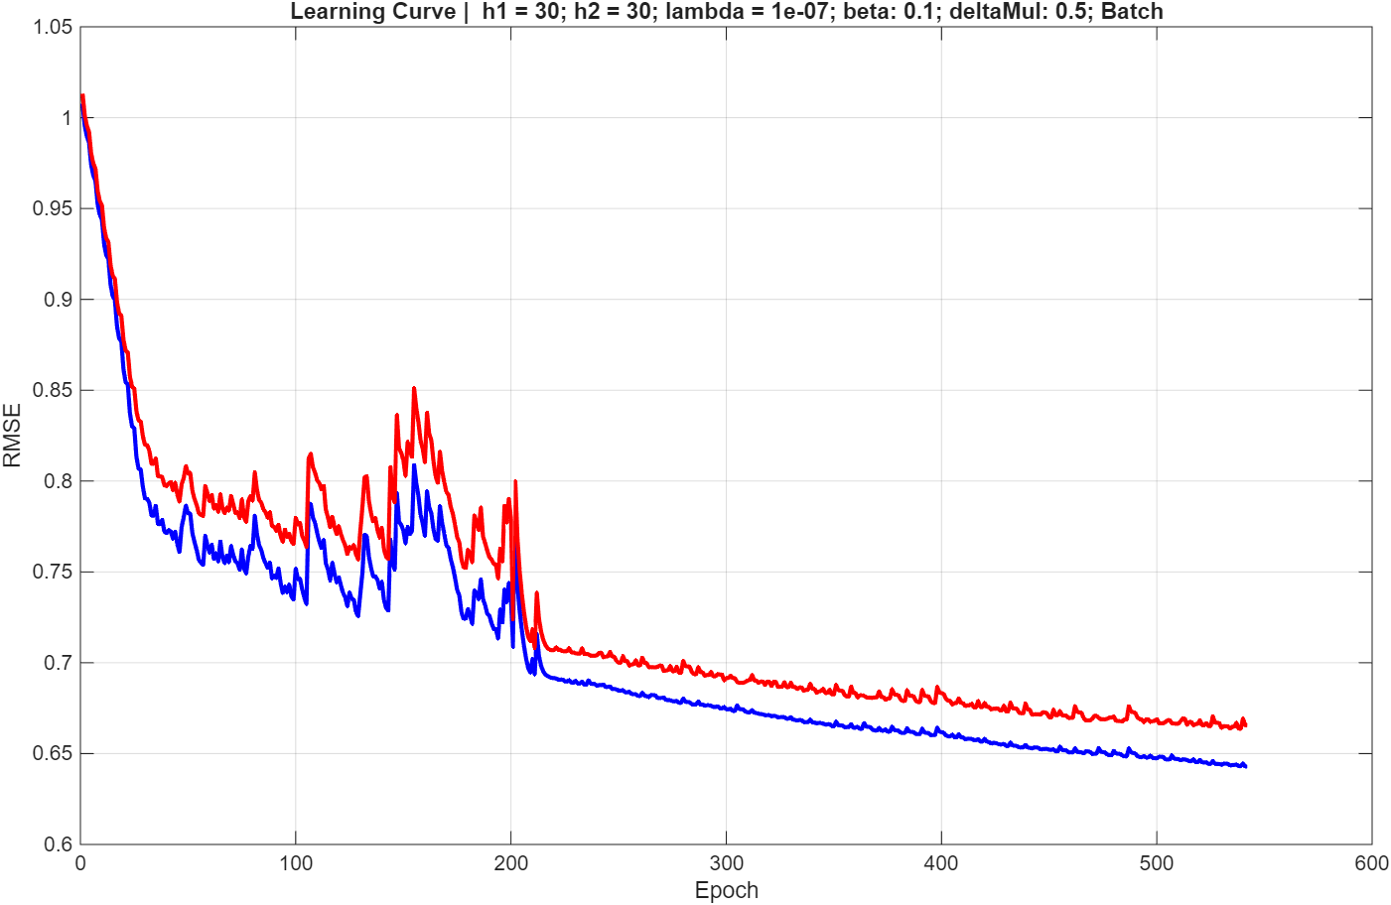
These unsmooth curves are caused by a too low λ value combined with an overly aggressive δ in the f* update.

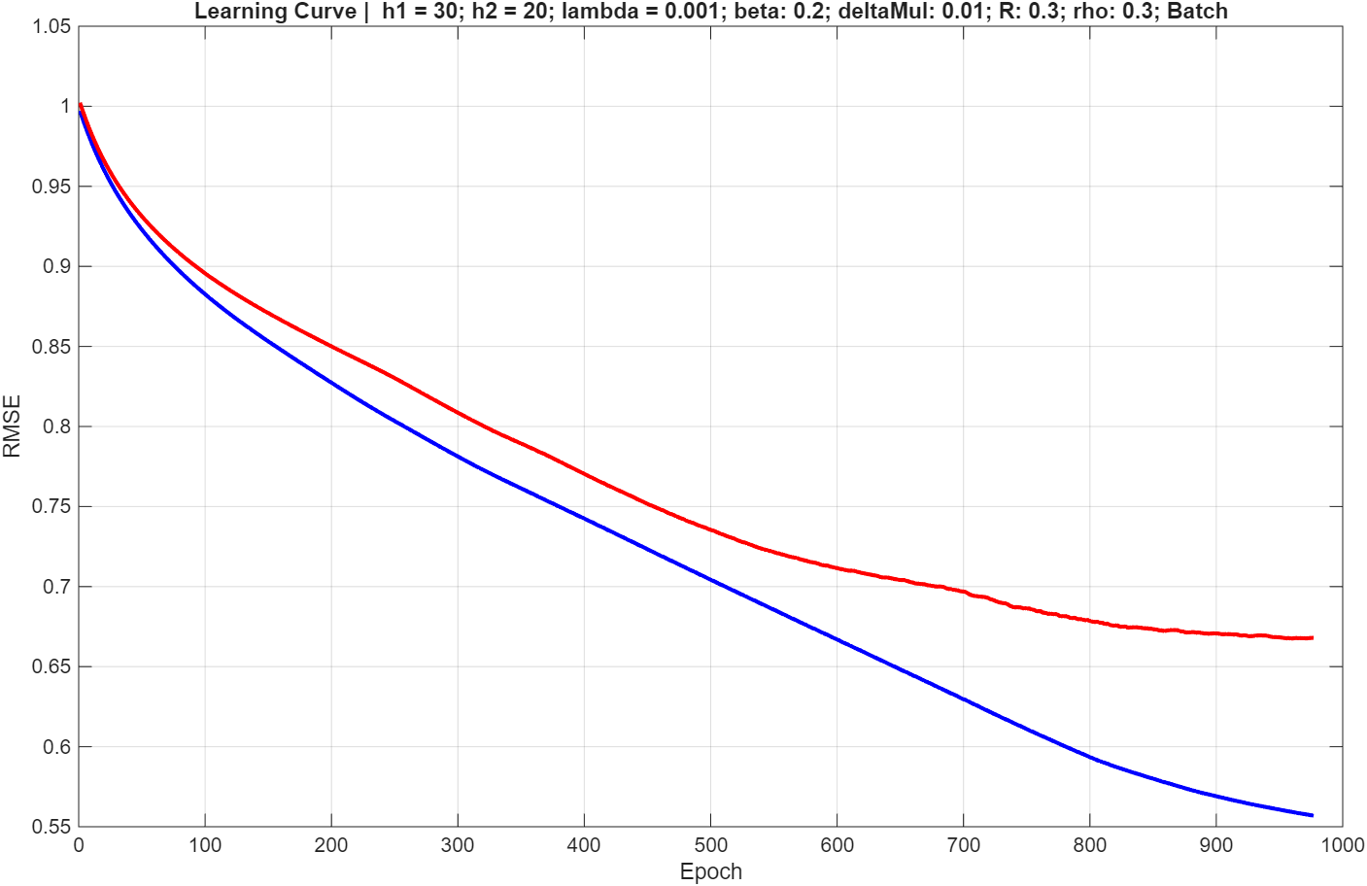
h1=30, h2=20, λ=1e-3, β=0.2, δ=0.01, R=0.3, ρ=0.3
In this model, we tested lower values of δ and ρ to reduce the step size and potentially improve validation performance. However, the learning curve again exhibited slow convergence, without any noticeable improvement in results.

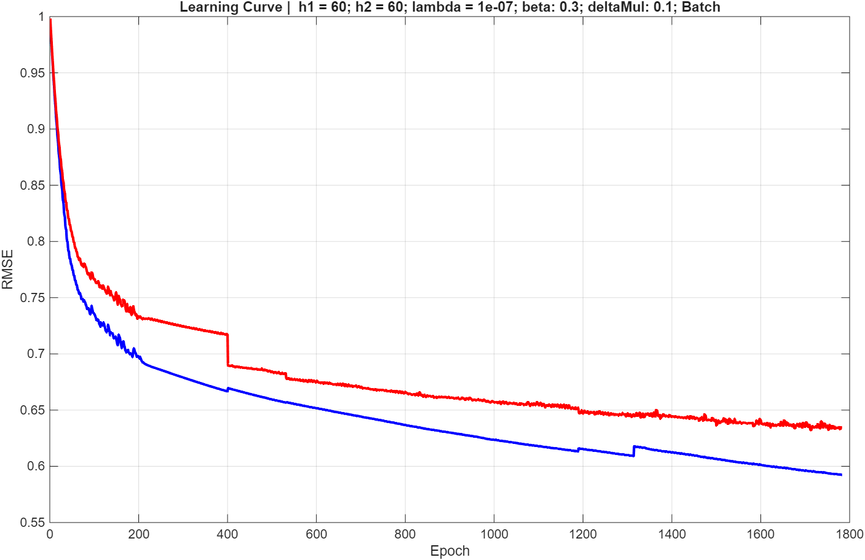
h1=60, h2=60, λ=1e-7, β=0.3, δ=0.1, R=0.1, ρ=0.7
Finally, by increasing the number of neurons while keeping the other hyperparameters at the levels of the best model, we observed irregular behavior: some folds terminated very early, while others reached slightly better convergence than the final model, but with irregular, unsmooth learning curves.

