****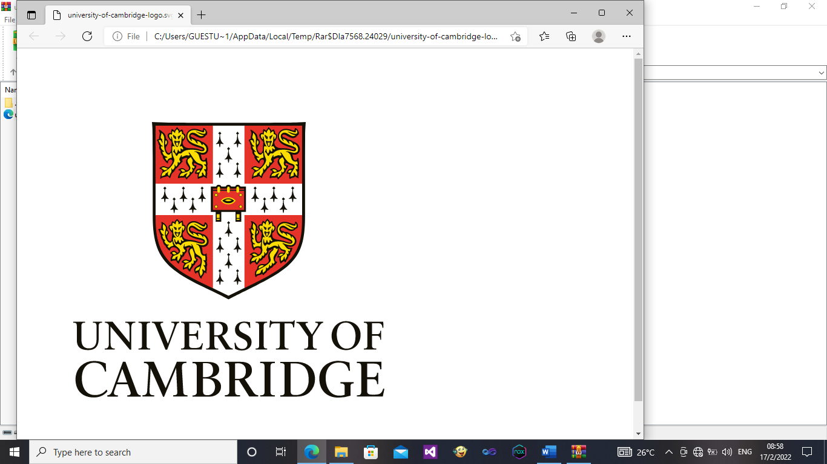

IN ASSOCIATION WITH

UNIVERSITY OF CAMBRIDGE

lingfield advent high school

Name : Joe Msindo

Class : 3 Diamond

Subject : Chemistry

Teacher : Ms Dondo

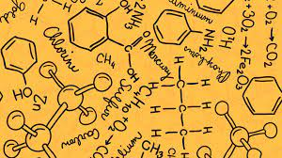

****

IN ASSOCIATION WITH

UNIVERSITY OF CAMBRIDGE

lingfield advent high school

Name : Joe Msindo

Class : Lower 6

Subject : Chemistry

Teacher : Ms Dondo



Edit and use your own Name and Class.

You have An:

1. Exercise book,
2. Test Book,
3. Homework book and
4. Notes

So edit The Subject accordingly.