**Specification document**

“Flight Control team”

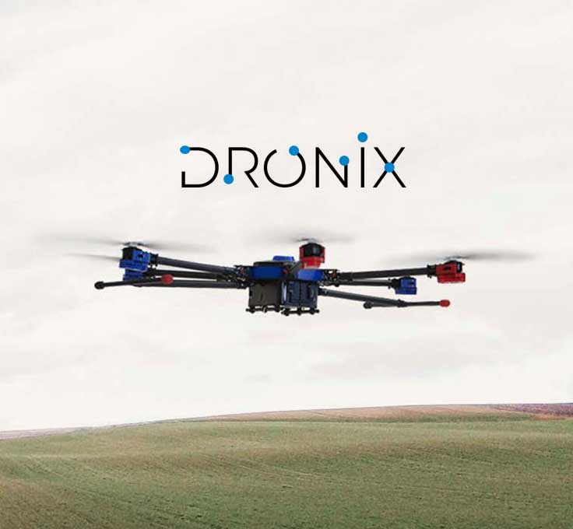

Submitted by: Tom Vivdenko, Maxim Melichov

Background

How do you make a drone fly safe?

First of all, you will need a drone (DR900).

Secondly, the flight controller, what we’re using is a Pixhawk Cube Orange which is designed for commercial systems and manufacturers who wish to fully integrate an autopilot into their system, improve reliability, and ease of assembly carry the board.

Third, the companion computer we’re using is an Nvidia jetson nano is a CPU.   
Jetson is a low-power system and is designed for accelerating deep learning applications that we use in our project.

Fourth, you will need a Lidar or a depth camera for obstacle avoidance. Lidar is a combination between light and radar and it gives the drone the ability to make high-resolution maps for high-accuracy obstacle avoidance.

The rest of the things that you will need are Gyroscopes and accelerometers, GPS, and a compass.

the purpose of the project:

Customer (college) requirements from the final product (drone) + adjustments we will have to make due to lack of time.

• fly only within the college

• Scanning with a camera of the area during the day and at night - due to lack of time the drone will perform scans only during the day, no need for a camera with night vision for easier identification of objects.

The drone should have the ability to encounter objects (obstacle avoidance).

• Identification of "suspicious" objects - currently due to lack of time, identification of objects has been reduced to the identification of humans only.

Flight control group tasks:

* Build the drone if necessary
* PID calibration
* Setting up the autopilot
* Make a successful take-off and landing
* Make sure the obstacle avoidance works properly with the autopilot
* Perform a successful flight on a pre-defined route.

The components:

Drone:

The drone is DR900 by Dronix, the estimated price is $ 40,000

The weight of the drone is about 15 kg

Can carry a weight of 5 kg for an estimated 45 minutes.

Flight controller:

By Pixhawk Model Cube Orange for $ 300

main features:

* Backup system incorporates mixing, provides consistency

Autopilot mixing modes and manual override

* Multi-colored LED main visual indicator
* External safety switch
* High volume, multi-tone audio slider
* High-speed microSD card for extended periods of time

Single board computer:

Nvidia model jetson nano for $ 180

Depth camera:

Intel® RealSense™ Depth Camera D435

A camera that detects distances between objects costs $ 300

The rest of the components:

* gyroscope sensors
* Accelerometers
* GPS
* compass

Simulator

Rviz – Ros visualization is a graphical interface that allows you to visualize a lot of information, using plugins for many kinds of available topics.

Work plan:

1/ Learn how to use the simulator.

2/ We will install the Ros system and the Rviz simulator

3/ Test run for the drone only in the Rviz simulator

4/ Build a take-off and landing test surface (this will test the PX4 autopilot for take-off and landing) (

5/ Check the PX4 algorithm for obstacle avoidance

If the algorithm provided by PX4 is not sufficient, you can also use this algorithm from GitHub (link: https://github.com/uzairakbar/rl-obstacle-avoidance)

Why not just re-create an algorithm?

Can a lot of problems with working with Lidar and it is not enough just to get a range of distance of the drone from the obstacle

The first problem the drone has to decide in real-time what it needs to do to avoid the obstacle of thinking about things like slowing down etc.

Then which direction to turn? Right or left down or up? And there is another problem with Lidar that it may not bring true information namely:

**QGroundControl:**

QGroundControl provides full flight control and vehicle setup for PX4 motor vehicles. It provides easy and simple use for beginners while providing support for advanced features to experienced users.

QGroundControl gives us simpler drone control, route planning, and displaying relevant data.

With QGroundControl we can make a route that is required very easily with the map displayed within the app and while controlling speed, altitude, battery, and more.

main features:

• Full definition / configuration

• Mission planning for an autonomous flight.

• Flight map view showing the vehicle's location, flight route, waypoints, and vehicle instruments.

• Streaming video with layers on the device display.

PX4

Low cost and available autopilot allow amateur use of a small remotely operated drone.

Basically, autopilot with all the necessary functions for the drone to be able to take off fly, and land successfully

main features:

• Task planning

• Safety (knows how to dodge objects and avoid collision)

• Knows how to work with the extra parts we work with whether it is Jetson, Orange Cube, Lidar else