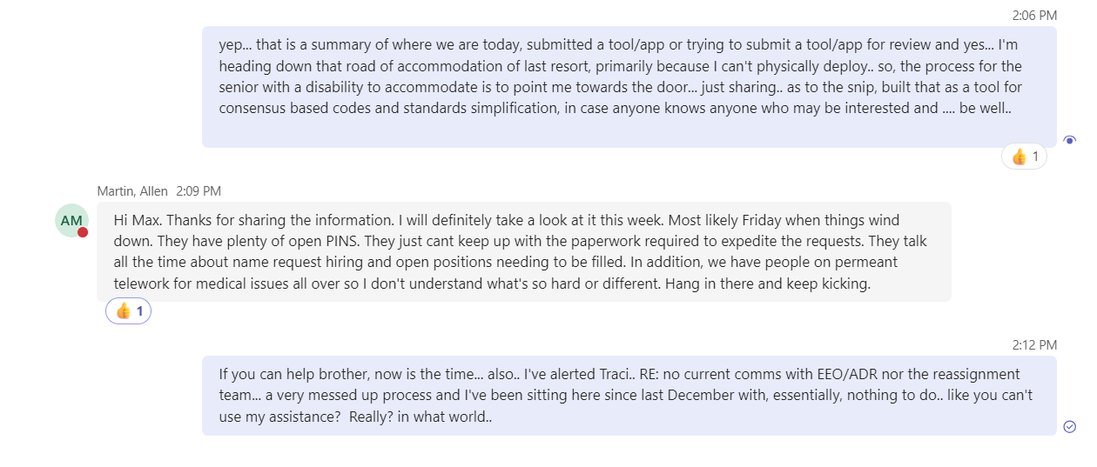

8/5 9:58 AM

Meindl, Max

I can't really help on Tony's team unless they can use me virtually... the next few months should be interesting..

Oh, I thought you had a remote position? by Martin, Allen

Martin, Allen

8/5 10:13 AM

Oh, I thought you had a remote position?

yep, a remote position that requires 50 wee... by Meindl, Max

8/5 10:22 AM

Meindl, Max

yep, a remote position that requires 50 weeks deployment a year, basically 100% on the road, Tony and I realized the issue during our first conversation and after I went to the doc to get cleared for being on the road and well.. to my surprise... I'm getting older and things don't quite work like they used to and I am a bit limited in what I can do.. we'll see how it all shakes out but the path is towards me applying for positions again, and the appeal with that having the potential of a reassignment, facilitating my RA like Mark and Rick did with a workaround provided by Karina allowing me to work virtually do to health issues. The current path is I'm unable to perform the position requirements (50 weeks on the road) and if I can get another position/offer or reassignment, well it is what it is, if not, it heads toward letting me go. I would think, with my experience and the forecast for the year they would be a bit more flexible getting qualified members onboard, just saying. Last summer was a test run to see if I (we) could handle me being on the road and the results were that it wouldn't work.. My options are limited, I'm counting on the basic humanity of FEMA team members so we'll see.

Have you went through the new RA process? I... by Martin, Allen

Martin, Allen

8/5 10:42 AM

Have you went through the new RA process? It doesn't involve your SOR anymore, unless you are requesting a temporary RA which your SOR has the ability to provide you up to 90 days. Reasonable Accommodation (RA) (sharepoint.com)

in the middle of the process for this speci... by Meindl, Max

8/5 10:44 AM

Meindl, Max

in the middle of the process for this specific request, it will be denied because of the deployment requirement, I'm limited to virtual at the moment... so.. it should be interesting.. I'll just have to do a new RA if I get a new position and my super will work with me like Mark and Rick did. If not... welp I'd rather not think about it.

oh okay. I understand. Pray it works out. I... by Martin, Allen

Martin, Allen

8/5 10:46 AM

oh okay. I understand. Pray it works out. I'm sure they should have an appeal process as well.

I had to get Traci to jumpstart this specif... by Meindl, Max

8/5 10:46 AM

Meindl, Max

I had to get Traci to jumpstart this specific RA because they are years behind and our hands were tied unless I just resign and try to get a new slot by going through the hiring process..

that doesnt make any sense, but whats new i... by Martin, Allen

Martin, Allen

8/5 10:47 AM

that doesnt make any sense, but whats new in R6.

same old ... busy with some closeout stuff,... by Meindl, Max

8/5 10:54 AM

Meindl, Max

same old ... busy with some closeout stuff, I actually enjoy it.

Monday, August 19

just an update FYI.... things are going so... by Meindl, Max

8/19 2:29 PM

Meindl, Max

just an update FYI.... things are going south very quickly... may be out of a job in mere weeks... \*\*\*\* Getting interesting... Email subject line... "Request to consider Reassignment - Reasonable Accommodation of Last Resort". Good morning, Max,

After the interactive process considering your position description (attached), the essential functions of your position, and your request for an accommodation (to work from home 100%), management has denied your reasonable accommodation request for the reasons indicated in the attached 256-02 form.

If you believe that you are no longer able to perform the essential functions of your position, you may request that the Agency consider reassigning you if there is a funded, open position, consistent with page 19 of the attached FEMA Instruction on Reasonable Accommodation. Please note that all FEMA positions require the ability to deploy and other positions may not be able to facilitate an accommodation that requires 100% work from home without the ability to deploy.

If you would like to go this route, please respond by COB no later than August 23, 2024.

in my humble opinion...a very flawed process...

I can and do provide the essential function... by Meindl, Max

8/19 2:31 PM

Meindl, Max

I can and do provide the essential functions and elements of the PDTFL position assist, PDTFL duties and responsibilities.

The majority of my time with FEMA has been in a virtual status.

Primarily due to declining health

A proactive SOR and assistive leadership sought out and provided an effective accommodation process that enabled me to enjoy the privileges and benefits of employment for over 3 years.

I have been,

virtually deployed (03/2020-05/2023)

38 months (not including this year)

physically deployed (09/2017-06/2018 (+/-) and 05/2023-11/2023.

15 months

In office guess (06/2018-03/2020).

21 months

Sorry to hear that. Keep working through th... by Martin, Allen

Martin, Allen

8/19 3:11 PM

Sorry to hear that. Keep working through the process. I know there is also a PD TFL position is Austin that they were hiring for if you applied for that one that can be an additional option with the PDMG one.

Today

Tool/app I made (with assistance), (Consens... by Meindl, Max, has an attachment.

1:20 PM

Meindl, Max

Tool/app I made (with assistance), (Consensus-Based Codes, Specifications and Standards for Public Assistance

FEMA Recovery Interim Policy FP- 104-009-11 Version 2.1) FYI. The 9th is the 30 day window for the "reassignment of last resort" option, so I thought I'd share before I'm put out to pasture... trying to find out who to send it to for review and maybe roll it out.. ... 9 days and counting before I may be involuntarily retired.. go figure.. you think there would be a pin out there with a SOR that could work with me the way Mark and Rick Malbrough did, just let me telework by signing the form. I can be reassigned to an open pin, nothing happening to date.. oh well.. I do believe someone somewhere can use my assistance... just saying..

48 of my 84 months of employment have been virtual... and yet here we are.. I'll keep you posted.. going to be an interesting 2 weeks or so..

bandicam 2024-10-01 10-44-11-600 8.mp4

1 Like reaction.

1

yep... that is a summary of where we are to... by Meindl, Max

2:06 PM

Meindl, Max

yep... that is a summary of where we are today, submitted a tool/app or trying to submit a tool/app for review and yes... I'm heading down that road of accommodation of last resort, primarily because I can't physically deploy.. so, the process for the senior with a disability to accommodate is to point me towards the door... just sharing.. as to the snip, built that as a tool for consensus based codes and standards simplification, in case anyone knows anyone who may be interested and .... be well..

1 Like reaction.

1

Hi Max. Thanks for sharing the information.... by Martin, Allen

Martin, Allen

2:09 PM

Hi Max. Thanks for sharing the information. I will definitely take a look at it this week. Most likely Friday when things wind down. They have plenty of open PINS. They just cant keep up with the paperwork required to expedite the requests. They talk all the time about name request hiring and open positions needing to be filled. In addition, we have people on permeant telework for medical issues all over so I don't understand what's so hard or different. Hang in there and keep kicking.

1 Like reaction.

1

If you can help brother, now is the time...... by Meindl, Max

2:12 PM

Meindl, Max

If you can help brother, now is the time... also.. I've alerted Traci.. RE: no current comms with EEO/ADR nor the reassignment team... a very messed up process and I've been sitting here since last December with, essentially, nothing to do.. like you can't use my assistance? Really? in what world..

has context menu

has context menu