Perfect ones (No apex missing; No slice misalignment)
ACDC_Shift 5 (1) Patient 001 ES
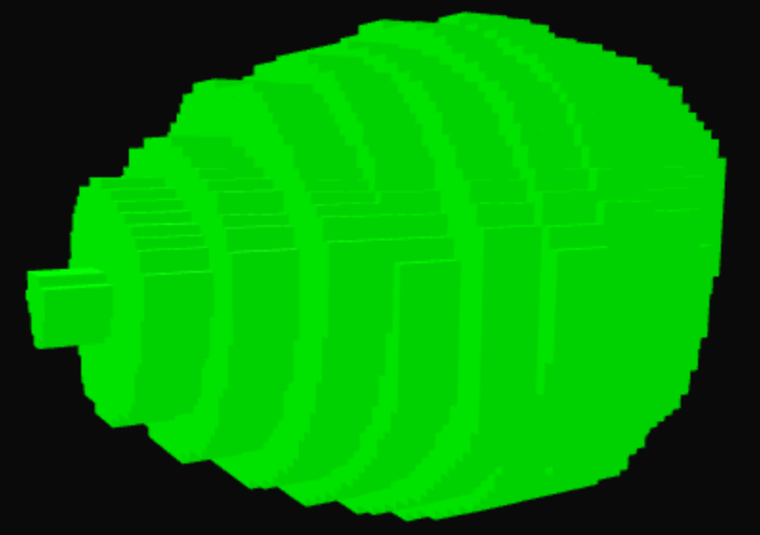
ACDC_Shift 5 (1) Patient 131 ED
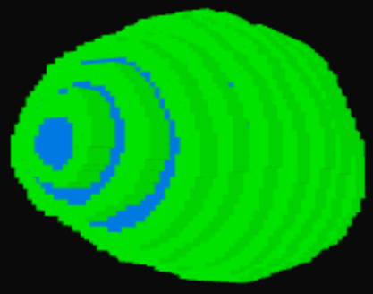

Cases with apex missing but without slice misalignment
ACDC_Shift 5 (1) Patient 013 ED

The apex is not shape enough; judging from the rate of cross-sectional area reduction from slice to slice, it can be inferred that the lowest slice did not reach its minimum achievable area
ACDC_Shift 5 (1) Patient 079 ED

One more slice is expected at the apex, consisting of only a thin rim of myocardium with no visible chamber
ACDC_Shift 5 (1) Patient 054 ED

The lowest apical slice appears small enough, yet it may not reflect the true apex, possibly owing to scan-related factors
ACDC_Shift 5 (1) Patient 112 ED

After correction, the lowest slice contains only myocardium; however, based on the slice-to-slice trend, this slice should still retain a small cavity. This may result in apparent overestimation of the apical myocardial thickness
Cases with slice misalignment but without apex missing
ACDC_Shift 5 (1) Patient 126 ED
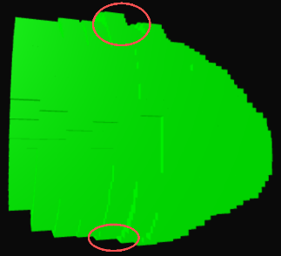
ACDC_Shift 5 (1) Patient 120 ED
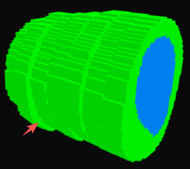
ACDC_Shift 5 (1) Patient 102 ED
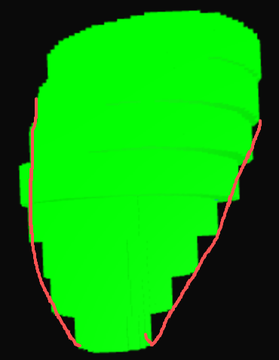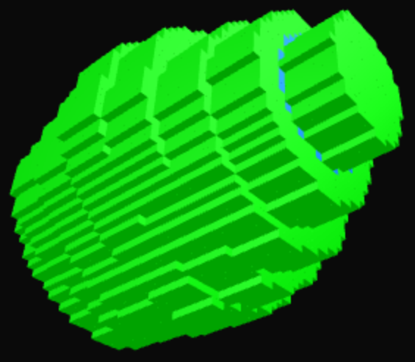
Almost all slices appeared mildly displacement in the same direction
ACDC_Shift 5 (1) Patient 132 ED

The apex appeared mild misalignment

Cases with both apex missing and slice misalignment
ACDC_Shift 5 (1) Patient 046 ED


