Simulation of the Trajectory of the Cassini Mission to Saturn and Beyond

Max Murmann

Supervisor: Dr Rajan Vepa

# Intro

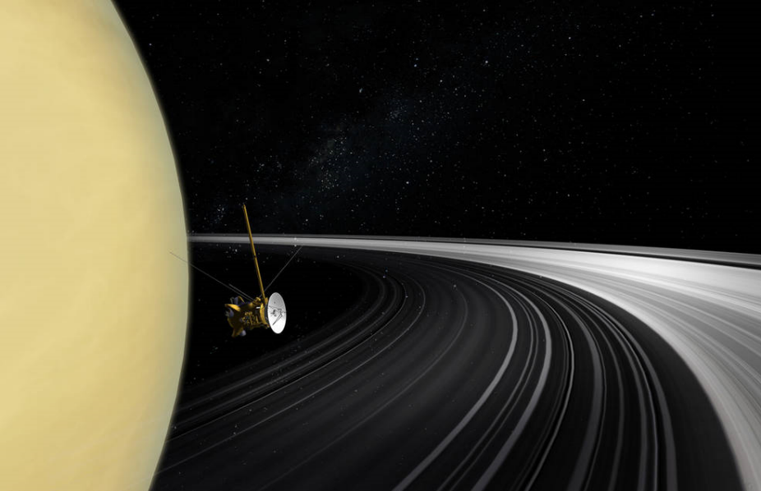

Figure 1. Artist's concept of the Cassini orbiter crossing Saturn's ring plane1

In 1997, the Cassini mission to Saturn launched from Cape Canaveral on top of a Titan IV launch stage. It performed an escape manoeuvre headed towards Venus, and proceeded to do gravity assists around Venus twice, Earth, and finally Jupiter before it had gained enough energy to be able to arrive at Saturn, after nearly 7 years of traveling in space. The mission lasted successfully for 13 more years in the Saturn system, before deliberately being crashed into the surface of Saturn.1

# Aims + Objectives

The aim of this project is to design an interplanetary trajectory to get from the Earth to Saturn through usage of gravity assists from the other planets. This trajectory will hopefully save fuel compared to just doing a Hohmann Transfer burn. The outcome that is found might not completely match the Cassini mission, and hopefully a few outcomes can be found. A computer program written in Python.

If fuel can be saved, then this can allow for either a smaller launch vehicle, which will reduce the cost of the mission, or allow for a larger spacecraft mass, which could mean more scientific payload.

# Gravity Assist

A gravity assist is a method of gaining orbital energy using the gravity well of another planet. The physics behind the assist are based around the spacecraft being accelerated by the planet it’s being assisted by, due to it falling into the gravity well. This gain in energy is matched by the planet, keeping the law of conservation of momentum accurate. However due to the large difference in mass of the planet, the acceleration of the planet is hardly measurable compared to the spacecraft, which can gain a very large amount of delta V3

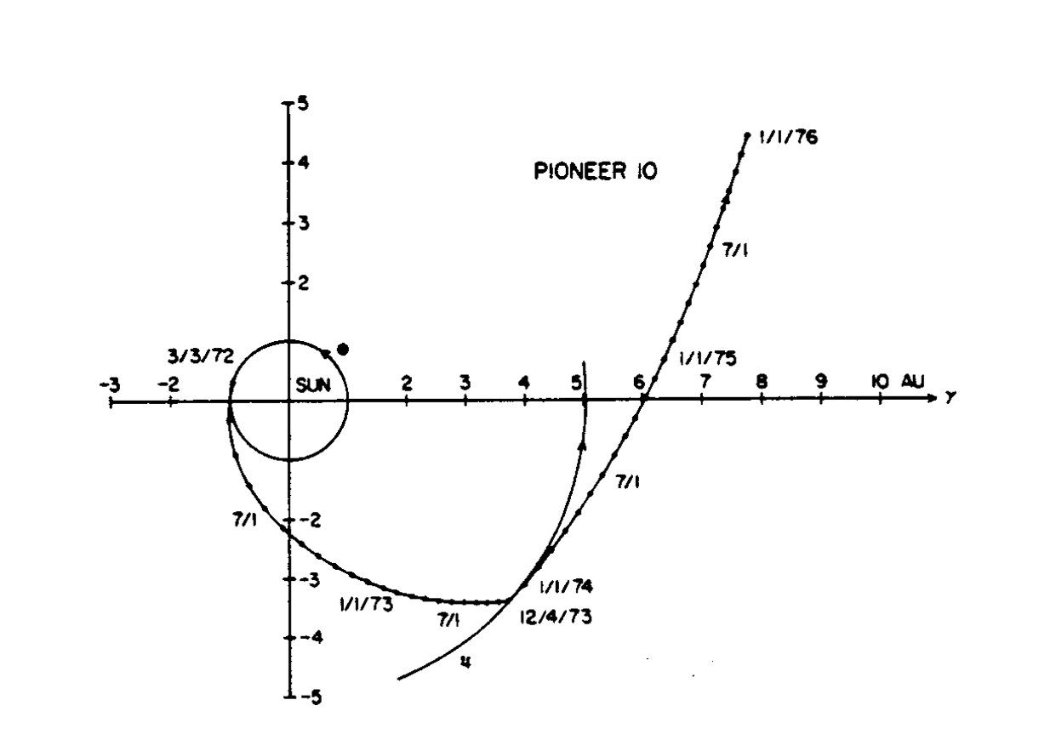

Figure 2. Demostration of a Gravity assist trajectory taken by Pioneer 10

# Method

The simulation will be built in Python. There are multiple libraries that exist within python to help with the creation of this simulation, for example astropy, which includes many of the required solar system constants. The simulation will use an n-body type calculation, however instead of the planets interacting with each other, they are on fixed paths following their orbits. This reduces the total accuracy of the program very slightly, however the planetary orbits are hardly affected by the spacecraft due to the low ratio between their masses.

Once an adequate simulation of the solar system is created (likely only including relevant planets), a system will be designed which will find acceptable trajectories. Due to the complexity of some of these trajectories, only the simpler solutions will be considered, mainly based around the actual trajectory followed by the Cassini probe. This will work off a trial and error basis.

# Expected Results

The expected results will come out with a trajectory that follows the Cassini mission, and will also show a significant drop in delta V requirements for the mission.

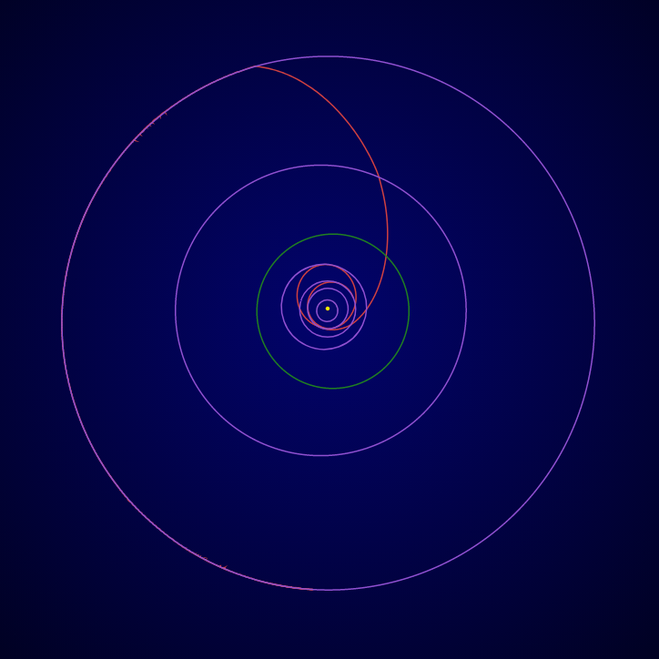

Figure 3. Cassini probe trajectory to Saturn2

# Discussion

These results will be a fairly good representation of the mission, however as it does make some significant assumptions, such as the planets being perfectly in plane and having circular orbits. This was done to reduce computing requirements due to the hardware being used. Future work could include altering the simulation to work in 3D and using a more realistic representation of the planetary locations, perhaps using the Python library “PyEphem” which can give accurate locations of the planets going back to any point.

# References

1. Greicius, T. (2019). *Cassini*. [online] NASA. Available at: https://www.nasa.gov/mission_pages/cassini/main/index.html [Accessed 5 Mar. 2019].
2. Theplanetstoday.com. (2019). *Cassini Spacecraft Flight Path*. [online] Available at: https://www.theplanetstoday.com/cassini_flight_path.html [Accessed 5 Mar. 2019].
3. Van Allen, J. (2002). Gravitational assist in celestial mechanics—a tutorial. American Association of Physics, 71(5), pp.448-451.