 | Министерство науки и высшего образования Российской Федерации  Федеральное государственное автономное образовательное учреждение  высшего образования  «Московский государственный технический университет  имени Н.Э. Баумана  (национальный исследовательский университет)»  (МГТУ им. Н.Э. Баумана)

ФАКУЛЬТЕТ «Информатика и системы управления» (ИУ)

КАФЕДРА «Информационная безопасность» (ИУ8)

Отчёт
по лабораторной работе № 8
по дисциплине «Алгоритмические языки»
Тема: «Файловая система. Сериализация.»

Выполнил: Варламов М. И.,
студент группы ИУ8-31

Проверил: Куликова А. В.

г. Москва, 2025 г.

1. Цель работы
Цель работы:
- Научиться работать с механизмом сериализации средствами языка C#.
- Научиться работать с файловой системой средствами языка C#.

2. Постановка задачи
Задание №1
Используя диаграмму классов из лабораторной работы №7, реализуйте поддержку сериализации и десериализации класса Animal.
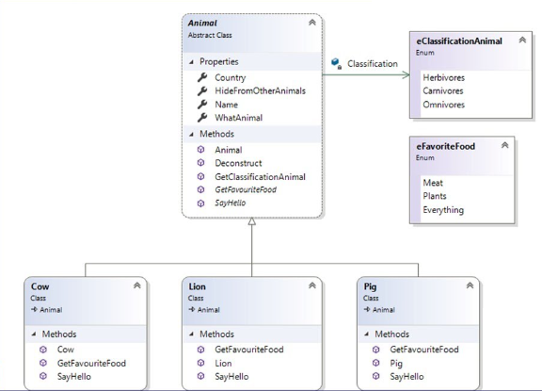
Создайте экземпляр класса-наследника Animal, инициализируйте все поля и выполните его Xml-сериализацию.
Добавьте в решение новый консольный проект, в котором десериализуйте класс Animal и выведите полученный объект на консоль.
Задание№2
Напишите приложение для поиска заданного файла во всех поддиректориях указанного пользователем пути.
Используйте FileStream для вывода содержимого файла на консоль.
Добавьте возможность сжатия найденного файла стандартными средствами .Net.

3. Ход работы
Задание 1.
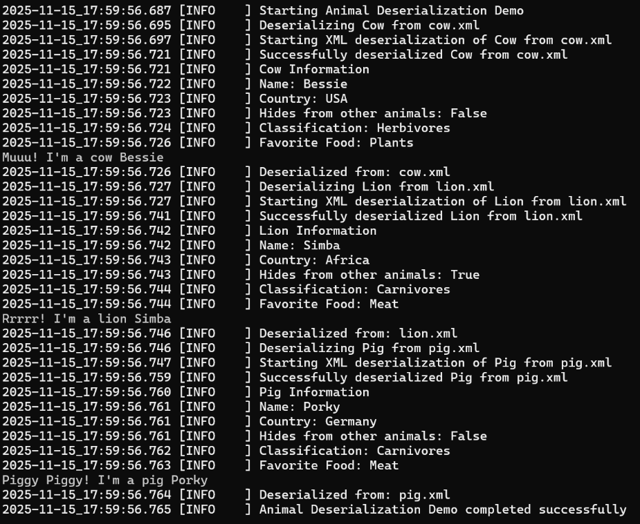
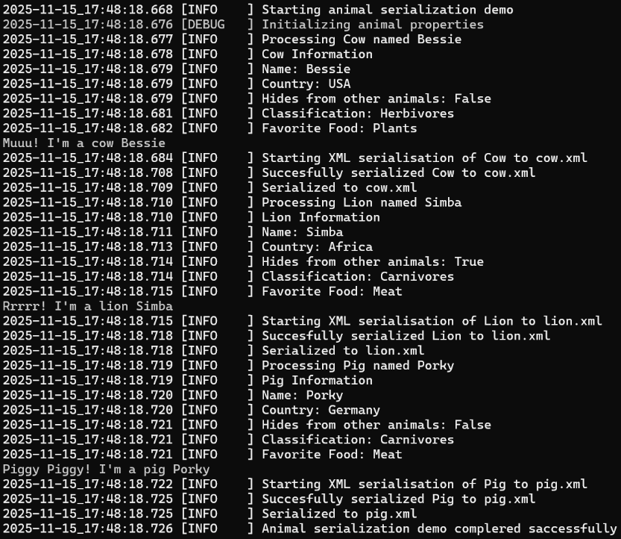
В данной работе был реализован свой класс сериализации и десериализации в XML файл, а также добавлен атрибут сериализации к классам библиотеки. Задача выполнена с помощью встроенных средства языка C#. Изменённые классы животных находятся в листинг 1, класс сериализации – листинг 2, программа сериализации – листинг 3, программа десирализации – листинг 4, xml файлы животных в листинг 5, 6 и 7, файлы логов в листинг 8 и 9.

Задание 2.
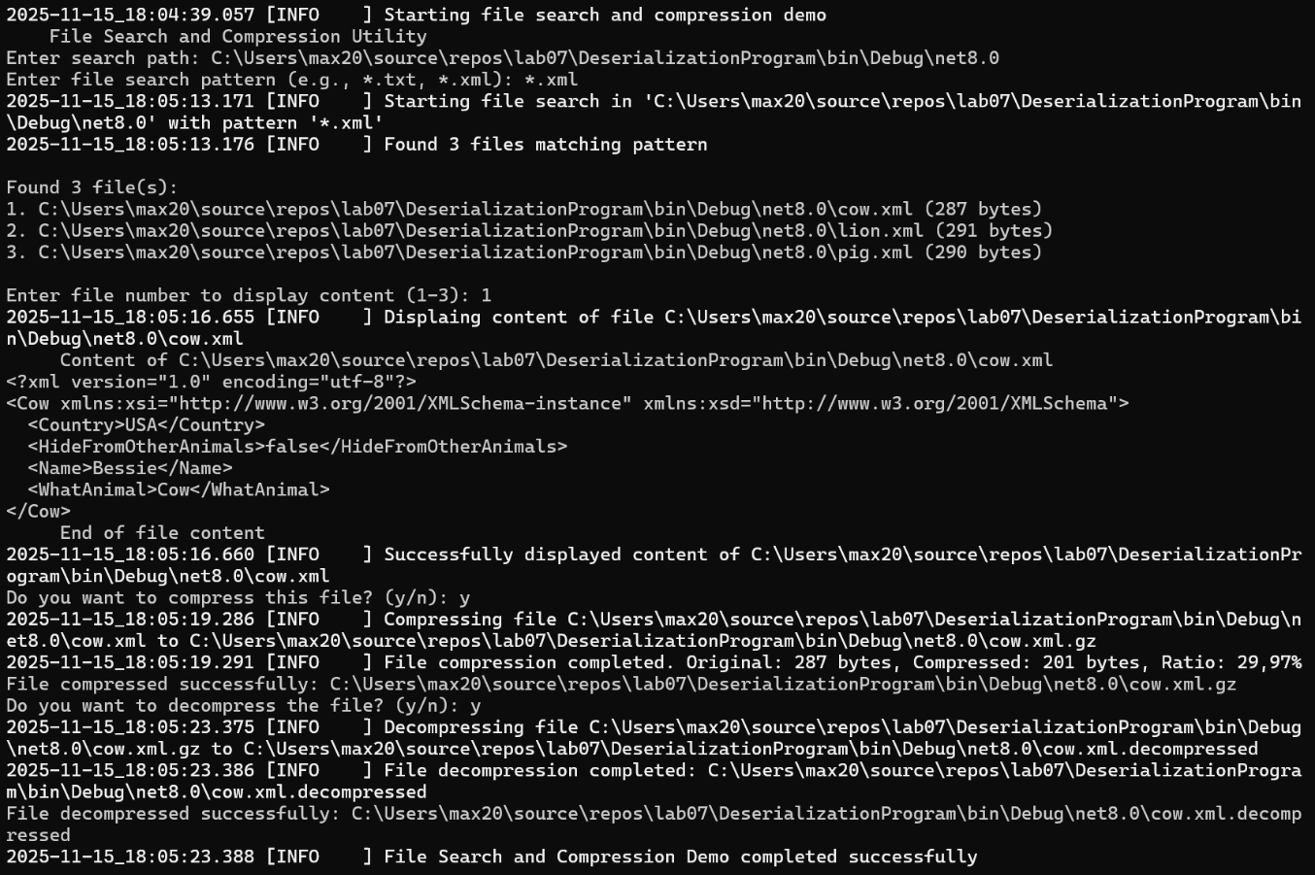
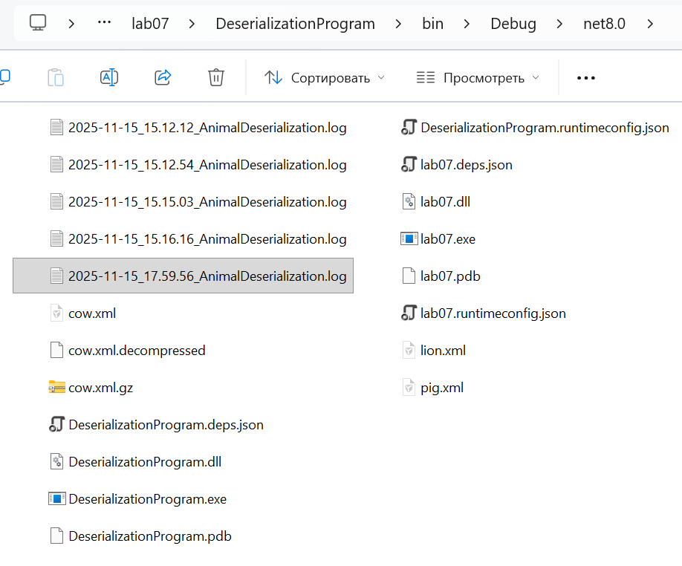
В данной работе был реализован свой класс, который искал в указанной директории и её поддиректориях файлы по указанным параметрам и мог архивировать и разархивировать файл в формат GZ. Код собственного класса находится в листинг 10, код функции Main в листинг 11, вывод логов – листинг 12.

4. Заключение
В ходе работы были получены навыки по сериализации и десериализации, по работе с файловой системой, а именно поиск файлов, работа с директориями и поддиректориями, а также способы архивирования и разархивирования файлов.

5. ПРИЛОЖЕНИЕ
Листинг 1 – изменённые классы животных
using System.ComponentModel.Design.Serialization;
using System.Xml.Serialization;

namespace AnimalLibrary
{
/// <summary>
/// Animal classification by feeding type
/// </summary>
[Serializable]
public enum ClassificationAnimal
{
Herbivores,
Carnivores,
Omnivores
}

/// <summary>
/// Favorite food of animals
/// </summary>
[Serializable]
public enum FavoriteFood
{
Meat,
Plants,
Everything
}

/// <summary>
/// Attribute for adding comments to classes and methods
/// </summary>
[Serializable]
public class CommentAttribute : Attribute
{
/// <summary>
/// Comment text
/// </summary>
public string Comment { get; set; }

/// <summary>
/// Initializes a new instance of CommentAttribute
/// </summary>
/// <param name="comment">The comment text</param>
public CommentAttribute(string comment)
{
Comment = comment;
}
}

/// <summary>
/// Abstract base class for all animals
/// </summary>
[Serializable]
[XmlInclude(typeof(Cow))]
[XmlInclude(typeof(Lion))]
[XmlInclude(typeof(Pig))]
[Comment("Abstract base class for all animals")]
public abstract class Animal
{
/// <summary>
/// Country where the animal lives
/// </summary>
public string Country { get; set; }
/// <summary>
/// Whether the animal hides from other animals
/// </summary>
public bool HideFromOtherAnimals { get; set; }
/// <summary>
/// Name of the animal
/// </summary>
public string Name { get; set; }
/// <summary>
/// Type of animal
/// </summary>
public string WhatAnimal { get; set; }

/// <summary>
/// Default constructor for XML serialization
/// </summary>
protected Animal()
{
// Required for XML serialization
}

/// <summary>
/// Initializes a new instance of Animal
/// </summary>
/// <param name="country">Country where the animal lives</param>
/// <param name="hideFromOtherAnimals">Whether the animal hides from other animals</param>
/// <param name="name">Name of the animal</param>
/// <param name="whatAnimal">Type of animal</param>
protected Animal(string country, bool hideFromOtherAnimals, string name, string whatAnimal)
{
Country = country;
HideFromOtherAnimals = hideFromOtherAnimals;
Name = name;
WhatAnimal = whatAnimal;
}

/// <summary>
/// Deconstructs the animal into its components
/// </summary>
/// <param name="country">Country where the animal lives</param>
/// <param name="hideFromOtherAnimals">Whether the animal hides from other animals</param>
/// <param name="name">Name of the animal</param>
/// <param name="whatAnimal">Type of animal</param>
public void Deconstruct(out string country, out bool hideFromOtherAnimals, out string name, out string whatAnimal)
{
country = Country;
hideFromOtherAnimals = HideFromOtherAnimals;
name = Name;
whatAnimal = WhatAnimal;
}

/// <summary>
/// Gets the classification of the animal
/// </summary>
/// <returns>Animal classification</returns>
public abstract ClassificationAnimal GetClassificationAnimal();

/// <summary>
/// Gets the favorite food of the animal
/// </summary>
/// <returns>Favorite food</returns>
public abstract FavoriteFood GetFavoriteFood();

/// <summary>
/// Makes the animal say hello
/// </summary>
public abstract void SayHello();
}

/// <summary>
/// A class representing cows
/// </summary>
[Serializable]
[Comment("A class representing cows")]
public class Cow : Animal
{
/// <summary>
/// Default constructor for XML serialization
/// </summary>
public Cow() : base()
{
WhatAnimal = "Cow";
}

/// <summary>
/// Initializes a new instance of Cow
/// </summary>
/// <param name="country">Country where the cow lives</param>
/// <param name="hideFromOtherAnimals">Whether the cow hides from other animals</param>
/// <param name="name">Name of the cow</param>
public Cow(string country, bool hideFromOtherAnimals, string name)
: base(country, hideFromOtherAnimals, name, "Cow") { }

/// <summary>
/// Gets the classification of the cow
/// </summary>
/// <returns>Herbivores classification</returns>
public override ClassificationAnimal GetClassificationAnimal()
{
return ClassificationAnimal.Herbivores;
}

/// <summary>
/// Gets the favorite food of the cow
/// </summary>
/// <returns>Plants as favorite food</returns>
public override FavoriteFood GetFavoriteFood()
{
return FavoriteFood.Plants;
}

/// <summary>
/// Makes the cow say hello
/// </summary>
public override void SayHello()
{
Console.WriteLine("Muuu! I'm a cow " + Name);
}
}

/// <summary>
/// Class representing lions
/// </summary>
[Serializable]
[Comment("A class representing lions")]
public class Lion : Animal
{
/// <summary>
/// Default constructor for XML serialization
/// </summary>
public Lion() : base()
{
WhatAnimal = "Lion";
}

/// <summary>
/// Initializes a new instance of Lion
/// </summary>
/// <param name="country">Country where the lion lives</param>
/// <param name="hideFromOtherAnimals">Whether the lion hides from other animals</param>
/// <param name="name">Name of the lion</param>
public Lion(string country, bool hideFromOtherAnimals, string name)
: base(country, hideFromOtherAnimals, name, "Lion") { }

/// <summary>
/// Gets the classification of the lion
/// </summary>
/// <returns>Carnivores classification</returns>
public override ClassificationAnimal GetClassificationAnimal()
{
return ClassificationAnimal.Carnivores;
}

/// <summary>
/// Gets the favorite food of the lion
/// </summary>
/// <returns>Meat as favorite food</returns>
public override FavoriteFood GetFavoriteFood()
{
return FavoriteFood.Meat;
}

/// <summary>
/// Makes the lion say hello
/// </summary>
public override void SayHello()
{
Console.WriteLine("Rrrrr! I'm a lion " + Name);
}
}

/// <summary>
/// Class representing pigs
/// </summary>
[Serializable]
[Comment("A class representing pigs")]
public class Pig : Animal
{
/// <summary>
/// Default constructor for XML serialization
/// </summary>
public Pig() : base()
{
WhatAnimal = "Pig";
}

/// <summary>
/// Initializes a new instance of Pig
/// </summary>
/// <param name="country">Country where the pig lives</param>
/// <param name="hideFromOtherAnimals">Whether the pig hides from other animals</param>
/// <param name="name">Name of the pig</param>
public Pig(string country, bool hideFromOtherAnimals, string name)
: base(country, hideFromOtherAnimals, name, "Pig") { }

/// <summary>
/// Gets the classification of the pig
/// </summary>
/// <returns>Omnivores classification</returns>
public override ClassificationAnimal GetClassificationAnimal()
{
return ClassificationAnimal.Carnivores;
}

/// <summary>
/// Gets the favorite food of the pig
/// </summary>
/// <returns>Everything as favorite food</returns>
public override FavoriteFood GetFavoriteFood()
{
return FavoriteFood.Meat;
}

/// <summary>
/// Makes the pig say hello
/// </summary>
public override void SayHello()
{
Console.WriteLine("Piggy Piggy! I'm a pig " + Name);
}
}
}
Листинг 2 – XmlSerializer.cs
using AnimalLibrary;
using MyLogger;
using System;
using System.Collections.Generic;
using System.Linq;
using System.Text;
using System.Threading.Tasks;
using System.Xml.Serialization;

namespace AnimalSerialization
{
/// <summary>
/// Provides XML serialisation and desirialization functional for anumal objects
/// </summary>
public class AnimalXmlSerializer
{
private readonly Logger _logger;

/// <summary>
/// Initialize a new instance of AnimalXmlSerializer
/// </summary>
/// <param name="logger"></param>
public AnimalXmlSerializer(Logger logger) { _logger = logger; }

/// <summary>
/// Serialize Animal object to XML file
/// </summary>
/// <typeparam name="T">Type of Animal to serialize</typeparam>
/// <param name="animal">Animal object to serialize</param>
/// <param name="filePath">Path to output XML file</param>
public void SerializeToXml<T>(T animal, string filePath) where T: Animal
{
try
{
_logger.Info($"Starting XML serialisation of {typeof(T).Name} to {filePath}");

var serializer = new XmlSerializer(typeof(T));

using (var writer = new StreamWriter(filePath))
{
serializer.Serialize(writer, animal);
}

_logger.Info($"Succesfully serialized {typeof(T).Name} to {filePath}");
}
catch (Exception ex)
{
_logger.Error(ex, $"Failed to serialized {typeof(T).Name} to XML");
}
}

/// <summary>
/// Deserialize an Animal object from XML file
/// </summary>
/// <typeparam name="T">Type of Animal to deserialize</typeparam>
/// <param name="filePath">Path to input XML file</param>
/// <returns>Deserialized Animal object</returns>
public T DeserializeFromXml<T>(string filePath) where T: Animal
{
try
{
_logger.Info($"Starting XML deserialization of {typeof(T).Name} from {filePath}");

if (!File.Exists(filePath))
{
throw new FileNotFoundException($"XML file not found {filePath}");
}

var serializer = new XmlSerializer(typeof(T));

using (var reader = new StreamReader(filePath))
{
var animal = (T)serializer.Deserialize(reader);
_logger.Info($"Successfully deserialized {typeof(T).Name} from {filePath}");

return animal;
}
}
catch (Exception ex)
{
_logger.Error(ex, $"Failedto deserialize {typeof(T).Name} from XML");
throw;
}
}
}
}
Листинг 3
using AnimalLibrary;
using MyLogger;
using System;
using System.Collections.Generic;
using System.Linq;
using System.Text;
using System.Threading.Tasks;

namespace AnimalSerialization
{
/// <summary>
/// Main program class for animal serialization demonstration
/// </summary>
class SerializationProgram
{
/// <summary>
/// Main entry point for serialization demonstration
/// </summary>
static void Main()
{
var logger = new Logger(new LoggerConfig
{
WriteToConsole = true,
WriteToFile = true,
LogFilePath = $"{DateTime.Now:yyyy-MM-dd_HH.mm.ss}_AnimalSerialization.log",
MinLogLevel = LogLevel.DEBUG
});

try
{
logger.Info("Starting animal serialization demo");

var cow = new Cow("USA", false, "Bessie");
var lion = new Lion("Africa", true, "Simba");
var pig = new Pig("Germany", false, "Porky");

logger.Debug("Initializing animal properties");

var serializer = new AnimalXmlSerializer(logger);

SerializeAnimal(cow, "cow.xml", serializer, logger);
SerializeAnimal(lion, "lion.xml", serializer, logger);
SerializeAnimal(pig, "pig.xml", serializer, logger);

logger.Info("Animal serialization demo complered saccessfully");
}
catch (Exception ex)
{
logger.Error(ex, "Animal serialization demo failed");
}
}

/// <summary>
/// Serialize an animal and displays its ifromation
/// </summary>
/// <typeparam name="T">Type of animal</typeparam>
/// <param name="animal">Animal instance</param>
/// <param name="fileName">Output XML file name</param>
/// <param name="serializer">XML serializer instance</param>
/// <param name="logger">Logger instance</param>
static void SerializeAnimal<T>(T animal, string fileName, AnimalXmlSerializer serializer, Logger logger) where T: Animal
{
logger.Info($"Processing {animal.WhatAnimal} named {animal.Name}");

logger.Info($"{animal.WhatAnimal} Information");
logger.Info($"Name: {animal.Name}");
logger.Info($"Country: {animal.Country}");
logger.Info($"Hides from other animals: {animal.HideFromOtherAnimals}");
logger.Info($"Classification: {animal.GetClassificationAnimal()}");
logger.Info($"Favorite Food: {animal.GetFavoriteFood()}");

animal.SayHello();

serializer.SerializeToXml(animal, fileName);

logger.Info($"Serialized to {fileName}");
}
}
}
Листинг 4 – cow.xml
using AnimalLibrary;
using AnimalSerialization;
using MyLogger;

namespace AnimalDeserialization
{
/// <summary>
/// Main rpogram class for animal deserialization demostrate
/// </summary>
class DeserializationProgram
{
/// <summary>
/// Main entry point for deserialization demonstration
/// </summary>
static void Main()
{
var logger = new Logger(new LoggerConfig
{
WriteToConsole = true,
WriteToFile = true,
LogFilePath = $"{DateTime.Now:yyyy-MM-dd_HH.mm.ss}_AnimalDeserialization.log",
MinLogLevel = LogLevel.DEBUG
});

try
{
logger.Info("Starting Animal Deserialization Demo");

var serializer = new AnimalXmlSerializer(logger);

DeserializeAndDisplayAnimal<Cow>("cow.xml", serializer, logger);
DeserializeAndDisplayAnimal<Lion>("lion.xml", serializer, logger);
DeserializeAndDisplayAnimal<Pig>("pig.xml", serializer, logger);

logger.Info("Animal Deserialization Demo completed successfully");
}
catch (Exception ex)
{
logger.Error(ex, "Animal Deserialization Demo failed");
}
}
/// <summary>
/// Deserializes an animal and displays its information
/// </summary>
/// <typeparam name="T">Type of animal</typeparam>
/// <param name="fileName">Input XML file name</param>
/// <param name="serializer">XML serializer instance</param>
/// <param name="logger">Logger instance</param>
static void DeserializeAndDisplayAnimal<T>(string fileName, AnimalXmlSerializer serializer, Logger logger) where T : Animal
{
try
{
logger.Info($"Deserializing {typeof(T).Name} from {fileName}");

if (!System.IO.File.Exists(fileName))
{
logger.Warning($"XML file not found: {fileName}");
return;
}

var animal = serializer.DeserializeFromXml<T>(fileName);

logger.Info($"{animal.WhatAnimal} Information");
logger.Info($"Name: {animal.Name}");
logger.Info($"Country: {animal.Country}");
logger.Info($"Hides from other animals: {animal.HideFromOtherAnimals}");
logger.Info($"Classification: {animal.GetClassificationAnimal()}");
logger.Info($"Favorite Food: {animal.GetFavoriteFood()}");

animal.SayHello();

logger.Info($"Deserialized from: {fileName}");
}
catch (Exception ex)
{
logger.Error(ex, $"Failed to deserialize {typeof(T).Name} from {fileName}");
}
}
}
}
Листинг 5 – cow.xml
<?xml version="1.0" encoding="utf-8"?>
<Cow xmlns:xsi="http://www.w3.org/2001/XMLSchema-instance" xmlns:xsd="http://www.w3.org/2001/XMLSchema">
<Country>USA</Country>
<HideFromOtherAnimals>false</HideFromOtherAnimals>
<Name>Bessie</Name>
<WhatAnimal>Cow</WhatAnimal>
</Cow>
Листинг 6 – lion.xml
<?xml version="1.0" encoding="utf-8"?>
<Lion xmlns:xsi="http://www.w3.org/2001/XMLSchema-instance" xmlns:xsd="http://www.w3.org/2001/XMLSchema">
<Country>Africa</Country>
<HideFromOtherAnimals>true</HideFromOtherAnimals>
<Name>Simba</Name>
<WhatAnimal>Lion</WhatAnimal>
</Lion>
Листинг 7 – pig.xml
<?xml version="1.0" encoding="utf-8"?>
<Pig xmlns:xsi="http://www.w3.org/2001/XMLSchema-instance" xmlns:xsd="http://www.w3.org/2001/XMLSchema">
<Country>Germany</Country>
<HideFromOtherAnimals>false</HideFromOtherAnimals>
<Name>Porky</Name>
<WhatAnimal>Pig</WhatAnimal>
</Pig>

Листинг 8 - 2025-11-15_17.48.18_AnimalSerialization.log
2025-11-15_17:48:18.668 [INFO ] Starting animal serialization demo
2025-11-15_17:48:18.676 [DEBUG ] Initializing animal properties
2025-11-15_17:48:18.677 [INFO ] Processing Cow named Bessie
2025-11-15_17:48:18.678 [INFO ] Cow Information
2025-11-15_17:48:18.679 [INFO ] Name: Bessie
2025-11-15_17:48:18.679 [INFO ] Country: USA
2025-11-15_17:48:18.679 [INFO ] Hides from other animals: False
2025-11-15_17:48:18.681 [INFO ] Classification: Herbivores
2025-11-15_17:48:18.682 [INFO ] Favorite Food: Plants
2025-11-15_17:48:18.684 [INFO ] Starting XML serialisation of Cow to cow.xml
2025-11-15_17:48:18.708 [INFO ] Succesfully serialized Cow to cow.xml
2025-11-15_17:48:18.709 [INFO ] Serialized to cow.xml
2025-11-15_17:48:18.710 [INFO ] Processing Lion named Simba
2025-11-15_17:48:18.710 [INFO ] Lion Information
2025-11-15_17:48:18.711 [INFO ] Name: Simba
2025-11-15_17:48:18.713 [INFO ] Country: Africa
2025-11-15_17:48:18.714 [INFO ] Hides from other animals: True
2025-11-15_17:48:18.714 [INFO ] Classification: Carnivores
2025-11-15_17:48:18.715 [INFO ] Favorite Food: Meat
2025-11-15_17:48:18.715 [INFO ] Starting XML serialisation of Lion to lion.xml
2025-11-15_17:48:18.718 [INFO ] Succesfully serialized Lion to lion.xml
2025-11-15_17:48:18.718 [INFO ] Serialized to lion.xml
2025-11-15_17:48:18.719 [INFO ] Processing Pig named Porky
2025-11-15_17:48:18.719 [INFO ] Pig Information
2025-11-15_17:48:18.720 [INFO ] Name: Porky
2025-11-15_17:48:18.720 [INFO ] Country: Germany
2025-11-15_17:48:18.721 [INFO ] Hides from other animals: False
2025-11-15_17:48:18.721 [INFO ] Classification: Carnivores
2025-11-15_17:48:18.721 [INFO ] Favorite Food: Meat
2025-11-15_17:48:18.722 [INFO ] Starting XML serialisation of Pig to pig.xml
2025-11-15_17:48:18.725 [INFO ] Succesfully serialized Pig to pig.xml
2025-11-15_17:48:18.725 [INFO ] Serialized to pig.xml
2025-11-15_17:48:18.726 [INFO ] Animal serialization demo complered saccessfully

Листинг 9 - 2025-11-15_17.59.56_AnimalDeserialization.log
2025-11-15_17:59:56.687 [INFO ] Starting Animal Deserialization Demo
2025-11-15_17:59:56.695 [INFO ] Deserializing Cow from cow.xml
2025-11-15_17:59:56.697 [INFO ] Starting XML deserialization of Cow from cow.xml
2025-11-15_17:59:56.721 [INFO ] Successfully deserialized Cow from cow.xml
2025-11-15_17:59:56.721 [INFO ] Cow Information
2025-11-15_17:59:56.722 [INFO ] Name: Bessie
2025-11-15_17:59:56.723 [INFO ] Country: USA
2025-11-15_17:59:56.723 [INFO ] Hides from other animals: False
2025-11-15_17:59:56.724 [INFO ] Classification: Herbivores
2025-11-15_17:59:56.726 [INFO ] Favorite Food: Plants
2025-11-15_17:59:56.726 [INFO ] Deserialized from: cow.xml
2025-11-15_17:59:56.727 [INFO ] Deserializing Lion from lion.xml
2025-11-15_17:59:56.727 [INFO ] Starting XML deserialization of Lion from lion.xml
2025-11-15_17:59:56.741 [INFO ] Successfully deserialized Lion from lion.xml
2025-11-15_17:59:56.742 [INFO ] Lion Information
2025-11-15_17:59:56.742 [INFO ] Name: Simba
2025-11-15_17:59:56.743 [INFO ] Country: Africa
2025-11-15_17:59:56.743 [INFO ] Hides from other animals: True
2025-11-15_17:59:56.744 [INFO ] Classification: Carnivores
2025-11-15_17:59:56.744 [INFO ] Favorite Food: Meat
2025-11-15_17:59:56.746 [INFO ] Deserialized from: lion.xml
2025-11-15_17:59:56.746 [INFO ] Deserializing Pig from pig.xml
2025-11-15_17:59:56.747 [INFO ] Starting XML deserialization of Pig from pig.xml
2025-11-15_17:59:56.759 [INFO ] Successfully deserialized Pig from pig.xml
2025-11-15_17:59:56.760 [INFO ] Pig Information
2025-11-15_17:59:56.761 [INFO ] Name: Porky
2025-11-15_17:59:56.761 [INFO ] Country: Germany
2025-11-15_17:59:56.761 [INFO ] Hides from other animals: False
2025-11-15_17:59:56.762 [INFO ] Classification: Carnivores
2025-11-15_17:59:56.763 [INFO ] Favorite Food: Meat
2025-11-15_17:59:56.764 [INFO ] Deserialized from: pig.xml
2025-11-15_17:59:56.765 [INFO ] Animal Deserialization Demo completed successfully
Листинг 10 – FileSearcher.cs
using MyLogger;
using System;
using System.Collections.Generic;
using System.IO.Compression;
using System.Linq;
using System.Text;
using System.Threading.Tasks;

namespace FileSearchUtility
{
/// <summary>
/// Provides file search funstion with compression capabilities
/// </summary>
public class FileSearcher
{
private readonly Logger _logger;

/// <summary>
/// Initialize a new instance of FileSearcher
/// </summary>
/// <param name="logger">Logger instance for logging operations</param>
public FileSearcher(Logger logger) { _logger = logger; }

/// <summary>
/// Searches for files with specified pattern in directory and subdirectories
/// </summary>
/// <param name="searchPath">Root directory path to search in</param>
/// <param name="searchPattern">File search patter</param>
/// <returns>List of found file paths</returns>
public List<string> SearchFiles(string searchPath, string searchPattern)
{
var foundFiles = new List<string>();

try
{
_logger.Info($"Starting file search in '{searchPath}' with pattern '{searchPattern}'");

if (!Directory.Exists(searchPath))
{
_logger.Warning($"Search path does not exists {searchPath}");
return foundFiles;
}

foundFiles.AddRange(Directory.GetFiles(searchPath, searchPattern, SearchOption.AllDirectories));
_logger.Info($"Found {foundFiles.Count} files matching pattern");
}
catch (Exception ex)
{
_logger.Error(ex, "Error during file search operation");
}

return foundFiles;
}

/// <summary>
/// Display file content to console using FileStream
/// </summary>
/// <param name="filePath">Path of the file to display</param>
public void DisplayFileContent(string filePath)
{
try
{
_logger.Info($"Displaing content of file {filePath}");

if (!File.Exists(filePath))
{
_logger.Warning($"File not found {filePath}");
return;
}

using (var fileStream = new FileStream(filePath, FileMode.Open, FileAccess.Read))
using (var reader = new StreamReader(fileStream, Encoding.UTF8))
{
Console.WriteLine($" Content of {filePath}");
string? line;
while ((line = reader.ReadLine()) != null)
{
Console.WriteLine(line);
}
Console.WriteLine(" End of file content");
}

_logger.Info($"Successfully displayed content of {filePath}");
}
catch (Exception ex)
{
_logger.Error(ex, $"Failed to display content of file {filePath}");
}
}

/// <summary>
/// Compresses a file using GZip compression
/// </summary>
/// <param name="sourceFilePath">Path to the source file</param>
/// <param name="compressedFilePath">Path for the compressed file</param>
public void CompressFile(string sourceFilePath, string compressedFilePath)
{
try
{
_logger.Info($"Compressing file {sourceFilePath} to {compressedFilePath}");

if (!File.Exists(sourceFilePath))
{
throw new FileNotFoundException($"Source file not found: {sourceFilePath}");
}

using (var sourceStream = new FileStream(sourceFilePath, FileMode.Open, FileAccess.Read))
using (var targetStream = File.Create(compressedFilePath))
using (var compressionStream = new GZipStream(targetStream, CompressionMode.Compress))
{
sourceStream.CopyTo(compressionStream);
}

var originalSize = new FileInfo(sourceFilePath).Length;
var compressedSize = new FileInfo(compressedFilePath).Length;
var compressionRatio = (1 - (double)compressedSize / originalSize) * 100;

_logger.Info($"File compression completed. Original: {originalSize} bytes, Compressed: {compressedSize} bytes, Ratio: {compressionRatio:F2}%");
}
catch (Exception ex)
{
_logger.Error(ex, $"Failed to compress file: {sourceFilePath}");
throw;
}
}

/// <summary>
/// Decompresses a GZip compressed file
/// </summary>
/// <param name="compressedFilePath">Path to the compressed file</param>
/// <param name="decompressedFilePath">Path for the decompressed file</param>
public void DecompressFile(string compressedFilePath, string decompressedFilePath)
{
try
{
_logger.Info($"Decompressing file {compressedFilePath} to {decompressedFilePath}");

if (!File.Exists(compressedFilePath))
{
throw new FileNotFoundException($"Compressed file not found: {compressedFilePath}");
}

using (var sourceStream = new FileStream(compressedFilePath, FileMode.Open, FileAccess.Read))
using (var decompressionStream = new GZipStream(sourceStream, CompressionMode.Decompress))
using (var targetStream = File.Create(decompressedFilePath))
{
decompressionStream.CopyTo(targetStream);
}

_logger.Info($"File decompression completed: {decompressedFilePath}");
}
catch (Exception ex)
{
_logger.Error(ex, $"Failed to decompress file: {compressedFilePath}");
throw;
}
}
}
}
Листинг 11 – FileSearchProgram.cs
using MyLogger;

namespace FileSearchUtility
{
/// <summary>
/// Main program class for file search and compression demonstration
/// </summary>
class FileSearchProgram
{
/// <summary>
/// Main entry point for file search demonstration
/// </summary>
static void Main()
{
var logger = new Logger(new LoggerConfig
{
WriteToConsole = true,
WriteToFile = true,
LogFilePath = $"{DateTime.Now:yyyy-MM-dd_HH.mm.ss}_FileSearch.log",
MinLogLevel = LogLevel.DEBUG
});

try
{
logger.Info("Starting file search and compression demo");

var fileSearcher = new FileSearcher(logger);
Console.WriteLine(" File Search and Compression Utility");

Console.Write("Enter search path: ");
string searchPath = Console.ReadLine();

Console.Write("Enter file search pattern (e.g., *.txt, *.xml): ");
string searchPattern = Console.ReadLine();

if (string.IsNullOrWhiteSpace(searchPath))
{
searchPath = ".";
}

if (string.IsNullOrWhiteSpace(searchPattern))
{
searchPattern = "*.*";
}

List<string> foundFiles = fileSearcher.SearchFiles(searchPath, searchPattern);

if (foundFiles.Count == 0)
{
Console.WriteLine("No files found matching the specified criteria.");
logger.Info("No files found matching search criteria");
return;
}

Console.WriteLine($"\nFound {foundFiles.Count} file(s):");
for (int i = 0; i < foundFiles.Count; i++)
{
var fileInfo = new System.IO.FileInfo(foundFiles[i]);
Console.WriteLine($"{i + 1}. {foundFiles[i]} ({fileInfo.Length} bytes)");
}

Console.Write($"\nEnter file number to display content (1-{foundFiles.Count}): ");
if (int.TryParse(Console.ReadLine(), out int fileNumber) && fileNumber >= 1 && fileNumber <= foundFiles.Count)
{
string selectedFile = foundFiles[fileNumber - 1];

fileSearcher.DisplayFileContent(selectedFile);

Console.Write("Do you want to compress this file? (y/n): ");
string compressChoice = Console.ReadLine()?.ToLower();

if (compressChoice == "y" || compressChoice == "yes")
{
string compressedFile = selectedFile + ".gz";
fileSearcher.CompressFile(selectedFile, compressedFile);

Console.WriteLine($"File compressed successfully: {compressedFile}");

Console.Write("Do you want to decompress the file? (y/n): ");
string decompressChoice = Console.ReadLine()?.ToLower();

if (decompressChoice == "y" || decompressChoice == "yes")
{
string decompressedFile = selectedFile + ".decompressed";
fileSearcher.DecompressFile(compressedFile, decompressedFile);
Console.WriteLine($"File decompressed successfully: {decompressedFile}");
}
}
}
else
{
Console.WriteLine("Invalid file number selected.");
logger.Warning("User entered invalid file number");
}

logger.Info("File Search and Compression Demo completed successfully");
}
catch (Exception ex)
{
logger.Error(ex, "File Search and Compression Demo failed");
}
}
}
}
Листинг 12 - 2025-11-15_18.04.39_FileSearch.log
2025-11-15_18:04:39.057 [INFO ] Starting file search and compression demo
2025-11-15_18:05:13.171 [INFO ] Starting file search in 'C:\Users\max20\source\repos\lab07\DeserializationProgram\bin\Debug\net8.0' with pattern '*.xml'
2025-11-15_18:05:13.176 [INFO ] Found 3 files matching pattern
2025-11-15_18:05:16.655 [INFO ] Displaing content of file C:\Users\max20\source\repos\lab07\DeserializationProgram\bin\Debug\net8.0\cow.xml
2025-11-15_18:05:16.660 [INFO ] Successfully displayed content of C:\Users\max20\source\repos\lab07\DeserializationProgram\bin\Debug\net8.0\cow.xml
2025-11-15_18:05:19.286 [INFO ] Compressing file C:\Users\max20\source\repos\lab07\DeserializationProgram\bin\Debug\net8.0\cow.xml to C:\Users\max20\source\repos\lab07\DeserializationProgram\bin\Debug\net8.0\cow.xml.gz
2025-11-15_18:05:19.291 [INFO ] File compression completed. Original: 287 bytes, Compressed: 201 bytes, Ratio: 29,97%
2025-11-15_18:05:23.375 [INFO ] Decompressing file C:\Users\max20\source\repos\lab07\DeserializationProgram\bin\Debug\net8.0\cow.xml.gz to C:\Users\max20\source\repos\lab07\DeserializationProgram\bin\Debug\net8.0\cow.xml.decompressed
2025-11-15_18:05:23.386 [INFO ] File decompression completed: C:\Users\max20\source\repos\lab07\DeserializationProgram\bin\Debug\net8.0\cow.xml.decompressed
2025-11-15_18:05:23.388 [INFO ] File Search and Compression Demo completed successfully

