CPE333: Software Engineering

Topic

GitHub

Instructor

Aj. Suthep Madarasmi

Members

Mr. Maytas Tirachitman ID: 55070503437

Mr. Pitipat Buniam ID: 55070503429

Semester 2/2014

Computer Engineering Department

King Mongkut’s University of Technology Thonburi

User A (g241136) create repository named “GITHUB”

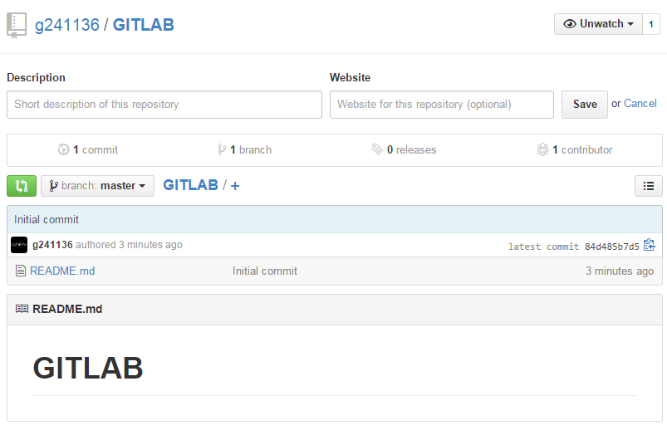

Add user B (g2411362) to repository

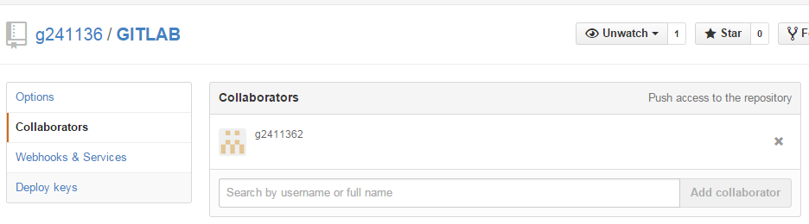

Initial and show status of user A

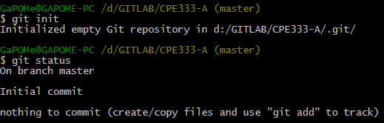

Initial and show status of user B

