MP BRT Shipping information via SOAP

This module allows you to check the status of the shipment of an order, receive the tracking and automatically set the status to DELIVERED.

Created by Massimiliano Palermo
MP Soft ©2021

Installation
Before installing the module, make sure that the SOAP libraries have been installed and activated otherwise the module will not work

Configuration
Once installed, click the configure button
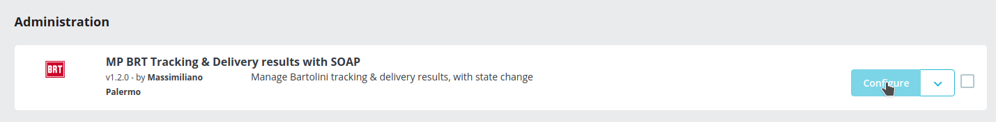

The configuration page looks like this:
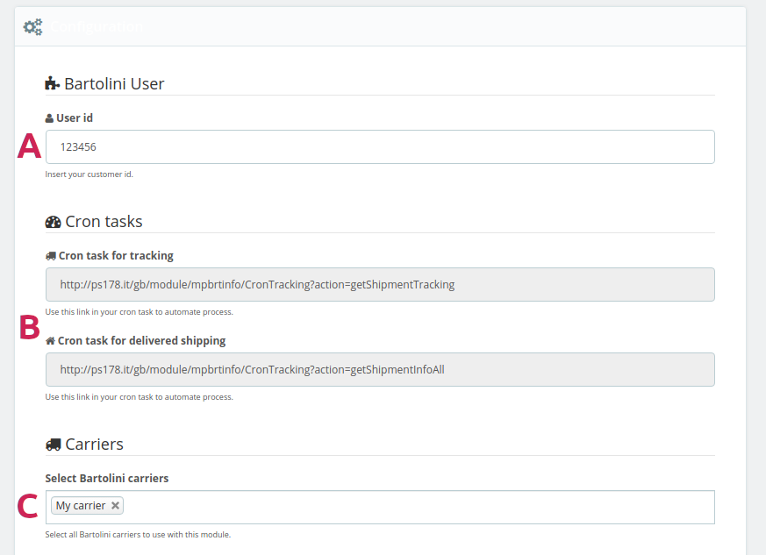
A: Enter your Bartolini customer ID here
B: These two links allow you to perform the operations automatically: Copy these links and insert them in your CRON TASK to automate the search for tracking and automatic delivery.
C: Select your Bartolini carriers, without this selection the module cannot woks correctly.

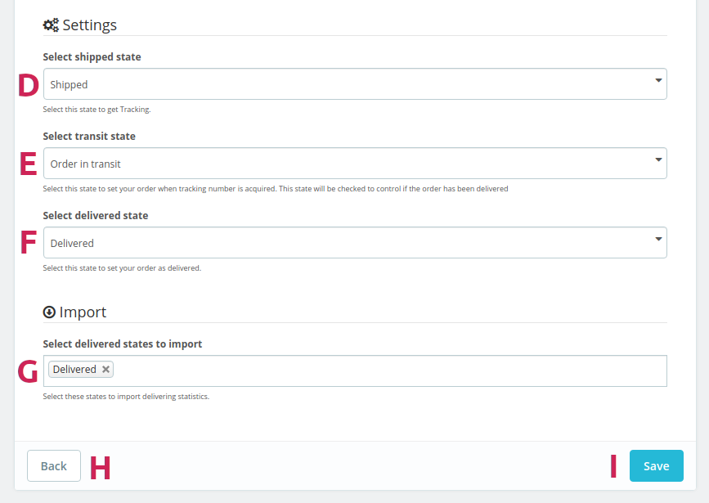
The form is based on a specific chronology of the order status:
1) The order has been taken over by Bartolini, he has not yet received the tracking. In this case, the order is in the BRT SHIPPED ORDER status (I recommend that you add these statuses to your status list for better management of the shipping history). This status is used by the module to be able to automatically search for shipment tracking. See Point D.

2) The order is in transit to its destination, has received tracking and information on the status of the shipment can be requested. The order is in the status ORDER IN TRANSIT BRT
If the shipment has arrived at its destination, the status DELIVERED can be automatically set.
See Point E.

3) The order has been delivered. You can still read the information regarding the shipment. In this case the order is in the BRT DELIVERED ORDER status. See point F.
Choose carefully these three states for the correct working of the module !!
G) Choose the order statuses that need to be imported to activate delivery statistics. Orders in that state and with Bartolini carrier will be imported into a new database table and will be part of the delivery statistics, where you can check the days elapsed from shipment to delivery of the package.

Use
On the order page, on the toolbar, new buttons will be displayed:
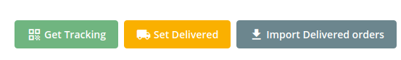
GET TRACKING: Through this button, all orders in the status SHIPPED with Bartolini carrier will be processed to search for Tracking. If found, the order will be updated with the tracking number and ORDER IN TRANSIT will be set. If the state provides for an email to be sent to the customer, an email will be sent with the tracking number and the link to the Bartolini website to receive information on the shipment. (This can be automated by placing the configuration page link in a cron task)
SET DELIVERED: Through this button, all orders in TRANSIT status with Bartolini courier will be processed to check if they have been delivered. In this case, the order is set to DELIVERED
IMPORT DELIVERED ORDERS: This procedure allows you to import all orders delivered by Bartolini carrier to get an overview of the delivery days of the packages. The statistics can be consulted via the appropriate page in the SHIPPING menu (MP Statistics delivered)

Information about shipping
On the order page, next to the order code, a new column is shown with icons that indicate the status of the order. By pressing these icons you can proceed to search for tracking, consult information on shipments or set the order to be delivered.
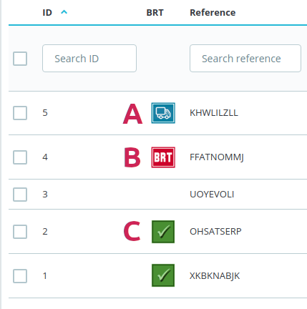

A: This icon indicates the SHIPPED status, by pressing on it you can search for the shipment tracking. If the tracking has been entered in Bartolini's archives, then the order will be updated with the tracking and the status will be set to IN TRANSIT.
B: This icon indicates the IN TRANSIT status. By clicking on it, you will be able to consult the status of the shipment and, if necessary, manually set the status to DELIVERED.
C: This icon indicates the DELIVERED status. Pressing on it will take you again to consult the history of the shipment.
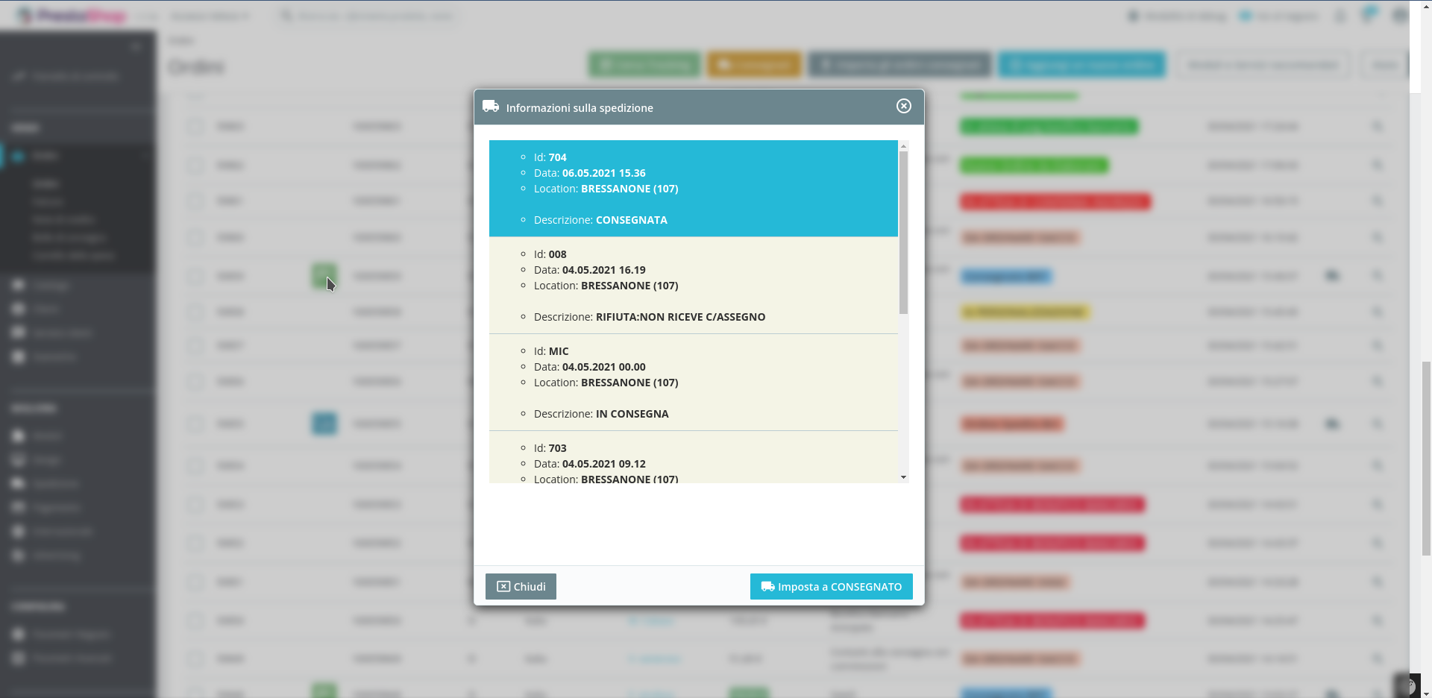Figure 1: Example of Order Shipping Status History. The box in BLUE indicates that the package has been delivered and therefore you can proceed, if necessary, to manually set the status of the order to DELIVERED (note that informations are processed in ITALIAN language)

Shipping statistics
From the shipping menu, select the MP BRT Delivery Statistics item
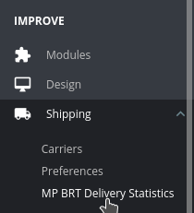

A page will open containing the list of shipments delivered and the days elapsed for delivery. Days are calculated as working days, so all calendar holidays are excluded. Working days are calculated according to the Italian holiday calendar.

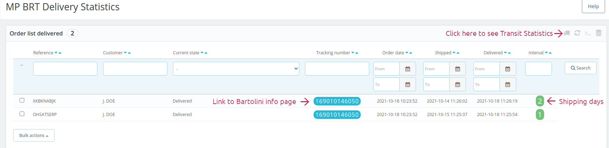
By clicking on the tracking, a new page of Bartolini's website will open containing the shipment history. Clicking on the truck icon in top right of toolbar menu, you can see another page with Transit statistics.

Conclusions
This module simplifies the management of shipments, by constantly monitoring the status of shipments. In addition, if you set up a cron task, the order delivery setting operation is performed automatically.

ATTENTION
Do not use the manual import button too often, because Bartolini has restrictions on the use of its API, excessive use could cause your BAN from the service.
The limits are:
• 3600 API calls per hour
• maximum 20 times the average number of shipments per day.
Remember that an API inquiry for a shipment may require multiple API calls.

