Introduction
Sometimes, you need to clean your Prestashop Database from unnecessary data, such as unused languages, old carriers, too much currencies that make just confusion in your e-commerce.
With this module, you can clan all these informations, leaving no trace in your database.
Be very careful to use this form, because it works at the database level, and could cause irreversible damage if used without knowing what you're doing.
Before using this form, it is recommended to make a whole backup of the database.

After installation, you can find Db Clean menu voice under Advanced parameters Tab.
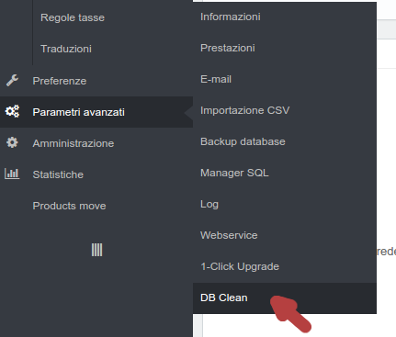

Language Tab
The language tab, permits to delete unnecessary languages from you database.
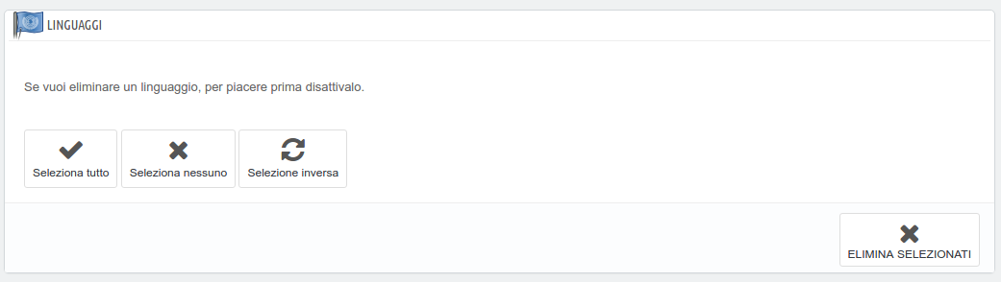
Before you can delete a language, you have to deactivate it in Languages administration page.
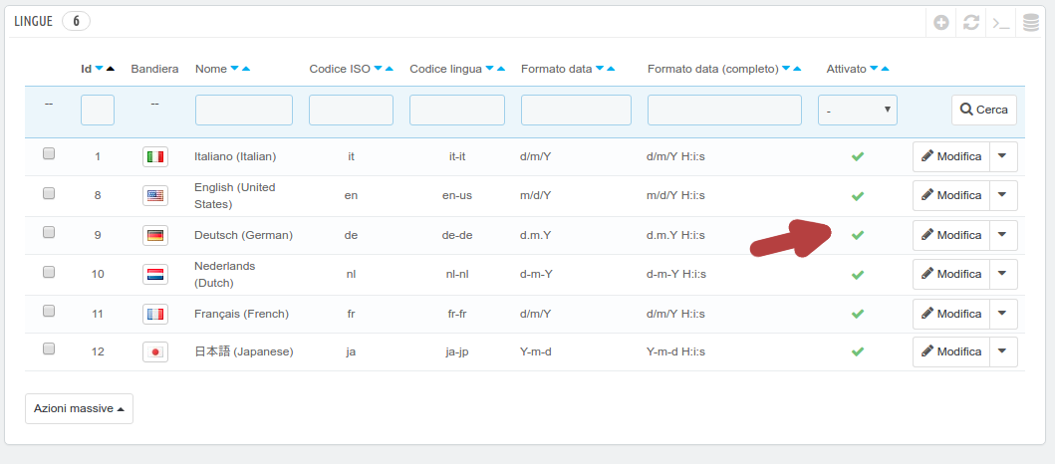
Click to deactivate
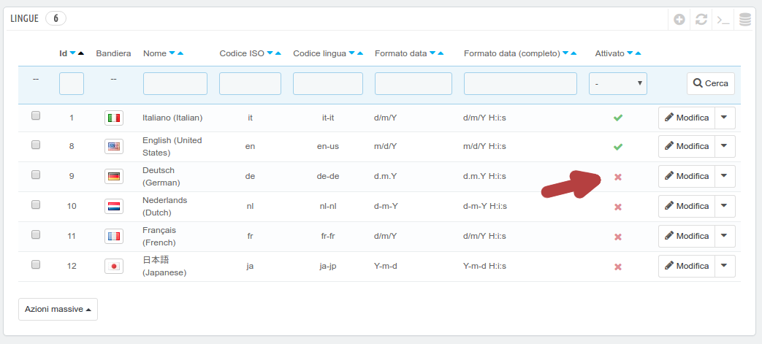
Now you can see deactivated languages in Language tab.
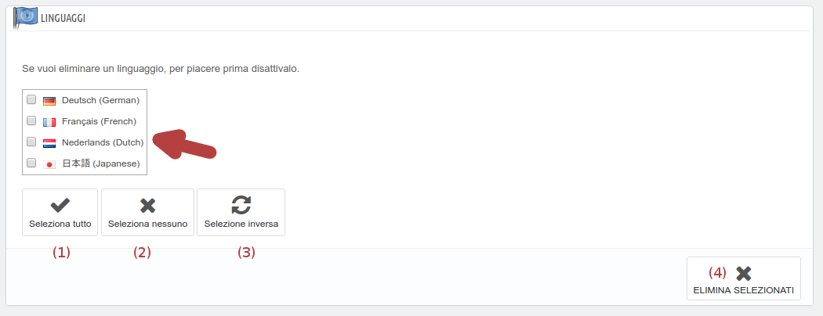
To select a language, click on the box on the left of the corresponding language.
(1) this button permits to select all languages in the box.
(2) this button permits to deselect all languages in the box.
(3) this button permits to invert selection in the box.
(4) press this button to delete selected languages.

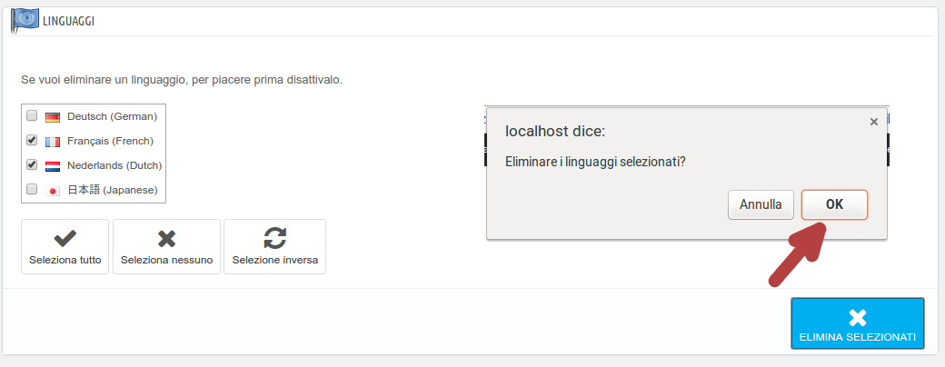
After confirmation, the module proceed to delete all information from database. This operation delete only language references from database. When you install a new localization in Prestashop, it install also other information such as taxes, currencies and more. If you want to reinstall a localization after deletion, be careful to check only translation option.
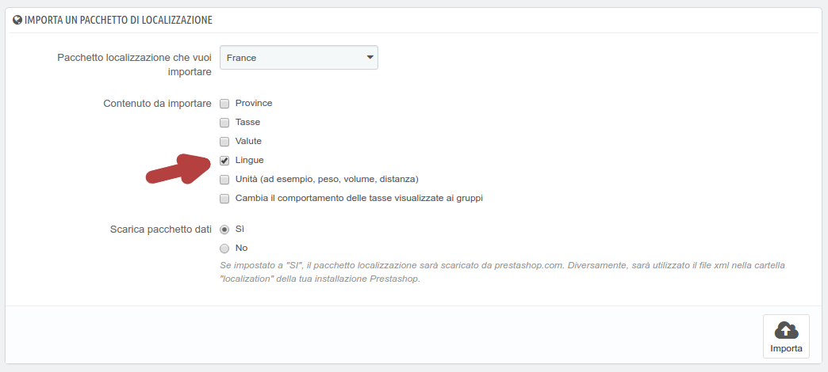
Once deleted, a message informs you of the success of the operation and the tab shows only the remaining languages.
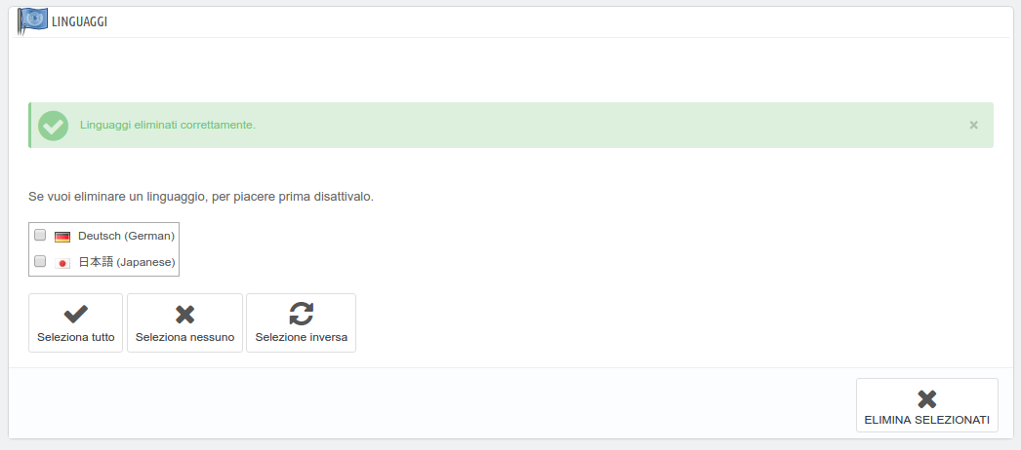

Carriers tab
The carriers tab, permits to delete unnecessary carriers from you database.
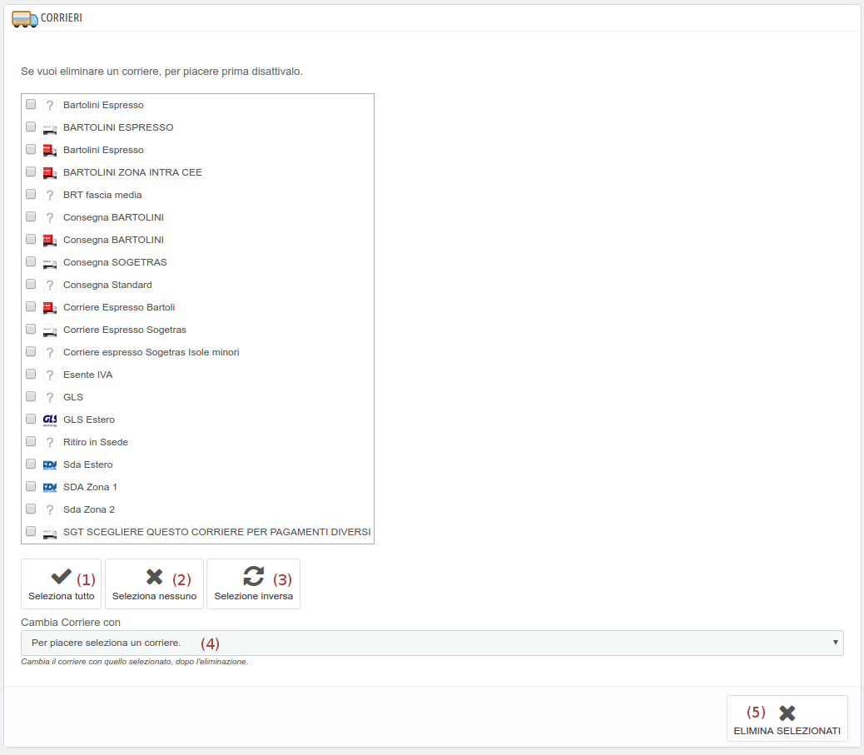
To select a carrier, click on the box on the left of the corresponding carrier.
(1) this button permits to select all carriers in the box.
(2) this button permits to deselect all carriers in the box.
(3) this button permits to invert selection in the box.
(4) press this button to change carrier after deletion. Since the deletion is permanent, the carriers eliminated will be replaced by the carrier selected, in all documents that are referenced. The operation can not continue if you do not select a replacement before delivery.
(5) press this button to delete selected carriers.

As you see before, to show carriers to delete, you have to deactivate them first from carriers page.
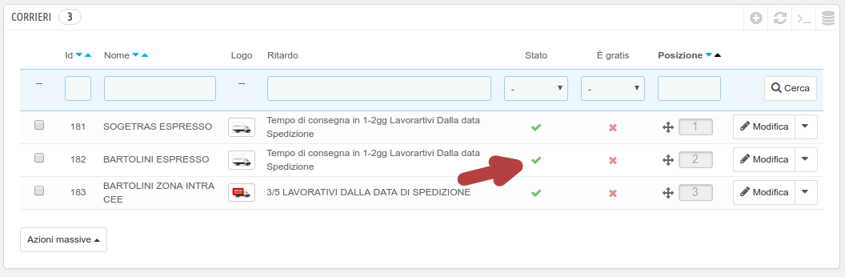

Currency tab
The currency tab, permits to delete unnecessary currencies from you database.
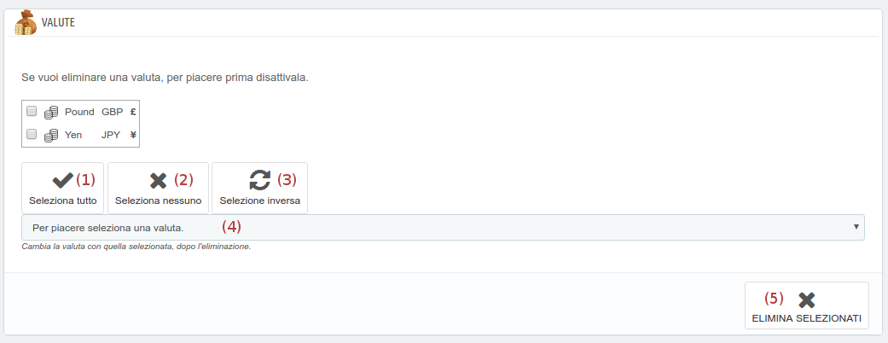
To select a currency, click on the box on the left of the corresponding currency.
(1) this button permits to select all currencies in the box.
(2) this button permits to deselect all currencies in the box.
(3) this button permits to invert selection in the box.
(4) press this button to change currency after deletion. Since the deletion is permanent, the currencies eliminated will be replaced by the currency selected, in all documents that are referenced. The operation can not continue if you do not select a replacement before delivery.
(5) press this button to delete selected currencies.
As you see before, to show carriers to delete, you have to deactivate them first from carriers page.
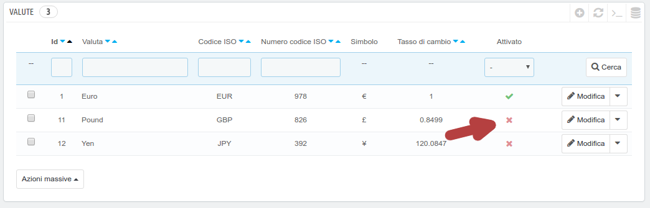
For info and request, please contact me to
info@mpsoft.it

