Logs

Trigonometry

$sin(A+B)=sin(A)cos(B)+sin(B)cos(A)$

$2sin(x)cos(x)=sin(2x)$

Different

$b^{x-y}=\frac{b^{x}}{b^{y}}$

$R-\{nπ: n an integer\}$

$\sqrt[x]{x}=1$

$|x|=\sqrt{x^{2}}$

Derivatives

$A_{f}(x)=\lim_{n→∞}f(x_{1})△x+...+f(x_{n})△x=\lim_{n→∞}\sum_{j=1}^{n}{}f(x_{j})△x=\int_{a}^{b}{}f(x)dx$

$△x=\frac{b-a}{n}$

$x_{i}=a+i△x$

$\sum_{j=m}^{n}{}{(a}_{j}±b_{j})=\sum_{j=m}^{n}{}a_{j}±\sum_{j=m}^{n}{}b_{j}$

$\sum_{j=m}^{n}{}{ca}_{j}=c\sum_{j=m}^{n}{}a_{j}$

$\sum_{j=m}^{n}{}c=c(n-m+1)$

$\sum_{j=1}^{n}{}j=\frac{n(n+1)}{2}$

$\sum_{j=1}^{n}{}j^{2}=\frac{n(n+1)(2n+1)}{6}$

$\sum_{j=1}^{n}{}j^{3}=\frac{n^{2}{(n+1)}^{2}}{4}$

$\int_{a}^{b}{}f(x)dx=-\int_{b}^{a}{}f(x)dx$

$\int_{a}^{a}{}f(x)dx=0$

$\int_{a}^{b}{}cdx=c(b-a)$

$\int_{a}^{b}{}f(x)dx=\int_{a}^{c}{}f(x)dx+\int_{c}^{b}{}f(x)dx$

$\int_{a}^{b}{}f(x)±g(x)dx=\int_{a}^{b}{}f(x)±\int_{a}^{b}{}g(x)$

$\int_{a}^{b}{}cf(x)dx =c\int_{a}^{b}{}f(x)dx$

$ICP\#1: if f(x)≥0 for xϵ(a,b) then \int_{a}^{b}{}f(x)dx≥0$

$ICP\#2: if f(x)≥g(x) then \int_{a}^{b}{}f(x)dx>\int_{a}^{b}{}g(x)dx$

$ICP\#3: if m≤f(x)≤M then m(b-a)≤\int_{a}^{b}{}f(x)dx≤M(b-a)$

$\int{}x^{n}dx=\frac{x^{n+1}}{n+1}+C, x≠-1$

$\int{}x^{-1}dx=ln|x|+C$

$\int{}e^{x}dx=e^{x}+C$

$\int{}cos(x)dx=sin(x)+C$

$\int{}sin(x)dx=-cos(x)+C$

$\int{}\sec^{2}(x)dx=tan(x)+C$

$\int{}sex(x)tan(x)dx=sec(x)+C$

$\int{}a^{x}dx=\frac{a^{x}}{lna}+C$

$\int{}\frac{1}{x^{2}+1}dx=arctan(x)+C$

$\int{}\frac{1}{\sqrt{x^{2}+1}}dx=arcsin(x)+C$

$\int{}f(x)dx=F(x)+C; general antiderivative == indefinite integral; F'(x)=f(x)$

$\int{}cf(x)dx=cF(x)+C$

$\int{}(f±g)(x)dx=(F±G)(x)+C$

$FTC1: \int_{a}^{b}{}f(x)dx=F(b)-F(a)=F(x)|_{a}^{b}$

$FTC2: \frac{d}{dx}(F(x))=f(x)$

Function inside integral - integrand

C - constant of integration

dx - variable of integration

$x_{n+1}=x_{n}+\frac{f(x_{n})}{f'(x_{n})}$

$\lim_{x→a}\frac{1}{x}-cscx=\lim_{x→a}\frac{sinx-x}{xsinx}==> l'Hopital's rule$

$\lim_{x→a}f(x)g(x)=\lim_{x→a}\frac{f(x)}{\frac{1}{g(x)}}=\lim_{x→a}\frac{g(x)}{\frac{1}{f(x)}}$

$\lim_{x→a}x=\lim_{x→a}e^{lnx}=exp(\lim_{x→a}lnx)$

$\lim_{x→∞}\frac{f(x)}{g(x)}=∞ ==> f(x) is faster growing ==> g<<f$

$\lim_{x→∞}\frac{g(x)}{f(x)}=0 ==> f(x) is faster growing ==> g<<f$

$x^{n}<<e^{x}, for any n$

$x^{n}<<a^{x}, for any n, a>1$

$\log_{a}x<<x^{n}, for any n, a>0$

$\frac{d}{dx}(c^{x})=c^{x}lnc$

$\frac{d}{dx}(|x|)=\frac{x}{|x|}$

$\lim_{x→-∞}\frac{x}{e^{-x}}=1$

$x^{2}=|x|$, if lim towards inf, then =x, else =-x

$\frac{∞}{∞}$ $⇒$ factor out fastest growing

$\frac{0}{0}$ $⇒$ simplify

$f'(a)=\lim_{x→a}\frac{f(x)-f(a)}{x-a}=\lim_{h→0}\frac{f(a+h)-f(h)}{h}$

${\log_{b}b^{x}=x=x\log_{b}b=e^{lnx}={lne}^{x} (x>0)}_{}^{}$

$f∘f^{-1}(x)=f^{-1}∘f(x)=x$

$\frac{d}{dx}(lna) ⇒ \frac{d}{dx}(ln|a|)$

$\lim_{x→0}\frac{sin(x)}{x}=\lim_{x→0}\frac{x}{sin(x)}=1$

$\lim_{x→0}\frac{cos(x)-1}{x}=0$

$\lim_{x→0}\frac{tan(x)}{x}=\lim_{x→0}\frac{x}{tan(x)}=1$

----------------------

Limits

$\lim_{x→a}c=c$

$\lim_{x→a}x=a$

$\lim_{x→a}(cf(x))=c(\lim_{x→a}f(x))$

$\lim_{x→a}(|f(x)|)=|\lim_{x→a}f(x)|$

$\lim_{x→a}(f(x)+-*/g(x))=(\lim_{x→a}f(x))+-*/(\lim_{x→a}g(x))$

$\lim_{x→a}{x^{3}=}^{}(\lim_{x→a}x)(\lim_{x→a}x^{2})=a^{3}$

$\lim_{x→a}{x^{n}=a^{n}}^{}$

$\lim_{x→a}{{{[f(x)]}^{n}}^{}{=(\lim_{x→a}f(x))}^{n}}^{}$

$\lim_{x→a}{{\sqrt[n]{f(x)}}^{}{={\sqrt[n]{(\lim_{x→a}f(x)}}^{}}^{}}^{}$

$Log(x)=lg(x)=\log_{10}x=logx$

${\log_{b}b^{x}=x=x\log_{b}b=e^{lnx} (x>0)}_{}^{}$

Functions

Vertical mirroring: f(-x)

Horizontal mirroring: -f(x)

Numerator / Denominator

Quadratic function: y=ax^2+bx+c

Exponential function y=b^x , never (0,0)

Logarithmic (inverse of exponential)

Point discontinuing __-__ (has lim)

Jump discontinuing __--- (no lim)

Asymmetric Discontinuing (or infinite sometimes)

Function solving steps:



Left continuous: lim-=f(x)

Right continuous: lim+=f(x)

Elementary functions: all that I ever knew

Non-elementary functions: piecewise function

Polynomial: $y=c_{n}x^{n}+c_{n}-1x^{n-1}+...+c_{1}x^{1}+c_{0}$, where c is coefficient

A polynomial: $f(x)=7x^{5}-x^{3}+\sqrt{2}x$

Not a polynomial:

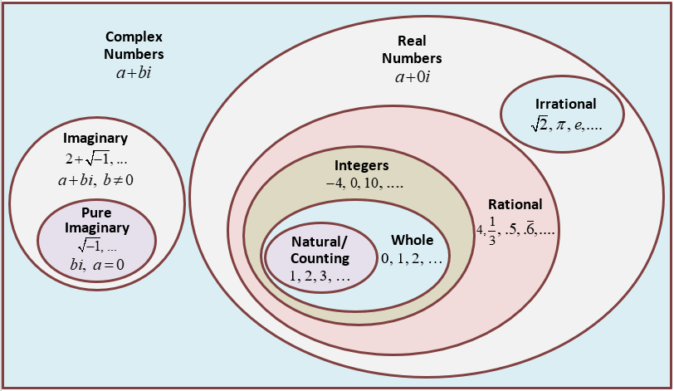



Manipulation of continuous functions results in a continuous, unless f(x)/d(x) and d(x)=0

Even root function is continuous at positive x

Odd root numbers are continuous at real numbers

sin and cos are always continuous. tan (sin/cos) and sec (1/cos) continuous except $\frac{π}{2}+nπ$ (when cos=0)

$y=n^{x}$ is an inverse of $y={\log_{2}^{x}}_{}$

${(x+2)}^{1}{x(-3)}^{1}=0$ (odd powers, so sign changes at the breakpoints

If piecewise function has division but x=0 is out of range, then ok

Always check the roots in $x_{1}+x_{2}=\frac{-b}{a}$ and $x_{1}*x_{2}=\frac{c}{a}$

Parabola min/max:

- constant multiple

- sum/difference

- product

- quotient

- composition

Basic functions

- constants

- powers

- exponentials

- logarithms

- trigonometric

- inverse trigonometric

$D(f(x))=E(f^{-1}(x))$

$E(f(x))=D(f^{-1}(x))$

Trigonometry

Different

DNE - does not exist

Always factor out the smallest

Geogebra.org

$\sqrt{a^{b}}={\sqrt{a}}^{b}$

Geometry

Sphere:

$V=\frac{4}{3}πr^{3}$

$S=4πr^{2}$

Cone:

$V=\frac{1}{3}πr^{2}h$

Derivatives

$V=\frac{f(x+0.1)-f(x-0.1)}{2*0.1}$ = velocity at f(x)

- derivative of a derivative

- derivative of a derivative of a derivative

- derivative of a derivative n times



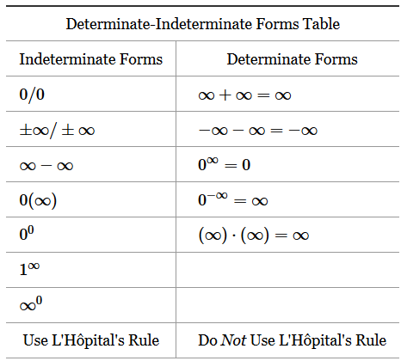

To find VA, search for $\frac{x}{0}$ and $\sqrt{-x}$

To find HA, search for and 

Explicit function: y=f(x)

Implicit function: $x^{2}+y^{2}=9$…

$x^{2}=|x|$, if lim towards inf, then =x, else =-x

|  |  |  |  |
| --- | --- | --- | --- |
| Quantity | Symbol | Calculus | Units |
| Distance | s(t) |  | distance |
| Velocity | v(t) | =s’(t) | distance/time |
| Acceleration | a(t) | =v’(t)=s’’(t) | distance/time2 |
| Jerk | j(t) | =a’(t)=v’’(t)=s’’’(t) | distance/time3 |

Finding HA: fill in > deterministic/irr > try left and right > simplify/fold

If $f''(x)>0$ on (a,b) then f is concave up on (a,b), and opposite

Decreasing/Increasing(if odd, sign change)



Concave up/down







If plug in x and y, then get y’ sign

If y is positive, then y’’ is positive (concave up)

$\frac{d}{dx}(lnf(x))=\frac{f'(x)}{f(x)}$

$\frac{d}{dx}(y=arcsin(x)) ⇒\frac{d}{dx}(sin(y)=x)$

* If f is continuous and differentiable at [a,b] and f(a)=f(b), then there exists a point c, where f’(c)=0
* If f(x) is continuous at [a,b], then there is an absolute minimum at f(c) and absolute maximum f(d), where c and d are in [a,b]
* If f(c) is a local maximum or local minimum, then f’(c)=0

- real change

dx and dy - approximate change

$\frac{dy}{dx}=f'(a)$

$f'(a)dx=dy=f'(a)△x=df≈△f=△y=f(a+△x)-f(a)=f(x)-f(a)$

Absolute points finder:

Finder critical of f’

Add boundaries of local

Find max and min among x value