SOFTWARE FACTORY
ARCHITECTURE
3 Athena Instances · Skill-Based Agent Swarm · Self-Improving Pipeline
Stack: OpenClaw + lossless-claw + Instinct8 + tree-sitter + Ralph Loop + Linear
Applied to: Athena Digital SF-2026-02 · March 2026
1. Three Athena Instances
One OpenClaw agent per domain. Same architecture, different missions. Each spawns its own PM tree. They share artifacts through a /shared/ folder with manual human verification: ideation research goes from todo to done, human copies what's useful into shared, PM picks up from there.

Instance | In / Out | Core Tools | Handoff
Athena-Ideation | Rising trends in → Opportunity briefs out | Gummy Search API (Reddit, YouTube, X). Scores: rising vs stable vs declining. | Done items saved. Human copies useful ones to /shared/.
Athena-Build | Spec in → Deployed PR out | OpenClaw, lossless-claw, Instinct8, tree-sitter, Ralph loop, Linear. | PM reads from /shared/. Assigns to skill-based agents.
Athena-Marketing | Shipped feature in → Distribution out | Vevo (video), Latedev (autopost), Claude ext + Comet browser. | 2-agent loop: Planner writes, Verifier checks. Loop until 10/10.

Linear structure: 1 workspace, 3 teams (Ideation, Build, Marketing). Human has full visibility: Product → Projects → Epics (features) → Sprints → Tasks. This hierarchy is version-controlled alongside the agent worktree (see Section 5).
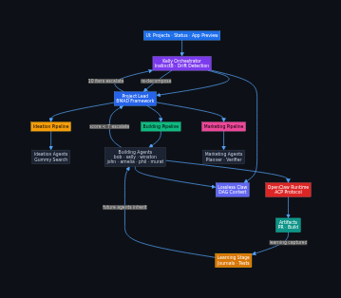
2. Build Phase: Skill-Based Agent Hierarchy
Agents are named by their skill, not generic "worker" labels. Each agent type has specific capabilities, boundaries, and a defined relationship with other agent types.

2.1 Chain of Command
Level | Agent | Responsibility | Key Rule
L0 | Athena-Build | Orchestrates all PMs. Interviews human (GSD-style). Generates specs. Has access to all PM agents. | If Athena pauses, ALL subagents pause (cascade). Only agent that talks to human.
L1 | PM | Decomposes project into sprints/tickets. Researches frameworks (trending vs stable). Assigns skill-agents to tickets. Decides quality gate: 9/10 or 10/10. | PM sets the stop quality. Usually 9/10 minimum. Going from 8.5→10 takes more iterations than 1→8.
L2 | Architect | Designs system structure. Defines interfaces between components. Makes technology decisions with PM's framework research. | Produces architecture doc that all other agents reference. Version-controlled.
L2 | Engineer | Writes code. Executes implementation tickets. Runs in Ralph loop. Uses convention map from tree-sitter. | Can only be called by QA or PM. Iterates on QA feedback in batches, not one-off fixes.
L2 | UI Agent | Frontend specialist. React components, styling, accessibility. Uses existing component conventions. | Same rules as Engineer but scoped to frontend. References design system from codebase intel.
L2 | QA | Reviews ALL engineer/UI output. Collects ALL problems first, then calls Engineer/UI to iterate in one batch. Uses Instinct8 metrics. | QA finds ALL problems before calling Engineer. No one-at-a-time feedback. Batch everything.
L2 | Repair | Activated on drift (evaluator < 7 twice). Patches agent context, re-aligns with plan. Can kill and respawn any agent. | Only appears when needed. Disappears when drift is corrected.

2.2 The QA → Engineer Flow
This is the core quality mechanism. QA does NOT give piecemeal feedback. The flow is:

Step 1: Engineer completes ticket, self-evals, CI passes.

Step 2: QA receives ALL completed tickets for the phase. QA reviews everything. Collects every problem across all tickets into a single batch report.

Step 3: QA calls Engineer with the full batch. Engineer iterates on ALL issues at once. This prevents the ping-pong of fix-one-break-another.

Step 4: QA re-reviews. If new problems found, repeat steps 2-3. If clean, QA scores against plan (Instinct8 metrics).

Step 5: PM makes the final call: ship at 9/10 or demand 10/10. PM understands that the last 1.5 points (8.5→10) often cost more iterations than the first 8 points. This is a deliberate trade-off decision, not an automatic gate.
3. Ralph Loop with PM Quality Gates
Every skill-agent runs inside a Ralph loop. But the PM controls when to stop iterating. The triple consensus (self-eval + CI + QA) provides the score; the PM decides the threshold.

# | Step | Detail
1 | Execute | Skill-agent (Engineer, UI Agent, Architect) works on the ticket. Uses skills.md constraints, convention map, ticket context. lossless-claw persists context across iterations.
2 | Self-Eval | Agent scores own work 1-10. Logs reasoning. If < 8, identifies gaps and loops immediately (no need to bother QA).
3 | CI/CD | Real CI in Docker: lint, typecheck, unit tests, integration tests. Binary pass/fail. Fail = re-loop with error context.
4 | QA Batch | QA collects ALL issues across all completed tickets. Scores each with Instinct8: goal coherence, constraint recall, behavioral alignment. Returns batch feedback.
5 | Engineer Iterates | Engineer fixes all QA issues in one iteration. Not one-at-a-time. Full batch. Then back to step 2.
6 | PM Decision | PM sees the score. Decides: ship at 9/10 (good enough for this sprint) or demand 10/10 (critical path, needs perfection). PM understands diminishing returns.
7 | Drift Check | If QA score < 7 for 2 consecutive rounds, Repair agent activates. Patches context, re-aligns, may kill/respawn the agent.
8 | Escalate | 10 iterations without PM-acceptable quality → escalate to Athena → human input. Re-decompose ticket or change approach.

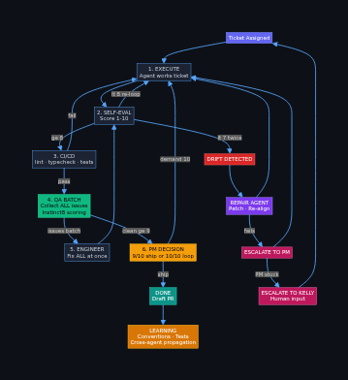
4. Dimension 1: File System
Two folder trees. Tree A = hierarchy (who reports to whom, reflects the worktree view). Tree B = agent identity (skills, learning, logs, tasks).

4.1 Hierarchy Tree
Path | Purpose
.factory/ | Root factory directory
athena-build/ | Athena-Build instance
pm-{project}/ | PM agent per project
architect/ | Architect agent (designs structure)
engineers/{ticket}/ | Engineer agent per backend ticket
ui-agents/{ticket}/ | UI Agent per frontend ticket
qa/ | QA agent (batch reviewer)
repair/ | Repair agent (on-demand)
athena-ideation/ | Separate instance, same structure
athena-marketing/ | Separate instance, same structure
/shared/ | Cross-Athena artifact folder. Human-curated.

4.2 Agent Identity Tree
Path | Purpose
.agents/{agent-id}/ | One folder per agent instance
skills.md | CAN do / CANNOT do / ESCALATES TO. Pre-approved scripts.
learning/journal.md | What worked, what failed, conventions discovered.
learning/tests/ | Assertions future agents must pass. Self-improving.
logs/{run-id}.log | Full execution log per Ralph iteration.
tasks/current.json | Active Linear ticket reference.
tasks/history/ | Completed task summaries with scores.
scripts/ | Pre-approved bash only. No ad-hoc execution.
state.json | alive/working/paused/done, Ralph iteration #, current score.
5. Dimension 2: Worktree + Plan View
Two panels side by side. Left: agent worktree (who is doing what). Right: plan view (Product → Project → Epic → Sprint → Task). They stay in sync: when a worker finishes a task, the plan view updates. When a human changes a ticket in the plan view, the alignment propagates to the agent.

5.1 Worktree Panel (Left)
Live tree showing every active agent, their current task, and their decisions. Four buttons per agent:

Button | Behavior
⏸ Pause | Freezes this agent. If the agent has children, ALL children pause too (cascade). Other branches keep running. Click again to resume the whole subtree.
✎ Align | Opens text input. Human types new direction. A note is added to the ticket: "Human changed direction: [text]". The agent decides if this is an override or supplement to the current ticket. If it changes scope, agent updates the ticket in Linear.
▶ Expand | Shows decision log: 1 line per important decision the agent made. Not files, not diffs --- decisions. Each line appears in real-time. Done decisions get ✓. Active decision pulses.
⏹ Stop | Kills this specific agent. Work is NOT saved. The agent's parent (PM or Athena) takes human input on the next step for this ticket. Rest of the tree keeps running.

Cascade pause rule: If Athena-Build pauses, every PM, Engineer, QA, UI Agent, and Repair agent under it pauses. If a PM pauses, only its children pause. This is hierarchical --- pausing a leaf agent affects nothing else.

5.2 Plan View (Right)
The plan view mirrors the Linear hierarchy and is version-controlled. Every change to a ticket, sprint, or epic is logged.

Level | What It Shows | How It Changes
Product | Top-level: "Payments Dashboard" | Rarely changes. Set by Athena.
Project | e.g., "Payment Methods CRUD" | PM creates. Human can rename/re-scope.
Epic (Feature) | e.g., "API Layer", "Frontend", "Security" | PM decomposes. Can be split/merged by PM or human.
Sprint | Iteration boundary. Shows which tickets are in scope. | PM schedules. Tickets move between sprints based on progress.
Task (Ticket) | Individual work item. Shows: agent assigned, status, score, iteration count. | Updates in real-time as agents work. Human can change via Align button or directly in plan view.

Version control of plan: Every change to the plan (ticket created, ticket changed, epic re-scoped, human alignment) is logged with a timestamp, who changed it (agent or human), and what changed. This history is viewable in the plan view as a changelog. If a human changes a future ticket, the alignment propagates: affected agents see the change in their next iteration.

Sync between panels: When an Engineer finishes ticket PM-002, the worktree shows it as Done with ✓ and the plan view moves PM-002 to Done in the sprint. When QA finds issues, the plan view shows PM-002 back to "In Review" with QA score. When a human clicks Align on an agent in the worktree, the corresponding ticket in the plan view gets a note: "Human changed direction" with the text.
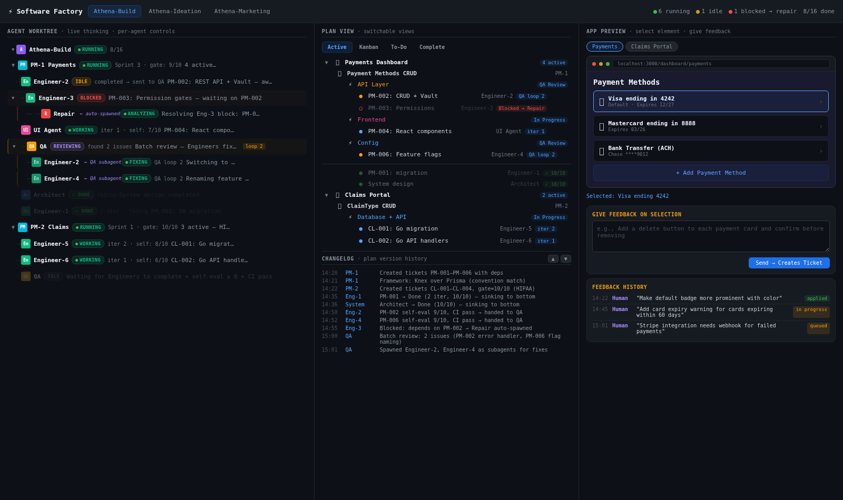
6. Technology Stack
Layer | Tool | Role
Agent Runtime | OpenClaw | 24/7 daemon. Runs all agents. ACP protocol for inter-agent messaging. Heartbeat for long tasks. Plugin architecture for all custom components.
Context Memory | lossless-claw | DAG-based persistent context. Agents retain full history across Ralph iterations. Cross-agent context sharing via shared memory nodes.
Goal Integrity | Instinct8 | Strategy F (protected core) ported into lossless-claw. QA agents use Instinct8 metrics for scoring. Goal coherence + constraint recall + behavioral alignment.
Codebase Intel | tree-sitter plugin | AST-based convention mapping per repo. Re-indexes on git push. Feeds convention context to every agent at generation time.
Orchestration | Ralph Loop | Iterate until PM-acceptable quality. Fresh context per iteration via lossless-claw snapshot/restore. QA batch feedback injected between iterations.
Project Tracking | Linear API | 1 workspace, 3 teams (Ideation, Build, Marketing). Every phase = ticket. Status driven by agents. Human has full Product → Task visibility.
CI/CD | Docker + project CI | Mirrors real CI. Runs lint, typecheck, tests in container. Binary gate in Ralph loop.
Trend Research | Gummy Search API | Reddit, YouTube, X search for rising trends. Athena-Ideation uses it. Results scored by velocity, relevance, competition.
Visibility | Worktree UI (HTML) | Live agent tree + plan view side by side. Pause/Align/Expand/Stop per agent. Like Claude Code subagent visibility but for OpenClaw.
9. Sources
OpenClaw: github.com/openclaw/openclaw
lossless-claw: github.com/Martian-Engineering/lossless-claw
Instinct8: github.com/jjjorgenson/instinct8
GSD: github.com/gsd-build/get-shit-done
Ralph Loop: github.com/snarktank/ralph
Ralph Multi-Agent: github.com/alfredolopez80/multi-agent-ralph-loop
Gummy Search: gummysearch.com
Linear API: linear.app/docs
Aider (tree-sitter): aider.chat
Case Study: Athena Digital SF-2026-02, Gauntlet, March 2026

