Muza de Cafe

*WHERE EVERY BREW TELLS A STORY*

A Midterm & Final Output Presented to the School of Computing

Holy Angel University



In Partial Fulfillment

of the Requirements for the Degree

School of Computing

Submitted to:

Mr. Chris Almocera

6INTROWEB/6WEBCS Instructor

Submitted by:

Quiambao, Maxene P.  
WD-201

September 2024

**DOCUMENTATION**

**Your website Purpose & Objectives**

This website purpose is to give important details regarding the location, best sellers, background of the cafe and hours of operation of the café. Additionally, the website has a review part where users can post comments, reviews, and their experiences. By doing this, the website seeks to provide users with a smooth and interesting experience, encouraging them to fall in love with Muza de Cafe and establish it as their favorite place in Concepcion, Tarlac.

**Objectives:**

1. **Inform and Engage**- give customers a thorough and interesting online experience by providing them with important information about the cafe's background, location, best sellers, and operating hours. As well, to have feedbacks from customers.
2. **Create Brand Loyalty**- encourage consumers to form a close emotional bond with Muza de Cafe in order to help them grow to love the cafe and make it their first choice when visiting Concepcion, Tarlac.

**Website Plan**

|  |  |
| --- | --- |
| Website Name & Tagline | Muza De Café (where every brew tells a story) |
| Purpose of the Website | The website’s aims to provide essential details about the cafe, including location, best sellers, background, and hours of operation. It also features a review section where users can share their experiences. |
| Target Audience | The target audience of this website are the coffee connoisseurs and food enthusiasts who are looking for a unique dining experience in Concepcion, Tarlac. |
| Graphics | Imagery – high quality and creative images of the place, drinks, and foods.  Videos – showcasing the café's exterior and the process of making coffee. |
| Color | Background color - #FFF8E7  Text color – (#5E0D16, #000000, #FFFFFF)  Footer – (#5E0D16, #000000)  Forms – (#D9D9D9, #000000, #5E0D16) |
| Accessibility | The website adapts well to different screen sizes, including mobile devices. This ensures that the website remains accessible across various devices. The font size is large enough to be easily read, even by users with low vision. |
| Project Timeline | Less than a month |

**Style Guide:**

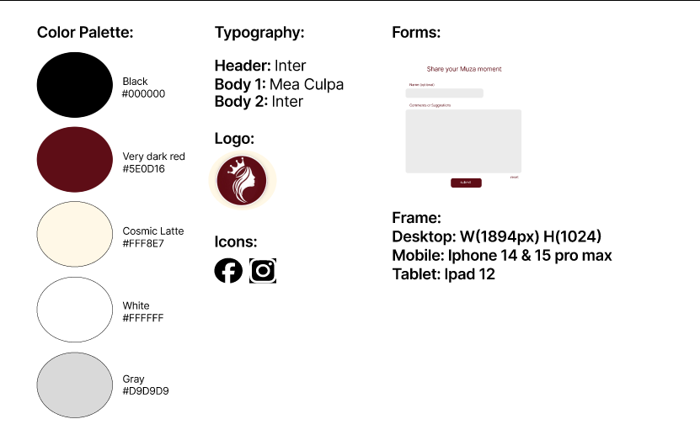

**Site Map/Diagram**

**Link:** **https://www.figma.com/design/GKJSTH7q0NOllvVHJE8nJW/sitemap%2Fstyleguide?node-id=0-1&t=KR5S2lMa1lkrJOpe-1**

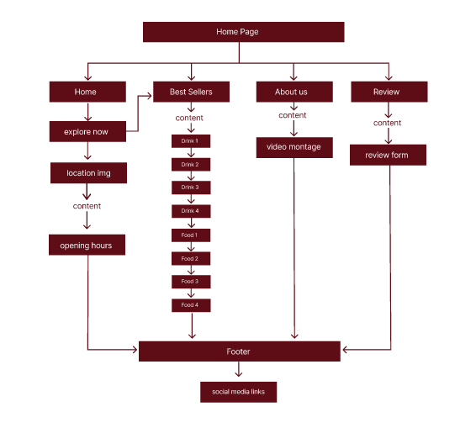

**Figma Mockup** (Link to your Mockup of different viewports. Make sure it’s viewable by the instructor)

**Link:** [**https://www.figma.com/design/EaB5gbBZDyW2GcMjrd2a8Q/QuiambaoMaxene_Mockup?node-id=53-42&t=NMnjCcpBaumLgahX-1**](https://www.figma.com/design/EaB5gbBZDyW2GcMjrd2a8Q/QuiambaoMaxene_Mockup?node-id=53-42&t=NMnjCcpBaumLgahX-1)

**Midterm: Proposed Website Design in Figma**

|  |  |  |  |  |
| --- | --- | --- | --- | --- |
| **Criteria and Percentage** | **4** | **3** | **2** | **1** |
| **CREATIVITY, AND DESIGN (20%)** | The web site has an exceptionally attractive and usable design. It is easy to locate all important elements. White space, graphic elements and/or alignment are used effectively to organize material. | The web site has an attractive and usable design. It is easy to locate most of the important elements. White space and/or alignment are used to organize material. | The web site has an attractive and usable design. It is easy to locate some of the important elements. White space and/or alignment are used to organize material | The web site is poor in design. It is hard to locate important elements. The material was not organized. |
| **COMPLETENESS (10%)** | All the necessary components that should be included are present. | Most of the necessary components that should be included are present. | Some of the necessary components that should be included are present. | None of the necessary components that should be included were present. |
| **CONTENT (15%)** | The site has a well- stated clear purpose and theme that is carried out throughout the site. | The site has a clearly stated purpose and theme but may have one or two elements that do not seem to be related to it. | The purpose and theme of the site is somewhat muddy or vague. | The site lacks a purpose and theme. |
| **GRAPHICS (15%)**  *Total (60) score is x40% for midterm output | Graphics are related to the theme/purpose of the site, are thoughtfully cropped, are of high quality and enhance reader interest or understanding. | Graphics are related to the theme/purpose of the site, are of good quality and enhance reader interest or understanding. | Graphics are related to the theme/purpose of the site and are of good quality. | The site lacks a purpose and theme. |

**Finals: Rubrics for Grading the Github Published Website**

|  |  |  |  |  |
| --- | --- | --- | --- | --- |
|  | **4** | **3** | **2** | **1** |
| **Content & Accuracy,**  **Spelling & Grammar (20%)** | The site has a well- stated clear purpose and theme that is carried out throughout the site.  All information provided by the student on the Web site is accurate and all the requirements of the assignment have been met.  There are no errors in spelling, punctuation, or grammar in the final draft of the Web site. | The site has a clearly stated purpose and theme but may have one or two elements that do not seem to be related to it.  Most of the information provided by the student on the Web site were accurate and most of the all requirements of the assignment have been met.  There are 1-3 errors in spelling, punctuation, or grammar in the final draft of the Web site. | The purpose and theme of the site is somewhat muddy or vague.  Some of the information provided by the student on the Web site were accurate and some requirements of the assignment have been met.  There are 4-5 errors in spelling, punctuation, or grammar in the final draft of the Web site. | The site lacks a purpose and theme.  All the information provided were not accurate and requirements of the assignment were not met.  There are more than 5 errors in spelling, punctuation, or grammar in the final draft of the Web site. |
| **Layout (15%)** | The Web site has an exceptionally attractive and usable layout. It is easy to locate all important elements. White space, graphic elements and/or alignment are used effectively to organize material. | The Web pages have an attractive and usable layout. It is easy to locate all important elements. | The Web pages have a usable layout but may appear busy or boring. It is easy to locate most of the important elements. | The Web pages are cluttered looking or confusing. It is often difficult to locate important elements. |
| **Theme & Consistency (Color Choices, Background)**  **(10%)** | • Website uses a consistent color scheme throughout the website.  • Less than three fonts are used and they consistently highlight titles and have readable content.  • Pages all seem related. | • Website has a color scheme.  • Less than three fonts are used. | • Website uses a color scheme, but not all pages are the same.  • Less than three fonts are used within the website. | • Website has randomly chosen elements throughout.  • More than three fonts are used within the website. |
| **Creativity & Design/ Innovation (Graphics) (15%)** | The web site has an exceptionally attractive and usable design. It is easy to locate all important elements. White space, graphic elements and/or alignment are used effectively to organize material. | The web site has an attractive and usable design. It is easy to locate most of the important elements. White space and/or alignment are used to organize material. | The web site has an attractive and usable design. It is easy to locate some of the important elements. White space and/or alignment are used to organize material | The web site is poor in design. It is hard to locate important elements. The material was not organized. |
| **Navigation (10%)** | Links are clearly labeled, consistently placed, and allow the reader to easily move from page to page. | • Links are labeled and allow the reader to easily move from page to page. | Links allow the reader to move from page to page, but some links seem to be missing. | Links seem to be missing and don’t allow the ready to easily navigate. |
| **Coding Style (HTML, CSS, JS)**  **(15%)** | The coding style used was 100% readable. It follows the standard in using HTML 5 Semantics and CSS 3 Layout tags. All tags utilized were efficient, usable, and recommended for future references. Established JS. | The coding style used was 70% readable. It follows the standard in using HTML 5 Semantics and CSS 3 Layout tags. Most tags utilized were efficient, usable, and recommended for future references. Some JS. | The coding style used was 50% readable. It follows the standard in using HTML 5 Semantics and CSS 3 Layout tags. Some tags utilized were efficient, usable, and recommended for future references. Some JS. | The coding style used was not readable. It does not follow the standard in using HTML 5 Semantics and CSS 3 Layout tags. Tags utilized were not efficient, usable and cannot be recommended for future references. 0 JS. |
| **Responsiveness (15%)** | Responsive in all viewports with no errors | Responsive with deceivable errors | Responsive with many errors | Not responsive. |
| **Prsentation (25%)** | Check rubrics below |  |  |  |

**Finals – Presentation Podcast**

Presenting your website online with peers for critiquing.

|  |  |  |  |  |
| --- | --- | --- | --- | --- |
| **Criteria** | **5 - Excellent** | **4 - Good** | **3 - Fair** | **1 - Poor** |
| **Organization** | Student presents information in logical, interesting sequence which audience can follow. | Student presents information in logical sequence which audience can follow. | Audience has difficulty following presentation because student jumps around. | Audience cannot understand presentation because there is no sequence of information. |
| **Response to Questions or Critique** | Student demonstrates full knowledge (more than required) by answering all questions and critiques with explanations and elaboration. | Student is at ease with expected answers to all questions and critiques, but fails to elaborate. | Student is uncomfortable with information and is able to answer only rudimentary questions. | Student does not have grasp of information; student cannot answer questions about subject. |
| **Web Presence** | Student's website has been updated and engages as well as enhances to the overall presentation. | Student's website has been updated and adds to the overall presentation. | Student's website has not been updated or shows a lack of engagement for the presentation. | Student's website is seriously lacking various components and detracts from the presentation. |
| **Engagement/ Impact** | Student is fully engaged with audience with enthusiasm | Student presents with minimal impact. | Student presents with low engagement and impact. | Student needs to improve presenting with impact. |
| **Elocution** | Student uses a clear voice and correct, precise pronunciation of terms so that all audience members can hear presentation. | Student's voice is clear. Student pronounces most words correctly. Most audience members can hear presentation. | Student's voice is low. Student incorrectly pronounces terms. Audience members have difficulty hearing presentation. | Student mumbles, incorrectly pronounces terms, and speaks too quietly for students in the back of class to hear. |