DOE Analysis Report - Technical Summary
Updated Design of Experiments (DOE) analysis for the cyclic process.
Factors: version (v1,v2,v3), mode (summarized vs notsummarized), case (application).
Responses: success probability and iteration count conditional on success.

1. Logistic Regression (Success Probability)
Model: success ~ C(version) + C(case) + C(mode)
Term | Coef | Std Err | z | P>|z|
Intercept | -0.821 | 0.309 | -2.659 | 0.0078
C(version)[T.v2] | -0.305 | 0.337 | -0.906 | 0.3650
C(version)[T.v3] | 0.910 | 0.352 | 2.586 | 0.0097
C(case)[T.JetRacer] | 1.031 | 0.359 | 2.872 | 0.0041
C(case)[T.Open Energy Monitor] | 1.402 | 0.410 | 3.416 | 0.0006
C(case)[T.Stack4Things] | -1.508 | 0.541 | -2.789 | 0.0053
C(case)[T.WordPress] | 2.314 | 0.687 | 3.367 | 0.0008
C(case)[T.eWeLink] | 1.945 | 0.627 | 3.101 | 0.0019
Likelihood ratio tests indicate that version, case, and mode are all significant factors for success probability (p≈0.001, p≈1e-11, p≈0.02 respectively).

2. Marginal Predicted Probabilities
Marginal predicted success probability from the logistic model.
By version:
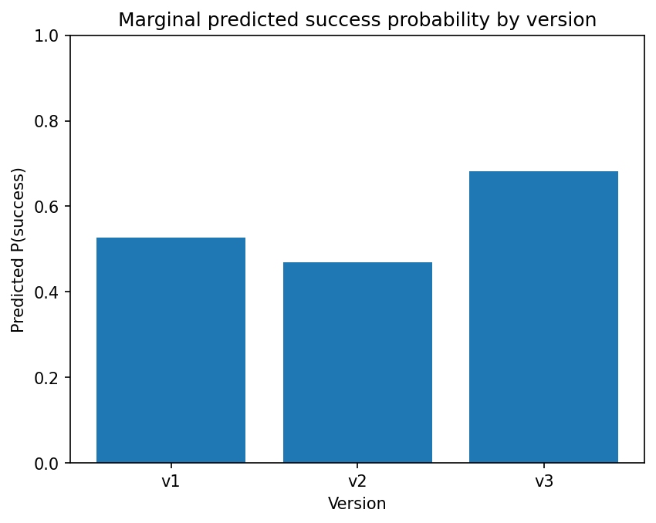
By mode:
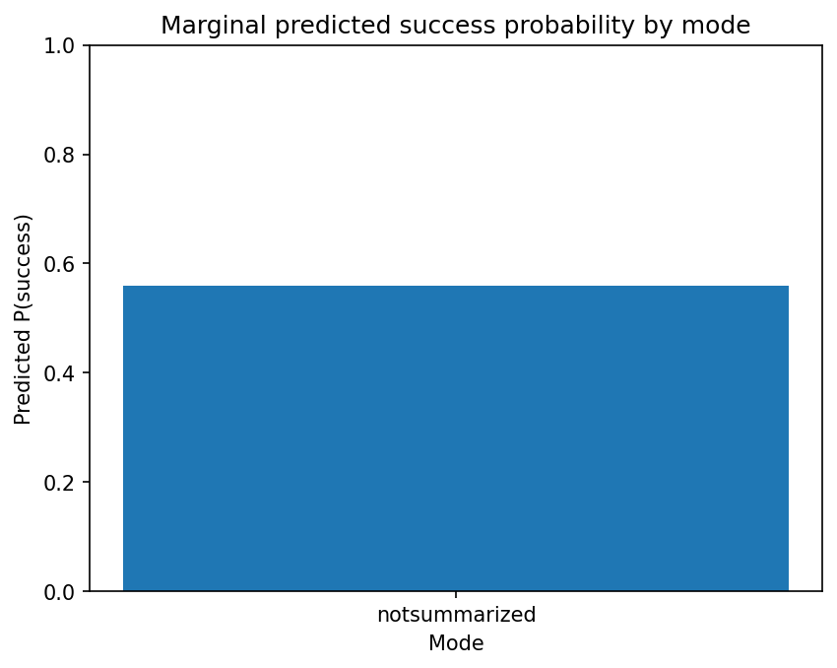
By case:
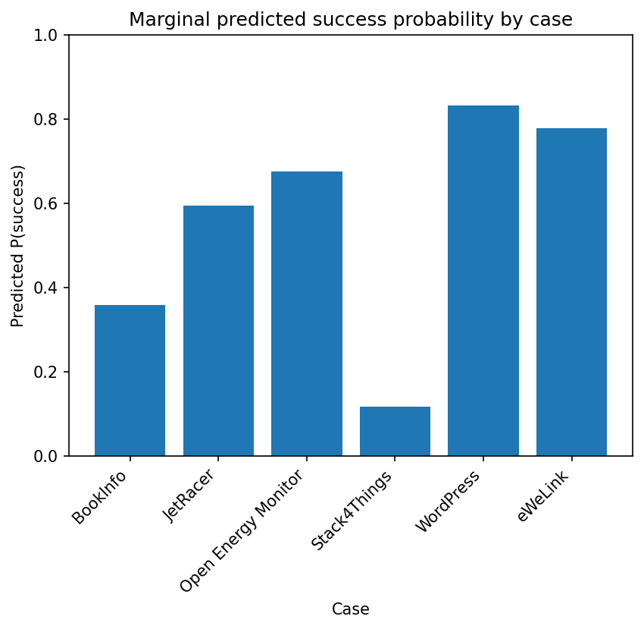

3. Uplift Analysis
Uplift in predicted success probability relative to baseline v1 and notsummarized.
Version uplift vs v1:
Version | Predicted P(success) | Uplift vs v1 (%)
v1 | 0.527 | 0.0
v2 | 0.470 | -10.8
v3 | 0.682 | 29.4
Mode uplift vs notsummarized:
Mode | Predicted P(success) | Uplift vs baseline (%)
notsummarized | 0.559 | 0.0

4. Bayesian Estimation of Success Probability
A Beta(1,1) prior was used for p in each group. The posterior is Beta(1+k,1+n-k). Below are posterior summaries for version+mode combinations.
Level (version/mode) | n | Posterior mean p | CI 2.5% | CI 97.5%
v1 / notsummarized | 92 | 0.447 | 0.348 | 0.548
v2 / notsummarized | 90 | 0.391 | 0.295 | 0.492
v3 / notsummarized | 85 | 0.621 | 0.517 | 0.719

5. DOE Planning (Target ±10% Precision)
Using current success rates per case and a 95% CI target of ±10 percentage points on p, the required total runs per case are estimated via n ≈ z^2 p(1-p) / h^2 with h=0.10.
Case | Current p_hat | Current n | Required total n (±10%) | Suggested runs per (version,mode) cell
BookInfo | 0.354 | 82 | 88 | 30
JetRacer | 0.581 | 62 | 94 | 32
Open Energy Monitor | 0.682 | 44 | 84 | 28
Stack4Things | 0.116 | 43 | 40 | 14
WordPress | 0.833 | 18 | 54 | 18
eWeLink | 0.778 | 18 | 67 | 23
The DOE plan is also saved as DOE_plan.csv for further technical processing.

