Module Two – Milestone One – Project Proposal

Max Rodriguez
Southern New Hampshire University
CS 330 – Comp. Graphic and Visualization
Brian Battersby
May 17th, 2026

Revised on May 30th, 2026

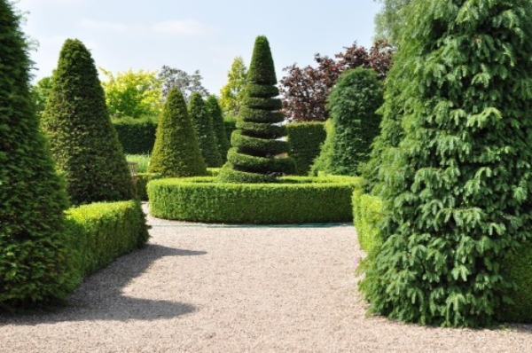
I selected the topiary garden image as the 2D scene for my 3D project. The scene contains several different objects and shapes that can be recreated in OpenGL. I chose this image because it includes repeating objects, simple geometry, and one complex object that can be built from multiple shapes. The scene will contain at least four objects, including the conical bushes, rectangular hedges, circular hedge, and spiral topiary. The ground and pathway will also be included to complete the environment.

The conical bushes will be created using tapered cylinders for the main body, and a cone for the head of the bushes.. The rectangular hedges will use boxes, but with a scale applied to their geometry to lengthen as needed. The gravel pathway/ground will be represented with planes. The circular hedge in the center can be created using a torus combined with a cylinder. The spiral topiary is the most detailed object and will require multiple cones and cylinders stacked together to create the spiral shape. Background trees may use cones and spheres to simplify the design.

These objects are a good choice because they use several different 3D shapes while remaining manageable to create. The scene is visually interesting but still achievable within the project scope. I’m going to use textures and camera movement to make the final 3D environment look as good as possible.

