Internet of Things

Group 3: Maxim-Leonid Rezan, Tiago Caldas De Silva, Elena Maria Pesci

Winter semester 2023-2024

Project: Thingy52 connected to Raspberry PI through ESP32

The aim of the project is to transfer data collected by the sensors of the thingy52 through Bluetooth Low Energy to the ESP32. The information is then passed using the MQTT protocol to the Raspberry Pi and visualized in the ThingsBoard cloud service.

Hardware:

Thingy52

It is a compact, power-optimized, multi-sensor development kit device designed for collecting environmental data. Thingy can sense movement, orientation, temperature, humidity, air pressure, light, color, and air quality. The data can be transmitted via Bluetooth to Bluetooth-enabled devices.

J-Link EDU Mini

It is a minimalistic debug probe that has been used in the developing of the project to flash code into the Thingy52.

ESP32

ESP32 is a series of low-cost, low-power [system on a chip](https://en.wikipedia.org/wiki/System_on_a_chip) [microcontrollers](https://en.wikipedia.org/wiki/Microcontroller) with integrated [Wi-Fi](https://en.wikipedia.org/wiki/Wi-Fi) and dual-mode [Bluetooth](https://en.wikipedia.org/wiki/Bluetooth).

It includes a built-in support for Wi-Fi and supports Bluetooth Low Energy, which are both vital in our application.

Figure 1: Thingy52 Figure 2: J-Link Figure 3: ESP32

Source: <https://www.nordicsemi.com/Nordic-news/2017/06/nordic-thingy>

Source: <https://www.segger.com/products/debug-probes/j-link/models/j-link-edu-mini/>

Source: <https://www.digikey.at/en/products/detail/espressif-systems/ESP32-DEVKITC-VIE/12091811>

Raspberry Pi

The Raspberry Pi is a series of small, affordable, single-board computers (SBCs). It encapsulates all essential components of a computer in compact manner.

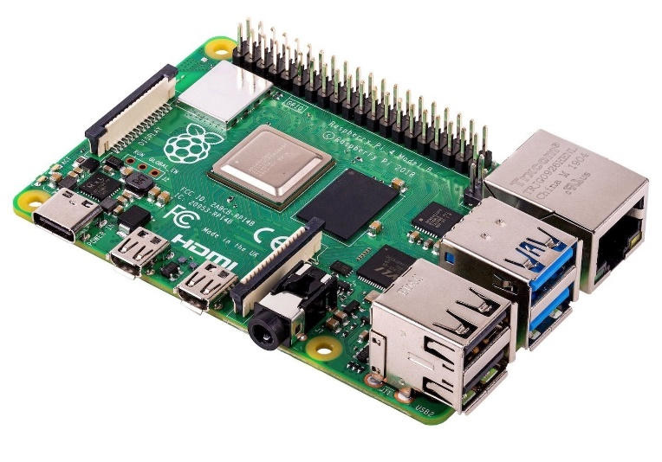

Figure 4: Raspberry Pi 4

Source: <https://www.berrybase.at/raspberry-pi-4-computer-modell-b-4gb-ram>

Development steps:

We started working on the Raspberry Pi first. Since it is a computer, to function it needs a running operating system. Raspbian is an operating system tailored to work on Raspberry Pi, we proceed by uploading it on microSD using a laptop. The microSD was then inserted into the computer.

We don’t dispone of a keyboard or monitor to use with the Raspberry Pi. Therefore, we built a headless configuration for the Raspberry Pi. This procedure allows to visualize the desktop of the computer directly on a laptop connected to the same Wi-Fi. This result was accomplished by the usage of TigerVNC and PuTTY.