

|  |  |  |
| --- | --- | --- |
| ***Estudante:*** | | |
| ***Turma: 7º*** | ***2º Bimestre*** | |
| ***Prof(a). Diego Zanoni*** | |  |
| ***EXERCÍCIOS DE EXTRAS*** | | |

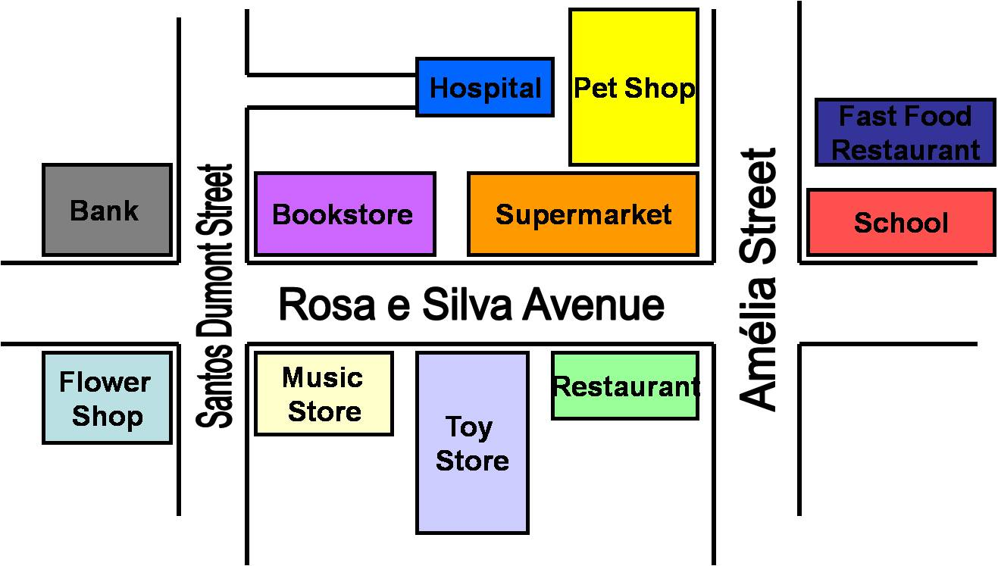

1. Escreva frases usando as preposições dadas, use o mapa:
   1. Next to

__________________________________________________________________________________________

* 1. Behind

__________________________________________________________________________________________

* 1. Between

__________________________________________________________________________________________

* 1. Near

__________________________________________________________________________________________

* 1. Opposite to

__________________________________________________________________________________________

1. Responda as questões, use o mapa:
   1. Where is the toy store?

__________________________________________________________________________________

* 1. Where is the flower shop?

__________________________________________________________________________________

* 1. Where is the pet shop?

__________________________________________________________________________________

* 1. Where is the fast food restaurant?

__________________________________________________________________________________

* 1. Where is the bank?

__________________________________________________________________________________

* 1. Where is the book store?

__________________________________________________________________________________

* 1. Where is the school?

__________________________________________________________________________________

* 1. Where is the hospital?

__________________________________________________________________________________

* 1. Is there a supermarket near the school?

__________________________________________________________________________________

* 1. Are there restaurants near the supermarket?

__________________________________________________________________________________

* 1. Is there a museum opposite to the hospital?

__________________________________________________________________________________

* 1. Are there houses behind the bank?

__________________________________________________________________________________