Updated: 8/24/2022

Sky Cen

Using Google Protocol Buffers in Python

Installation (Windows 11):

1. Download and install python 3.7 or later: https://www.python.org/downloads/
2. Download and extract protobuf and protoc from: https://github.com/protocolbuffers/protobuf/releases
3. To install protoc (.proto file compiler), copy the path to protoc.exe into PATH found under Environment Variables: Settings -> System ->Advanced System Settings -> Advanced -> Environment Variables -> Path -> Edit -> New
4. To install protobuf (run time environment), navigate to the python folder and execute the following commands in command prompt:
   1. python setup.py build
   2. python setup.py install
5. Install grpc related dependencies:
   1. pip install grpcio
   2. pip install protobuf
   3. pip install grpcio-tools

Sample Proto File:

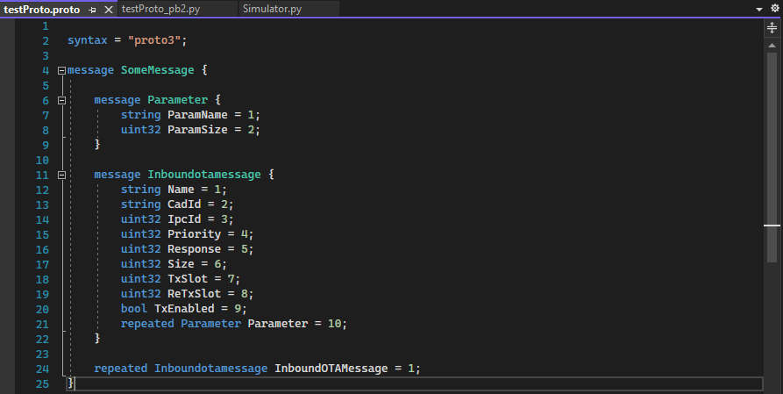

Compile Proto File using GRPC:

Navigate to the folder containing .proto file in command prompt. Execute:

python –m grpc_tools.protoc –I. --python_out=. --grpc_python_out=. .\testProto.proto

This generates the testProto_pb2.py and testProto_pb2_grpc.py files.

Once generated, import the necessary _pb2.py files into python script.

Using Google Protocol Buffers in C++

Installation (Windows 11):

1. Install Microsoft Visual Studio with MSVC and CMake
2. Download and extract protobuf-cpp zip into C:\Users\scen\Desktop\Protobuf folder from <https://github.com/protocolbuffers/protobuf/releases>
3. Follow steps in Protobuf\protobuf-cpp-3.21.4\protobuf-3.21.4\cmake\README.md:
   1. Create install folder in C:\Users\scen\Desktop\Protobuf
   2. Copy C:\Users\scen\Desktop\Protobuf\protobuf-cpp-3.21.4\protobuf-3.21.4 into C:\Users\scen\Desktop\Protobuf\install
   3. Open x64 Native Tools Command Prompt for VS 2022
   4. cd C:\Users\scen\Desktop\Protobuf\install\protobuf-3.21.4\cmake
   5. mkdir build & cd build
   6. mkdir release & cd release
   7. 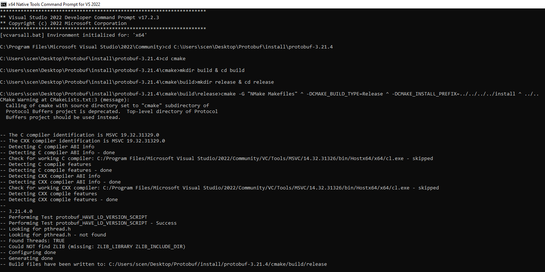cmake –G “NMake Makefiles” ^ -DCMAKE_BUILD_TYPE=Release ^ -DCMAKE_INSTALL_PREFIX=../../../../install ^ ../..
   8. cd ..
   9. mkdir debug & cd debug
   10. 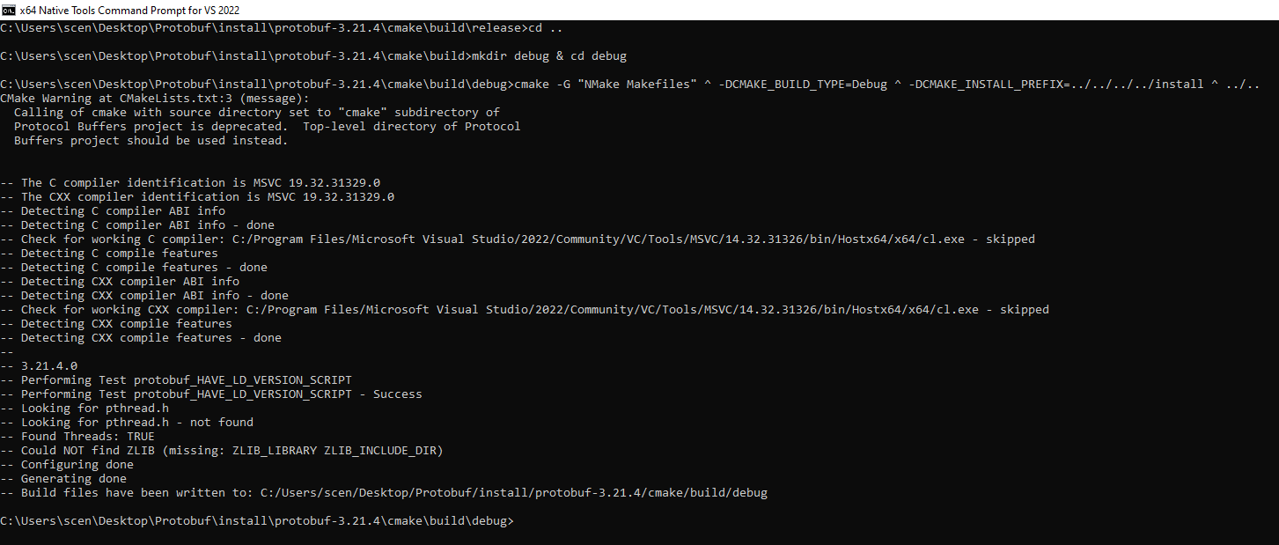cmake –G “NMake Makefiles” ^ -DCMAKE_BUILD_TYPE=Debug ^ -DCMAKE_INSTALL_PREFIX=../../../../install ^ ../..
   11. cd ..
   12. mkdir solution & cd solution
   13. 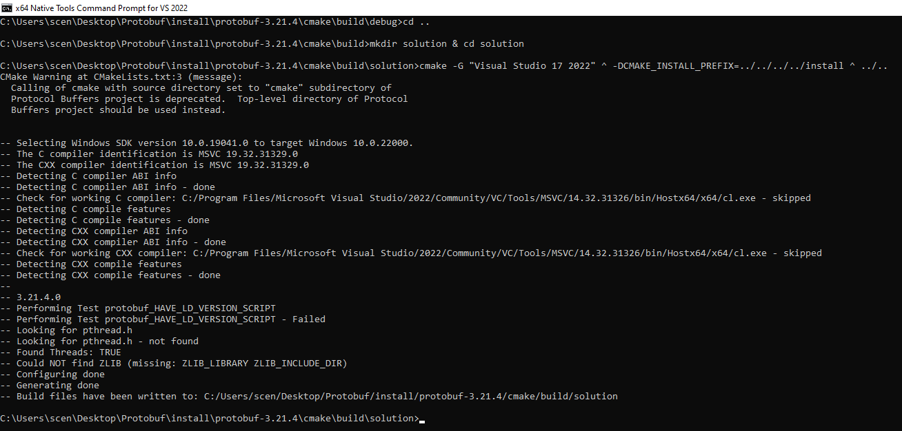cmake –G “Visual Studio 17 2022” ^ -DCMAKE_INSTALL_PREFIX=../../../../install ^ ../..
   14. cd ..\release
   15. nmake
   16. cd C:\Users\scen\Desktop\Protobuf\install\protobuf-3.21.4\cmake\build\debug
   17. nmake
   18. Make sure you pass tests in both debug and release folders:
   19. tests.exe --gtest_filter=AnyTest*
   20. cd C:\Users\scen\Desktop\Protobuf\install\protobuf-3.21.4\cmake\build\release
   21. tests.exe --gtest_filter=AnyTest*
   22. Build for both folders:
   23. nmake install
   24. cd C:\Users\scen\Desktop\Protobuf\install\protobuf-3.21.4\cmake\build\debug
   25. nmake install
4. There should be a new install folder and four new folders in C:\Users\scen\Desktop\Protobuf\install\install

Usage (Release):

1. Copy libprotobuf.lib, libprotobuf-lite.lib, libprotoc.lib and protoc.exe from C:\Users\scen\Desktop\Protobuf\install\protobuf-3.21.4\cmake\build\release to workspace: C:\Workspace\Protobuf_CPP
2. Create/Paste .proto files into workspace
3. Compile .proto files: protoc.exe -I=. --cpp_out=. InboundMessage.proto
4. Create VS project in workspace.
5. Copy .cc and .h files created from protobuf compiler into project directory.
6. In VS, select .cc and .h files and right click -> Include in Project.
7. In VS, copy and paste libprotobuf.lib, libprotobuf-lite.lib, libprotoc.lib into project.
8. In VS, right click project -> Properties -> C/C++ -> Code Generation -> Change Runtime Library to Multi-threaded DLL (/MD)
9. In VS, right click project -> Properties -> C/C++ -> General -> Change Additional Included Directories to path of include folder from installation: C:\Users\scen\Desktop\Protobuf\install\install\include
10. Make sure VS is in release mode.
11. Rebuild project. Build should be successful.

Using Google Protocol Buffers in C#

Installation (Windows 11):

1. Download and extract protoc from: https://github.com/protocolbuffers/protobuf/releases
2. To install protoc (.proto file compiler), copy the path to protoc.exe into PATH found under Environment Variables: Settings -> System ->Advanced System Settings -> Advanced -> Environment Variables -> Path -> Edit -> New

Usage:

1. Compile .proto files: protoc.exe -I=. –csharp_out=. InboundMessage.proto
2. Create VS project
3. In VS, packet manager console, install Google.Protobuf runtime package: Install-Package Google.Protobuf
4. Paste in compiled .proto files into project