Exercise 1

1. Which organism does each given genome belong to?
29.fa.txt Saccharomyces cerevisiae S288C chromosome IX, complete sequence
44.fa.txt Leuconostoc gelidum JB7, complete genome
47.fa.txt Neisseria meningitidis alpha710, complete genome

2. What is the size of this genome (in bp)?
29.fa.txt 439888
44.fa.txt 1893499
47.fa.txt 2242947

3. What is the number of genes?
29.fa.txt 232
44.fa.txt 1,967
47.fa.txt 2,104

4. What type of organism is it (i.e., prokaryotic or eukaryotic)?
29.fa.txt eukaryotic
44.fa.txt prokaryotic
47.fa.txt prokaryotic

Exercise 2

1.
blastn – blastn provides the best matching DNA sequence to the query sequence (query sequence = DNA)
blastp – The input for blastp should be a protein sequence and the return will be the most similar protein sequence taken from the by the user chosen protein database.
blastx – blastx creates a six-frame conceptual translation product of the given nucleotide sequence input and compares it to a chosen protein sequence database.

3.
A super-family of proteins can be seen as the largest assembly of proteins together with their common protein ancestors. This concept of group is derived from a structural alignment or mechanistic similarity, not necessarily regarding their sequence similarity, where the proteins can be distantly related.

The term protein family corresponds to a group of proteins with related functions and similarities concerning their structure or sequence. Their corresponding genes are usually also grouped together in gene families.

3.1.
Yes.
3.2.
It is the p53-super-family.

5.
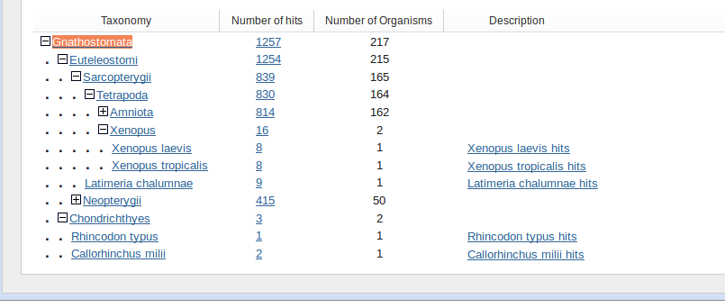

The taxonomic spread derived from the blast-search shows, that the p53 super family only occurs in the kingdom animalia, as the species Gnathostomata (jawed vertebrates) is part of the animal kingdom. The blast-search was done with the database refseq_protein, 20000 of maximum aligned sequences and an expected e-value threshold of 0.001.

Exercise 4
3. Blast is slightly faster than phmmer and much faster compared to jackhmmer. Phmmer and jackhmmer both use the probabilistic method profile hidden Markov model for their search, whereas blast is using scoring matrices, such as matrices derived from the Needleman-Wunsch-algorithm.

4.
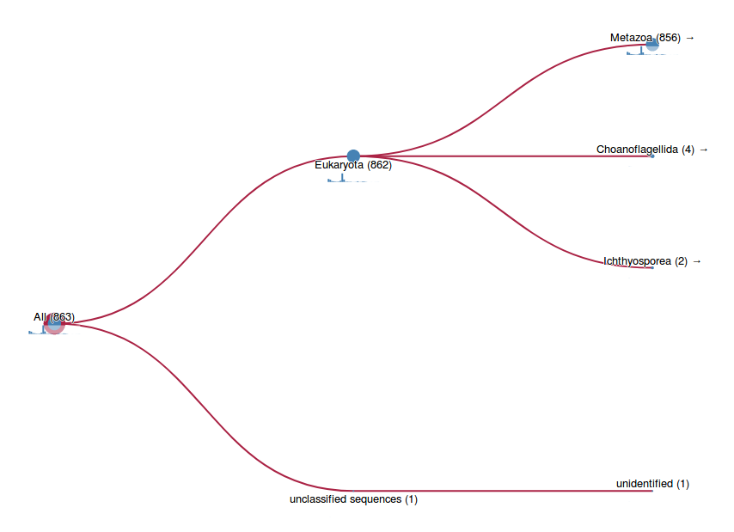

The taxonomic spread for jackhmmer and phmmer is the same. Both show, that most of the homologs exist in the kingdom of metazoa (animalia). Additionally, two unranked kingdoms are shown (Choanoflagellida and Ichtyosporea), as they both contain species with the p53 superfamily, which is different to the blast search. The unclassified sequence can be disregarded.

