Practical 8
This practical is about functional association networks in your proteomes. You will identify
and characterise networks, its topology, and compare the results about functional
association gained with FunCoup and STRING. Further, you will compare the enriched
pathways based on differentially expressed gene sets found in a yeast chromosome via two
state of the art networks analysis tools (PathwAX, DAVID).

Summary:

In this practical, the functional association networks of our proteomes is investigated. First, the average connectivity is derived with a certain python code to observe the number of interactions vs. the number of genes. Second, a scatter-plot is derived from the node degrees and their frequencies, which gives a better insight into the degree distribution. Nevertheless, a power-distribution is not observed. Third,

Comparative network analysis using STRING
1.
Organism TaxID NCBI fileID
29.fa.txt: Saccharomyces cerevisiae 4932 1
44.fa.txt: Leuconostoc gelidum 927691 2
47.fa.txt: Neisseria meningitidis 122586 3
16.fa.txt: Rhodopirellula baltica 243090 4
20.fa.txt: Thermotoga maritima 243274 5

2. Extraction
gzip -cd prot… | grep “^nr\.” > file

for i in 927691 4932 122586 243090 243274; do gzip -cd ../../protlinks/protein.links.v10.5.txt.gz | grep "^$i\." > $i.txt; echo "$i done"; done

Key question:

Comparative network analysis using STRING
1.
File: 1, Number of Genes: 6391, Number of Interactions: 2007134, Average connectivity: 314.0563
File: 2, Number of Genes: 1899, Number of Interactions: 238668, Average connectivity: 125.6809
File: 3, Number of Genes: 2049, Number of Interactions: 284938, Average connectivity: 139.0620
File: 4, Number of Genes: 7094, Number of Interactions: 951832, Average connectivity: 134.1742
File: 5, Number of Genes: 1850, Number of Interactions: 298816, Average connectivity: 161.5222

python script: key_questions_1and2.py – function quest1

2.
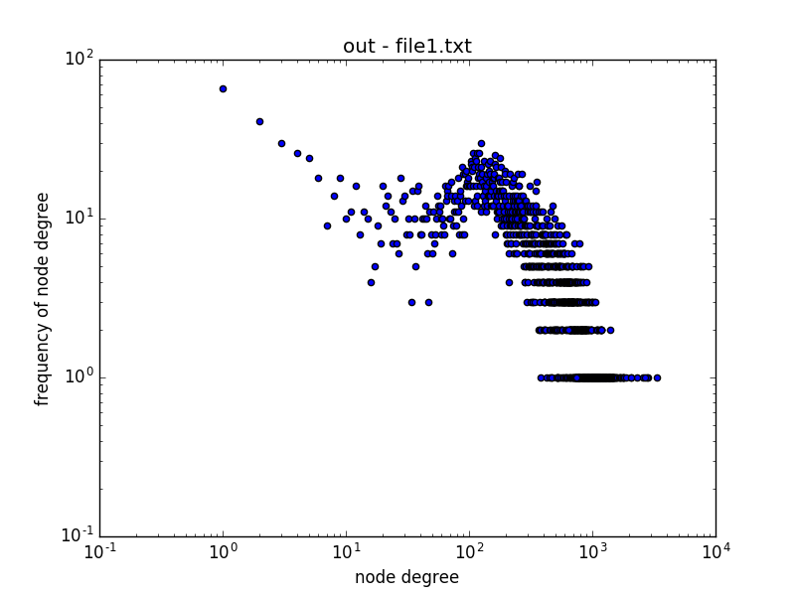
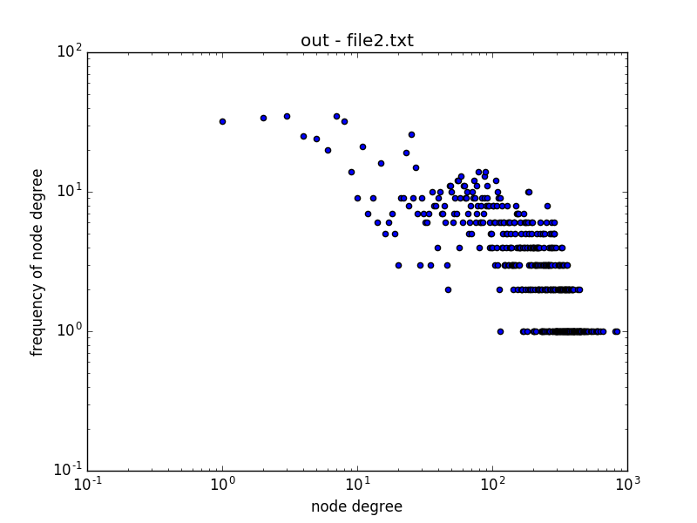

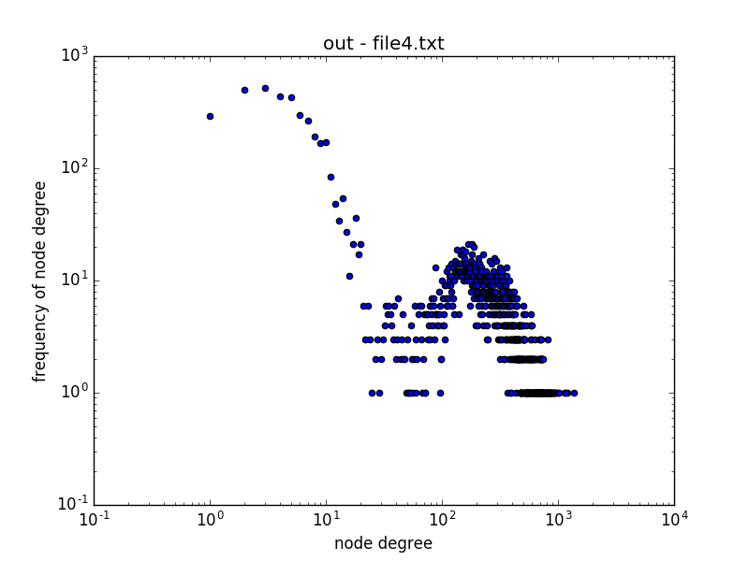
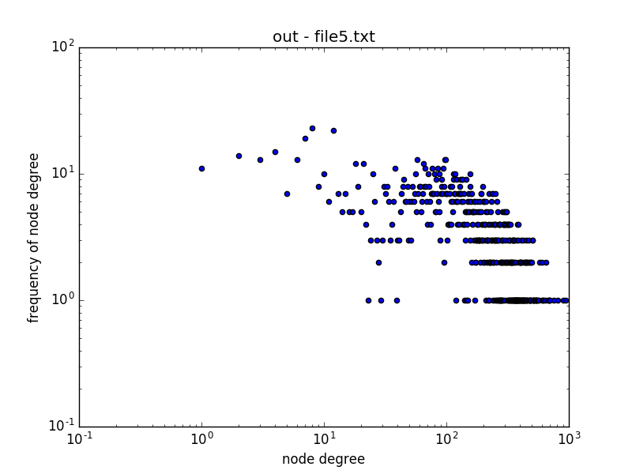
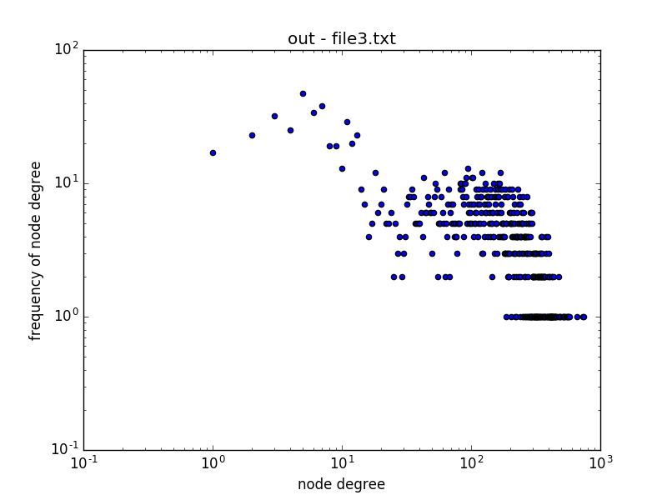

A power-law distribution is when there is a quantitative relationship between two variables (in this case, the variables are the node degree and the frequency of the node degree). In all five interactomes, there is no power-law distribution existent.

python script: key_questions_1and2.py – function quest2

Creation of two experimental gene sets containing differentially expressed genes (DEGs)
1.
makeblastdb ... | blastp …
blastp -db -outfmt 7 -max_target_seqs 1 > outblastp

blastp -outfmt 7 -query ../29.fa.txt.pfa -db uniprot-proteome%3AUP000002311.fasta -out ../outblastp -max_hsps 1

