1. Give at least two examples of concrete problems where clustering could be useful.

- Usage for sequence analysis, to pool homologous sequences into families.
- Setting groups of genes with similar expression patterns, or co-expressed genes

2. Name two types of clustering methods and describe the concept behind them?

- Centroid-based clustering (k-means clustering). Classified as a type of unsupervised learning, k-means clustering is an algorithm, in which data are pooled in groups, by which the number of groups is represented by the variable k. Each data point gets assigned to one of the k groups iteratively based on the specifics provided.
- connectivity-based clustering (Hierarchical clustering). Datapoints in a Dataset are in this algorithm summed in a group based on their distance to each other. The general concept is, that objects are more related to objects nearby, than to objects further away.

3. Give three examples of distance metrics commonly employed in clustering.

- Euclidean
- Manhatten
- Pearson Correlation

4. Assume we have four data points, A, B, C, D, with the distances between them given in the matrix below. Build the dendogram obtained when applying hierarchical single linkage clustering.
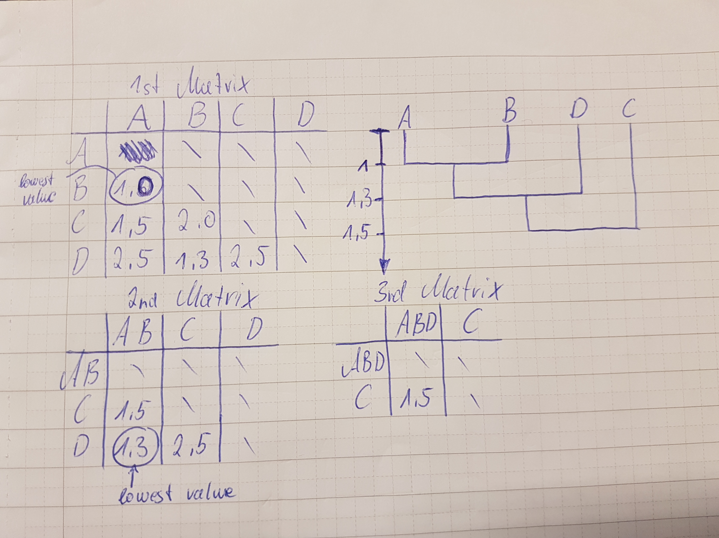

5. Download the file clustering.tar and decompress it (tar xfv clustering.tar). Enter this directory (cd clustering).

6. Open the file clustering_scikit.py. It loads the data from a text file and performs the k-means algorithm. Do you understand what it does? How many clusters does it create by default? You may want to look at the documentation: http://scikit-learn.org/stable/modules/clustering.html
7. Run the program. Modify it as needed so you get the names of the sequences belonging to each cluster.
Sequencename: YAR007C Clustername 2
Sequencename: YBL024W Clustername 0
Sequencename: YBL002W Clustername 1
Sequencename: YBR126C Clustername 0
Sequencename: YBL003C Clustername 1
Sequencename: YBL052C Clustername 0
Sequencename: YBL087C Clustername 0
Sequencename: YBL088C Clustername 0
Sequencename: YBL092W Clustername 0
Sequencename: YBL097W Clustername 0
Sequencename: YBR009C Clustername 1
Sequencename: YBR010W Clustername 1
Sequencename: YBR048W Clustername 0
Sequencename: YBR073W Clustername 2
Sequencename: YBR081C Clustername 0
Sequencename: YBR088C Clustername 2
Sequencename: YBR103W Clustername 0
Sequencename: YBR199W Clustername 0
Sequencename: YBR241C Clustername 0
Sequencename: YCL040W Clustername 0
Sequencename: YCR036W Clustername 0
Sequencename: YDL021W Clustername 0
Sequencename: YDL115C Clustername 0
Sequencename: YNL102W Clustername 2
8. What does k in k-means mean?
K is the value of the maximum amount of clusters. Setting k to 3 means, that the data is put into three clusters.
9. If you change k=2, how many sequences do you get in the smallest cluster?
The cluster with the least sequences is in this case cluster 0 with 4 sequences.
Sequencename: YAR007C Clustername 1
Sequencename: YBL024W Clustername 1
Sequencename: YBL002W Clustername 0
Sequencename: YBR126C Clustername 1
Sequencename: YBL003C Clustername 0
Sequencename: YBL052C Clustername 1
Sequencename: YBL087C Clustername 1
Sequencename: YBL088C Clustername 1
Sequencename: YBL092W Clustername 1
Sequencename: YBL097W Clustername 1
Sequencename: YBR009C Clustername 0
Sequencename: YBR010W Clustername 0
Sequencename: YBR048W Clustername 1
Sequencename: YBR073W Clustername 1
Sequencename: YBR081C Clustername 1
Sequencename: YBR088C Clustername 1
Sequencename: YBR103W Clustername 1
Sequencename: YBR199W Clustername 1
Sequencename: YBR241C Clustername 1
Sequencename: YCL040W Clustername 1
Sequencename: YCR036W Clustername 1
Sequencename: YDL021W Clustername 1
Sequencename: YDL115C Clustername 1
Sequencename: YNL102W Clustername 1

10. Change to k=3. How many sequences do you now get in the smallest cluster(s)? You can also try other values for k.
There are two smallest cluster, both with the value (amount of sequences) of 4.
11. For k=3, what is the function of the genes in the two smaller clusters? Look at the functional classification and also use your database search skills. NB: the numbering of the clusters may change between runs.
YAR007C Replication, recombination, repair, Replication factor A protein 1
YBR073W Replication, recombination, repair, DNA repair and recombination protein RDH54
YBR088C Replication, recombination, repair, Proliferating cell nuclear antigen
YNL102W Replication, recombination, repair, DNA polymerase alpha catalytic subunit A

YBL002W Chromatin structure and dynamics, Histone H2B.2
YBL003C Chromatin structure and dynamics, Histone H2A.2
YBR009C Chromatin structure and dynamics, Histone H4
YBR010W Chromatin structure and dynamics, Histone H3
12. There is a sequence (YDL115C) of unknown function in the dataset. Can you make a prediction of the functional class of this protein (according to the classification in functioncodes.txt)?
Being detective
13. For comparison, take a look at the result of a neighbour joining clustering (nj_clustering). This tree has been created from the same data set. (However before calculating the tree the correlation between the profiles of each gene pair has been calculated.) What do you think are the advantages/disadvantages of the two clustering methods? When is k-means clustering useful and when is NJ preferable?

In order to perform NJ clustering, one has to know the distance between each pair of sequence. Because of that, it is a supervised method
K-means clustering is unsupervised, so there does not have to be any calculation beforehand, the process is then easier. One disadvantage concerning k-means clustering is, that the k-value is hard to predict. If it is set to high or k value gets close to the amount of input sequences, the distribution of sequences in the clusters are not distinct. Is it set to low, distribution is too superficial.
14. Modify the program to use a different clustering algorithm. Do you get significantly different results? Which one would you trust most? You will find a list and descriptions of algorithms already available here: http://scikit-learn.org/stable/modules/clustering.html#k-means
By using hirarchical clustering in addition to k-means clustering (k set to 3 for both), it shows, that both algorithms show the same results. Both algorithms assign the same sequences to the same clusters.

