Lab: 3D Structure Prediction
1. Give a short description of how X-Ray Crystallography is performed?

It is divided into three steps
- Obtaining of crystal structure of the desired material
- Irradiation of crystal with monochromatic X-rays, production of regular pattern of reflections. Since the crystal is rotating, every reflection of every part of the surface are collected to a dataset.
- Computational combination of yielded data set with complementary chemical information, a model of the atoms and their arrangement is composed and saved in a public database

2. Why did researchers develop methods for protein structure prediction?

Ab initio visualization, such as X-ray crystallography, takes too much time and resources and is too complicated to perform for every single desired protein. Structure prediction provides a much better approach, because one can use already existing data to produce a structure model.

3. Use the PDB Advanced Search and find out how many PDB entries that have had their structures determined via X-Ray Crystallography?

123050

4. Search for Azurin in the SCOP database. Select the top hit. What class, fold and family do they belong to?

Class: All beta proteins
Fold: Cupredoxin-like
Family: Plastocyanin/azurin like, mono-domain proteins

5. Search for Azurin in the CATH database. Select the top hit. What class, architecture and topology do they belong to?

Class: Alpha Beta
Architecture: 3-Layer(aba) Sandwich
Toppology: Dimethylsulfoxide Reductase; domain 2

6. Search for Azurin in the ECOD database. Select the top hit. What architecture, H-group and topology do they belong to?

Architecture: beta sandwiches
H-group: Cupredoxin-related
Topology: Cupredoxin-related

7. To make their web services more user-friendly, ECOD, SCOP and CATH have divided their protein folds into classes. Which classes do they have?

SCOP
all alpha, all beta, alpha and beta (alpha and beta structures are interspersed), alpha + beta (a and b are segregated), multi domain

ECOD
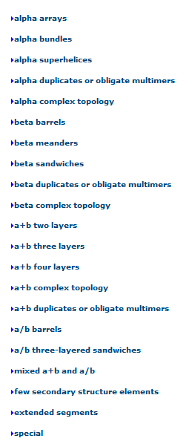 http://prodata.swmed.edu/ecod/complete/
CATH
few secondary structures, mainly alpha, alpha beta, mainly beta
8. Which of the three databases are most up to date?

ECOD

9. Give a short description of how fold recognition (threading) generally works?

In the first step, one produces a template database with using

10. What is a template structure and how does one generally find it?

The template structure is being compared to the target sequence, in order to find any similarity between the template and the target sequence. In the first step, one might start to find any sequence homology in databases. Next, it is possible to use threading, where one compares the 3-dimensional structure, as in folds.

11. What do you think is a meta-server?

A meta server is basically an interface, which can combine for example databases and returns the results to the user. With a meta server, data between different databases can be easily compared. Nevertheless, the meta server does not have any algorithms on its own, it rather sends the data to the connected algorithms/webserver, where the prediction is done and the results are then send back to the meta server and to the user.

12. Which methods did Pcons.net use to perform the homology modeling? (Hint: Paper: Pcons.net: protein structure prediction meta server)

13. Give a short description of how homology modelling generally works

14. Look at the "Quality by SOLVX" tab what does it mean when the blue line is inside the red area?

When the blue line enters the red (here in this case it is purple) area, the corresponding residues have a very bad score and cant be trusted.

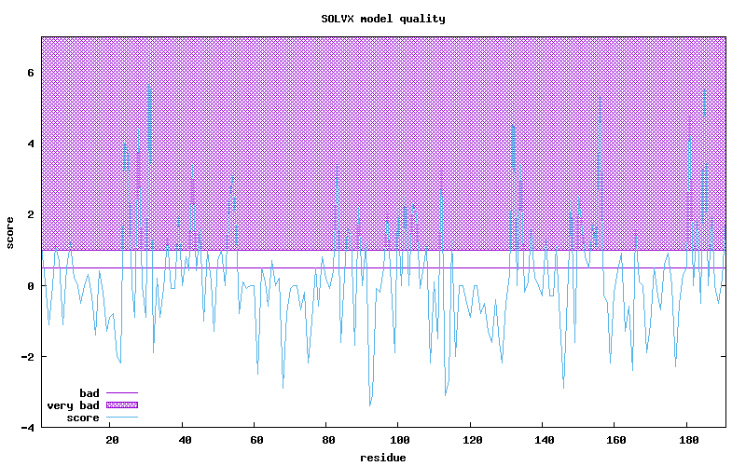
15. Download the pdb file, open it in Pymol, save an image and attach it to your report. (To be able to save the molecule as an image, Pymol needs to create a 2D representation of the 3D model. This can be done by simply typing "ray" into the Pymol command line in the structure window. Then you can save the image.)
