Lab: Secret sequence
1. What Pfam domain does this sequence you got match?
7 transmembrane receptor (rhodopsin familiy)
2. What is the secondary structure of your sequffence ?
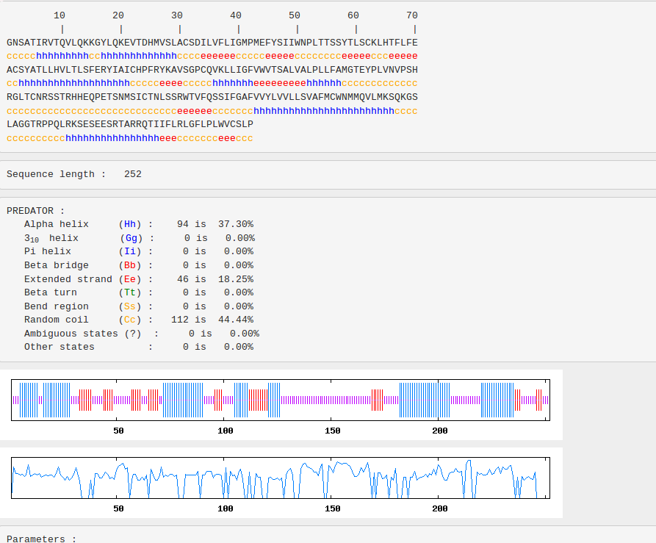
The secondary structure consists of 7 alpha helices, which is about 37% and random coil (44%) and extended strand (18%).

3. Identify possible interaction partners of your protein domain. What is the evidence for that ?
There are 12 interactions according to Pfam to the searched protein sequence:
1. Cytochrome b562 Arnesano F, Banci L, Bertini I, Faraone-Mennella J, Rosato A, Barker PD, Fersht AR; , Biochemistry 1999;38:8657-8670.: The solution structure of oxidized Escherichia coli cytochrome b562
2. G-protein alpha subunit https://en.wikipedia.org/wiki/G_alpha_subunit
3. Amino terminal of the G-protein receptor rhodopsin Yeagle PL, Salloum A, Chopra A, Bhawsar N, Ali L, Kuzmanovski G, Alderfer JL, Albert AD; , J Pept Res. 2000;55:455-465.: Structures of the intradiskal loops and amino terminus of the G-protein receptor, rhodopsin
4. Phage_lysozyme https://en.wikipedia.org/w/index.php?title=Glycoside_hydrolase_family_24
5. CXCR4 Chemokine receptor N terminal Veldkamp CT, Seibert C, Peterson FC, De la Cruz NB, Haugner JC 3rd, Basnet H, Sakmar TP, Volkman BF;, Sci Signal. 2008;1:ra4.: Structural basis of CXCR4 sulfotyrosine recognition by the chemokine SDF-1/CXCL12
6. Signal peptide binding domain Clemons WM Jr, Gowda K, Black SD, Zwieb C, Ramakrishnan V; , J Mol Biol 1999;292:697-705.: Crystal structure of the conserved subdomain of human protein SRP54M at 2.1 A resolution: evidence for the mechanism of signal peptide binding.
7. WD40 repeat https://en.wikipedia.org/w/index.php?title=WD40_repeat
8. SRP19 protein Lingelbach K, Zwieb C, Webb JR, Marshallsay C, Hoben PJ, Walter P, Dobberstein B; , Nucleic Acids Res 1988;16:9431-9442.: Isolation and characterization of a cDNA clone encoding the 19 kDa protein of signal recognition particle (SRP): expression and binding to 7SL RNA
4. Identify the full length protein. What is the name and UniProt ID of the protein ? Which organism does it belong to?
A6QR72, Organism Homo sapiens
5. What PDB files are homologous to your protein. Make a model of as long part as possible of your protein. Upload a picture of the model as a part your answer.
Checking the PDB database, the output is 211 homnologous models. Nevertheless, the identity is very low for all of them (max. = 39%). Because of that I produced my own model on SWISS-MODEL.
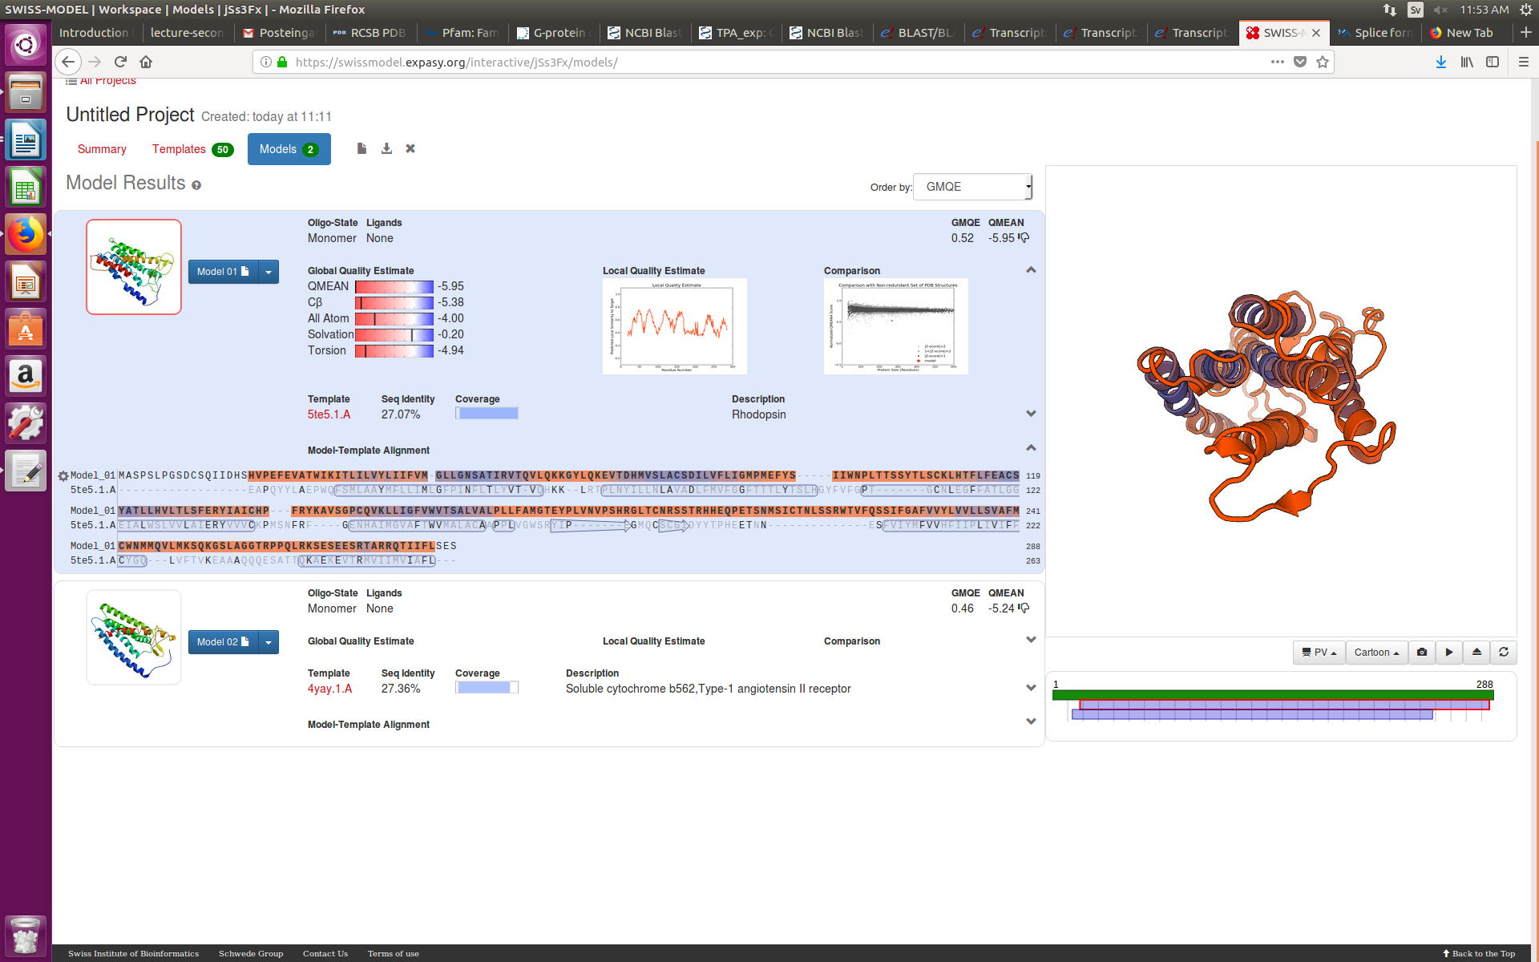

6. Find the closest protein in mouse. What is the sequence identity ?
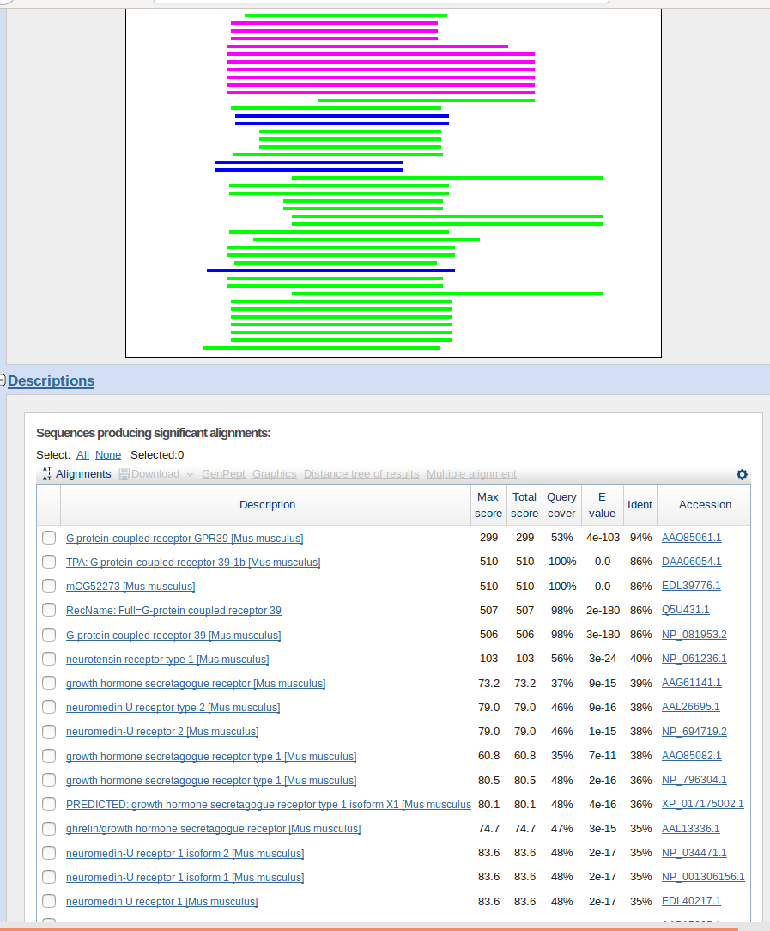
The closest protein is G-protein-coupled receptor GPR39 and the sequence identity is 94%.

7. What is the annotation score and evidence for the full length protein ?
The annotation score is 1 out of 5.
Evidence:
GPR39 splice variants versus antisense gene LYPD1: expression and regulation in gastrointestinal tract, endocrine pancreas, liver, and white adipose tissue."
Egerod K.L., Holst B., Petersen P.S., Hansen J.B., Mulder J., Hokfelt T., Schwartz T.W.
Mol. Endocrinol. 21:1685-1698(2007)
"Two alternatively spliced GPR39 transcripts in seabream: molecular cloning, genomic organization, and regulation of gene expression by metabolic signals."
Zhang Y., Liu Y., Huang X., Liu X., Jiao B., Meng Z., Zhu P., Li S., Lin H., Cheng C.H.
J. Endocrinol. 199:457-470(2008)
8. What is the sub-cellular location of your full length protein?
Integral component of membrane.
9. What is the molecular function of your full length protein ? Please provide the relevant GO-terms.
G-protein coupled receptor activity, GO:0004930

10. Use Ensembl to find possible splice forms of your protein. How many splice forms exist ?
There is one splice form, which consists of 2 exons and one intron.

