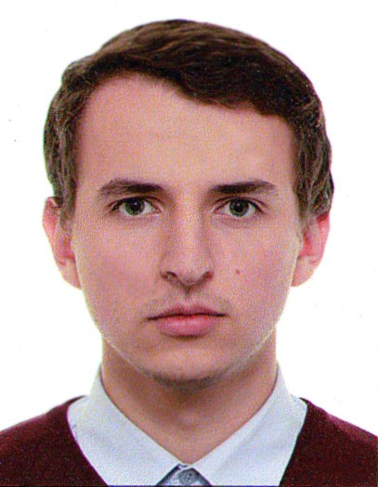/* MAXIM SHEVCHENKO */

.Contact {

Phone: +375-29-134-54-84;

Email: max_shev@list.ru;

Skype: max.shevchenko1;

LinkedIn: www.linkedin.com/in/max-shevchenko/;

/* see my full resume on LinkedIn*/

}

/* Applying for a position of a Front-end Developer */

.Skills {

Languages: CSS, HTML, JavaScript, Gulp, Sass;

Programs: Adobe Photoshop, MS Visual Studio Code, Sublime Text 3, browser's console;

Knowledge: Web standards and accessibility, Cross-browser compatibility, Responsive, Adaptive, Semantics, BEM;

English Proficiency: Intermediate (read technical literature, news and s.o.);

}

.Education {

#Educational Center of High-Tech Park (IT-Academy)

{

Time: 2017 – 2018;

Course: Development of web applications in JavaScript;

}

#Educational Center of High-Tech Park (IT-Academy)

{

Time: 2017 – 2017;

Course: Website development using HTML, CSS and JavaScript;

}

#The BNTU {

Time: 2011 – 2016;

Specialization: Technical security;

}

}

.Experience {

#Design engineer of security systems {

Time: February 2016 – now;

Employee: OOO «Belprogrammproject»;

Position: Design engineer;

Responsibilities: Full support of the development of documentation from the preparation of commercial proposals to the signing of acts of work performed;

}

}

.Additional_Information {

Portfolio: <https://maxshev.github.io>;

Hobby: I live active rest, such as: airsoft, cycling, camping trip. Every day I try to learn something new;

Military obligation status: Unfit [for military service](http://context.reverso.net/%D0%BF%D0%B5%D1%80%D0%B5%D0%B2%D0%BE%D0%B4/%D0%B0%D0%BD%D0%B3%D0%BB%D0%B8%D0%B9%D1%81%D0%BA%D0%B8%D0%B9-%D1%80%D1%83%D1%81%D1%81%D0%BA%D0%B8%D0%B9/for+military+service);

}