**(a)**

for k = 1

user Validation Accuracy: 0.6244707874682472

for k = 6

user Validation Accuracy: 0.6780976573525261

for k = 11

user Validation Accuracy: 0.6895286480383855

for k = 16

user Validation Accuracy: 0.6755574372001129

for k = 21

user Validation Accuracy: 0.6692068868190799

for k = 26

user Validation Accuracy: 0.6522720858029918

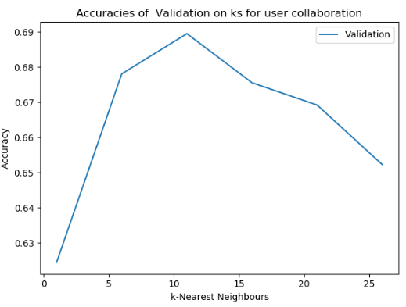

**(b)**

User collaboration's k with best accuracy is: 11

User collaboration's final test accuracy is: 0.6841659610499576

(c)

**for k = 1**

**item Validation Accuracy: 0.607112616426757**

**for k = 6**

**item Validation Accuracy: 0.6542478125882021**

**for k = 11**

**item Validation Accuracy: 0.6826136042901496**

**for k = 16**

**item Validation Accuracy: 0.6860005644933672**

**for k = 21**

**item Validation Accuracy: 0.6922099915325995**

**for k = 26**

**item Validation Accuracy: 0.69037538808919 (d)**

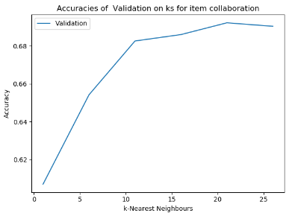

item collaboration's k with best accuracy is: 21

item collaboration's final test accuracy is: 0.6816257408975445

(d)

Comparing the test performance between user and item based collaborative filtering, we can see item collaboration with the test accuracy of 68.1% with the k= 26 and user collaborative with test accuracy of 68.4% with k = 11. So, in general the user based collaborative filtering has slightly a better performance for our model.

**(e)**